ELEC 5220/6220 Information Networks and Technology
LAB 1 REPORT

Jie ZOU
Xiao LIN

Abstract
This lab includes installing XAMPP and changing the root password, learning to do the fundamental operation to build a database of a commercial shop. Besides, it consists adding user name and limit the authority of it.

Introduction
The first lab require to install XAMPP. The installment package can be downloaded on the website http://www.apachefriends.org/en/xampp.html. The process of installing is simple, which just need to click next button. After installing, the panel of XAMPP will be shown as Figure A.
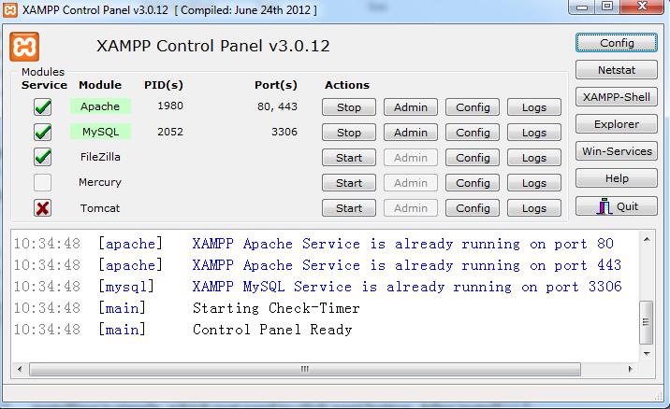
Figure A: XAMPP control panel after installing

Design

Exercise 1
This exercise require to create a new password for the root user. The password can be changed by going to http://localhost/xampp/ and click the security option on the left. Then, the password can be changed as the Figure 1-1 showed
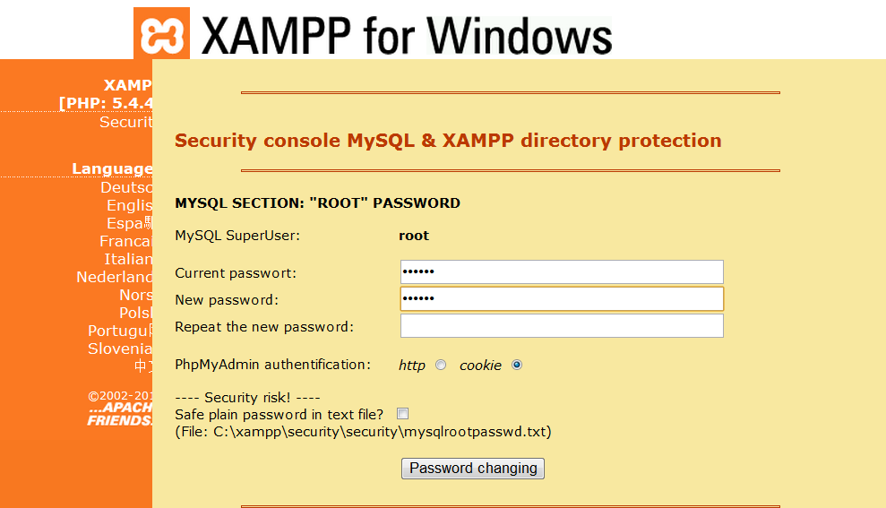
Figure 1-1 changing the root password
After changing root user password, you can go to http://localhost/phpmyadmin/ to log in. Figure 1-2 shows the log in page.
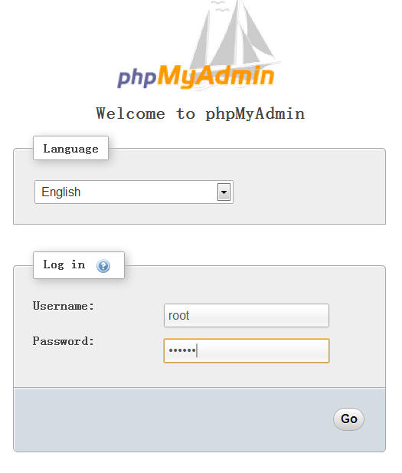
Figure 1-2 log in

Exercise 2
This exercise require to create a database named pet_store1 and a table named animal.
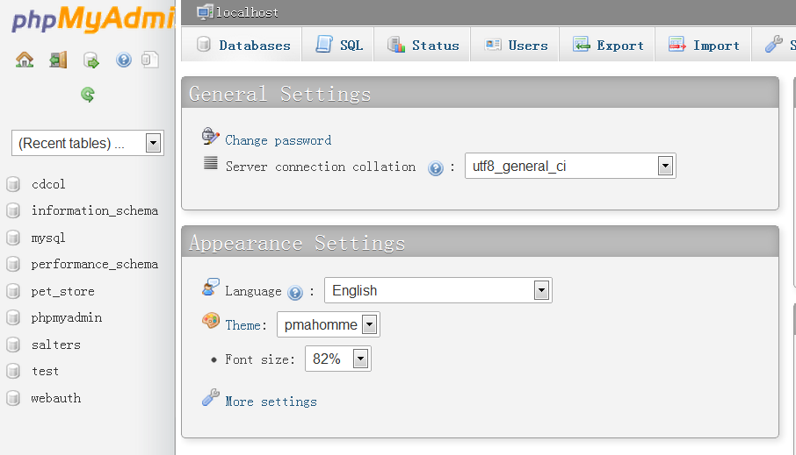
Figure 2-1 select database on the left of top
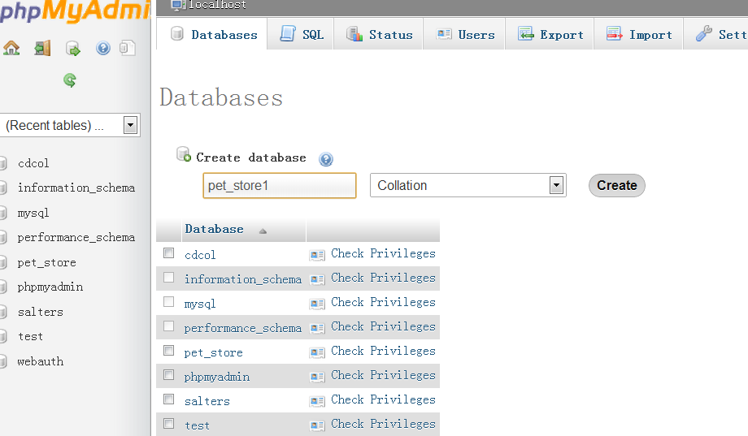
Figure 2-2 enter the name of database and click create
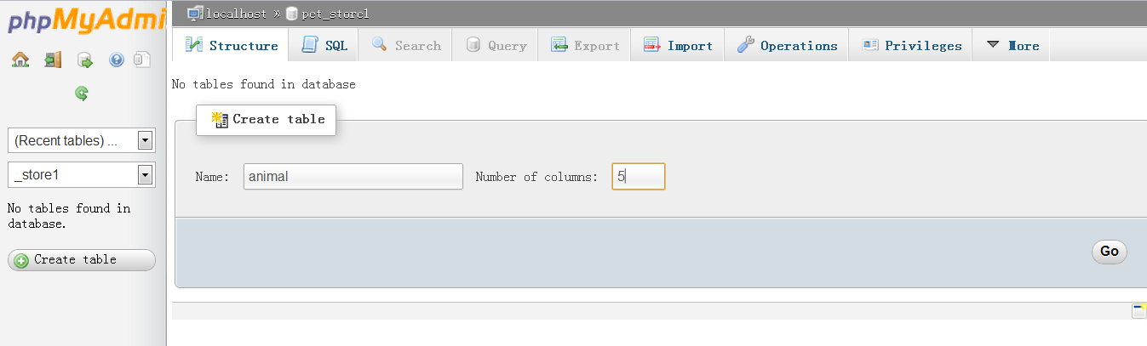
Figure 2-3 chose pet_store1 and type the name of your new table and the number of column, then click go
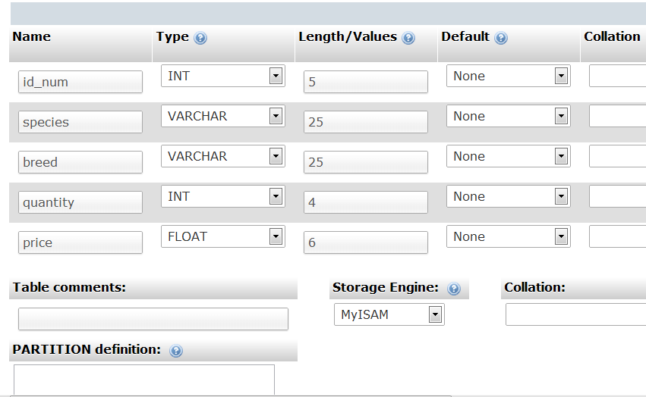
Figure 2-4 type in the name of each column and define type and length, change the Storage Engine to MyISAM
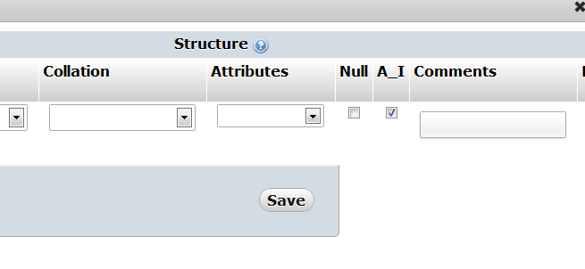
Figure 2-5 make id_num to be auto increment
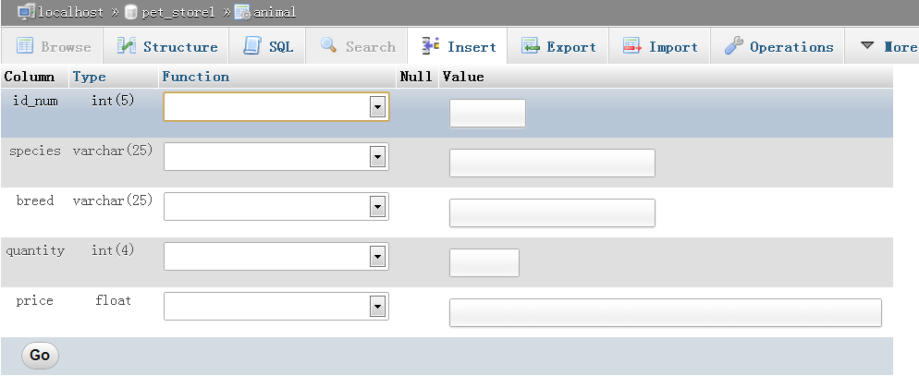
Figure 2-6 select Insert and input data
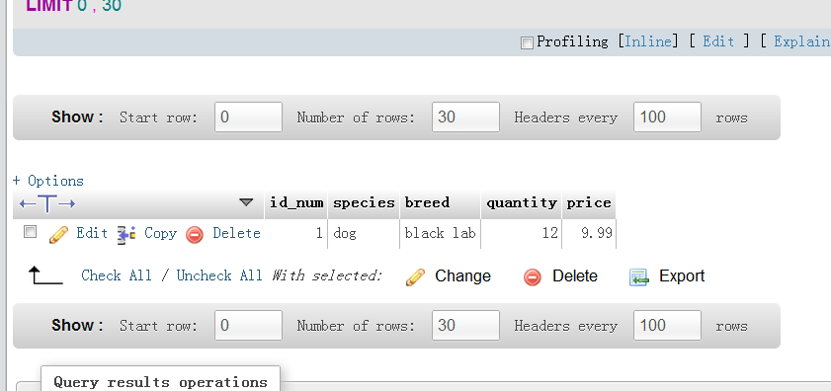
Figure2-7 after inputting one data
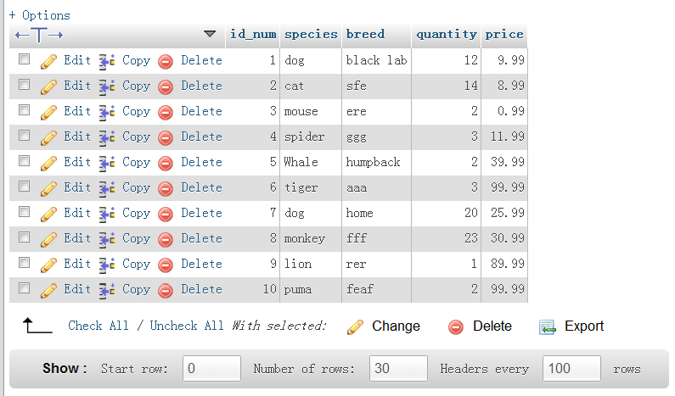
Figure 2-8 after adding 10 items

Exercise 3
This exercise concern with setting up additional users and their privileges. This allows an admin to control who has access to databases.

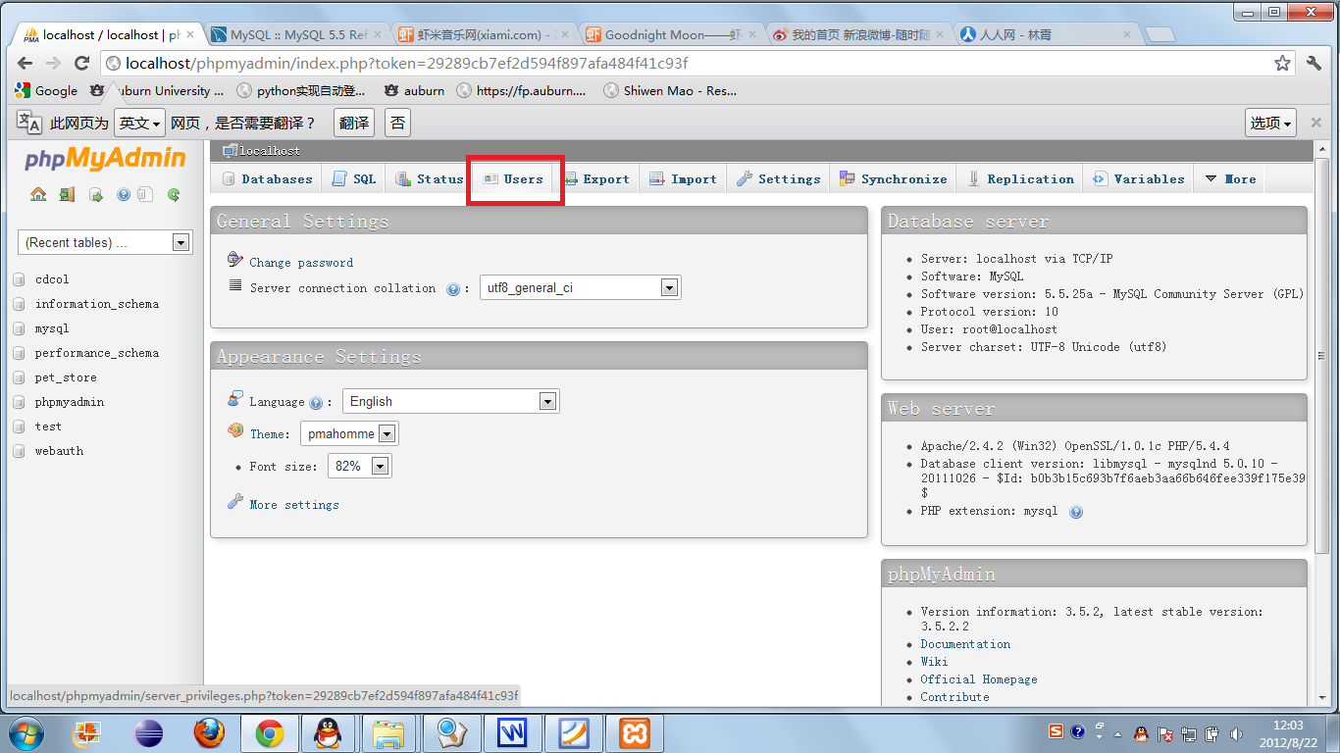
Figure 3-1: turn to the page adding new user by clicking the tap

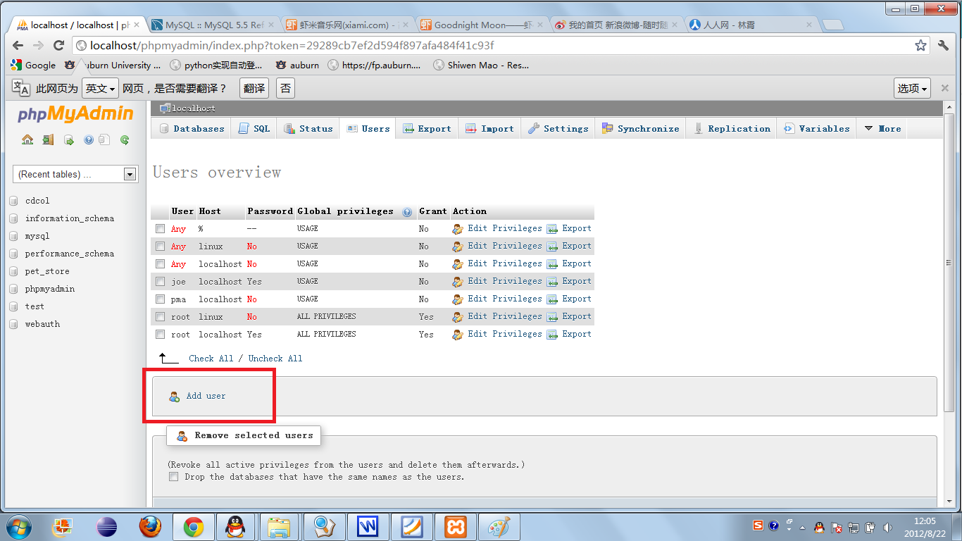

Figure 3-2: add new user by click on Add user

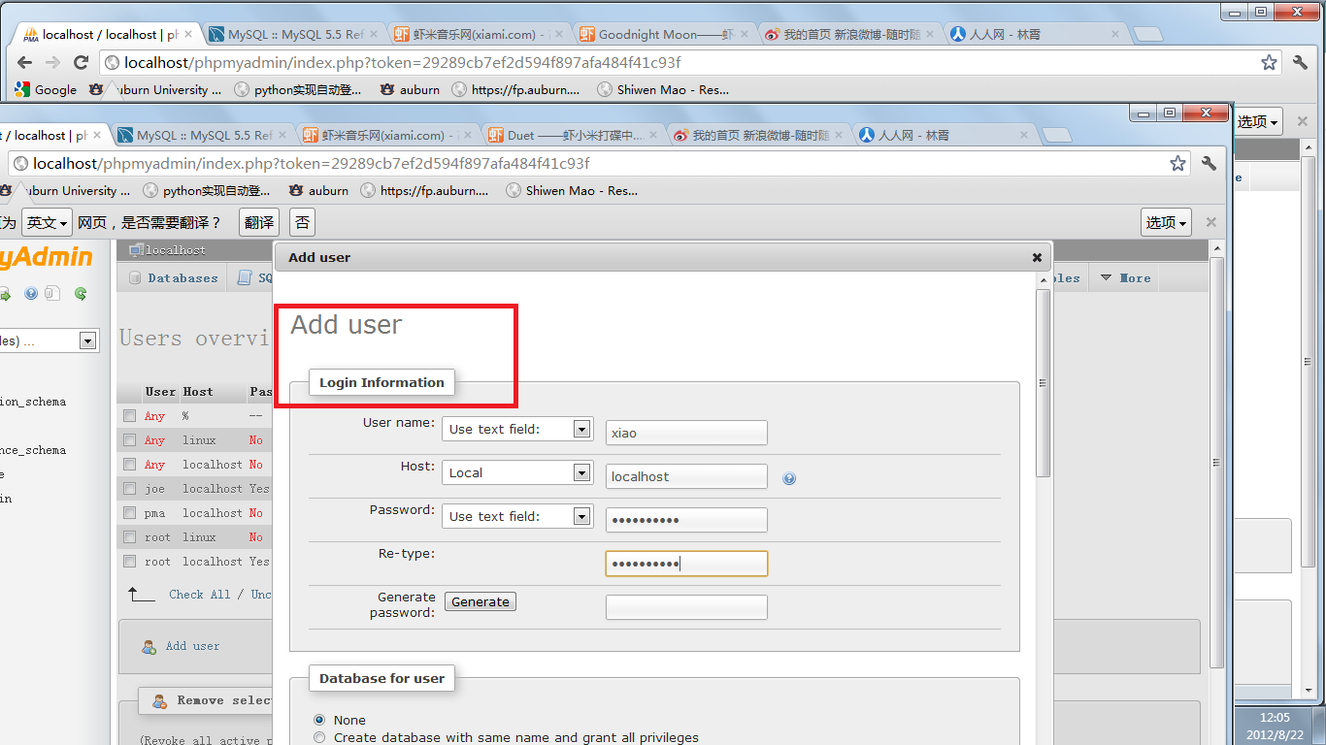
Figure 3-3: Fill in new user information

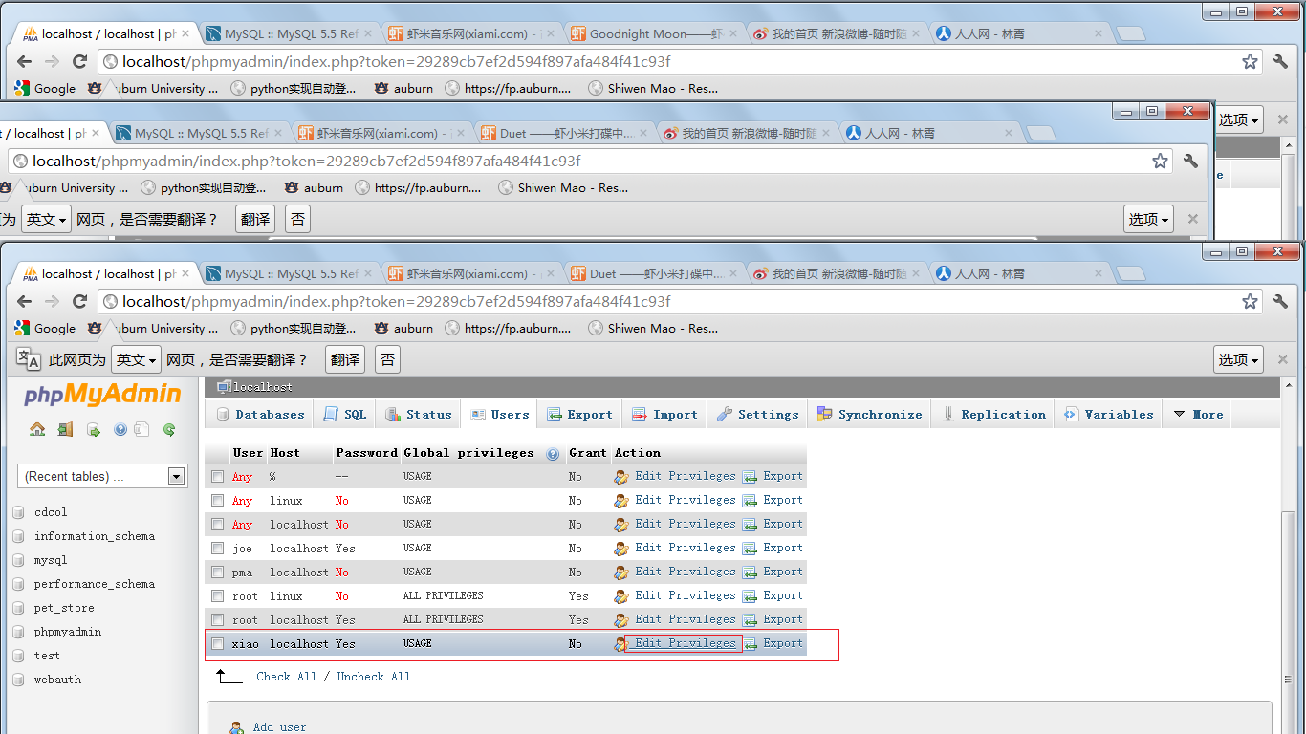
Figure 3-4: new user have been added and click on Edit privileges

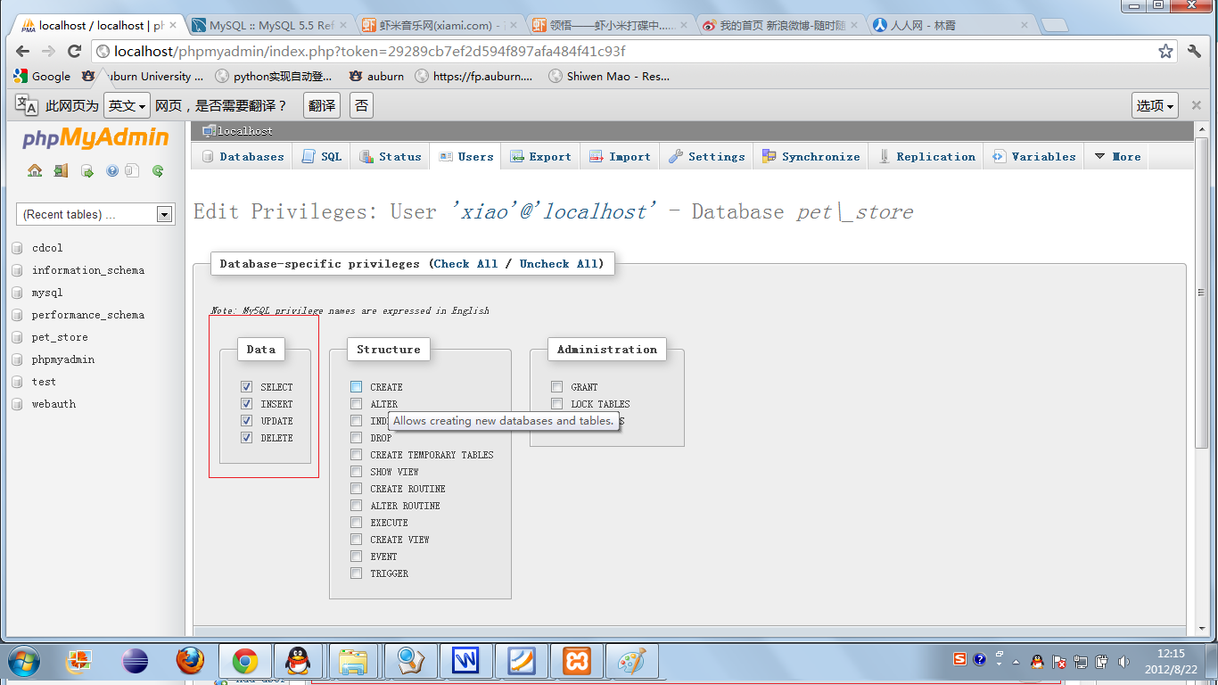
Figure 3-5: Edit privilege

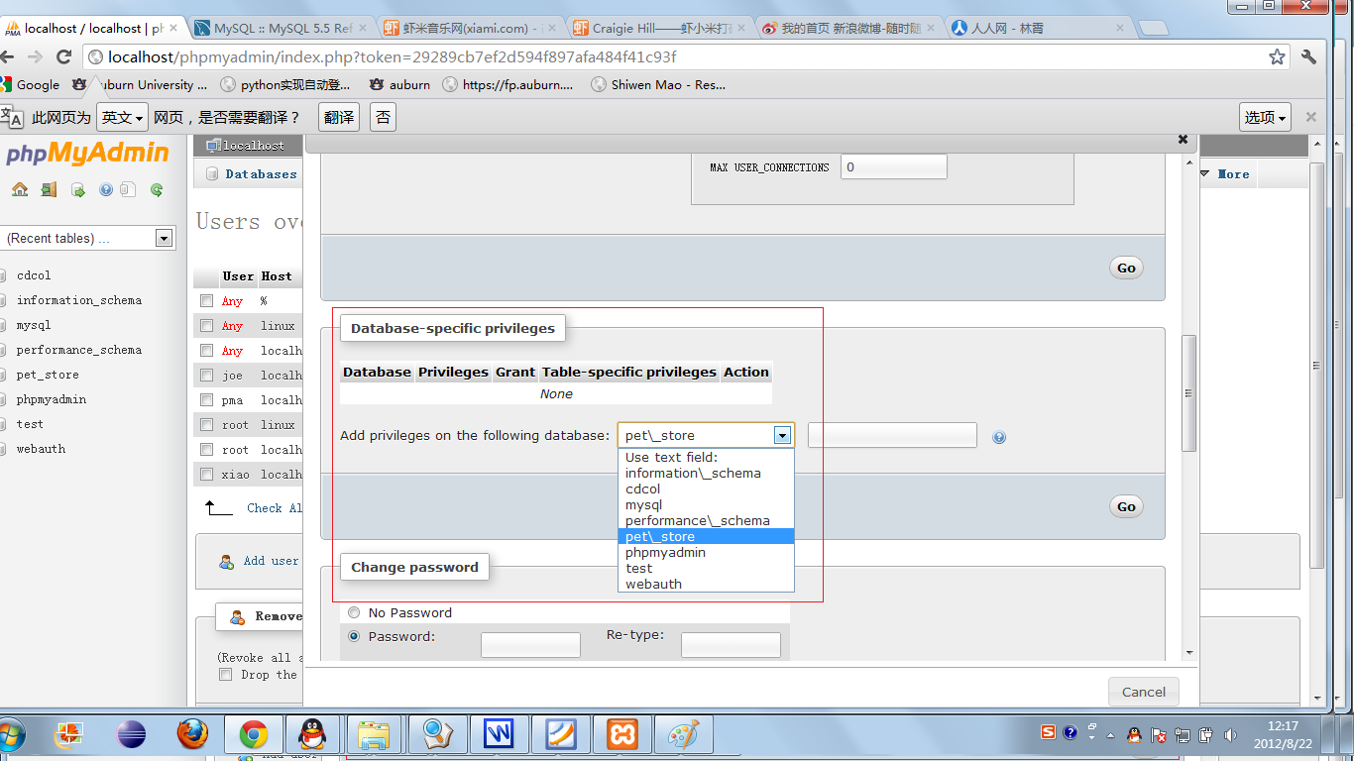
Figure 3-6: Edit privilege
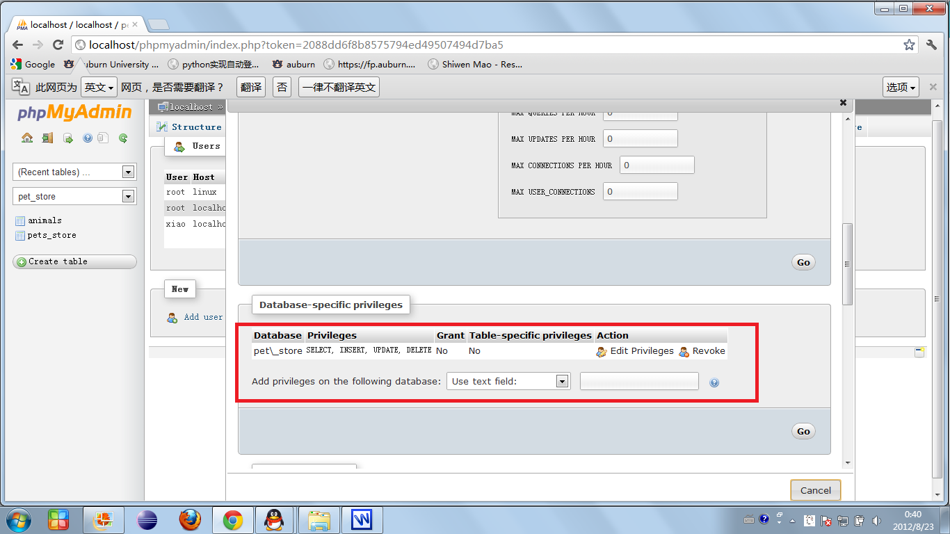
Figure 3-7: edit database privilege

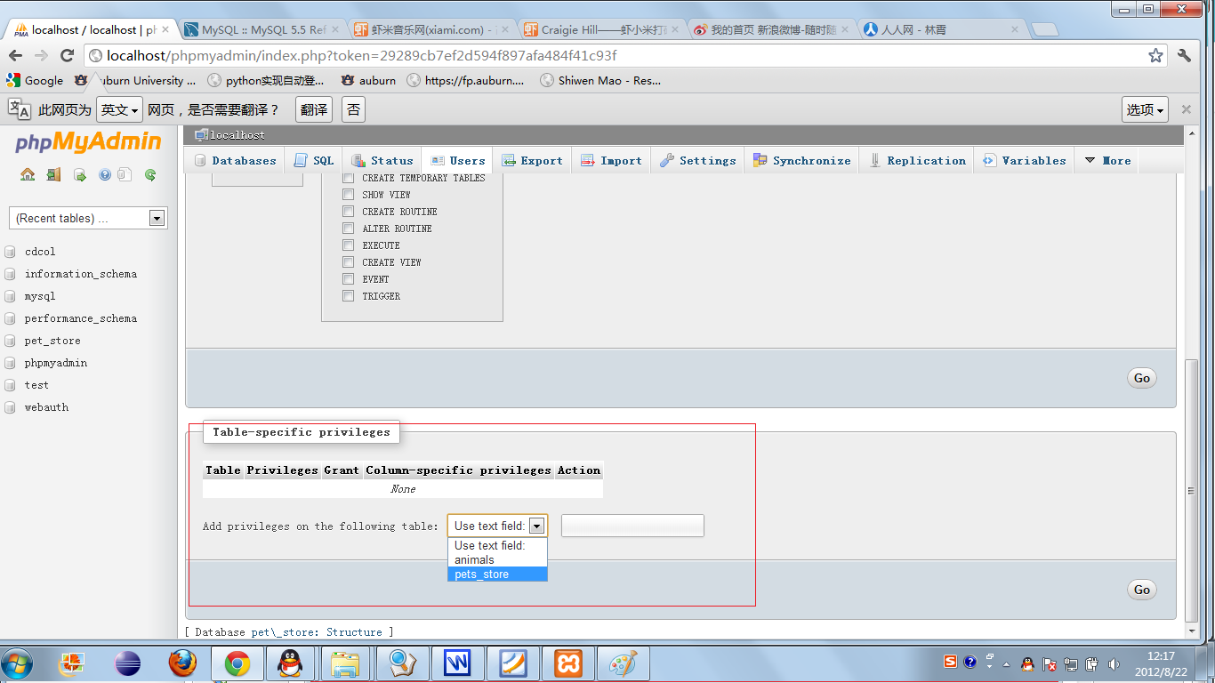
Figure 3-8: edit table privilege

Exercise 4
In exercise 4, it involves creating a e-commercial database and three table in it.

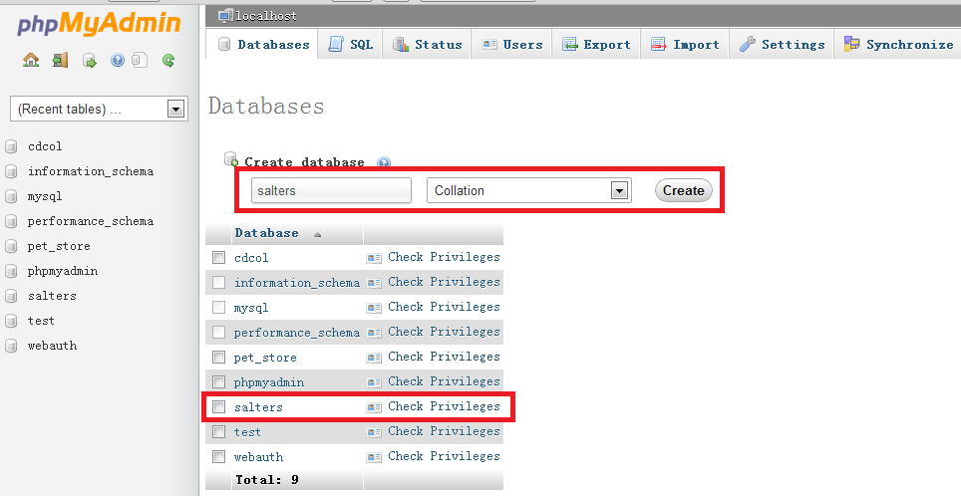
Figure 4-1: create new database named salters

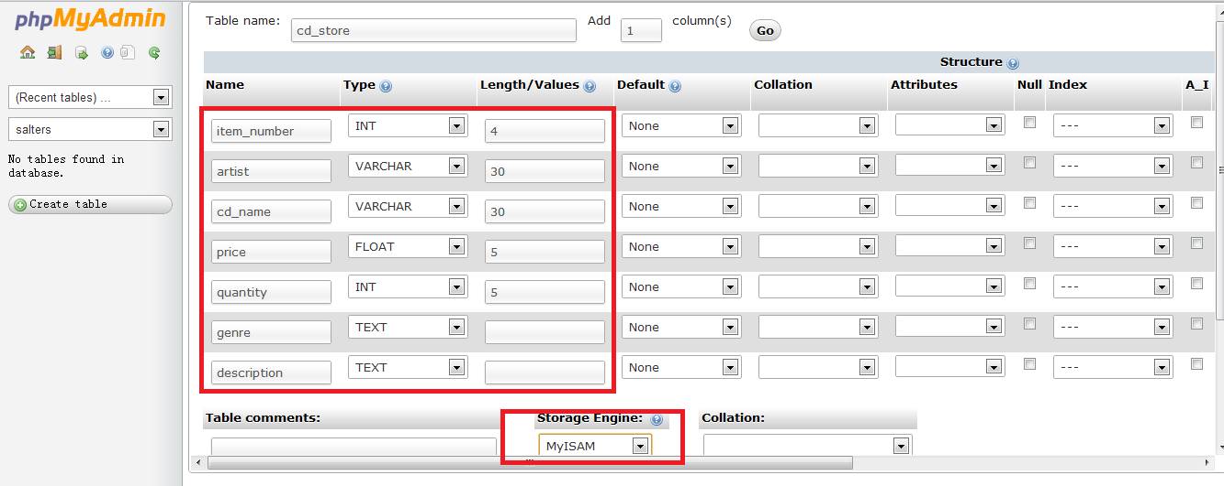
Figure 4-2: create new table called cd_store in database salters

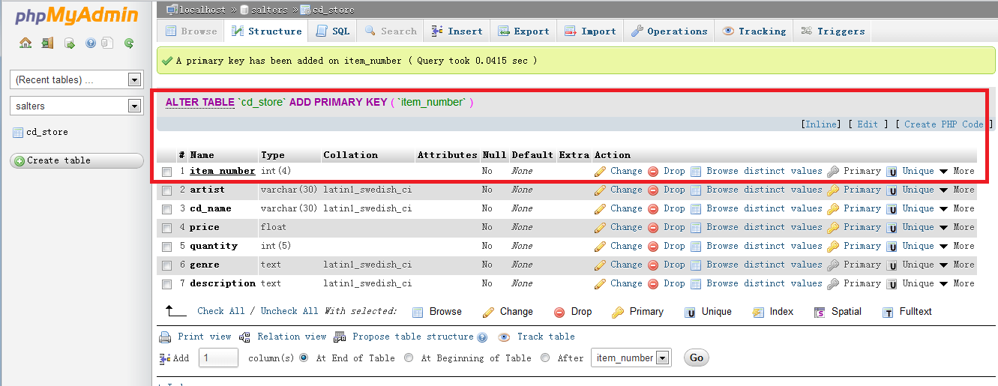
Figure 4-3: new table cd_store have been created successfully

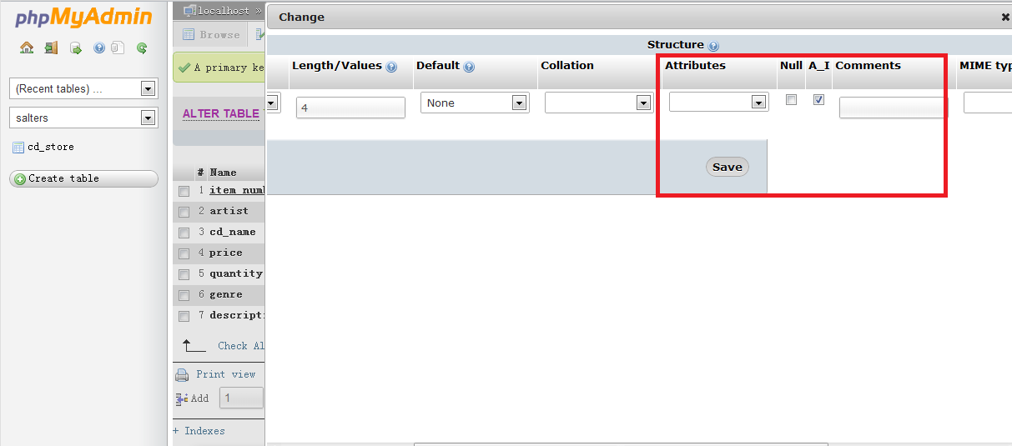
Figure 4-4: add primary key and enable auto-increment
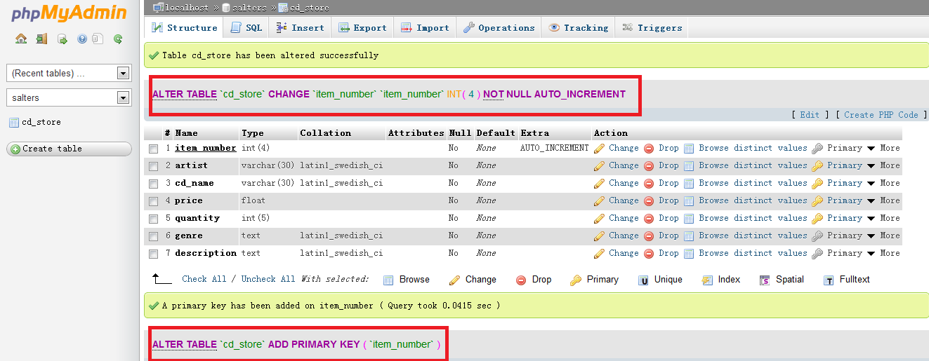
Figure 4-5: key and auto-increment have been set successfully
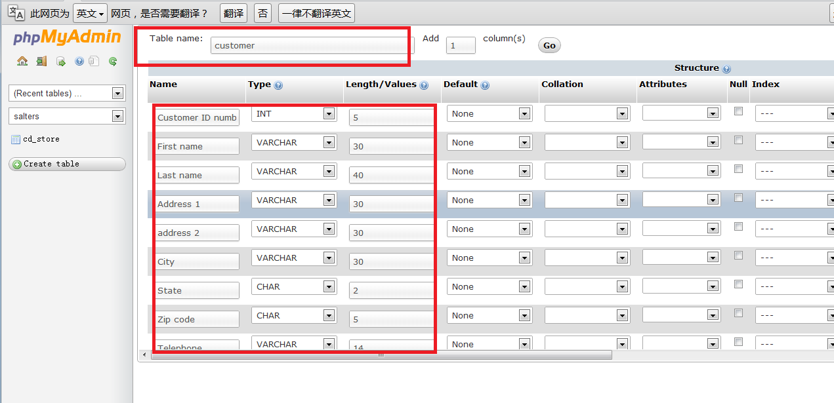
Figure 4-6: add new table customer to database

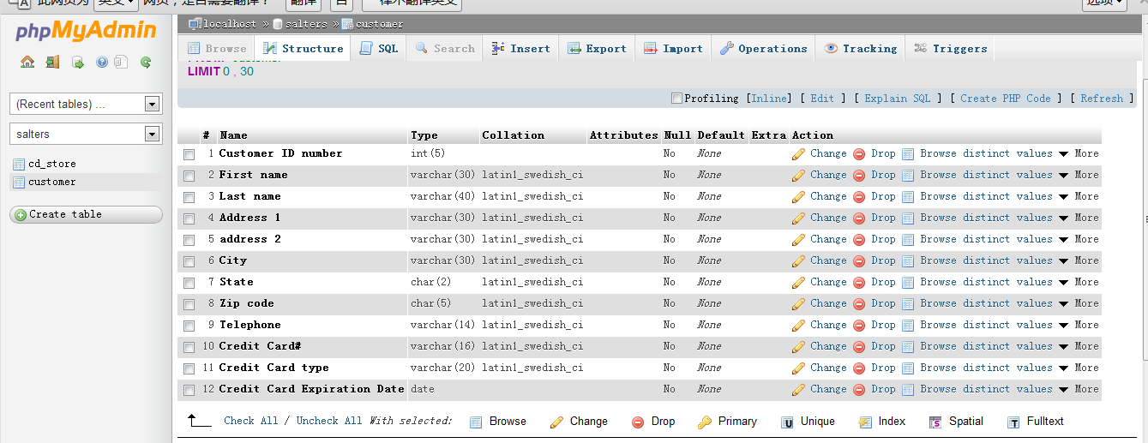
Figure 4-7: table customer have been created successfully
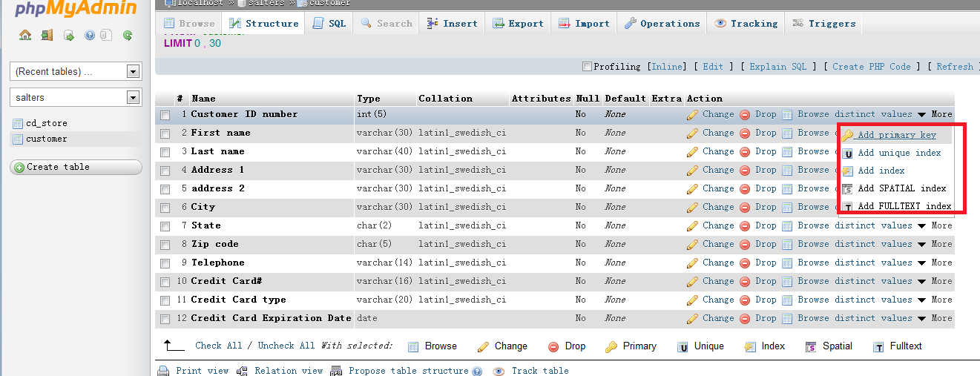
Figure 4-8: also set primary key and auto-increment
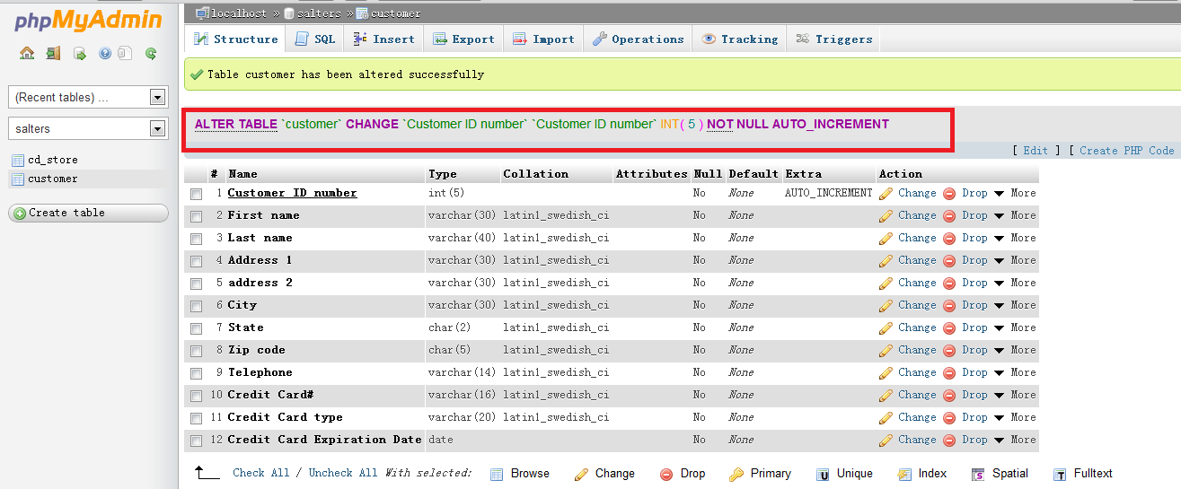
Figure 4-9: auto-increment have been set successfully

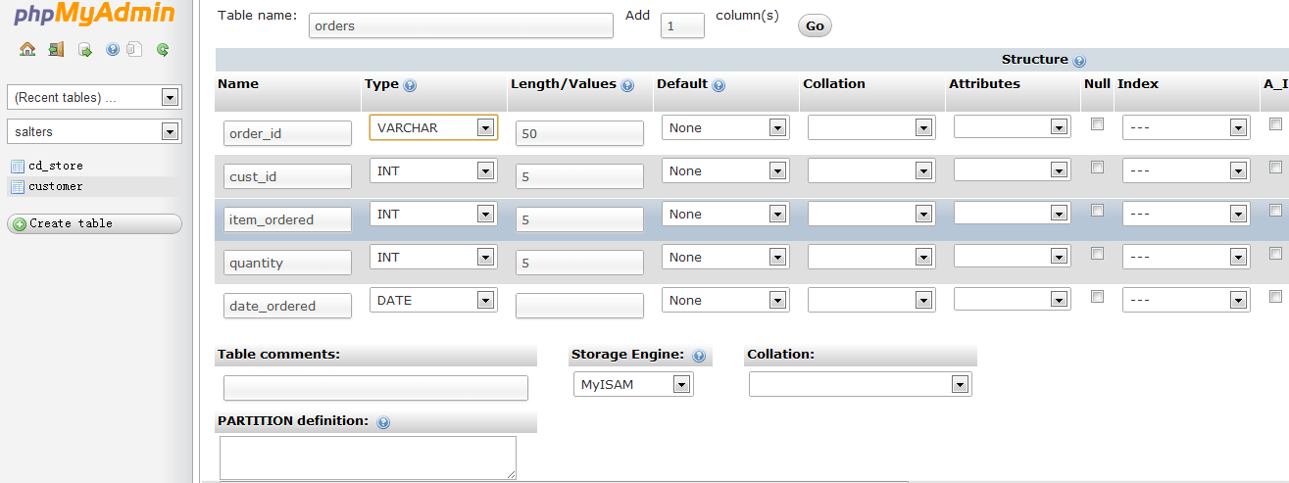
Figure 4-10: add new table orders to database
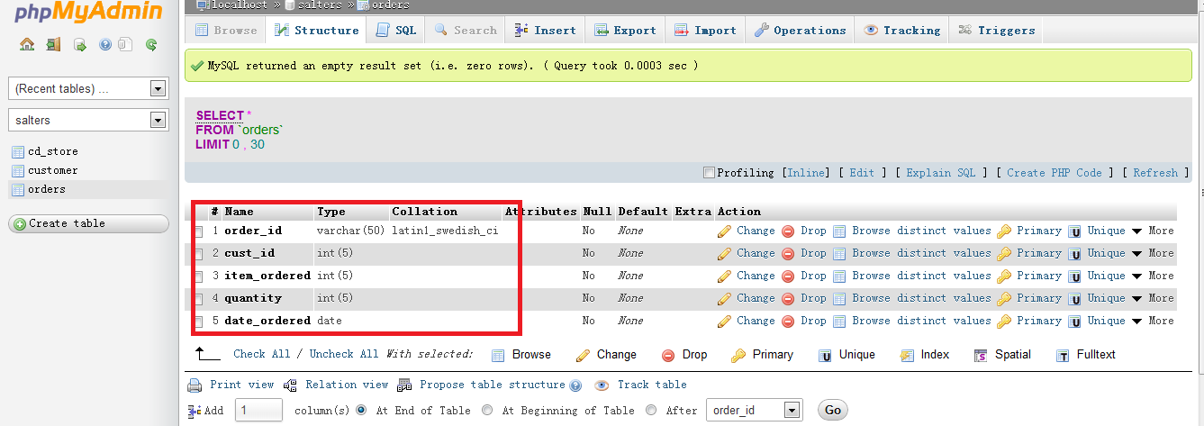
Figure 4-11: table orders have been created successfully
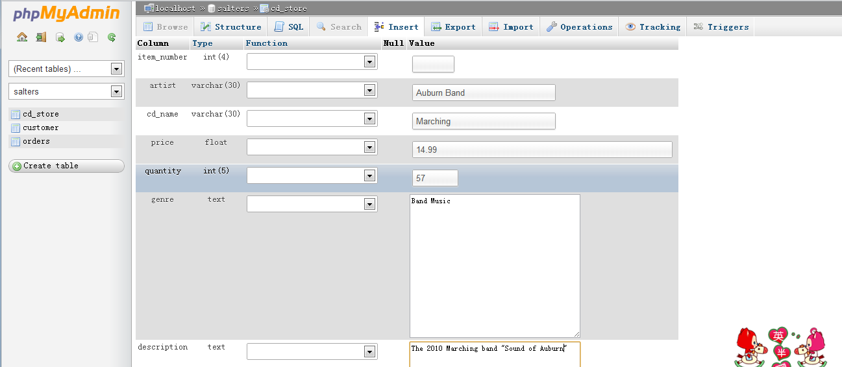
Figure 4-12: insert item to table cd_store
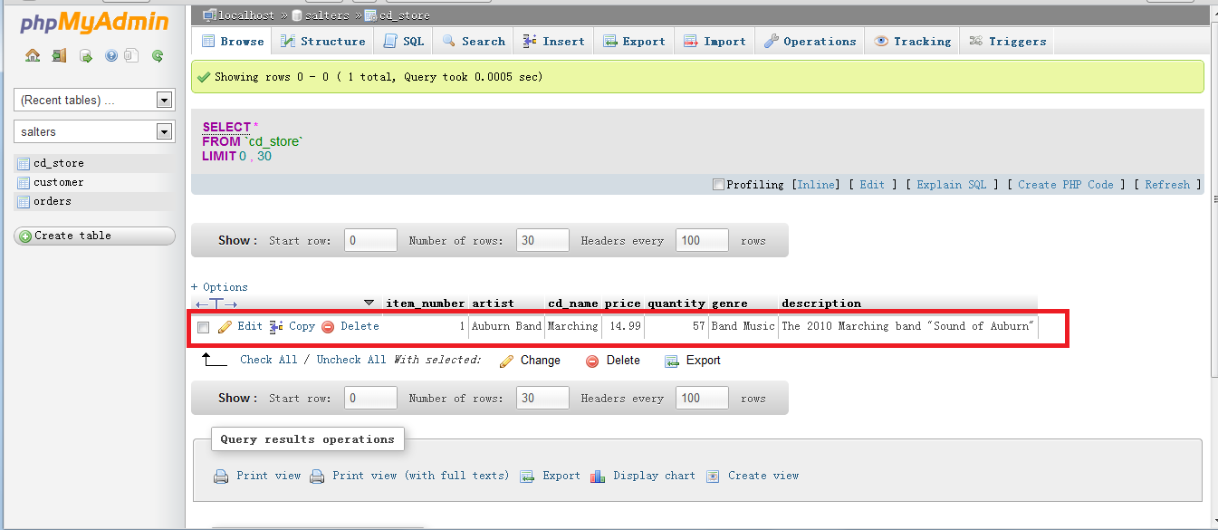
Figure 4-13 : item have been added successfully

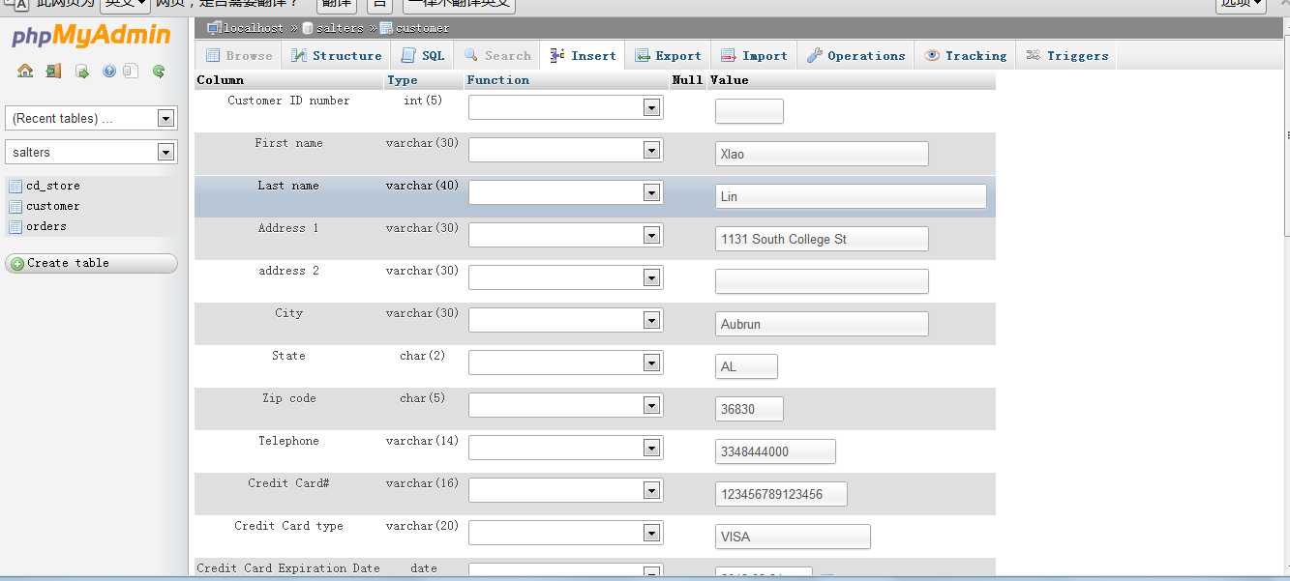
Figure 4-14: insert customer information to table customer
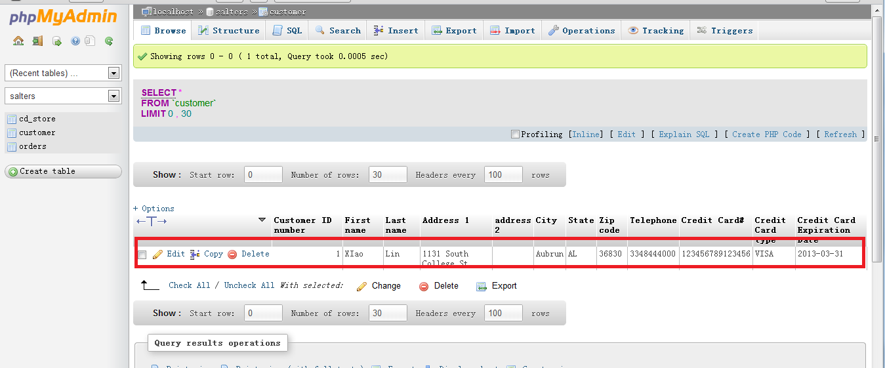
Figure 4-15: add customer successfully

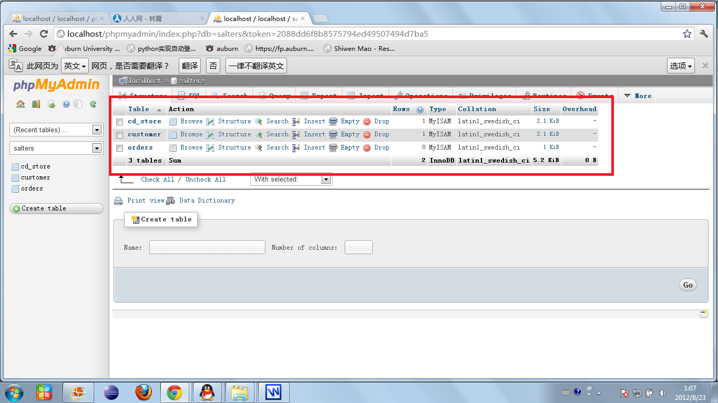
Figure 4-16: tables in database\

Result
All of the exercises in Lab1 have been completed successfully. With the four exercise we learn basic knowledge about XAMPP and MySQL, and now we are able to create new database, table, user and edit the user's privilege in database as well as table.

Conclusion
The lab was completed successfully without any significant problems. Almost all of our hang-ups were caused by differences between the versions of XAMPP we used, the latest, and the version that the instructions were written from. The lab served as a good quick start guide to XAMPP and MySQL.
The lab has been completed successfully, in this lab we have not encounter significant problems. It still exist some small problems because of the different versions between what we use and the version in the example. This lab makes us know some basic knowledge about XAMPP and MySQL.

References
- Lab guides offered by Dr. Wu and the explanation of GTA Mr.Hou
- XAMPP website, http://www.apachefriends.org/en/xampp.html
- MySQL website, http://dev.mysql.com/doc/refman/5.5/en/index.html

