ELEC 5220/6220 Information Networks and Technology
LAB 10 REPORT

Jie ZOU
Xiao LIN

Abstract
This lab includes using Java language to program a socket for TCP and UDP connection.

Introduction
Socket provides an API between application and transport protocol. A server has a socket bound to a specific port number and waits for a connection request from a client. A client makes a connection request based on the IP address and the port number of the server. Then then can create connection.

Design
Exercise 1 TCP socket
Server opens a socket and wait for the client to connect. Client use the server’s IP address and port, which is open by server, to connect to server. The following screen shot show the connection.
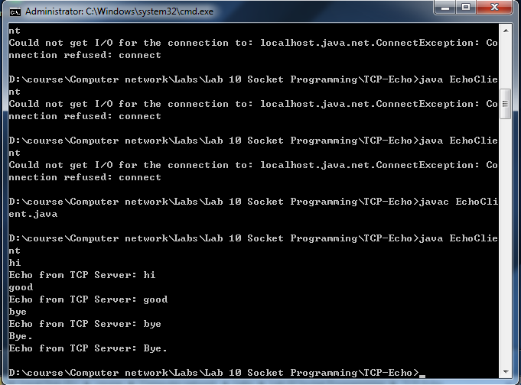
Figure Client side
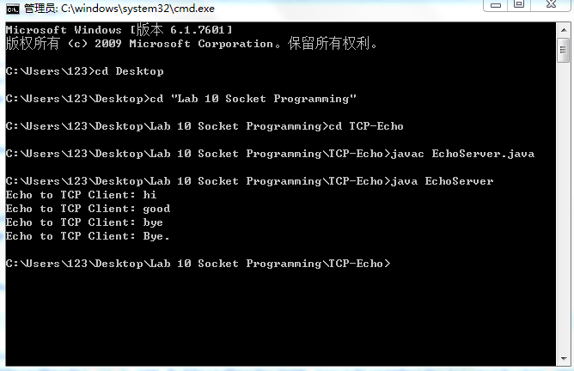
Figure Sever side

Exercise 2 Multi-thread TCP
Two client connect to the server simultaneously. The following screen shot show the connection.
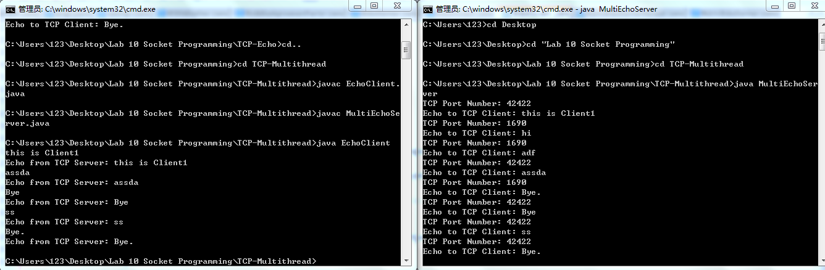
Figure One computer including server side and client side
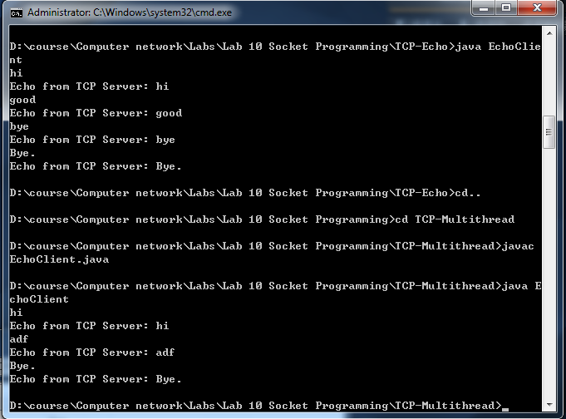
Figure Client side

Exercise 3 UDP connection of single client and two client
In this exercise we use UDP for connection, which only require the server’s IP address and port number. The following screen shot show single client connection.
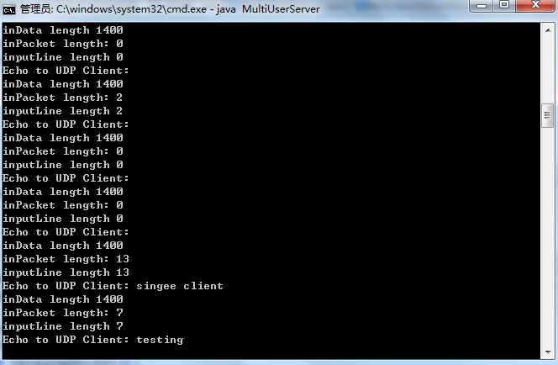
Figure Server side
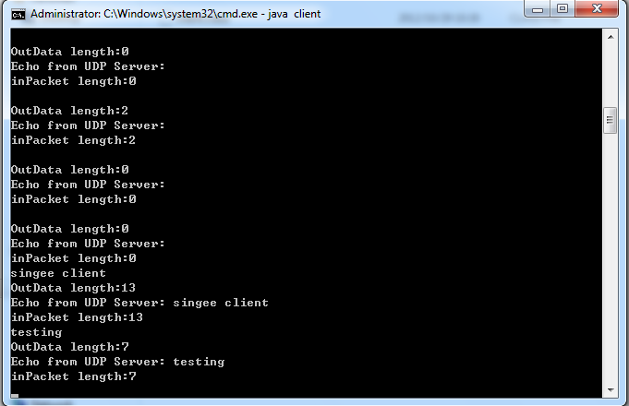

Figure Client side
Next we use two client to connect to the server.
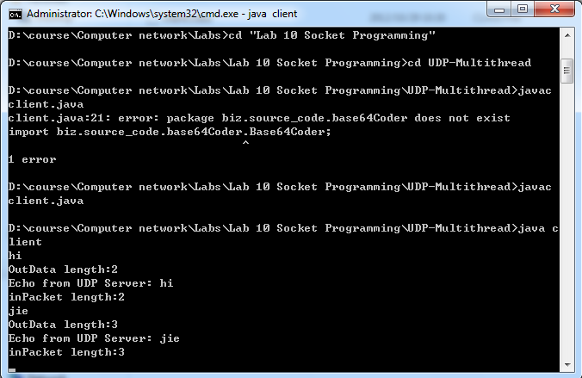
Figure Client side
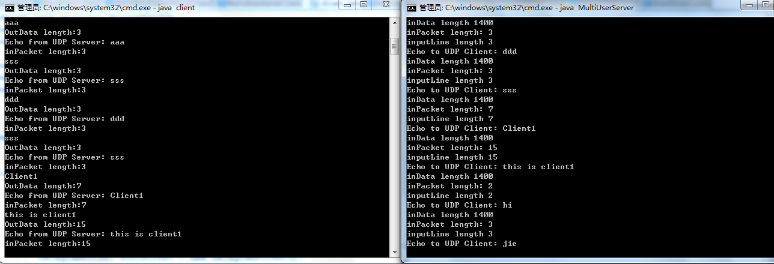
Figure One computer including server side and client side

Result
We learn to use Java language to program a socket to create a connection between computers based on TCP and UDP transportation protocol.

Conclusion
This lab is useful and interesting. We are now familiar with the sockets and basic procedure for server/client connection programming.
.

References
- Lab guides offered by Dr. Wu and the explanation of GTA Mr.Hou
- Socket programming in Java, http://java.sun.com/developer/onlineTraining/Programming/BasicJava2/socket.html
- A Simple Multithreaded Web Server, http://java.sun.com/developer/technicalArticles/Networking/Webserver/

