And following the former lab just also add the <meta> tag into the <head> tag and open the AVD and test the page.
Here is the credit card expiration page test in AVD
The original page
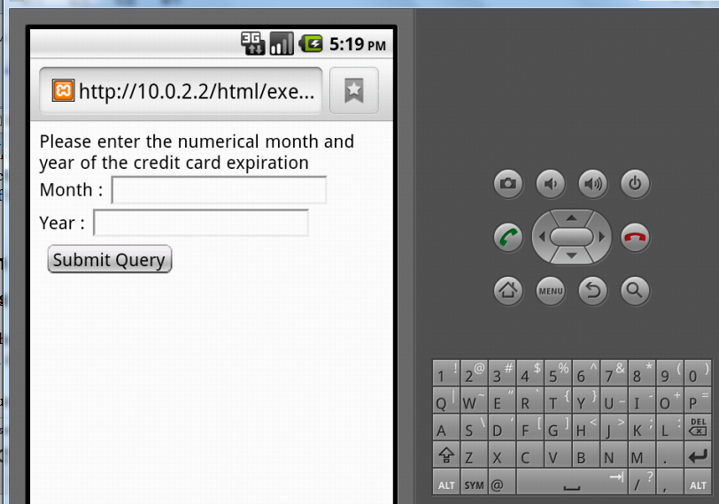
And then we enter month and year
Validation failed

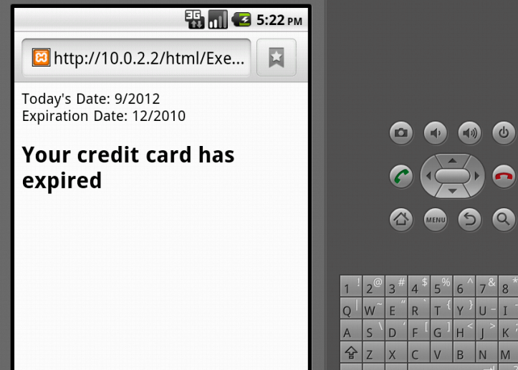
Validation successful
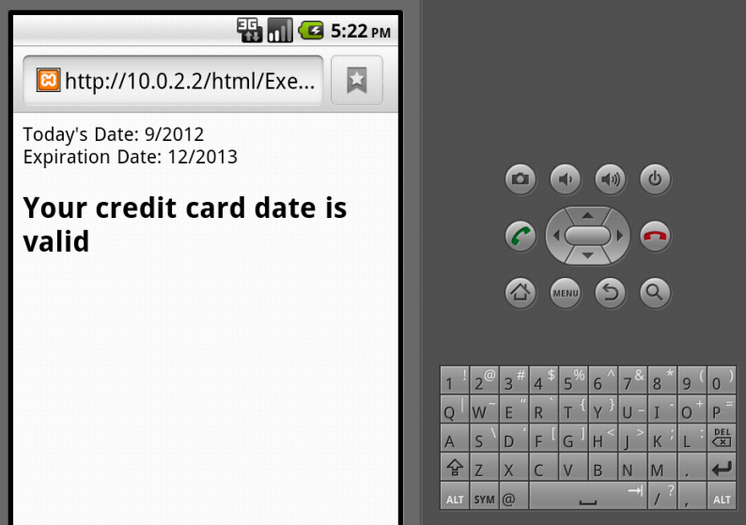
And then test the type and card number validation page

Chose the type of card
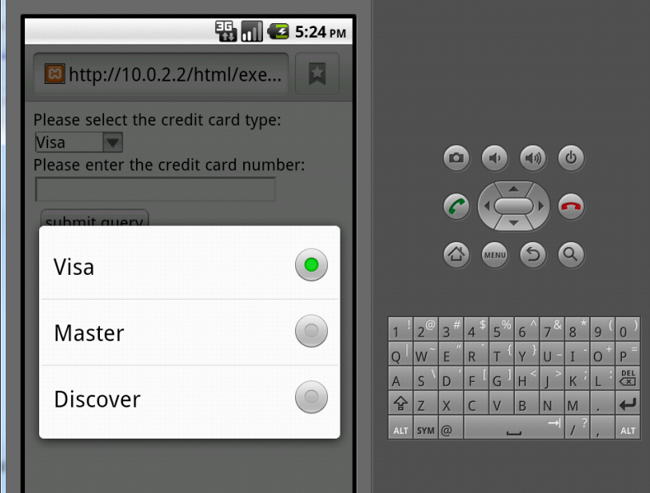
Enter card number and submit
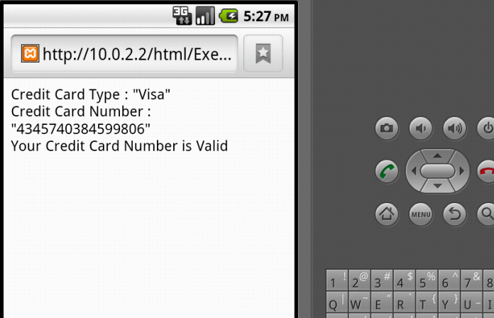

And in the own exercise, we are going to combine the expiration validation and card number validation together. Here are the figures of test result

Chose the card type
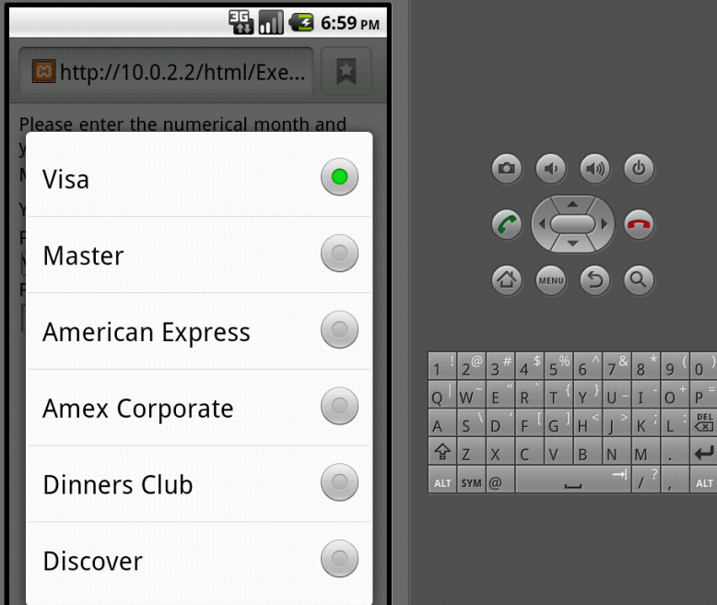
Enter information
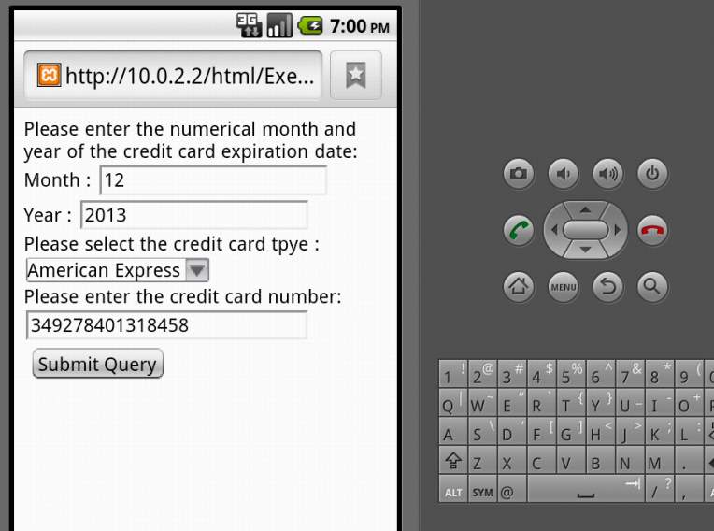
And click the submit button
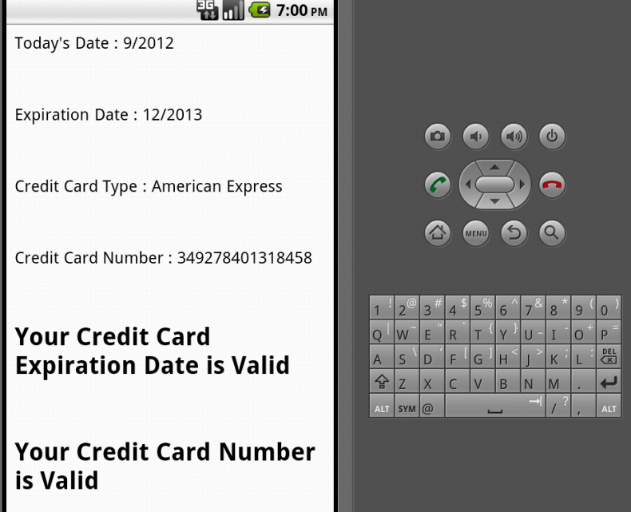
Here is the test result of JavaScript version

Enter a invalid month
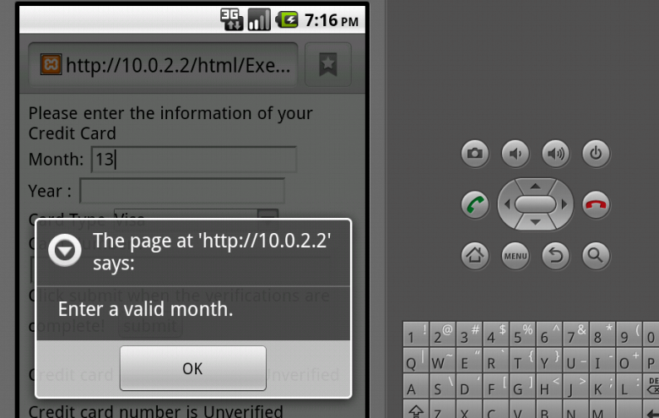

Enter valid information
