You must first finish all exercise and add the <meta> tag into the <head> tag in every file
<meta name="viewport" content="width=device-width, initial-scale=1"/>

And when we test the web in AVD it will like this

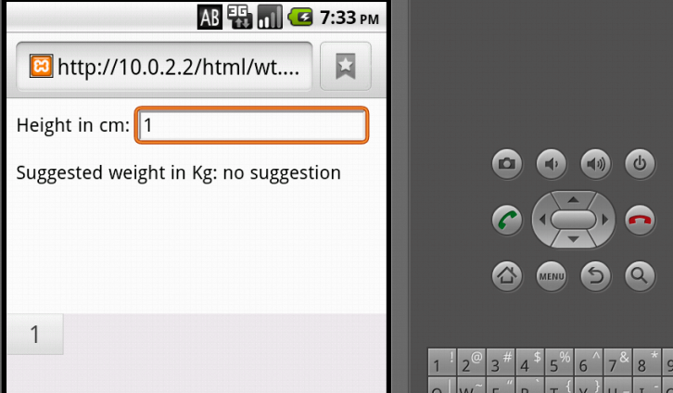
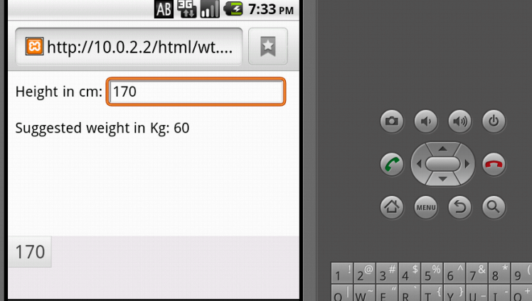
Here is the result of search personal information:
The original page
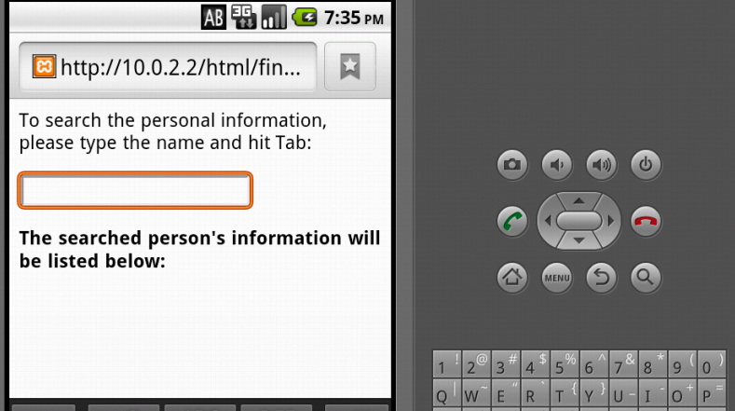
Search a person do not exist in XML file

Search a person exist in XML file
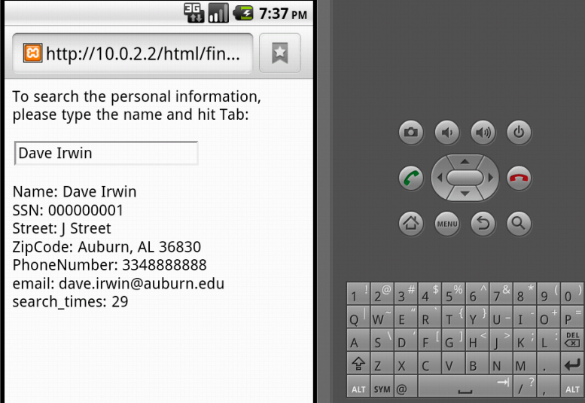
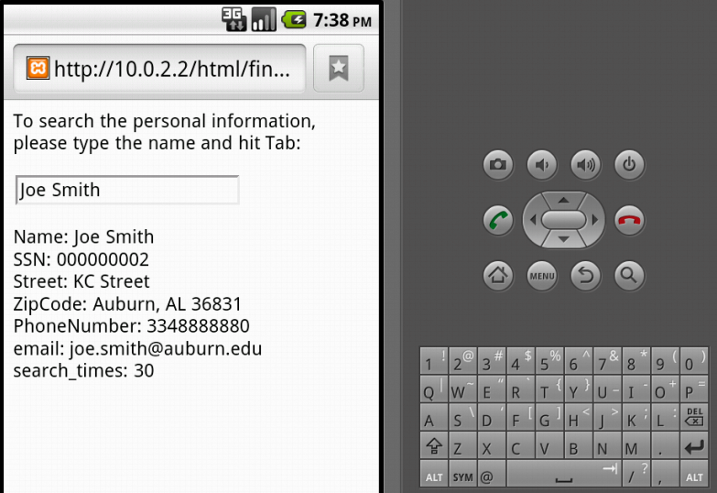
Here is the test result of own exercise
The original page
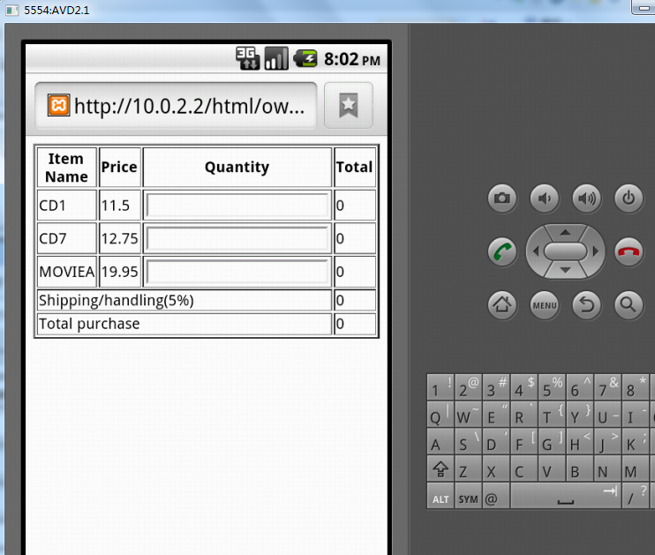
Enter the quantity
