In exercise 3 there are several bugs in the code, the bugs are:

In xmlDatabase4.php and xmlDatabase5.php

If we add a author and then refresh the page the same author will continued be add to database
It likes this
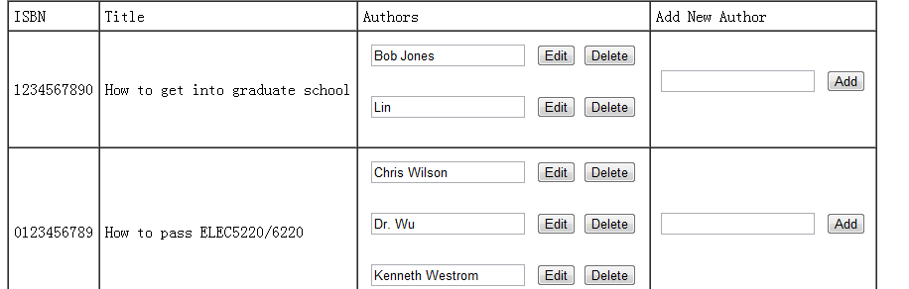
And refresh
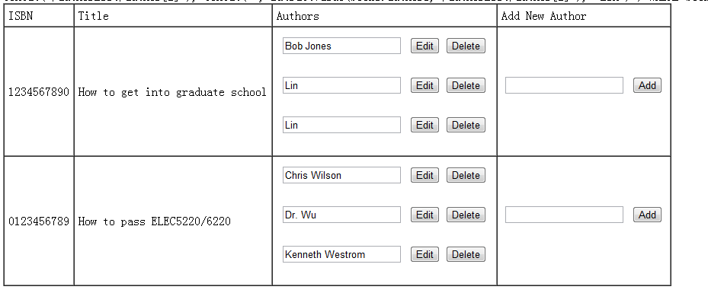
I have modify this bug, the new code is in xmlDatabase4_modify.php and xmlDatabase5_modify.php

Another bug is if we add same author in a book into the database,we will can not delete or edit the author anymore. It likes this
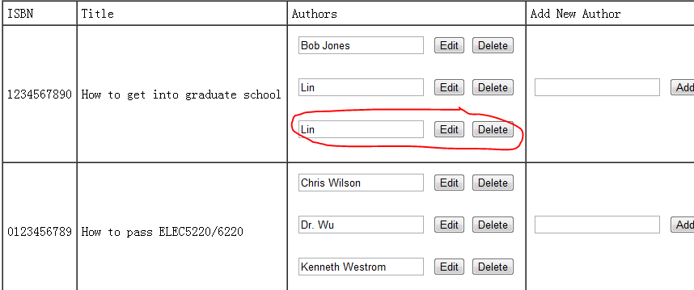
In this case, no matter we click delete or edit it will not work, i have not modify this bug.

