Project 1 Report
By
Xiao Lin
and
Jie Zou

ELEC 6220 – Information Networks and Technology
Dr. Chwan-Hwa Wu
10/13/11

Abstract

In today’s business, more and more people are using the Ecommerce industry. In every day, a large amount of deals are accomplished online, which we call ecommerce. This increased demand for Ecommerce requires that more and more people understand the necessities for developing these sorts of online environments in order to attract customers and run a successful business. In this project, we learn to set up own business shopping website using the skills in the former labs. This project will require us to cover several aspects of an Ecommerce store. We are required to create a fully functional shopping cart which will allow the client to add items, change quantity, and calculate an accurate total for the order. A shopping catalog with at least five categories, at least five products, and the ability to search must also be included. The project will also include shipping information, hide a credit card number, and have inventory control, which will inform a customer if a product is unavailable. Finally, it will check if the information is correct to be uses before proceeding to the finally step. We use cookie to recognize customer when they come to our website second time and we will show the browsing history of him or her.

Introduction

This project require us to create an online shopping store which can provide customers or users to search key word for product and use shopping cart in the process of purchasing. When he proceed to make a deal, we will check if the information the customer supply is correct before we make the deal. Besides, the total amount will be calculated at the server side.

Design

First we need to create table and enter the information in the database such table for product, customer, order and so on. As shown, below, tables for products, customers and orders.
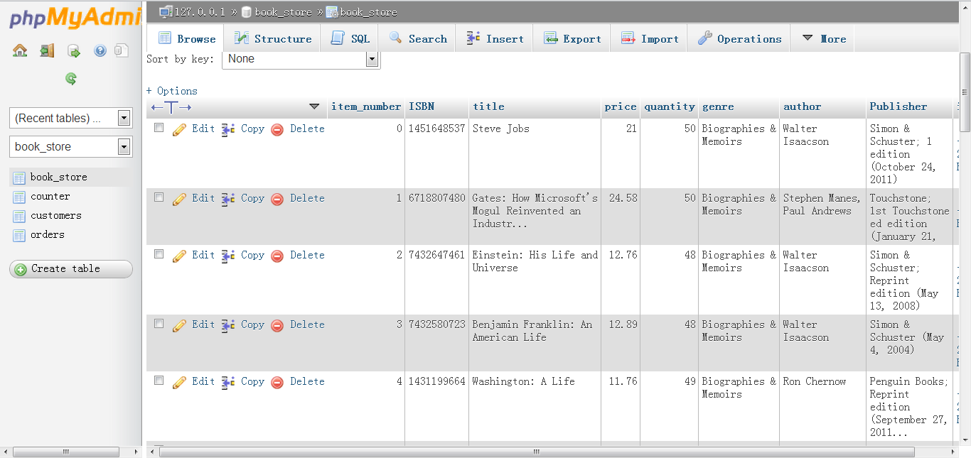
Figure 1 – Books table in Database
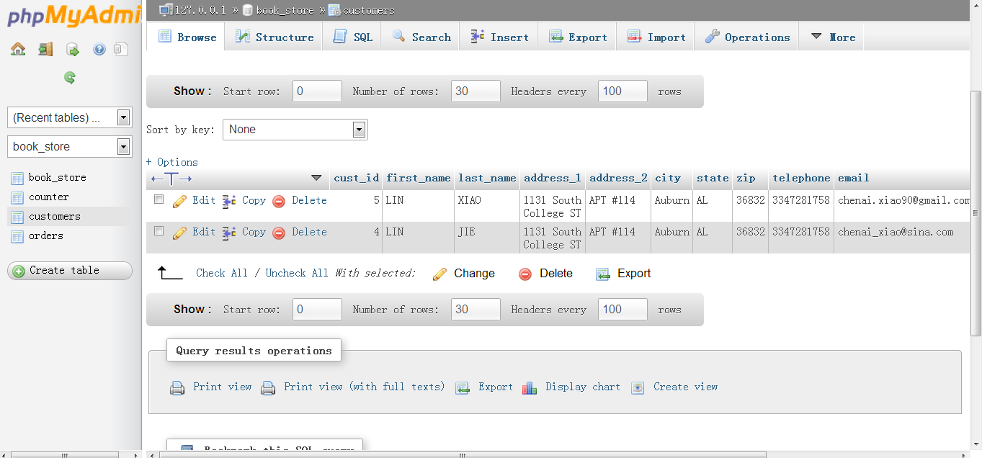
Figure 2 – Customers Table in the Dtabase
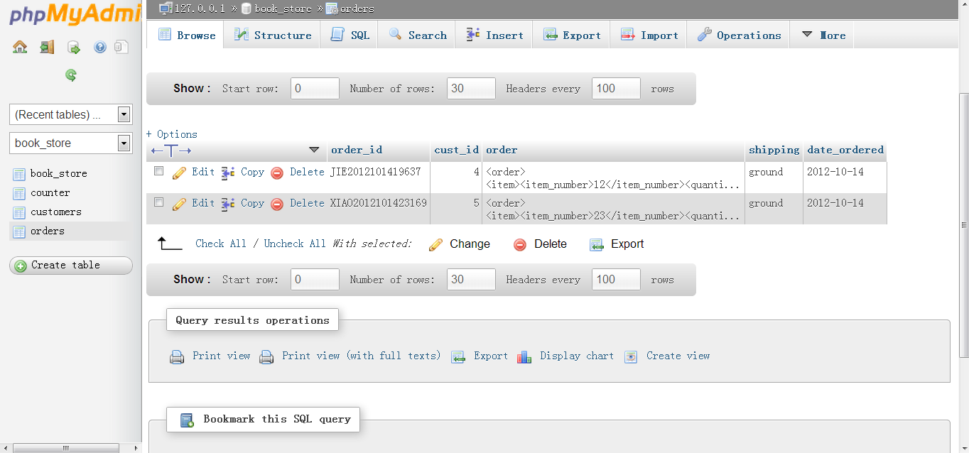
Figure 3 – Oreders History Table
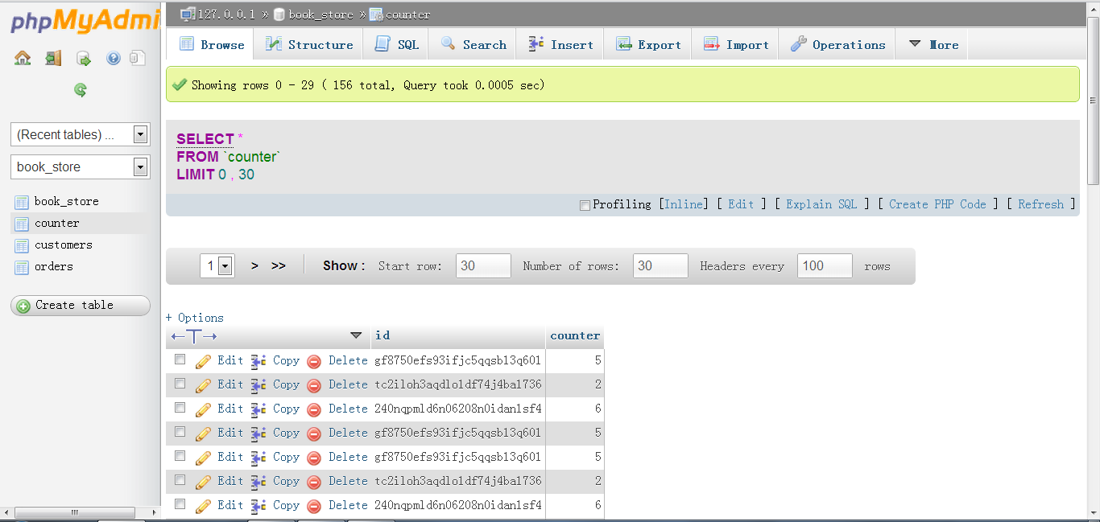
Figure 4 – Counter table in database

The project should have function of shopping cart, which allow customer to select items, change quantity and generate total cost using AJAX.

The main page (/index.php), shows some books that are available in the database and allow client to search books by ISBN, publisher, tittle and author. It also shows the amount of time the browser has visited the site. Besides, it provides shopping cart for customers.

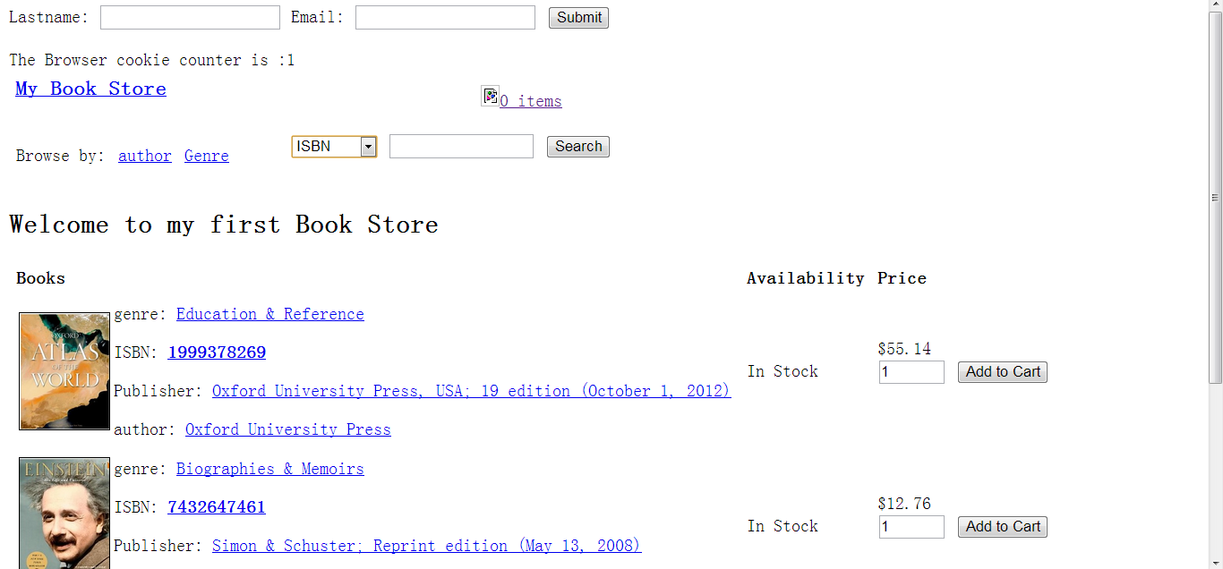
Figure 5 – Main Page

And, as the project required, the client should be able to search product catalog. We can test the searching function by entering the author name of Teri. The following screen shot shows the searching result.
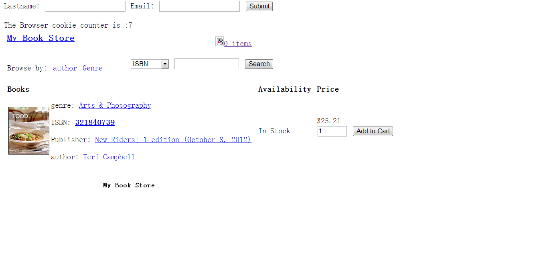
Figure 6 - Results for author’ name Teri

In case client will be overwhelmed with products, we can browse our store by author or genre. Figure 7 shows the feature of allowing client to brows by author and Figure 8 shows browsing by genre.
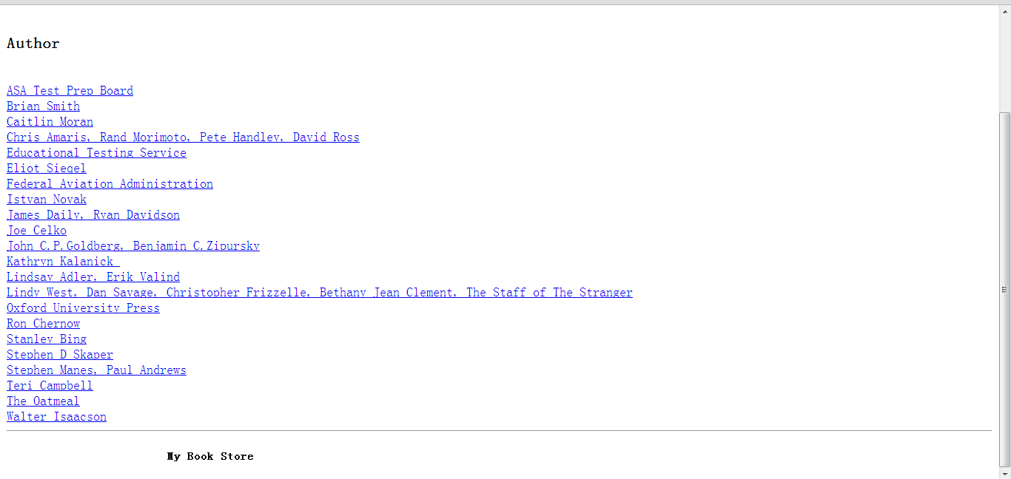
Figure 7 – Browse by author

Figure 8- Browse by genre

Then, an online shopping cart will allow the client to add multiple quantities to their cart. Figures 9 and 10 shows the items to be added to the cart.
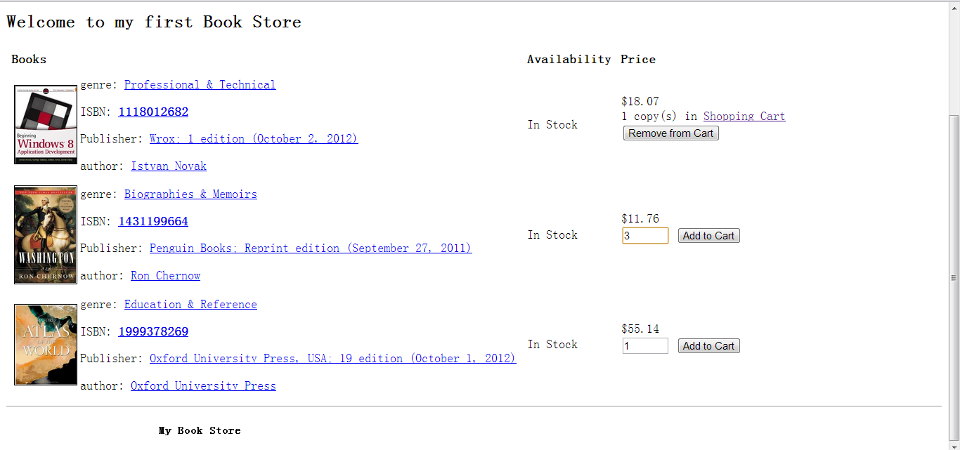
Figure 9 Add multiple books to shopping cart
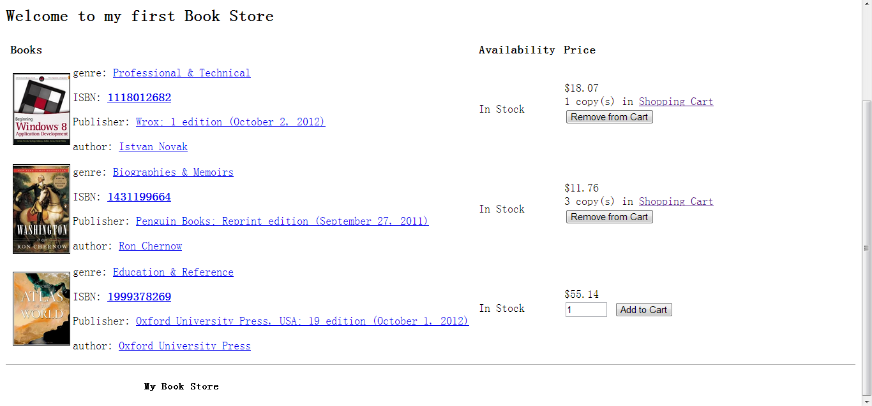
Figure 10 Multiple books have been add to shopping cart

It is also required to make the client able to update quantity, choose shipping service and estimate taxes based on their state. Figure 11 shows the overall interface of the shopping cart and the features available to the user. Figures 12 and 13 show before and after the quantity is updated.
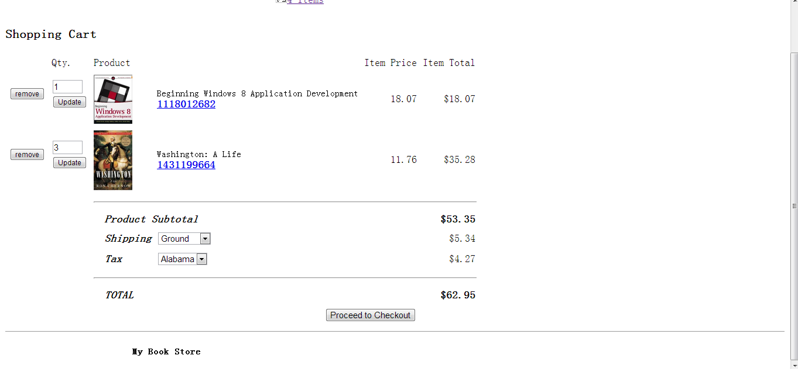
Figure 11 Display shopping cart
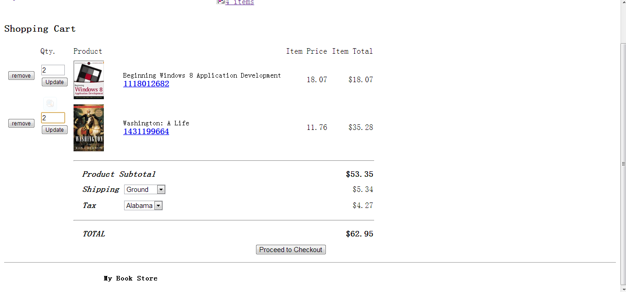
Figure 12 Change the quantity amount
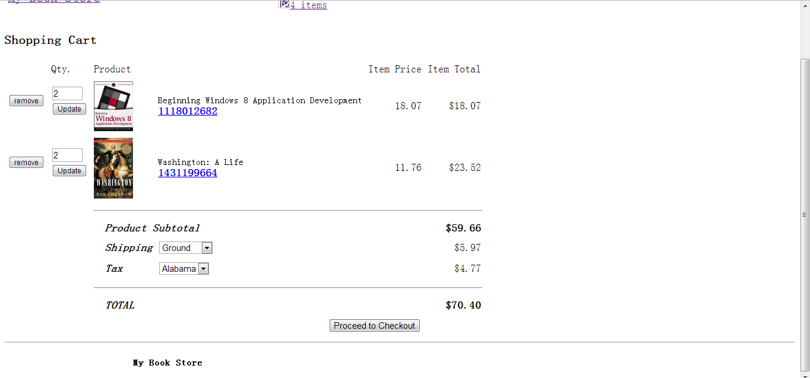
Figure 13 Price updating

And more important, we should not allow client to add more items than we have in stock. So, when they add those large numbers, we should warn them and limit the number. The following figure show this function.
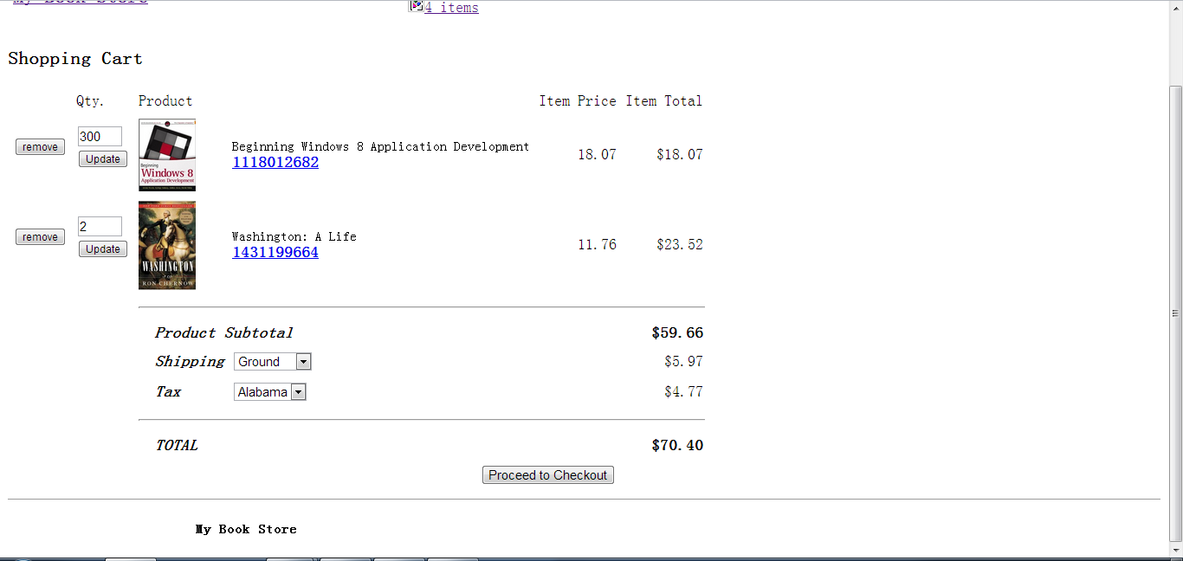
Figure 14 – Client try to add 300 books
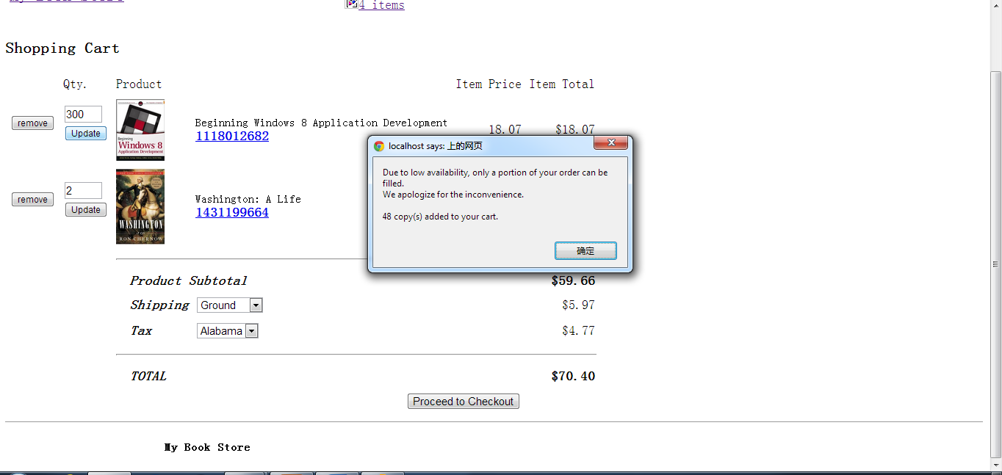
Figure 15 – Warning of the limit
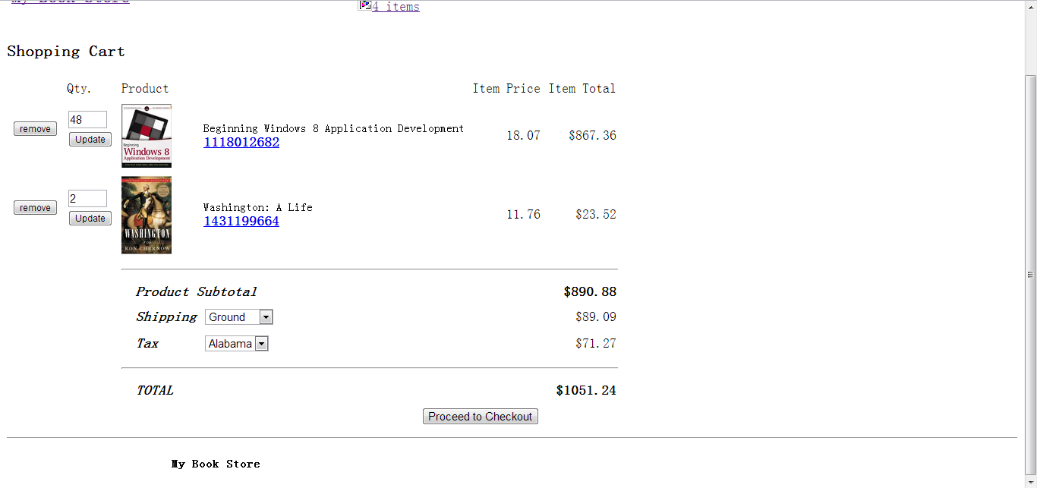
Figure 16 Add what is available

When the customer is satisfied with the order, they will proceed to checkout. At this page, they are required to enter their information such as mailing address and billing information. Each input is to be verified before the user is allowed to place their order. Most importantly, the credit card number should be hidden. Figure 17,18, 19 show a successful run through the checkout process, while figures 20,21 show where the user is stopped when data is not entered properly.
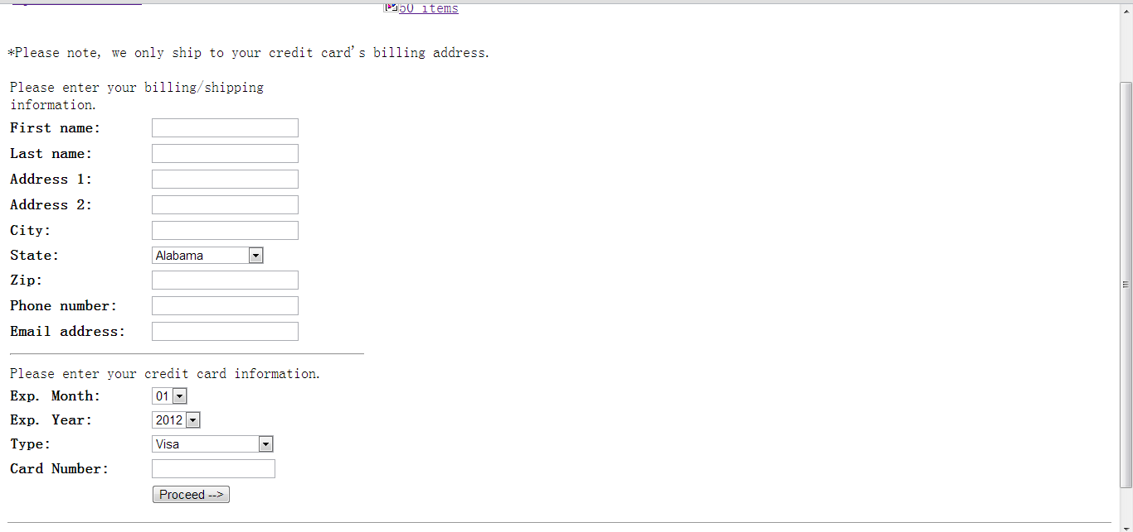
Figure – 17 Proceed to checkout
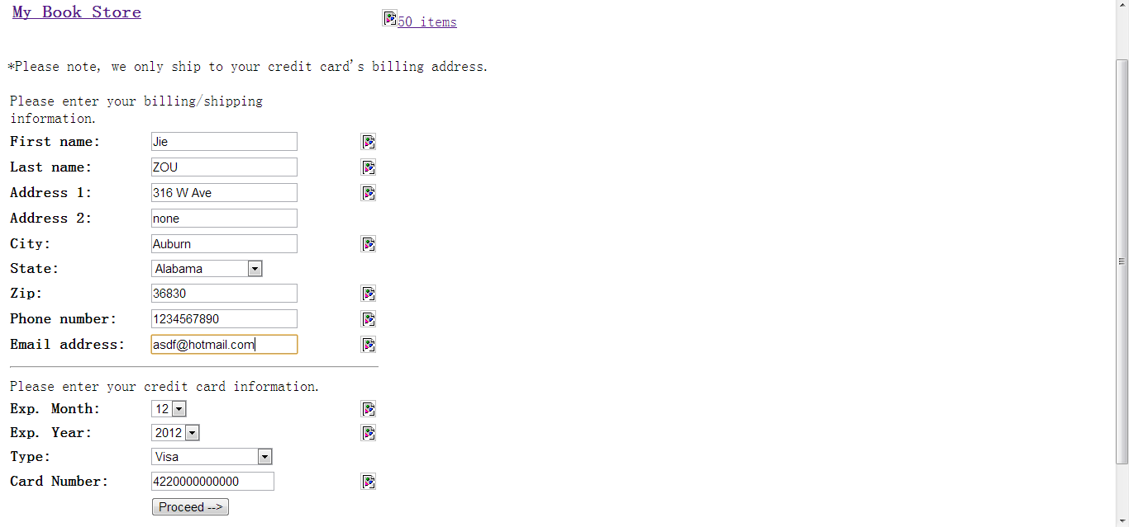
Figure – 18 Check out

Figure 19 – Confirm information 19 – Confirm information
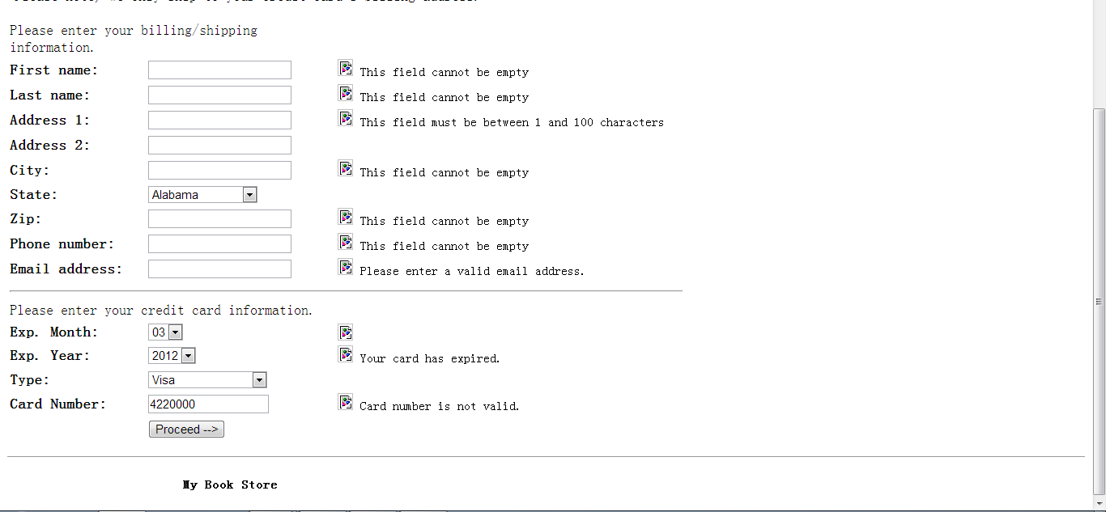
Figure 20 – Data is not valid
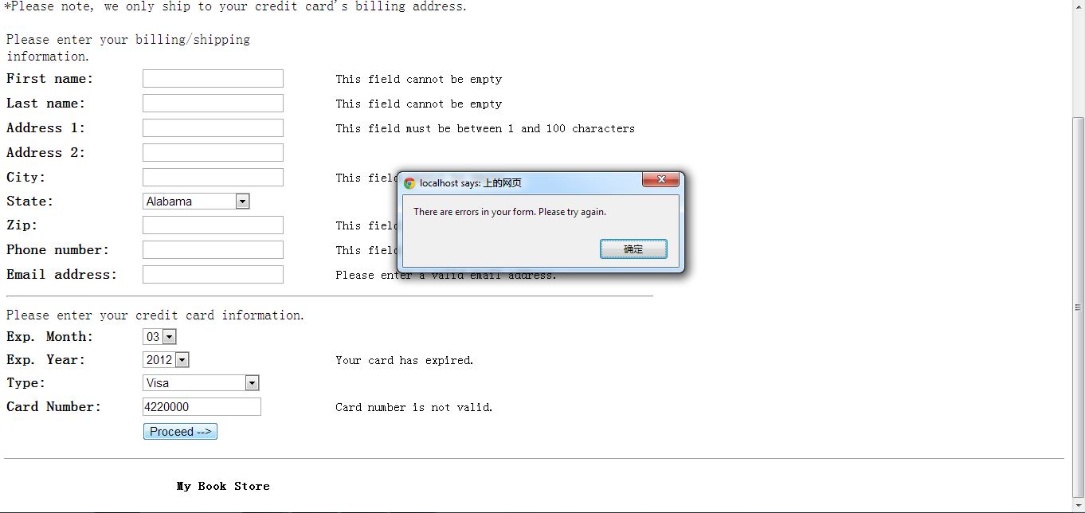
Figure 21 – Not allowed to proceed

Once the order is finished, the customer can print the page of the order detail. The database for this order are updated.
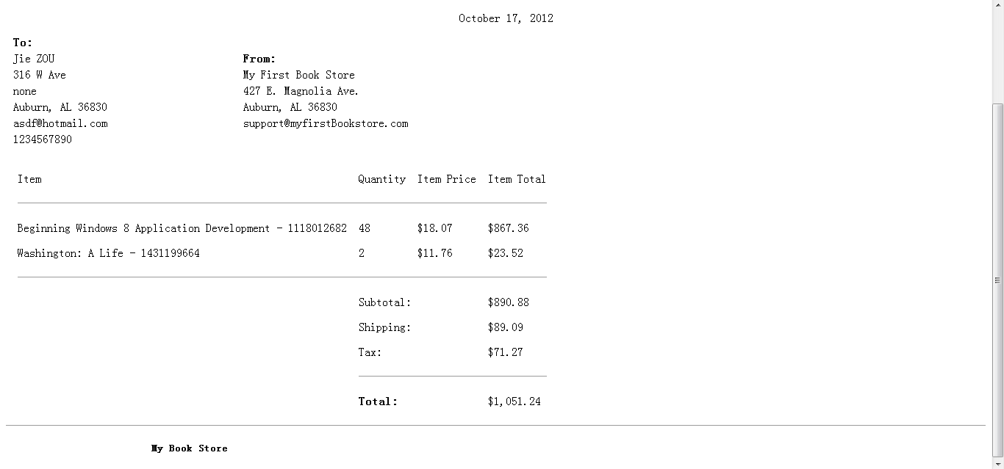
Figure22 – Order confirmation
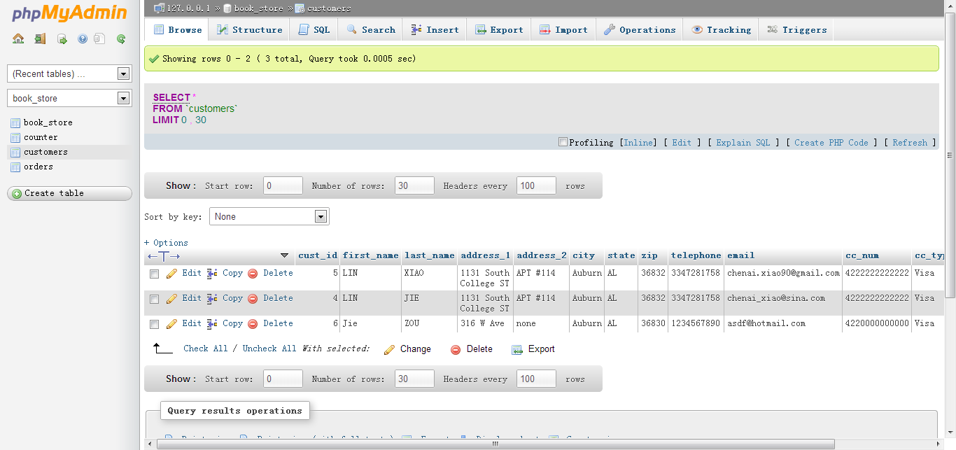
Figure 23 – Zou is added to customer table

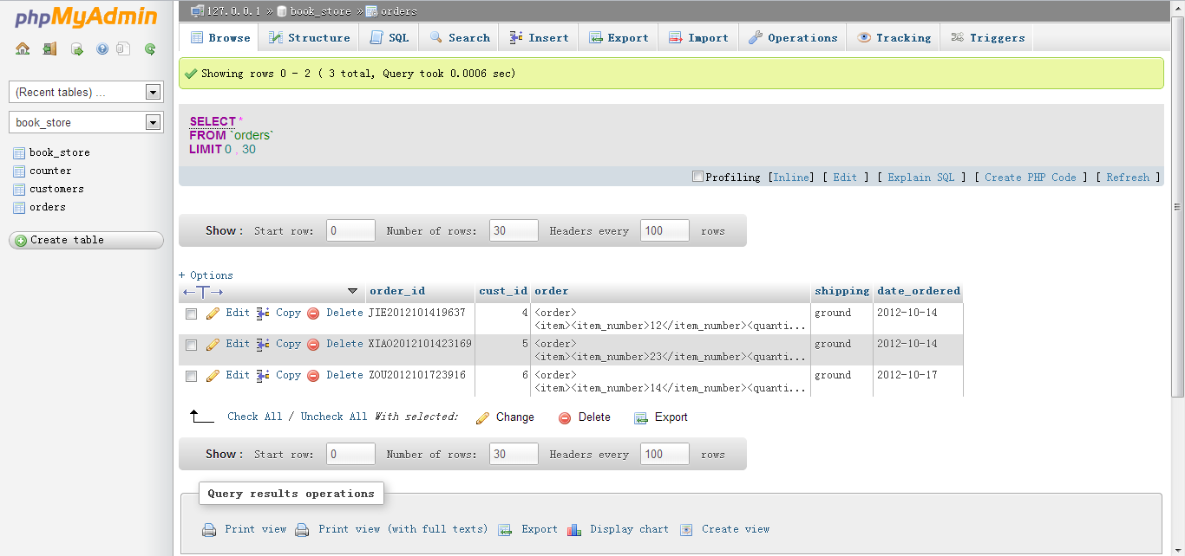
Figure 24 – Zou’s order to the orders table(the last one)

Android
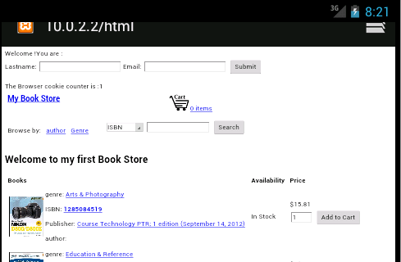
Figure 25:The page when first visit
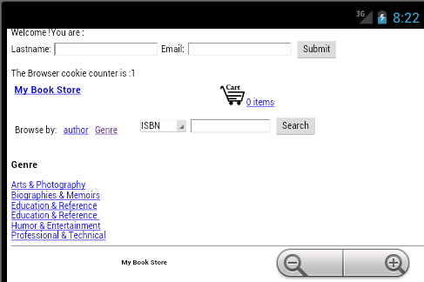
Figure 26: the capture when browse by genre


Figure 27: the capture when browse by author

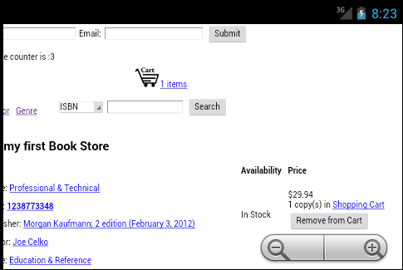
Figure 28: add a book to shopping cart

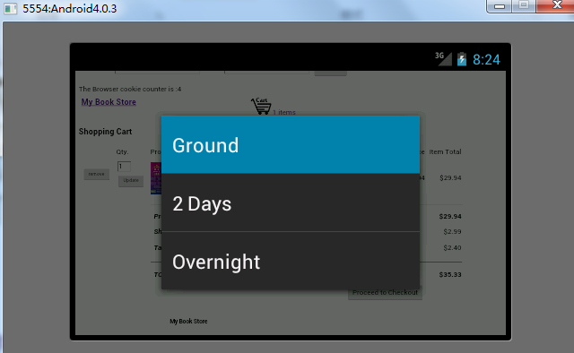
Figure 29: chose different shipping

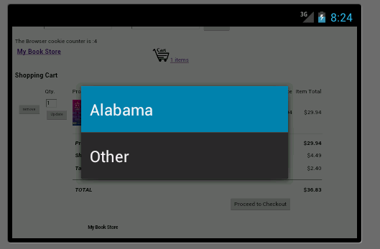
Figure 30: chose the state

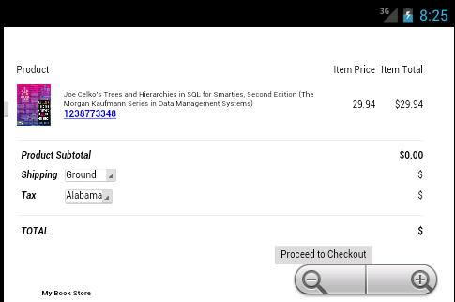
Figure 31: check out

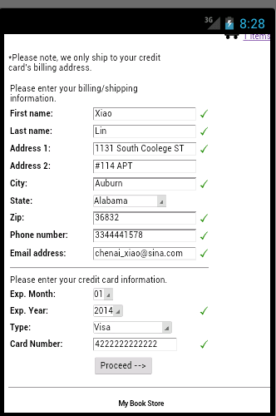
Figure 32: filling in the customer information

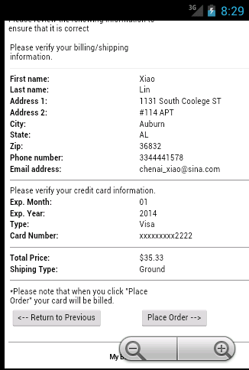
Figure 33: order confirm

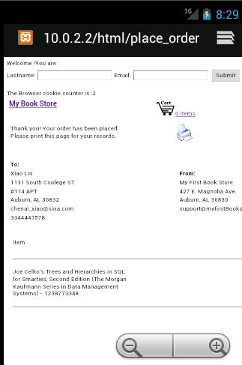
Figure 34: place the order

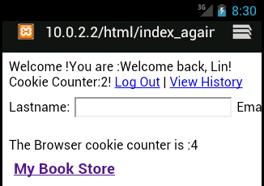
Figure 35: use the name and email to login

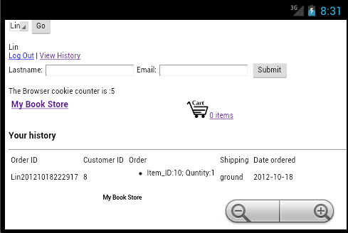
Figure 36: view history

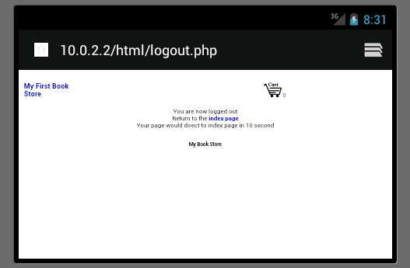
Figure 37: log out

Figure 38: use the menu to login

Results

This project can be used to be a online store since it has many function for customer to search product, browse by different types and use shopping to add items. We use the tools in the former labs to create this ecommerce website and it is functional through times of testing.

Conclusion

Online shopping occupies a large portion of today’s business since it is convenient for people to purchase goods at home instead of going outside. So it is important to master the skill of using SQL databases, HTML, PHP, AJAX and so on.

References

sftp://scp.eng.auburn.edu /home/eewu/wuchwan/Teachings/5220-6220/Project
Ecommerce project description.pdf

sftp://scp.eng.auburn.edu /home /home/eewu/wuchwan/Teachings/5220-6220/Labs/Ecommerce examples/project1/PHP Example

http://www.configure-all.com/page_view_counter.php

www.amazon.com for product images and descriptions

w3schools.com for PHP and JS function reference

Also reference these files attached to this report:
browse.php
checkout.php
display_image.php
index.php
item.php
place_order.php
search.php
view_cart.php
add_to_cart.php
calculate_total.php
cart_size.php
checkout.js
clientSide.js
constants.php
creditCard.js
functions.php
mysql_connect.php
mysql_functions.php
remove_from_cart.php
update_view_cart.php
xml_functions.php

