ELEC 6220 Information Networks and Technology  
LAB 6 REPORT

Xiao Lin & Jie Zou

# Abstract

In this lab we are going to learn the AJAX which means asynchronnous JavaScript and XML. This techonology can be very useful because we can generate a dynamic web page which mean we can update the web page without refreshing the whole page. In this way, it can imporve the user’s experience visiting the web page.

# Introduction

AJAX is built on the JavaScript and XMLHttpRequest objext. It allow us to dynamically display the web page. It can be used to set up an interactive web-based service that means with the XMLHttpRequest object, the JavaScript can communicate directly with the server and the client side JavaScript can exchange data with a web server without reloading the whole page. In this lab we have exercises of AJAX, which is used to caculate the total price of different merchant.

# Design

**Interactive health calculator**

In this example, we will ask user input a height and give the suggest weight in return in a HTML file. We will get the input in a HTML file page and use the dedicated JavaScript file to send the input to server and receive the caculated result from server and show it in the input page. The JavaScript file also will check if the client web browser support AJAX.

Here are the figures to show the result:

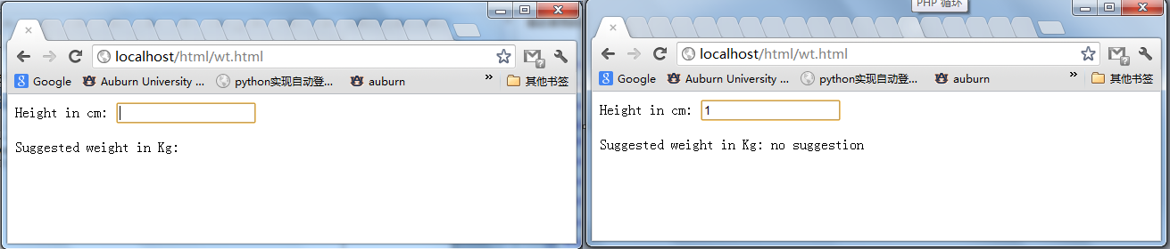

Figure 1: input page

When we enter the height the browser will detect whether the number has changed or not, if the entered number has changed, the broswer will resend the number to server and show the respons. And if the number we entered is too small it will no suggestion until we have entered a big enough number.

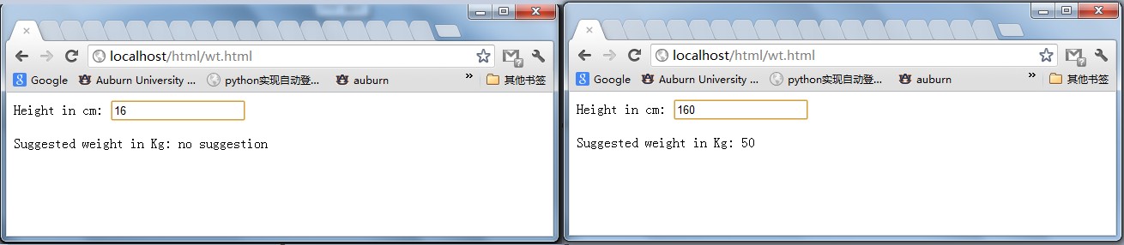

Figure 2: the result

**AJAX’s XML Processing**

In this exercise we will create a XML file to save some information and we will use the AJAX in client send the request to PHP in server side ask for the information of a certain people and how the result in the client web page.

Here are the figures of test result:

Here is the page ask user to type in the name

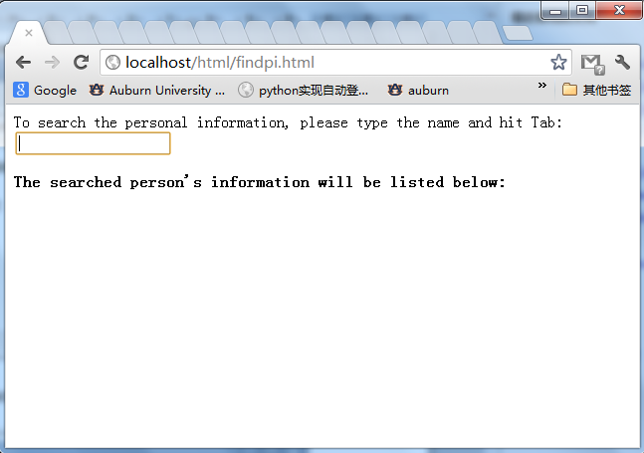

Figure 3:the original page to ask user type in name

And we type in “Dave Irwin” which has saved in the XML file

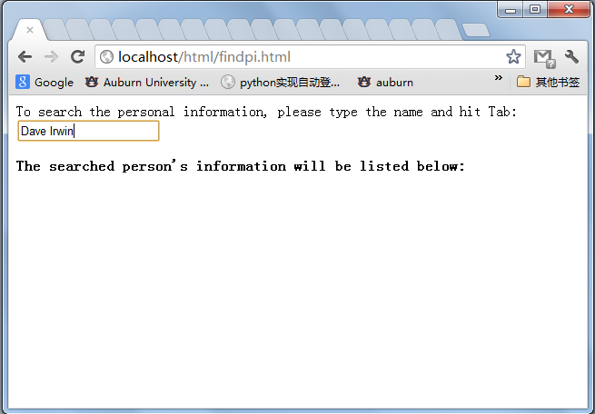

Figure 4: type in a name

Then we hit the tab, it will be like this. The information showing below the text box is saved in the XML file and it is send from server to client by the request of client.

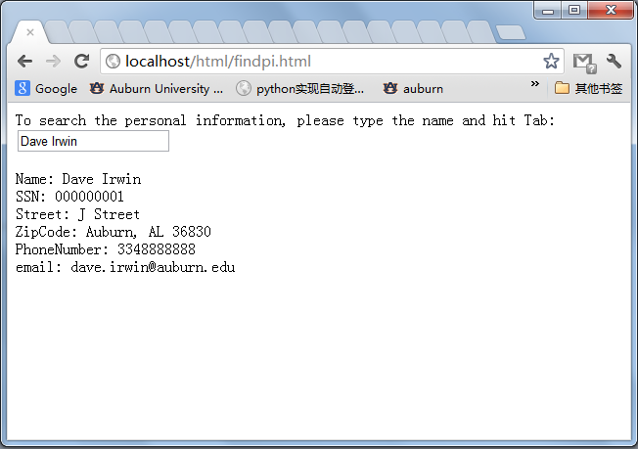

Figure 5: the research result of a certain name

Here is another figure to show the result. The left one is entering the name but have not hit the tab and the right one is have hit the tab, there are different because before we hit the tab, the request will not be sent wo server, so the information in client will not be updated.

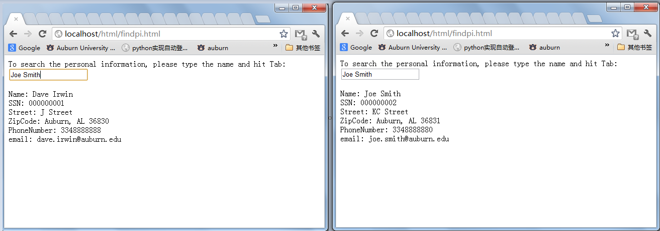

Figure 6:another name before and after hitting the tab

**AJAX’s XML Processing----changes and save xml contents**

In this exercise we are going to update the PHP code in server and we will add an additional function which is used to count how many times we have do the search in client. And we will all a new element in XML file and save the times of search into the XML file. Here are the figures to show the result.

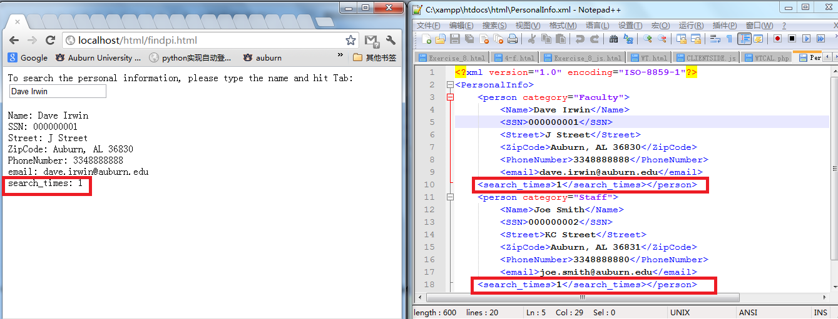

Figure 7: first time search

As we can see the XML file has add a new element named search_times and then we search another name.

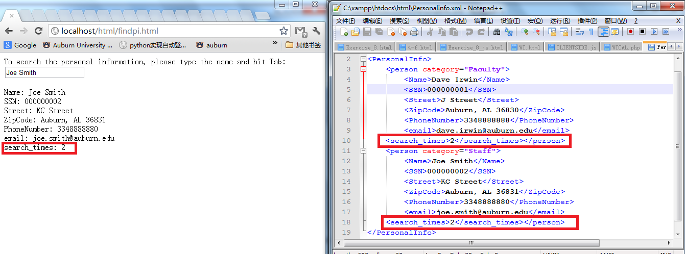

Figure 8: second time search

And we do search again

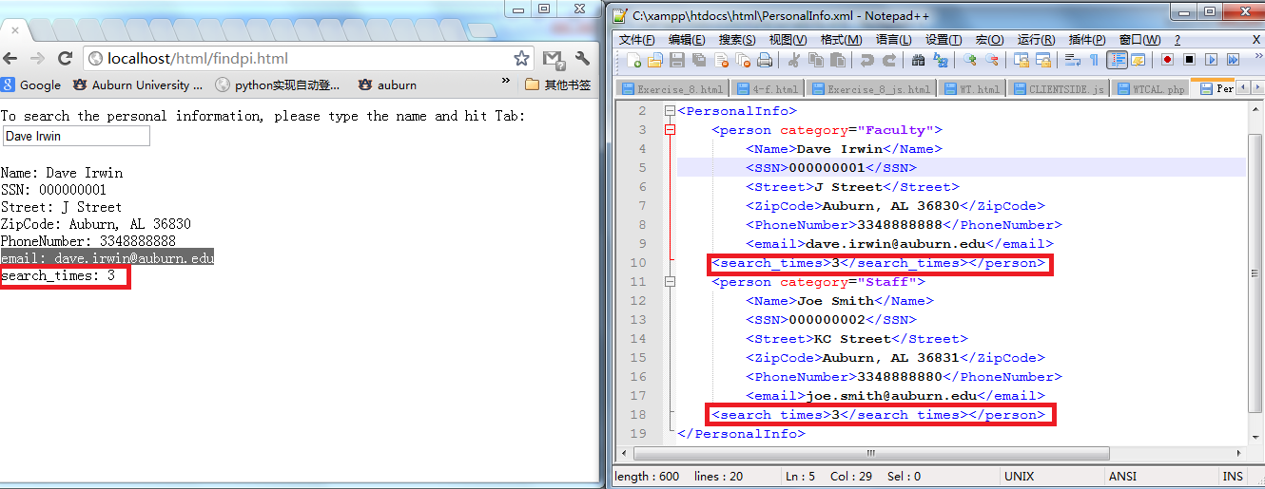

Figure 9: third time search

**Own exercise**

In the own exercise we are going to create a page with a form which contains the information of three items and we will ask the user to enter the quantities of the item the user want have. When user is entering the quantity the client page will send message and request to server and the server will caculate the total price and send back the price, the client will show the total price information in its page. Here are the figures of the test result:

Here is the form in client page:

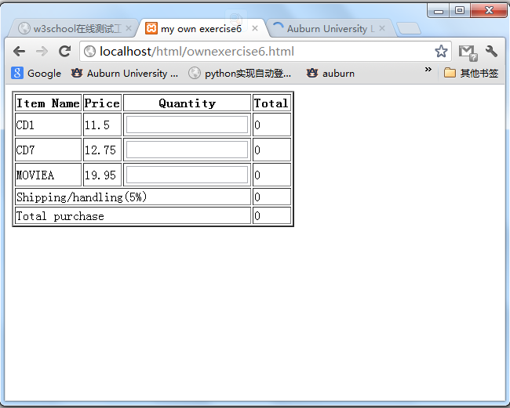

Figure 10: form in client page

When we are entering the quantity it will caculate the price immediately, just like this:

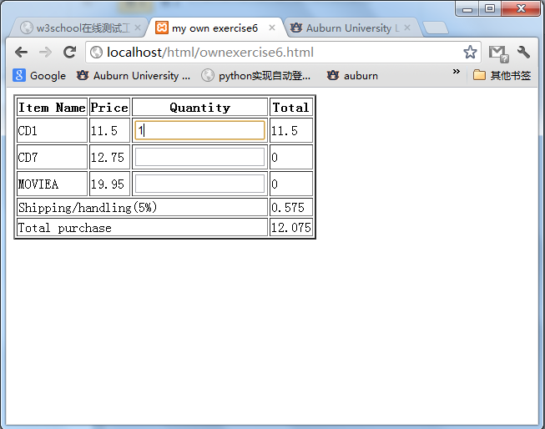

Figure 12: entering the quantity and caculate the price immediately

Entering another item’s quantity

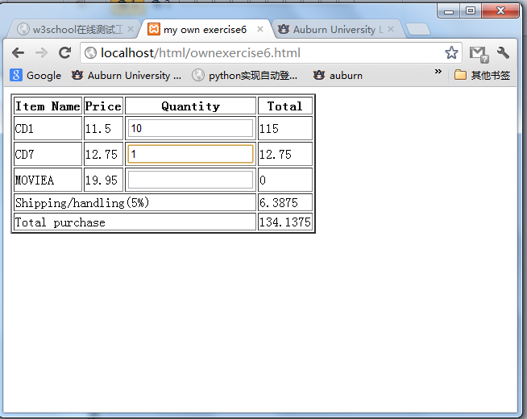

Figure 13: entering another item’s quantity

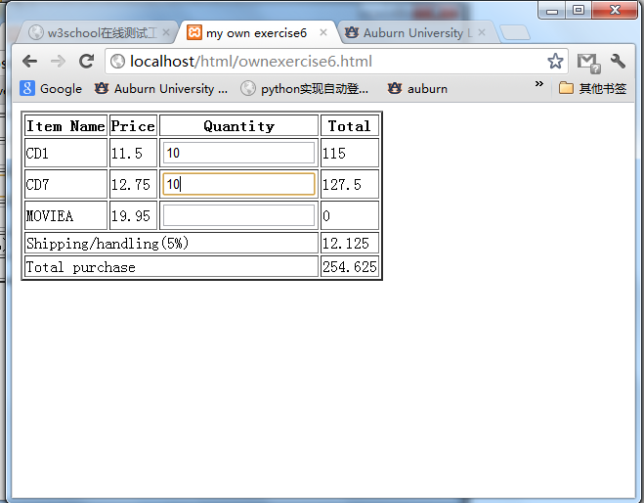

Figure 14: entering quantity

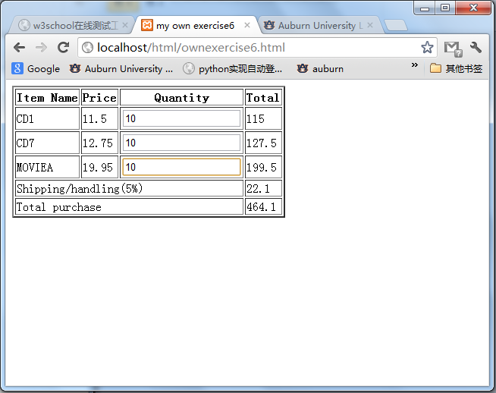figure 15: entering quantity

Another exercise is adding additional function to the exercise we have done before. The function likes this, if the name we are searching does not exist in the XML file, we will return a information in client page.

Here are the figures of the test result:

First we search for a exist name

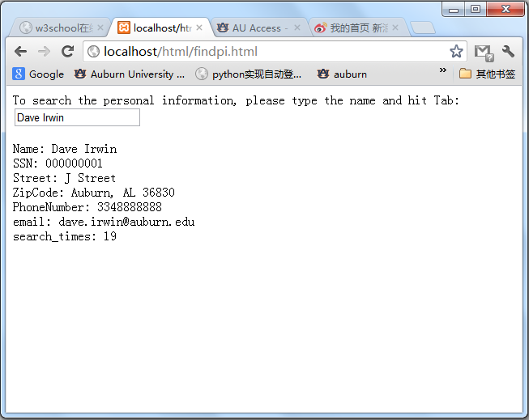

Figure 16: search for a exist name

As we can notice that the search time is 19 and we search another name which is not exist in XML file

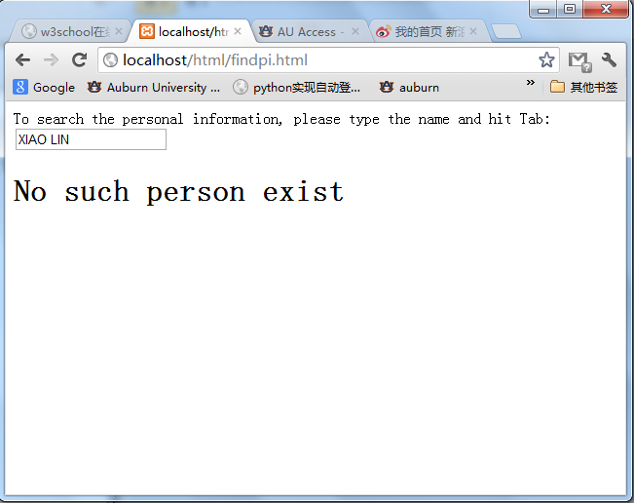

Figure 17: search for a name do not exist

And we search the exist name again and to see the search time

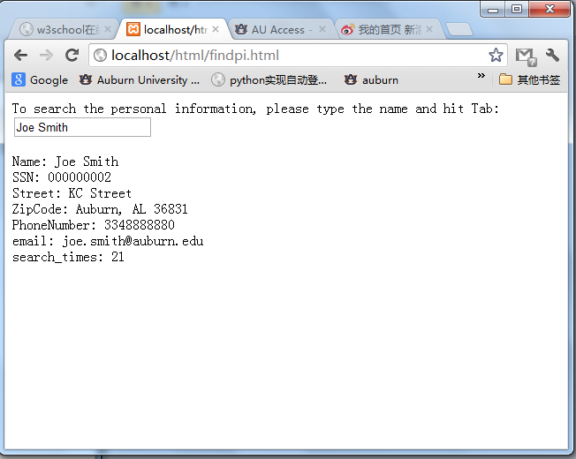

Figure 18: search a exist name again

As we can see the search time has been add up to 21.

# Result

We have finish this lab without significant problems. The main point of this lab is learning how to write a dynamiclly web page and update the certain information in client web page without refreshing the whole page. This is a great method to reduce the traffic between client and server it improves the user experience significantly.

# Conclusion

The AJAX is not a programming language but a structure. It is a useful technology in web proramming especially in the communication between the client and server. One thing should pay attention to is that the communication in client is done by JavaScript by using the XMLHttpRequest object.

# References

* PHP, <http://www.apachefriends.org/en/xampp.html>
* HTML Specification, <http://www.w3.org/TR/html4/>
* Javascript, <http://www.javascript.com/>
* AJAX Tutorial, <http://www.w3schools.com/Ajax/Default.Asp>
* Dr. Wu’s lab guides