ELEC 6220 Information Networks and Technology  
LAB 7 REPORT

Xiao Lin & Jie Zou

# Abstract

In this lab we are going to learn to use XMl, which is similar to HTML.

# Introduction

Although XML is similar to HTML, it serves to describing information while HTML serves to present data. XML is short of Extensible Markup Language, which can organizing and storing data. The data adapted through XML can be understand and used by other system since it is independent of any hardware or software.

# Design

**Exercise 1**

We can use a php file to collect the book information from book.xml file and then display them on the web browser page. The following picture is the web browser displaying the XML data.

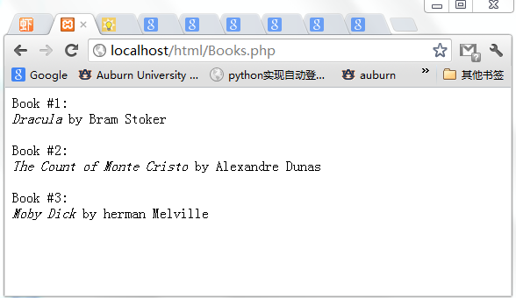

Figure 1.1 Web browser displaying XML informaitio

Also, we can output the xml data after we have fully collected it. In this case, we can insert some extra information or diplay the information in any order we want. Following is the screen shot.

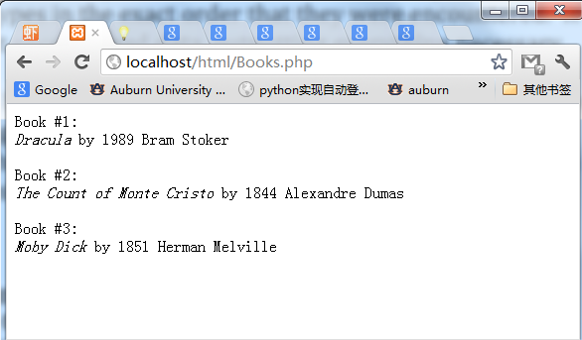

Figure 1.2 Web browser displaying XML informaition

Then in our own exercise, we diplay the books information from books3.xml, which includes a book with 3 authors. Following is the screen capture.

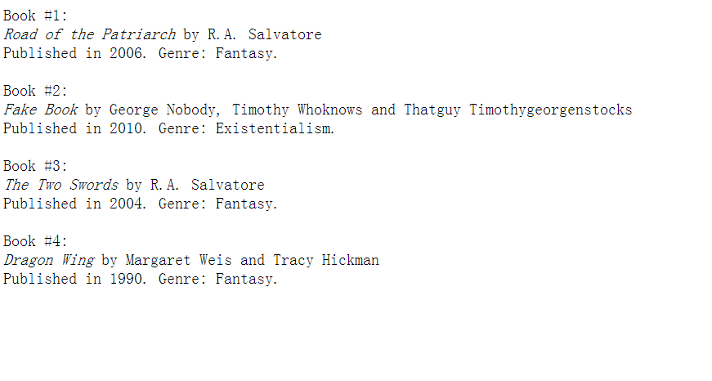

Figure 1.3 Four books with multiple authors

**Exercise 2 XML Schema&XForms**

In this exercise we will learn XML Schema, which is alternative to Document Type Definition. XML Schema defines rules for what to strore in data files and it is separate from the xml file.

Following screen shot shows how the xsd define the attribute of the tag.

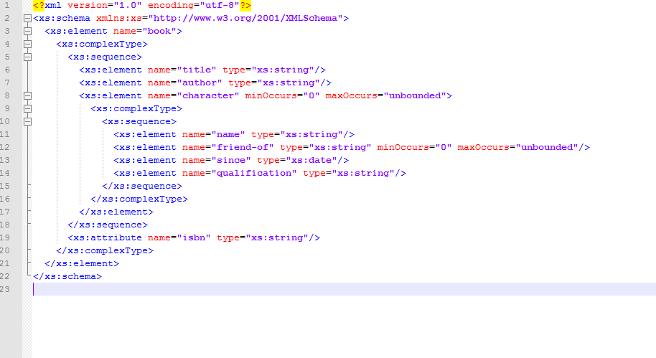

Figure 2.1 xsd file defining attribute

On our own exercise, we add some information into the XML and XSD files.

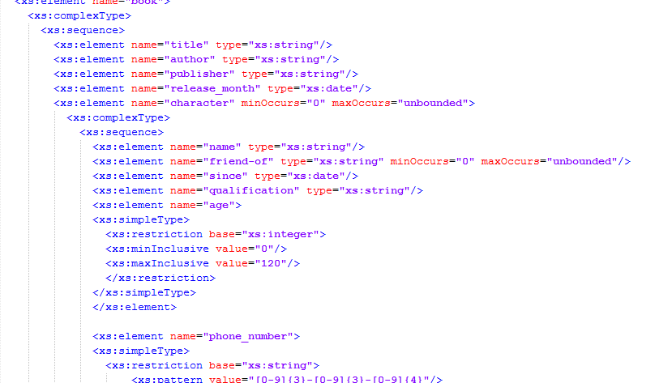

Figure 2.2 XSD file with adding information

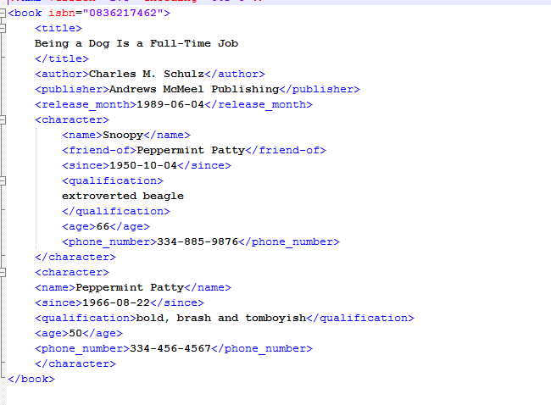

Figure 2.3 XML file adding information

Also, after we create the XML file and XSD file, we shoule check if the XML file meet the requirement of XSD file. So, we use an online validator to check them.

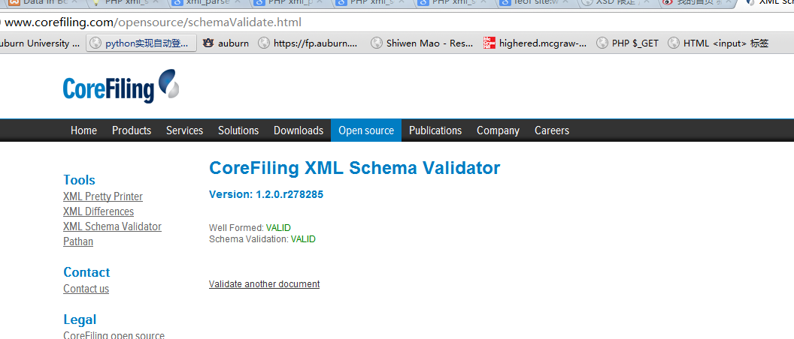

Figure 2.4 Validating XML file and XSD file

Besides, we can further use XForm, a next generation of HTML forms. It separate data model and form for data entry.

**Exercise 3 Using XML in a Database**

In this exercise, we are going to use XML form to edit and extract datas instored in SQL database. For example, we can first creat a database of books.

First we creat a test example named “test”.

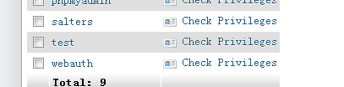

Figure 3.1 creating database

Then we create a table named “books”, with attribution of ISBN, title and authors.

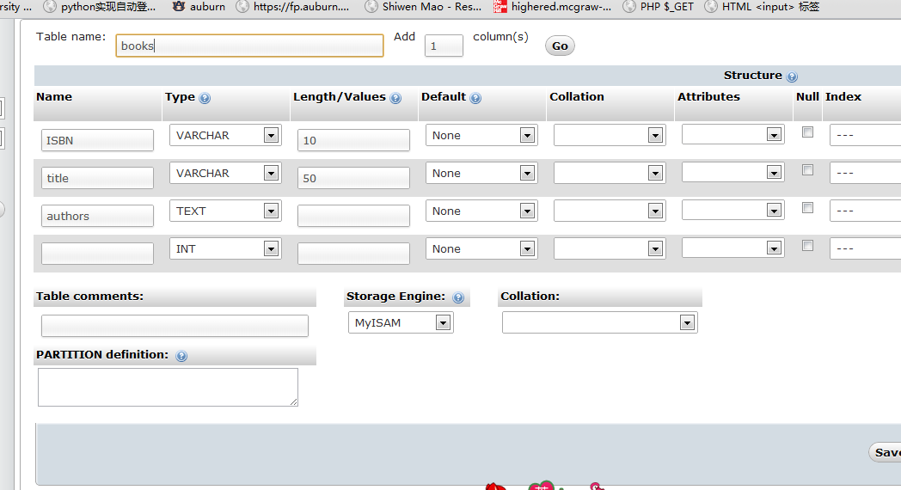

Figure 3.2 Books table

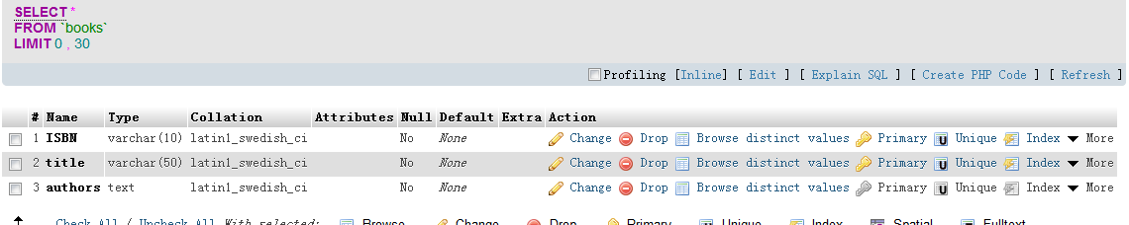

Figure 3.3 Attibutions

Next, we can insert books information by typing the query.

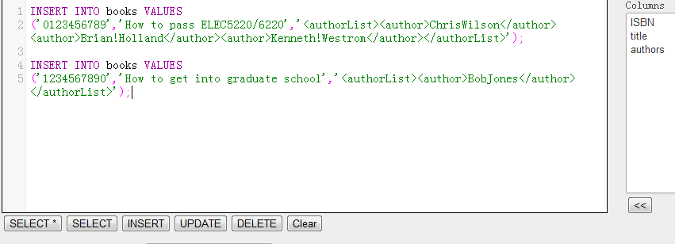

Figure 3.4 Insert books information

And we want to see the actual data, we can type the ExtractValue query.

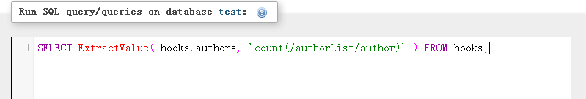

Figure 3.5 ExtractValue

If we want to see the first author in our book, we use SELECT query.

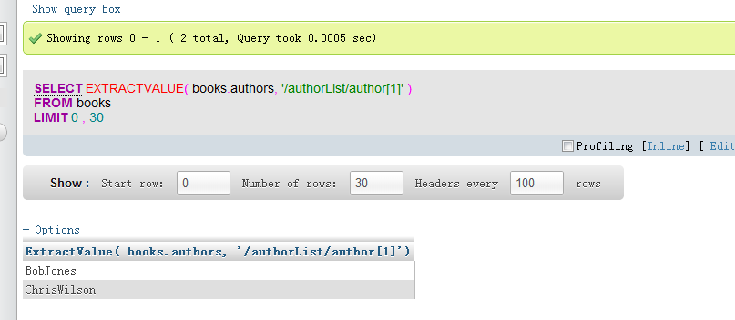

Figure 3.6 Select book

If we want to see the first author of a book which has multiple authors, we can then type as the following screen shot shows.

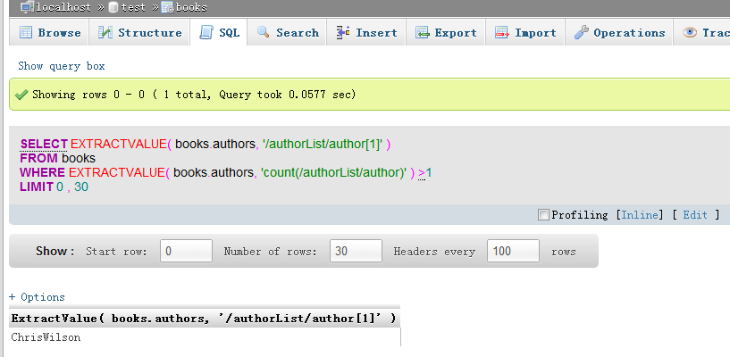

Figure 3.7 Exthract data of book with multiple authors

Now we can display contents of the database with PHP file.

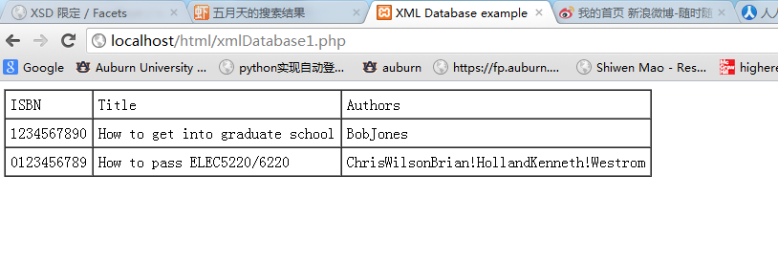

Figure 3.8 Displaying database contents

And to do in a better way, we use MySQL’s ExtraceValue function.

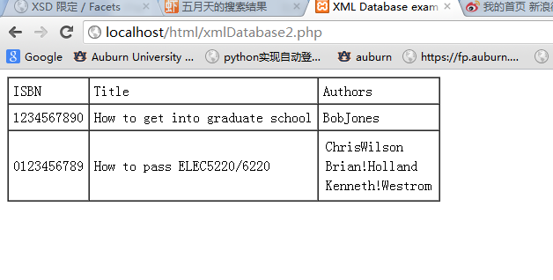

Figure 3.9 Displaying in a better way

Now, we try to edit the database data in the PHP file which allows us to edit or delete authors’ information.

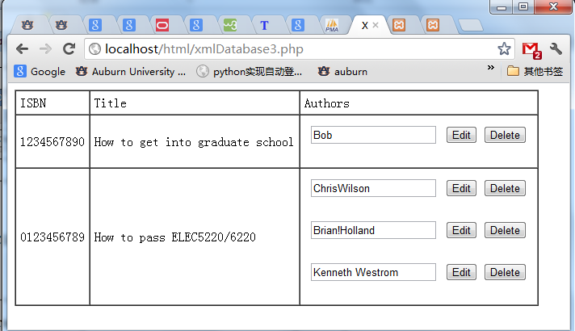

Then, we can add a new function to add new author to the books’ database

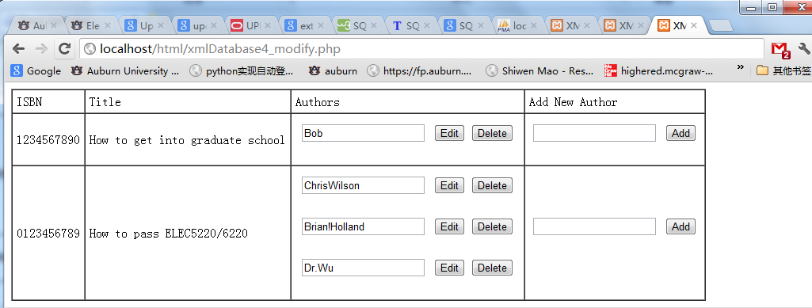

Figure 3.10 Adding author function

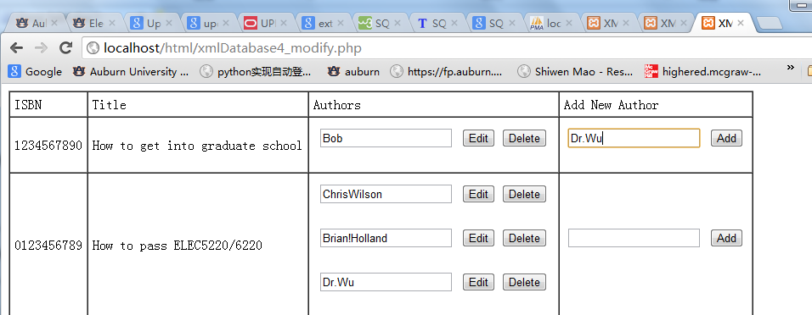

Figure 3.11 Adding author information

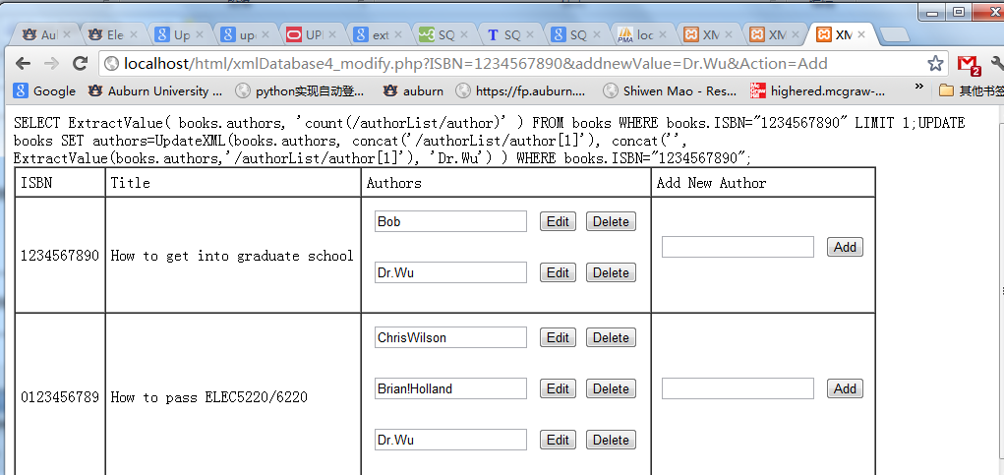

Figure 3.12 Adding information

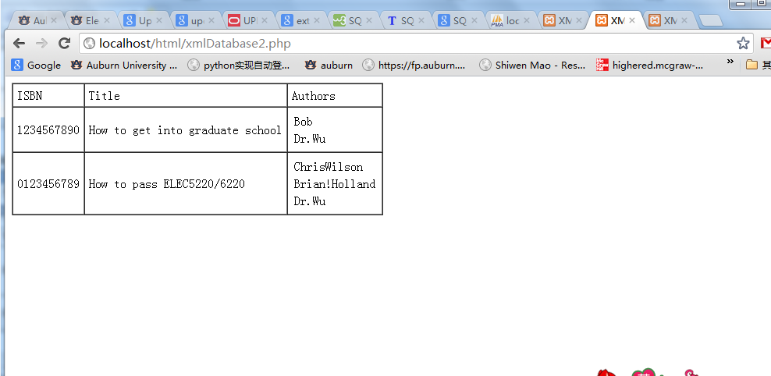

Figure 3.13 Adding information has been done

Next we add searching function for the PHP file

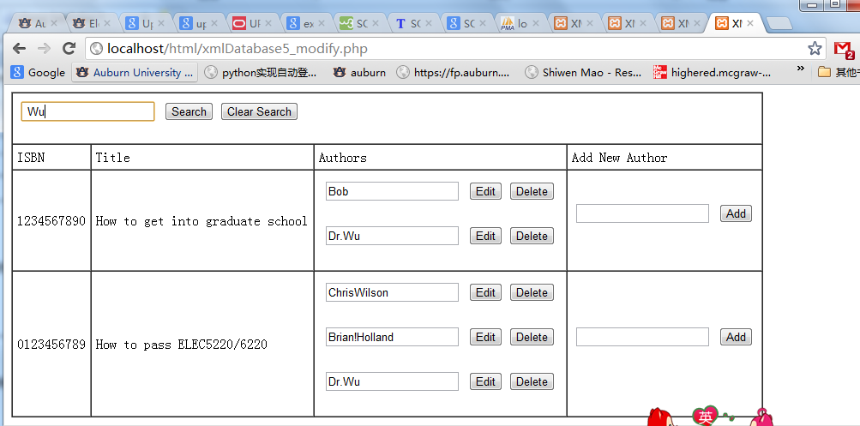

Figure 3.14 Searching function

For homework, we add errata

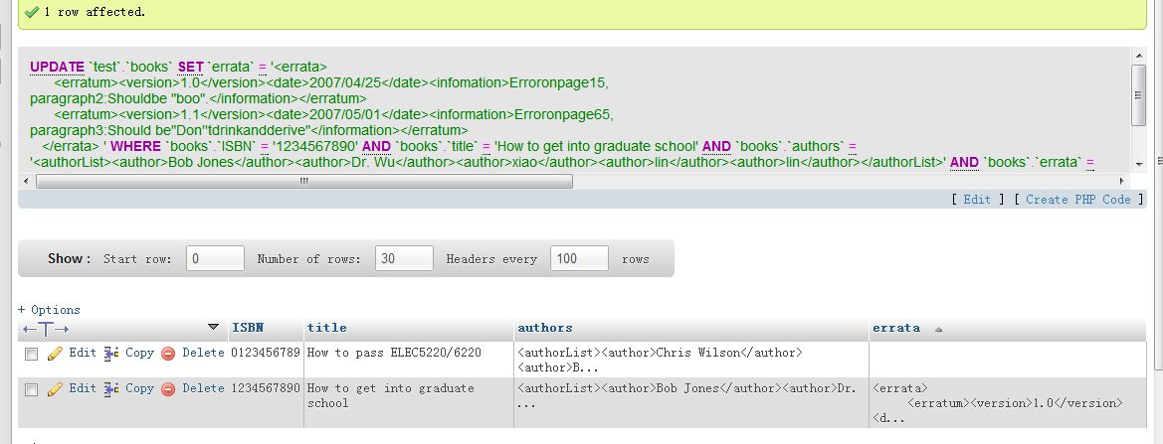

Figure 3.15 Adding errata in MySQL

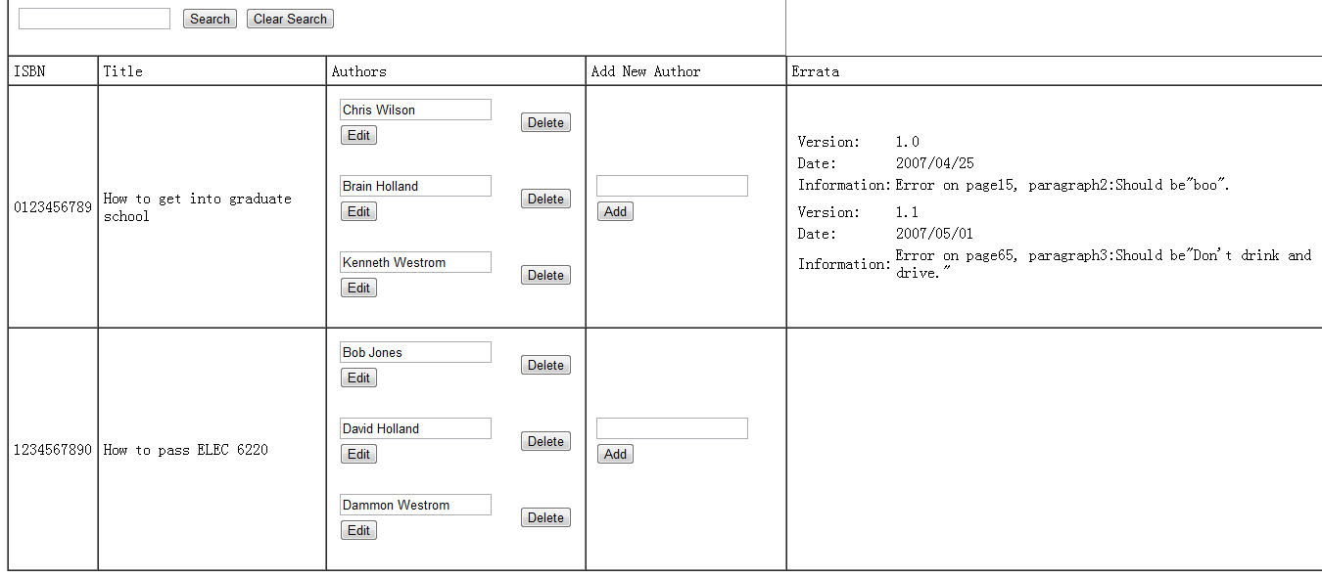

Figure 3.16 After adding errata

For our own exercise, we create product database for cellphone

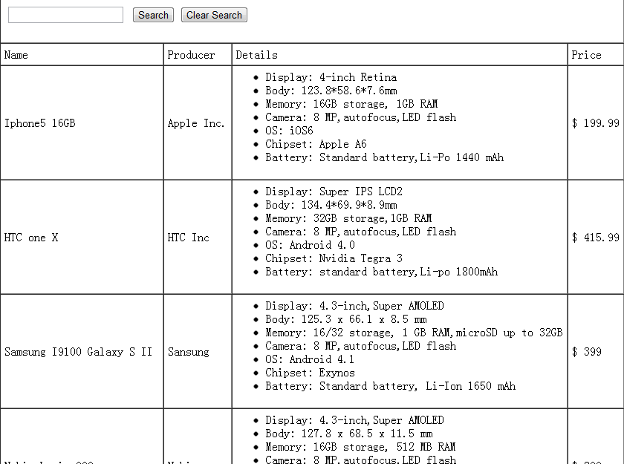

Figure 3.16 Own Exercise

# Result

We have finish this lab without significant problems. The main point of this lab is learning how to diplay the information in the MySQL database and to use different function to extract data from it, including adding a searching function. In our own exercise, we create a database for cellphone and display it on web browser.

# Conclusion

As a wise saying “Let the data drive your database”. XML provide us to extract data from phpMyAdmin database and display them on the web browser. It is useful when we create a webside for online buying, especially for our project.

# References

* PHP, <http://www.apachefriends.org/en/xampp.html>
* HTML Specification, <http://www.w3.org/TR/html4/>
* Javascript, <http://www.javascript.com/>
* AJAX Tutorial, <http://www.w3schools.com/Ajax/Default.Asp>
* Dr. Wu’s lab guides