Project 1 Report

By

Xiao Lin

and

Jie Zou

ELEC 6220 – Information Networks and Technology

Dr. Chwan-Hwa Wu

10/13/11

**Abstract**

In today’s business, more and more people are using the Ecommerce industry. In every day, a large amount of deals are accomplished online, which we call ecommerce. This increased demand for Ecommerce requires that more and more people understand the necessities for developing these sorts of online environments in order to attract customers and run a successful business. In this project, we learn to set up own business shopping website using the skills in the former labs. This project will require us to cover several aspects of an Ecommerce store. We are required to create a fully functional shopping cart which will allow the client to add items, change quantity, and calculate an accurate total for the order. A shopping catalog with at least five categories, at least five products, and the ability to search must also be included. The project will also include shipping information, hide a credit card number, and have inventory control, which will inform a customer if a product is unavailable. Finally, it will check if the information is correct to be uses before proceeding to the finally step. We use cookie to recognize customer when they come to our website second time and we will show the browsing history of him or her.

**Introduction**

This project require us to create an online shopping store which can provide customers or users to search key word for product and use shopping cart in the process of purchasing. When he proceed to make a deal, we will check if the information the customer supply is correct before we make the deal. Besides, the total amount will be calculated at the server side.

**Design**

First we need to create table and enter the information in the database such table for product, customer, order and so on. As shown, below, tables for products, customers and orders.

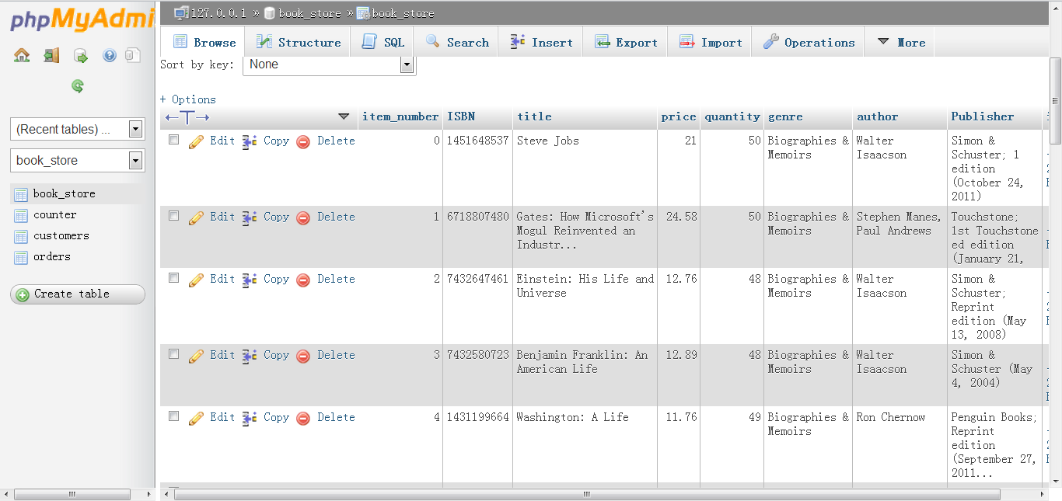

Figure 1 – Books table in Database

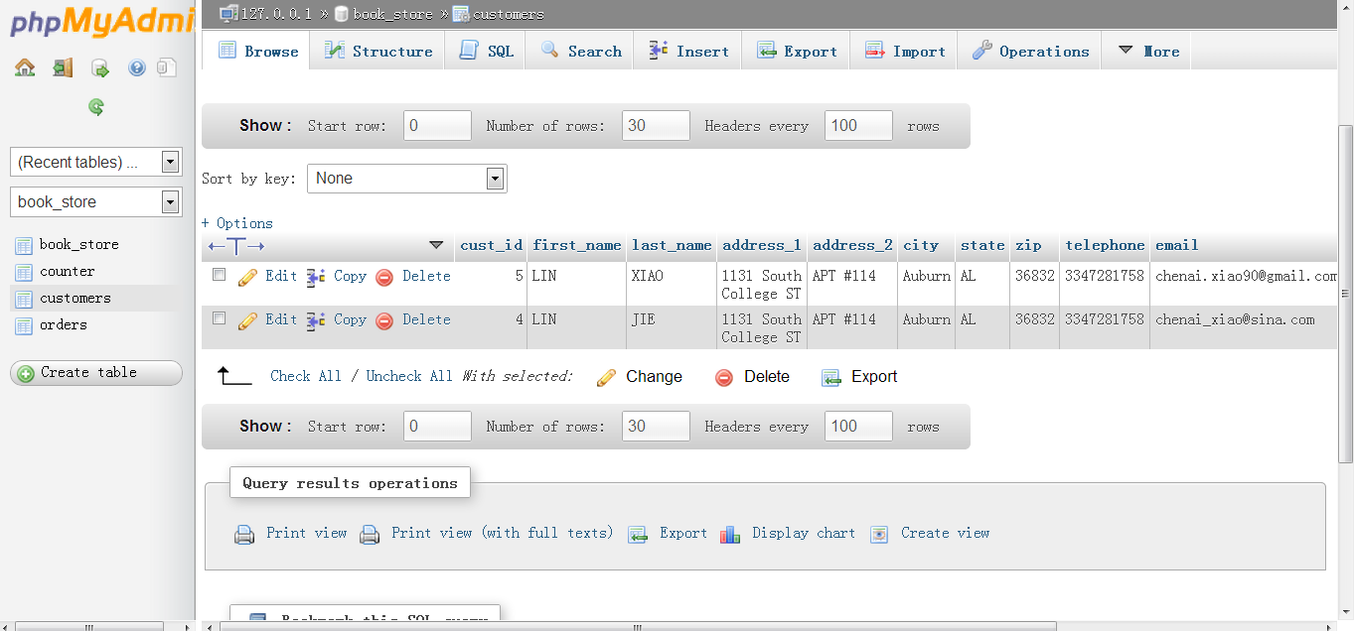

Figure 2 – Customers Table in the Dtabase

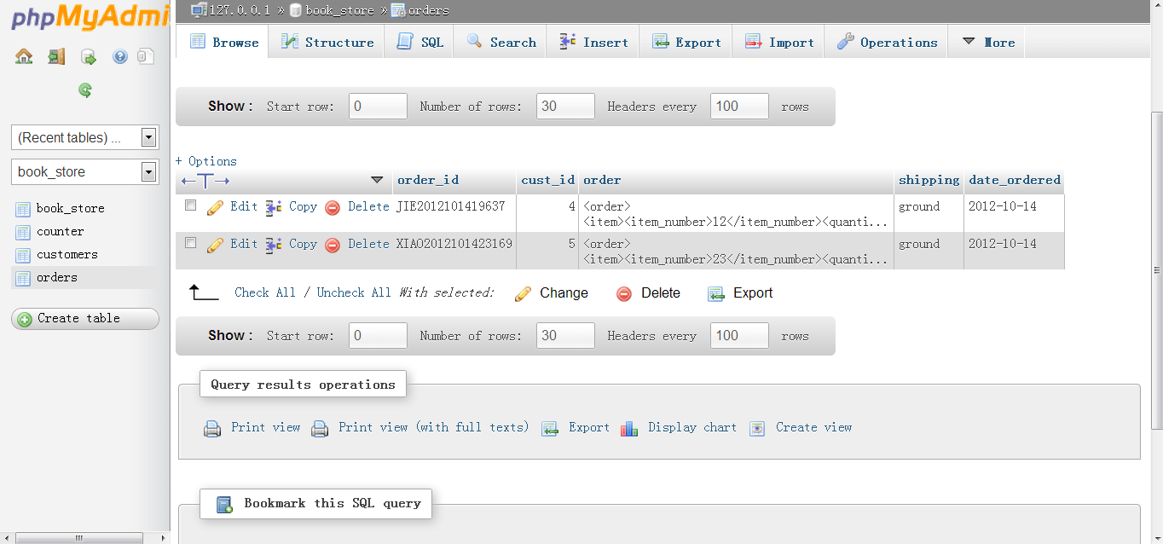

Figure 3 – Oreders History Table

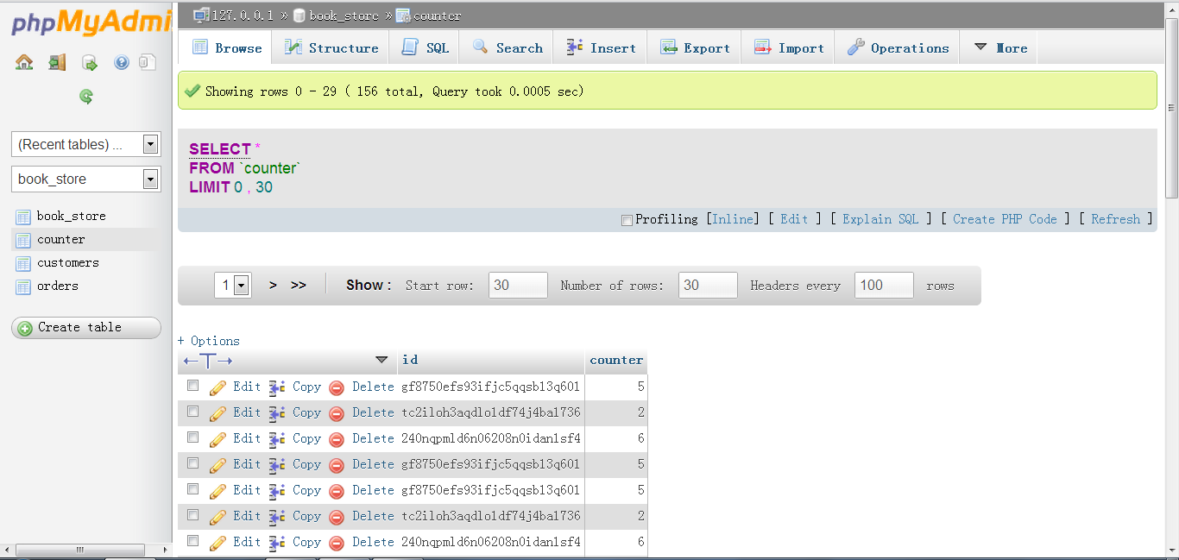

Figure 4 – Counter table in database

The most important function of this project is the cookies, which can remember customers’ history and show them. As the following screen shot shows, when customer first enter the website, it require customer to type username and email.

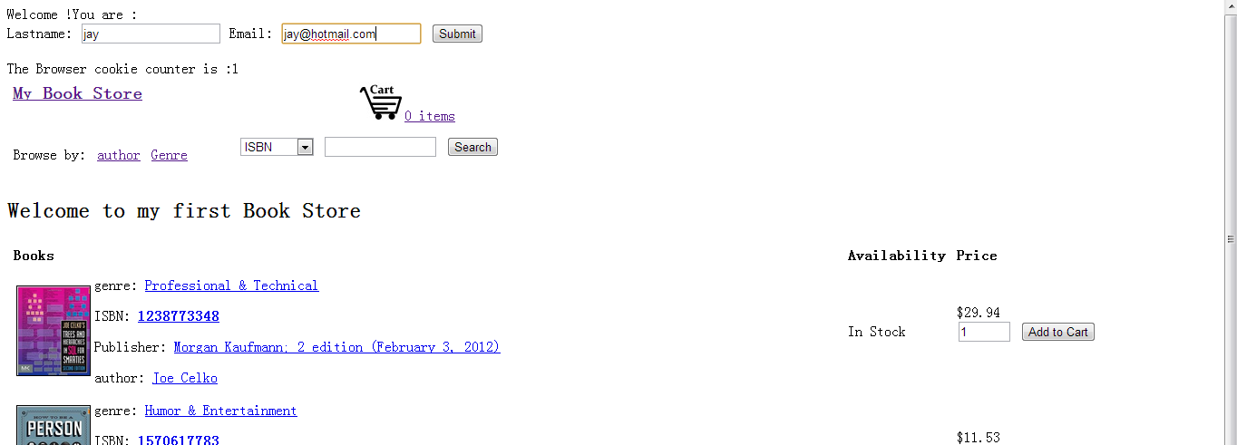

Figure 5 Asking last name when first come to store

When I enter my account and click submit, it shows the purchasing history and visiting times as the following graph shows.

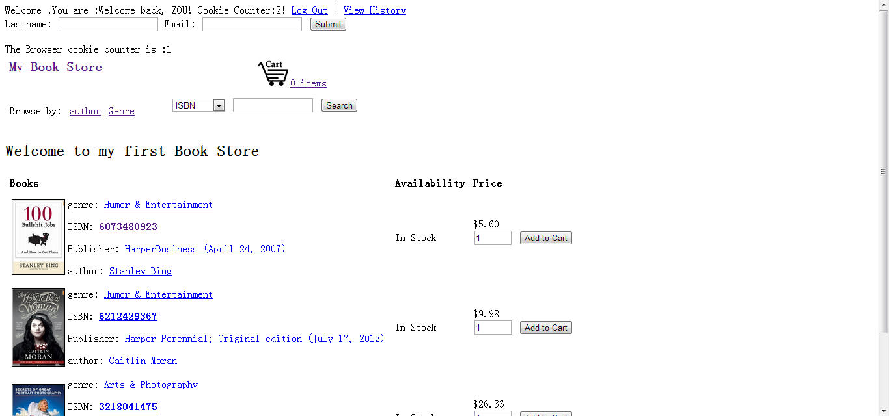

Figure 6 Showing my account and visiting time

If we click view history, we can see our history.

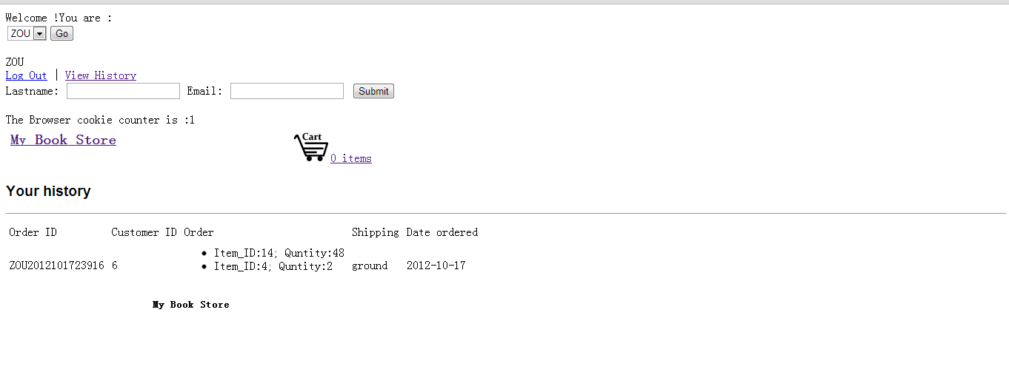

Figure 7 Showing history

The project should have function of shopping cart, which allow customer to select items, change quantity and generate total cost using AJAX.

The main page (/index.php), shows some books that are available in the database and allow client to search books by ISBN, publisher, tittle and author. It also shows the amount of time the browser has visited the site. Besides, it provides shopping cart for customers.

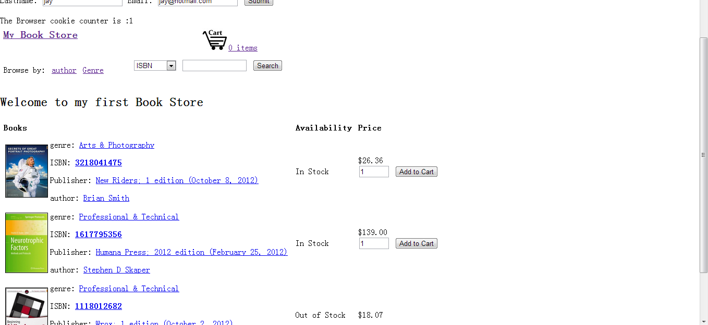

Figure 8 – Main Page

And, as the project required, the client should be able to search product catalog. We can test the searching function by entering the author name of Teri. The following screen shot shows the searching result.

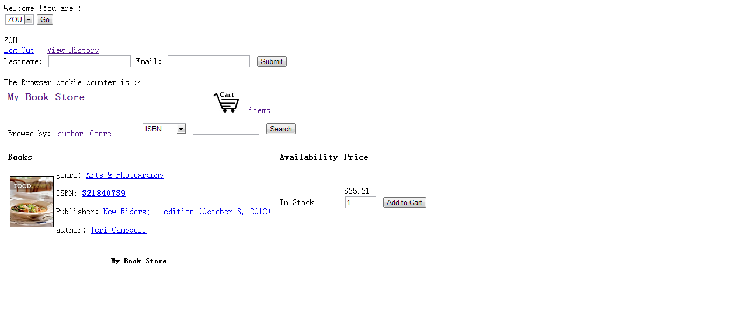

Figure 9 - Results for author’ name Teri

In case client will be overwhelmed with products, we can browse our store by author or genre. Figure 7 shows the feature of allowing client to brows by author and Figure 8 shows browsing by genre.

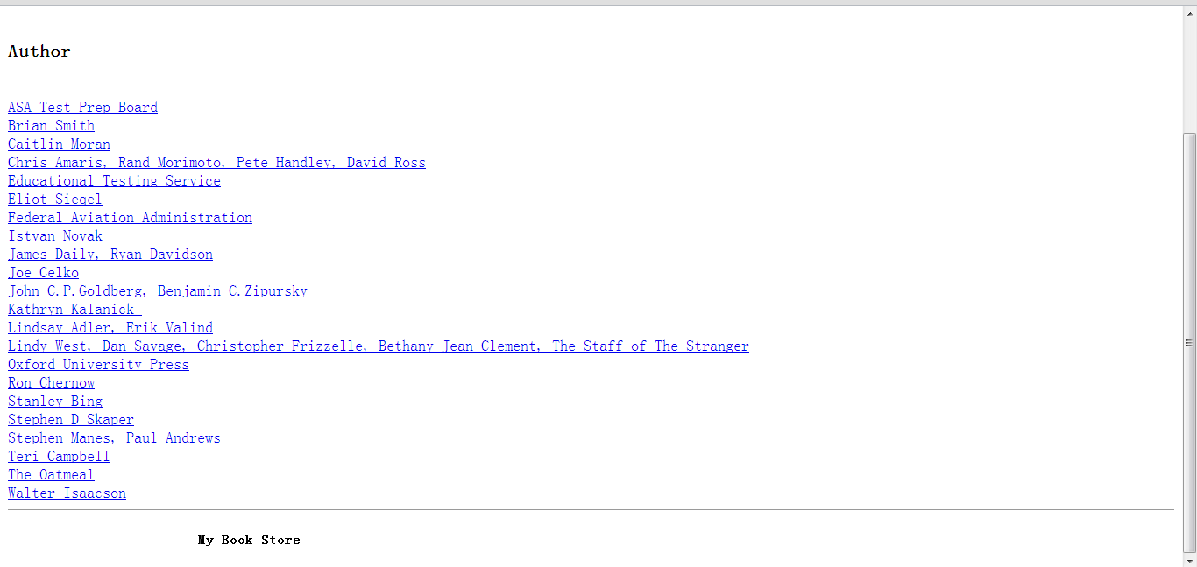

Figure 10 – Browse by author

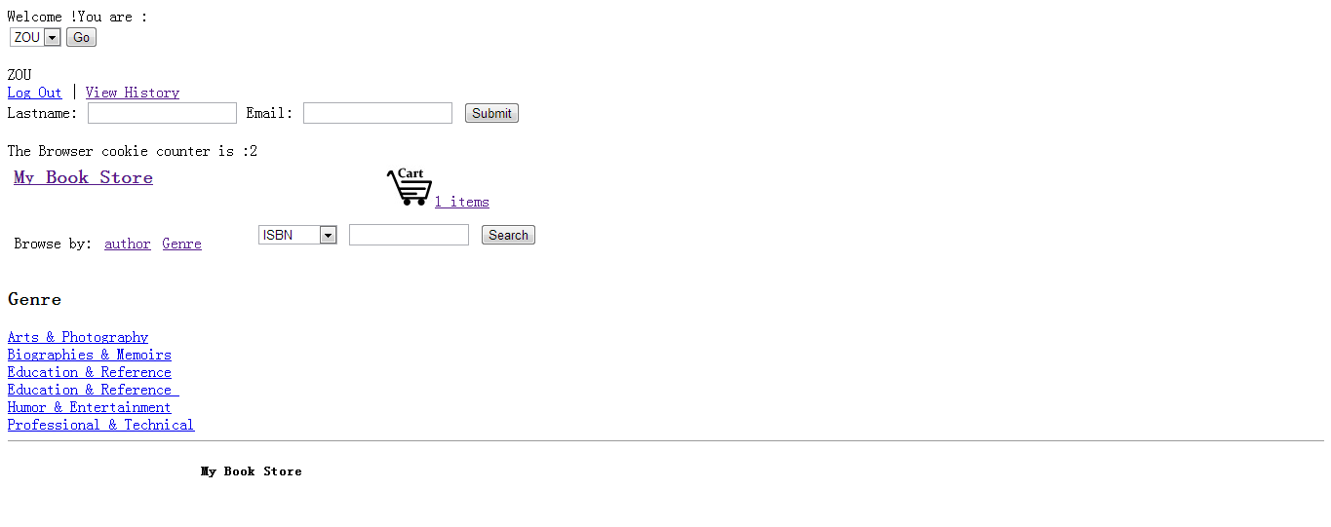

Figure 11- Browse by genre

Then, an online shopping cart will allow the client to add multiple quantities to their cart. Figures 12 and 13 shows the items to be added to the cart.

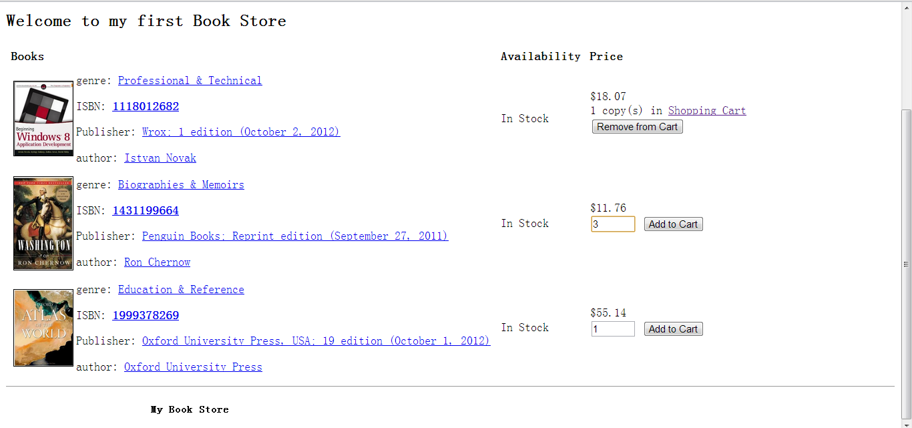

Figure 12 Add multiple books to shopping cart

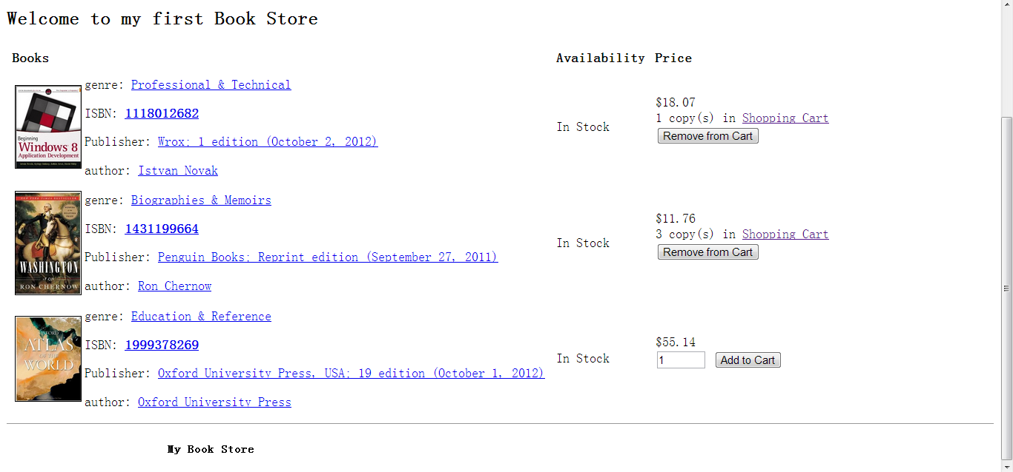

Figure 13 Multiple books have been add to shopping cart

It is also required to make the client able to update quantity, choose shipping service and estimate taxes based on their state. Figure 11 shows the overall interface of the shopping cart and the features available to the user. Figures 14 and 15 show before and after the quantity is updated.

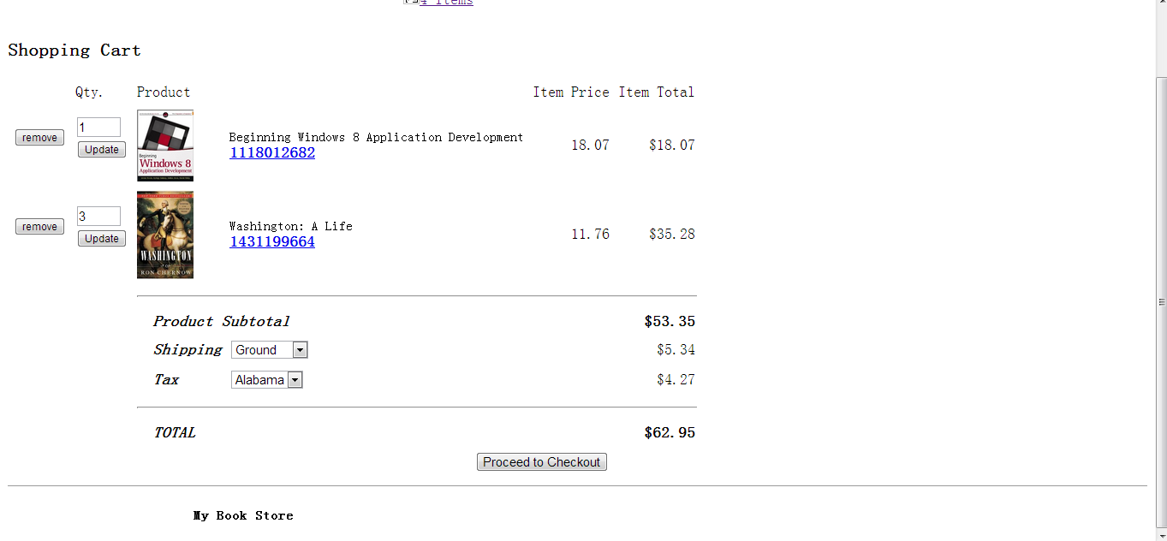

Figure 14 Display shopping cart

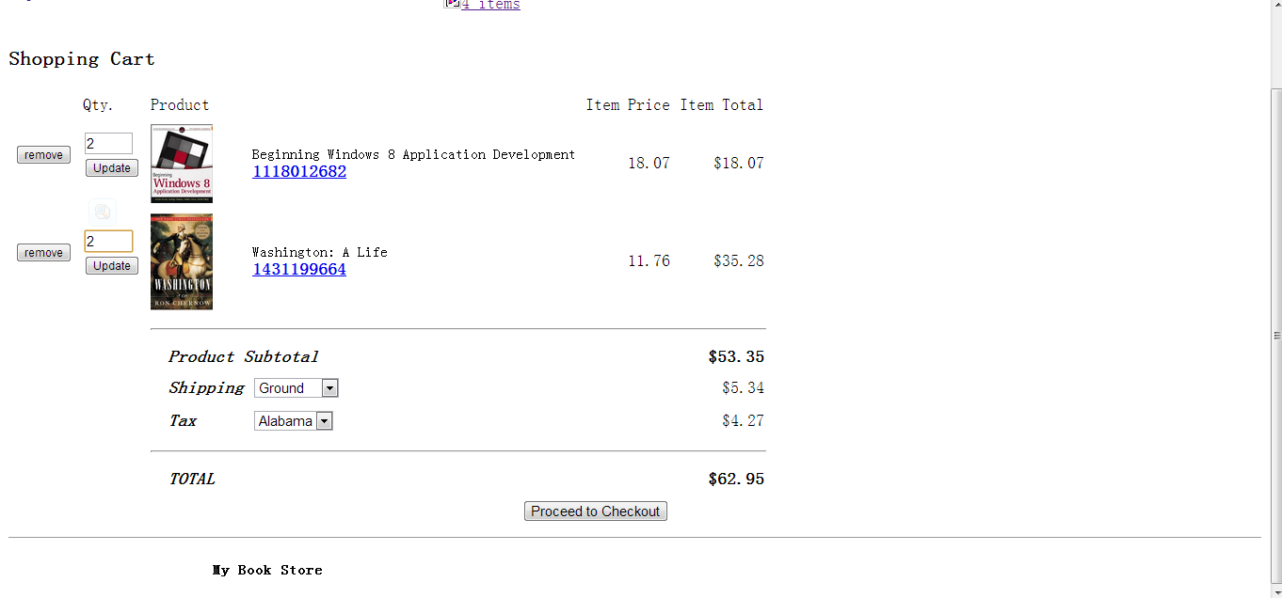

Figure 15 Change the quantity amount

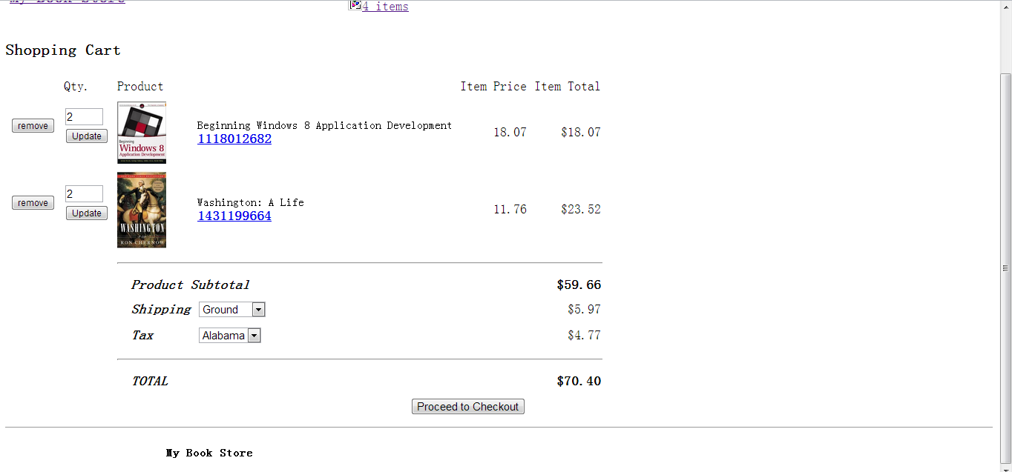

Figure 16 Price updating

And more important, we should not allow client to add more items than we have in stock. So, when they add those large numbers, we should warn them and limit the number. The following figure show this function.

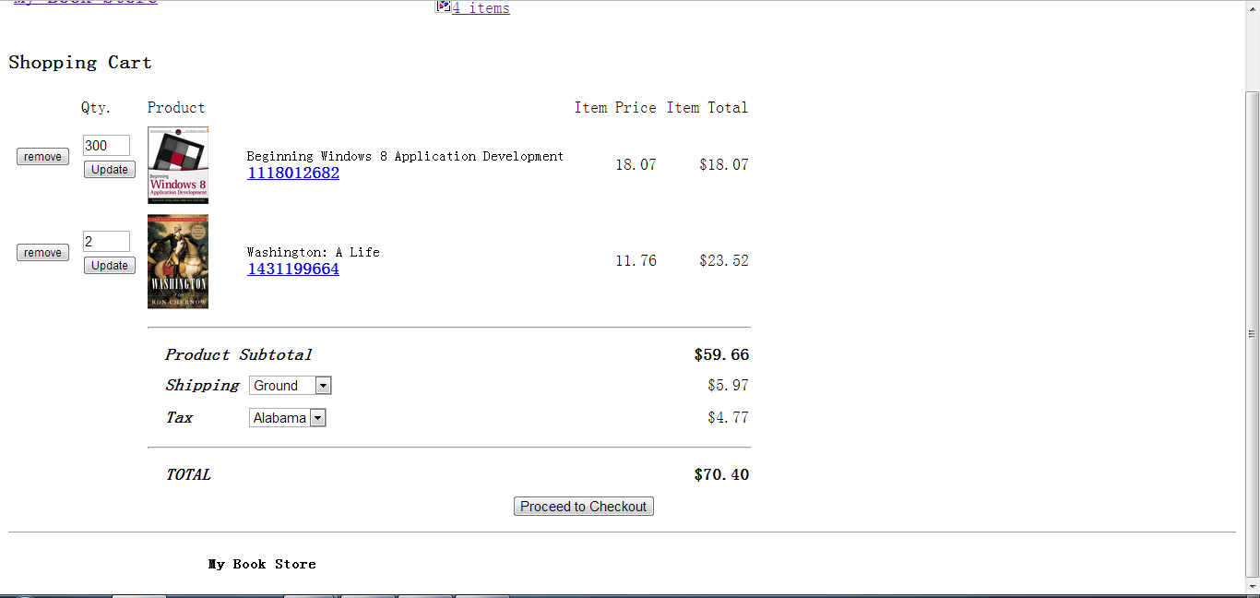

Figure 17 – Client try to add 300 books

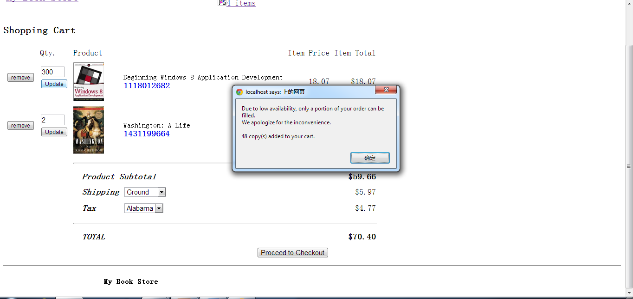

Figure 18 – Warning of the limit

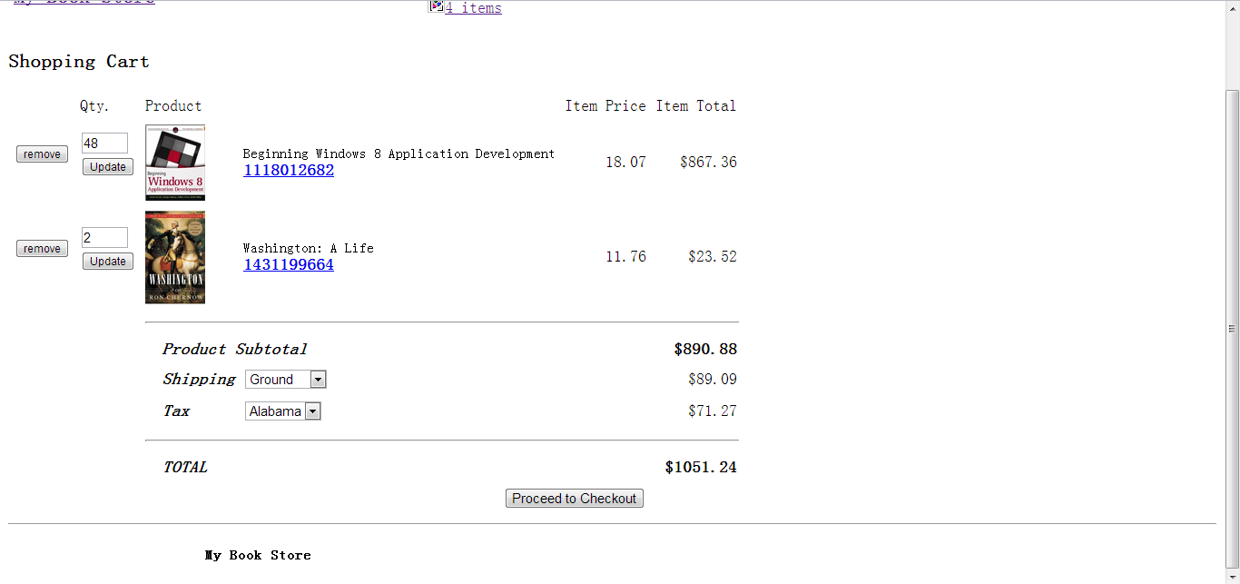

Figure 19 Add what is available

When the customer is satisfied with the order, they will proceed to checkout. At this page, they are required to enter their information such as mailing address and billing information. Each input is to be verified before the user is allowed to place their order. Most importantly, the credit card number should be hidden. Figure 20,21, 22 show a successful run through the checkout process, while figures 23,24 show where the user is stopped when data is not entered properly.

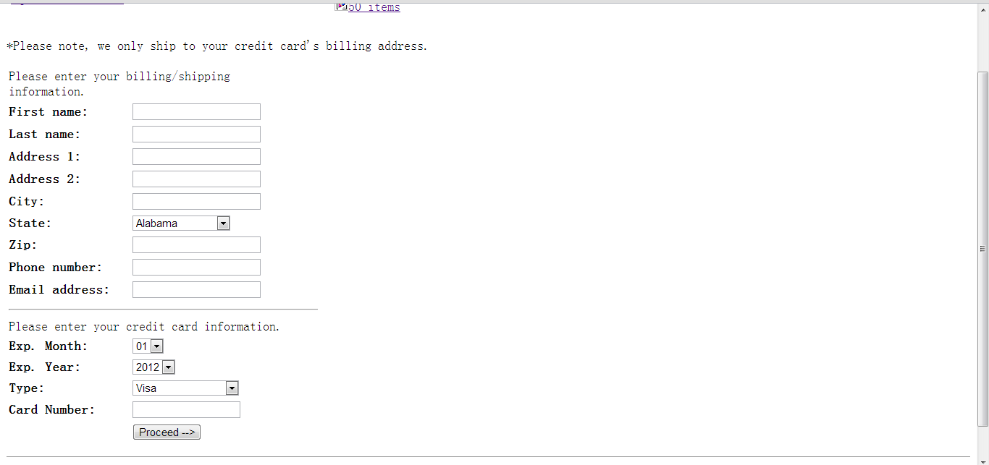

Figure – 20 Proceed to checkout

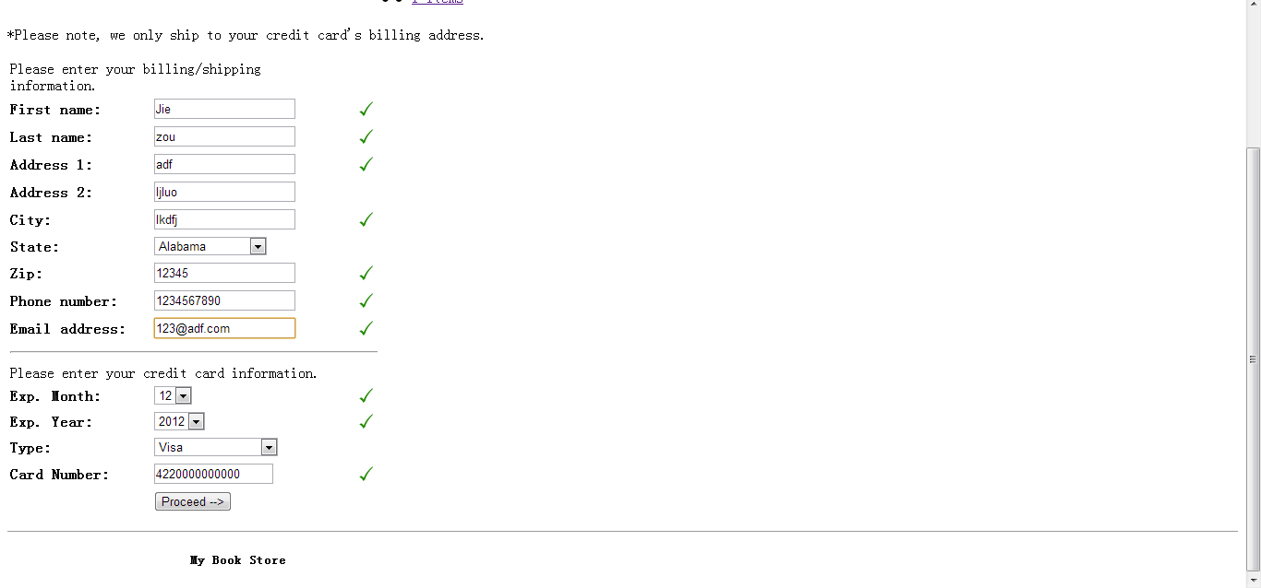

Figure – 21 Check out

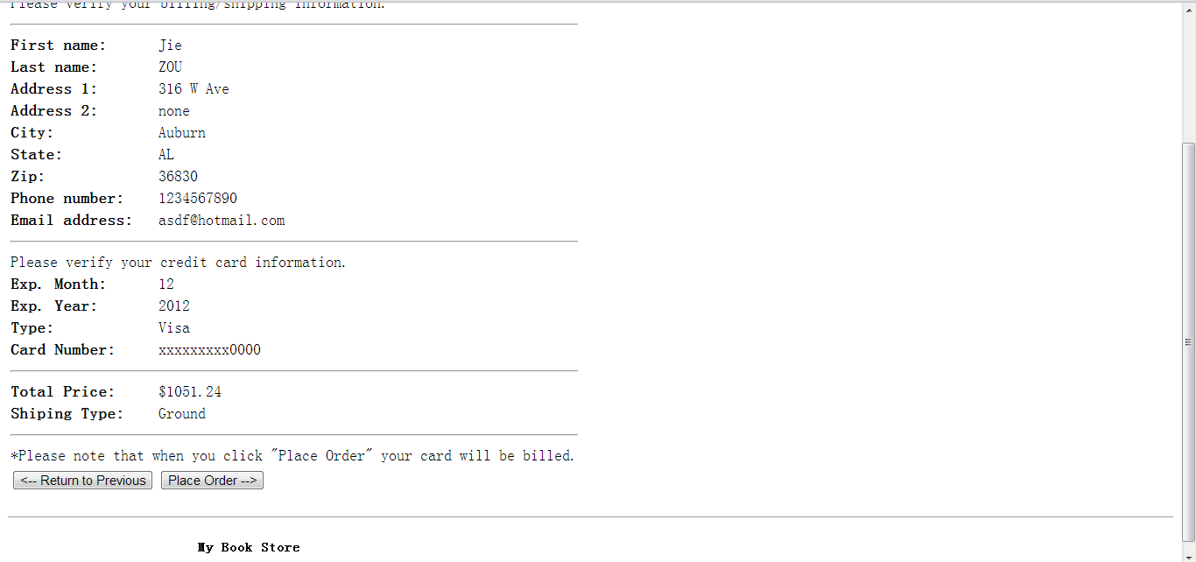

Figure 22 – Confirm information 19 – Confirm information

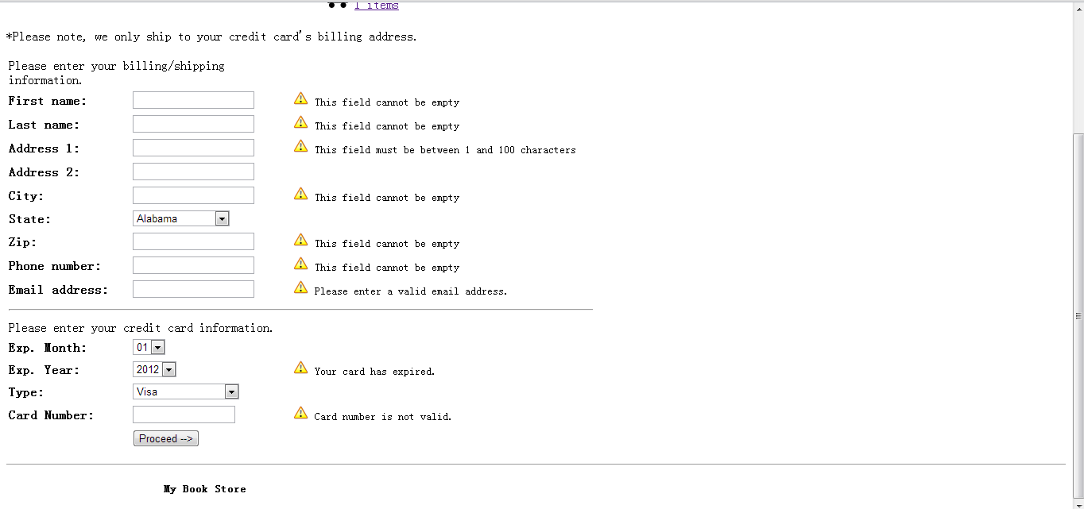

Figure 23 – Data is not valid

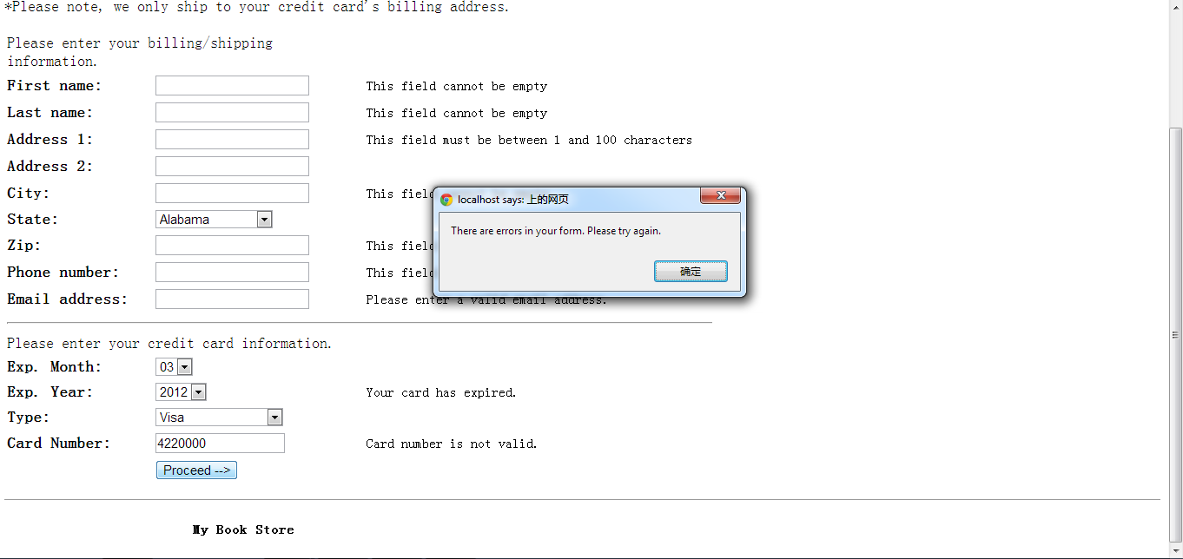

Figure 24 – Not allowed to proceed

Once the order is finished, the customer can print the page of the order detail. The database for this order are updated.

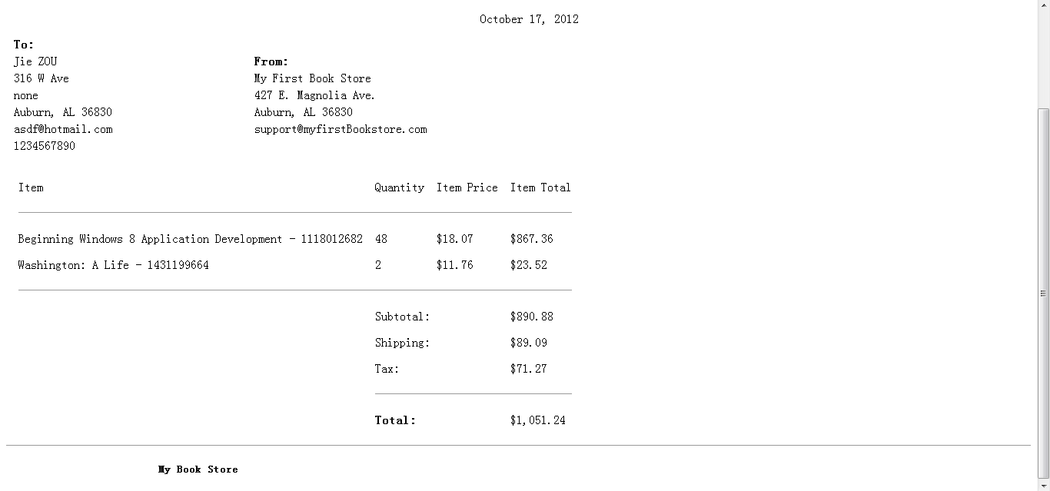

Figure 25 – Order confirmation

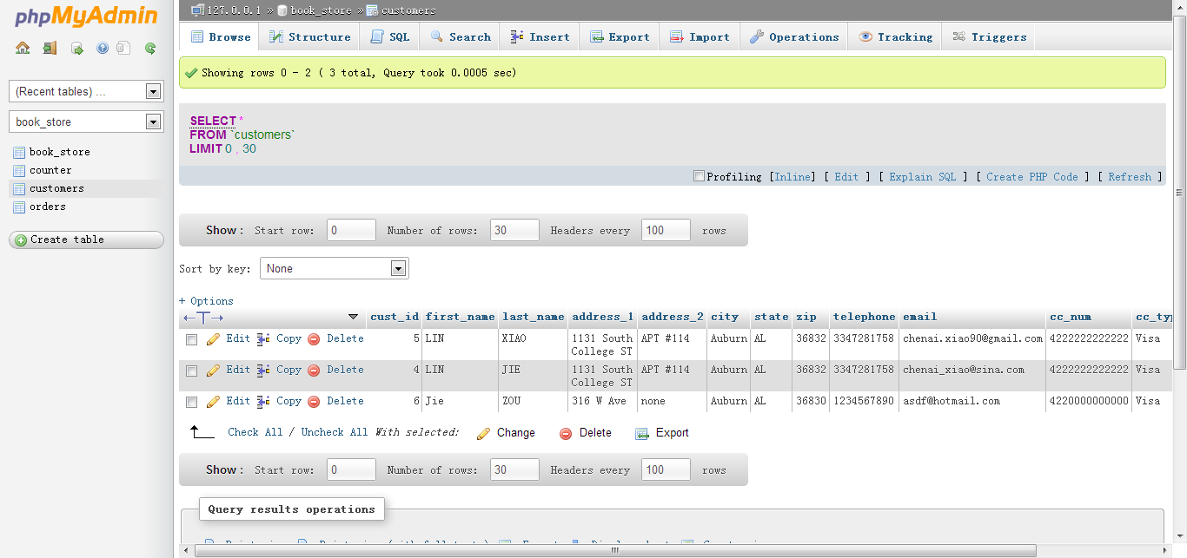

Figure 26 – Zou is added to customer table

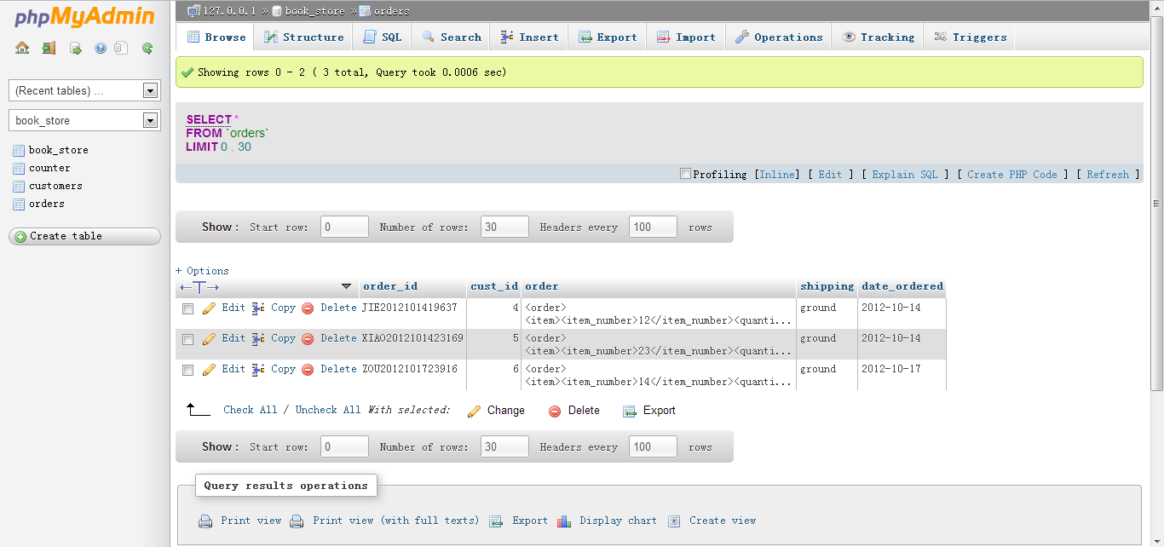

Figure 27 – Zou’s order to the orders table(the last one)

**Android**

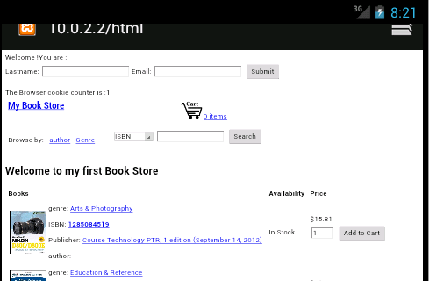

Figure 28:The page when first visit

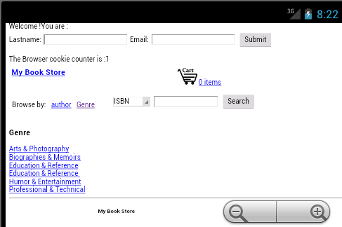

Figure 29: the capture when browse by genre

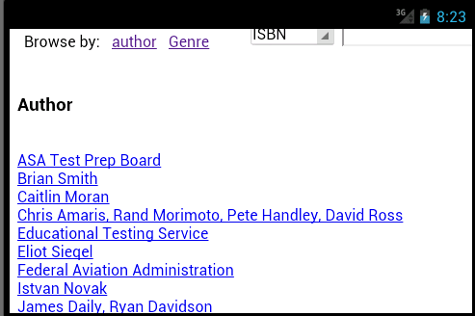

Figure 30: the capture when browse by author

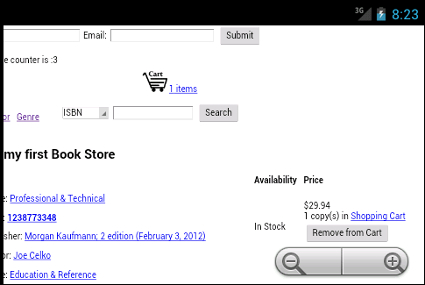

Figure 31: add a book to shopping cart

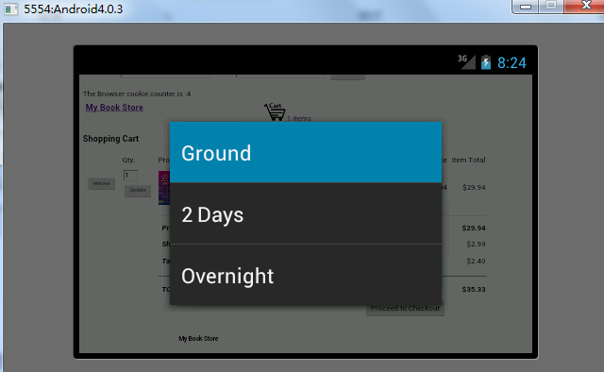

Figure 32: chose different shipping

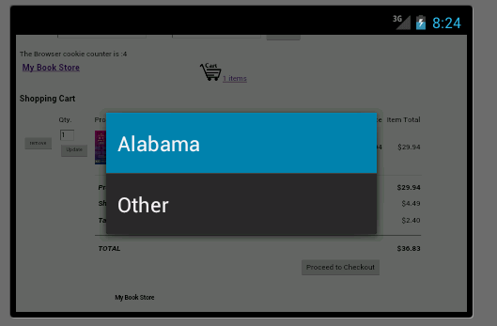

Figure 33: chose the state

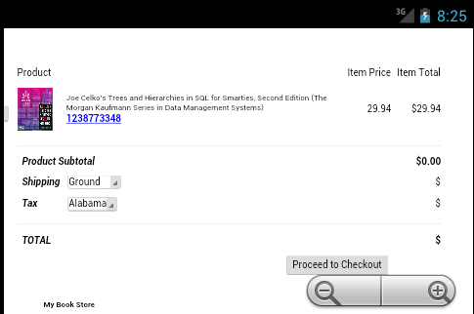

Figure 34: check out

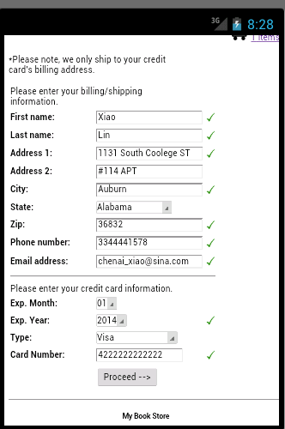

Figure 35: filling in the customer information

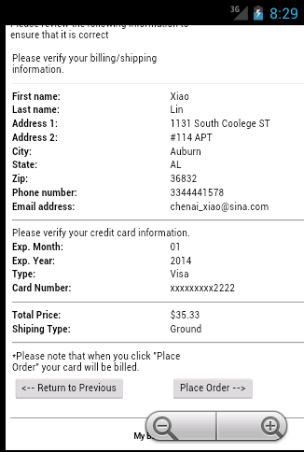

Figure 36: order confirm

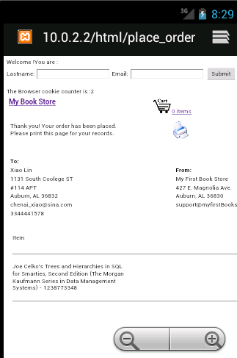

Figure 37: place the order

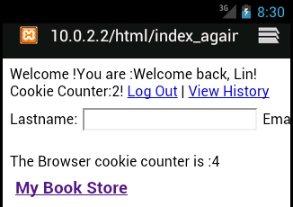

Figure 38: use the name and email to login

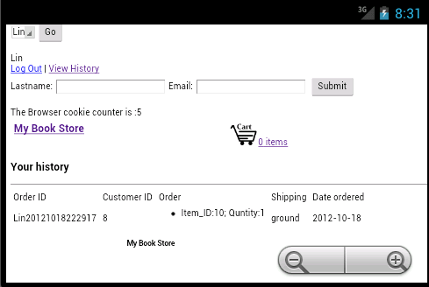

Figure 39: view history

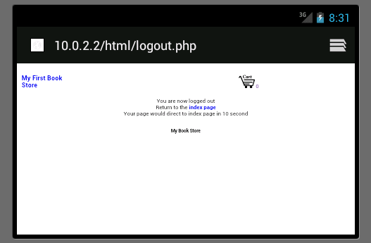

Figure 40: log out

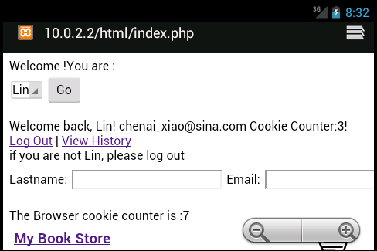

Figure 41: use the menu to login

**Results**

This project can be used to be a online store since it has many function for customer to search product, browse by different types and use shopping to add items. We use the tools in the former labs to create this ecommerce website and it is functional through times of testing.

**Conclusion**

Online shopping occupies a large portion of today’s business since it is convenient for people to purchase goods at home instead of going outside. So it is important to master the skill of using SQL databases, HTML, PHP, AJAX and so on.

**References**

sftp://scp.eng.auburn.edu /home/eewu/wuchwan/Teachings/5220-6220/Project

Ecommerce project description.pdf

sftp://scp.eng.auburn.edu /home /home/eewu/wuchwan/Teachings/5220-6220/Labs/Ecommerce examples/project1/PHP Example

<http://www.configure-all.com/page_view_counter.php>

[www.amazon.com](http://www.amazon.com) for product images and descriptions

w3schools.com for PHP and JS function reference

Also reference these files attached to this report:

browse.php

checkout.php

display_image.php

index.php

item.php

place_order.php

search.php

view_cart.php

add_to_cart.php

calculate_total.php

cart_size.php

checkout.js

clientSide.js

constants.php

creditCard.js

functions.php

mysql_connect.php

mysql_functions.php

remove_from_cart.php

update_view_cart.php

xml_functions.php