ELEC 5150/6150 Information Security

LAB 2 REPORT
Xiao Lin & Yuanqi Chen

Abstract
In this lab, we are going to do the cipher algorithm of AES, DES and different mode of the algorithm. We will encrypt plaintext with a bit different key in the same algorithm and compare the output result. Besides we will use the same key and same algorithm to encrypt two one character different plaintext and compare their output result. And following the sample solution we also try to implement the lab 2.

Introduction
In this lab, we will implement several block encryption algorithm such as DES, AES in java as well as in android. The algorithm we will involve in this lab include: DES, AES 3DES and different mode in AES. It contains CBC, CTR and GCM mode in AES. We will develop the implement in eclipse and also test it in eclipse. There are some pre-step likes installing the RSA should to do first before the lab. And in order to implement this lab in android it also needed to set the android development environment.

Here is the screen shot of RSA configuration result:
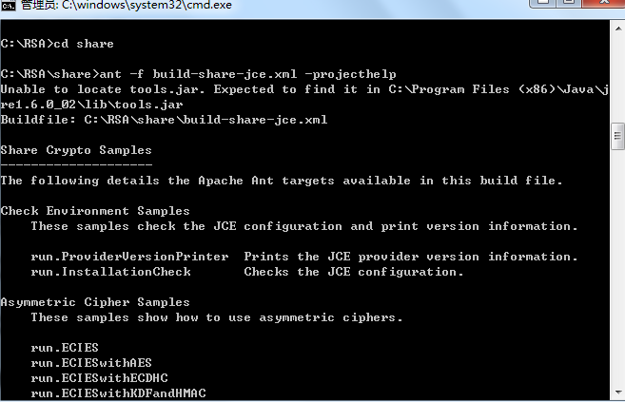

Design

Step 1
Encrypt file using DES(DES/CBC/PKCS5Padding)
- Key: 2011BCSC (save in DESKey.Hex)
- IV: Generate a random number and save it in a file (IV.Hex)
- Input file: plaintext.txt (provided in the folder)
- Output file: ciphertextDES.txt
- Submit the codes
- Show the screen capture in report

Here is the related code:
import java.io.*;
import java.security.*;
import javax.crypto.spec.*;

import javax.crypto.*;
import javax.crypto.spec.*;

public class DESEncryptFile{

private SecretKey Skey; /* key used by encrypt/decrypt routines */
private String cipherAlgorithm = "DES"; /* Algorithm used for encrypt/decrypt, for example DES or AES(Rijndael) */
private String clearText; /* name of file to store clear text output. encrypt routine takes this as input stream */
private String cipherText; /* name of file to store cipher text output. decrypt routine takes this as input stream */
private Cipher ecipher;
private Cipher dcipher;
byte[] buffer = new byte[1024];
/*
* public DESEncryptFile(String,String,String)
* @PARAMS:
* String initKey: key material used to create the Key
* String clearText: name of file to store clear text output.
* String cipherText: name of file to store cipher text output.
* @OUTPUT:
* Returns: nothing.
* Creates: EncryptFile object
*/

public DESEncryptFile(String initKey, String clearText, String cipherText) throws Exception{
//translate the key
this.Skey = toKey(initKey.getBytes());
this.clearText = clearText;
this.cipherText = cipherText;
// Create an 8-byte initialization vector
byte[] iv = createiv();
AlgorithmParameterSpec paramSpec = new IvParameterSpec(iv);
try {
ecipher = Cipher.getInstance("DES/CBC/PKCS5Padding");
dcipher = Cipher.getInstance("DES/CBC/PKCS5Padding");
// CBC requires an initialization vector
ecipher.init(Cipher.ENCRYPT_MODE, Skey, paramSpec);
dcipher.init(Cipher.DECRYPT_MODE, Skey, paramSpec);

} catch (java.security.InvalidAlgorithmParameterException e) {
} catch (javax.crypto.NoSuchPaddingException e) {
} catch (java.security.NoSuchAlgorithmException e) {
} catch (java.security.InvalidKeyException e) {
}
}
/*
* public DESEncryptFile(SecretKey,String,String)
* @PARAMS:
* SecretKey key: key object to store in class variable key
* String clearText: name of file to store clear text output.
* String cipherText: name of file to store cipher text output.
* @OUTPUT:
* Returns: nothing.
* Creates: EncryptFile object
*/

public DESEncryptFile(SecretKey key, String clearText, String cipherText) throws IOException{
this.Skey = key;
this.clearText = clearText;
this.cipherText = cipherText;
// Create an 8-byte initialization vector
byte[] iv = createiv();

AlgorithmParameterSpec paramSpec = new IvParameterSpec(iv);
try {
ecipher = Cipher.getInstance("DES/CBC/PKCS5Padding");
dcipher = Cipher.getInstance("DES/CBC/PKCS5Padding");
// CBC requires an initialization vector
ecipher.init(Cipher.ENCRYPT_MODE, Skey, paramSpec);
dcipher.init(Cipher.DECRYPT_MODE, Skey, paramSpec);
} catch (java.security.InvalidAlgorithmParameterException e) {
} catch (javax.crypto.NoSuchPaddingException e) {
} catch (java.security.NoSuchAlgorithmException e) {
} catch (java.security.InvalidKeyException e) {
}
}

/*
* public DESEncryptFile(String,String)
* @PARAMS:
* String clearText: name of file to store clear text output.
* String cipherText: name of file to store cipher text output.
* @OUTPUT:
* Returns: nothing.
* Creates: EncryptFile object with DES as default algorithm, creating a DES key
*/

public DESEncryptFile(String clearText, String cipherText){
Skey = efKeyGenerator(cipherAlgorithm);
this.clearText = clearText;
this.cipherText = cipherText;
// Create an 8-byte initialization vector
byte[] iv = new byte[]{
(byte)0x8E, 0x12, 0x39, (byte)0x9C,
0x07, 0x72, 0x6F, 0x5A
};
AlgorithmParameterSpec paramSpec = new IvParameterSpec(iv);
try {
ecipher = Cipher.getInstance("DES/CBC/PKCS5Padding");
dcipher = Cipher.getInstance("DES/CBC/PKCS5Padding");
// CBC requires an initialization vector
ecipher.init(Cipher.ENCRYPT_MODE, Skey, paramSpec);
dcipher.init(Cipher.DECRYPT_MODE, Skey, paramSpec);
} catch (java.security.InvalidAlgorithmParameterException e) {
} catch (javax.crypto.NoSuchPaddingException e) {
} catch (java.security.NoSuchAlgorithmException e) {
} catch (java.security.InvalidKeyException e) {
}
}

private byte[] createiv() throws IOException
{
SecureRandom random = null;
try{
random = SecureRandom.getInstance("SHA1PRNG");
}
catch(NoSuchAlgorithmException e){
System.out.println("NoSuchAlgorithmException:" + e);
System.exit(-1);
}
byte[] bIV = new byte[8];
random.nextBytes(bIV);
ToHEX(bIV,"IV.hex");
return bIV;

}
public static void ToHEX(byte[] text ,String fileName ) throws IOException
{
String hexString = "";
for(int i=0;i<text.length;i++)
{
String hex = Integer.toHexString(text[i]&0xFF);
if(hex.length() == 1)
{
hex = "0"+hex;
}
hexString = hexString + hex;
}
FileOutputStream fos = new FileOutputStream(fileName);
fos.write(hexString.getBytes());
fos.close();
}
private static SecretKey toKey(byte[] key) throws InvalidKeyException, NoSuchAlgorithmException, InvalidKeySpecException{
DESKeySpec dks = new DESKeySpec(key);
SecretKeyFactory keyFactory = SecretKeyFactory.getInstance("DES");
SecretKey secretKey = keyFactory.generateSecret(dks);
return secretKey;
}

/*
* public SecretKey efKeyGenerator(String)
* @PARAMS:
* String c: name of algorithm used to generate key.
* @OUTPUT:
* Returns: SecretKey key
* Creates: nothing.
*/

public SecretKey efKeyGenerator(String c){
try{
KeyGenerator keyGen = KeyGenerator.getInstance(c);
SecretKey key = keyGen.generateKey();
return key;
}catch(NoSuchAlgorithmException e){
}
return null;
}

public void encrypt(){
try{
InputStream fin = new FileInputStream(clearText);
OutputStream fout = new FileOutputStream(cipherText);
fout = new CipherOutputStream(fout,ecipher);
int numRead = 0;
while((numRead = fin.read(buffer)) >= 0){
fout.write(buffer,0,numRead);
}
fout.close();
}catch(IOException e){
}
}
public static byte[] getBytesFromFile(File file) throws IOException {
InputStream is = new FileInputStream(file);

// Get the size of the file
long length = file.length();

if (length > Integer.MAX_VALUE) {
// File is too large
}

public static void main(String[] args) throws IOException{
String InitialKey = "2011BCSC";
ToHEX(InitialKey.getBytes(),"DESKey.hex");
try{
DESEncryptFile des = new DESEncryptFile(InitialKey,"plaintext.txt","ciphertextDES.txt");
des.encrypt();

}catch(Exception e){
}
}

}

Here is the IV.hex
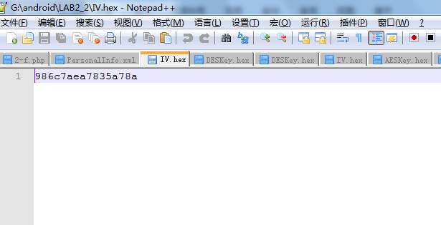

Here is the DESKey.hex
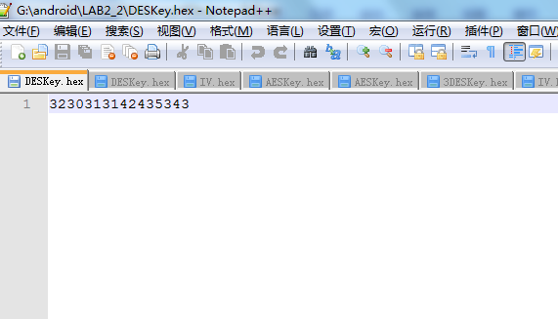

And here is the output cipher text:
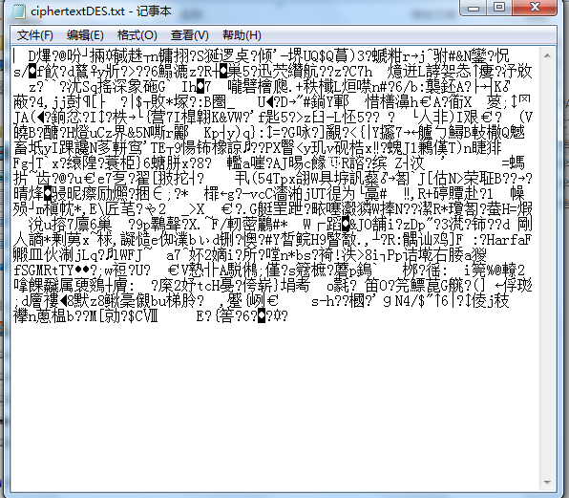

Step 2
Decrypt a file using DES:
- Key: 2011BCSC (save in DESKey.Hex)
- IV: Use the random number in the file (IV.Hex)
- Input file: ciphertextDES.txt
- Output file: plaintextD-DES.txt
- Submit the codes
- Show the screen capture in report

Here is the related code:
import java.io.*;
import java.security.*;
import java.security.spec.*;
import javax.crypto.*;
import javax.crypto.spec.*;

public class DESDecryptFile{

private SecretKey key; /* key used by encrypt/decrypt routines */
private String cipherAlgorithm = "DES"; /* Algorithm used for encrypt/decrypt, for example DES or AES(Rijndael) */
private String clearText; /* name of file to store clear text output. encrypt routine takes this as input stream */
private String cipherText; /* name of file to store cipher text output. decrypt routine takes this as input stream */
private Cipher ecipher;
private Cipher dcipher;
byte[] buffer = new byte[1024];

/*
* public DESDecryptFile(String,String,String)
* @PARAMS:
* String initKey: key material used to create the Key
* String clearText: name of file to store clear text output.
* String cipherText: name of file to store cipher text output.
* @OUTPUT:
* Returns: nothing.
* Creates: EncryptFile object
*/

public DESDecryptFile(String initKey, String clearText, String cipherText) throws Exception{
//translate the key
this.key = toKey(initKey.getBytes());
this.clearText = clearText;
this.cipherText = cipherText;
// Create an 8-byte initialization vector
byte[] iv = IVFromHex("IV.hex");
AlgorithmParameterSpec paramSpec = new IvParameterSpec(iv);
try {
ecipher = Cipher.getInstance("DES/CBC/PKCS5Padding");
dcipher = Cipher.getInstance("DES/CBC/PKCS5Padding");
// CBC requires an initialization vector
ecipher.init(Cipher.ENCRYPT_MODE, key, paramSpec);
dcipher.init(Cipher.DECRYPT_MODE, key, paramSpec);
} catch (java.security.InvalidAlgorithmParameterException e) {
} catch (javax.crypto.NoSuchPaddingException e) {
} catch (java.security.NoSuchAlgorithmException e) {
} catch (java.security.InvalidKeyException e) {
}
}

/*
* public DESDecryptFile(SecretKey,String,String)
* @PARAMS:
* SecretKey key: key object to store in class variable key
* String clearText: name of file to store clear text output.
* String cipherText: name of file to store cipher text output.
* @OUTPUT:
* Returns: nothing.
* Creates: EncryptFile object
*/

public DESDecryptFile(SecretKey key, String clearText, String cipherText){
this.key = key;
this.clearText = clearText;
this.cipherText = cipherText;
// Create an 8-byte initialization vector
byte[] iv = new byte[]{
(byte)0x8E, 0x12, 0x39, (byte)0x9C,
0x07, 0x72, 0x6F, 0x5A
};

AlgorithmParameterSpec paramSpec = new IvParameterSpec(iv);
try {
ecipher = Cipher.getInstance("DES/CBC/PKCS5Padding");
dcipher = Cipher.getInstance("DES/CBC/PKCS5Padding");
// CBC requires an initialization vector
ecipher.init(Cipher.ENCRYPT_MODE, key, paramSpec);
dcipher.init(Cipher.DECRYPT_MODE, key, paramSpec);
} catch (java.security.InvalidAlgorithmParameterException e) {
} catch (javax.crypto.NoSuchPaddingException e) {
} catch (java.security.NoSuchAlgorithmException e) {
} catch (java.security.InvalidKeyException e) {
}
}

/*
* public DESDecryptFile(String,String)
* @PARAMS:
* String clearText: name of file to store clear text output.
* String cipherText: name of file to store cipher text output.
* @OUTPUT:
* Returns: nothing.
* Creates: EncryptFile object with DES as default algorithm, creating a DES key
*/

public DESDecryptFile(String clearText, String cipherText){
key = efKeyGenerator(cipherAlgorithm);
this.clearText = clearText;
this.cipherText = cipherText;
// Create an 8-byte initialization vector
byte[] iv = new byte[]{
(byte)0x8E, 0x12, 0x39, (byte)0x9C,
0x07, 0x72, 0x6F, 0x5A
};
AlgorithmParameterSpec paramSpec = new IvParameterSpec(iv);
try {
ecipher = Cipher.getInstance("DES/CBC/PKCS5Padding");
dcipher = Cipher.getInstance("DES/CBC/PKCS5Padding");
// CBC requires an initialization vector
ecipher.init(Cipher.ENCRYPT_MODE, key, paramSpec);
dcipher.init(Cipher.DECRYPT_MODE, key, paramSpec);

} catch (java.security.InvalidAlgorithmParameterException e) {
} catch (javax.crypto.NoSuchPaddingException e) {
} catch (java.security.NoSuchAlgorithmException e) {
} catch (java.security.InvalidKeyException e) {
}
}

/*
* private SecretKey toKey(byte[])
* @PARAMS:
* byte[] key: translate initial key to secret key
* @OUTPUT:
* Returns: SecretKey key
* Creates: nothing.
*/

private static SecretKey toKey(byte[] key) throws Exception {
DESKeySpec dks = new DESKeySpec(key);
SecretKeyFactory keyFactory = SecretKeyFactory.getInstance("DES");
SecretKey secretKey = keyFactory.generateSecret(dks);
return secretKey;
}

/*
* public SecretKey efKeyGenerator(String)
* @PARAMS:
* String c: name of algorithm used to generate key.
* @OUTPUT:
* Returns: SecretKey key
* Creates: nothing.
*/
public SecretKey efKeyGenerator(String c){
try{
KeyGenerator keyGen = KeyGenerator.getInstance(c);
SecretKey key = keyGen.generateKey();
return key;
}catch(NoSuchAlgorithmException e){
}
return null;
}

/*
* public static void ToHEX(byte[], String)
* @PARAMS:
* byte[] text: the text need to be stored in Hex
* String String fileNam: name of the file
* @OUTPUT:
* Returns: noting
* Creates: hex file.
*/

public static void ToHEX(byte[] text, String fileName) throws IOException{

String hexString = "";
for(int i = 0; i < text.length; i++)
{
String hex = Integer.toHexString(text[i]&0xFF );
if (hex.length() == 1) {
hex = "0" + hex;
}
hexString = hexString + hex;
}
FileOutputStream fos = new FileOutputStream(fileName);
fos.write(hexString.getBytes());
fos.close();
}

/*
* public static void IVFromHex(String)
* @PARAMS:
* String String fileNam: name of the file
* @OUTPUT:
* Returns: IV in byte[]
* Creates: nothing.
*/

private static byte[] IVFromHex(String filename) throws IOException {
BufferedReader reader = new BufferedReader( new FileReader (filename));
String line = null;
StringBuilder stringBuilder = new StringBuilder();
// String ls = System.getProperty("line.separator");

while( ( line = reader.readLine() ) != null ) {
stringBuilder.append( line );
// stringBuilder.append( ls );
}
String sIV = stringBuilder.toString();
int len = sIV.length();
byte[] bIV = new byte[len / 2];
for (int i = 0; i < len; i += 2) {
bIV[i / 2] = (byte) ((Character.digit(sIV.charAt(i), 16) << 4)
+ Character.digit(sIV.charAt(i+1), 16));
}
return bIV;
}

/*
* private static byte[] createIV()
* @PARAMS:
* Null
* @OUTPUT:
* Returns: byte[] IV
* Creates: IV。hex file.
*/

private static byte[] createIV() throws IOException
{
SecureRandom random = null;
try
{
random = SecureRandom.getInstance("SHA1PRNG");
}
catch (NoSuchAlgorithmException e)
{
System.out.println("NoSuchAlgorithmException: " + e);
System.exit(-1);
}
byte[] bIV = new byte[8];
random.nextBytes(bIV);
ToHEX(bIV,"IV.hex");

return bIV;
}

public void encrypt(){
try{
InputStream fin = new FileInputStream(clearText);
OutputStream fout = new FileOutputStream(cipherText);
fout = new CipherOutputStream(fout,ecipher);
int numRead = 0;
while((numRead = fin.read(buffer)) >= 0){
fout.write(buffer,0,numRead);
}
fout.close();
}catch(IOException e){
}
}

public void decrypt(){
try{
InputStream fin = new FileInputStream(cipherText);
OutputStream fout = new FileOutputStream("plaintextD-DES.txt");
fin = new CipherInputStream(fin,dcipher);
int numRead = 0;
while((numRead = fin.read(buffer)) >= 0){
fout.write(buffer,0,numRead);
}
fout.close();
}catch(IOException e){
}
}

public static void main(String[] args) throws Exception{
//Key used for DES decryption
String InitialKey = "2011BCSC";
//Export to "DESKey.hex"
ToHEX(InitialKey.getBytes(),"DESKey.hex");

DESDecryptFile DES = new DESDecryptFile(InitialKey,"plaintext.txt","ciphertextDES.txt");
DES.decrypt();
}

}

Here is the DESKey.hex
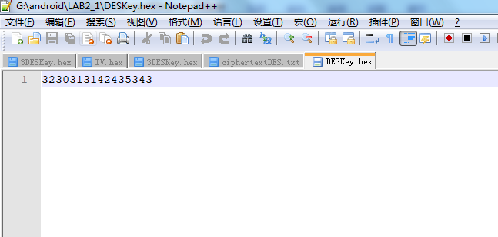

Here is the IV.hex
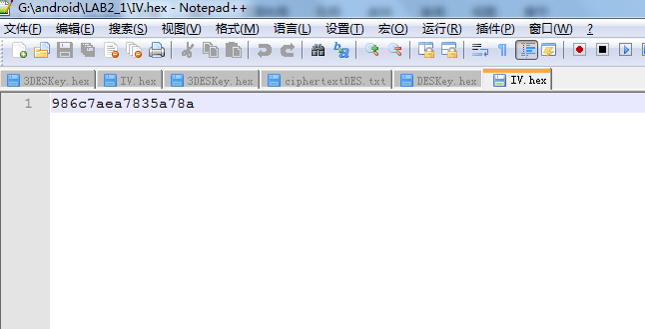
Here is the output result of decipher file:
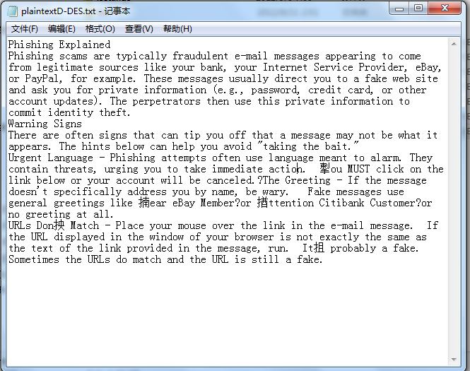

Step 3

Encrypt a file using DES (DES/CBC/PKCS5Padding):
- Key: 2011BCSD (save in DESKey.Hex)
- IV: Use the random number in the file (IV.Hex)
- Input file: plaintext.txt (provided in the folder) with the modification of the first character from P to Q
- Output file: ciphertextDES.txt
- Compare the output with Step 1
- Submit the codes
- Show the screen capture in report

Here is the related code:

/*
* DESEncryptFile.java
* Lincoln Anderson
* ELEC 5150
* Spring 08
* Lab 2 Part 1
*
*/

import java.io.*;
import java.security.*;
import java.security.spec.*;
import javax.crypto.*;
import javax.crypto.spec.*;

public class DESEncryptFile{

private SecretKey Skey; /* key used by encrypt/decrypt routines */
private String cipherAlgorithm = "DES"; /* Algorithm used for encrypt/decrypt, for example DES or AES(Rijndael) */
private String clearText; /* name of file to store clear text output. encrypt routine takes this as input stream */
private String cipherText; /* name of file to store cipher text output. decrypt routine takes this as input stream */
private Cipher ecipher;
private Cipher dcipher;
byte[] buffer = new byte[1024];
/*
* public DESEncryptFile(String,String,String)
* @PARAMS:
* String initKey: key material used to create the Key
* String clearText: name of file to store clear text output.
* String cipherText: name of file to store cipher text output.
* @OUTPUT:
* Returns: nothing.
* Creates: EncryptFile object
*/

public DESEncryptFile(String initKey, String clearText, String cipherText) throws Exception{
//translate the key
this.Skey = toKey(initKey.getBytes());
this.clearText = clearText;
this.cipherText = cipherText;
// Create an 8-byte initialization vector
byte[] iv = IVFromHex("IV.hex");
AlgorithmParameterSpec paramSpec = new IvParameterSpec(iv);
try {
ecipher = Cipher.getInstance("DES/CBC/PKCS5Padding");
dcipher = Cipher.getInstance("DES/CBC/PKCS5Padding");
// CBC requires an initialization vector
ecipher.init(Cipher.ENCRYPT_MODE, Skey, paramSpec);
dcipher.init(Cipher.DECRYPT_MODE, Skey, paramSpec);
} catch (java.security.InvalidAlgorithmParameterException e) {
} catch (javax.crypto.NoSuchPaddingException e) {
} catch (java.security.NoSuchAlgorithmException e) {
} catch (java.security.InvalidKeyException e) {
}
}
/*
* public DESEncryptFile(SecretKey,String,String)
* @PARAMS:
* SecretKey key: key object to store in class variable key
* String clearText: name of file to store clear text output.
* String cipherText: name of file to store cipher text output.
* @OUTPUT:
* Returns: nothing.
* Creates: EncryptFile object
*/

public DESEncryptFile(SecretKey key, String clearText, String cipherText) throws IOException{
this.Skey = key;
this.clearText = clearText;
this.cipherText = cipherText;
// Create an 8-byte initialization vector
byte[] iv = createiv();
AlgorithmParameterSpec paramSpec = new IvParameterSpec(iv);

try {
ecipher = Cipher.getInstance("DES/CBC/PKCS5Padding");
dcipher = Cipher.getInstance("DES/CBC/PKCS5Padding");
// CBC requires an initialization vector
ecipher.init(Cipher.ENCRYPT_MODE, Skey, paramSpec);
dcipher.init(Cipher.DECRYPT_MODE, Skey, paramSpec);
} catch (java.security.InvalidAlgorithmParameterException e) {
} catch (javax.crypto.NoSuchPaddingException e) {
} catch (java.security.NoSuchAlgorithmException e) {
} catch (java.security.InvalidKeyException e) {
}
}

/*
* public DESEncryptFile(String,String)
* @PARAMS:
* String clearText: name of file to store clear text output.
* String cipherText: name of file to store cipher text output.
* @OUTPUT:
* Returns: nothing.
* Creates: EncryptFile object with DES as default algorithm, creating a DES key
*/

public DESEncryptFile(String clearText, String cipherText){
Skey = efKeyGenerator(cipherAlgorithm);
this.clearText = clearText;
this.cipherText = cipherText;
// Create an 8-byte initialization vector
byte[] iv = new byte[]{
(byte)0x8E, 0x12, 0x39, (byte)0x9C,
0x07, 0x72, 0x6F, 0x5A
};
AlgorithmParameterSpec paramSpec = new IvParameterSpec(iv);
try {
ecipher = Cipher.getInstance("DES/CBC/PKCS5Padding");
dcipher = Cipher.getInstance("DES/CBC/PKCS5Padding");
// CBC requires an initialization vector
ecipher.init(Cipher.ENCRYPT_MODE, Skey, paramSpec);
dcipher.init(Cipher.DECRYPT_MODE, Skey, paramSpec);
} catch (java.security.InvalidAlgorithmParameterException e) {
} catch (javax.crypto.NoSuchPaddingException e) {
} catch (java.security.NoSuchAlgorithmException e) {
} catch (java.security.InvalidKeyException e) {
}
}

private byte[] createiv() throws IOException
{
SecureRandom random = null;
try{
random = SecureRandom.getInstance("SHA1PRNG");
}
catch(NoSuchAlgorithmException e){
System.out.println("NoSuchAlgorithmException:" + e);
System.exit(-1);
}
byte[] bIV = new byte[8];
random.nextBytes(bIV);
ToHEX(bIV,"IV.hex");
return bIV;

}
public static void ToHEX(byte[] text ,String fileName ) throws IOException
{
String hexString = "";
for(int i=0;i<text.length;i++)
{
String hex = Integer.toHexString(text[i]&0xFF);
if(hex.length() == 1)
{
hex = "0"+hex;
}
hexString = hexString + hex;
}
FileOutputStream fos = new FileOutputStream(fileName);
fos.write(hexString.getBytes());
fos.close();
}
/*
* public static void IVFromHex(String)
* @PARAMS:
* String String fileNam: name of the file
* @OUTPUT:
* Returns: IV in byte[]
* Creates: nothing.
*/

private static byte[] IVFromHex(String filename) throws IOException {
BufferedReader reader = new BufferedReader( new FileReader (filename));
String line = null;
StringBuilder stringBuilder = new StringBuilder();
// String ls = System.getProperty("line.separator");
while( ( line = reader.readLine() ) != null ) {
stringBuilder.append( line );
// stringBuilder.append( ls );
}
String sIV = stringBuilder.toString();
int len = sIV.length();
byte[] bIV = new byte[len / 2];
for (int i = 0; i < len; i += 2) {
bIV[i / 2] = (byte) ((Character.digit(sIV.charAt(i), 16) << 4)
+ Character.digit(sIV.charAt(i+1), 16));
}
return bIV;
}
private static SecretKey toKey(byte[] key) throws InvalidKeyException, NoSuchAlgorithmException, InvalidKeySpecException{
DESKeySpec dks = new DESKeySpec(key);
SecretKeyFactory keyFactory = SecretKeyFactory.getInstance("DES");
SecretKey secretKey = keyFactory.generateSecret(dks);
return secretKey;
}

/*
* public SecretKey efKeyGenerator(String)
* @PARAMS:
* String c: name of algorithm used to generate key.
* @OUTPUT:
* Returns: SecretKey key
* Creates: nothing.
*/
public SecretKey efKeyGenerator(String c){
try{
KeyGenerator keyGen = KeyGenerator.getInstance(c);
SecretKey key = keyGen.generateKey();
return key;

}catch(NoSuchAlgorithmException e){
}
return null;
}

public void encrypt(){
try{
InputStream fin = new FileInputStream(clearText);
OutputStream fout = new FileOutputStream(cipherText);
fout = new CipherOutputStream(fout,ecipher);
int numRead = 0;
while((numRead = fin.read(buffer)) >= 0){
fout.write(buffer,0,numRead);
}
fout.close();
}catch(IOException e){
}
}

public static void main(String[] args) throws IOException{
String InitialKey = "2011BCSD";
ToHEX(InitialKey.getBytes(),"DESKey.hex");
try{
DESEncryptFile des = new DESEncryptFile(InitialKey,"plaintext.txt","ciphertextDES.txt");
des.encrypt();

}catch(Exception e){
}
}

}

Here is the DESKey.hex

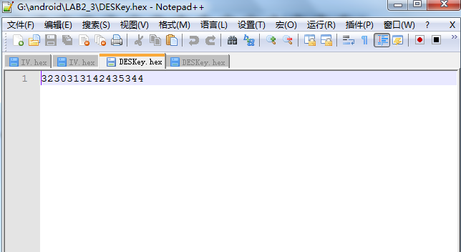
Here is the IV.hex
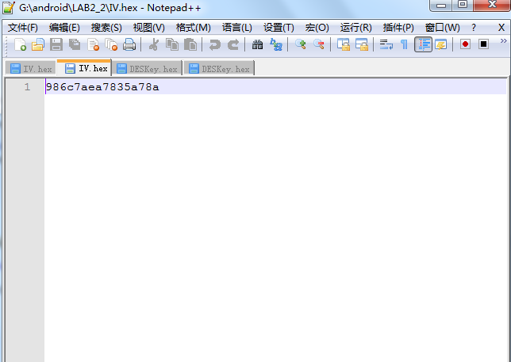
And here is the result cipher file:
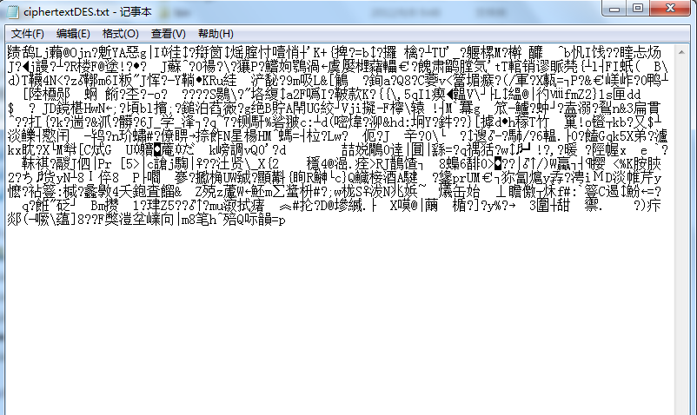

Step 4
Encrypt a file using AES-128(AES/CTR/PKCS5Padding)
- Key: 2011BCSChampionA (save in AESKey.Hex)
- IV: Generate a random number and save it in a file (IV.Hex)
- Input file: plaintext.txt (provided in the folder)
- Output file: ciphertextAES.txt
- Submit the codes
- Show the screen capture in report

here is the related code:
import java.io.*;
import java.security.*;
import java.security.spec.*;
import javax.crypto.*;
import javax.crypto.spec.*;

public class AES128EncryptFile{

private SecretKey key; /* key used by encrypt/decrypt routines */
private String cipherAlgorithm = "AES"; /* Algorithm used for encrypt/decrypt, for example AES or AES(Rijndael) */
private String clearText; /* name of file to store clear text output. encrypt routine takes this as input stream */
private String cipherText; /* name of file to store cipher text output. decrypt routine takes this as input stream */
private Cipher ecipher;
private Cipher dcipher;
byte[] buffer = new byte[1024];
* public AES128EncryptFile(String,String,String)
* @PARAMS:
* String initKey: key string to generate key
* String clearText: name of file to store clear text output.
* String cipherText: name of file to store cipher text output.
* @OUTPUT:
* Returns: nothing.
* Creates: AES128EncryptFile object
public AES128EncryptFile(String initKey, String clearText, String cipherText) throws Exception{
//translate the key
this.key = new SecretKeySpec(initKey.getBytes(), "AES");
this.clearText = clearText;
this.cipherText = cipherText;
// Create an 16-byte initialization vector
byte[] iv = createIV();
AlgorithmParameterSpec paramSpec = new IvParameterSpec(iv);
try {
ecipher = Cipher.getInstance("AES/CTR/PKCS5Padding");
dcipher = Cipher.getInstance("AES/CTR/PKCS5Padding");
// CTR requires an initialization vector
ecipher.init(Cipher.ENCRYPT_MODE, key, paramSpec);
dcipher.init(Cipher.DECRYPT_MODE, key, paramSpec);
} catch (java.security.InvalidAlgorithmParameterException e) {
} catch (javax.crypto.NoSuchPaddingException e) {
} catch (java.security.NoSuchAlgorithmException e) {
} catch (java.security.InvalidKeyException e) {
}
}

/*
* public AES128EncryptFile(SecretKey,String,String)
* @PARAMS:
* SecretKey key: key object to store in class variable key
* String clearText: name of file to store clear text output.
* String cipherText: name of file to store cipher text output.
* @OUTPUT:
* Returns: nothing.
* Creates: AES128EncryptFile object
*/

public AES128EncryptFile(SecretKey key, String clearText, String cipherText){
this.key = key;
this.clearText = clearText;
this.cipherText = cipherText;
try {
ecipher = Cipher.getInstance("AES");
dcipher = Cipher.getInstance("AES");
ecipher.init(Cipher.ENCRYPT_MODE, key);
dcipher.init(Cipher.DECRYPT_MODE, key);
} catch (java.security.InvalidKeyException e) {
} catch (javax.crypto.NoSuchPaddingException e) {
} catch (java.security.NoSuchAlgorithmException e) {
}
}

/*
* public AES128EncryptFile(String,String)
* @PARAMS:
* String clearText: name of file to store clear text output.
* String cipherText: name of file to store cipher text output.
* @OUTPUT:
* Returns: nothing.
* Creates: AES128EncryptFile object with AES as default algorithm, creating a AES key
*/

public AES128EncryptFile(String clearText, String cipherText){
key = efKeyGenerator(cipherAlgorithm);
this.clearText = clearText;
this.cipherText = cipherText;
try {

ecipher = Cipher.getInstance("AES");
dcipher = Cipher.getInstance("AES");
// CTR requires an initialization vector
ecipher.init(Cipher.ENCRYPT_MODE, key);
dcipher.init(Cipher.DECRYPT_MODE, key);
} catch (java.security.InvalidKeyException e) {
} catch (javax.crypto.NoSuchPaddingException e) {
} catch (java.security.NoSuchAlgorithmException e) {
}
}

/*
* public SecretKey efKeyGenerator(String)
* @PARAMS:
* String c: name of algorithm used to generate key.
* @OUTPUT:
* Returns: SecretKey key
* Creates: nothing.
*/

public SecretKey efKeyGenerator(String c){
try{
KeyGenerator keyGen = KeyGenerator.getInstance(c);
keyGen.init(128);
SecretKey key = keyGen.generateKey();
return key;
}catch(NoSuchAlgorithmException e){
}
return null;
}

/*
* public static void ToHEX(byte[], String)
* @PARAMS:
* byte[] text: the text need to be stored in Hex
* String String fileNam: name of the file
* @OUTPUT:
* Returns: noting
* Creates: hex file.
*/

public static void ToHEX(byte[] text, String fileName) throws IOException{

String hexString = "";
for(int i = 0; i < text.length; i++)
{
String hex = Integer.toHexString(text[i]&0xFF );
if (hex.length() == 1) {
hex = "0" + hex;
}
hexString = hexString + hex;
}
FileOutputStream fos = new FileOutputStream(fileName);
fos.write(hexString.getBytes());
fos.close();
}

/*
* private static byte[] createIV()
* @PARAMS:
* Null
* @OUTPUT:
* Returns: byte[] IV
* Creates: IV。hex file.
*/

private static byte[] createIV() throws IOException
{
SecureRandom random = null;
try
{
random = SecureRandom.getInstance("SHA1PRNG");
}
catch (NoSuchAlgorithmException e)
{
System.out.println("NoSuchAlgorithmException: " + e);
System.exit(-1);
}
byte[] bIV = new byte[16];
random.nextBytes(bIV);
ToHEX(bIV,"IV.hex");

return bIV;
}

public void encrypt(){
try{
InputStream fin = new FileInputStream(clearText);
OutputStream fout = new FileOutputStream(cipherText);
fout = new CipherOutputStream(fout,ecipher);
int numRead = 0;
while((numRead = fin.read(buffer)) >= 0){
fout.write(buffer,0,numRead);
}
fout.close();
}catch(IOException e){
}
}

public static void main(String[] args) throws IOException{
//Key used for AES128 encryption
String InitialKey = "2011BCSChampionA";
//Export to "AES128Key.hex"
ToHEX(InitialKey.getBytes(),"AESKey.hex");
try{
AES128EncryptFile aes128 = new AES128EncryptFile(InitialKey,"plaintext.txt","ciphertextAES.txt");
aes128.encrypt();
}catch(Exception e){
}
}
}

Here is the AESKey.hex

Here is the AESKey.hex 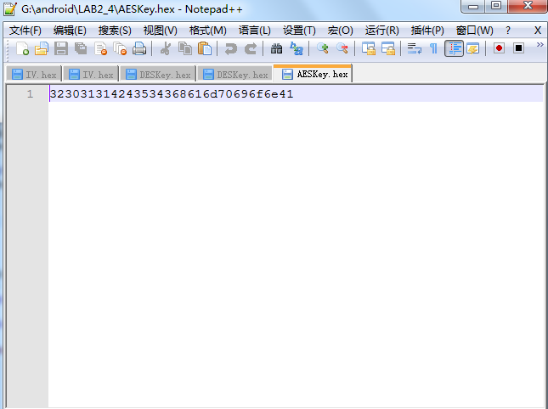
Here is the IV.hex
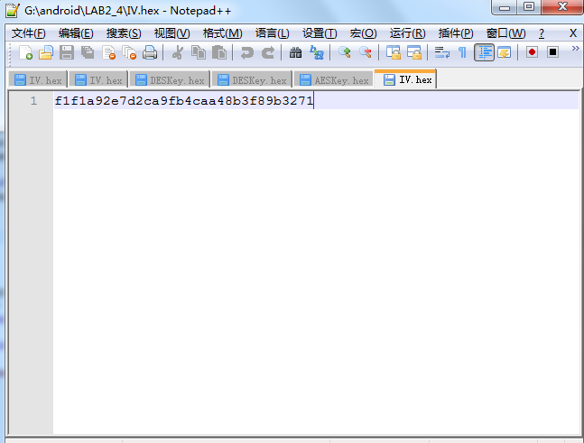
And here is the result encrypted file:
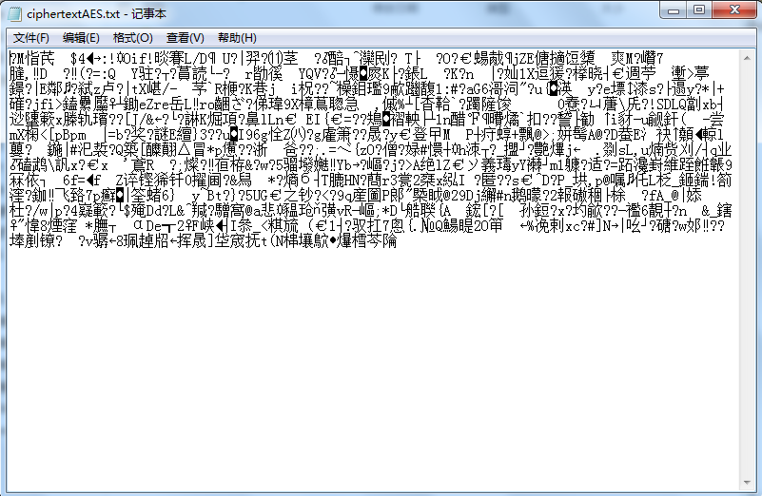

Step 5
Decrypt a file using AES-128:
- Key: 2011BCSChampionA (save in AESKey.Hex)
- IV: Use the random number in the file (IV.Hex)
- Input file: ciphertextAES.txt
- Output file: plaintextD-AES.txt
- Compare the output with Step 4
- Submit the codes
- Show the screen capture in report

Here is the related code:

import java.io.*;
import java.security.*;
import java.security.spec.*;
import javax.crypto.*;
import javax.crypto.spec.*;

public class AES128DecryptFile{

private SecretKey key; /* key used by encrypt/decrypt routines */
private String cipherAlgorithm = "AES"; /* Algorithm used for encrypt/decrypt, for example AES or AES(Rijndael) */
private String clearText; /* name of file to store clear text output. encrypt routine takes this as input stream */
private String cipherText; /* name of file to store cipher text output. decrypt routine takes this as input stream */
private Cipher ecipher;
private Cipher dcipher;
byte[] buffer = new byte[1024];

/*
* public AES128DecryptFile(String,String,String)
* @PARAMS:
* String initKey: key string to generate key
* String clearText: name of file to store clear text output.
* String cipherText: name of file to store cipher text output.
* @OUTPUT:
* Returns: nothing.
* Creates: AES128DecryptFile object
*/

public AES128DecryptFile(String initKey, String clearText, String cipherText) throws Exception{
//translate the key
this.key = new SecretKeySpec(initKey.getBytes(), "AES");
this.clearText = clearText;
this.cipherText = cipherText;
// Create an 8-byte initialization vector
byte[] iv = IVFromHex("IV.hex");
AlgorithmParameterSpec paramSpec = new IvParameterSpec(iv);
try {

ecipher = Cipher.getInstance("AES/CTR/PKCS5Padding");
dcipher = Cipher.getInstance("AES/CTR/PKCS5Padding");
// CTR requires an initialization vector
ecipher.init(Cipher.ENCRYPT_MODE, key, paramSpec);
dcipher.init(Cipher.DECRYPT_MODE, key, paramSpec);
} catch (java.security.InvalidAlgorithmParameterException e) {
} catch (javax.crypto.NoSuchPaddingException e) {
} catch (java.security.NoSuchAlgorithmException e) {
} catch (java.security.InvalidKeyException e) {
}
}

/*
* public AES128DecryptFile(SecretKey,String,String)
* @PARAMS:
* SecretKey key: key object to store in class variable key
* String clearText: name of file to store clear text output.
* String cipherText: name of file to store cipher text output.
* @OUTPUT:
* Returns: nothing.
* Creates: AES128DecryptFile object
*/

public AES128DecryptFile(SecretKey key, String clearText, String cipherText){
this.key = key;
this.clearText = clearText;
this.cipherText = cipherText;
try {
ecipher = Cipher.getInstance("AES");
dcipher = Cipher.getInstance("AES");
ecipher.init(Cipher.ENCRYPT_MODE, key);
dcipher.init(Cipher.DECRYPT_MODE, key);
} catch (java.security.InvalidKeyException e) {
} catch (javax.crypto.NoSuchPaddingException e) {
} catch (java.security.NoSuchAlgorithmException e) {
}
}

/*
* public AES128DecryptFile(String,String)
* @PARAMS:
* String clearText: name of file to store clear text output.
* String cipherText: name of file to store cipher text output.
* @OUTPUT:
* Returns: nothing.
* Creates: AES128DecryptFile object with AES as default algorithm, creating a AES key
*/

* String cipherText: name of file to store cipher text output.
* @OUTPUT:
* Returns: nothing.
* Creates: AES128DecryptFile object with AES as default algorithm, creating a AES key
*/

public AES128DecryptFile(String clearText, String cipherText){
key = efKeyGenerator(cipherAlgorithm);
this.clearText = clearText;
this.cipherText = cipherText;
try {
ecipher = Cipher.getInstance("AES");
dcipher = Cipher.getInstance("AES");
// CTR requires an initialization vector
ecipher.init(Cipher.ENCRYPT_MODE, key);
dcipher.init(Cipher.DECRYPT_MODE, key);
} catch (java.security.InvalidKeyException e) {
} catch (javax.crypto.NoSuchPaddingException e) {
} catch (java.security.NoSuchAlgorithmException e) {
}
}

/*
* public SecretKey efKeyGenerator(String)
* @PARAMS:
* String c: name of algorithm used to generate key.
* @OUTPUT:
* Returns: SecretKey key
* Creates: nothing.
*/

public SecretKey efKeyGenerator(String c){
try{
KeyGenerator keyGen = KeyGenerator.getInstance(c);
keyGen.init(128);
SecretKey key = keyGen.generateKey();
return key;
}catch(NoSuchAlgorithmException e){
}
return null;
}

/*
* public static void ToHEX(byte[], String)
* @PARAMS:
* byte[] text: the text need to be stored in Hex
* String String fileNam: name of the file
* @OUTPUT:
* Returns: noting
* Creates: hex file.
*/

public static void ToHEX(byte[] text, String fileName) throws IOException{

String hexString = "";
for(int i = 0; i < text.length; i++)
{
String hex = Integer.toHexString(text[i]&0xFF );
if (hex.length() == 1) {
hex = "0" + hex;
}
hexString = hexString + hex;
}
FileOutputStream fos = new FileOutputStream(fileName);
fos.write(hexString.getBytes());
fos.close();
}

/*
* private static byte[] createIV()
* @PARAMS:
* Null
* @OUTPUT:
* Returns: byte[] IV
* Creates: IV.hex file.
*/

private static byte[] createIV() throws IOException
{
SecureRandom random = null;
try
{
random = SecureRandom.getInstance("SHA1PRNG");
}

catch (NoSuchAlgorithmException e)
{
System.out.println("NoSuchAlgorithmException: " + e);
System.exit(-1);
}
byte[] bIV = new byte[16];
random.nextBytes(bIV);
ToHEX(bIV,"IV.hex");

return bIV;
}

/*
* public static void ToHEX(byte[], String)
* @PARAMS:
* String String fileNam: name of the file
* @OUTPUT:
* Returns: IV in byte[]
* Creates: nothing.
*/

private static byte[] IVFromHex(String filename) throws IOException {
BufferedReader reader = new BufferedReader( new FileReader (filename));
String line = null;
StringBuilder stringBuilder = new StringBuilder();
// String ls = System.getProperty("line.separator");
while( ( line = reader.readLine() ) != null ) {
stringBuilder.append( line );
// stringBuilder.append( ls );
}
String sIV = stringBuilder.toString();
int len = sIV.length();
byte[] bIV = new byte[len / 2];
for (int i = 0; i < len; i += 2) {
bIV[i / 2] = (byte) ((Character.digit(sIV.charAt(i), 16) << 4)
+ Character.digit(sIV.charAt(i+1), 16));
}
return bIV;
}

public void encrypt(){
try{
InputStream fin = new FileInputStream(clearText);
OutputStream fout = new FileOutputStream(cipherText);
fout = new CipherOutputStream(fout,ecipher);
int numRead = 0;
while((numRead = fin.read(buffer)) >= 0){
fout.write(buffer,0,numRead);
}
fout.close();
}catch(IOException e){
}
}

public void decrypt(){
try{
InputStream fin = new FileInputStream(cipherText);
OutputStream fout = new FileOutputStream("plaintextD-AES.txt");
fin = new CipherInputStream(fin,dcipher);
int numRead = 0;
while((numRead = fin.read(buffer)) >= 0){
fout.write(buffer,0,numRead);
}
fout.close();
}catch(IOException e){
}
}

public static void main(String[] args) throws Exception{
//Key used for AES128 encryption
String InitialKey = "2011BCSChampionA";
//Export to "AES128Key.hex"
ToHEX(InitialKey.getBytes(),"AESKey.hex");

AES128DecryptFile AES128 = new AES128DecryptFile(InitialKey,"plaintext.txt","ciphertextAES.txt");
AES128.decrypt();
}

}

Here is the AESKey.hex
Here is the AESKey.hex 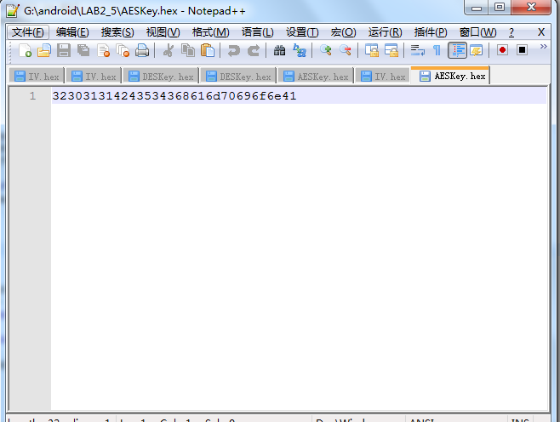
Here is the IV.hex
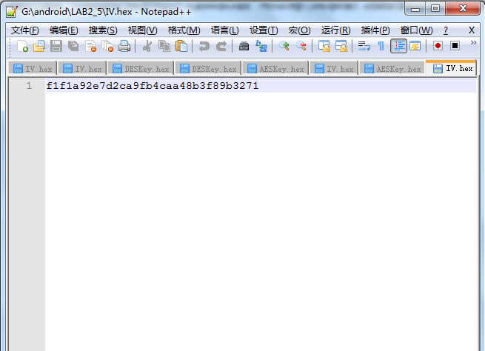
Here is the result decrypted file:
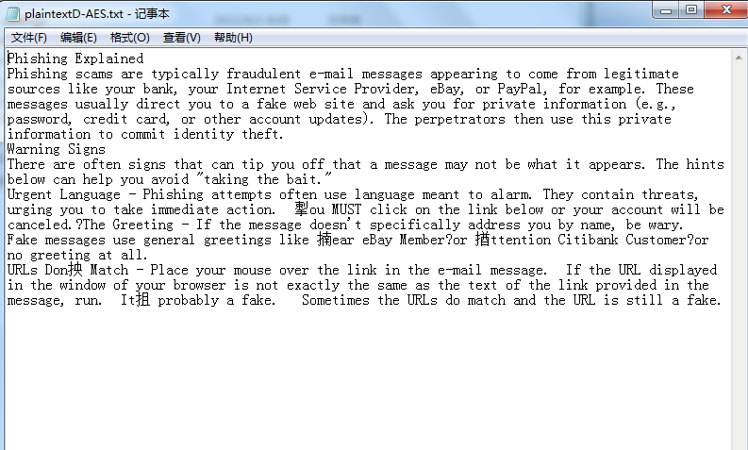

Step 6
Encrypt a file using AES-128(AES/CTR/PKCS5Padding)
- Key: 2011BCSChampionA (save in AESKey.Hex)
- IV: Use the random number in the file (IV.Hex)
- Input file: plaintext.txt (provided in the folder) with the modification of the first character from P to Q
- Output file: ciphertextAES.txt
- Submit the codes
- Show the screen capture in report

Here is the related code
import java.io.*;
import java.security.*;
import java.security.spec.*;
import javax.crypto.*;
import javax.crypto.spec.*;

public class AES128EncryptFile{

private SecretKey key; /* key used by encrypt/decrypt routines */
private String cipherAlgorithm = "AES"; /* Algorithm used for encrypt/decrypt, for example AES or AES(Rijndael) */
private String clearText; /* name of file to store clear text output. encrypt routine takes this as input stream */
private String cipherText; /* name of file to store cipher text output. decrypt routine takes this as input stream */
private Cipher ecipher;
private Cipher dcipher;
byte[] buffer = new byte[1024];

/*
* public AES128EncryptFile(String,String,String)
* @PARAMS:
* String initKey: key string to generate key
* String clearText: name of file to store clear text output.
* String cipherText: name of file to store cipher text output.
* @OUTPUT:
* Returns: nothing.
* Creates: AES128EncryptFile object
*/

public AES128EncryptFile(String initKey, String clearText, String cipherText) throws Exception{
//translate the key
this.key = new SecretKeySpec(initKey.getBytes(), "AES");
this.clearText = clearText;
this.cipherText = cipherText;
// Create an 16-byte initialization vector
byte[] iv = IVFromHex("IV.hex");
AlgorithmParameterSpec paramSpec = new IvParameterSpec(iv);
try {
ecipher = Cipher.getInstance("AES/CTR/PKCS5Padding");
dcipher = Cipher.getInstance("AES/CTR/PKCS5Padding");
// CTR requires an initialization vector
ecipher.init(Cipher.ENCRYPT_MODE, key, paramSpec);
dcipher.init(Cipher.DECRYPT_MODE, key, paramSpec);
} catch (java.security.InvalidAlgorithmParameterException e) {

} catch (javax.crypto.NoSuchPaddingException e) {
} catch (java.security.NoSuchAlgorithmException e) {
} catch (java.security.InvalidKeyException e) {
}
}

/*
* public AES128EncryptFile(SecretKey,String,String)
* @PARAMS:
* SecretKey key: key object to store in class variable key
* String clearText: name of file to store clear text output.
* String cipherText: name of file to store cipher text output.
* @OUTPUT:
* Returns: nothing.
* Creates: AES128EncryptFile object
*/

public AES128EncryptFile(SecretKey key, String clearText, String cipherText){
this.key = key;
this.clearText = clearText;
this.cipherText = cipherText;
try {
ecipher = Cipher.getInstance("AES");
dcipher = Cipher.getInstance("AES");
ecipher.init(Cipher.ENCRYPT_MODE, key);
dcipher.init(Cipher.DECRYPT_MODE, key);
} catch (java.security.InvalidKeyException e) {
} catch (javax.crypto.NoSuchPaddingException e) {
} catch (java.security.NoSuchAlgorithmException e) {
}
}

/*
* public AES128EncryptFile(String,String)
* @PARAMS:
* String clearText: name of file to store clear text output.
* String cipherText: name of file to store cipher text output.
* @OUTPUT:
* Returns: nothing.
* Creates: AES128EncryptFile object with AES as default algorithm, creating a AES key
*/

public AES128EncryptFile(String clearText, String cipherText){
key = efKeyGenerator(cipherAlgorithm);
this.clearText = clearText;
this.cipherText = cipherText;
try {
ecipher = Cipher.getInstance("AES");
dcipher = Cipher.getInstance("AES");
// CTR requires an initialization vector
ecipher.init(Cipher.ENCRYPT_MODE, key);
dcipher.init(Cipher.DECRYPT_MODE, key);
} catch (java.security.InvalidKeyException e) {
} catch (javax.crypto.NoSuchPaddingException e) {
} catch (java.security.NoSuchAlgorithmException e) {
}
}

/*
* public SecretKey efKeyGenerator(String)
* @PARAMS:
* String c: name of algorithm used to generate key.
* @OUTPUT:
* Returns: SecretKey key
* Creates: nothing.
*/

public SecretKey efKeyGenerator(String c){
try{
KeyGenerator keyGen = KeyGenerator.getInstance(c);
keyGen.init(128);
SecretKey key = keyGen.generateKey();
return key;
}catch(NoSuchAlgorithmException e){
}
return null;
}

/*
* public static void ToHEX(byte[], String)
* @PARAMS:
* byte[] text: the text need to be stored in Hex
* String String fileNam: name of the file
* @OUTPUT:
* Returns: noting
* Creates: hex file.
*/

public static void ToHEX(byte[] text, String fileName) throws IOException{

String hexString = "";
for(int i = 0; i < text.length; i++)
{
String hex = Integer.toHexString(text[i]&0xFF );
if (hex.length() == 1) {
hex = "0" + hex;
}
hexString = hexString + hex;
}
FileOutputStream fos = new FileOutputStream(fileName);
fos.write(hexString.getBytes());
fos.close();
}

/*
* public static void ToHEX(byte[], String)
* @PARAMS:
* String String fileNam: name of the file
* @OUTPUT:
* Returns: IV in byte[]
* Creates: nothing.
*/

private static byte[] IVFromHex(String filename) throws IOException {
BufferedReader reader = new BufferedReader( new FileReader (filename));
String line = null;
StringBuilder stringBuilder = new StringBuilder();

while( ( line = reader.readLine() ) != null ) {
stringBuilder.append( line );
}
String sIV = stringBuilder.toString();
int len = sIV.length();
byte[] bIV = new byte[len / 2];
for (int i = 0; i < len; i += 2) {
bIV[i / 2] = (byte) ((Character.digit(sIV.charAt(i), 16) << 4)
+ Character.digit(sIV.charAt(i+1), 16));
}
return bIV;
}

public void encrypt(){
try{
InputStream fin = new FileInputStream(clearText);
OutputStream fout = new FileOutputStream(cipherText);
fout = new CipherOutputStream(fout,ecipher);
int numRead = 0;
while((numRead = fin.read(buffer)) >= 0){
fout.write(buffer,0,numRead);
}
fout.close();
}catch(IOException e){
}
}

public static void main(String[] args) throws IOException{
//Key used for AES128 encryption
String InitialKey = "2011BCSChampionA";
//Export to "AES128Key.hex"
ToHEX(InitialKey.getBytes(),"AESKey.hex");

try{
AES128EncryptFile aes128 = new AES128EncryptFile(InitialKey,"plaintext.txt","ciphertextAES.txt");
aes128.encrypt();
}catch(Exception e){
}
}

}

Here is the AESKey.hex
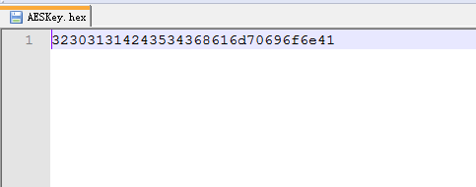
Here is the IV.hex
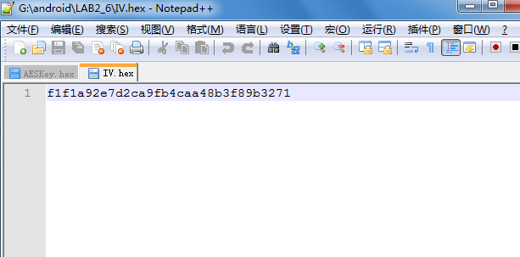
Here is the result output encrypted file:
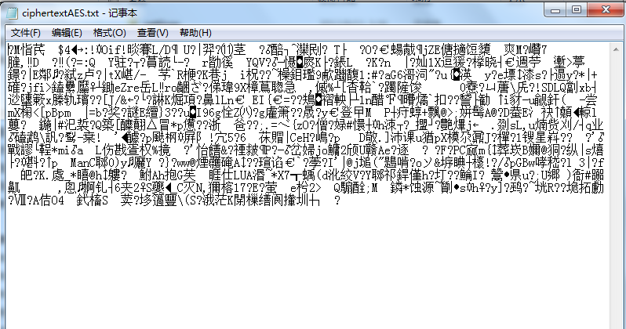

Step 7
Encrypt a file using 3DES:
A.Key: 2011BCSChampionAuburnUni (save in 3DESKey.Hex)
B.IV: Generate a random number and save it in a file (IV.Hex)
C.Input file: plaintext.txt
D.Output file: ciphertext3DES.txt
E.Submit the codes
F.Show the screen capture in report

Here is the related code:
import java.io.*;
import java.security.*;
import java.security.spec.*;
import javax.crypto.*;
import javax.crypto.spec.*;
public class DESedeEncryptFile{

private SecretKey key; /* key used by encrypt/decrypt routines */
private String cipherAlgorithm = "DESede";
private String clearText;
private String cipherText;
private Cipher ecipher;
private Cipher dcipher;
byte[] buffer = new byte[1024];
/*
* public DESedeEncryptFile(String,String,String)
* @PARAMS:
* String initKey: key material used to create the Key
* String clearText: name of file to store clear text output.
* String cipherText: name of file to store cipher text output.
* @OUTPUT:
* Returns: nothing.
* Creates: EncryptFile object
*/

public DESedeEncryptFile(String initKey, String clearText, String cipherText) throws Exception{
//translate the key
this.key = toKey(initKey.getBytes());
this.clearText = clearText;
this.cipherText = cipherText;
// Create an 8-byte initialization vector
byte[] iv = createIV();
AlgorithmParameterSpec paramSpec = new IvParameterSpec(iv);
try {
ecipher = Cipher.getInstance("DESede/CBC/PKCS5Padding");
dcipher = Cipher.getInstance("DESede/CBC/PKCS5Padding");
// CBC requires an initialization vector
ecipher.init(Cipher.ENCRYPT_MODE, key, paramSpec);
dcipher.init(Cipher.DECRYPT_MODE, key, paramSpec);
} catch (java.security.InvalidAlgorithmParameterException e) {
} catch (javax.crypto.NoSuchPaddingException e) {
} catch (java.security.NoSuchAlgorithmException e) {
} catch (java.security.InvalidKeyException e) {
}
}

/*
* public DESedeEncryptFile(SecretKey,String,String)
* @PARAMS:
* SecretKey key: key object to store in class variable key
* String clearText: name of file to store clear text output.
* String cipherText: name of file to store cipher text output.
* @OUTPUT:
* Returns: nothing.
* Creates: EncryptFile object
*/

public DESedeEncryptFile(SecretKey key, String clearText, String cipherText){
this.key = key;
this.clearText = clearText;
this.cipherText = cipherText;
// Create an 8-byte initialization vector
byte[] iv = new byte[]{
(byte)0x8E, 0x12, 0x39, (byte)0x9C,
0x07, 0x72, 0x6F, 0x5A
};

AlgorithmParameterSpec paramSpec = new IvParameterSpec(iv);
try {
ecipher = Cipher.getInstance("DESede/CBC/PKCS5Padding");
dcipher = Cipher.getInstance("DESede/CBC/PKCS5Padding");
// CBC requires an initialization vector
ecipher.init(Cipher.ENCRYPT_MODE, key, paramSpec);
dcipher.init(Cipher.DECRYPT_MODE, key, paramSpec);
} catch (java.security.InvalidAlgorithmParameterException e) {
} catch (javax.crypto.NoSuchPaddingException e) {
} catch (java.security.NoSuchAlgorithmException e) {
} catch (java.security.InvalidKeyException e) {
}
}

/*
* public DESedeEncryptFile(String,String)
* @PARAMS:
* String clearText: name of file to store clear text output.
* String cipherText: name of file to store cipher text output.
* @OUTPUT:
* Returns: nothing.
* Creates: EncryptFile object with DESede as default algorithm, creating a DESede key
*/

public DESedeEncryptFile(String clearText, String cipherText){
key = efKeyGenerator(cipherAlgorithm);
this.clearText = clearText;
this.cipherText = cipherText;
// Create an 8-byte initialization vector
byte[] iv = new byte[]{
(byte)0x8E, 0x12, 0x39, (byte)0x9C,
0x07, 0x72, 0x6F, 0x5A
};
AlgorithmParameterSpec paramSpec = new IvParameterSpec(iv);
try {
ecipher = Cipher.getInstance("DESede/CBC/PKCS5Padding");
dcipher = Cipher.getInstance("DESede/CBC/PKCS5Padding");
// CBC requires an initialization vector
ecipher.init(Cipher.ENCRYPT_MODE, key, paramSpec);
dcipher.init(Cipher.DECRYPT_MODE, key, paramSpec);

} catch (java.security.InvalidAlgorithmParameterException e) {
} catch (javax.crypto.NoSuchPaddingException e) {
} catch (java.security.NoSuchAlgorithmException e) {
} catch (java.security.InvalidKeyException e) {
}
}

/*
* private SecretKey toKey(byte[])
* @PARAMS:
* byte[] key: translate initial key to secret key
* @OUTPUT:
* Returns: SecretKey key
* Creates: nothing.
*/

private static SecretKey toKey(byte[] key) throws Exception {
DESedeKeySpec dks = new DESedeKeySpec(key);
SecretKeyFactory keyFactory = SecretKeyFactory.getInstance("DESede");
SecretKey secretKey = keyFactory.generateSecret(dks);
return secretKey;
}

/*
* public SecretKey efKeyGenerator(String)
* @PARAMS:
* String c: name of algorithm used to generate key.
* @OUTPUT:
* Returns: SecretKey key
* Creates: nothing.
*/

public SecretKey efKeyGenerator(String c){
try{
KeyGenerator keyGen = KeyGenerator.getInstance(c);
SecretKey key = keyGen.generateKey();
return key;
}catch(NoSuchAlgorithmException e){
}
return null;
}

/*
* public static void ToHEX(byte[], String)
* @PARAMS:
* byte[] text: the text need to be stored in Hex
* String String fileNam: name of the file
* @OUTPUT:
* Returns: noting
* Creates: hex file.
*/

public static void ToHEX(byte[] text, String fileName) throws IOException{

String hexString = "";
System.out.println(text.length);
for(int i = 0; i < text.length; i++)
{ System.out.println(i+"text"+text[i]);
String hex = Integer.toHexString(text[i]&0xFF );
System.out.println("text[]&0xff"+(text[i]&0xFF));
System.out.println(hex);
if (hex.length() == 1) {
hex = "0" + hex;
System.out.println("ss"+hex);
}
hexString = hexString + hex;
}
FileOutputStream fos = new FileOutputStream(fileName);
fos.write(hexString.getBytes());
fos.close();
}
/*
* private static byte[] createIV()
* @PARAMS:
* Null
* @OUTPUT:
* Returns: byte[] IV
* Creates: IV。hex file.
*/

private static byte[] createIV() throws IOException
{

SecureRandom random = null;
try
{
random = SecureRandom.getInstance("SHA1PRNG");
}
catch (NoSuchAlgorithmException e)
{
System.out.println("NoSuchAlgorithmException: " + e);
System.exit(-1);
}
byte[] bIV = new byte[8];
random.nextBytes(bIV);
System.out.println("bIV"+bIV[0]);
ToHEX(bIV,"IV.hex");

return bIV;
}

public void encrypt(){
try{
InputStream fin = new FileInputStream(clearText);
OutputStream fout = new FileOutputStream(cipherText);
fout = new CipherOutputStream(fout,ecipher);
int numRead = 0;
while((numRead = fin.read(buffer)) >= 0){
fout.write(buffer,0,numRead);
}
fout.close();
}catch(IOException e){
}
}
public static void main(String[] args) throws IOException{
//Key used for DESede encryption
String InitialKey = "2011BCSChampionAuburnUni";
//Export to "DESedeKey.hex"
ToHEX(InitialKey.getBytes(),"3DESKey.hex");

try{
DESedeEncryptFile DESede = new DESedeEncryptFile(InitialKey,"plaintext.txt","ciphertext3DES.txt");
DESede.encrypt();
}catch(Exception e){
}
}

}

Here is the the 3DESKey.hex
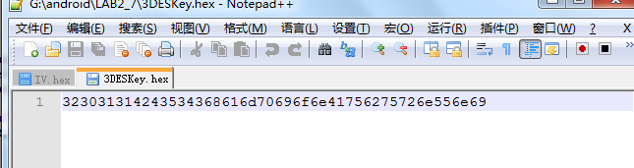
Here is the IV.hex
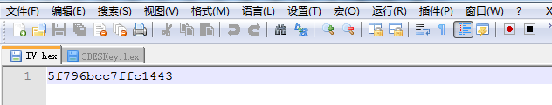

Here is the output encrypted file:
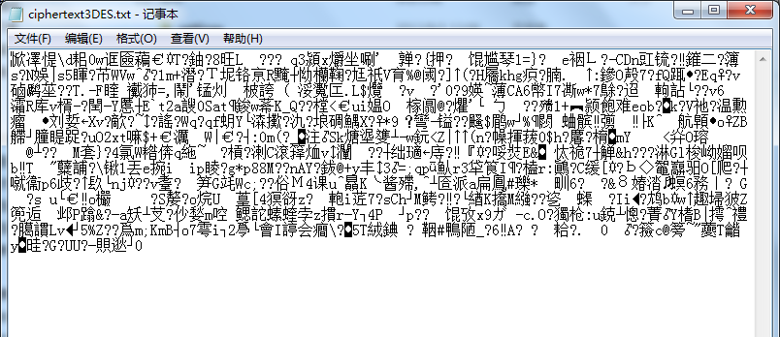

Step 8
Decrypt a file using 3DES
- Key: 2011BCSChampionAuburnUni (save in 3DESKey.Hex)
- IV: Use the random number in the file (IV.Hex)
- Input file: ciphertext3DES.txt
- Output file: plaintextD-3DES.txt
- Submit the codes
- Show the screen capture in report

Here is the 3DESKey.hex
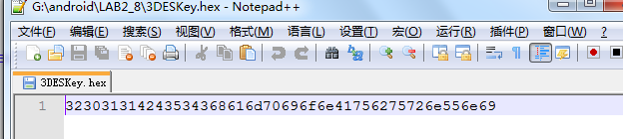
Here is the IV.hex
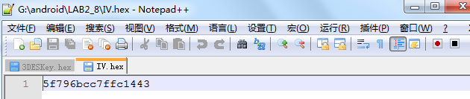
Here is the output decrypted file
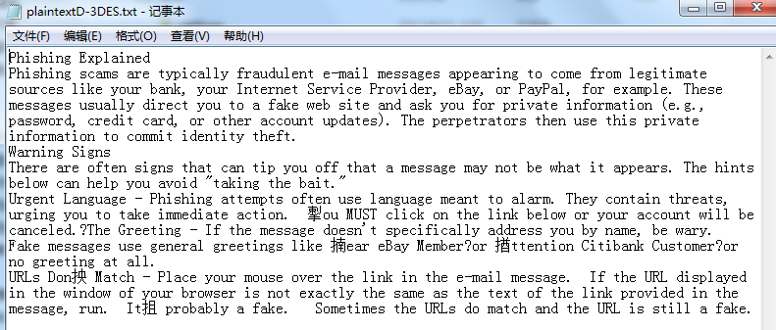

Step 9
Encrypt a file using AES-256 using GCM.
- Key: 2011BCSChampion-AuburnUniversity (save in AES-256Key.Hex)
- IV: Generate a random number and save it in a file (IV.Hex)
- Input file: plaintext.txt
- Output file: ciphertext-AES-256.txt
- Submit the codes
- Show the screen capture in report

AES256/CBC mode
Here is the related code:
import java.io.*;
import java.security.*;
import java.security.spec.*;
import javax.crypto.*;
import javax.crypto.spec.*;

public class AES256EncryptFile{

private SecretKey key; /* key used by encrypt/decrypt routines */
private String cipherAlgorithm = "AES"; /* Algorithm used for encrypt/decrypt, for example AES or AES(Rijndael) */
private String clearText; /* name of file to store clear text output. encrypt routine takes this as input stream */
private String cipherText; /* name of file to store cipher text output. decrypt routine takes this as input stream */
private Cipher ecipher;
private Cipher dcipher;
byte[] buffer = new byte[1024];

/*
* public AES256EncryptFile(String,String,String)
* @PARAMS:
* String initKey: key string to generate key
* String clearText: name of file to store clear text output.
* String cipherText: name of file to store cipher text output.

* @OUTPUT:
* Returns: nothing.
* Creates: AES256EncryptFile object
*/

public AES256EncryptFile(String initKey, String clearText, String cipherText) throws Exception{
//translate the key
KeyGenerator generator = KeyGenerator.getInstance("AES");
generator.init(256,new SecureRandom(initKey.getBytes()));
key = generator.generateKey();
// byte[] encodeformat = key.getEncoded();
// SecretKeySpec skey = new SecretKeySpec(encodeformat,"AES");
System.out.println("key length is " + key.getEncoded().length);

this.clearText = clearText;
this.cipherText = cipherText;
// Create an 16-byte initialization vector
byte[] iv = createIV();
AlgorithmParameterSpec paramSpec = new IvParameterSpec(iv);
try {
ecipher = Cipher.getInstance("AES/CBC/PKCS5Padding");
dcipher = Cipher.getInstance("AES/CBC/PKCS5Padding");
// CBC requires an initialization vector
ecipher.init(Cipher.ENCRYPT_MODE, key, paramSpec);
dcipher.init(Cipher.DECRYPT_MODE, key, paramSpec);
} catch (java.security.InvalidAlgorithmParameterException e) {
} catch (javax.crypto.NoSuchPaddingException e) {
} catch (java.security.NoSuchAlgorithmException e) {
} catch (java.security.InvalidKeyException e) {
}
}
/*
* public AES256EncryptFile(SecretKey,String,String)
* @PARAMS:
* SecretKey key: key object to store in class variable key
* String clearText: name of file to store clear text output.
* String cipherText: name of file to store cipher text output.
* @OUTPUT:
* Returns: nothing.
* Creates: AES256EncryptFile object
*/

public AES256EncryptFile(SecretKey key, String clearText, String cipherText){
this.key = key;
this.clearText = clearText;
this.cipherText = cipherText;
try {
ecipher = Cipher.getInstance("AES");
dcipher = Cipher.getInstance("AES");
ecipher.init(Cipher.ENCRYPT_MODE, key);
dcipher.init(Cipher.DECRYPT_MODE, key);
} catch (java.security.InvalidKeyException e) {
} catch (javax.crypto.NoSuchPaddingException e) {
} catch (java.security.NoSuchAlgorithmException e) {
}
}

/*
* public AES256EncryptFile(String,String)
* @PARAMS:
* String clearText: name of file to store clear text output.
* String cipherText: name of file to store cipher text output.
* @OUTPUT:
* Returns: nothing.
* Creates: AES256EncryptFile object with AES as default algorithm, creating a AES key
*/

public AES256EncryptFile(String clearText, String cipherText){
key = efKeyGenerator(cipherAlgorithm);
this.clearText = clearText;
this.cipherText = cipherText;
try {
ecipher = Cipher.getInstance("AES");
dcipher = Cipher.getInstance("AES");
// CBC requires an initialization vector
ecipher.init(Cipher.ENCRYPT_MODE, key);
dcipher.init(Cipher.DECRYPT_MODE, key);
} catch (java.security.InvalidKeyException e) {
} catch (javax.crypto.NoSuchPaddingException e) {
} catch (java.security.NoSuchAlgorithmException e) {
}
}

public AES256EncryptFile(SecretKey key, String clearText, String cipherText){
this.key = key;
this.clearText = clearText;
this.cipherText = cipherText;
try {
ecipher = Cipher.getInstance("AES");
dcipher = Cipher.getInstance("AES");
ecipher.init(Cipher.ENCRYPT_MODE, key);
dcipher.init(Cipher.DECRYPT_MODE, key);
} catch (java.security.InvalidKeyException e) {
} catch (javax.crypto.NoSuchPaddingException e) {
} catch (java.security.NoSuchAlgorithmException e) {
}
}

/*
* public AES256EncryptFile(String,String)
* @PARAMS:
* String clearText: name of file to store clear text output.
* String cipherText: name of file to store cipher text output.
* @OUTPUT:
* Returns: nothing.
* Creates: AES256EncryptFile object with AES as default algorithm, creating a AES key
*/

public AES256EncryptFile(String clearText, String cipherText){
key = efKeyGenerator(cipherAlgorithm);
this.clearText = clearText;
this.cipherText = cipherText;
try {
ecipher = Cipher.getInstance("AES");
dcipher = Cipher.getInstance("AES");
// CBC requires an initialization vector
ecipher.init(Cipher.ENCRYPT_MODE, key);
dcipher.init(Cipher.DECRYPT_MODE, key);
} catch (java.security.InvalidKeyException e) {
} catch (javax.crypto.NoSuchPaddingException e) {
} catch (java.security.NoSuchAlgorithmException e) {
}
}

/*
* public SecretKey efKeyGenerator(String)
* @PARAMS:
* String c: name of algorithm used to generate key.
* @OUTPUT:
* Returns: SecretKey key
* Creates: nothing.
*/

public SecretKey efKeyGenerator(String c){
try{
KeyGenerator keyGen = KeyGenerator.getInstance("AES");
keyGen.init(256);
SecretKey key = keyGen.generateKey();
return key;
}catch(NoSuchAlgorithmException e){
}
return null;
}

/*
* public static void ToHEX(byte[], String)
* @PARAMS:
* byte[] text: the text need to be stored in Hex
* String String fileNam: name of the file
* @OUTPUT:
* Returns: noting
* Creates: hex file.
*/

public static void ToHEX(byte[] text, String fileName) throws IOException{

String hexString = "";
for(int i = 0; i < text.length; i++)
{
String hex = Integer.toHexString(text[i]&0xFF );
if (hex.length() == 1) {

hex = "0" + hex;
}
hexString = hexString + hex;
}
FileOutputStream fos = new FileOutputStream(fileName);
fos.write(hexString.getBytes());
fos.close();
}

/*
* private static byte[] createIV()
* @PARAMS:
* Null
* @OUTPUT:
* Returns: byte[] IV
* Creates: IV。hex file.
*/

private static byte[] createIV() throws IOException
{
SecureRandom random = null;
try
{
random = SecureRandom.getInstance("SHA1PRNG");
}
catch (NoSuchAlgorithmException e)
{
System.out.println("NoSuchAlgorithmException: " + e);
System.exit(-1);
}
byte[] bIV = new byte[16];
random.nextBytes(bIV);
ToHEX(bIV,"IV.hex");

return bIV;
}

public void encrypt(){
try{
InputStream fin = new FileInputStream(clearText);
OutputStream fout = new FileOutputStream(cipherText);
fout = new CipherOutputStream(fout,ecipher);
int numRead = 0;
while((numRead = fin.read(buffer)) >= 0){
fout.write(buffer,0,numRead);
}
fout.close();
}catch(IOException e){
}
}

public static void main(String[] args) throws IOException{
//Key used for AES256 encryption
String InitialKey = "2011BCSChampion-AuburnUniversity";
//Export to "AES256Key.hex"
ToHEX(InitialKey.getBytes(),"AES256Key.hex");

try{
AES256EncryptFile AES256 = new AES256EncryptFile(InitialKey,"plaintext.txt","ciphertext-AES-256.txt");
AES256.encrypt();
}catch(Exception e){
}
}

}

Here is the AES256Key.hex
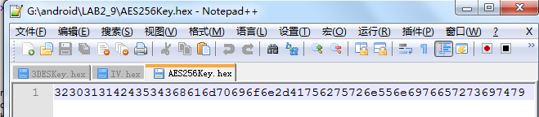
Here is the IV.hex
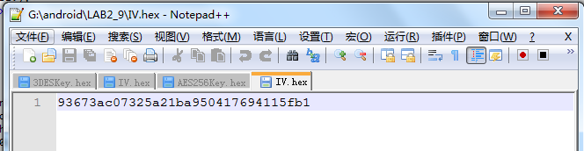
Here is the output encrypted file
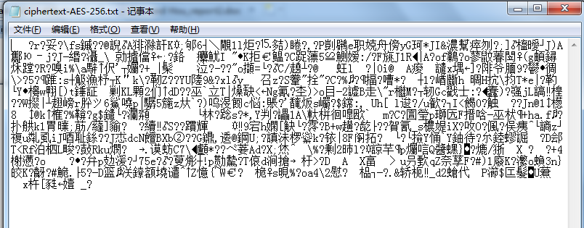
AES256-GCM mode
Here is the related code:
import java.io.*;
import javax.crypto.*;
import javax.crypto.spec.*;
import java.security.NoSuchAlgorithmException;
import java.security.SecureRandom;

public class GCM_ENCRYPT
{
public static void main(String[] arg) throws IOException
{

try
{
String InitialKey = "2011BCSChampion-AuburnUniversity";
ToHEX(InitialKey.getBytes(),"GCMKey.hex");
System.out.println("Key Saved into GCMKey.hex");
KeyGenerator keyGen = KeyGenerator.getInstance("AES");
keyGen.init(256,new SecureRandom(InitialKey.getBytes()));
SecretKey key = keyGen.generateKey();
Encrypter encrypter = new Encrypter(key);
// Encrypt
encrypter.encrypt(getBytesFromFile(new File("plaintext.txt")),"ciphertext-GCM.txt");

FileOutputStream output = new FileOutputStream("key.dat");
output.write(key.getEncoded());
output.close();
for (byte b : key.getEncoded()) {
System.out.format("%02x", b);
}
System.out.println("\nKey written to key.dat");
}
catch(Exception e)
{
System.out.println(e.getMessage());

}
public static void ToHEX(byte[] text, String fileName) throws IOException{

String hexString = "";
for(int i = 0; i < text.length; i++)
{
String hex = Integer.toHexString(text[i]&0xFF );
if (hex.length() == 1) {
hex = "0" + hex;
}
hexString = hexString + hex;
}
FileOutputStream fos = new FileOutputStream(fileName);
fos.write(hexString.getBytes());
fos.close();
}

public static byte[] getBytesFromFile(File file) throws IOException {
InputStream is = new FileInputStream(file);

// Get the size of the file
long length = file.length();

if (length > Integer.MAX_VALUE) {
// File is too large
}

// Create the byte array to hold the data
byte[] bytes = new byte[(int)length];

// Read in the bytes
int offset = 0;
int numRead = 0;
while (offset < bytes.length
&& (numRead=is.read(bytes, offset, bytes.length-offset)) >= 0) {
offset += numRead;
}

// Ensure all the bytes have been read in
if (offset < bytes.length) {
throw new IOException("Could not completely read file "+file.getName());
}

// Close the input stream and return bytes
is.close();
return bytes;
}

}
class Encrypter {
Cipher ecipher;

Encrypter(SecretKey key) throws IOException {
byte[] finaliv = new byte[21];
byte[] newiv = createIV();
// 21 bytes in total
byte[] iv = new byte[]{
// This is the authentication tag length (12).
(byte) 0x0c,

// This is the length of the authenticated data (10).
(byte) 0x00, (byte) 0x00, (byte) 0x00, (byte) 0x00,
(byte) 0x00, (byte) 0x00, (byte) 0x00, (byte) 0x0a,

// This is the GCM IV data used for encryption and decryption.
// These 12-bytes MUST be unique for a key choice
// for security reasons
};
System.arraycopy(iv,0,finaliv,0,iv.length);
System.arraycopy(newiv, 0, finaliv, 9, newiv.length);
ToHEX(finaliv,"IV.hex");

try {
ecipher = Cipher.getInstance("AES/GCM/NoPadding","JsafeJCE");

IvParameterSpec params = new IvParameterSpec(finaliv);
ecipher.init(Cipher.ENCRYPT_MODE, key, params);

} catch (javax.crypto.NoSuchPaddingException e) { System.out.println(e.getMessage());
} catch (java.security.NoSuchAlgorithmException e) { System.out.println(e.getMessage());
} catch (java.security.InvalidKeyException e) { System.out.println(e.getMessage());
} catch (IllegalArgumentException e) { System.out.println(e.getMessage());
} catch (Exception e){
System.out.println(e.getMessage());
}
}

// Buffer used to transport the bytes from one stream to another
byte[] buf = new byte[1024];
public void encrypt(byte[] in, String out) {
try {

byte[] encryptedMessage =new byte[ecipher.getOutputSize(in.length)];

byte[] authenticatedData = new byte[10];
int outputLenUpdate = ecipher.update(authenticatedData,0, authenticatedData.length, encryptedMessage, 0);
outputLenUpdate += ecipher.update(in, 0, in.length, encryptedMessage, outputLenUpdate);
ecipher.doFinal(encryptedMessage,outputLenUpdate);
System.out.println("Encryption Successful. Data Written to: " + out);

// byte[] encryptedMessage = ciphertext;

FileOutputStream output = new FileOutputStream(out);
output.write(encryptedMessage);
output.close();

} catch (Exception e){System.out.println("Decryption Failed: " + e.getMessage());
}
}
public static byte[] createIV() throws IOException
{
SecureRandom random = null;
try
{
random = SecureRandom.getInstance("SHA1PRNG");
}
catch (NoSuchAlgorithmException e)
{
System.out.println("NoSuchAlgorithmException: " + e);
System.exit(-1);
}
byte[] bIV = new byte[12];
random.nextBytes(bIV);

return bIV;
}
public static void ToHEX(byte[] text, String fileName) throws IOException{

String hexString = "";
for(int i = 0; i < text.length; i++)
{
String hex = Integer.toHexString(text[i]&0xFF );
if (hex.length() == 1) {
hex = "0" + hex;
}
hexString = hexString + hex;
}
FileOutputStream fos = new FileOutputStream(fileName);
fos.write(hexString.getBytes());
fos.close();
}

}

Here is the GCMKey.hex
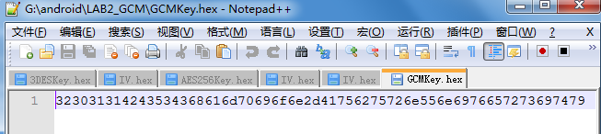
Here is the IV.hex
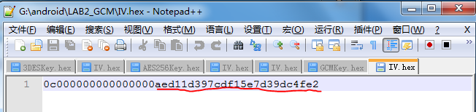
The last 12 bytes for GCM is random
Here is the result encryption file:
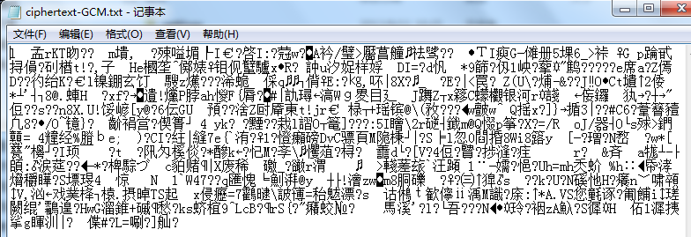

Step 10
Decrypt a file using AES256 using GCM
- Key: 2011BCSChampion-AuburnUniversity (save in AESKey-256.Hex)
- IV: Use the random number in the file (IV.Hex)
- Input file: ciphertext-AES-256.txt
- Output file: plaintextD-AES256.txt
- Submit the codes
- Show the screen capture in report

AES256-CBC mode
Here is the related code
import java.io.*;
import java.security.*;
import java.security.spec.*;
import javax.crypto.*;
import javax.crypto.spec.*;

public class AES256DecryptFile{

private SecretKey key; /* key used by encrypt/decrypt routines */
private String cipherAlgorithm = "AES"; /* Algorithm used for encrypt/decrypt, for example AES or AES(Rijndael) */
private String clearText; /* name of file to store clear text output. encrypt routine takes this as input stream */
private String cipherText; /* name of file to store cipher text output. decrypt routine takes this as input stream */
private Cipher ecipher;
private Cipher dcipher;
byte[] buffer = new byte[1024];

/*
* public AES256DecryptFile(String,String,String)
* @PARAMS:
* String initKey: key string to generate key
* String clearText: name of file to store clear text output.
* String cipherText: name of file to store cipher text output.
* @OUTPUT:
* Returns: nothing.
* Creates: AES256DecryptFile object
*/

public AES256DecryptFile(String initKey, String clearText, String cipherText) throws Exception{
//translate the key
KeyGenerator generator = KeyGenerator.getInstance( "AES" );
generator.init(256,new SecureRandom(initKey.getBytes()));
key = generator.generateKey();
this.clearText = clearText;
this.cipherText = cipherText;
// Create an 8-byte initialization vector
byte[] iv = IVFromHex("IV.hex");
AlgorithmParameterSpec paramSpec = new IvParameterSpec(iv);
try {
ecipher = Cipher.getInstance("AES/CBC/PKCS5Padding");
dcipher = Cipher.getInstance("AES/CBC/PKCS5Padding");
// CBC requires an initialization vector
ecipher.init(Cipher.ENCRYPT_MODE, key, paramSpec);
dcipher.init(Cipher.DECRYPT_MODE, key, paramSpec);
} catch (java.security.InvalidAlgorithmParameterException e) {
} catch (javax.crypto.NoSuchPaddingException e) {
} catch (java.security.NoSuchAlgorithmException e) {
} catch (java.security.InvalidKeyException e) {
}
}

/*
* public AES256DecryptFile(SecretKey,String,String)
* @PARAMS:
* SecretKey key: key object to store in class variable key
* String clearText: name of file to store clear text output.
* String cipherText: name of file to store cipher text output.
* @OUTPUT:
* Returns: nothing.
* Creates: AES256DecryptFile object
*/
public AES256DecryptFile(SecretKey key, String clearText, String cipherText){
this.key = key;
this.clearText = clearText;
this.cipherText = cipherText;
try {
ecipher = Cipher.getInstance("AES");
dcipher = Cipher.getInstance("AES");
ecipher.init(Cipher.ENCRYPT_MODE, key);
dcipher.init(Cipher.DECRYPT_MODE, key);
} catch (java.security.InvalidKeyException e) {
} catch (javax.crypto.NoSuchPaddingException e) {
} catch (java.security.NoSuchAlgorithmException e) {
}
}

/*
* public AES256DecryptFile(String,String)
* @PARAMS:
* String clearText: name of file to store clear text output.
* String cipherText: name of file to store cipher text output.
* @OUTPUT:
* Returns: nothing.
* Creates: AES256DecryptFile object with AES as default algorithm, creating a AES key
*/

public AES256DecryptFile(String clearText, String cipherText){
key = efKeyGenerator(cipherAlgorithm);
this.clearText = clearText;
this.cipherText = cipherText;
try {
ecipher = Cipher.getInstance("AES");
dcipher = Cipher.getInstance("AES");
// CBC requires an initialization vector
ecipher.init(Cipher.ENCRYPT_MODE, key);
dcipher.init(Cipher.DECRYPT_MODE, key);
} catch (java.security.InvalidKeyException e) {
} catch (javax.crypto.NoSuchPaddingException e) {
} catch (java.security.NoSuchAlgorithmException e) {
}
}

/*
* public SecretKey efKeyGenerator(String)
* @PARAMS:
* String c: name of algorithm used to generate key.
* @OUTPUT:
* Returns: SecretKey key
* Creates: nothing.
*/

public SecretKey efKeyGenerator(String c){
try{
KeyGenerator keyGen = KeyGenerator.getInstance(c);
keyGen.init(128);
SecretKey key = keyGen.generateKey();
return key;
}catch(NoSuchAlgorithmException e){
}
return null;
}

/*
* public static void ToHEX(byte[], String)
* @PARAMS:
* byte[] text: the text need to be stored in Hex
* String String fileNam: name of the file
* @OUTPUT:
* Returns: noting
* Creates: hex file.
*/
public static void ToHEX(byte[] text, String fileName) throws IOException{

String hexString = "";
for(int i = 0; i < text.length; i++)
{
String hex = Integer.toHexString(text[i]&0xFF );
if (hex.length() == 1) {
hex = "0" + hex;
}
hexString = hexString + hex;
}
FileOutputStream fos = new FileOutputStream(fileName);
fos.write(hexString.getBytes());
fos.close();
}
/*
* public static void ToHEX(byte[], String)
* @PARAMS:
* String String fileNam: name of the file
* @OUTPUT:
* Returns: IV in byte[]
* Creates: nothing.
*/
private static byte[] IVFromHex(String filename) throws IOException {
BufferedReader reader = new BufferedReader( new FileReader (filename));
String line = null;
StringBuilder stringBuilder = new StringBuilder();
while( ( line = reader.readLine() ) != null ) {
stringBuilder.append( line );
}
String sIV = stringBuilder.toString();
int len = sIV.length();
byte[] bIV = new byte[len / 2];
for (int i = 0; i < len; i += 2) {
bIV[i / 2] = (byte) ((Character.digit(sIV.charAt(i), 16) << 4)
+ Character.digit(sIV.charAt(i+1), 16));
}
return bIV;
}

public void encrypt(){
try{
InputStream fin = new FileInputStream(clearText);
OutputStream fout = new FileOutputStream(cipherText);
fout = new CipherOutputStream(fout,ecipher);
int numRead = 0;
while((numRead = fin.read(buffer)) >= 0){
fout.write(buffer,0,numRead);
}
fout.close();
}catch(IOException e){
}
}

public void decrypt(){
try{
InputStream fin = new FileInputStream(cipherText);
OutputStream fout = new FileOutputStream("plaintextD-AES256.txt");
fin = new CipherInputStream(fin,dcipher);
int numRead = 0;
while((numRead = fin.read(buffer)) >= 0){
fout.write(buffer,0,numRead);
}
fout.close();
}catch(IOException e){
}
}

public static void main(String[] args) throws Exception{
//Key used for AES256 encryption
String InitialKey = "2011BCSChampion-AuburnUniversity";
//Export to "AES256Key.hex"
ToHEX(InitialKey.getBytes(),"AES256Key.hex");

AES256DecryptFile AES256 = new AES256DecryptFile(InitialKey,"plaintext.txt","ciphertext-AES-256.txt");
AES256.decrypt();
}

}

Here is the

Here is the AES256Key.hex
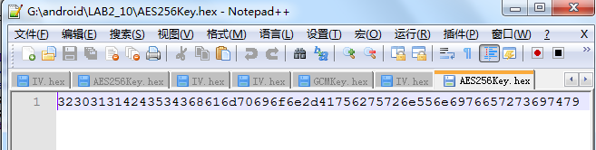
Here is the IV.hex
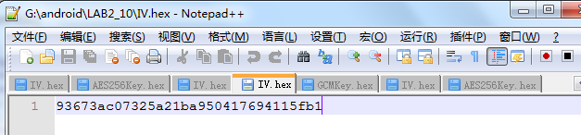
Here is the decrypted result
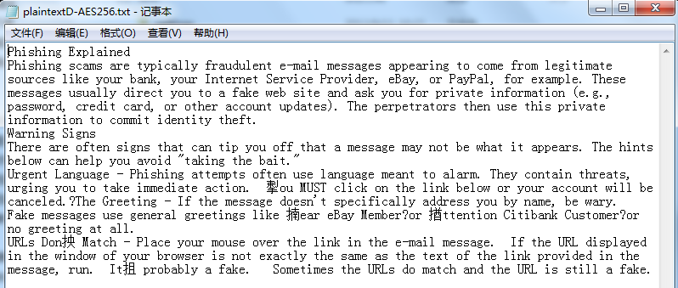

AES256-GCM mode
Here is the related code

import java.io.*;
import javax.crypto.*;
import javax.crypto.spec.*;
import java.security.SecureRandom;

public class GCM_DECRYPT
{
public static void main(String[] arg) throws IOException
{

try
{
String InitialKey = "2011BCSChampion-AuburnUniversity";
ToHEX(InitialKey.getBytes(),"GCMKey.hex");
System.out.println("Key Saved into GCMKey.hex");
KeyGenerator keyGen = KeyGenerator.getInstance("AES");
keyGen.init(256,new SecureRandom(InitialKey.getBytes()));
SecretKey key = keyGen.generateKey();
Decrypter decrypter = new Decrypter(key);
// Encrypt
decrypter.decrypt(getBytesFromFile(new File("ciphertext-GCM.txt")),"decipher-GCM.txt");

System.out.println("Using Key: ");
for (byte b : key.getEncoded()) {
System.out.format("%02x", b);
}

}
catch(Exception e)
{
System.out.println("Error in creating key");
}
}

public static void ToHEX(byte[] text, String fileName) throws IOException{

String hexString = "";
for(int i = 0; i < text.length; i++)
{
String hex = Integer.toHexString(text[i]&0xFF );
if (hex.length() == 1) {
hex = "0" + hex;
}
hexString = hexString + hex;
}
FileOutputStream fos = new FileOutputStream(fileName);
fos.write(hexString.getBytes());
fos.close();
}

public static byte[] getBytesFromFile(File file) throws IOException {
InputStream is = new FileInputStream(file);

// Get the size of the file
long length = file.length();

if (length > Integer.MAX_VALUE) {
// File is too large
}

// Create the byte array to hold the data
byte[] bytes = new byte[(int)length];

// Read in the bytes
int offset = 0;
int numRead = 0;
while (offset < bytes.length
&& (numRead=is.read(bytes, offset, bytes.length-offset)) >= 0) {
offset += numRead;
}

// Ensure all the bytes have been read in
if (offset < bytes.length) {
throw new IOException("Could not completely read file "+file.getName());
}

// Close the input stream and return bytes
is.close();
return bytes;
}

}

class Decrypter {
//Cipher ecipher;
Cipher dcipher;

Decrypter(SecretKey key) {

try {

byte[] newiv = IVFromHex("IV.hex");
for(int i=0;i<newiv.length;i++)
{

System.out.println(newiv[i]);
}
dcipher = Cipher.getInstance("AES/GCM/NoPadding","JsafeJCE");

IvParameterSpec params = new IvParameterSpec(newiv);

dcipher.init(Cipher.DECRYPT_MODE, key, params);

//dcipher.init(Cipher.DECRYPT_MODE, key);
} catch (javax.crypto.NoSuchPaddingException e) { System.out.println(e.getMessage());
} catch (java.security.NoSuchAlgorithmException e) { System.out.println(e.getMessage());
} catch (java.security.InvalidKeyException e) { System.out.println(e.getMessage());
} catch (IllegalArgumentException e) { System.out.println(e.getMessage());
} catch (Exception e){
System.out.println(e.getMessage());
}
}

// Buffer used to transport the bytes from one stream to another
byte[] buf = new byte[1024];

private static byte[] IVFromHex(String filename) throws IOException {
BufferedReader reader = new BufferedReader( new FileReader (filename));
String line = null;
StringBuilder stringBuilder = new StringBuilder();
while( ( line = reader.readLine() ) != null ) {
stringBuilder.append( line );
}
String sIV = stringBuilder.toString();
int len = sIV.length();
byte[] bIV = new byte[len / 2];
for (int i = 0; i < len; i += 2) {
bIV[i / 2] = (byte) ((Character.digit(sIV.charAt(i), 21) << 4)
+ Character.digit(sIV.charAt(i+1), 21));
}
return bIV;
}
public void decrypt(byte[] in, String out) {
try {

byte[] plainMessage = new byte[dcipher.getOutputSize(in.length)];
byte[] authenticatedData = new byte[10];
int outputLenUpdate = dcipher.update(authenticatedData,0, authenticatedData.length, plainMessage, 0);

outputLenUpdate += dcipher.update(in, 0, in.length, plainMessage, outputLenUpdate);

dcipher.doFinal(plainMessage,outputLenUpdate);

FileOutputStream output = new FileOutputStream(out);
output.write(plainMessage);
System.out.println("Decryption Successful. Written to: " + out);
output.close();

} catch (Exception e){System.out.println("Decryption Failed: " + e.getMessage());
}
}

}

Here is the result decryption file
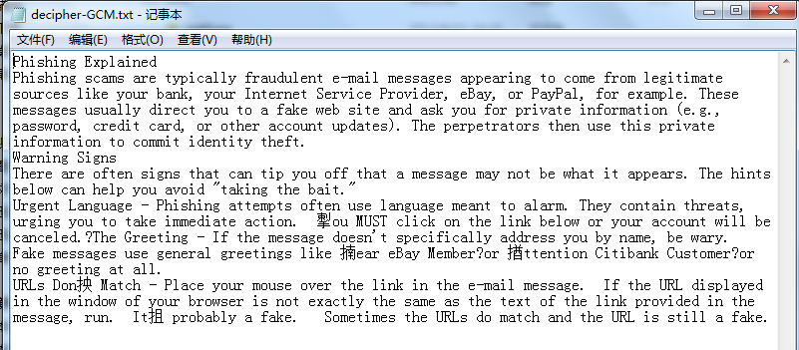

Step bonus
Implement each step in android.

Here is the code related

AndroidEncryptionActivity

package com.lab2.AndroidEncrypt;

import java.io.FileInputStream;
import java.io.FileOutputStream;
import android.app.Activity;
import android.content.Intent;
import android.os.Bundle;
import android.view.View;
import android.widget.Button;
import android.widget.EditText;

public class AndroidEncryptActivity extends Activity {
/** Called when the activity is first created. */
@Override

public void onCreate(Bundle savedInstanceState) {
super.onCreate(savedInstanceState);
setContentView(R.layout.main);

final Button button1 = (Button) findViewById(R.id.button1);
final EditText alg = (EditText) findViewById(R.id.EditText01);
final EditText mod = (EditText) findViewById(R.id.EditText02);
final EditText key = (EditText) findViewById(R.id.EditText03);

button1.setOnClickListener(new View.OnClickListener() {

public void onClick(View v) {
// Perform action on click
String salgorithm;
String smode;
String skey;

salgorithm = alg.getText().toString();
smode = mod.getText().toString();
skey = key.getText().toString();

try {
FileInputStream fclear = openFileInput("plaintext.txt");
FileOutputStream fcipher =openFileOutput("ciphertext.txt", MODE_PRIVATE);
CipherFile cf = new CipherFile(salgorithm, smode, skey);
cf.encrypt(fclear, fcipher);

FileInputStream fciphered = openFileInput("ciphertext.txt");
FileOutputStream fedcipher =openFileOutput("dephertext.txt", MODE_PRIVATE);
cf.decrypt(fciphered, fedcipher);

} catch (Exception e) {
}finally{
Intent secondPage = new Intent("android.intent.action.SHOWPLAINTEXT");
startActivity(secondPage);
}

}
});
}

}

Cipher.java

import java.io.IOException;
import java.io.InputStream;
import java.io.OutputStream;
import java.security.NoSuchAlgorithmException;
import java.security.SecureRandom;
import java.security.spec.AlgorithmParameterSpec;
import javax.crypto.Cipher;
import javax.crypto.CipherInputStream;
import javax.crypto.CipherOutputStream;
import javax.crypto.KeyGenerator;
import javax.crypto.SecretKey;
import javax.crypto.SecretKeyFactory;
import javax.crypto.spec.DESKeySpec;
import javax.crypto.spec.DESedeKeySpec;
import javax.crypto.spec.IvParameterSpec;

public class CipherFile{

private SecretKey key; /* key used by encrypt/decrypt routines */
private String Mode; /* name of file to store clear text output. encrypt routine takes this as input stream */
private Cipher ecipher;
private Cipher dcipher;
byte[] buffer = new byte[1024];
/*
* public CipherFile(SecretKey,String,String)
* @PARAMS:
* SecretKey key: key object to store in class variable key
* String clearText: name of file to store clear text output.
* String cipherText: name of file to store cipher text output.
* @OUTPUT:
* Returns: nothing.
* Creates: EncryptFile object
*/

public CipherFile(String algrithm, String mode, String initKey) throws Exception{
// this.Algorithm = algrithm;
this.Mode = mode;
//index used for the size of IV
int index = 0;
String config = "1";
if (algrithm.equals("AES128")){
index = 16;
KeyGenerator generator = KeyGenerator.getInstance( "AES" );
generator.init(128,new SecureRandom(initKey.getBytes()));
key = generator.generateKey();
config = "AES/" + Mode + "/PKCS5Padding";
}else if (algrithm.equals("AES256")){
index = 16;
KeyGenerator generator = KeyGenerator.getInstance( "AES" );
generator.init(256,new SecureRandom(initKey.getBytes()));
key = generator.generateKey();
config = "AES/" + Mode + "/PKCS5Padding";
}else if (algrithm.equals("DES")){
index = 8;
DESKeySpec dks = new DESKeySpec(initKey.getBytes());
SecretKeyFactory keyFactory = SecretKeyFactory.getInstance("DES");
key = keyFactory.generateSecret(dks);
config = "DES/" + Mode + "/PKCS5Padding";
}else if (algrithm.equals("3DES")){
index = 8;
DESedeKeySpec dks = new DESedeKeySpec(initKey.getBytes());
SecretKeyFactory keyFactory = SecretKeyFactory.getInstance("DESede");
key = keyFactory.generateSecret(dks);
config = "DESede/" + Mode + "/PKCS5Padding";
}
// Create an 8-byte initialization vector
byte[] iv = createIV(index);
AlgorithmParameterSpec paramSpec = new IvParameterSpec(iv);

try {

ecipher = Cipher.getInstance(config);
dcipher = Cipher.getInstance(config);
// CBC requires an initialization vector
ecipher.init(Cipher.ENCRYPT_MODE, key, paramSpec);
dcipher.init(Cipher.DECRYPT_MODE, key, paramSpec);

} catch (java.security.InvalidAlgorithmParameterException e) {
} catch (javax.crypto.NoSuchPaddingException e) {
} catch (java.security.NoSuchAlgorithmException e) {
} catch (java.security.InvalidKeyException e) {
}
}

public void encrypt(InputStream fclear, OutputStream fcipher){
try{
fcipher = new CipherOutputStream(fcipher,ecipher);
int numRead = 0;
while((numRead = fclear.read(buffer)) >= 0){
fcipher.write(buffer,0,numRead);
}
fcipher.close();
}catch(IOException e){
}
}

public void decrypt(InputStream fcipher, OutputStream fdecipher ){
try{

fcipher = new CipherInputStream(fcipher,dcipher);
int numRead = 0;
while((numRead = fcipher.read(buffer)) >= 0){
fdecipher.write(buffer,0,numRead);
}
fdecipher.close();
}catch(IOException e){
}
}

private static byte[] createIV(int index) throws IOException
{
SecureRandom random = null;
try
{
random = SecureRandom.getInstance("SHA1PRNG");
}
catch (NoSuchAlgorithmException e)
{
System.out.println("NoSuchAlgorithmException: " + e);
System.exit(-1);
}
byte[] bIV = new byte[index];
random.nextBytes(bIV);
return bIV;
}

}

Showplaintext.java
package com.lab2.AndroidEncrypt;

import java.io.FileInputStream;
import org.apache.http.util.EncodingUtils;
import android.app.Activity;
import android.os.Bundle;
import android.view.View;
import android.widget.Button;
import android.widget.TextView;

public class Showplaintext extends Activity{

@Override
protected void onCreate(Bundle savedInstanceState) {
// TODO Auto-generated method stub
super.onCreate(savedInstanceState);
setContentView(R.layout.plaintext);

final TextView Text = (TextView) findViewById(R.id.plaintext);
final Button bPlain = (Button) findViewById(R.id.plain);
final Button bEncript = (Button) findViewById(R.id.encript);
final Button bDecript = (Button) findViewById(R.id.decript);

bPlain.setOnClickListener(new View.OnClickListener() {
public void onClick(View v) {
// Perform action on click
String res="";

try{
FileInputStream fin = openFileInput("plaintext.txt");
int length = fin.available();
byte [] buffer = new byte[length];
fin.read(buffer);
res = EncodingUtils.getString(buffer, "UTF-8");
fin.close();
}

catch(Exception e){
e.printStackTrace();
}

Text.setText(res);
}

});

bEncript.setOnClickListener(new View.OnClickListener() {
public void onClick(View v) {
// Perform action on click
String res="";

try{
FileInputStream fin = openFileInput("ciphertext.txt");
int length = fin.available();
byte [] buffer = new byte[length];
fin.read(buffer);
res = EncodingUtils.getString(buffer, "UTF-8");
fin.close();
}
catch(Exception e){
e.printStackTrace();
}

Text.setText(res);
}

});

bDecript.setOnClickListener(new View.OnClickListener() {
public void onClick(View v) {
// Perform action on click
String res="";

try{
FileInputStream fin = openFileInput("dephertext.txt");
int length = fin.available();
byte [] buffer = new byte[length];
fin.read(buffer);
res = EncodingUtils.getString(buffer, "UTF-8");
fin.close();
}
catch(Exception e){
e.printStackTrace();
}

Text.setText(res);
}

});

And here are the captures of each step implement in android

Step1 Encrypt a file using DES (DES/CBC/PKCS5Padding)

Here is the capture

Chose the algorithm, mode and the key
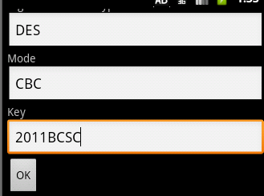

The plaintext
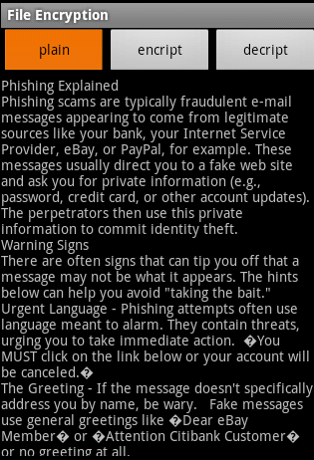
The encrypted file
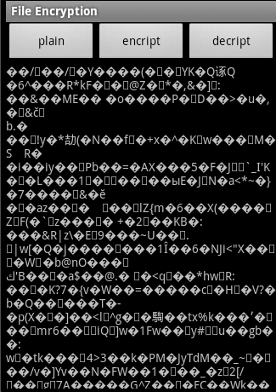
Step 2:Decrypt a file using DES
The decrypted file
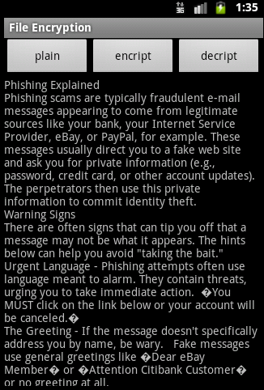

Step 3:Encrypt a file using DES (DES/CBC/PKCS5Padding) and change plaintext.txt (provided in the folder) with the modification of the first character from P to Q, the Key is 2011BCSD

The plaintext

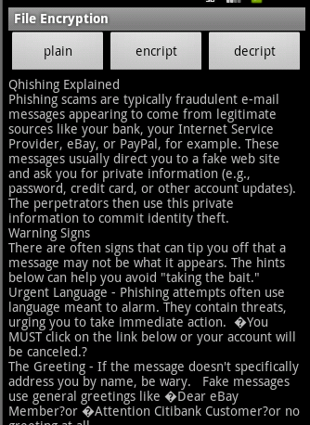
The encrypted file
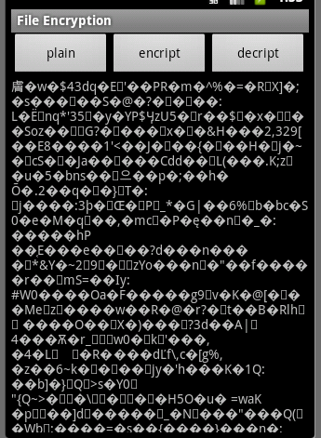

Step 4:Encrypt a file using AES-128 (AES/CTR/PKCS5Padding) and the key is 2011BCSChampionA
Algorithm, mode and key input
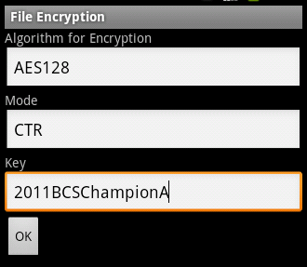
Original plaintext
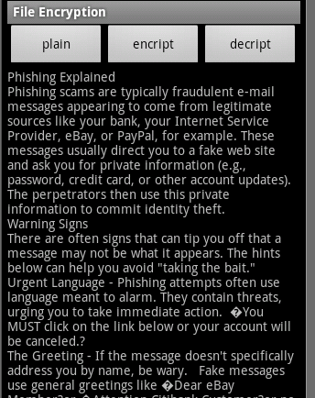

Encrypted file
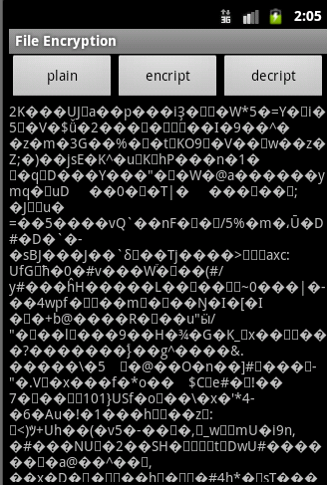
Step 5: decrypt the file encrypted in step 4
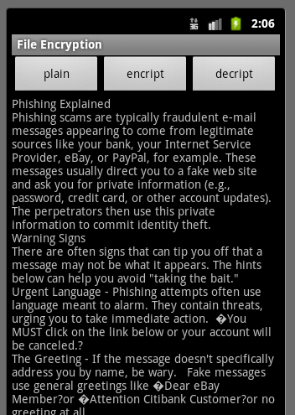

Step 6:Encrypt a file using AES-128 (AES/CTR/PKCS5Padding), change the plaintext with the modification of the first character from P to Q and the key is 2011BCSChampionA.
The original plaintext
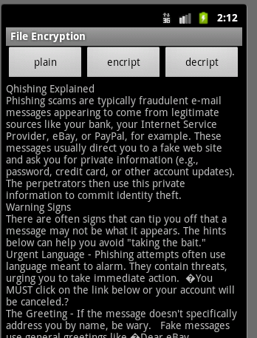
The encrypted file
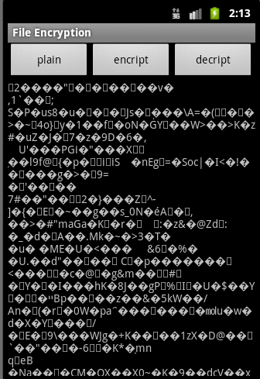

Step 7:Encrypt a file using 3DES with the Key 2011BCSChampionAuburnUni
The algorithm chose
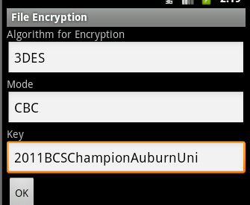
The original plaintext
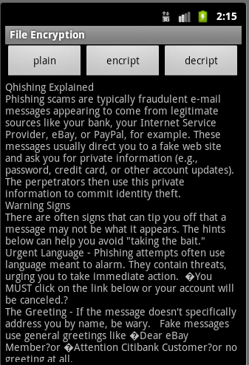

The encrypted file
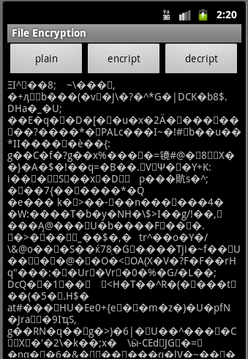
Step 8: decrypt the file encrypted in step 7
The decrypted file
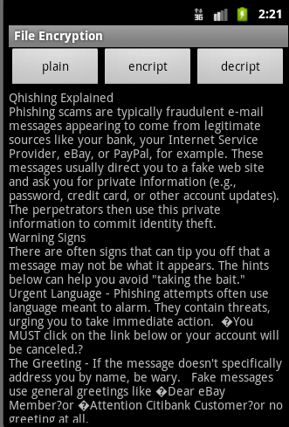
Step 9: Encrypt a file using AES-256 using GCM
Because the android security packet do not support GCM mode in AES, so we do not implement it.
The algorithm and mode chose
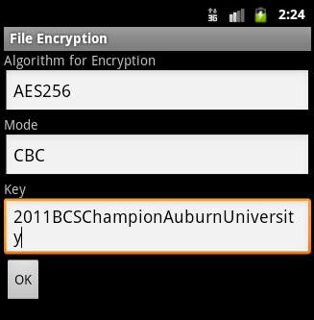
The original plaintext
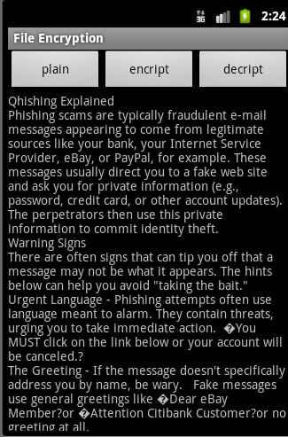

The encrypted file
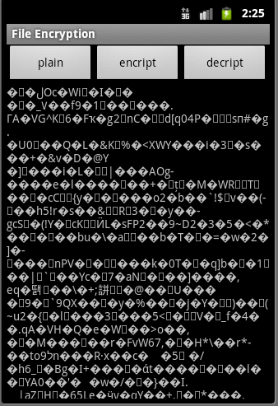
Step 10: decrypt the file encrypted in step 9
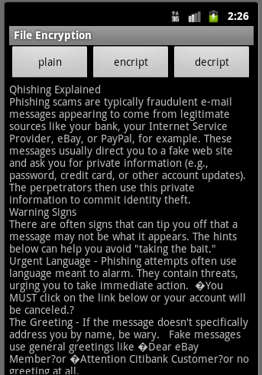

Result
Following the sample solution this lab have been completed with out significant problem. In this lab we have learned the block cipher algorithm's implement in JAVA. We do this in the eclipse so it may be a little different in cmd. And in the JAVA programming of the block encryption it is just need to use some library. It may be a little different in different mode with pre-configuration of the initial vector. And in bonus, we have implement most of the lab step, what we have not implement is the GCM mode of AES.

Conclusion
In the class we have learned that the block encryption algorithm is very important and some mode is very widely used. And as the JAVA is the most widely used language in different platform so this lab is very helpful to study about the information security. But I think what may be more helpful in this class is learning how to decrypt a given cipher or attacking. So we are hope to learn more about this in the future.

References
- Dr.Wu's example code and sample solution
- RSA AES GCM application demonstrates, http://developer-content.emc.com/docs/rsashare/share_for_java/1.1/dev_guide/group__JCESAMPLES__ENCDEC__SYMCIPHER__AESGCM.html
- AES-GCM encryption in android, http://bouncy-castle.1462172.n4.nabble.com/AES-GCM-encryption-in-Android-td1838266.html
- RFC 5647,http://www.armware.dk/RFC/rfc/rfc5647.html

