**CareConnect: Modeling**

**Use Case Diagram:**

[Use case diagram](https://app.diagrams.net/#G1GFq0zQ6ZlOgxxaTj-VFvY_luZNnMlWK0)

**Class diagram:**

[Class diagram](https://drive.google.com/file/d/1Ip5Bca01-EQbUeQnlAKTBWFDSnwRCEAY/view?usp=sharing)

**Significant use cases**

**1. Making an appointment:**

1.1 Use case scenario

1.2 Sequence diagram

1.3 Activity diagram

Links: [use case scenario](https://docs.google.com/document/d/1qO22DmNAg81W5w4Vk_sg7QgnScw5cj6-Qf9xor6l0i4/edit?usp=sharing), [Sequence diagram](https://drive.google.com/file/d/1dK2fh0ppVdsUi_5CAOIkVCGea5ES4CV7/view?usp=sharing), [Activity diagram](https://drive.google.com/file/d/1dTGs6qOoS0Y8gwx8KainYILrSJS8qxmW/view?usp=sharing)

**2. Online consultation**

2.1 Use case scenario

| **USE CASE NAME:** | Online Consultation | | **USE CASE TYPE Business Requirements:** |
| --- | --- | --- | --- |
| **USE CASE ID:** |  | |
| **PRIORITY:** | Very significant | |
|  | | |
| **PRIMARY BUSINESS ACTOR:** | patients | | |
| **OTHER PARTICIPATING ACTORS:** | doctors | | |
| **OTHER INTERESTED STAKEHOLDERS:** | Administrators, health centers | | |
| **SHORT DESCRIPTION:** | The patients is able to have a conversation with a specialist about their case either via chat or video conversation | | |
| **PRE-CONDITION:** | After appointment, patient will be able to attend and choose their preferred option( video or chat) for conversation | | |
| **TRIGGER:** | On appointment scheduled time, patient clicks on the ‘start a chat" button through the interface, and chooses chat or video option | | |
| **TYPICAL COURSE** | **Actor Action** | **System Response** | |
| **OF EVENTS:** | **Step 1**: | **Step 2**: | |
|  | Patient chooses join a conversation button | System allows users to choose chat or video conversation. Then creates a “socket” for conversation  § | |
|  | Patient chooses an option to chat(video or chat) | System redirects user to a video/chat “room” | |
|  | The Doctor also joins a conversation this time. | System redirects user to a video/chat “room” | |
|  | Patient and Doctor can leave a chat through the software interface | System redirects patient to medicine store if needed, otherwise doctor and patient redirected to main page | |
| **ALTERNATE COURSES:** | If the specialist is not available at the scheduled time, the careConnect system will prompt the patient to reschedule the appointment. | | |
| **CONCLUSION:** | The online consultation use case provides a convenient way for patients to receive medical advice from specialists. This feature improves patient access to healthcare services and reduces the need for in-person visits, especially in situations where it can be difficult to attend an in-person consultation. | | |
| **POST-CONDITION:** | The patient receives recommendations and advice from the specialist and can access the notes made during the “chat” and can have access to the medicine store. | | |
| **BUSINESS RULES:** | The online consultation feature is only available to patients who have scheduled an appointment with a specialist through the careConnect system( i.e. authorized user). The specialist must be available at the scheduled time for the consultation to take place. | | |
| **IMPLEMENTATION CONSTRAINTS AND SPECIFICATIONS:** | The online consultation feature requires a stable internet connection for the chat or video conversation. The careConnect system must also comply with relevant data protection and privacy regulations by providing authority checks. | | |
| **ASSUMPTIONS:** | The patient and specialist have access to a device with an internet connection and a camera and microphone for video conversations. | | |
| **OPEN ISSUES:** | The careConnect system may need to provide additional support or training to patients who are not familiar with online consultations or have difficulty navigating the system. | | |

2.2 Sequence diagram

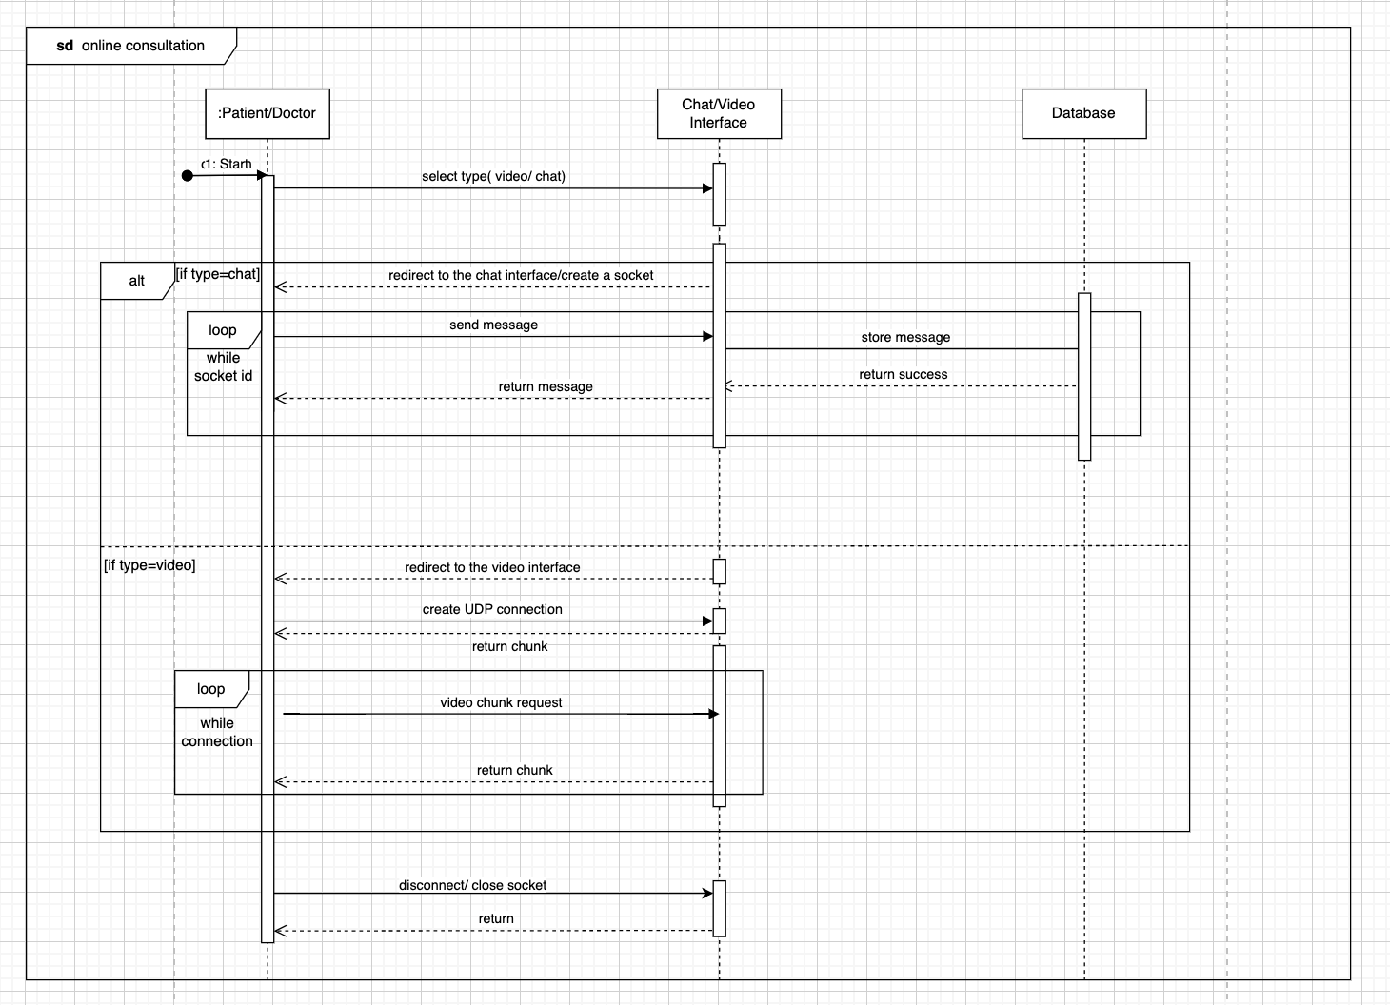

2.3 Activity diagram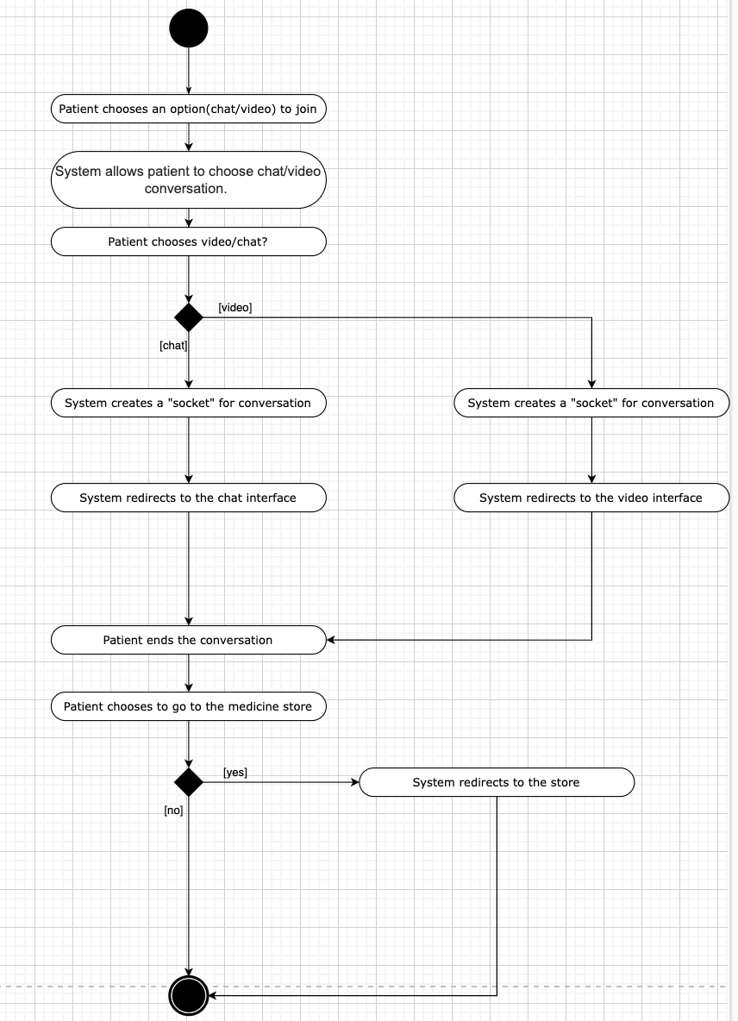

Links: [use case scenario](https://docs.google.com/document/d/1Udp3G7M3c4XGig5OdnVFXdgTMcZCVTO7OuJ1-GnVvE0/edit?usp=sharinghttps://docs.google.com/document/d/1Udp3G7M3c4XGig5OdnVFXdgTMcZCVTO7OuJ1-GnVvE0/edit?usp=sharing), [Activity diagram](https://drive.google.com/file/d/1WTxN0Ub5DID7DdJooFY1Zwh2dvfqTPZS/view?usp=sharing), [Sequence diagram](https://drive.google.com/file/d/1idERxBi2wvy9eL25lRZD0w0vKp-2k4KQ/view?usp=sharing)

3.Make an electronic medical records(prescriptions)

3.1 Use case scenario

3.2 Sequence diagram

3.3 Activity diagram

Links: [Use case scenario](https://docs.google.com/document/d/1FEtr5Z4RTvDHiGMqOPs7r9D_0u1Q_N9xDdc-S05-ZyI/edit), [Sequence diagram](https://drive.google.com/file/d/1dK2fh0ppVdsUi_5CAOIkVCGea5ES4CV7/view?usp=sharing)(page2), [Activity diagram](https://drive.google.com/file/d/1dTGs6qOoS0Y8gwx8KainYILrSJS8qxmW/view?usp=sharing)(page2)

（Conents below are only for our own reference)

1. Patient Success Scenario:
   1. The patient browses the medical centers’ catalog
   2. The patient filters the medical centers based on various parameters
   3. The patient chooses the medical center they want to visit
   4. The patient checks the availability of doctors
   5. The patient chooses the doctor they are interested in and makes an online/in-person appointment
   6. The patient gets personal schedules based on appointments
   7. The patient gets notified before an appointment
   8. The patient pays the booking fees through our platform
   9. If it is an online appointment, patients have the appointment online, and pay the consultation fees.
   10. The patient gets the recipient after payment through our platform
2. Patient Failure Scenario:
   1. The patient browses the medical centers catalog and does not find the one that satisfies his/her need
   2. The patient leaves the website/application
3. Doctors Success Scenarios:
   1. The doctor edits profile
   2. The doctor gets notifications when a patient books an appointment (relates to 1.5)
   3. The doctor determines the consultation and appointment fee (relates to 1.9)
   4. The doctor gets a personal schedule based on the appointments
   5. The doctor gets notified before an appointment

1. Doctors Failure Scenarios:
   1. The doctor receives the appointment, but has another meeting that clashes with this appointment, so the appointment is not made successfully
2. Administrators Success Scenarios:
   1. The administrator receives the notification when a patient makes an appointment, and checks with the doctor
3. Administrators Failure Scenarios