May 22, 2016

## Part A

library(stockPortfolio)  
ticker<-c("GOOG", "ABTL", "BIDU", "MEET", "YHOO", "AET", "ANTM", "CNC", "ESRX", "UNH", "AMZN", "EVLV", "GAIA", "LQDT", "MELI", "ADBE", "INTU", "ORCL", "RHT", "CRM", "EMC","NTAP", "STX", "TDC", "WDC", "S&P500")  
ind<-c(rep("Internet Information Providers", 5), rep("HEALTH CARE PLANS", 5), rep("Catalog & Mail Order Houses", 5), rep("Application Software", 5), rep("Data Storage Devices", 5), "Market")  
my_data<-as.data.frame(cbind(ticker,ind))  
my_data

## ticker ind  
## 1 GOOG Internet Information Providers  
## 2 ABTL Internet Information Providers  
## 3 BIDU Internet Information Providers  
## 4 MEET Internet Information Providers  
## 5 YHOO Internet Information Providers  
## 6 AET HEALTH CARE PLANS  
## 7 ANTM HEALTH CARE PLANS  
## 8 CNC HEALTH CARE PLANS  
## 9 ESRX HEALTH CARE PLANS  
## 10 UNH HEALTH CARE PLANS  
## 11 AMZN Catalog & Mail Order Houses  
## 12 EVLV Catalog & Mail Order Houses  
## 13 GAIA Catalog & Mail Order Houses  
## 14 LQDT Catalog & Mail Order Houses  
## 15 MELI Catalog & Mail Order Houses  
## 16 ADBE Application Software  
## 17 INTU Application Software  
## 18 ORCL Application Software  
## 19 RHT Application Software  
## 20 CRM Application Software  
## 21 EMC Data Storage Devices  
## 22 NTAP Data Storage Devices  
## 23 STX Data Storage Devices  
## 24 TDC Data Storage Devices  
## 25 WDC Data Storage Devices  
## 26 S&P500 Market

gr<-getReturns(ticker,start='2008-12-31', end='2013-12-31')  
summary(gr)

## 26 stocks, observed once per month between 2009-01-02 and 2013-12-02   
##   
## GOOG ABTL BIDU MEET YHOO AET ANTM CNC ESRX UNH  
## Mean Return 0.025 0.048 0.052 0.033 0.023 0.019 0.017 0.023 0.019 0.021  
## AMZN EVLV GAIA LQDT MELI ADBE INTU ORCL RHT CRM  
## Mean Return 0.038 0.099 0.016 0.028 0.043 0.021 0.022 0.016 0.029 0.038  
## EMC NTAP STX TDC WDC S&P500  
## Mean Return 0.017 0.023 0.057 0.023 0.041 0.04

## Question 1

m1<-stockModel(gr,drop=26,Rf= 0.001)  
summary(m1)

## Model: none   
## 60 observations, each one month apart  
## Dates: 2009-01-02 to 2013-12-02   
## Short selling is permitted

op1<-optimalPort(m1)   
# point of tangency  
op1$X

## GOOG ABTL BIDU MEET YHOO   
## 0.126336273 0.121364786 0.003451319 0.007738469 0.268164643   
## AET ANTM CNC ESRX UNH   
## 0.026958612 -0.103785059 0.067818742 0.061649545 0.518965908   
## AMZN EVLV GAIA LQDT MELI   
## 0.310782071 0.054234628 -0.156480783 0.105461792 0.041940830   
## ADBE INTU ORCL RHT CRM   
## -0.473869981 0.428861512 -0.365340482 -0.062513060 0.325748033   
## EMC NTAP STX TDC WDC   
## -0.140866723 -0.181806253 0.143328744 -0.144364658 0.016221096

# expected return  
op1$R

## [1] 0.05024222

# standard deviation  
op1$risk

## [1] 0.04649036

plot(op1)  
slope <- (op1$R-m1$Rf)/op1$risk  
slope

## [1] 1.059192

segments(0,m1$Rf,2*op1$risk, m1$Rf+slope*2*op1$risk)

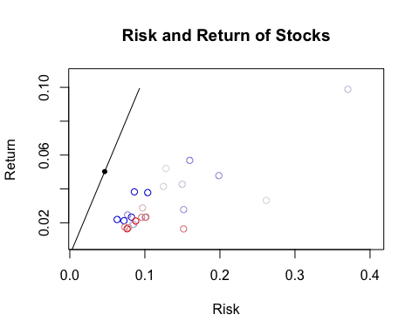

## Question 2

# choose Rf to be Rf=0.003  
m2<-stockModel(gr,drop=26,Rf=0.003)  
op2<-optimalPort(m2)  
plot(op2)  
slope2 <- (op2$R-m2$Rf)/op2$risk  
slope2

## [1] 1.018466

segments(0,m2$Rf,2*op1$risk, m2$Rf+slope2*2*op1$risk)  
portPossCurve(m2,add=TRUE,riskRange=4)

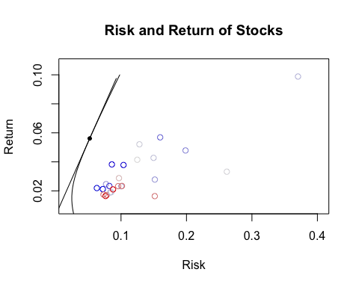

# choose Rf to be Rf=0.004  
m3<-stockModel(gr,drop=26,Rf=0.004)  
op3<-optimalPort(m3)  
plot(op3)  
slope3 <- (op3$R-m3$Rf)/op3$risk  
slope3

## [1] 0.9999275

segments(0, m3$Rf, 2*op1$risk, m3$Rf+slope3*2*op1$risk)  
portPossCurve(m3,add=TRUE,riskRange=4)

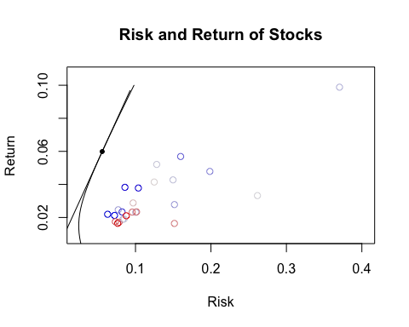

## Question 3

avg <- colMeans(as.data.frame(gr$R[,-26]))  
var_cov <- cov(gr$R[,-26])  
x_equal <- rep(1,25)/25  
Rbar_equal <- t(x_equal) %*% avg  
sd_equal <- (t(x_equal) %*% var_cov %*% x_equal)^0.5  
# expected return of this portfolio  
Rbar_equal

## [,1]  
## [1,] 0.03173216

# standard deviation of this portfolio  
sd_equal

## [,1]  
## [1,] 0.06536399

## Question 4a

m4a<-stockModel(gr,model='SIM', index=26, shortSelling=FALSE, Rf=0.001)  
op4a<-optimalPort(m4a)  
op4a

## Model: single index model  
## Expected return: 0.03038895   
## Risk estimate: 0.02770079   
##   
## Portfolio allocation:  
## GOOG ABTL BIDU MEET YHOO AET   
## 0.07407626 0.01796066 0.06575076 0.00000000 0.05365987 0.04361790   
## ANTM CNC ESRX UNH AMZN EVLV   
## 0.06066598 0.03765098 0.03390183 0.00000000 0.11579684 0.00000000   
## GAIA LQDT MELI ADBE INTU ORCL   
## 0.00420268 0.00000000 0.03338578 0.05735964 0.00000000 0.04587767   
## RHT CRM EMC NTAP STX TDC   
## 0.05418005 0.08501210 0.06027095 0.02230732 0.04643881 0.04856107   
## WDC   
## 0.03932285

## 4b

# alpha  
m4a$alpha

## GOOG ABTL BIDU MEET YHOO AET   
## 0.02093236 0.03709701 0.04679914 0.04146067 0.01868210 0.01559000   
## ANTM CNC ESRX UNH AMZN EVLV   
## 0.01625173 0.01907312 0.01439847 0.02311185 0.03604811 0.10024013   
## GAIA LQDT MELI ADBE INTU ORCL   
## 0.01019731 0.03499608 0.03562554 0.01950948 0.02211974 0.01370724   
## RHT CRM EMC NTAP STX TDC   
## 0.02426389 0.03722098 0.01535391 0.01593711 0.05138400 0.02054692   
## WDC   
## 0.03163243

# beta  
m4a$beta

## GOOG ABTL BIDU MEET YHOO   
## 0.092145338 0.267109675 0.131402488 -0.204302596 0.116384798   
## AET ANTM CNC ESRX UNH   
## 0.083368605 0.022050147 0.101343580 0.116977090 -0.046905406   
## AMZN EVLV GAIA LQDT MELI   
## 0.054533754 -0.035384574 0.153560273 -0.178428227 0.176786927   
## ADBE INTU ORCL RHT CRM   
## 0.037515103 -0.004248637 0.068532025 0.112451265 0.015163919   
## EMC NTAP STX TDC WDC   
## 0.052151436 0.185026103 0.136601700 0.067280351 0.243622444

## 4c

m4c<-stockModel(gr,model='SIM', index=26, shortSelling=TRUE, Rf=0.001)  
op4c<-optimalPort(m4c)  
op4c

## Model: single index model  
## Expected return: 0.02957225   
## Risk estimate: 0.0232071   
##   
## Portfolio allocation:  
## GOOG ABTL BIDU MEET YHOO AET   
## 0.056391362 0.014250784 0.048959689 0.012564727 0.042020670 0.033714163   
## ANTM CNC ESRX UNH AMZN EVLV   
## 0.044453040 0.029057166 0.027534648 0.083733048 0.084951378 0.013532219   
## GAIA LQDT MELI ADBE INTU ORCL   
## 0.004278827 0.032117449 0.025583226 0.042299300 0.098911367 0.035297787   
## RHT CRM EMC NTAP STX TDC   
## 0.041362761 0.061629371 0.045298275 0.019637633 0.034515269 0.036410911   
## WDC   
## 0.031494929

# alpha  
m4c$alpha

## GOOG ABTL BIDU MEET YHOO AET   
## 0.02093236 0.03709701 0.04679914 0.04146067 0.01868210 0.01559000   
## ANTM CNC ESRX UNH AMZN EVLV   
## 0.01625173 0.01907312 0.01439847 0.02311185 0.03604811 0.10024013   
## GAIA LQDT MELI ADBE INTU ORCL   
## 0.01019731 0.03499608 0.03562554 0.01950948 0.02211974 0.01370724   
## RHT CRM EMC NTAP STX TDC   
## 0.02426389 0.03722098 0.01535391 0.01593711 0.05138400 0.02054692   
## WDC   
## 0.03163243

# beta  
m4c$beta

## GOOG ABTL BIDU MEET YHOO   
## 0.092145338 0.267109675 0.131402488 -0.204302596 0.116384798   
## AET ANTM CNC ESRX UNH   
## 0.083368605 0.022050147 0.101343580 0.116977090 -0.046905406   
## AMZN EVLV GAIA LQDT MELI   
## 0.054533754 -0.035384574 0.153560273 -0.178428227 0.176786927   
## ADBE INTU ORCL RHT CRM   
## 0.037515103 -0.004248637 0.068532025 0.112451265 0.015163919   
## EMC NTAP STX TDC WDC   
## 0.052151436 0.185026103 0.136601700 0.067280351 0.243622444

## Question 5a

# short sale not allowed  
m5a<-stockModel(gr, model='CCM', shortSelling=FALSE, drop=26, Rf=0.001)  
op5a<-optimalPort(m5a)  
op5a

## Model: constant correlation model  
## Expected return: 0.03740928   
## Risk estimate: 0.06098727   
##   
## Portfolio allocation:  
## GOOG ABTL BIDU MEET YHOO AET   
## 0.07643787 0.00000000 0.14706831 0.00000000 0.01283080 0.00000000   
## ANTM CNC ESRX UNH AMZN EVLV   
## 0.00000000 0.00000000 0.00000000 0.02982491 0.27482998 0.00000000   
## GAIA LQDT MELI ADBE INTU ORCL   
## 0.00000000 0.00000000 0.01322520 0.00000000 0.15013618 0.00000000   
## RHT CRM EMC NTAP STX TDC   
## 0.03221508 0.12187915 0.00000000 0.00000000 0.07469085 0.00000000   
## WDC   
## 0.06686166

## Question 5b

# short sale allowed  
m5b<-stockModel(gr, model='CCM', drop=26, shortSelling=TRUE, Rf=0.001)  
op5b<-optimalPort(m5b)  
op5b

## Model: constant correlation model  
## Expected return: 0.043477   
## Risk estimate: 0.06514225   
##   
## Portfolio allocation:  
## GOOG ABTL BIDU MEET YHOO   
## 0.128994825 0.001175752 0.176467185 -0.058377829 0.063441919   
## AET ANTM CNC ESRX UNH   
## -0.031890156 -0.049403840 -0.018396199 -0.035053790 0.087093033   
## AMZN EVLV GAIA LQDT MELI   
## 0.317382376 0.011041167 -0.120406680 -0.052165211 0.040865814   
## ADBE INTU ORCL RHT CRM   
## -0.009871131 0.213131855 -0.057195457 0.074680595 0.159475135   
## EMC NTAP STX TDC WDC   
## -0.018459256 -0.018254549 0.099210511 -0.002383970 0.098897902

## Question 6

m6<-stockModel(gr, model='MGM', drop=26, industry=ind, Rf=0.001)  
op6<-optimalPort(m6)  
op6

## Model: multigroup model  
## Expected return: 0.04857923   
## Risk estimate: 0.07018739   
##   
## Portfolio allocation:  
## GOOG ABTL BIDU MEET YHOO   
## 0.202916714 0.033647025 0.213344029 -0.029171491 0.137233142   
## AET ANTM CNC ESRX UNH   
## -0.001730742 -0.020333084 0.008356926 -0.006258763 0.146979561   
## AMZN EVLV GAIA LQDT MELI   
## 0.383101875 0.034527027 -0.043677879 0.015580443 0.097187100   
## ADBE INTU ORCL RHT CRM   
## -0.084258776 0.174920445 -0.155919623 0.031336541 0.144897803   
## EMC NTAP STX TDC WDC   
## -0.170796457 -0.130509383 0.075846680 -0.114034955 0.056815842

## Question 7

plot(op1)  
portPossCurve(m1,add=TRUE,riskRange=4)  
points(op4a$risk, op4a$R, col="purple", pch=19)  
points(op4c$risk, op4c$R, col="blue", pch=19)  
points(op5a$risk, op5a$R, col="yellow", pch=19)  
points(op5b$risk, op5b$R, col="orange", pch=19)  
points(op6$risk, op6$R, col="green", pch=19)  
legend(0.30, 0.09, c("SIM no short sales", "SIM short sales", "CCM no short sales", "CCM short sales", "MGM"), text.col=c("purple", "blue", "yellow", "orange", "green"))

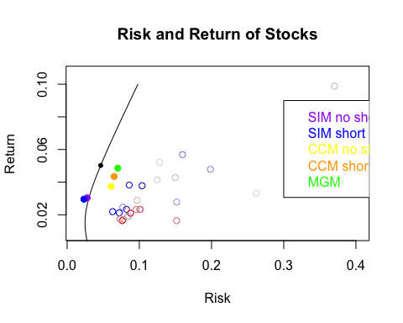

## Part B

## Question a

grb<-getReturns(ticker, start='2013-12-31', end='2016-04-30')  
avg_a <- colMeans(as.data.frame(grb$R[,-26]))  
x_equal_1 <- rep(1,25)/25  
var_cov_a <- cov(grb$R[,-26])  
Rbar_equal_1 <- t(x_equal_1) %*% avg_a  
var_a<-t(x_equal_1) %*%var_cov_a%*%x_equal_1  
Rbar_equal_1

## [,1]  
## [1,] 0.00578631

## Question b

# Single index model with no short sales allowed  
sim_partb<-stockModel(grb,model='SIM', index=26, shortSelling=FALSE)  
op_sim_partb<-optimalPort(sim_partb)  
op_sim_partb

## Model: single index model  
## Expected return: 0.0264967   
## Risk estimate: 0.03002931   
##   
## Portfolio allocation:  
## GOOG ABTL BIDU MEET YHOO   
## 0.0000000000 0.0003258552 0.0139857838 0.0287427053 0.0000000000   
## AET ANTM CNC ESRX UNH   
## 0.1657063474 0.1724954447 0.1176963895 0.0000000000 0.3180670702   
## AMZN EVLV GAIA LQDT MELI   
## 0.0768745205 0.0000000000 0.0000000000 0.0000000000 0.0000000000   
## ADBE INTU ORCL RHT CRM   
## 0.1555630637 0.0000000000 0.0000000000 0.0000000000 0.0641803213   
## EMC NTAP STX TDC WDC   
## 0.0176099398 0.0000000000 0.0000000000 -0.0724704544 -0.0587769871

## Question c

# 50% of the portfolio of part 4a and 50% of the risk free asset, 28 months  
rft=rep(0.01,28)   
xc<- as.matrix(cbind(op4a$X))  
Ret2<- as.matrix(cbind(grb$R[,-26]))  
Ret_c <-0.5*Ret2%*%xc+0.5*rft  
Ret_c

## [,1]  
## 2016-04-01 -0.0020096885  
## 2016-03-01 0.0457583307  
## 2016-02-01 0.0057326833  
## 2016-01-04 -0.0475794713  
## 2015-12-01 0.0015044261  
## 2015-11-02 0.0164351948  
## 2015-10-01 0.0576357097  
## 2015-09-01 -0.0124150528  
## 2015-08-03 -0.0282572934  
## 2015-07-01 0.0195388256  
## 2015-06-01 -0.0071872933  
## 2015-05-01 0.0131605626  
## 2015-04-01 0.0202837781  
## 2015-03-02 -0.0010113886  
## 2015-02-02 0.0446756188  
## 2015-01-02 -0.0061579867  
## 2014-12-01 -0.0002584524  
## 2014-11-03 0.0282202561  
## 2014-10-01 0.0276176811  
## 2014-09-02 -0.0059505374  
## 2014-08-01 0.0318546567  
## 2014-07-01 0.0099938115  
## 2014-06-02 0.0266969566  
## 2014-05-01 0.0206925921  
## 2014-04-01 -0.0179630583  
## 2014-03-03 -0.0089033487  
## 2014-02-03 0.0310218838  
## 2014-01-02 -0.0085870348

## Question d

ccm_partb<-stockModel(grb, model='CCM', shortSelling=FALSE, drop=26)  
op_ccm_partb<-optimalPort(ccm_partb)  
op_ccm_partb

## Model: constant correlation model  
## Expected return: 0.02181874   
## Risk estimate: 0.0376033   
##   
## Portfolio allocation:  
## GOOG ABTL BIDU MEET YHOO AET   
## 0.00000000 0.00000000 0.00000000 0.00000000 0.00000000 0.20399935   
## ANTM CNC ESRX UNH AMZN EVLV   
## 0.14687727 0.09957211 0.00000000 0.44761180 0.00411615 0.00000000   
## GAIA LQDT MELI ADBE INTU ORCL   
## 0.00000000 0.00000000 0.00000000 0.09782332 0.00000000 0.00000000   
## RHT CRM EMC NTAP STX TDC   
## 0.00000000 0.00000000 0.00000000 0.00000000 0.00000000 0.00000000   
## WDC   
## 0.00000000

## Question e

mgm_partb<-stockModel(grb,model='MGM', drop=26, industry=ind)  
op_mgm_partb<-optimalPort(mgm_partb)  
op_mgm_partb

## Model: multigroup model  
## Expected return: 0.1070969   
## Risk estimate: 0.1027318   
##   
## Portfolio allocation:  
## GOOG ABTL BIDU MEET YHOO AET   
## 0.05710054 -0.03095821 -0.04967559 0.05095598 -0.17459743 0.35739427   
## ANTM CNC ESRX UNH AMZN EVLV   
## 0.21141882 0.15542156 -0.78578823 0.94627026 0.14907948 -0.06629573   
## GAIA LQDT MELI ADBE INTU ORCL   
## -0.11007350 -0.40357778 -0.02483477 0.75944645 0.47839065 -0.02591686   
## RHT CRM EMC NTAP STX TDC   
## 0.24072664 0.25353766 0.31944041 -0.29809987 -0.21990577 -0.47340088   
## WDC   
## -0.31605811

tpSim <- testPort(grb, op_sim_partb)

## Warning in testPort(grb, op_sim_partb): Allocation X was standardized

tpCcm <- testPort(grb, op_ccm_partb)

## Warning in testPort(grb, op_ccm_partb): Allocation X was standardized

tpMgm <- testPort(grb, op_mgm_partb)

## Warning in testPort(grb, op_mgm_partb): Allocation X was standardized

tpEqu <- testPort(grb$R[,-26], X=rep(1,25)/25)

## Warning in testPort(grb$R[, -26], X = rep(1, 25)/25): Allocation X was  
## standardized

plot(tpSim, lty=2, col="orange",lwd=2, ylim=c(0.4, 4.0))  
lines(tpCcm, lty=3, col="green",lwd=2)  
lines(tpMgm, lty=4, col="blue",lwd=2)  
  
lines(tpEqu, lty=5, col="yellow",lwd=2)  
lines(cumprod(1+rev(Ret_c)),col="red", lty=6,lwd=2)  
lines(cumprod(1+rev(grb$R[,26])), col="pink", lwd=2)  
  
#Add a legend:  
legend("topleft", pt.cex=1,cex=0.6,lty=1:5, c( 'SIM', 'CCM', 'MGM', 'EQUAL', '50%SIM&50%Rf','S&P500'), col=c( "orange", "green", "blue", "yellow","red", "pink"))

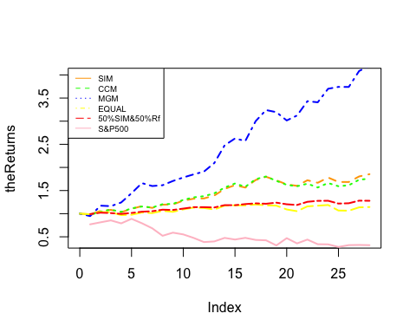

## Sharp Ratio

sim<-(op_sim_partb$R-0.01)/op_sim_partb$risk  
ccm<-(op_ccm_partb$R-0.01)/op_ccm_partb$risk  
mgm<-(op_mgm_partb$R-0.01)/op_mgm_partb$risk  
equal_all<-(Rbar_equal_1-0.01)/sqrt(var_a)  
sim_rf<-(mean(Ret_c)-0.01)/(0.25*op4a$risk)  
market<-(mean(grb$R[,26])-0.01)/sd(grb$R[,26])  
paste(ccm,mgm,equal_all,sim,sim_rf, market)

## [1] "0.314300661733711 0.945149237859513 -0.0847674954591737 0.549353321123088 -0.13128888889469 -0.207691166030772"

## Differential return

plot(x=c(op_ccm_partb$risk,0),y=c(op_ccm_partb$R,0.01), type="l", col="purple", ylim=c(0,0.1), xlim=c(0,0.1), xlab="risk", ylab="return")  
lines(x=c(op_mgm_partb$risk,0),y=c(op_mgm_partb$R,0.01), col="blue")  
lines(x=c(op_sim_partb$risk,0),y=c(op_sim_partb$R,0.01), col="orange")  
lines(x=c(0.25*op4a$risk,0),y=c(mean(Ret_c),0.01), col="green")  
lines(x=c(sqrt(var_a),0),y=c(Rbar_equal_1,0.01), col="black")  
lines(x=c(sd(grb$R[,26]),0),y=c(mean(grb$R[,26]),0.01), col="pink")  
legend("topleft", pt.cex=1,cex=0.6,lty=1:5, c( 'SIM', 'CCM', 'MGM', 'EQUAL', '50%SIM&50%Rf','S&P500'), col=c( "orange", "purple", "blue", "black", "green", "pink"))

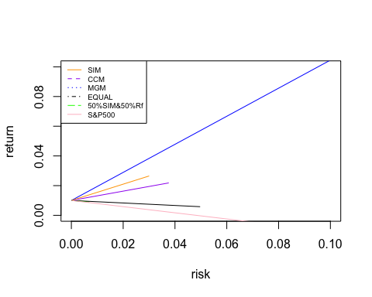

## Treyor Measure

library(PerformanceAnalytics)

## Loading required package: xts

## Loading required package: zoo

##   
## Attaching package: 'zoo'

## The following objects are masked from 'package:base':  
##   
## as.Date, as.Date.numeric

##   
## Attaching package: 'PerformanceAnalytics'

## The following object is masked from 'package:graphics':  
##   
## legend

rr<-grb$R[,1:25]  
sim_trey<-TreynorRatio(Ra=rr%*%op_sim_partb$X, Rb=grb$R[,26], Rf = 0.01, scale = 12)  
ccm_trey<-TreynorRatio(Ra=rr%*%op_ccm_partb$X, Rb=grb$R[,26], Rf = 0.01, scale = 12)  
mgm_trey<-TreynorRatio(Ra=rr%*%op_mgm_partb$X, Rb=grb$R[,26], Rf = 0.01, scale = 12)  
simrf_trey<-TreynorRatio(Ra=Ret_c, Rb=grb$R[,26], Rf = 0.01, scale = 12)  
equal_trey<-TreynorRatio(Ra=rr%*%x_equal_1, Rb=grb$R[,26], Rf = 0.01, scale = 12)  
paste(mgm_trey, ccm_trey, sim_trey, simrf_trey, equal_trey)

## [1] "28.4789915101722 3.46780545826538 3.36032801619556 -1.5878151389087 -2.0687628902273"