JSJSOJN1

1.这个方法的作用就是将json格式的数据转换成数组格式。

1. 2

2.，假设有Person这个类，有json类型数据str=str = [{"name":"张三","age":"1"},{"name":"李四","age":"4"}]，那么

List listt = json.parseArray(str, Person.class);listt就可以接收str了，

###### 1、multimap

Map和Multimap是将key/value pair 当做元素，进行管理。可以根据key的排序准则自动将元素排序。multimap允许重复元素，map不允许有重复，如图1所示。

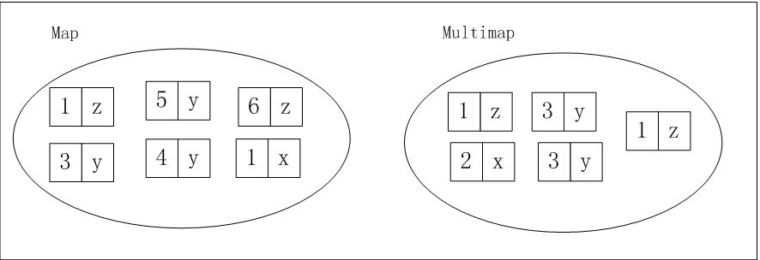

**public** **class** **MutliMapTest** {

**public** **static** void main(String... args) {

Multimap<String, String> myMultimap = ArrayListMultimap.create();

// Adding some key/value

myMultimap.put("Fruits", "Bannana");

myMultimap.put("Fruits", "Apple");

myMultimap.put("Fruits", "Pear");

myMultimap.put("Fruits", "Pear");

myMultimap.put("Vegetables", "Carrot");

// Getting the size

int size = myMultimap.size();

System.out.println(size); // 5

// Getting values

Collection<String> fruits = myMultimap.**get**("Fruits");

System.out.println(fruits); // [Bannana, Apple, Pear, Pear]

System.out.println(ImmutableSet.copyOf(fruits));// [Bannana, Apple, Pear]

// Set<Foo> set = Sets.newHashSet(list);

// Set<Foo> foo = new HashSet<Foo>(myList);

Collection<String> vegetables = myMultimap.**get**("Vegetables");

System.out.println(vegetables); // [Carrot]

// Iterating over entire Mutlimap

**for** (String value : myMultimap.values()) {

System.out.println(value);

}

// Removing a single value

myMultimap.remove("Fruits", "Pear");

System.out.println(myMultimap.**get**("Fruits")); // [Bannana, Apple, Pear]

// Remove all values for a key

myMultimap.removeAll("Fruits");

System.out.println(myMultimap.**get**("Fruits")); // [] (Empty Collection!)

}

}