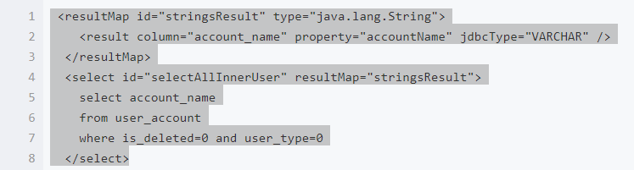

<resultMap id="stringsResult" type="java.lang.String">

<result column="account_name" property="accountName" jdbcType="VARCHAR" />

</resultMap>

<select id="selectAllInnerUser" resultMap="stringsResult">

select account_name

from user_account

where is_deleted=0 and user_type=0

</select>