大连东软信息学院

**毕业设计（论文）**

**报告题目：吉林兴业银行个人理财产品营销策略调研报告**

**A Survey Report on the Marketing Strategies of Personal Financial Products in the Industrial Bank in the City of Jilin**

**系 所： 外国语学院**

**专 业： 商务英语**

**学生姓名： 单思佳**

**学生学号： 15130300226**

**指导教师： 康琪**

**导师职称： 讲师**

**完成日期： 2018 年 4 月 26 日**

大连东软信息学院

**Dalian Neusoft University of Information**

**A Survey Report on the Marketing Strategies of Personal Financial Products in the Industrial Bank in the City of Jilin**

摘要内容应包括与设计（论文）等同量的主要信息，即说明论文的主题、研究目的、研究方法、重要结论等，

中英文摘要内容要对应，不能增译或者减译

# Abstract

In recent years, with the rapid development of China's economy, the status of the financial industry has been continuously improved, financial products have been continuously enriched, personal financial products have increased, and commercial competition has intensified. Therefore, for Industrial bank, in order to increase revenue, it is of great significance to conduct marketing strategy research.

This paper takes the personal financial products of Industrial Bank Jilin Branch as the starting point, comprehensively uses literature review, questionnaire survey and interviews, based on the theory of marketing and financial management, and analyze the strategic positioning, marketing methods, achievements and problems of the personal financial products of Jilin Industrial Bank. The bank financial business can be divided into three types from the perspective of the way customers obtain income, including guaranteed income financial products, guaranteed floating income financial products, and non-guaranteed floating income financial products. The paper first reviews the marketing theory of personal financial products and the development of personal financial products, as well as a comprehensive and systematic analysis of the development and status quo of domestic commercial banks and Industrial Bank's personal financial products marketing, through the design of relevant questionnaires, analyzes the marketing strategy of financial products, while proposing practical optimization suggestions. It is intended to provide more useful reference value for the financial products of Industrial Bank.

**Key Words**: financial products, marketing strategy, Industrial Bank

**吉林兴业银行个人理财产品营销策略调研报告**

摘要

近年来，随着我国经济的快速发展，金融业水平的地位不断提升，金融产品不断丰富，银行理财产品日益增多，商业竞争也日益加剧。因此，对于兴业银行而言，为了增加收益，进行营销策略研究具有重大意义。

本文以兴业银行吉林分行个人理财产品为切入点，综合运用文献查阅、问卷调查和访谈等方法，以市场营销、金融理财相关理论为依据，在掌握大量实证材料的基础上，分析吉林兴业银行的个人理财产品的战略定位、营销手段、取得的成绩及存在的问题。银行理财业务从客户获取收益方式的角度可以分为三种，包括保证收益理财产品、保本浮动收益理财产品以及非保本浮动收益理财产品。本文首先回顾了个人理财产品营销理论及个人理财产品的发展历程，以及对国内商业银行及兴业银行个人理财产品营销的发展与现状进行了系统的分析，通过设计相关的调查问卷，研究分析理财产品的营销策略，同时提出切中实际的优化建议,意在于为兴业银行理财产品的提供更多有用的参考价值。

**关键词**：理财产品，营销策略，兴业银行

摘要、目录共同编页码，采用大写罗马数字，宋体小五号，居中。

摘要、目录共同编页码，采用大写罗马数字，宋体小五号，居中。

摘要、目录共同编页码，采用大写罗马数字，宋体小五号，居中。

**Contents**

Abstract I

摘要 II

I. Introduction 1

II. Methodology 3

2.1 Research Question 3

2.2 Participants 3

2.3 Instruments 3

Ⅲ. Findings 6

3.1 Current Customer Analysis 6

3.1.1 Customer Age Analysis 6

3.1.2 Customer Job Occupation Analysis 6

3.1.3 Customer Annual Income Analysis 7

3.2 Specific Marketing Strategies 8

3.2.1 Customer's Purchase Channel 8

3.2.2 Customer’s Choice Habit 9

3.2.3 Analysis of the Starting Amount of Financial Products 10

3.2.4 Analysis of the Financial Product Price 10

3.2.5 Choice Preference of Customer 11

3.2.6 Customer’s Concerns and Questions 12

3.2.7 Customer’s Understanding of The Product 13

3.2.8 Analysis of The Platform 14

3.3 Industrial Bank's Personal Financial Product Marketing Strategy SWOT Analysis 16

3.3.1 Strength 16

3.3.2 Weakness 16

3.3.3 Opportunities 16

3.3.4 Threats 17

Ⅳ. Conclusions  18

Ⅴ. Recommendation  19

5.1 Reduce Risk and Increase Trust 19

5.2 Improve the Quality of Employees 19

5.3 Expand Marketing Channels 20

5.4 Multiple Marketing Mix Strategies 20

References 22

Acknowledgement 23

Appendix 24

摘要、目录共同编页码，采用大写罗马数字，宋体小五号，居中。

摘要、目录共同编页码，采用大写罗马数字，宋体小五号，居中。

摘要、目录共同编页码，采用大写罗马数字，宋体小五号，居中。

I. Introduction

With the sustainable development of economy, the income of citizens keeps growing which lead to the increasing demand of personal financial products. Through the research and survey on personal financial products, this report provides related suggestions to industrial bank to make up the shortage in marketing personal financial products. Industrial bank should focus on the risk control include matching customer, information spreading and operation to avoid the unnecessary loss.

Nowadays, the financial awareness of Chinese people is gradually increasing, but most people have limited time, energy or lack of professional investment and financial management knowledge. In order to avoid the blindness and randomness of individual investment, ordinary residents still hope to obtain investment-related planning and structural adjustment related services through banks, so as to maximize the return on investment. Therefore, this paper investigates the marketing strategy of Industrial Bank's personal financial products, and improves the personal financial business and market share for Jilin Industrial Bank. With the sustained and steady development of China's economy, the income of Chinese residents is increasing, and the demand for personal financial product is growing. The personal financial business of commercial banks will have tremendous development potential and space.

At present, domestic research articles on personal financial products are mostly focused on the macro aspect and overall level, a few researches on personal financial products of a specific bank. The article takes Jilin Industrial Bank's personal financial products as the starting point, and studies the marketing strategy of financial products, which will help to make up for the shortcomings of this research. At the same time, it also tries to provide more reference and suggestions for the development strategy research of personal financial business of other commercial banks in China.

From a practical point of view, the research on the marketing strategy of Industrial Bank's financial products are conducive to solving the practical problems existing in the financial products business of Industrial Bank, thereby improving the market competitiveness of Industrial Bank, aim to gain more market share. Maintain an advantage in inter-bank competition. At the same time, it discusses the marketing strategy of bank financial products. While improving the marketing performance of commercial banks and increasing the bank's revenue, it is also conducive to increasing the income of customers and promoting the preservation and appreciation of residents' wealth. From a macro perspective, by combing the development of the financial business of Industrial Bank, we can strengthen the guidance of the investment of Industrial Bank, improve the financing structure, guide the flow of private capital, meet the needs of customers, and increase the property income of residents, thus realize a win-win situation of banks, customers and society. The report should have a deep understanding of the marketing performance on personal financial products to develop various products and services to help the bank have a better performance so the bank can provide a more personal and professional financial plan. Bank can develop more customers and widen the market to have more target customers. Industrial Bank should have a much closer relationship with customers through more professional personal financial products so they can have more competitive ability through the whole fields compared to other banks.

II. Methodology

Under the guidance of the research purpose, this study conducted a questionnaire survey of 335 people in January 2019. The investigation process and results are as follows.

2.1 Research Question

The research questions in this paper mainly include the following three:

① What are the marketing strategies of Jilin Industrial Bank's personal financial products?

② What problems exist in the marketing of personal financial business of Jilin Industrial Bank?

③ What are the risks of the Industrial Bank's personal financial business? What are the precautions?

2.2 Participants

There are a total of 350 recipients in this questionnaire, and a total of 330 valid questionnaires were obtained in the final, with a recovery rate of 94%. The purpose of this survey is to study the problems in the marketing of personal financial products of Industrial Bank Jilin Branch, and to find out the factors affecting the demand for financial products, in order to further improve the marketing of financial products of Industrial Bank Jilin Branch. Targeted strategies and recommendations. The surveyed groups include the clients of Industrial Bank, university students, workers, various types of business practitioners, government personnel, etc. The scope is relatively wide, so that the results of the survey are more representative and persuasive. The types of design problems mainly include two categories. One is the investigation of the satisfaction of financial products marketing for the financial products of Industrial Bank, and the other is the awareness of the financial products of Industrial Bank and the factors affecting demand.

2.3 Instruments

The main tool used in this questionnaire is the questionnaire star. The questionnaire mainly includes 5 multiple-choice questions, 13 single-choice questions and 2 questions. Questionnaire questions are all about personal financial products or potential customers' knowledge of personal financial products. The paper firstly designed a reasonable paper through the questionnaire star, and then revised it according to the opinions of the tutor, which improved the design of the questionnaire, and finally published the paper for the research object. The reason why the questionnaire star was chosen as the research tool was because the questionnaire designed by it was more intuitive and quick, and it was more convenient to organize the survey results.

Ⅲ. Findings

3.1 Current Customer Analysis

3.1.1 Customer Age Analysis

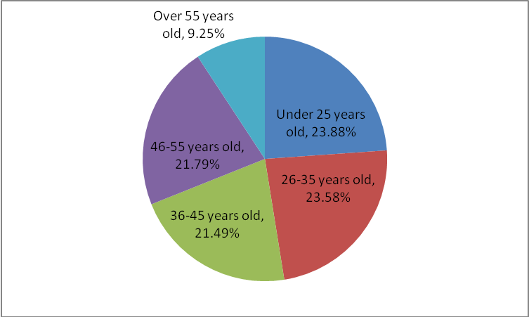

Figure 3.1 The Age Analysis of Customers

According to the above survey results, participants mainly include the following age groups: under 25 years old, 26 years old - 35 years old, 36 years old - 45 years old, 46 years old - 55 years old and over 55 years old. It can be clearly see that most of the participants are under 25 years old, about 23.88% of the total number. Secondly, there are some people aged between 26 and 35, about 23.58%. Thirdly, 21.79% of the participants are between 46-55 years old, and 21.49% of the participants are between the ages of 36 and 45. The lowest number is over the age of 55, which is less than 10% of all participants. In summary, the largest number of participants is under the age of 25 and the age of 26-35 years old. In the analysis of the basic age of customers, Industrial Bank conclude that product promotion and marketing should be roll out in these two age groups, to expand the scope of customers and to reach customers more purposefully. This is the result of the Industrial Bank's understanding of the basic information of customers. The participants' ages Industrial Bank can promote appropriate products and businesses to the corresponding age groups, and seize the target customers and bring good development to the Industrial Bank's wealth management products.

3.1.2 Customer Job Occupation Analysis

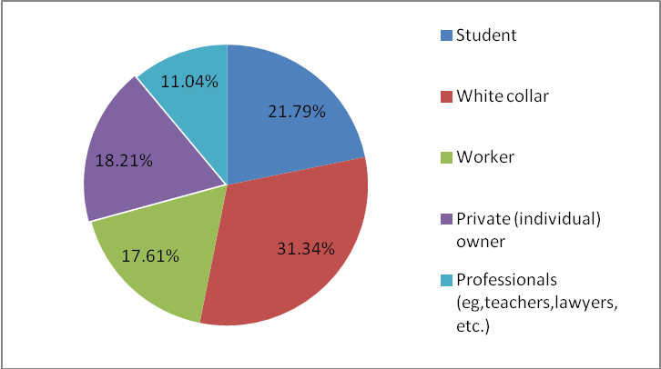

Figure 3.2 The Proportion of Customers' Work Types

From the above survey results, we can clearly see that among all the participants, white-collar workers account for the largest proportion, close to 32%. Next is the number of students, about 22%, only the number of professionals is the least, 11%. In addition to the large number of white-collar workers, the proportion of other occupations is relatively uniform. Workers account for about 17%, and private individual owners account for about 18%. That is to say, among all the participants, including the existing and potential customers of Industrial Bank, most of them are white-collar workers or professionals. In summary, we can understand the basic customer scope of the Industrial Bank's wealth management products business. In the future marketing strategy, white-collar workers and professionals can be regarded as the basic customer scope of Industrial Bank. Only closer and understanding the customers, it will can be the forefront of the financial products business.

3.1.3 Customer Annual Income Analysis

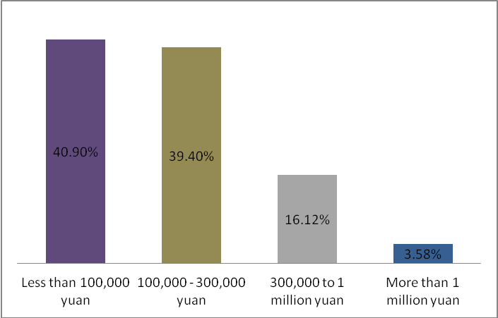

Figure 3.3 Customer's Annual Income

This histogram clearly shows the participant's annual income. Among the participants, 40.09% of the people earned less than 100,000 yuan a year, and people with an annual income of 100,000-300,000 yuan accounted for 39% of all participants. Only a small number of people have an annual income of more than 300,000 yuan. Therefore, the annual income of most families is basically around 100,000 yuan. Therefore, after understanding the basic situation of customers, Industrial Bank needs to make targeted adjustments to the price of wealth management products, so that people can have greater purchasing desires and purchase plans for Industrial Bank's wealth management products.

3.2 Specific Marketing Strategies

3.2.1 Customer's Purchase Channel

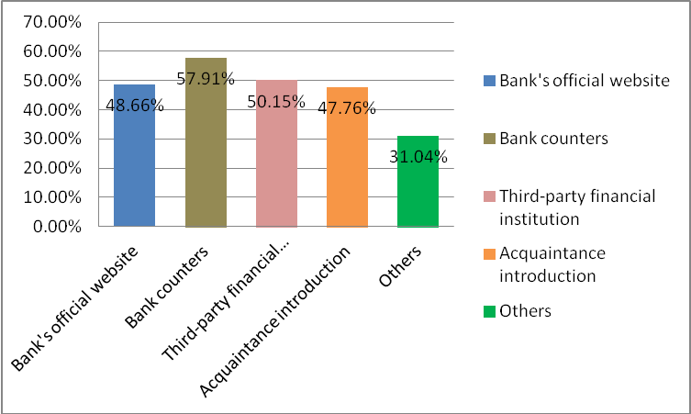

Figure 3.4 Ways for Customers to Purchase Products

The customer's purchase channel provided by Jilin Industrial Bank are mainly the third-party financial institutions and bank counters. The bank counters are more convenient for customers to understand the product, and the banks also provide more professional knowledge to customer.

The above data is the result of a survey of people's ways to purchase financial products. The chart clearly shows people's choice of intentions. More than half of the people say they would prefer to choose a bank counter to buy the product, which accounted for 57.91% of the participants. Second, 50% of people answered that they are also willing to choose a third-party financial institution to buy financial products. At the same time, 48.66% of the respondents like to choose the bank's official website for product understanding. There are still about 47% of participants who like to learn about and buy products through acquaintances. Only 31% chose other ways to buy. According to the survey results, Industrial Bank clearly understand the way people just prefer buy, so as to expand the excavation of counter customers in future marketing strategies, and also inject more detailed strategies into third-party financial institutions to facilitate the establishment, thus enlarger the customer scope.

Therefore, Industrial Bank should design more reasonable financial products based on the results of the questionnaire, and meet the needs of more customers, thus bringing more customer satisfaction.

3.2.2 Customer’s Choice Habit

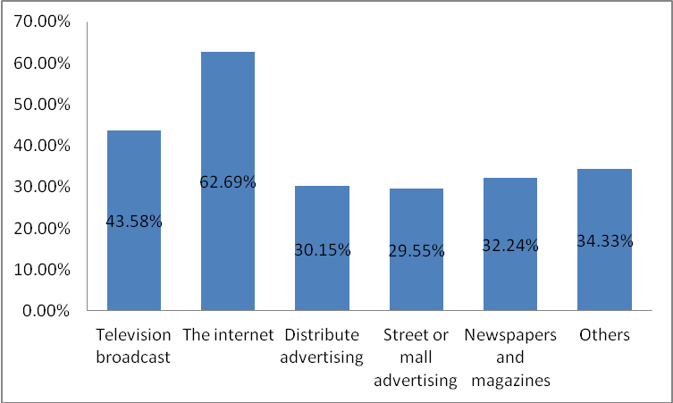

Figure 3.5 The Promoting Method in Customer’s Perspective

The promotional channels currently offered by the Industrial Bank to customers include two types, Internet and advertising. People's lives are inseparable from the Internet. The network not only brings convenience to people, but also brings people knowledge. Advertising is more widely publicized, so it is one of the reasons why Industrial Bank choose.

According to the listed char, participants gave clear answers to questions about the way they like promoted. According to the above figure, 62.69% of people prefer to promote and understand financial products through online promotion. The second method that is willing to accept is television broadcasting. 43.58% of people express their interest in promoting the promotion of financial products through TV broadcasting. This is the second promotion method that people like, and the proportion of other advertising magazines and other promotion methods. Both are around 30%. Only online promotion is the most popular way to promote. Therefore, the Industrial Bank's marketing strategy on the promotion method has a direction. The Industrial Bank should promote the network more because people are more willing to accept the Internet. As we all know, the network has become a range that people of different ages like to contact. So Industrial Bank should spend more energy on the Internet promotion.

3.2.3 Analysis of the Starting Amount of Financial Products

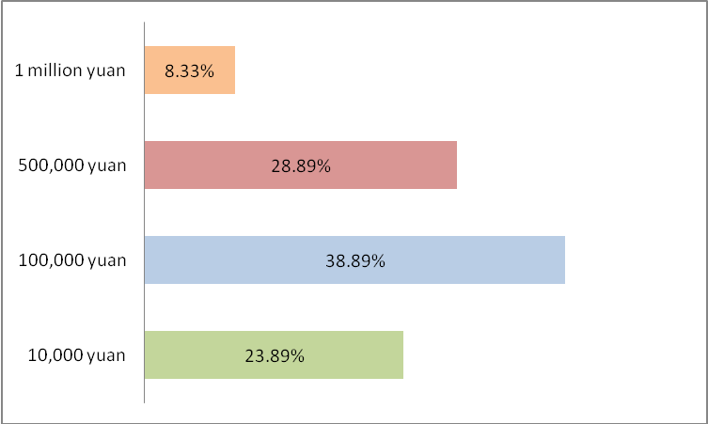

Figure 3.6 The Starting Point of the Financial Products

The starting amount of financial products currently offered by Industrial Bank is between 10,000 and 100,000 yuan. The higher purchase rate is around 100,000 yuan, which is the starting point for most customers to accept.

The above chart is a selection of the starting point for the amount of financial products. About 40% of people are willing to accept the starting point amount of 100,000 yuan. 28.89% of people are willing to accept the starting point amount of 50,000 yuan. Only 8% of people accept a starting point of 1,000 yuan, which only accounts for a small portion. The majority of the starting point is 100,000 yuan. Therefore, Industrial Bank can introduce some financial business with a starting point of around 100,000 yuan. In the beginning of the amount of financial products to make adjustments corresponding, in order to make more reasonable marketing strategy.

3.2.4 Analysis of the Financial Product Price

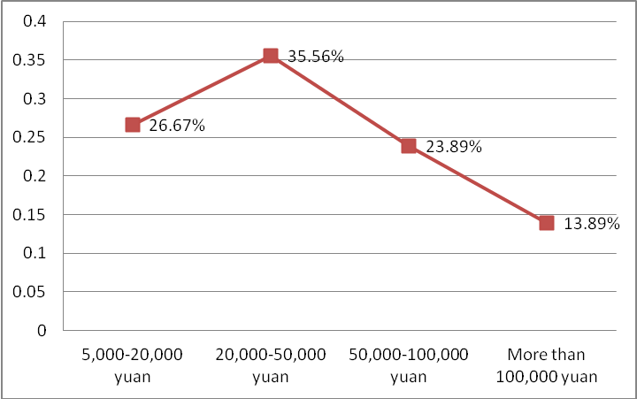

Figure 3.7 Customer-acceptable Financial Product Price

Industrial Bank currently offers the most products with a price range between 5,000 and 50,000 yuan, and the price of this range is more customers like to purchase. The purchase rate of financial products of more than 100,000 yuan is relatively low, so the current high purchase rate of Industrial Bank is between 5,000 yuan and 50,000 yuan. Therefore, Industrial Bank currently has an objective purchase rate for this price range. Subsequent will gradually design more products that meet customer’s needs.

The above chart clearly shows the price of affordable financial products. In answering the question of what price of financial products that people are willing to accept, 35.56% people have answered that the price of financial products they are willing to accept is between 20,000 and 50,000 yuan, and nearly 27% people can accept 5,000 to 20,000 yuan. At the same time, 23.89% of the people said that they can accept the price of 50,000-100,000 yuan of financial products. Obviously, only 13.89% of people are willing to buy more than 100,000 yuan of financial products. It can be concluded that most people are willing to buy 20,000-50,000 yuan of financial products, so the Industrial Bank should expand the promotion channels in the price of the 20,000-50,000 yuan financial products, roll out more products between 20,000 and 50,000 yuan, as much as possible to meet the needs of customers.

3.2.5 Choice Preference of Customer

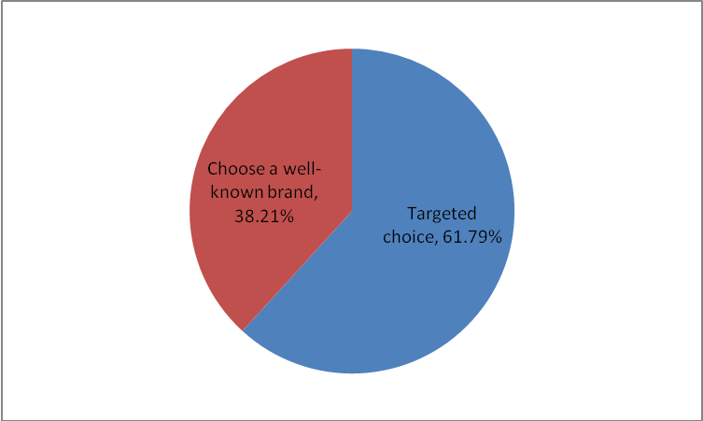

Figure 3.8 Brand Selection of Financial Product

Industrial Bank is also constantly expanding its publicity in terms of branding, paying more attention to brand marketing and enhancing the brand awareness of Industrial Bank. Some customers are more willing to choose brands with higher visibility, so the Industrial Bank is also constantly improving the visibility of products and deepening the breadth and depth of publicity. From all levels, customers can understand and accept the financial products of Industrial Bank, thus greatly enhancing the visibility of Industrial Bank's financial products.

The above pie chart is about people's choice of brand when choosing a financial product. From the above survey results, it can be seen that when people choose financial products, more than half of people answered they will chose the financial products by targeted, which accounts for about 62% of all participants. Only 38.21% of respondents would choose a brand that is well known. Therefore, Industrial Bank not only needs to design products according to the needs of customers, but also needs to pay attention to brand marketing, enhance the brand's popularity.

3.2.6 Customer’s Concerns and Questions

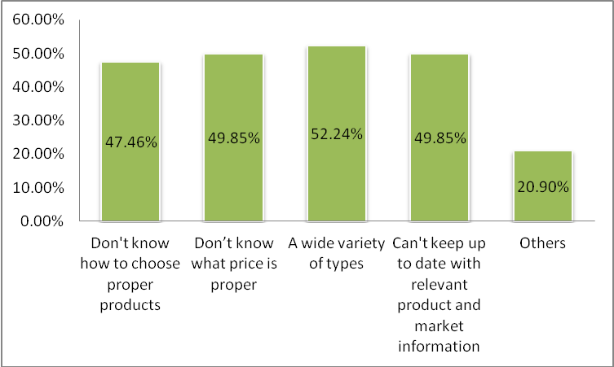

Figure 3.9 Problem at The Time of Purchasing

The main problem that the Industrial Bank currently solves is that customers do not know how to choose the product that suits them. On this issue, Industrial Bank has professional personnel to analyze and answer customer’s questions, and then design personalized products for each customer, so that solve customer’s concerns and questions.

The above chart clearly shows the problems of people when faced choose financial product. 52.24% of people think that their biggest problem is that the variety of products is complicated, they don't know how to choose a proper product. Another 49.85% of people answered the products that did not know what price to choose. Another 49.85% also answered that they had problems that they could not easily and timely understand the information related to financial products. Another 47.46% of people think that the problem they encounter is that they don't know how to choose the right product. Only 20.9% of people choose others. Therefore, the conclusion from the survey results is that a large number of people think that their biggest problem is that there are too many types of products and they don't know how to choose. After conducting research and research, the Industrial Bank should pay attention to the types of products and conduct more reasonable classification and sorting to help customers choose satisfactory products.

3.2.7 Customer’s Understanding of The Product

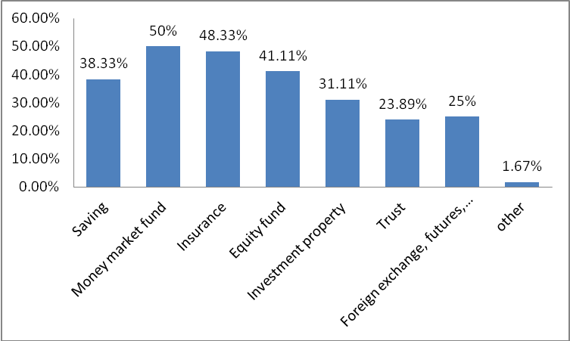

Figure 3.10 Customer's Understanding of The Product

At present, customer know more about the financial products of Industrial Bank, including insurance and equity funds. Insurance is a financial product that people often have access to in life, so most people know it. In addition, Industrial Bank will bring other financial products into more people's lives gradually.

This chart shows the results of the understanding of people's financial products. When answering the question "what do you know about the financial products of Industrial Bank?", 50% of people expressed they understanding the money market funds. There are also 48.33% of people who know about products that are insured, and about 42% know more about equity funds. The number of people who know about savings has also reached 38%. There are other small people who know more about foreign exchange and investment properties. It is clear from the survey results that most people have more understanding of money market funds and insurance, so the Industrial Bank needs to recommend more products that customers know, and it needs to deepen people’s unfamiliar products, in order to achieve the advantages of the product, thereby bringing more product benefits.

3.2.8 Analysis of The Platform

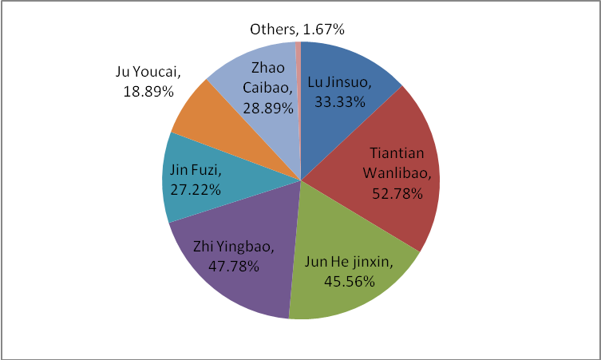

Figure 3.11 A Platform for Customers to Purchase Financial Products

The purchasing platform currently provided by Industrial Bank is Tiantian Wanlibao and Zhi Yingbao, because these two platforms have many advantages, and the development prospects are also broad, besides, they’re also the platform that most customers like. At the same time, Industrial Bank has also launched a number of other financial products. In the follow-up marketing, it will also recommend more suitable products to customers. In order to improve the financial products of Industrial Bank, and continue to improve customer satisfaction.

After investigating the purchasing platform of Industrial Bank's financial products, the following results were obtained: about 52% of the people respondents they often purchase financial products in Tiantian wanlibao, and nearly 48% of people prefer to buy products on the Zhi Yingbao platform, followed by Jun Hejinxin. On the Jun Hejinxin platform, 45.56% of people like buy products on this platform. In addition, 33.33% of people like purchase financial products on the Lu Jinsuo platform, and only 1.67% choose other platforms. After a more detailed understanding of the customer's platform purchases, Industrial Bank needs to design a reasonable marketing strategy. Most people purchase financial products in Tiantian wanlibao, so Industrial Bank should recommend this platform to more customers or potential customers, that this platform is getting better and better. For a platform with less selectivity, Industrial Bank should use a reasonable strategy to adjust the selection rate, bringing more security and satisfaction to customers.

3.3 Industrial Bank's Personal Financial Product Marketing Strategy SWOT Analysis

3.3.1 Strength

Industrial Bank brand advantage. In 2018, the first year of the Industrial Bank's new three-year development plan, according to the bank's new round of general strategic planning, Industrial Bank will actively comply with macro policy guidance and regulatory requirements, accelerate transformation and development, and strive to create "smart finance, professional services" corporate image to achieve sustainable value creation. In addition, Industrial Bank has a strong sense of innovation, keeping up with the needs of its customers and achieving innovation in its development.

3.3.2 Weakness

Financial management and service capabilities are insufficient. Sales strategies and sales organizations lack analysis of customer behavior. At the same time, there is a lack of effective management tools in sales execution and process supervision. These factors have led to the current low efficiency of Industrial Bank's wealth management. The average sales capacity of the network and the number of customer managers in the network are significantly different from those of advanced banks. The lack of data mining ability leads to the lack of systematic hierarchical management of customers, and it is impossible to accurately grasp the changes in customer demand. The differentiated sales service system that is compatible with the customer's hierarchical classification is not perfect, and there is no clear and effective “customer-product”. At the same time, due to the lack of system tools and data tools, the bank's ability to batch systemize marketing and maintain customers is still insufficient.

3.3.3 Opportunities

Wealth accumulation and demand are increasing day by day. With the rapid growth of China's household wealth, especially the middle and high net worth assets, it has stimulated more and more abundant investment and wealth management needs. Overall, the wealth management market has broad prospects. The size of China's private wealth market has increased fivefold in the past decade, and it continues to release considerable growth potential and huge market value. The “One Belt, One Road, Entrepreneurial Innovation” impact continues to deepen, boosting regional development, and the geographical distribution of high-net-worth people is more balanced. It is predicted that by the end of 2020, the total value of personal wealth market will reach 200 trillion yuan, of which high-net-worth customer assets will be about 110 trillion yuan, and the wealth management market has huge room for development.

3.3.4 Threats

Regulatory upgrades have entered a normalized mode. With the rapid development of the banking industry, the business form has been diversified and complicated, and the supervision has also been correspondingly “high”. Strong supervision is expected to become a long-term trend. In 2017, the Banking Regulatory Commission required continuous promotion of rectification of the banking industry's chaos, representing the entry of supervision into the key rectification stage, clearing the key points, establishing the system, returning to the source, and normalizing. Supervision is work-oriented, and the business of financial management, inter-bank, and off-balance-sheet is the focus of rectification in 2018, and it continues to promote de-leverage, de-channel, and de-chaining within the financial system. Under the background of such strong supervision, how to speed up the transformation and development on the basis of complying with the requirements of regulatory compliance, the commercial bank financial business is facing a huge test.

Ⅳ. Conclusions 

Through the analysis of the status quo of the development of personal financial business of the bank, this paper judges the current development trend of the financial market and points out the direction for the development of the personal financial market. Briefly speaking, from the perspective of the development trend of financial products, the following two types of customers will be key financial customers. The first is white-collar workers, and these customers prefer to purchase financial products. The second is the professional, the comprehensive financial products designed for this part of the customer will also grow rapidly. After a basic understanding of the needs of customer, it is also necessary to adjust the marketing strategy according to the needs of customers. Judging from the answers to the questionnaires, the information on the channels that customers receive is relatively diverse, and the personal wealth management products are understood through various channels. 61% of people will have targeted financial products, which means that they are currently highly targeted in personal finance, and they will have a detailed understanding and careful choice when purchasing products. In the financial products, more products with prices between 20,000 and 50,000 should be introduced. From the perspective of marketing channels, it also should distribute through multiple channels. The core channels are counters and networks, and we can strive to connect in a short period of time from propaganda to purchase. Provide customers with quality products and satisfactory service. It also provides a long-term development path for Industrial Bank's financial products. Industrial Bank Jilin should give full play to the Bank's economic resources advantage, emphasize the innovation of personal financial products after possessing certain capital, resources and market, analyze the needs of customers as the center, combine information technology, and develop more convenient and practical personal financial products.

Ⅴ. Recommendation 

Based on the marketing strategy theory of the second chapter, summarizing the current situation analysis of the intellectual property marketing of the Industrial Bank Jilin Branch, and based on the empirical conclusions of the research, it can be concluded that the factors that are more important for the marketing of wealth management products are product income stability, trust, and employment. The expertise of the personnel, the risk disclosure and the risk of the product itself. Therefore, this paper puts forward some suggestions: First, we should improve product revenue and reduce risk, increase product trust; second, improve the service attitude of employees and enhance customer satisfaction; third, with mobile internet technology and online product marketing, etc. , expand marketing channels. 

5.1 Reduce Risk and Increase Trust

Industrial Bank can take advantage of its capital scale and should increase investment in R&D investment in wealth management products, including human, financial and material resources in the areas of R&D team formation, capital investment selection and operation. Through customer demand research, obtain customer demand information, and design financial products services that can meet individual needs. In terms of risk control, from the counter-marketing of financial personnel to the investment operation of funds, setting up risk monitoring indicators for each link and the entire process, you can set up a 'product laboratory' to test the yield of products before the products are put on the market. Risks, through repeated testing, improve product revenue stability, and reduce product risk fluctuations. In short, scientific and reasonable organizational structure and reasonable staffing arrangements and scientific product design can actively control risks and increase product revenue.

5.2 Improve the Quality of Employees

According to research and analysis, Industrial Bank Jilin Branch has a disadvantage in terms of business structure and profit model, marketing strategy and relatively backward international business. According to the results of the survey and analysis, the overall quality of the financial products marketing of the Industrial Bank Jilin Branch is low. Faced with numerous customers and professional teams, it is essential for the design, management and marketing of wealth management products. Industrial Bank should make breakthroughs in professional knowledge and service attitude, and implement professional team operation mode in the design, operation, management and marketing of wealth management products, and take advantage of the strength and strength of team cooperation to improve the development of financial business of Xingye Yinqiao. Overall strength. Secondly, the comprehensive quality of marketing personnel should be improved in terms of talent recruitment and talent training. Specifically, in terms of talent recruitment, one can use marketing to attract talents, that is, to use the marketing service as the charm of the profession itself to recruit relevant talents in universities and talent markets; second, to focus on the combination of interests and abilities when recruiting talents, only Be interested in marketing and have the ability to do marketing well.

5.3 Expand Marketing Channels

Other banks and online financial management tools, such as Yubao's extremely low reputation, have occupied a huge market and have greatly impacted the banking products business. Therefore, Industrial Bank should keep up with market trends, speed up the response, and innovate mobile internet technology. And online product marketing and other service methods, simplify the procedures for the purchase of financial products, and vigorously expand the distribution channels of e-banking wealth management products to meet the new needs of customers, and provide customers with real convenience. With mobile internet technology, companies can adopt a new model to achieve online marketing, mainly based on targeted marketing based on targeted customers and social media marketing model based on information sharing. 

5.4 Multiple Marketing Mix Strategies

At present, from the above empirical analysis and actual research, the marketing strategy of Industrial Bank Jilin Branch's wealth management products is relatively backward, which is reflected in the following aspects: Industrial Bank's wealth management products in terms of product quality, yield stability, risk size, and purchase amount The customer satisfaction is lower in the aspect of the wealth management products, the number of customers recommended by friends and relatives is less, indicating the need to improve and lift the relationship marketing strategy, in the communication of customer care and marketing services, the customer's Satisfaction is low, indicating that the 4C strategy can be adopted. In a narrow sense, the marketing model is still stuck in the model of full-person marketing. In a market where residents' financial needs are increasing and market competition is increasing, this marketing strategy needs to change. A single marketing strategy can not adapt to market development, and must comprehensively apply marketing mix strategies according to the characteristics of the bank and the characteristics of the target market.

References

A. Jueland and Shugan S. Managing Channal Profits [J]. *Marketing Science* 2 (1983): 239-272.

Brian Scott-Quinn,1995,“*Investment Banking :Theory and Practice*”, Euromoney Book

Choi S.Chan.*Price Competition in a Channel Structure with a Common Retailer* [J]. *Markting Science* 10 (2017): 271-296.

C, Aiken. Financial Operations and Services [J]. *World Banking Abstracts* 36 (2019): 12-16.

G. Shaffer.Slotting Allowances and Retail Price Maintenance. A Comparison of Facilitating Handa. *Monetary Economics*, [M]. Routledge 2000.

Practices [J]. *RAND Journal of Economics* 22 (1991): 120-130

P. Rey and Stiglitz J. Vertical Restraint and Producers Competition [J]. *European Economic Review* 32 (1988): 561-568.

管海盟. 兴业银行安庆分行个人理财业务研究[J].合作经济与科技 6 (2018): 53-55.

李璐. 兴业银行长春分行理财业务营销策略研究[D].吉林大学, 2018.

刘月. 兴业银行长春分行“现宝”理财产品营销策略研究[D].吉林大学, 2017.

庞晓飞. 浦发银行郑州分行理财产品营销策略研究[D].西安理工大学, 2017.

伍丽玲. 兴业银行吉林分行理财产品营销策略分析[D].中南林业科技大学, 2016.

杨曌凉. 我国商业银行个人理财业务的问题——以兴业银行理财产品为例[J].池州学院学报 29.5 (2015): 67-70.

Acknowledgement

This paper took about several months from the beginning to the end. In the process, I encountered a lot of problems that I could not solve alone, but thanks to the help of teachers and classmates, I ended up quite. coming. I am especially grateful to my instructor. She has always been so serious and timely in answering my questions. I have been tired of over and over again to help me point out the shortcomings in my thesis and give guidance and advice. In addition, when the library checked the information, the library teacher also gave me a lot of help and support. Here I would like to express my deep gratitude to the teachers and students who have helped me. Thank you!

I also want to thank you for the scholars mentioned in this paper. This article cites the research literature of several scholars. If there is no knowledge accumulated by the predecessors, then the difficulty of completing this paper will increase tenfold or even 100 times. Thank you!

Thanks also to my friends and classmates. During this time, many problems were solved in our discussion. The paper layout and writing process also helped me a lot, thank you!

表达对导师或者对论文写作起辅助指导之人的感谢之词。

Appendix

1. 您的年龄是：

A. 25岁以下 B. 26岁至35岁 C. 36岁至45岁

D.45岁至55岁 E. 55岁以上

1. Your age is:

A. Under 25 years old B. 26 years old-35 years old

C. 36 years old -45 years old D. 45-55 years old

E. over 55 years old

2. 您的职业是：

A. 学生 B. 白领 C. 工人

D. 私营（个体）业主 E.专业人士（如，老师，律师等）

2. Your occupation is:

A. Student B. White Collar

C. Worker D. Private (individual) owners

E. Professionals (eg, teachers, lawyers, etc.)

3. 您的家庭年收入是

A. 10万元以下 B. 10万—30万

C. 30万—100万 D. 100万以上

3. Your family's annual income is?

A. Below 100,000 yuan B. 100,000 - 300,000 yuan

C. 300,000 - 1 million yuan D. More than 1 million yuan

4. 您偏好投资多长期限的理财产品:

A. 1个月以内 B. 1个月到6个月

C. 6个月到1年 D. 1年到2年

4. How long do you prefer to invest in financial products?

A. Within 1 month B. 1 month to 6 months

C. 6 months to 1 year D. 1 year to 2 years

5. 您在选择理财产品时，是有针对性和目的性的去选择还是会选择熟知的品牌？

A. 有针对性的选择 B. 选择熟知品牌

5. When you choose a financial product, you will chose a targeted product or a well-known brand?

A. Targeted choices B. Choose a well-known brand

6. 您一般会通过哪些途径了解理财产品？

A. 银行官网 B. 银行柜台

C. 第三方理财机构 D. 熟人介绍

6. How do you usually purchase financial products?

A. Bank’s official website B. Bank counter

C. Third-party financial institutions D. Introducing acquaintances

7. 在购买银行理财产品中，哪些问题困扰您? （多选）

A. 不知如何挑选适合自己的银行理财产品

B. 在购买时，不知道买入多少合适

C. 银行理财产品太复杂，很难理解

D. 不能方便及时的了解与理财产品市场相关的产品

E. 其他

7. What problems are plaguing you in purchasing bank financial products? (multiple choice)

A. I don't know how to choose the bank financial products that suit me.

B. When buying, I don’t know how much to buy.

C. Bank w financial products are too complicated to understand

D. It is not convenient and timely to understand the products related to the financial products market.

E. Others

8. 关于理财产品的推广方式和宣传了解，您更喜欢哪种推广方式？

A. 电视广播

B. 网络

C. 派发广告

D. 街头或商场广告

E. 报刊杂志

F. 其他

8. Regarding the promotion methods and publicity of financial products, which promotion method do you prefer?

A. Television broadcasting

B. Network

C. Distributing advertisements

D. Street or mall advertising

E. Newspapers and magazines

F. Others

9. 您最关注理财产品的哪个方面？（多选）

A. 收益是否有吸引力

B. 安全是否有保障

C. 推荐机构的信誉

D. 发行机构的实力与信誉

E. 其他

9. Which aspect of your financial products are you most concerned about? (multiple choice)

A. Is the income attractive?

B. Is security guaranteed?

C. Reputation of the recommending agency

D. The strength and credibility of the issuer

E. Other

10. 假如您要选择兴业银行的理财产品，您是出于看重了哪一方面的优势？

A. 详尽介绍理财产品

B. 该银行靠近您生活工作的地方，了解相关信息比较方便可靠 C. 该银行理财产品信息透明度高

10. If you want to choose the financial products of Industrial Bank, what advantage do you value?

A. Introducing financial products in detail

B. The bank is close to where you live and work, and the relevant information is more convenient and reliable.

C. The bank's financial products have high transparency

11. 您购买的吉林兴业银行个人理财产品收益率达到以下哪个水平？

A. 银行定期存款 B. 理财产品平均水平

C. 基金平均收益率 D. 国债收益率

11. Which of the following levels does the profit rate of the personal financial products of Jilin Industrial Bank you purchase?

A. Bank time deposits B. Average wealth management products

C. Average fund yield D. Treasury yield

12. 您对吉林兴业银行个人理财产品哪个要素最满意？

A. 收益率 B. 保本

C. 起售金额 D. 期限

12. Which element of the personal wealth management products of Jilin Industrial Bank is most satisfied with?

A. Yield B. Guaranteed

C. Starting amount D. Term

13. 请问您对吉林兴业银行个人理财产品出现亏损的现象的看法是？

 A.不能忍受亏损 B.能接受无利息

 C.能接受亏损5%的本金 D. 能接受亏损5%以上的本金

13. What is your opinion on the loss of personal financial products of Jilin Industrial Bank?

 A. Can't stand the loss B. Can accept no interest

 C. Can accept a loss of 5% of the principal D. Can accept a loss of more than 5% of the principal

14. 您会将您收入中的多大比例购买理财产品：

A、10%以下 B、10%－20%

C、20%－50% D、50%以上

14. How much of your income will you spend on financial products?

A, 10% or less B, 10%-20%

C, 20%-50% D, 50% or more

15. 您满意的理财产品金额起点是多少？

A. 1万元 B. 10万元

C.50万元 D. 100万元

15. What is the starting point for your satisfactory financial product?

A. 1 million yuan B. 100,000 yuan

C.500 million yuan D. 1 million yuan

16. 您购买了吉林兴业银行什么价位的理财产品？

A. 5千元-2万元 B. 2万元-5万元

C. 5万元-10万元 D.10万元以上

16. Which price of the financial product did you purchase from Jilin Industrial Bank??

A. 5 thousand yuan - 2 million yuan B. 2 million yuan -50,000 yuan

C. 50,000 yuan to 100,000 yuan D. 100,000 yuan or more

17. 你了解以下吉林兴业银行的哪种个人理财产品？（多选）

A. 储蓄

B. 货币市场基金

C. 保险

D.股票基金

E.投资房产

F.信托

G.外汇、期货、黄金

H. 其他

17. Do you know the following personal financial products of Jilin Industrial Bank? (multiple choice)

A. Savings

B. Money market fund

C. Insurance

D. Equity fund

E. Investment property

F. Trust

G. Foreign exchange, futures, gold

H. Others

18. 您是通过什么渠道了解的以上个人理财产品？（多选）

A. 亲人朋友介绍 B. 相关专业人员推荐

C. 自己了解 D. 其他

18. What channel do you know about the above personal financial products? (multiple choice)

A. Introduction of relatives and friends B. Recommended by relevant professionals

C. Know for yourself D. Others

19. 您对以下吉林兴业银行哪些理财增值服务比较感兴趣？（多选）

 A.提供专业的理财咨询服务

 B.定期举办交流活动

C. 定期举办专业的知识讲座

D. 有专业顾问通过邮件、短信或者QQ等工具及时传达资讯

E.不需要

F. 其他

19. Which of the following financial value-added services of Jilin Industrial Bank are you interested in? (multiple choice)

 A. Provide professional financial consulting services

 B. Regular exchange activities

C. Regular professional knowledge lectures

D. Have professional consultants to timely convey information through email, SMS or QQ tools

E. No need

F. Others

20. 平常购买吉林兴业银行理财产品的平台是哪个？（多选）

 A.陆金所

B. 天天万利宝

C. 骏合金信

D. 智盈宝

E. 金斧子

F. 聚有财

G.新浪微财富

H.招财宝

I. 金银猫

J.其他

20. Which platform is the usual purchase of financial products of Jilin Industrial Bank? (multiple choice)

 A. Lu Jinsuo

B. Everyday Wanlibao

C. Jun Alloy Letter

D. Zhiyingbao

E. Golden axe

F. Gathering wealth

G. Sina micro wealth

H. Lucky treasure

I. Gold and silver cat

J. Others

21. 您认为以上提供吉林兴业银行个人理财产品的平台有什么优势？（多选）

A. 收益率高 B. 流动性灵活

C. 安全性高 D. 结构简单，操作便捷

21. What advantages do you think are the advantages of the above platform for providing personal financial products of Jilin Industrial Bank? (multiple choice)

A. High yield B. Flexible mobility

C. High security D. Simple structure and convenient operation

22. 您对我国兴业银行开展个人理财业务的营销策略的看法是?

________________________________

22. What is your opinion on the marketing strategy of China Industrial Bank to carry out personal financial business?

________________________________

大连东软信息学院

毕业设计（论文）原创承诺书

1、本人承诺：所提交的毕业设计（论文）是认真学习理解学校的《毕业设计（论文）工作规范》后，在教师的指导下，独立地完成了任务书中规定的内容，不弄虚作假，不抄袭别人的工作内容。

2、本人在毕业设计（论文）中引用他人的观点和研究成果，均在文中加以注释或以参考文献形式列出，对本文的研究工作做出重要贡献的个人和集体均已在文中注明。

3、在毕业设计（论文）中对侵犯任何方面知识产权的行为，由本人承担相应的法律责任。

4、本人完全了解学校关于保存、使用毕业设计（论文）的规定，即：按照学校要求提交论文和相关材料的印刷本和电子版本；同意学校保留毕业设计（论文）的复印件和电子版本，允许被查阅和借阅；学校可以采用影印、缩印或其他复制手段保存毕业设计（论文），可以公布其中的全部或部分内容。

5、本人完全了解《毕业（设计）论文工作规范》关于“学生毕业设计（论文）出现购买、他人代写、或者抄袭、剽窃等作假情形的，取消其学位申请资格；已经获得学位的，依法撤销其学位。取消学位申请资格或者撤销学位者，从处理决定之日起3年内，学校不再接受学生学位申请”的规定内容。

6、本人完全了解《学生手册》中关于在“毕业设计（论文）等环节中被认定抄袭他人成果者”不授予学士学位，并且“毕业学年因违纪受处分影响学位的学生不授予学士学位，并且无学士学位申请资格”的规定内容。

以上承诺的法律结果、不能正常毕业及其他不可预见的后果由学生本人承担！

学生本人签字：

 年 月 日