Test case for invalid school name entry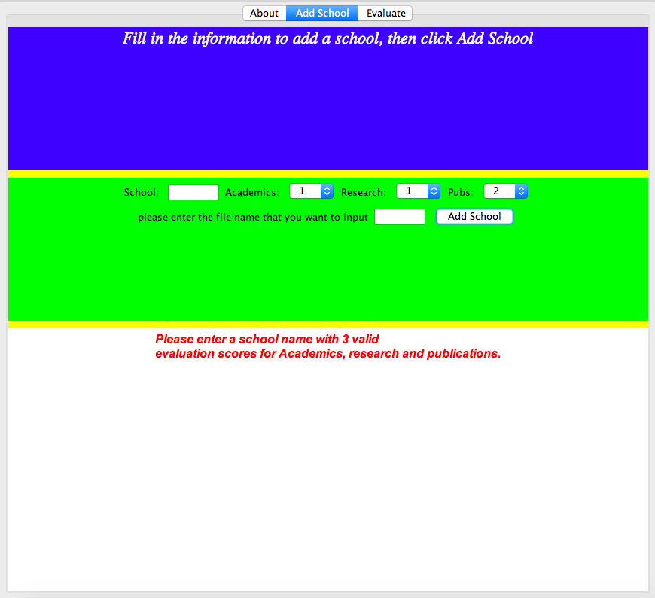

Test case for adding a school that is not in capital letter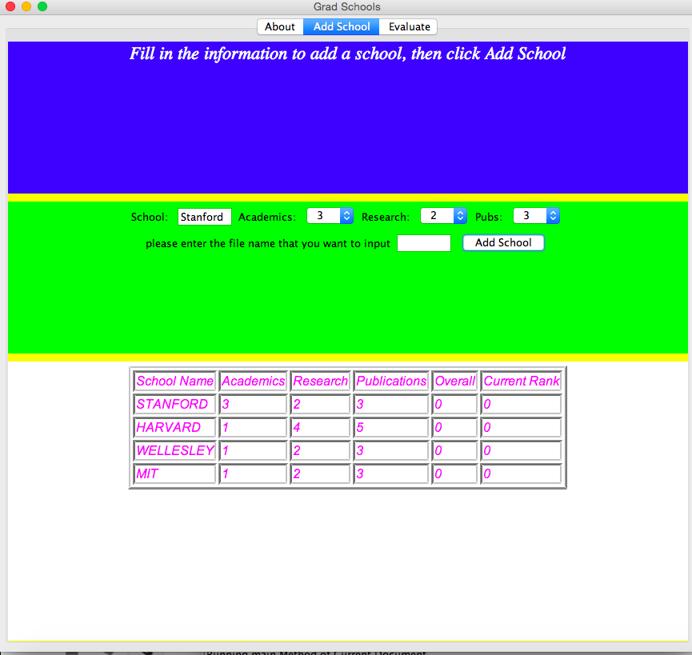

Test case for importing from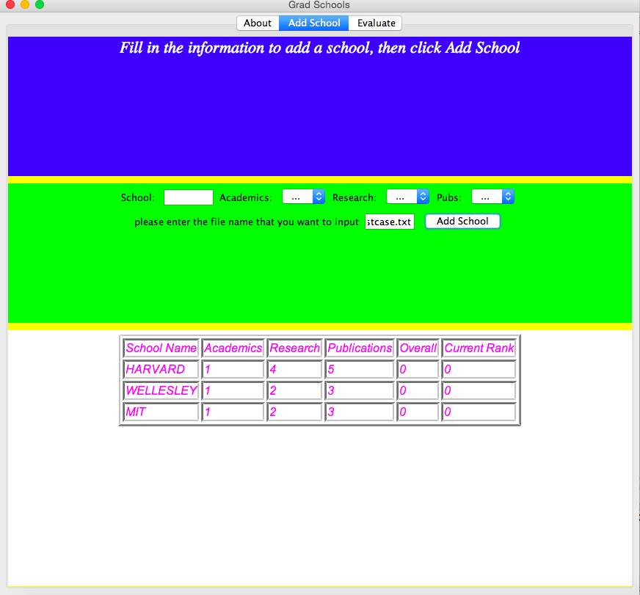 file

Test case for invalid file name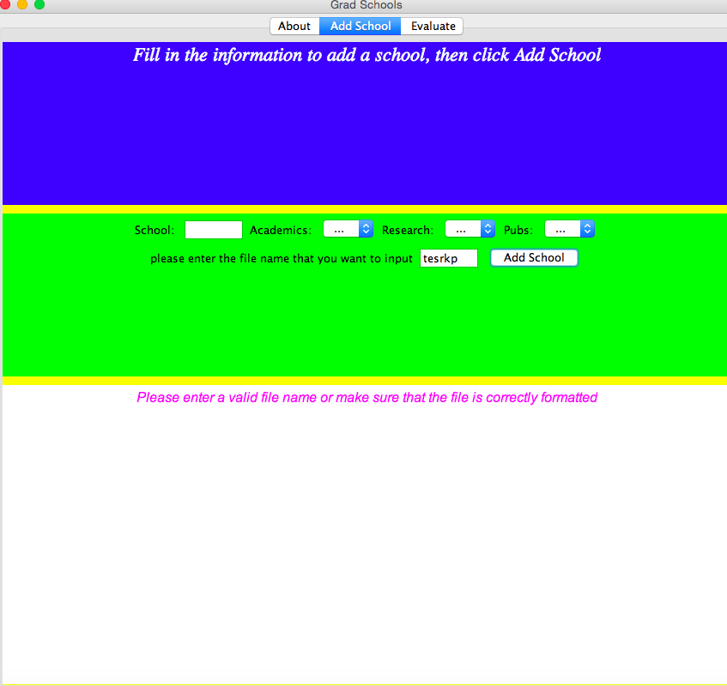

test case for leaving everything blank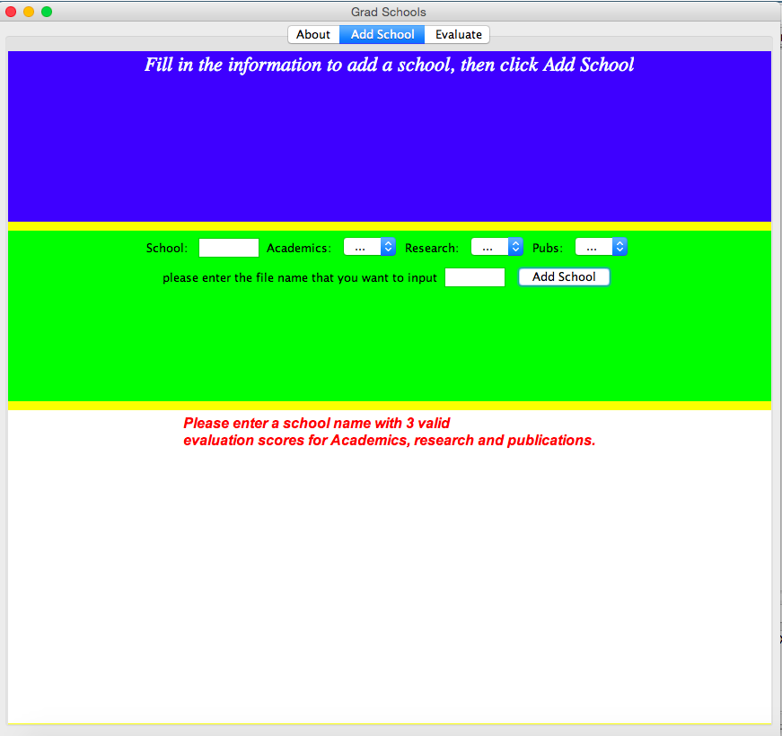

check if ranking id correctly ranked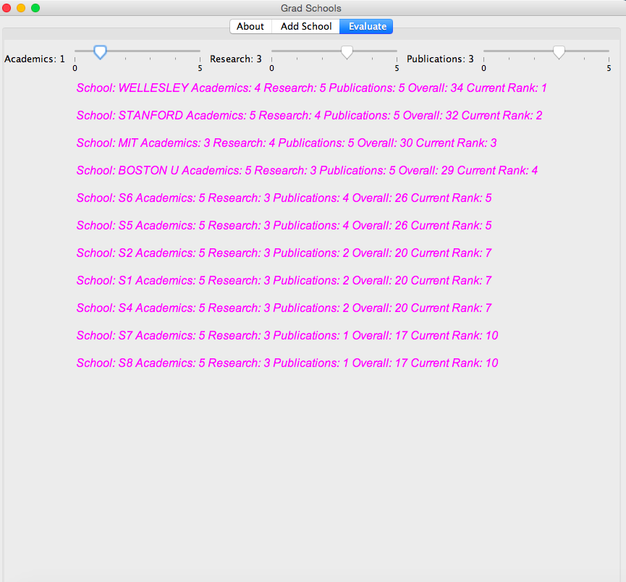

check if our catch number format error is properly implemented, because one of the number in testcaseF.txt is a ltter.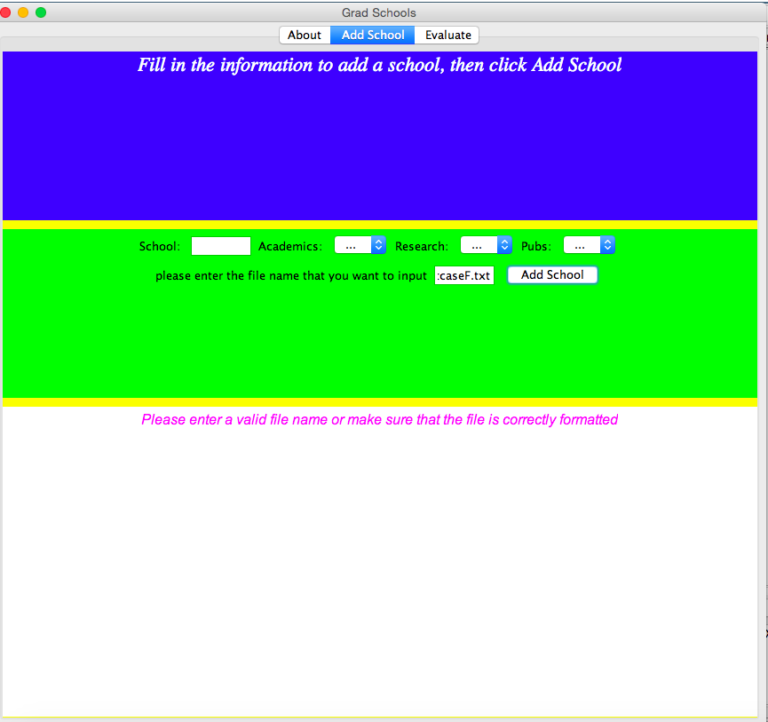

check if the list only keeps 10 schools in the current window.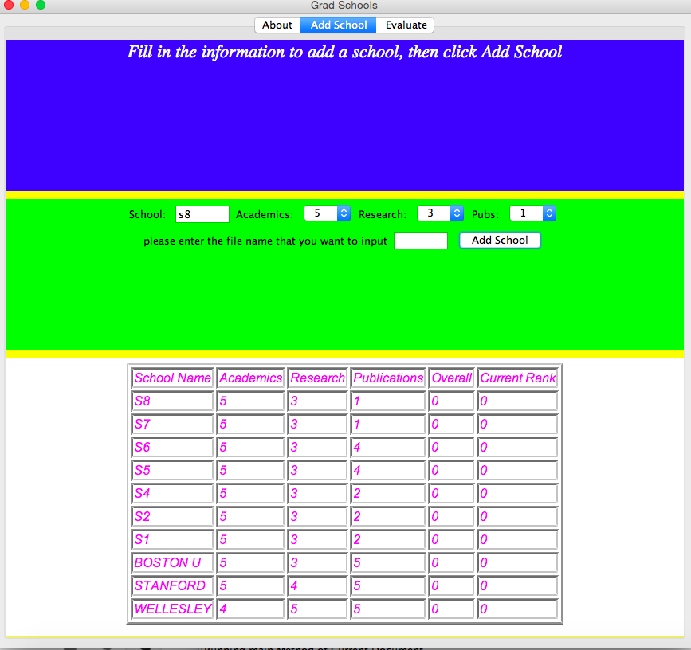

Check if inputting the same school cause any changes. Expect it should not, since we implement it this way in our code.