A healthy houses dashboard
- Most flexible design
  - Select 311 call type from list
  - Select year range (possibly by month)
  - Select health outcome
  - Create a point map for 311, spatial join with health outcome spatial units, compute rates
  - Map rates for 311 and health outcomes
- Short-term mock-up
  - Shapefiles with point data for 2020-24 311 calls
    - Select type of 311 call
      - HDF – lead inspection
      - AAF – water in basement
      - BBA – building violation
      - SGA - rats
  - Master shape file with zip code zone data for health outcomes, 311 call counts and rates per 10,000 population
    - Select health outcome per zip code zone
      - Edvisr2024 – youth asthma emergency dept visit rate / 10,000 youth pop
      - Edvis24rc – same rate per 10,000 pop
      - Edvis2024 - youth asthma emergency dept visit count
  - Select rates from master shape file
    - One drop down list for 311 calls
    - One drop down list for health outcomes
- Map type options:
  - Point map (hdf_20_24cl.shp), Quantile map, Box map (outlier map), relative rate/excess risk map
  - Illustrations (using HDF points/rates and Edvisr2024, from chicago_zip.shp)
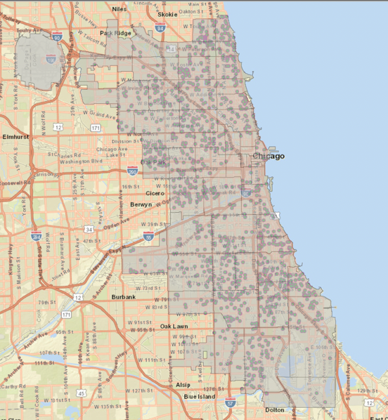
HDF points
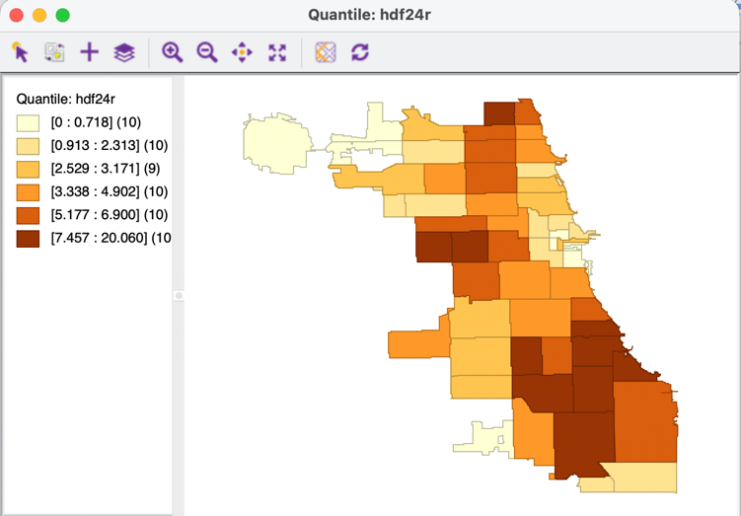
HDF rate – 6 quantiles
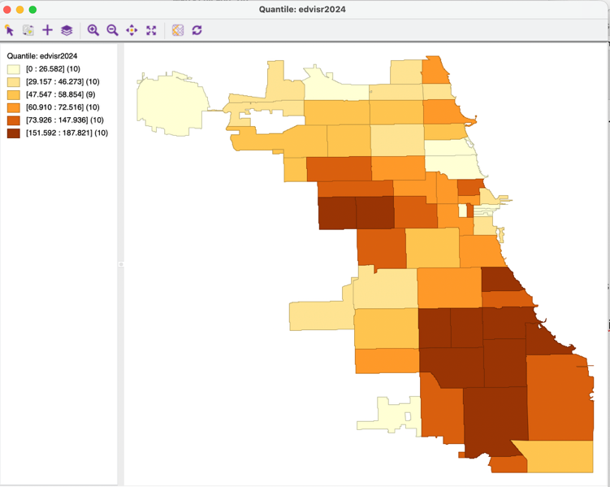
EDvisitrate – 6 quantiles
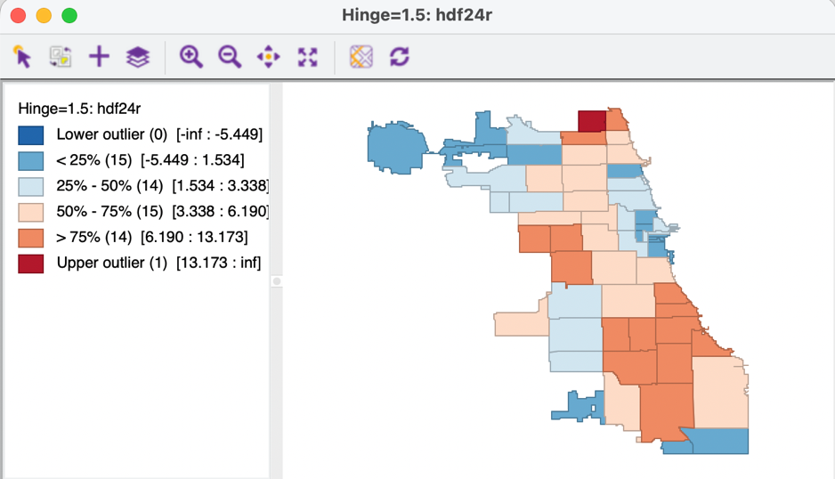
HDF rate – box map
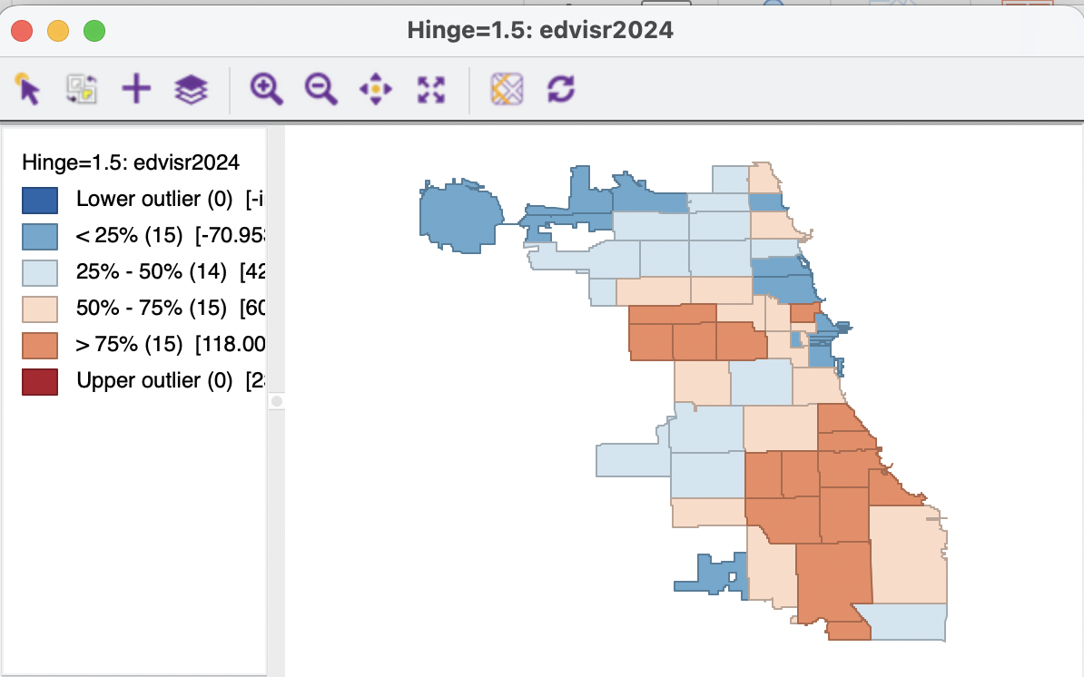
Edvisrate – box map
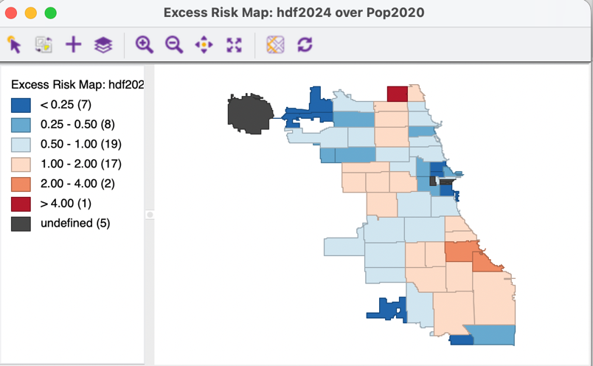
HDF excess risk
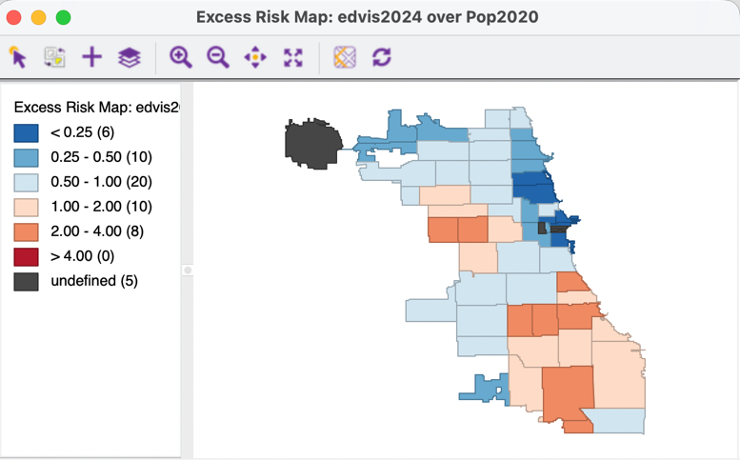
ED visits – excess risk
- Analysis options
  - Scatterplot health outcome on 311 call rate
    - Assess effect of outliers
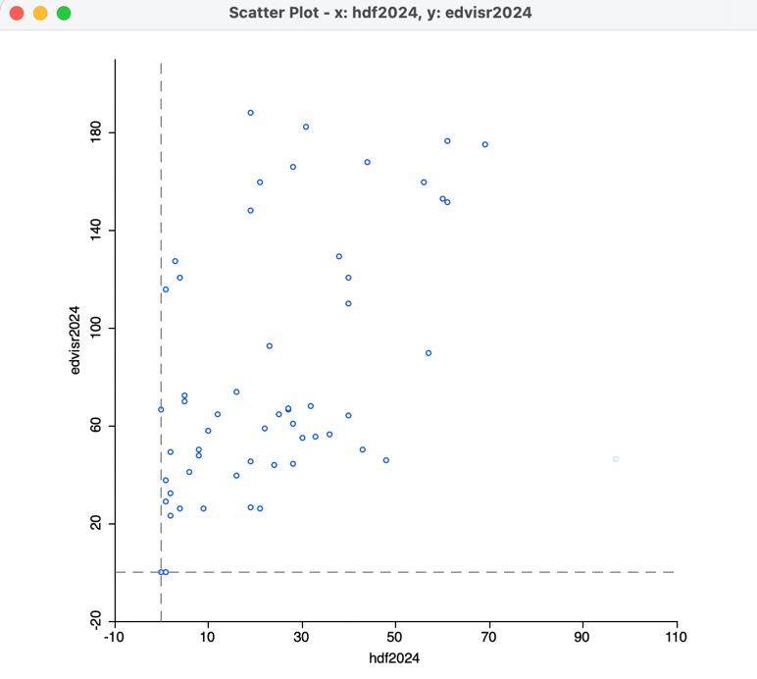
Scatterplot – edvisrate and HDFrate
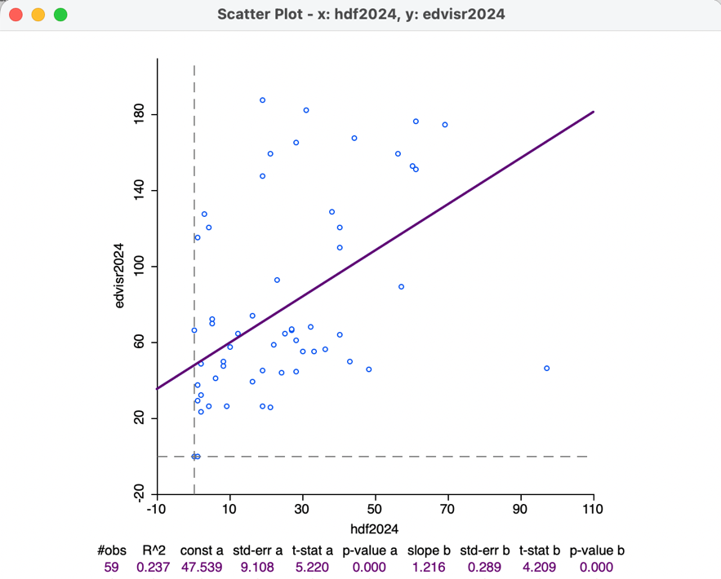
Scatterplot, linear association – edvisrate and HDFrate
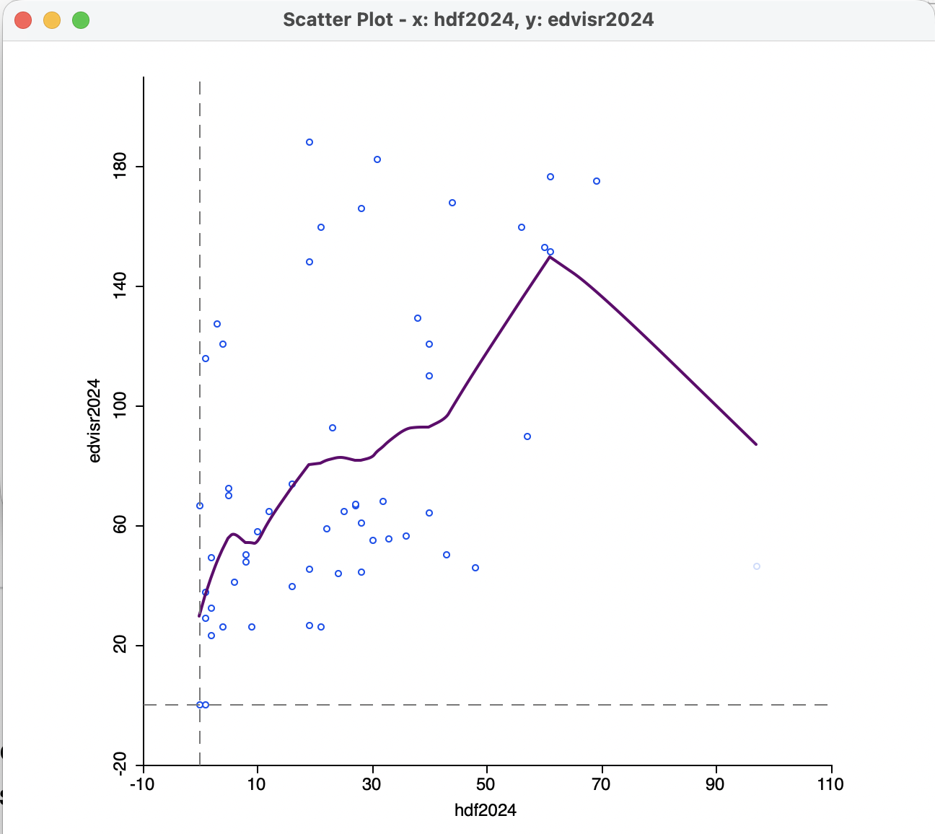
Scatterplot, local regression – edvisrate and HDFrate
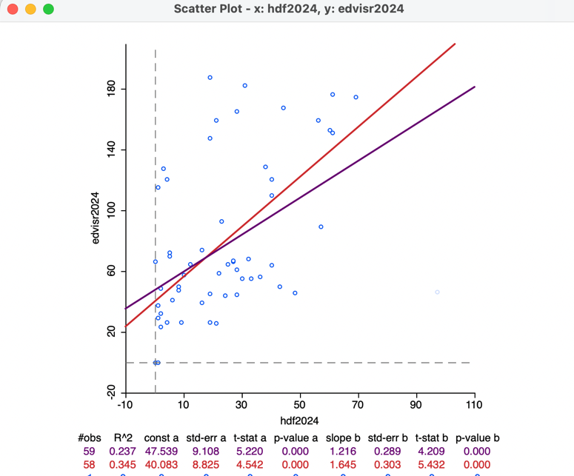
Scatterplot, effect of outlier – edvisrate and HDFrate
  - Scatterplot matrix row
    - Y-axis is health outcome
    - X-axis are various 311 call rates

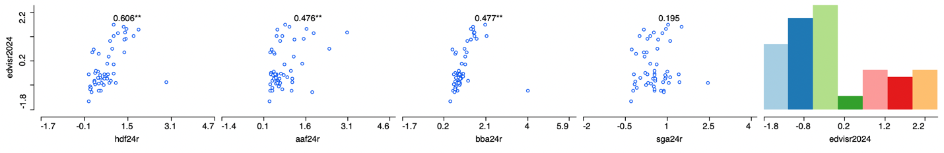
Scatterplot matrix: edvisrate vs 311 call rates
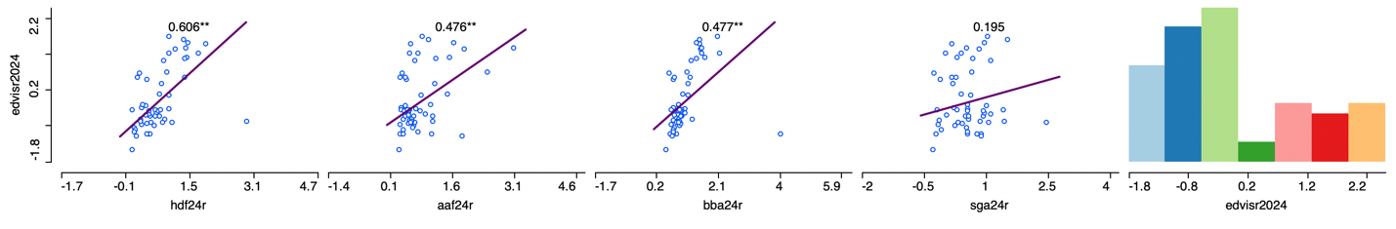
Scatterplot matrix, linear association: edvisrate vs 311 call rates
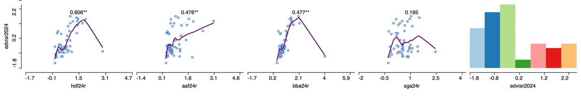
Scatterplot matrix, local regression: edvisrate vs 311 call rates
  - Pre-computed spatial weights: queen contiguity, chicago_zip_q.gal.
    - Weights in pygeoda or libpysal
  - Overlay of extreme quantiles, quantile LISA
    - Implement co-location map for quantiles
      - Common six quantile categories between edvisrate and hdfrate (i.e., those tracts that fall in same quantile for both)
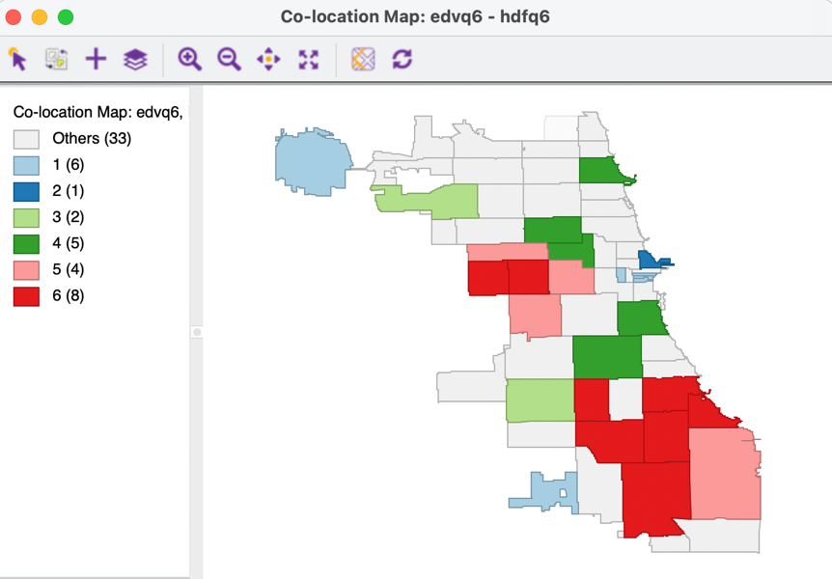
Quantile co-location map (k=6) – edvisrate and HDFrate
      - Common extreme quantiles (top only)
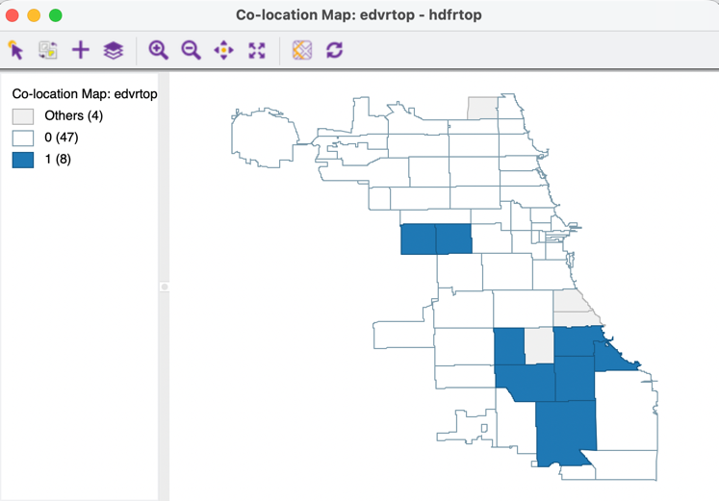

    - Implement quantile LISA for extreme quantiles (local clusters of coincidence, i.e., co-located zip code zone surrounded by other co-located zip-code zones, based on local join count statistic)
      - Quantile lisa in pygeoda
      - Univariate
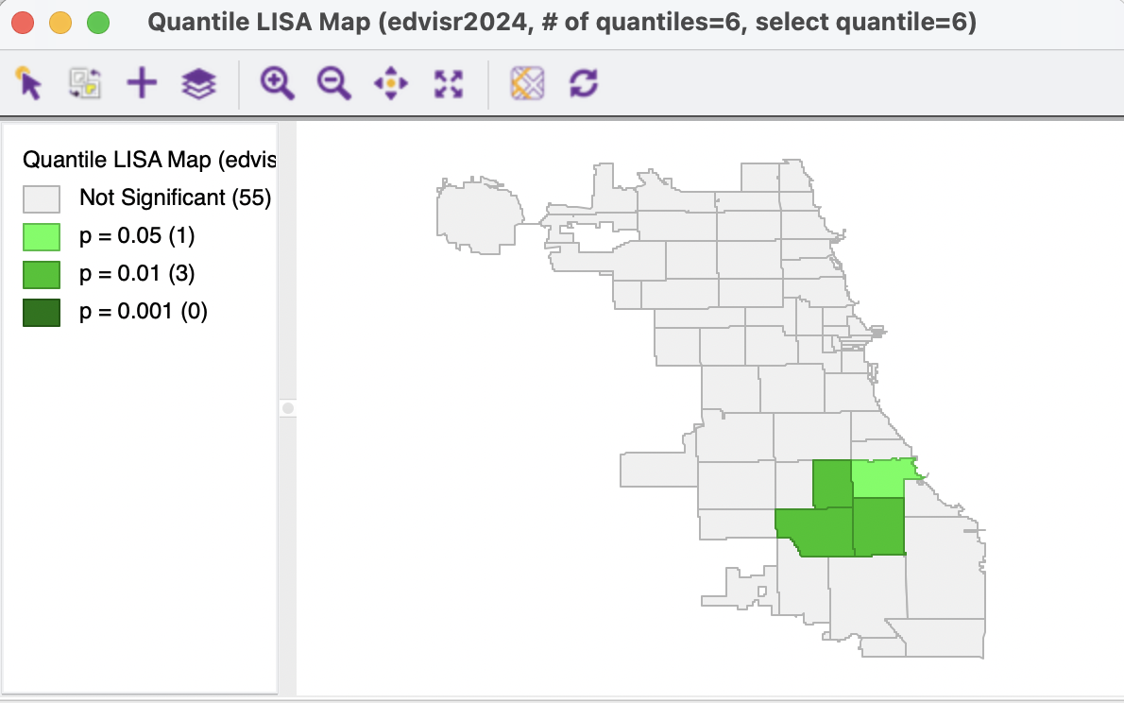
Edvisrate – quantile lisa (top 6th quantile)
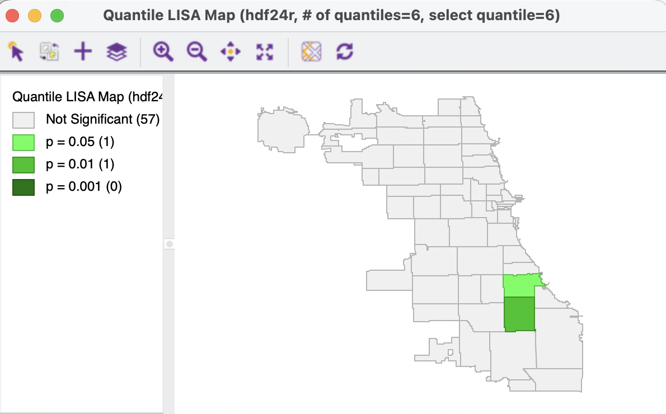
HDFrate – quantile lisa (top 6th quantile)

      - Bivariate
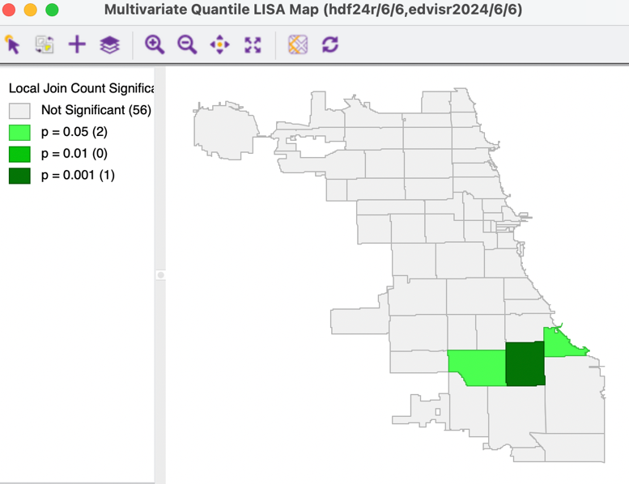
Bivariate quantile lisa (top 6th quantile)

  - Hot spots and cold spots (Local Moran – needs spatial weights)
    - Pre-computed spatial weights
    - Local Moran in pygeoda
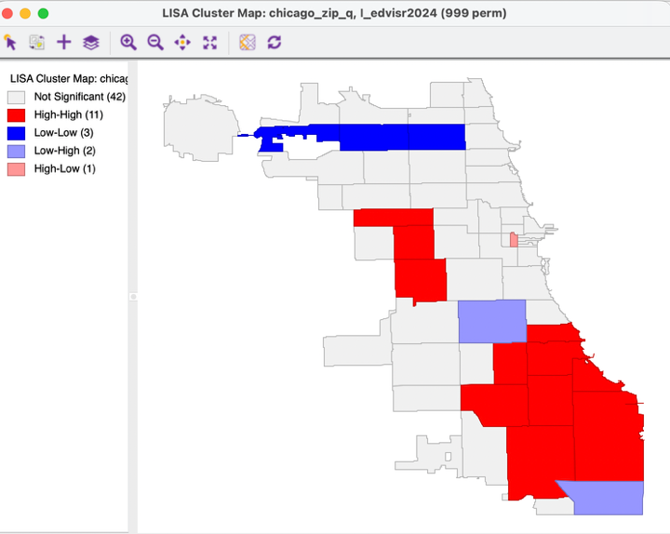
Edvisrate – hot spots and cold spots
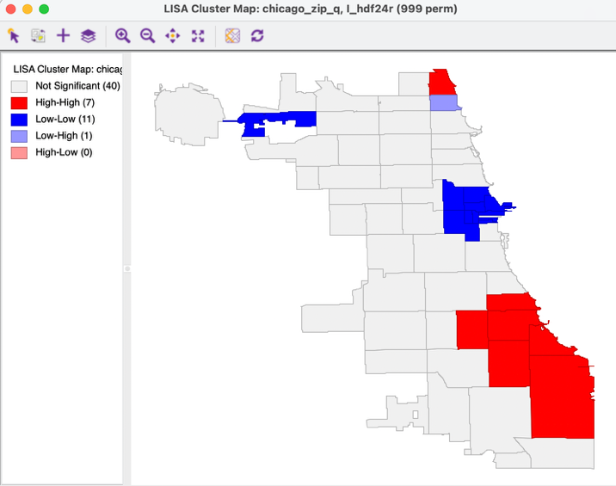
HDF rate – hot spots and cold spots
- Extensions
  - If data are available, make dynamic, show patterns over time

