Infrastructure is not under survey, see here the main hierarchy

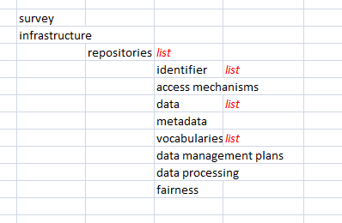

Structure for repositories:

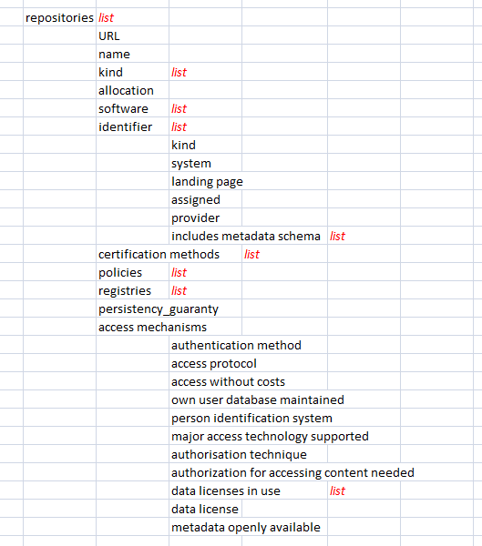

The changes of repository worked and are included in script22.

Structure for data:

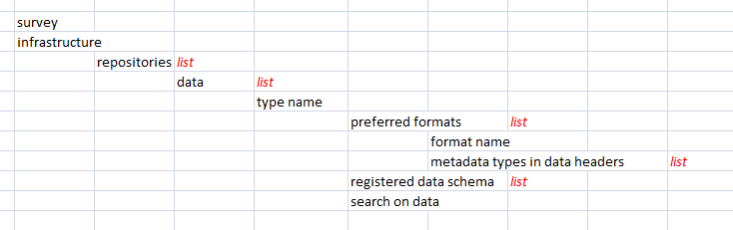

How I would change data (but seems not totally correct):

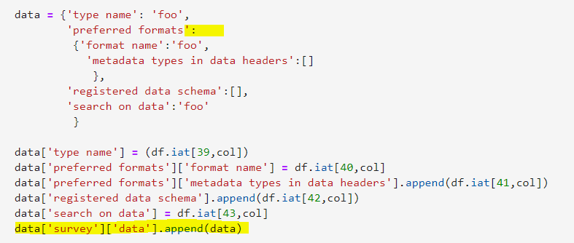

Preferred formats should be a list [], but then I get an error

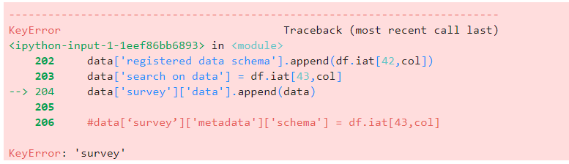

Structure for metadata:

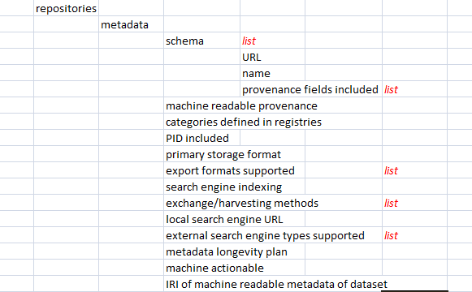

How I would change metadata (but seems not totally correct):

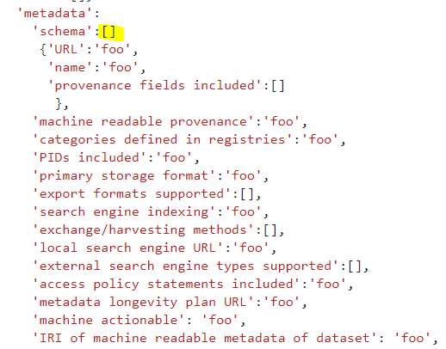

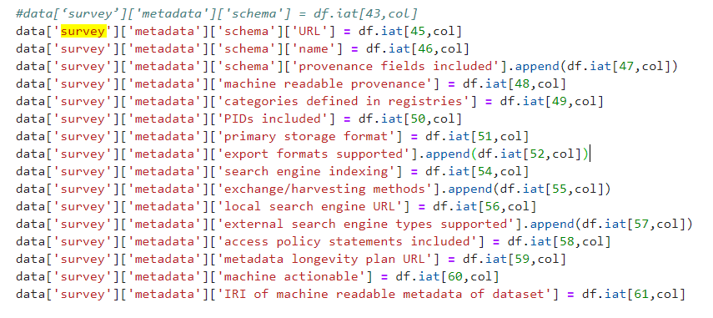

I get this error:

