JDK API Question

- LinkedList vs ArrayList
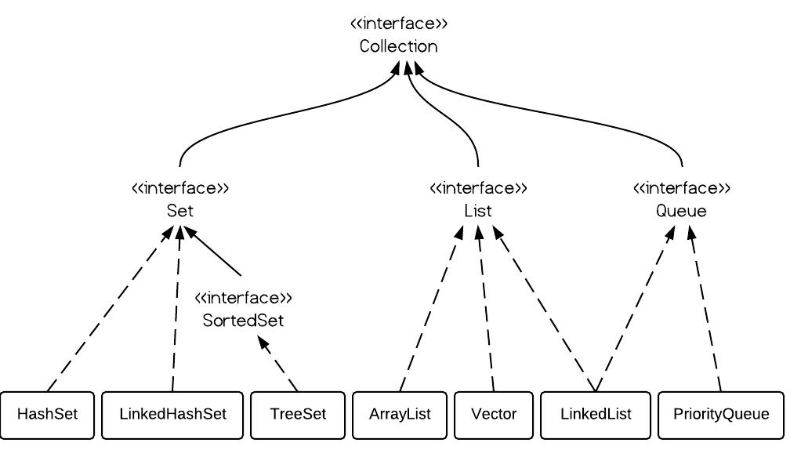
* ArrayList: Basically array, dynamic increasing 50%, not thread safe. Get/Set fast because it is array.
* Vector: array, dynamic increasing 100% size, thread safe.
* LinkedList: Doubly linkedlist implemented, so it has poll(), peek(), offer();
Remove/Add fast. Get/Set slow.

Vector vs ArrayList: Vector is slow and take more space. Most of time, developer use locks to lock a few instruction, so does not need thread-safe data structure like vector.
ArrayList vs LinkedList:

- Create two dimensional List, which syntax is correct?
The following are ok.

List<List<Integer>> table4 = new ArrayList<List<Integer>>();
List<List<Integer>> table1 = new ArrayList<List<Integer>>();
List<ArrayList<Integer>> table2 = new ArrayList<ArrayList<Integer>>();
ArrayList<ArrayList<Integer>> table3 = new ArrayList<ArrayList<Integer>>();

The following is wrong,
List<List<Integer>> table = new ArrayList<ArrayList<Integer>>();

Rule of thumb, the inner type must be identical from left to right. The outter type in the rhs needs to be solid type not interface.

- Iterate map
There are a few ways to do this,

* EntrySet and loop,
public void iterateUsingEntrySet(Map<String, Integer> map) {
for (Map.Entry<String, Integer> entry : map.entrySet()) {
System.out.println(entry.getKey() + ":" + entry.getValue());
}
}

* Using keySet()
for (Integer key : customers.keySet()) {
System.out.println("Key : " + key + " value : " + customers.get(key));
}

* EntrySet and Iterator
public void iterateUsingIteratorAndEntry(Map<String, Integer> map) {
Iterator<Map.Entry<String, Integer>> iterator = map.entrySet().iterator();
while (iterator.hasNext()) {
Map.Entry<String, Integer> entry = iterator.next();
System.out.println(entry.getKey() + ":" + entry.getValue());
}
}

* KeySet and Iterator
Iterator<Integer> iterator = customers.keySet().iterator();
while (iterator.hasNext()) {
Integer key = iterator.next();
System.out.println("Key : " + key + " value : " + customers.get(key));
}

* With Lambda(forEach)
public void iterateUsingLambda(Map<String, Integer> map) {
map.forEach((k, v) -> System.out.println((k + ":" + v)));
}

* Stream API
public void iterateUsingStreamAPI(Map<String, Integer> map) {
map.entrySet().stream()
// ...
.forEach(e -> System.out.println(e.getKey() + ":" + e.getValue()));
}

Another example,

map.entrySet().stream()
.filter(x -> "Jan".equals(x.getValue()))
.forEach( x -> System.out.println("Key : " + x.getKey() + " Value : " + x.getValue()));

- Sort Map by Key
Use treemap, first build a hashmap, and then add hashmap object as parameter to treemap constructor.

Map<String, String> unsortMap = new HashMap<String, String>();
Map<String, String> treeMap = new TreeMap<String, String>(unsortMap);

Then when you iterator each entry, their key is sorted.

- Sort Map by Value
Still uses TreeMap, but you have to implement a comparator object.

Map<Integer, String> treeMap = new TreeMap<Integer, String>(
new Comparator<Integer>() {

@Override
public int compare(Integer o1, Integer o2) {
return o2.compareTo(o1);
}

});

/* For Java 8, try this lambda
Map<Integer, String> treeMap = new TreeMap<>(
(Comparator<Integer>) (o1, o2) -> o2.compareTo(o1)
);
*/
treeMap.putAll(unsortMap);

printMap(treeMap);

- ArrayDeque vs Linkedlist

- The usage of priority queue.

- Sort a list of object by value
public static void main(String[] args) throws Exception
{
List<Movie> m = new ArrayList<>();
m.add(new Movie("a", 3));
m.add(new Movie("b", 5));
m.add(new Movie("c", 4));
m.add(new Movie("d", 1));
Collections.sort(m, new Comparator<Movie>() {
public int compare(Movie m1, Movie m2) {
return (int) (m1.rate - m2.rate);
}
});
m.forEach(e-> System.out.println(e.rate));
}

