Software And Design Pattern

1. Microservice

A concept to architecture software system in seperate indepedant services, and interconnect by http APIs.It is against monolithic software.

Advantage:

1/ easy to develop, and deploy.

2/ faster to push new functionalities

3/ easy to scale

Disadvantage

1/ might be slow on remote call than in process call

2/ data access

3/ reallocate responsiblity

The following is netflix’s achitecture.

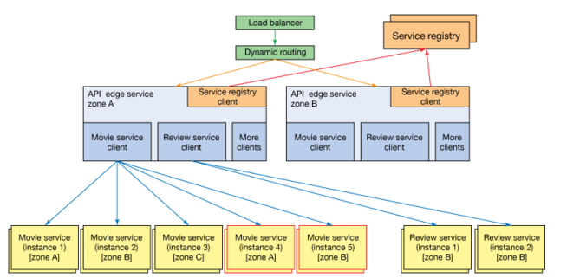

To scale a monolithic software to a distributed system, then we need to run another instance of vm, another instance of servlet container, and jvm resource...etc.

1. What is Agile?

2. What is SOLID?

3. What is extreme programming?

4. What is singleton? Write an example.

5. What is factory design pattern, write an example

6. what is abstract factory pattern, write an example.

7. What is MVC?

8. What is TDD and BDD?

1. What is restful?
2. Mobile app development

Two types of apps. One is a generic type of app developed by c, java in apple and android phone that can be pre-installed. The other type is javascript web UI within a web browser.