Library Management System

1. Project Background and Objectives
With the development of information technology, traditional libraries have gradually exposed problems such as low efficiency, high manual costs, and scattered data in aspects like book borrowing, book maintenance, and user management. To improve the standardization, maintainability, and automation level of library management, this project designs and implements a Web-based Library Management System.
Based on real library business as a prototype, this system covers core functions such as user management, book management, and borrowing management, focusing on demonstrating the following capabilities:
- Analysis and abstraction ability for real business requirements
- Logical modeling (LDM) and structural design ability for relational databases
- Basic front-end and back-end collaboration ability for web applications

2. Requirements Analysis

2.1 System Roles and User Types
Two core roles are defined in the system:
- Regular User (Reader)
  - Register and log into the system
  - Browse and search book information
  - View personal borrowing records
- Administrator (Admin)
  - Log into the system
  - Maintain book basic data (Create / Read / Update / Delete)
  - Manage basic information such as authors and categories
  - View global borrowing records
The system distinguishes permissions through “user + role” rather than designing completely separate systems for different users.

2.2 Functional Requirements

2.2.1 User Management Requirements
- User registration (username, password, email)
- User login and logout
- User and role association management (Regular User / Administrator)

2.2.2 Book Management Requirements (Core Function)
- Add book information
- Modify book information
- Delete book information
- Query book information (support search by title, author, category, etc.)

2.2.3 Author and Category Management Requirements
- A book can correspond to multiple authors
- An author can participate in writing multiple books
- Books must belong to a category

2.2.4 Borrowing Management Requirements
- Record user book borrowing behavior
- Record borrowing time, due time, return time
- Support query of current and historical borrowing records

2.3 Non-functional Requirements
- Maintainability: Clear module division, normalized database structure
- Consistency: Business rules remain consistent between database and business layer
- Extensibility: Can add functions such as reservation, statistical reports in the future
- Security (at specification level): User passwords are not stored in plain text

3. Database Logical Data Model (LDM, Complete Field Description Version)
All entities satisfy Third Normal Form (3NF), with field types designed for MySQL as the target database.

3.1 Entity Overview (for drawing LDM diagram)
No. | Entity Name | Description
E1 | User | Basic user information in the system
E2 | UserProfile | User extended information (1:1)
E3 | Role | System roles
E4 | UserRole | User-role association (M:N)
E5 | Book | Basic book information
E6 | Author | Author information
E7 | BookAuthor | Book-author association (M:N)
E8 | Category | Book categories
E9 | Publisher | Publisher information
E10 | Borrow | Borrowing records

3.2 Detailed Field Description for Each Entity (Core)

3.2.1 User (User Table)
Business Meaning: Basic account information for all users who can log into the system.
Field Name | Type | Primary Key | Foreign Key | Description
user_id | INT | ✔ |  | Unique user identifier, auto-increment
username | VARCHAR(50) |  |  | Login username, unique
password | VARCHAR(255) |  |  | Encrypted password
email | VARCHAR(100) |  |  | Email
status | TINYINT |  |  | Status: 1=enabled, 0=disabled
created_at | DATETIME |  |  | Registration time

3.2.2 UserProfile (User Extended Information Table)
Business Meaning: Stores user’s personal attribute information, one-to-one association with User.
Field Name | Type | Primary Key | Foreign Key | Description
profile_id | INT | ✔ |  | Primary key
user_id | INT |  | ✔ | Reference User(user_id)
real_name | VARCHAR(50) |  |  | Real name
phone | VARCHAR(20) |  |  | Contact phone
register_date | DATE |  |  | Registration date

3.2.3 Role (Role Table)
Business Meaning: Role types defined in the system.
Field Name | Type | Primary Key | Foreign Key | Description
role_id | INT | ✔ |  | Role ID
role_name | VARCHAR(50) |  |  | Role name (ADMIN / READER)
description | VARCHAR(100) |  |  | Role description

3.2.4 UserRole (User-Role Association Table)
Business Meaning: Implements the many-to-many relationship between User and Role.
Field Name | Type | Primary Key | Foreign Key | Description
Id | INT | ✔ |  | Primary key
user_id | INT |  | ✔ | Reference User
role_id | INT |  | ✔ | Reference Role

3.2.5 Book (Book Table)
Business Meaning: Basic information for all books in the system.
Field Name | Type | Primary Key | Foreign Key | Description
book_id | INT | ✔ |  | Book ID
isbn | VARCHAR(20) |  |  | ISBN number
title | VARCHAR(200) |  |  | Book title
category_id | INT |  | ✔ | Category
publisher_id | INT |  | ✔ | Publisher
publish_date | DATE |  |  | Publication date
total_stock | INT |  |  | Total stock
available_stock | INT |  |  | Available stock

3.2.6 Author (Author Table)
Business Meaning: Stores basic author information.
Field Name | Type | Primary Key | Foreign Key | Description
author_id | INT | ✔ |  | Author ID
name | VARCHAR(100) |  |  | Author name
country | VARCHAR(50) |  |  | Country

3.2.7 BookAuthor (Book-Author Association Table)
Business Meaning: Implements the many-to-many relationship between Book and Author.
Field Name | Type | Primary Key | Foreign Key | Description
id | INT | ✔ |  | Primary key
book_id | INT |  | ✔ | Reference Book
author_id | INT |  | ✔ | Reference Author

3.2.8 Category (Category Table)
Business Meaning: Book category information, used for queries and statistics.
Field Name | Type | Primary Key | Foreign Key | Description
category_id | INT | ✔ |  | Category ID
category_name | VARCHAR(100) |  |  | Category name
description | VARCHAR(200) |  |  | Category description
parent_id | INT |  | ✔ | Parent category ID, used for self-join queries

3.2.9 Publisher (Publisher Table)
Business Meaning: Book publisher information.
Field Name | Type | Primary Key | Foreign Key | Description
publisher_id | INT | ✔ |  | Publisher ID
name | VARCHAR(100) |  |  | Publisher name
address | VARCHAR(200) |  |  | Address
contact | VARCHAR(50) |  |  | Contact

3.2.10 Borrow (Borrowing Record Table)
Business Meaning: Records user book borrowing behavior.
Field Name | Type | Primary Key | Foreign Key | Description
borrow_id | INT | ✔ |  | Borrowing record ID
user_id | INT |  | ✔ | Borrowing user
book_id | INT |  | ✔ | Borrowed book
borrow_date | DATETIME |  |  | Borrowing time
due_date | DATETIME |  |  | Due time
return_date | DATETIME |  |  | Actual return time (nullable)
status | ENUM |  |  | borrowed / returned / overdue

3.3 Entity Relationship Summary
- One-to-One (1:1)
  - User —— UserProfile
- One-to-Many (1:N)
  - Category —— Book
  - Publisher —— Book
  - User —— Borrow
  - Book —— Borrow
- Many-to-Many (M:N)
  - User —— Role (via UserRole)
  - Book —— Author (via BookAuthor)

3.4 Data Model Diagrams
The following diagrams illustrate the logical and physical data models for the Library Management System:
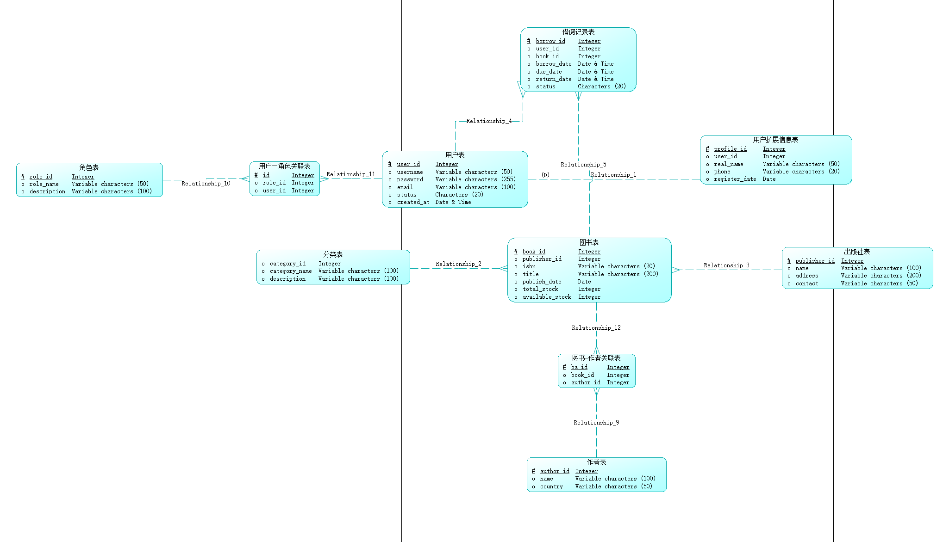
Logical Data Model
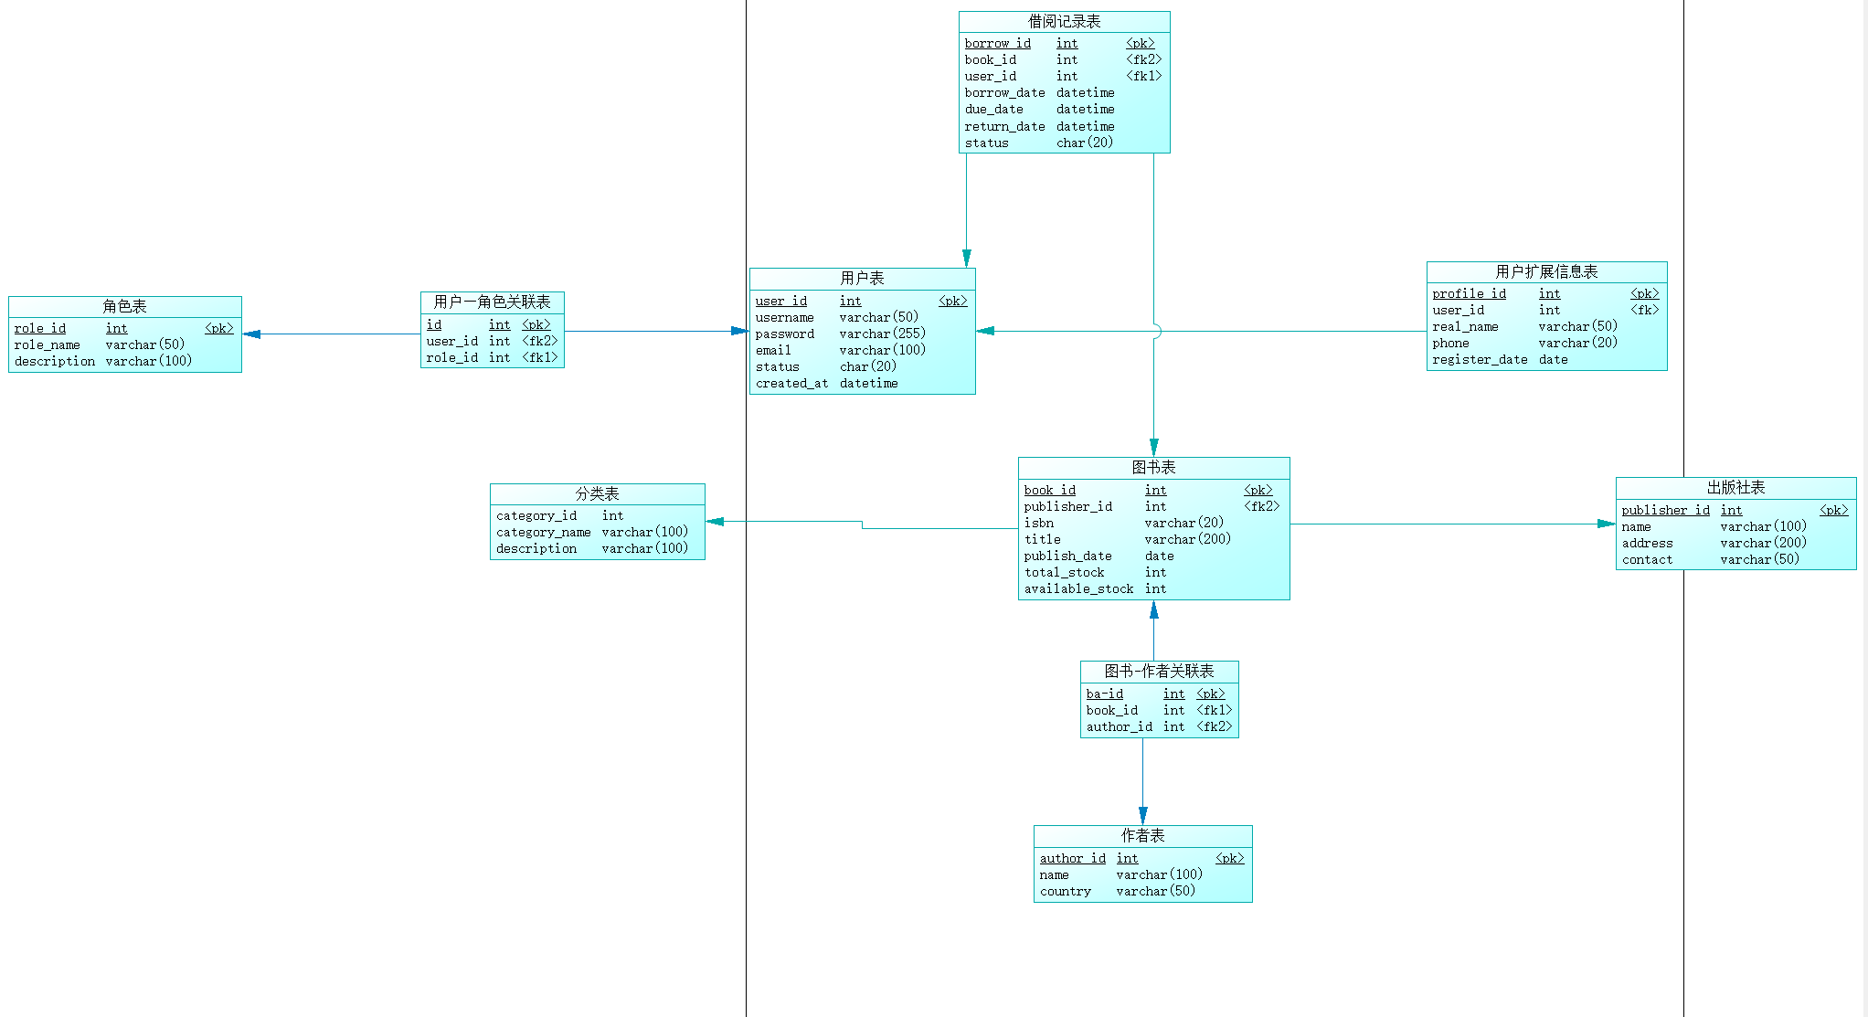
Physical Data Model

4. System Overall Design
Based on the requirements analysis, this chapter provides detailed design for the system’s overall architecture, module division, and front-end and back-end interface specifications. This design serves as the basis for system implementation and as a unified interface document for team member collaborative development.

4.1 System Architecture Design
The system adopts a typical B/S (Browser / Server) architecture with front-end and back-end separation design:
- Front-end (Client):
  - Technology: HTML + CSS + JavaScript + Bootstrap
  - Responsibilities: Page display, user interaction, sending HTTP requests to the back-end
- Back-end (Server):
  - Technology: PHP (or Python Flask)
  - Responsibilities: Business logic processing, permission verification, database access, unified data return
- Database (Database):
  - Technology: MySQL
  - Responsibilities: Data persistence and consistency constraints
The front-end communicates with the back-end through HTTP/HTTPS, with data format unified as JSON.

4.2 Interface Design General Conventions (Global Specifications)
To ensure unified system interface style and reduce front-end and back-end collaboration costs, all interfaces follow the following conventions.

4.2.1 Request Conventions
- Request method: GET / POST / PUT / DELETE
- Request path: /api/module-name/operation
- Parameter location:
  - GET: Parameters passed through URL Query
  - POST / PUT: Parameters passed through JSON Request Body
  - Path parameters: Identified by {}, such as /api/book/{book_id}

4.2.2 Unified Return Data Format
All back-end interfaces return a unified JSON structure:
{
"code": 0,
"message": "success",
"data": {}
}
- code: Status code
  - 0: Success
  - Non-zero: Failure
- message: Result description
- data: Returned data content (object or array)

4.3 Module Division and Detailed Interface Design
The system is divided into the following core modules, each module interface can be independently developed and tested.

4.3.1 User Management Module
Module Responsibilities:
- User registration, login, and identity information query

Interface 1: User Registration
- URL: POST /api/user/register
- Request Body (JSON):
{
"username": "string",
"password": "string",
"email": "string"
}
- Return Data:
{
"code": 0,
"message": "register success",
"data": null
}

Interface 2: User Login
- URL: POST /api/user/login
- Request Body (JSON):
{
"username": "string",
"password": "string"
}
- Return Data:
{
"code": 0,
"message": "login success",
"data": {
"user_id": 1,
"role": "ADMIN"
}
}

4.3.2 Book Management Module
Module Responsibilities:
- Basic book information Create, Read, Update, Delete (core CRUD module)

Interface 1: Create Book
- URL: POST /api/book/create
- Request Body (JSON):
{
"title": "string",
"isbn": "string",
"category_id": 1,
"publisher_id": 1
}
- Return Data:
{
"code": 0,
"message": "book created successfully",
"data": {
"book_id": 1
}
}

Interface 2: Update Book
- URL: PUT /api/book/update/{book_id}
- Request Body (JSON):
{
"title": "string",
"category_id": 1
}
- Return Data:
{
"code": 0,
"message": "book updated successfully",
"data": null
}

Interface 3: Delete Book
- URL: DELETE /api/book/delete/{book_id}
- Return Data:
{
"code": 0,
"message": "book deleted successfully",
"data": null
}

Interface 4: Query Book List
- URL: GET /api/book/list
- Query Parameters:
  - title (optional)
  - category_id (optional)
- Return Data:
{
"code": 0,
"message": "success",
"data": [
{
"book_id": 1,
"title": "Database System",
"isbn": "978-0123456789",
"category_id": 1,
"category_name": "Computer Science",
"publisher_id": 1,
"publisher_name": "Academic Press",
"publish_date": "2024-01-01",
"total_stock": 10,
"available_stock": 8
}
]
}

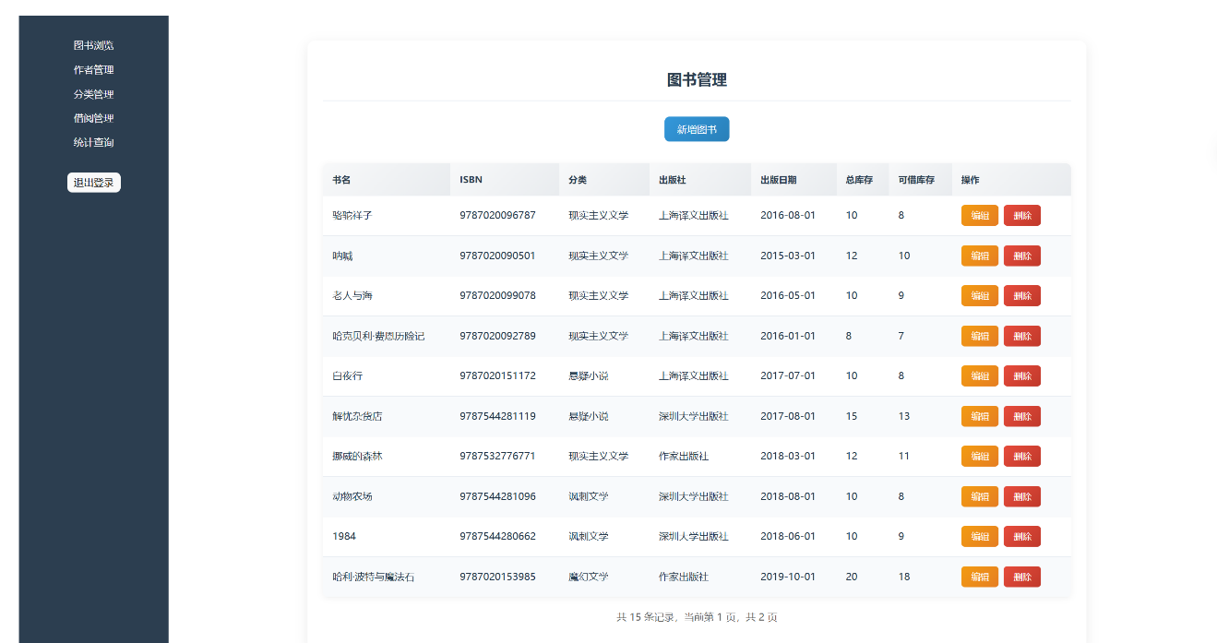

4.3.3 Author Management Module
Module Responsibilities:
- Author information maintenance

Interface 1: Create Author
- URL: POST /api/author/create
- Request Body (JSON):
{
"name": "string",
"country": "string"
}
- Return Data:
{
"code": 0,
"message": "author created successfully",
"data": {
"author_id": 1
}
}

Interface 2: Query Author List
- URL: GET /api/author/list
- Query Parameters:
  - name (optional): Author name keyword
- Return Data:
{
"code": 0,
"message": "success",
"data": [
{
"author_id": 1,
"name": "Author A",
"country": "Country A"
}
]
}

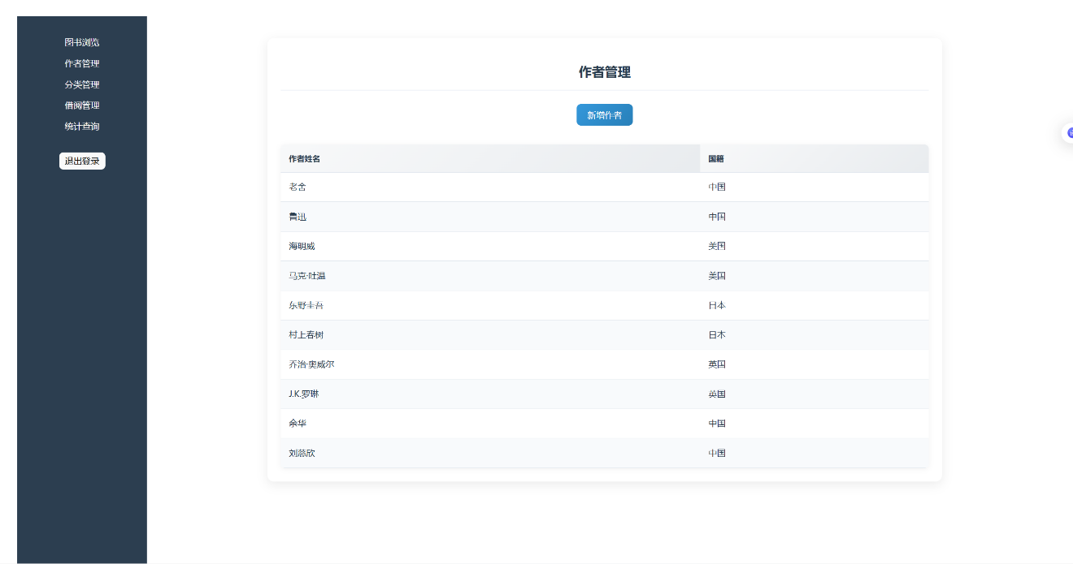

4.3.4 Category Management Module
Module Responsibilities:
- Book category maintenance

Interface 1: Create Category
- URL: POST /api/category/create
- Request Body (JSON):
{
"category_name": "string",
"description": "string"
}
- Return Data:
{
"code": 0,
"message": "category created successfully",
"data": {
"category_id": 1
}
}

Interface 2: Query Category List
- URL: GET /api/category/list
- Return Data:
{
"code": 0,
"message": "success",
"data": [
{
"category_id": 1,
"category_name": "Computer Science",
"description": "Books related to computer science"
}
]
}

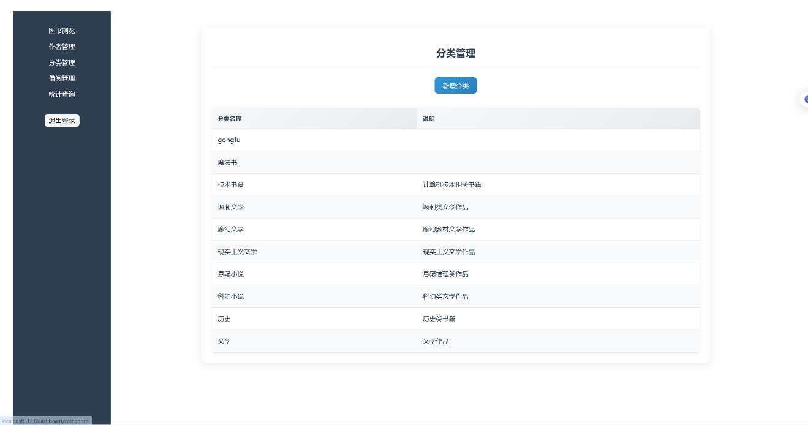

4.3.5 Borrowing Management Module
Module Responsibilities:
- Manage borrowing records

Interface 1: Create Borrowing Record
- URL: POST /api/borrow/create
- Request Body (JSON):
{
"user_id": 1,
"book_id": 1,
"due_date": "2025-01-01"
}
- Return Data:
{
"code": 0,
"message": "borrow record created successfully",
"data": {
"borrow_id": 1
}
}

Interface 2: Return Book
- URL: PUT /api/borrow/return/{borrow_id}
- Return Data:
{
"code": 0,
"message": "book returned successfully",
"data": null
}

Interface 3: Query User Borrowing Records
- URL: GET /api/borrow/user/{user_id}
- Return Data:
{
"code": 0,
"message": "success",
"data": [
{
"borrow_id": 1,
"user_id": 1,
"username": "Alice",
"book_id": 1,
"book_title": "Database System",
"borrow_date": "2024-12-01T10:00:00Z",
"due_date": "2025-01-01T10:00:00Z",
"return_date": null,
"status": "borrowed"
}
]
}

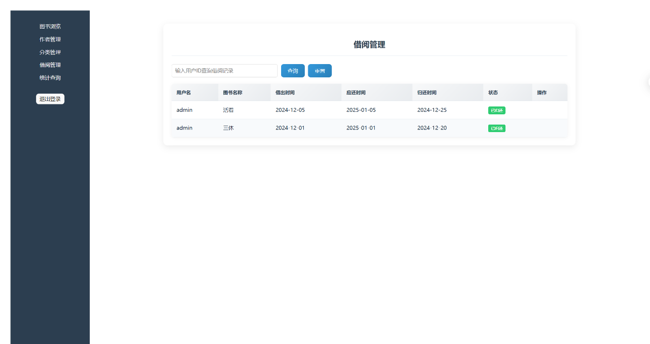

4.3.6 Data Query and Analytics Module

Module Responsibilities
- Unifiedly handle complex SQL query logic
- Provide query interfaces externally, avoiding complex SQL scattered in business modules
- Support concentrated demonstration of SQL capabilities in teaching and evaluation scenarios

Interface 1: Join Query (Inner / Outer)
- URL: GET /api/query/book-authors
- Request Parameters (Query):
  - book_id (int, optional)
- Return Data:
{
"code": 0,
"message": "success",
"data": [
{
"book_id": 1,
"book_title": "Database System",
"author_id": 1,
"author_name": "Author A",
"country": "Country A"
}
]
}
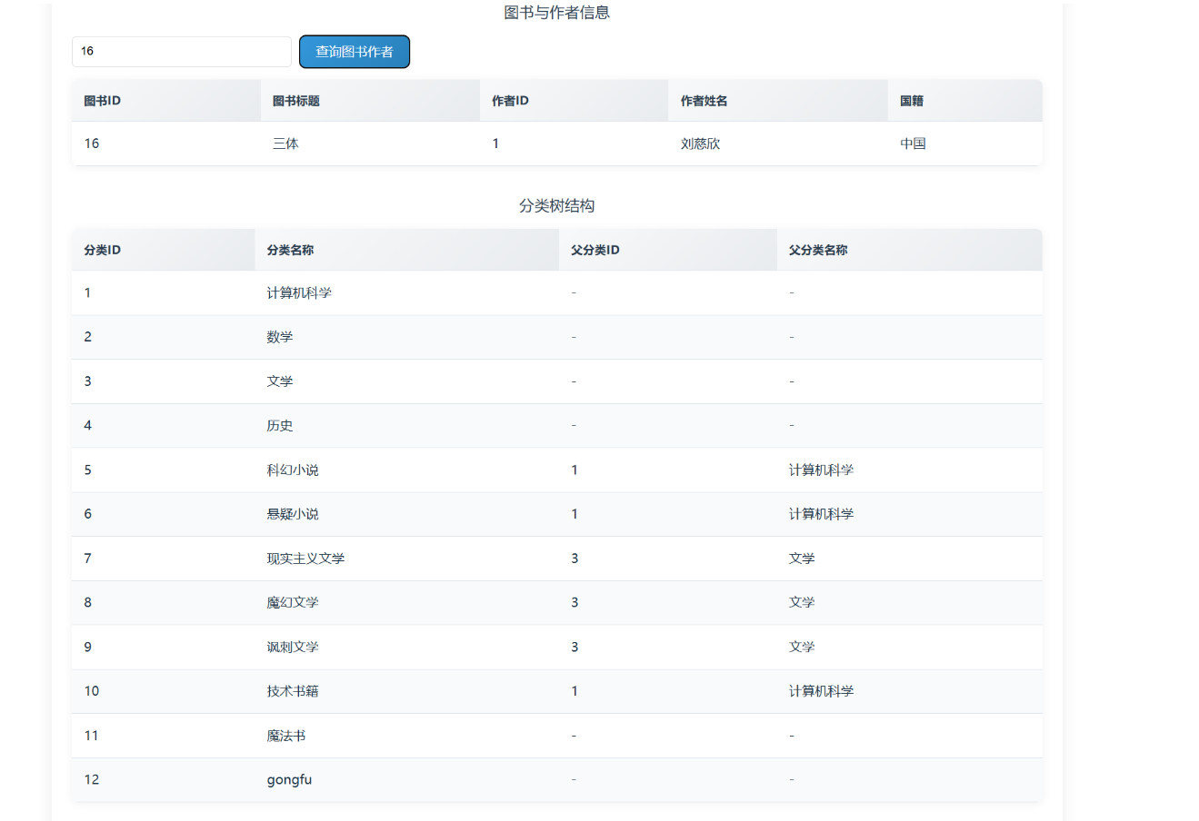
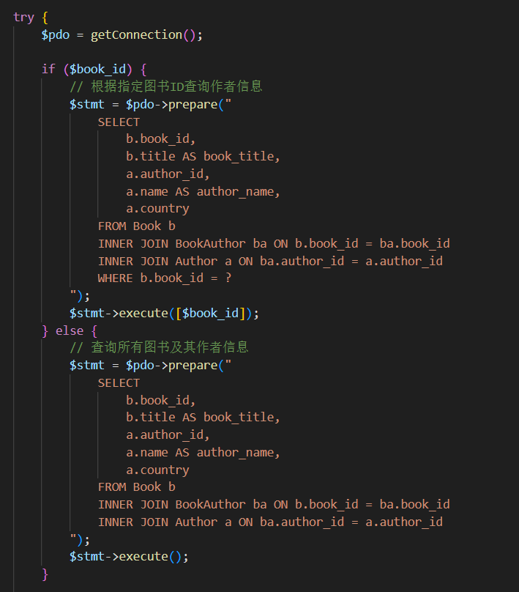

Interface 2: Self Join Query
- URL: GET /api/query/category-tree
- Request Parameters: None
- Return Data:
{
"code": 0,
"message": "success",
"data": [
{
"category_id": 1,
"category_name": "Computer Science",
"parent_category_id": null,
"parent_category_name": null
},
{
"category_id": 2,
"category_name": "Database",
"parent_category_id": 1,
"parent_category_name": "Computer Science"
}
]
}
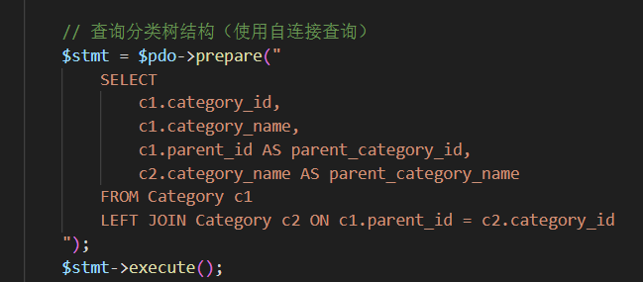

Interface 3: Aggregation Query (GROUP BY / ORDER BY)
- URL: GET /api/query/book-count-by-category
- Request Parameters: None
- Return Data:
{
"code": 0,
"message": "success",
"data": [
{
"category_id": 1,
"category_name": "Computer Science",
"book_count": 10
},
{
"category_id": 2,
"category_name": "Mathematics",
"book_count": 5
}
]
}
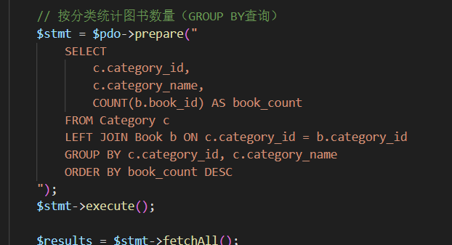
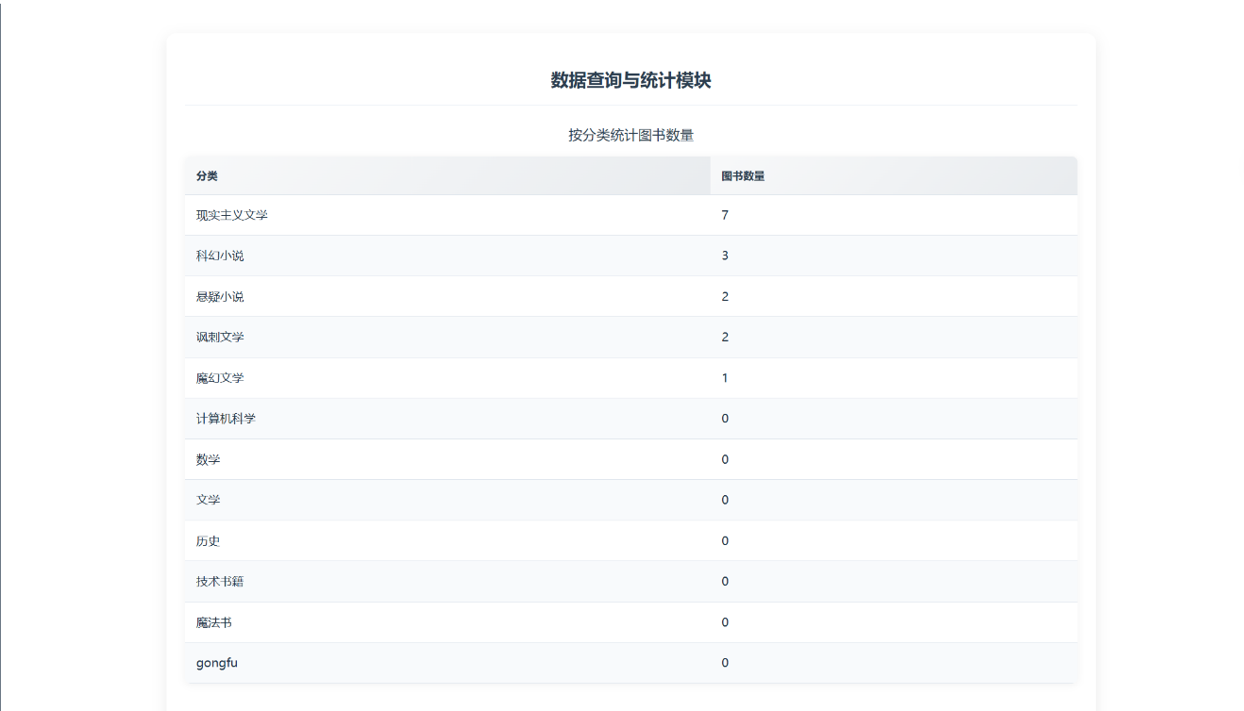

Interface 4: Date and Time Function Query
- URL: GET /api/query/overdue-borrow
- Request Parameters: None
- Return Data:
{
"code": 0,
"message": "success",
"data": [
{
"borrow_id": 1,
"user_id": 1,
"username": "Alice",
"book_id": 1,
"book_title": "Database System",
"borrow_date": "2024-11-01T10:00:00Z",
"due_date": "2024-11-30T10:00:00Z",
"days_overdue": 27
}
]
}
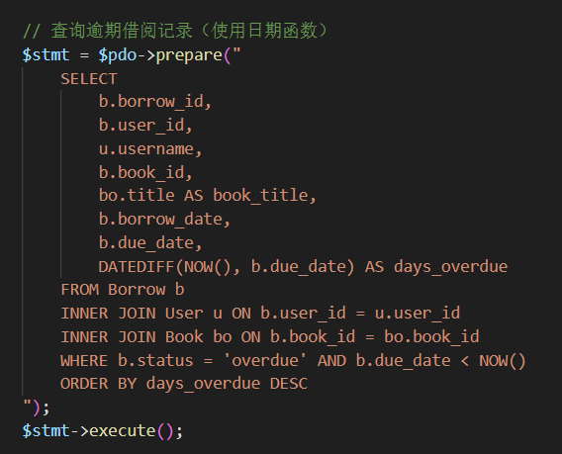
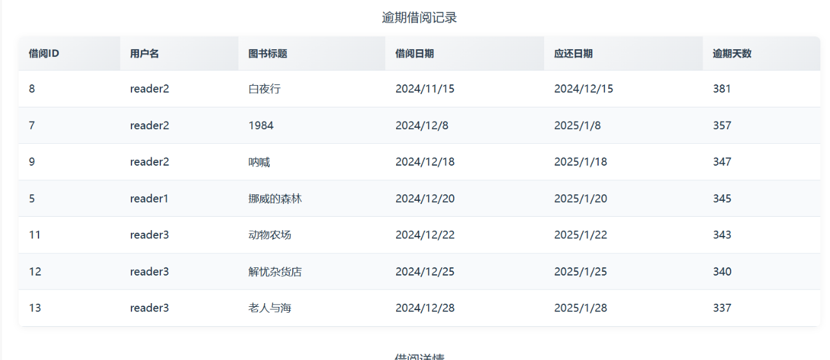

Interface 5: Subquery
- URL: GET /api/query/users-borrowed-book/{book_id}
- Path Parameters:
  - book_id (int): Book ID
- Return Data:
{
"code": 0,
"message": "success",
"data": [
{
"user_id": 1,
"username": "Alice",
"borrow_date": "2024-12-01T10:00:00Z"
}
]
}
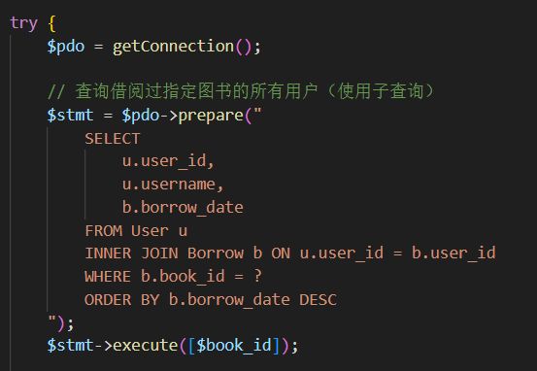
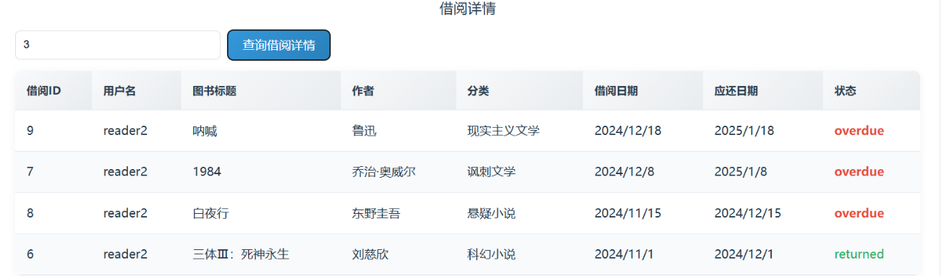

Interface 6: Correlated Subquery
- URL: GET /api/query/most-active-users
- Request Parameters: None
- Return Data:
{
"code": 0,
"message": "success",
"data": [
{
"user_id": 2,
"username": "Bob",
"borrow_count": 12
}
]
}
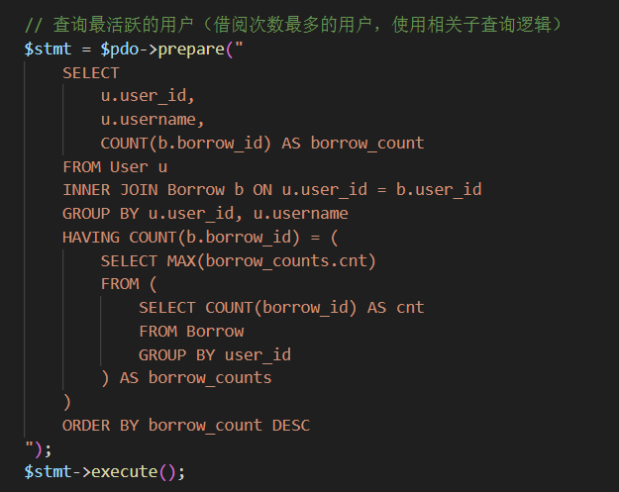
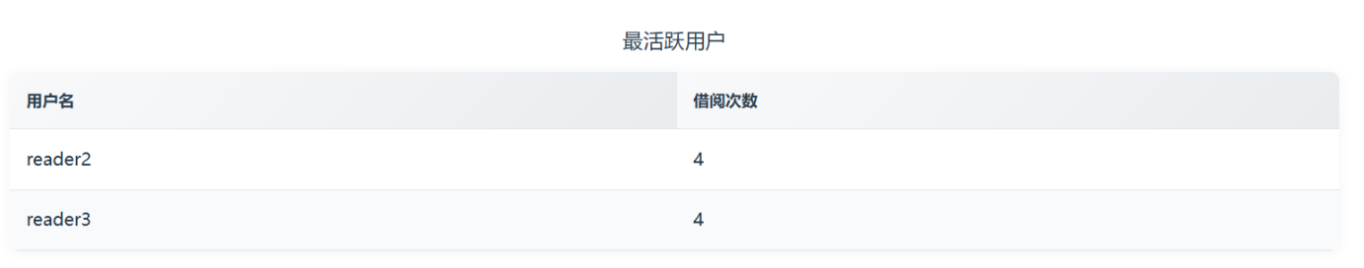

Interface 7: Set Operations
- URL: GET /api/query/active-or-admin-users
- Request Parameters: None
- Return Data:
{
"code": 0,
"message": "success",
"data": [
{
"user_id": 1,
"username": "Alice",
"role": "READER"
},
{
"user_id": 3,
"username": "Admin",
"role": "ADMIN"
}
]
}
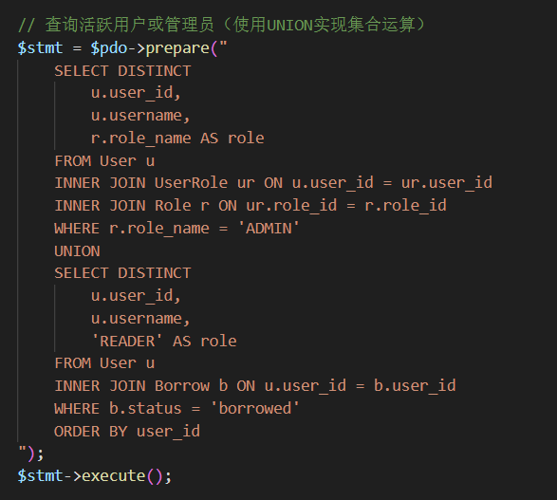
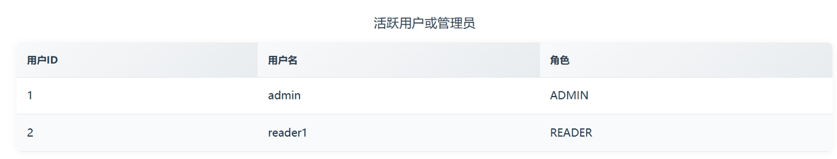

Interface 8: Multi-table Join Query
- URL: GET /api/query/borrow-detail
- Request Parameters (Query):
  - user_id (int, optional)
- Return Data:
{
"code": 0,
"message": "success",
"data": [
{
"borrow_id": 1,
"user_id": 1,
"username": "Alice",
"book_id": 1,
"book_title": "Database System",
"author_names": "Author A, Author B",
"category_name": "Computer Science",
"borrow_date": "2024-12-01T10:00:00Z",
"due_date": "2025-01-01T10:00:00Z",
"return_date": null,
"status": "borrowed"
}
]
}
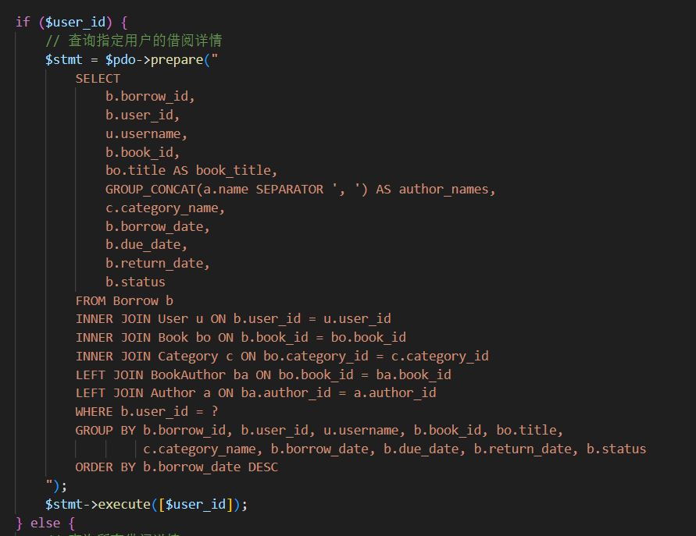
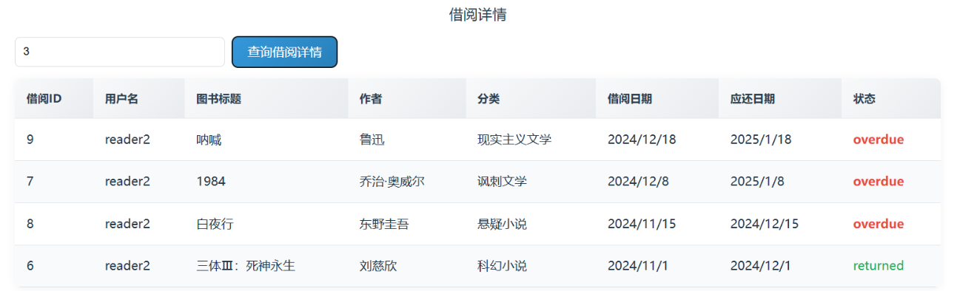

Interface 9: Division Query
- URL: GET /api/query/users-borrowed-all-categories
- Request Parameters: None
- Return Data:
{
"code": 0,
"message": "success",
"data": [
{
"user_id": 5,
"username": "Charlie"
}
]
}
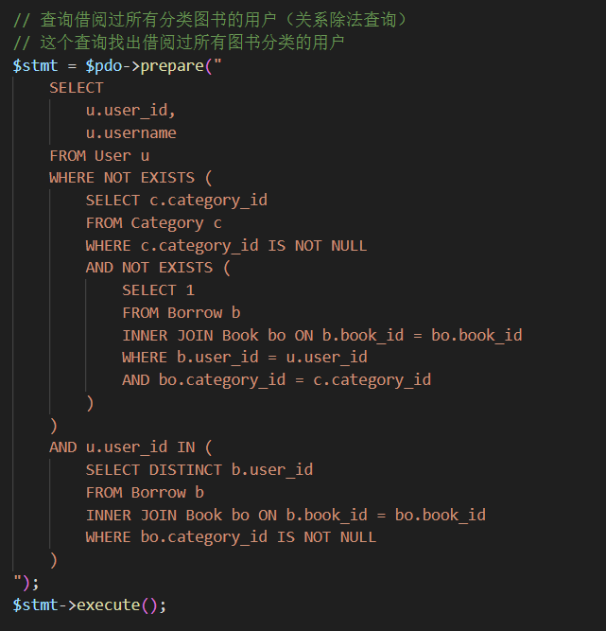

5. Summary
This document serves as the unified requirements and design basis for the Library Management System project, detailing system functions, module division, interface design, and database logical model.

