#include<opencv2/opencv.hpp>
#include<opencv2/photo.hpp>
#include<opencv2/objdetect.hpp>
#include<opencv2/xfeatures2d.hpp>
#include<opencv2/features2d.hpp>
#include<opencv2/calib3d/calib3d.hpp>
#include<opencv2/stitching.hpp>
#include<opencv2/video.hpp>
#include<opencv2/bgsegm.hpp>
#include<iostream>
#include<vector>
#include<fstream>
using namespace std;
using namespace cv;
using namespace cv::xfeatures2d;
int main()
{
Mat Image = imread("E:/Images/face.jpg");
CascadeClassifier face_cascade,eyes_cascade;
face_cascade.load("D:/opencv-3.1.0/opencv/build/install/etc/haarcascades/haarcascade_frontalface_alt.xml");
eyes_cascade.load("D:/opencv-3.1.0/opencv/build/install/etc/haarcascades/haarcascade_eye.xml");
vector<Rect> faces;
vector<Rect> eyes;
Mat face_gray;
cvtColor(Image, face_gray, CV_RGB2GRAY);
face_cascade.detectMultiScale(face_gray, faces, 1.1, 3, CASCADE_SCALE_IMAGE, Size(30, 30));
//face_cascade.detectMultiScale(face_gray, faces, 1.1, 3, 0, Size(30, 30)); //两个参数实现大致相同
for (int i = 0; i < faces.size(); i++)
{
//ellipse(Image, center, Size(faces[i].width / 2, faces[i].height / 2), 0, 0, 360, Scalar(255, 0, 255), 4, 8, 0);
//rectangle(Image, Rect(faces[i].x, faces[i].y, faces[i].width, faces[i].height), Scalar(255, 255, 0), 2, 8, 0);
rectangle(Image, faces[i], Scalar(255, 255, 0), 2, 8, 0);
//在图片上加入字体,1.2表示字体的大小
putText(Image, "face", Point(faces[i].x, faces[i].y), 3, 1.2, Scalar(0, 255, 0), 2, 8, 0);
Mat face = face_gray(faces[i]);
eyes_cascade.detectMultiScale(Image, eyes, 1.1, 3, CASCADE_SCALE_IMAGE, Size(30, 30));
for (int j = 0; j < eyes.size(); j++)
{
rectangle(Image, eyes[j], Scalar(0, 0, 255), 2, 8, 0);
putText(Image, "eye", Point(eyes[j].x, eyes[j].y), 3, 0.5, Scalar(0, 255, 0), 2, 8, 0);
}
}
imshow("Image", Image);
//imshow("face_gray", face_gray);
waitKey(0);
return 0;
}

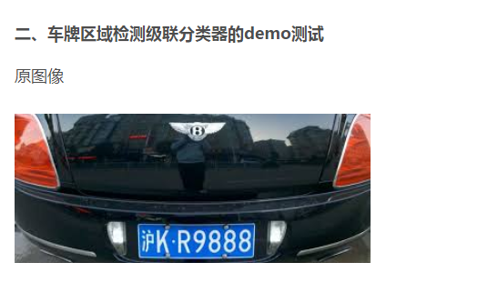

int main()
{
Mat Image = imread("E:/Images/carlicense2.png");
imshow("original", Image);
CascadeClassifier car_cascade;
//车牌级联器
car_cascade.load("D:/opencv-3.1.0/opencv/build/install/etc/haarcascades/haarcascade_russian_plate_number.xml");
vector<Rect> cars;
car_cascade.detectMultiScale(Image, cars, 1.1, 3, 0, Size(15, 15));
for (int i = 0; i < cars.size(); i++)
{
rectangle(Image, cars[i], Scalar(0, 0, 255), 2, 8, 0);
}
imshow("Image", Image);
waitKey(0);
return 0;
}
