Homework: Lithium Material Flow Analysis, 2015–2019
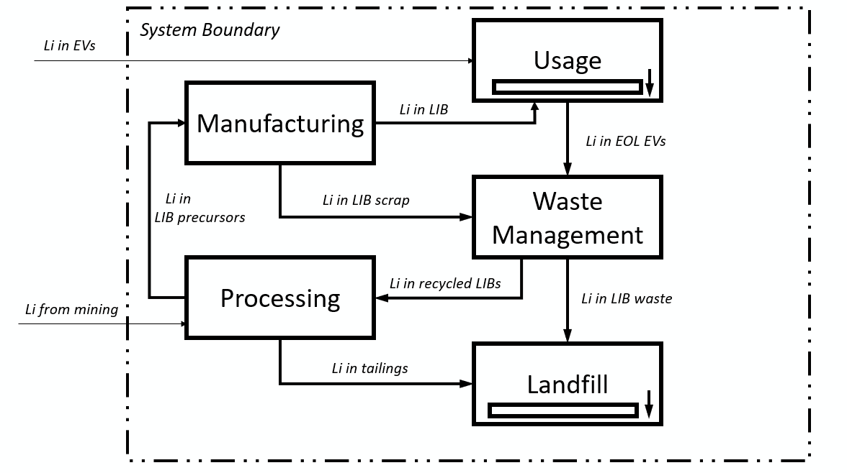
Figure 1. System boundary of the lithium material flow analysis.
For each year $t=2015,…,2019$, two exogenous inputs are provided:
$$M_{t}=\text{Li from mining}$$
where $M_{t}$represents Li from mining.
$$E_{t}=\text{Li entering the U.S. in EVs}$$
where $E_{t}$represents Li entering the U.S. in EVs.
The following four parameters are provided:
$$r_{p}=\text{Processing recovery rate}$$
$$r_{s}=\text{Manufacturing scrap rate}$$
$$r_{e}=\text{End-of-life (EOL) rate}$$
$$r_{r}=\text{Waste recycling rate}$$
Assume that all parameters remain constant from 2015–2019.

Questions
- Mass balance:
Based on the system boundary shown in Figure 1, write the mass-balance equations for the Processing, Manufacturing, Usage, Waste Management, and Landfill processes.
- Baseline scenario:
Using the provided annual inputs and parameter values, calculate the total amount of Li accumulated in landfill from 2015 to 2019.
- Improvement scenario:
Assume that the processing recovery rate, EOL rate, and waste recycling rate each increase by 10% relative to their baseline values, while the manufacturing scrap rate decreases by 10%. Recalculate the cumulative Li accumulation in landfill from 2015 to 2019 and determine the percentage reduction compared with the baseline scenario.
Questions 2 and 3 are recommended to be completed using ODYM.

Data Provided:

Table 1. Annual Lithium Inputs, 2015–2019
Unit: metric tons of elemental lithium (t Li)
Year | Li from Mining (Mₜ) | Li in Imported EVs (Eₜ)
2015 | 492 | 262
2016 | 598 | 336
2017 | 693 | 407
2018 | 1,315 | 762
2019 | 1,335 | 817

Table 2. Baseline Model Parameters
Parameter | Symbol | Value
Processing recovery rate | rₚ | 85%
Manufacturing scrap rate | rₛ | 10%
End-of-life (EOL) rate | rₑ | 10%
Waste recycling rate | rᵣ | 50%

