Homework: Dynamic MFA of Copper Stocks
Copper enters the use phase each year and is distributed among several end-use sectors. Each sector has a different average product lifetime. Using the annual copper inflow, sector proportions, and lifetime information provided, develop a dynamic material flow model for 1970–2020. Annual inflow, sector proportions, and lifetime assumptions are given. Assuming there is no copper consumption in the U.S. before 1970.
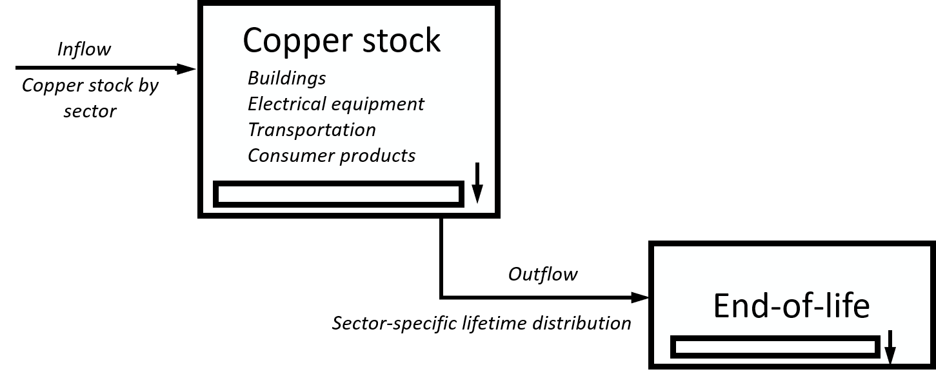
Figure 1 System boundary of the copper life cycle
Table 1. Sector proportions and lifetime
Sector | Proportion | Mean Lifetime | Standard deviation | Distribution
Buildings | 40% | 50 years | 15 years | Lognormal
Electrical equipment | 30% | 30 years | 10 years | Lognormal
Transportation | 20% | 18 years | 5 years | Lognormal
Consumer products | 10% | 10 years | 4 years | Lognormal

Tasks
Using Python and ODYM:
- Calculate the annual stock for each sector from 1970 to 2020
- Calculate the annual outflow (recycling potential) for each sector from 1970 to 2020.

Data Provided:
Table 1. Estimated Annual Total Copper Inflow (1970–2020)
Unit: million metric tons (Mt)
Year | Total Copper Inflow (Mt)
1971 | 1.91
1972 | 2.13
1973 | 2.19
1974 | 2.07
1975 | 1.51
1976 | 1.92
1977 | 2.09
1978 | 2.37
1979 | 2.40
1980 | 2.19
1981 | 2.24
1982 | 1.78
1983 | 1.98
1984 | 2.12
1985 | 2.14
1986 | 2.14
1987 | 2.20
1988 | 2.23
1989 | 2.19
1990 | 2.20
1991 | 2.11
1992 | 2.35
1993 | 2.56
1994 | 2.69
1995 | 2.57
1996 | 2.85
1997 | 2.98
1998 | 3.04
1999 | 3.14
2000 | 3.08
2001 | 2.54
2002 | 2.61
2003 | 2.46
2004 | 2.56
2005 | 2.43
2006 | 2.22
2007 | 2.26
2008 | 2.00
2009 | 1.59
2010 | 1.75
2011 | 1.73
2012 | 1.75
2013 | 1.75
2014 | 1.78
2015 | 1.82
2016 | 1.88
2017 | 1.86
2018 | 1.83
2019 | 1.84
2020 | 1.69

