实验7 S3C2440实时时钟部件编程
班级 B10511 姓名 05 学号 朱小虎 日期 2012-11-25 成绩评定

1．实验目的
（1）掌握实时时钟部件的功能和相应寄存器设置，可参考示例程序；
（2）掌握实时时钟的时间设置、定时设置、中断的程序编写。

2．实验环境
普通PC机，Windows系统下安装ADS1.2集成开发环境，ARM实验设备，串口线，USB线，网线。

3．实验原理
S3C2440实时时钟部件需要通过引脚XTIrtc、XTOrtc外接32768Hz的晶振作为时钟源；实时时钟在不接电源时，由电池供电运行；S3C2440 RTC提供以下功能：（1）可设置、读取系统时间（年月日星期时分秒）；（2）能够设置报警时间，产生报警内部中断INT_RTC；（3）具备毫秒级时间片计时器，产生时间片中断INT_TICK，可以编程设置时间片。
提供了可读写的时间寄存器：BCDYEAR（年）BCDMON（月）BCDDAY（星期）BCDDATE（日）BCDHOUR（时）BCDMIN（分）BCDSEC（秒），编程读取时一般先后读取年月日星期时分秒，若读取到寄存器BCDSEC为0，应重新读取所有寄存器；RTCCON（RTC控制寄存器）进行读写允许和复位设置。提供了以下寄存器设置报警时间：ALMYEAR（年）ALMMON（月）ALMDATE（日）ALMHOUR（时）ALMMIN（分）ALMSEC（秒）RTCALM（报警控制寄存器）用来使能报警时间。

4．实验步骤与内容
编程实现实时时钟部件编程，实现设置时间，读取时间，报警时间到触发蜂鸣器或闪烁led灯。
实现程序的C语言部分写在main.c文件中，如下：

main.c文件 | rRTCALM = 0x00;  }  //rtc中断  void __irq rtc_isr(void)  {  Uart_Printf("\n%s\n", "报警时间到！");  rGPBDAT |=1;///蜂鸣器响  rGPFDAT |= 0xFF;  rGPFDAT &=~(15<<4);//灯全亮~~~  rSRCPND |= (1<<30);  rINTPND |= (1<<30);  }  void readtime()  {  rRTCCON |= 0x1;  year_bcd = rBCDYEAR; month_bcd = rBCDMON; day_bcd = rBCDDAY; date_bcd = rBCDDATE;  hour_bcd = rBCDHOUR; min_bcd = rBCDMIN; sec_bcd = rBCDSEC;  if(0 == sec_bcd)  {  year_bcd = rBCDYEAR; month_bcd = rBCDMON; day_bcd = rBCDDAY; date_bcd = rBCDDATE;  hour_bcd = rBCDHOUR; min_bcd = rBCDMIN; sec_bcd = rBCDSEC;  }  rRTCCON &= 0xE;  year = (year_bcd&0xf0)/16*10 + (year_bcd&0xf);  month = (month_bcd&0xf0)/16*10 + (month_bcd&0xf);  day = day_bcd&0x7;  date = (date_bcd&0xf0)/16*10 + (date_bcd&0xf);  hour = (hour_bcd&0xf0)/16*10 + (hour_bcd&0xf);  min = (min_bcd&0xf0)/16*10 + (min_bcd&0xf);  sec = (sec_bcd&0xf0)/16*10 + (sec_bcd&0xf);  Uart_Printf("\n目前时间：%u年%u月%u日星期%u %u时%u分%u秒\n", year, month, date, day, hour, min, sec);  }  Uart_Printf("当前时间为\n");  readtime();  Uart_Printf("\n下面开始设置报警时间\n");  Uart_Printf("请输入年\n");  alm_year=Uart_GetIntNum();  Uart_Printf("请输入月\n");  alm_month=Uart_GetIntNum();  Uart_Printf("请输入日\n");  alm_date=Uart_GetIntNum();  Uart_Printf("请输入时\n");  alm_hour=Uart_GetIntNum();  Uart_Printf("请输入分\n");  alm_min=Uart_GetIntNum();  Uart_Printf("请输入秒\n");  alm_sec=Uart_GetIntNum();  alm_year_bcd = (unsigned char)(alm_year/10*16 + alm_year%10);  alm_month_bcd = (unsigned char)(alm_month/10*16 + alm_month%10);  alm_date_bcd = (unsigned char)(alm_date/10*16 + alm_date%10);  alm_hour_bcd = (unsigned char)(alm_hour/10*16 + alm_hour%10);  alm_min_bcd = (unsigned char)(alm_min/10*16 + alm_min%10);  alm_sec_bcd = (unsigned char)(alm_sec/10*16 + alm_sec%10);  rALMYEAR = alm_year_bcd;  rALMMON = alm_month_bcd;  rALMDATE = alm_date_bcd;  rALMHOUR = alm_hour_bcd;  rALMMIN = alm_min_bcd;  rALMSEC = alm_sec_bcd;  //报警使能  rRTCALM = 0x7F;  }  void Main(void)  {  //初始化串口0以方便调试  Uart0_Init_all();  //调用初始化程序  rtc_init();  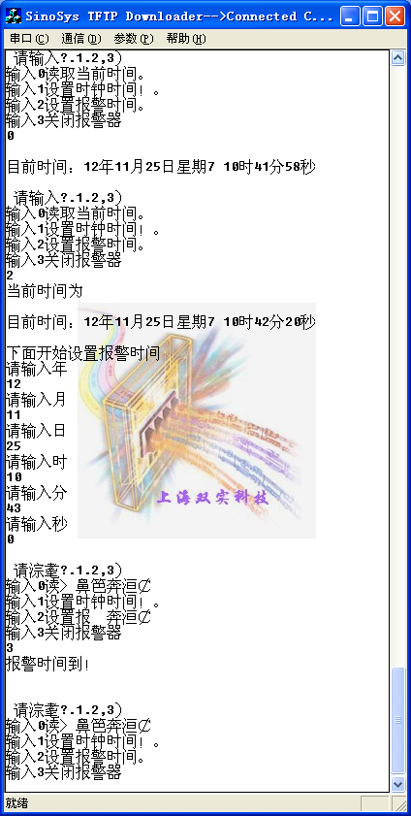
#include "2440addr.h"
#include "2440lib.h"

void __irq rtc_isr(void);
///////////定义变量的时候只能在代码最前面定义变量。可以定义到函数外面
unsigned char year, month, day, date, hour, min, sec;
unsigned char year_bcd, month_bcd, day_bcd, date_bcd, hour_bcd, min_bcd, sec_bcd;
unsigned char alm_year, alm_month, alm_date, alm_hour, alm_min, alm_sec;
unsigned char alm_year_bcd, alm_month_bcd, alm_date_bcd, alm_hour_bcd, alm_min_bcd, alm_sec_bcd;
int i=0;//用来分辨是设置时钟时间还是设置报警时间，还是读取当前时间。

//Led 连接用到的引脚初始化
void Led_Init(void)
{
rGPFCON &= ~( (3<<8)|(3<<10)|(3<<12)|(3<<14));
rGPFCON |= ( (1<<8)|(1<<10)|(1<<12)|(1<<14));
rGPFUP &= 0x0F;
rGPFDAT |= 0xFF; // 初始灯全灭
}

//初始化函数
void rtc_init()
{
Led_Init();
//引脚功能初始化
rGPBCON &= ~(3<<0);/////这三个语句是用来控制蜂鸣器初始化。
rGPBCON |= (1<<0);
rGPBUP |= (1<<0);
//清除中断相关寄存器
rSRCPND |= (1<<30);
rINTPND |= (1<<30);
//选择中断屏蔽
rINTMSK &= ~(1<<30);
//安装中断处理函数
pISR_RTC = (unsigned int)rtc_isr;
//报警不使能

void set_time()
{
//设置时间
//year = 12; month = 11; day = 7; date = 25; hour = 9; min = 0; sec = 0;
Uart_Printf("\n下面开始设置报时钟时间\n");
Uart_Printf("请输入年\n");
year=Uart_GetIntNum();
Uart_Printf("请输入月\n");
month=Uart_GetIntNum();
Uart_Printf("请输入日\n");
date=Uart_GetIntNum();
Uart_Printf("请输入时\n");
hour=Uart_GetIntNum();
Uart_Printf("请输入分\n");
min=Uart_GetIntNum();
Uart_Printf("请输入秒\n");
sec=Uart_GetIntNum();

year_bcd = (unsigned char)(year/10*16 + year%10);
month_bcd = (unsigned char)(month/10*16 + month%10);
//day_bcd = (unsigned char)day;
date_bcd = (unsigned char)(date/10*16 + date%10);
hour_bcd = (unsigned char)(hour/10*16 + hour%10);
min_bcd = (unsigned char)(min/10*16 + min%10);
sec_bcd = (unsigned char)(sec/10*16 + sec%10);
rRTCCON |= 0x1;
rBCDYEAR = year_bcd;
rBCDMON = month_bcd;
//rBCDDAY = day_bcd;
rBCDDATE = date_bcd;
rBCDHOUR = hour_bcd;
rBCDMIN = min_bcd;
rBCDSEC = sec_bcd;
rRTCCON &= 0xE;
}

void set_almtime()
{
//设置报警时间
//alm_year = 12; alm_month = 11; alm_date = 25; alm_hour = 9; alm_min = 0; alm_sec = 10;//默认时间

while(1)
{
//Uart_Getch();
//报警不使能
//rRTCALM = 0x00;

Uart_Printf("\n 请输入（0.1.2,3）\n输入0读取当前时间。\n输入1设置时钟时间！。\n输入2设置报警时间。\n输入3关闭报警器\n");
i=Uart_GetIntNum();
switch(i)
{
case 0:readtime();break;
case 1:set_time();break;
case 2:set_almtime();break;
case 3:rGPBDAT &=0;break;
}

}
}

5．实验总结
通过这次实验，我学会了如何使用实时时钟部件，并且学会了用Uart的函数灵活设置时钟时间，报警时间，以及联系到蜂鸣器了led灯。

