J2ME课程实验报告

实验名称： Socket网络编程
班级： B10511
学号： 20104051105
姓名： 朱小虎

日期： 2013 年 4 月 28

- 实验目的：
练习Socket网络编程
- 实验环境
Ecplise 、MyEcplise
- 实验内容
利用socket网络编程实现聊天功能。
- 具体实验关键代码

服务器：

package com.xh.main.chat;

import java.io.DataInputStream;
import java.io.DataOutputStream;
import java.io.IOException;

import javax.microedition.io.Connector;
import javax.microedition.io.ServerSocketConnection;
import javax.microedition.io.SocketConnection;
import javax.microedition.lcdui.Command;
import javax.microedition.lcdui.CommandListener;
import javax.microedition.lcdui.Display;
import javax.microedition.lcdui.Displayable;
import javax.microedition.lcdui.Form;
import javax.microedition.lcdui.TextField;
import javax.microedition.midlet.MIDlet;
import javax.microedition.midlet.MIDletStateChangeException;

public class ChatServerMIDlet extends MIDlet implements CommandListener {

private Display display;
private Form form;
private TextField dataField;
private Command sendCmd;

// 建立Socket连接、打开输入输出流
private ServerSocketConnection serverSocketConn;
private SocketConnection socketConn1;
private SocketConnection socketConn2;

private DataInputStream dis1;
private DataOutputStream dos1;

private DataInputStream dis2;
private DataOutputStream dos2;

public ChatServerMIDlet() {
display = Display.getDisplay(this);
form = new Form("Chat Server");

dataField = new TextField("发送给所有客户: ", "", 16, TextField.ANY);
sendCmd = new Command("发送", Command.SCREEN, 1);
}

protected void destroyApp(boolean arg0) throws MIDletStateChangeException {
if (dis1 != null) {
try {
dis1.close();
} catch (IOException e) {
// TODO Auto-generated catch block
e.printStackTrace();
}
}
if (dos1 != null) {
try {
dos1.close();
} catch (IOException e) {
// TODO Auto-generated catch block
e.printStackTrace();
}
}

if (socketConn1 != null) {
try {
socketConn1.close();
} catch (IOException e) {
// TODO Auto-generated catch block
e.printStackTrace();
}
}
if (socketConn1 != null) {
try {
socketConn2.close();
} catch (IOException e) {
// TODO Auto-generated catch block
e.printStackTrace();
}
}
if (serverSocketConn != null) {
try {
serverSocketConn.close();
} catch (IOException e) {
// TODO Auto-generated catch block
e.printStackTrace();
}
}

}

protected void pauseApp() {
// TODO Auto-generated method stub

}

protected void startApp() throws MIDletStateChangeException {
display.setCurrent(form);

form.append(dataField);
form.append("客户端的消息记录：\n");
form.addCommand(sendCmd);
form.setCommandListener(this);

//new Thread(new SocektThread()).start();

try {
String url = "socket://:9999";////这里的9999算是自己设置的一个服务器的端口号。
serverSocketConn = (ServerSocketConnection) Connector.open(url);
} catch (IOException e) {
// TODO Auto-generated catch block
e.printStackTrace();
}
new Thread(new SocektThread1()).start();
new Thread(new SocektThread2()).start();
}

public void commandAction(Command cmd, Displayable dis) {
if (cmd == sendCmd) {
// 接收到服务器的输入，发送给所有客户
String data = dataField.getString();
try {
dos1.writeUTF("Server："+data);
dos2.writeUTF("Server："+data);
dataField.setString("");
} catch (IOException e) {
// TODO Auto-generated catch block
e.printStackTrace();
}
}
}

class SocektThread1 implements Runnable {
public SocektThread1() {
try {
socketConn1 = (SocketConnection) serverSocketConn.acceptAndOpen();
dos1 = socketConn1.openDataOutputStream();
dis1 = socketConn1.openDataInputStream();
System.out.println("连接1的地址为："+socketConn1.getAddress());///输出和他连接的用户地址；
System.out.println("当前地址为："+socketConn1.getLocalAddress());///输出和他连接的用户地址；
} catch (IOException e) {
// TODO Auto-generated catch block
e.printStackTrace();
}
}

public void run() {
String clientData = "";
while(true)
{
try {
clientData = dis1.readUTF();
dos2.writeUTF("Client1："+clientData);
if(clientData=="")break;////防止另一个终端关闭后dis无法阻塞，导致一直死循环。
form.append("Client1: " + clientData + "\n");
} catch (IOException e) {
e.printStackTrace();
}
}
}
}
class SocektThread2 implements Runnable {
public SocektThread2() {
try {
socketConn2 = (SocketConnection) serverSocketConn.acceptAndOpen();
dos2 = socketConn2.openDataOutputStream();
dis2 = socketConn2.openDataInputStream();
System.out.println("连接2的地址为："+socketConn2.getAddress());///输出和他连接的用户地址；
} catch (IOException e) {
// TODO Auto-generated catch block
e.printStackTrace();
}
}
public void run() {
String clientData = "";
while(true)
{
try {
clientData = dis2.readUTF();
dos1.writeUTF("Client2："+clientData);
if(clientData=="")break;////防止另一个终端关闭后dis无法阻塞，导致一直死循环。
form.append("Client2: " + clientData + "\n");
} catch (IOException e) {
if(e.equals(dis2))
{
System.out.println("dis2出现异常！");
break;
}
e.printStackTrace();
}
}

}
}
}

用户1：

package com.xh.main.chat;
import java.io.DataInputStream;
import java.io.DataOutputStream;
import java.io.IOException;
import javax.microedition.io.Connector;
import javax.microedition.io.SocketConnection;
import javax.microedition.lcdui.Command;
import javax.microedition.lcdui.CommandListener;
import javax.microedition.lcdui.Display;
import javax.microedition.lcdui.Displayable;
import javax.microedition.lcdui.Form;
import javax.microedition.lcdui.TextField;
import javax.microedition.midlet.MIDlet;
import javax.microedition.midlet.MIDletStateChangeException;

public class ChatClientMIDlet extends MIDlet implements CommandListener {
private Display display;
private Form form;
private TextField dataField;
private Command sendCmd;

// 建立Socket连接、打开输入输出流
private SocketConnection socketConn;

private DataInputStream dis;
private DataOutputStream dos;

public ChatClientMIDlet() {
display = Display.getDisplay(this);
form = new Form("Chat Client1");
dataField = new TextField("信息: ", "", 16, TextField.ANY);
sendCmd = new Command("发送", Command.SCREEN, 1);
}

protected void destroyApp(boolean arg0) throws MIDletStateChangeException {
// TODO Auto-generated method stub
try {
dos.close();
dis.close();
socketConn.close();

} catch (IOException e) {
// TODO Auto-generated catch block
e.printStackTrace();
}
}
protected void pauseApp() {
// TODO Auto-generated method stub
}
protected void startApp() throws MIDletStateChangeException {
display.setCurrent(form);

form.append(dataField);

form.addCommand(sendCmd);
form.setCommandListener(this);

new Thread(new ClientThread()).start();
}
public void commandAction(Command cmd, Displayable dis) {
if (cmd == sendCmd) {
// 接收到用户的输入，发送出去
String data = dataField.getString();
try {
dos.writeUTF(data);
dataField.setString("");
} catch (IOException e) {
// TODO Auto-generated catch block
e.printStackTrace();
}
}
}

class ClientThread implements Runnable {
public ClientThread() {

try {
String url = "socket://127.0.0.1:9999";//设置自己的地址为127.0.0.1向端口为9999的服务器发送
socketConn = (SocketConnection) Connector.open(url);

dos = socketConn.openDataOutputStream();
dis = socketConn.openDataInputStream();

} catch (IOException e) {
// TODO Auto-generated catch block
e.printStackTrace();
}
}
public void run() {
while(true) {

// 读入数据
String serverData = "";
try {
serverData = dis.readUTF();
} catch (IOException e1) {
// TODO Auto-generated catch block
e1.printStackTrace();
}
if(serverData=="")break;
form.append(serverData + "\n");

try {
Thread.currentThread().sleep(100);
} catch (InterruptedException e) {
// TODO Auto-generated catch block
e.printStackTrace();
}
}
}
}

}

用户2的代码基本和用户1一样。
- 运行效果
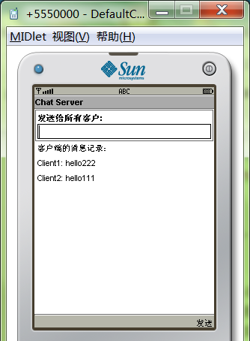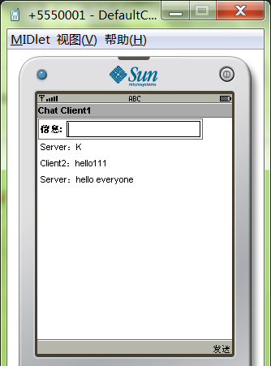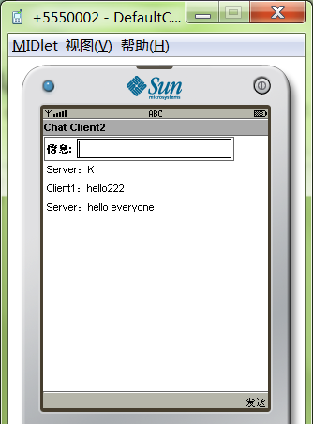
图1 服务器端 图2客户端1 图 3 客户端2
- 遇到的问题与解决方法
在实验过程中想实现多用户端通信，通信方法是先读入string的前几位，判断出信息来自哪里，要发向哪里，然后在服务器端调用不同的函数。不过这个想法在写报告时还没有完全写完。

