J2ME课程实验报告

实验名称： Sprite与TiledLayer的综合开发
班级： B10511
学号： 20104051105
姓名： 朱小虎

日期： 2013 年 5 月 17 日

- 实验目的：
搭建游戏开发的基本结构
练习GmaeCanvas、Sprite、TiledLayer的相关方法实现
- 实验环境
J2ME,WTK,图书馆5楼PC。
- 实验内容
实现Sprite与TiledLayer的碰撞检测功能
- 具体实验关键代码

package com.soft.xiaohu;

import java.io.IOException;
import javax.microedition.lcdui.Display;
import javax.microedition.lcdui.Graphics;
import javax.microedition.lcdui.Image;
import javax.microedition.lcdui.game.GameCanvas;
import javax.microedition.lcdui.game.Sprite;
import javax.microedition.lcdui.game.TiledLayer;
import javax.microedition.midlet.MIDlet;
import javax.microedition.midlet.MIDletStateChangeException;

public class MultiTiledLayerMIDlet extends MIDlet {
private Display display;
private MyGameCanvas gameCanvas;

public MultiTiledLayerMIDlet() {
display = Display.getDisplay(this);
gameCanvas = new MyGameCanvas();
}

protected void startApp() throws MIDletStateChangeException {
display.setCurrent(gameCanvas);

}

class MyGameCanvas extends GameCanvas implements Runnable {
private Graphics g;
private TiledLayer tiledLayer1;
private TiledLayer tiledLayer2;
private Sprite sprite1;
private Sprite sprite2;
private Sprite sprite3;
private boolean isSmall;

int[] seq0 = {0, 1, 2, 1};
int[] seq1 = {3, 4, 5, 4};
int[] seq2 = {6, 7, 8, 7};
int[] seq3 = {9, 10, 11, 10};
int up=0;
int down=0;
int right=0;
int left=0;

protected MyGameCanvas() {
super(true);
g = this.getGraphics();
try {
Image img1 = Image.createImage("/hero.png");
sprite1 = new Sprite(img1, img1.getWidth()/3, img1.getHeight()/4);

Image img2 = Image.createImage("/ball.gif");
sprite2 = new Sprite(img2);

Image img3 = Image.createImage("/small.gif");
sprite3 = new Sprite(img3);

sprite1.setFrameSequence(seq2);
sprite1.setPosition(24,24);
sprite2.setPosition(24,88);
sprite3.setPosition(88,112);
Image img = Image.createImage("/map.png");

tiledLayer1 = new TiledLayer(10, 12, img, img.getWidth() / 2, img.getHeight());
tiledLayer2 = new TiledLayer(10, 12, img, img.getWidth() / 2, img.getHeight());
int[][] cells1 = {
{0,0,1,0,1,0,0,0,1,0,1},
{0,0,1,0,1,0,0,0,1,0,1},
{1,0,1,0,1,0,1,0,1,0,0},
{1,0,0,0,1,0,1,0,1,0,1},
{1,0,0,0,1,0,1,0,1,0,1},
{1,0,1,0,1,0,1,0,1,0,1},
{1,0,1,0,1,0,1,0,1,0,1},
{1,0,1,0,0,0,1,0,1,0,1},
{0,0,1,0,0,0,1,0,1,0,1},
{0,0,1,0,1,0,1,0,0,0,1},
{1,0,1,0,1,0,1,0,0,0,1},
{1,0,1,0,1,0,1,0,1,0,1}
};
int[][] cells2 = {
{2,2,0,2,0,2,2,2,0,2,0},
{2,2,0,2,0,2,2,2,0,2,0},
{0,2,0,2,0,2,0,2,0,2,2},
{0,2,2,2,0,2,0,2,0,2,0},
{0,2,2,2,0,2,0,2,0,2,0},
{0,2,0,2,0,2,0,2,0,2,0},
{0,2,0,2,0,2,0,2,0,2,0},
{0,2,0,2,2,2,0,2,0,2,0},
{2,2,0,2,2,2,0,2,0,2,0},
{2,2,0,2,0,2,0,2,2,2,0},
{0,2,0,2,0,2,0,2,2,2,0},
{0,2,0,2,0,2,0,2,0,2,0}
};
for (int i = 0; i < 12; i++) {
for (int j = 0; j < 10; j++) {
tiledLayer1.setCell(j, i, cells1[i][j]);
tiledLayer2.setCell(j, i, cells2[i][j]);
}
}
tiledLayer1.setPosition(0, 0);
tiledLayer2.setPosition(0, 0);
} catch (IOException e) {
// TODO Auto-generated catch block
e.printStackTrace();
}
isSmall = true;

new Thread(this).start();

new Thread(new jump()).start();
}
//新加此线程的作用是，小人在跳跃的时候防止出现按一下按钮跳跃好多次。
//加了一个线程睡觉函数。但此线程睡觉函数又不会影响主线程的进行。
class jump implements Runnable{
public void run() {
// TODO Auto-generated method stub
while(true)
{
int keyState = MyGameCanvas.this.getKeyStates();
if ((keyState & GameCanvas.FIRE_PRESSED) != 0) {
System.out.println("跳跃！！！");
if(up>0)
sprite1.move(0, -48);
else if(down>0)
sprite1.move(0, 48);
else if(left>0)
sprite1.move(-48, 0);
else if(right>0)
sprite1.move(48, 0);

int x=sprite1.getX();
int y=sprite1.getY();//这里解决跳跃出边境后到草坪上消失的问题。
if(sprite1.getX()>218)
{
System.out.println("跳跃出右边境！");
sprite1.setPosition(24, y);
}

if(sprite1.getY()>264)
{
System.out.println("达到边境！");
sprite1.setPosition(x, 24);
}
if(sprite1.getX()<0)
{
System.out.println("达到边境！");
sprite1.setPosition(218, y);
}
if(sprite1.getY()<0)
{
System.out.println("达到边境！");
sprite1.setPosition(x, 264);
}

//sprite1.move(2, 0);

try {
Thread.sleep(400);
} catch (InterruptedException e) {
// TODO Auto-generated catch block
e.printStackTrace();
}
MyGameCanvas.this.draw();
}

}
}
}

// 绘制界面
public void draw() {
// 清屏
g.setColor(255, 255, 255);
g.fillRect(0, 0, this.getWidth(), this.getHeight());

// 绘制
tiledLayer1.paint(g);
tiledLayer2.paint(g);
sprite1.paint(g);
sprite2.paint(g);

if(isSmall)
{
sprite3.paint(g);
}

this.flushGraphics();
}

// 判断用户的输入，进行逻辑处理
private void logic() {
//sprite1.move(1, 1);
int x,y;
x=sprite1.getX();
y=sprite1.getY();

int keyState = this.getKeyStates();
if ((keyState & GameCanvas.UP_PRESSED) != 0) {
if(up==0)
sprite1.setFrameSequence(seq0);
up++;
//up=0;
down=0;
left=0;
right=0;
sprite1.nextFrame();
sprite1.move(0, -2);
this.draw();
} else if ((keyState & GameCanvas.DOWN_PRESSED) != 0) {
if(down==0)
sprite1.setFrameSequence(seq2);
down++;
up=0;
//down=0;
left=0;
right=0;
sprite1.nextFrame();
sprite1.move(0, 2);
this.draw();
} else if ((keyState & GameCanvas.LEFT_PRESSED) != 0) {
if(left==0)
sprite1.setFrameSequence(seq3);
left++;
up=0;
down=0;
//left=0;
right=0;
sprite1.nextFrame();
sprite1.move(-2, 0);
this.draw();
} else if ((keyState & GameCanvas.RIGHT_PRESSED) != 0) {
if(right==0)
sprite1.setFrameSequence(seq1);
right++;
up=0;
down=0;
left=0;
//right=0;
sprite1.nextFrame();
sprite1.move(2, 0);
this.draw();
}
if(sprite1.getX()>218)
{
System.out.println("达到边境！");
sprite1.setPosition(0, y);
}
if(sprite1.getY()>264)
{
System.out.println("达到边境！");
sprite1.setPosition(x, 0);
}
if(sprite1.getX()<0)
{
System.out.println("达到边境！");
sprite1.setPosition(218, y);
}
if(sprite1.getY()<0)
{
System.out.println("达到边境！");
sprite1.setPosition(x, 264);
}

//使用false参数的目的是防止小人在那么窄的道路上行走的时候走动动作碰到小草，导致一直触碰小草
if(sprite1.collidesWith(tiledLayer1, false)) {
//isRun = false;
System.out.println("不能践踏草坪！！");
sprite1.setPosition(x, y);
}

if(sprite2.collidesWith(sprite3, true)) {
//isRun = false;
System.out.println("踢中笑脸！！");

isSmall=false;
}

if(sprite1.collidesWith(sprite2, true)) {
//isRun = false;
System.out.println("踢到球！");

//int xx=sprite2.getX();
//int yy=sprite2.getY();
if(up>0)
//yy-=8;
ballrun(0,-18);
else if(down>0)
//yy+=8;
ballrun(0,+18);
else if(left>0)
//xx-=8;
ballrun(-18,0);
else if(right>0)
//xx+=8;
ballrun(18,0);
//sprite2.setPosition(xx, yy);
}
int xx=sprite2.getX();
int yy=sprite2.getY();
if(sprite2.getX()>218)
{
System.out.println("达到边境！");
sprite2.setPosition(0, yy);
}
if(sprite2.getY()>264)
{
System.out.println("达到边境！");
sprite2.setPosition(xx, 0);
}
if(sprite2.getX()<0)
{
System.out.println("达到边境！");
sprite2.setPosition(218, yy);
}
if(sprite2.getY()<0)
{
System.out.println("达到边境！");
sprite2.setPosition(xx, 264);
}
//sprite1.nextFrame();
this.draw();
}

void ballrun(int x,int y)/////此函数的作用是让小球移动的时候有动画效果，而不是直接跳跃x或y的距离。
{
int i=0;
int xx=sprite2.getX();
int yy=sprite2.getY();
if(x>0)
for(i=0;i<x;i++)
{
xx++;
sprite2.setPosition(xx, yy);
this.draw();
}
if(x<0)
for(i=0;i>x;i--)
{
xx--;
sprite2.setPosition(xx, yy);
this.draw();
}
if(y>0)
for(i=0;i<y;i++)
{
yy++;
sprite2.setPosition(xx, yy);
this.draw();
}
if(y<0)
for(i=0;i>y;i--)
{
yy--;
sprite2.setPosition(xx, yy);
this.draw();
}

}

public void run() {
this.draw();

while(true)
{
logic();
try {
Thread.sleep(10);//不同的数值可以控制小人的持续移动速度
} catch (InterruptedException e) {
// TODO Auto-generated catch block
e.printStackTrace();
}
}
}
}
protected void destroyApp(boolean arg0) throws MIDletStateChangeException {
// TODO Auto-generated method stub
}
protected void pauseApp() {
// TODO Auto-generated method stub
}
}
- 运行效果
游戏介绍和规则：Hero不可以践踏草坪。但Hero可以跳过草坪（按方向键中间的键是跳跃）也可以跳到草坪上，在草坪上不能移动只能跳跃。Hero和小球达到地图边界后会从另一个边界出来。小球的行动路线没有限制。最终Hero通过踢小球把目标笑脸撞消失为胜利。

图1 初始画面 图2 踢到球
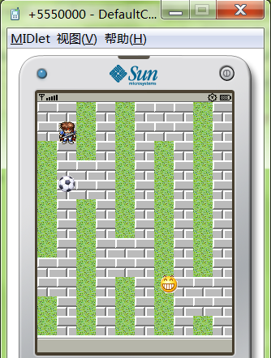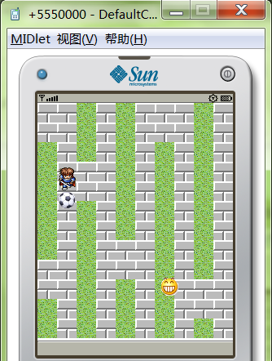

图3~4 Hero穿过边界到达另一边
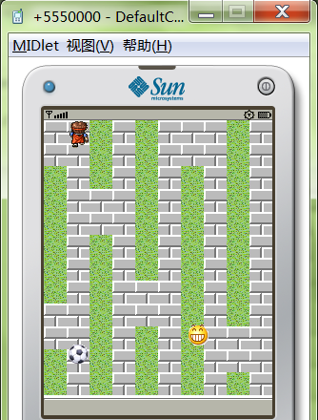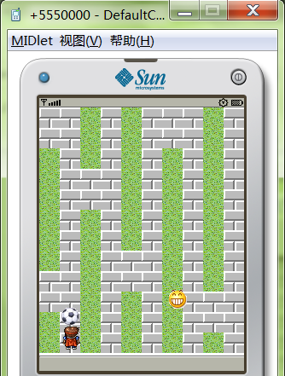
图5~6 把球踢好位置Hero通过穿边界绕到小球左边踢小球
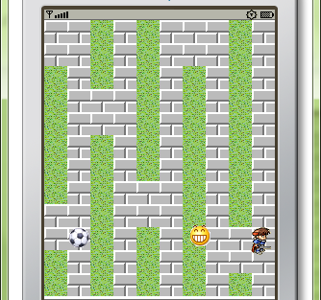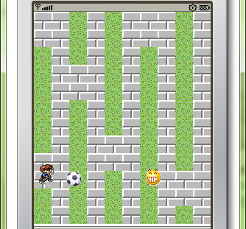

图7 Hero无法践踏草坪 图8 Hero通过跳跃跳过草坪并踢到小球
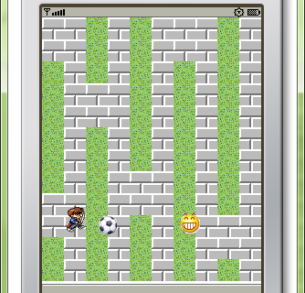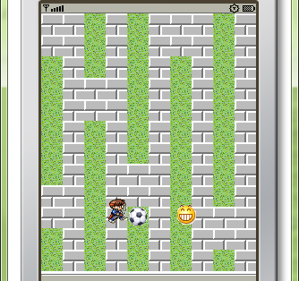

图9 继续跳跃踢小球发现刚好无法踢到 图10 想办法通过跳跃草坪调整小球位置
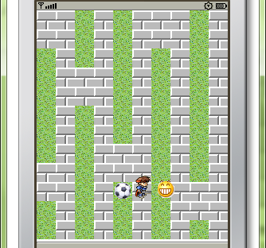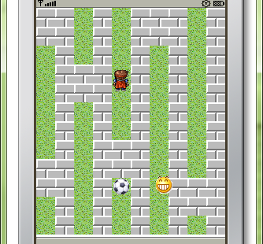

图11 把小球调整到好踢位置 图12 继续调整小球位置
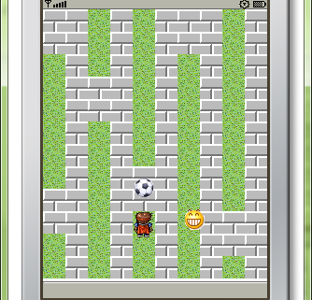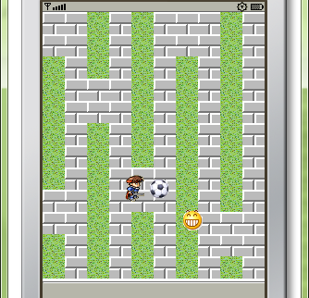

图13 踢小球到目标笑脸附近 图14 Hero移动好位置准备踢小球边缘踢向目标
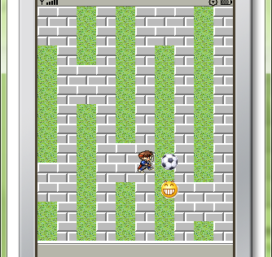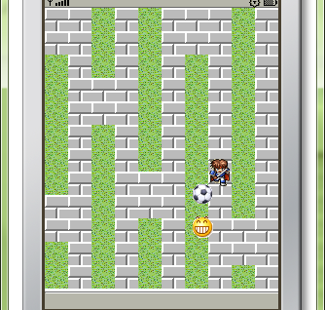

图15 通过踢小球边缘踢动小球将笑脸踢中，胜利！
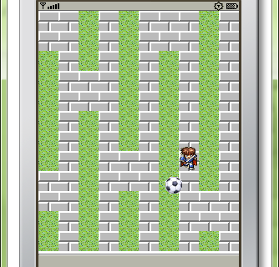

- 遇到的问题与解决方法
如果想把它做成一个完整的游戏，可以设计让目标笑脸随机的产生在地图上，并且多加几个目标笑脸。
在编程过程中没有遇到太大的问题，遇到的小问题通过问老师和上网查资料都解决了。

