

DoD Architecture Framework
Version 2.03

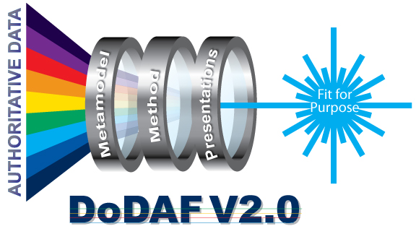

Volume 1: Introduction, Overview, and Concepts

Manager’s Guide

31 December 2011

This page left intentionally blank

EXECUTIVE SUMMARY
The Department of Defense Architecture Framework (DoDAF) serves as the overarching, comprehensive framework and conceptual model enabling the development of architectures to facilitate the ability of Department of Defense (DoD) managers at all levels to make key decisions more effectively through organized information sharing across the Department, Joint Capability Areas (JCAs), Mission, Component, and Program boundaries. The DoDAF serves as one of the principal pillars supporting the DoD Chief Information Officer (CIO) in his responsibilities for development and maintenance of architectures required under the Clinger-Cohen Act. It also reflects guidance from the Office of Management and Budget (OMB) Circular A-130, and other Departmental directives and instructions. This version of the Framework provides extensive guidance on the development of architectures supporting the adoption and execution of Net-centric services within the Department.
DoD managers, as process owners, specify the requirements and control the development of architectures, as described in this volume, within their areas of authority and responsibility. In that role, they select an architect and an architecture development team to create the architecture in accordance with the requirements defined by the process owner. As described in Volume 1, architecture concentrates on those data that correspond to architecture requirements.
The duties of the architect and the architecture team that create the architecture are further described in more technical language in Volume 2 of DoDAF. The architect supervises development of the architecture, and ensures that the requirements and visual representations of the architecture meet process owner requirements and ensures that conformance requirements described in this volume and in Volume 2 are met.
DoD Components are expected to conform to DoDAF in development of architectures within the Department. Conformance ensures that reuse of information, architecture artifacts, models, and viewpoints can be shared with common understanding.
DoDAF conformance is achieved by levels as follows:

- Level 1 -- Conceptually conformant
  - Uses DoDAF terms and aliases (from DM2 CDM) to categorize its concepts
  - DoDAF views (AV-1 thru DIV-3) have correct information according to “monster matrix”). For example, an OV-2 with radios would be non-conformant or an OV-4 with Tank parts would be non-conformant
  - Fit-For-Purpose (FFP) would have to be conformant with whatever the FFP model creator(s) specified, e.g., a “xV-1" view for which the creator(s) specified the model as Services mapping to Capabilities should have Services and Capabilities and the relationship but shouldn't have unrelated info
- Level 2 -- Logically conformant. The data in a described architecture is defined according to the DM2 concepts, associations, and attributes. Level 1 + adheres to terms and relationships from DM2 LDM and aliases
- Level 3 -- Physically conformant. The architectural data is capable of transfer in accordance with the PES. Level 2 + expressed as DoDAF – DM2 PES that can be consumed by others. The mapping of the DM2 Concepts, Associations, and Attributes to each DoDAF-described Model is listed in Table B-1, “DM2 Concepts (Classes, Aliases, and Composite Terms) Mapping to DoDAF Models” in Volume 2 indicates the related metadata in the PES.
- Level 4 -- Semantically conformant. Level 3 + IDEAS semantics are correct

DoDAF V2.0 focuses on architectural data, rather than on developing individual products as described in previous versions. In general, data can be collected, organized, and stored by a wide range of architecture tools developed by commercial sources. It is anticipated that these tools will adopt the DM2 PES for the exchange of architectural data.
A Data Capture Method for each data group of the DM2 is provided in Volume 2 to guide architects in collecting and organizing the necessary architectural data.
The DoDAF enables architectural content to be built that is “Fit-for-Purpose”, defined and described in Volume 1 as an Architectural Description consistent with specific project or mission objectives. Because an Architectural Description can be applied at myriad levels of an enterprise, the purpose or use of an Architectural Description at each level will be different in content, structure, and level of detail. Tailoring the Architectural Description development to address specific, well-articulated, and understood purposes, will help ensure the necessary data is collected at the appropriate level of detail to support specific decisions or objectives.
Visualizing architectural data is accomplished through models (e.g., the products described in previous versions of DoDAF). Models (which can be documents, spreadsheets, dashboards, or other graphical representations) serve as a template for organizing and displaying data in a more easily understood format. When data is collected and presented in this way, the result is called a view. Organized collections of views (often representing processes, systems, services, standards, etc.) are referred to as viewpoints, and with appropriate definitions are collectively called the Architectural Description.
DoDAF V2.0 discusses DoDAF-described Models and Fit-for-Purpose Views:
- DoDAF-described Models (also referred to as Models) are created from the subset of data for a particular purpose and are fully explained in DoDAF V2.0, Volume 2. Once the DoDAF-described Models are populated with data, these “views” are useful as examples for presentation purposes, and can be used as described, modified, or tailored as needed.
- Fit-for-Purpose Views are user-defined views of a subset of architectural data created for some specific purpose (i.e., “Fit-for-Purpose”). While these views are not described or defined in DoDAF, they can be created, as needed, to ensure that presentation of architectural data is easily understood within an agency. This enables agencies to use their own established presentation preferences in their deliberations.
The Models described in DoDAF, including those that are legacy products from previous versions of the Framework, are provided as pre-defined examples that can be used when developing presentations of architectural data.

DoDAF is prescribed for the use and development of Architectural Descriptions in the Department. Specific DoDAF-described Models for a particular purpose are prescribed by process-owners. All the DoDAF-described Models do not have to be created. DoDAF V2.0 is “Fit-for-Purpose”, based on the decision-maker needs. DoDAF concentrates on data as the necessary ingredient for architecture development. If an activity model is created, a necessary set of data for the activity model is required. Key process owners will decide what architectural data is required, generally through DoDAF-described Models or Fit-for-Purpose Views. However, other regulations and instructions from the DoD and the Chairman, Joint Chiefs of Staff (CJCS) have particular presentation view requirements. These views are supported by DoDAF V2.0, and should be consulted for specific view requirements. The architectural data described in DoDAF V2.0 can support many model and view requirements and the regulations and instructions should be consulted for those specific requirements.

The architect and stakeholders select views to ensure that the Architectural Descriptions will support current and future states of the process or activity under review. Selecting Architecture Viewpoints carefully ensures that the views adequately frame concerns, e.g., by explaining the requirements and proposed solutions, in ways that enhance audience understanding.
DoDAF also serves as the principal guide for development of integrated architectures as defined in DoD Instruction 4630.8, which defines an integrated architecture as “An architecture consisting of multiples views or perspectives facilitating integration and promoting interoperability across capabilities and among integrated architectures”. The term integrated means that data required in more than one instance in architectural views is commonly understood across those views.
The DM2 provides information needed to collect, organize, and store data in a way easily understood. The presentation description of various types of views in Volumes 1 and 2 provide the guidance for developing graphical representations of that data that is useful in defining acquisition requirements under the DoD Instruction 5000-series.
The DM2 replaces the Core Architecture Data Model (CADM) which supported previous versions of the DoDAF. DM2 is a data construct that facilitates reader understanding of the use of data within an architecture document. CADM can continue to be used in support of architectures created in previous versions of DoDAF.
DoDAF V2.0 is a marked change from earlier versions of Command, Control, Communications, Computers, and Intelligence Surveillance Reconnaissance Architecture Framework (C4ISRAF) or DoDAF, in that architects now have the freedom to create enterprise architectures to meet the demands of their customer requirements. The central core of DoDAF V2.0 is a data-centric approach where the creation of architectures to support decision-making is secondary to the collection, storage, and maintenance of data needed for efficient and effective decisions. The architect and stakeholders select views to ensure that architectures will explain current and future states of the process or activity under review. Selecting architectural views carefully ensures that the views adequately explain the requirement and proposed solution in ways that will enhance audience understanding.
DoDAF V2.0 also provides, but does not require, a particular methodology in architecture development. Volume 1 contains numerous examples of how to utilize the DoDAF methodology either alone, or in conjunction with other methods. Volume 1 provides guidance and suggestions on how to ensure that other proposed methods can be adapted as needed to meet the DoD requirements for data collection and storage. Similarly, the views presented in DoDAF are examples, intended to serve as a possible visualization of a particular view. DoDAF V2.0 also continues providing support for views (i.e., ‘products’ developed in previous versions of the Framework). These views do not require any particular graphical design by toolset vendors.
DoDAF V2.0 is composed of three volumes, along with an electronic DoDAF Journal currently hosted on Defense Knowledge Online, https://www.us.army.mil/suite/page/454707. Together, these volumes and the DoDAF Journal provide a resource enabling users to access the DoD’s entire body of knowledge associated with architecture.
- Volume 1 provides general guidance for development, use, and management of DoD architectures. This volume is designed to help non-technical users understand the role of architecture in support of major decision support processes. Volume 1 provides a 6-step methodology (Section 7) that can be used to develop architectures at all levels of the Department, and a Conceptual Data Model (CDM) (Section 9) for organizing data collected by an architecture effort.
- Volume 2 describes the construct of architectures, data descriptions, data exchange requirements, and examples of their use in developing architectural views in technical detail, to include the development and use of service-oriented architecture (SOAs) in support of Net-centric operations. Volume 2 provides a Logical Data Model (LDM), based on the CDM, which describes and defines architectural data; further describes the methods used to populate architectural views, and describes how to use the architectural data in DoDAF-described Models, or in developing Fit-for-Purpose Views that support decision-making.
- Volume 3 relates the CDM structure with the LDM relationships and associations, along with business rules described in Volume 2 to introduce a PES, which provides the constructs needed to enable exchange of data among users and COIs. NOTE: DoDAF V2.0 does NOT prescribe a Physical Data Model (PDM), leaving that task to software developers who will implement the principles and practices of DoDAF in their own software offerings.
- The DoDAF Journal, https://www.us.army.mil/suite/page/454707, is the electronic interface for DoDAF support. The DoDAF Journal provides a place for submitting future change requests to DoDAF or the DM2 (Section 9); provides examples referenced in the various DoDAF volumes, and includes descriptions of other best practices, lessons learned, and reference documents that supplement the information contained in the three volumes of DoDAF V2.0, including:
DoDAF Architecture Development Process for the Models
DoDAF Product Development Questionnaire & Analysis Report
DoDAF V2.0 Meta-model Data Dictionary
In DoDAF V2.0, data leans heavily on the major areas of change within the Department, including the Joint Capabilities Integration and Development System (JCIDS), the Defense Acquisition System (DAS), Systems Engineering (SE), the Planning, Programming, Budgeting, and Execution (PPBE) Process, and Portfolio Management (PfM). These major processes produce far-reaching change across all Military Departments, Agencies, the Joint Staff, and other Departmental functions. Architectures developed utilizing the guidance in DoDAF demonstrate how change is documented and executed through an architecturally based approach that:
- Establishes and documents scope and boundaries.
- Documents best practices.
- Defines and describes generic performance measures (metrics).
- Documents and describes potential solutions for management review and approval.
DoDAF V2.0 is organized to facilitate the organization, and maintenance of data collected in an architectural development effort. The data centric approach facilitates both the production of multiple custom views of the architecture and continuing requirements to produce integrated architectures made up of traditional DoDAF views. This approach supports Departmental programs, such as Business Transformation Agency (BTA), JCIDS, and other major functions with significant impact throughout the Department that have developed requirements for multiple, custom views beyond the customary operational, systems, and technical views contained in previous versions of DoDAF and is also consistent with DoDI 4630.8 requirements for integrated architectures. These customized views, and the models that utilize the data, enable the architecture information to be communicated to, and understood by, stakeholders in diverse functional organizations. Products developed under previous versions of DoDAF continue to be supported, as described in Volume 2.
DoDAF data can be collected, organized, and stored by a wide range of architecture tools developed by commercial sources. Visualization of views in DoDAF V2.0 is for illustration purposes only. There may be multiple techniques that can be employed creating architectural models in differing views.

This page left intentionally blank

TABLE OF CONTENTS

SECTION PAGE

1 INTRODUCTION 1
1.1 Vision for DoDAF V2.0 2
1.2 DoDAF V2.0 Organization and Intended Audience 2
1.2.1 DoDAF Volume 1 – Introduction, Overview, and Concepts. (Primary audience: Executives, Project Directors, & Managers) 2
1.2.2 DoDAF Volume 2 – Architectural Data and Models. (Primary Audience: architects, program managers, portfolio managers, and other technically oriented architecture users) 3
1.2.3 DoDAF Volume 3 – DM2 PES 3
1.2.4 DoDAF Journal 4
1.3 Purpose and Scope 4
1.3.1 Developing Architectures 5
1.3.2 Maintaining and Managing Architectures 6
1.3.3 Using Architectures 7
1.3.4 DoDAF Conformance 7
1.4 What is New in DoDAF V2.0 7
1.5 What DoD Managers and Executives Need to Know About DoDAF 8
2 DoDAF VOLUMES AND JOURNAL OVERVIEW 10
2.1 DoDAF Overview 10
2.2 DoDAF Background Error! Bookmark not defined.
2.2.1 Authority: Law, Policy, and Historic Perspective Error! Bookmark not defined.
2.2.2 Historical Evolution of DoDAF Error! Bookmark not defined.
2.2.3 DoDAF V2.0 – The Need for Change Error! Bookmark not defined.
2.3 Assumptions Error! Bookmark not defined.
2.4 DoDAF Structure 12
2.4.1 Architectural Data 13
2.4.2 Architecture Viewpoints and DoDAF-described Models 13
2.5 DoDAF Development Guidelines 19
2.5.1 Guiding Principles 19
2.5.2 Multiple Techniques and Toolsets, Including Structured and Object Oriented Analysis 20
2.5.3 Essential Toolset Attributes 21
2.6 Architecture Resources 21
3 DoDAF META-MODEL 1
3.1 The DoDAF Conceptual Data Model 1
APPENDIX A 5
GLOSSARY 5
APPENDIX C 12
REFERENCES/BIBLIOGRAPHY 12

LIST OF FIGURES

FIGURE PAGE

Figure 1.5-1: What the Decision-Maker Needs to Do 10
Figure 2-1: Establishing the Scope for Architecture Development Error! Bookmark not defined.
Figure 2-2: Mission Outcomes Supported by Architectures Error! Bookmark not defined.
Figure 3.4.2-1: Architecture Viewpoints in DoDAF V2.0 14
Figure 4.1-1: Components of the DoD EA Error! Bookmark not defined.
Figure 7.1.1-1: Architecture Development 6-Step Process Error! Bookmark not defined.
Figure 7.1.3-1: Plan, Do, Check, and Act (PDCA) Cycle Error! Bookmark not defined.
Figure 7.2.2-1: Deployment/Operational Model Error! Bookmark not defined.
Figure 8.1-1: Presentation Techniques Error! Bookmark not defined.
Figure 8.1-2: The Information Bridge Error! Bookmark not defined.
Figure 8.2-1: Levels of Decision-Makers Error! Bookmark not defined.
Figure 8.2-2: Presentation Development Process Error! Bookmark not defined.
Figure 8.3.2-1: Example Composite View Error! Bookmark not defined.
Figure 8.3.2-2: Another Composite View Error! Bookmark not defined.
Figure 8.4.2.-1: Notional Dashboard Error! Bookmark not defined.
Figure 8.5.2-1: Financial Data Fusion View Error! Bookmark not defined.
Figure 8.5.2-2: Fusion View without External Financial Data Error! Bookmark not defined.
Figure 8.6.2-1: Non-prescriptive, Illustrative High-level Concept Description (OV-1) Error! Bookmark not defined.
Figure 8.6.2-2: Non-prescriptive, Illustrative High-level Operational Connectivity
Description (OV-2) Error! Bookmark not defined.
Figure 8.7-1: A Notional Reference Model Error! Bookmark not defined.
Figure 8.7.2-1: BRM Structure Error! Bookmark not defined.
Figure 8.7.2-2: BRM Areas Error! Bookmark not defined.
Figure 9.1-1: DoDAF Conceptual Data Model 5
Figure 9.1-2: Overview of DM2 Foundation 3
Figure 10.1-1: Analytics Process, Central to Transforming Architectural Data into
Usable Forms to Support Decision-Makers Error! Bookmark not defined.
Figure 10.1-2: Iterative Approach Error! Bookmark not defined.

LIST OF TABLES

TABLE PAGE

Table 3.2.1-1: Federal Law and Policy Error! Bookmark not defined.
Table 3.4.2.9-1: DoDAF V2.0 Models 16
Table 3.6-1: Architecture Resources 21
Table 4.6-1: References to Architectural Description Development Error! Bookmark not defined.
Table 8.4.2-1: Visualization Techniques Error! Bookmark not defined.
Table 10.4-1: DOTMLPF Error! Bookmark not defined.
Table B-1: Conceptual Data Model Definitions B-Error! Bookmark not defined.

INTRODUCTION
DoDAF V2.0 is the overarching, comprehensive framework and conceptual model enabling the development of architectures to facilitate DoD managers at all levels to make key decisions more effectively through organized information sharing across Department, Joint Capability Areas (JCAs), Component, and Program boundaries. DoDAF V2.0 focuses on architectural data as information required by key DoD decision makers, rather than on developing individual products. The DoDAF-described Models described in this volume and Volume 2 are used to obtain and visualize data requirements. The framework also enables architecture content to be built that is “Fit-for-Purpose”, as defined and described in Section 1.4. DoDAF is one of the principal pillars supporting the responsibilities Department of Defense Chief Information Officer (DoD CIO) in exercise of his responsibilities for development and maintenance of architectures required under the Clinger-Cohen Act. DoDAF also explains guidance from OMB Circular A-130 and other appropriate DoD directives and instructions; this version of the Framework also provides guidance on the development of architectures supporting the development of Net-centric services within the Department.
DoDAF also serves as the principal guide for development of integrated architectures, as defined in DoD Instruction 4630.8, which states: “An architecture consisting of multiple views or perspectives facilitating integration and promoting interoperability across capabilities and among integrated architectures”. The term integrated means that data utilized in more than one instance in the architectural views is commonly understood across those views.
The OMB annually evaluates agency efforts to improve performance in strengthening the quality and usefulness of information technology investments requested by agencies through well-organized strategic decisions relating to investments and PfM. This process evaluates the use of enterprise and segment architectures, discussed in Section 3 of this document, as a principal means of ensuring mission requirements are met, while achieving savings and cost avoidance goals. Each agency is required to adopt an architecture framework—either existing or created within the agency for that purpose. DoDAF is the designated architecture framework with the DoD for architecture development.
The DM2 is a data model that provides information needed to collect, organize, and store data or derived information in a way easily understood. The descriptions of DoDAF-described Models in Volumes 1 and 2 provide guidance on how to develop graphical representations of that data and derived information that will be useful in defining acquisition requirements under the DoD Instruction 5000 series.
DoD managers, as process owners and/or decision-makers, specify the requirements, and control the development of architectures, as described in this volume, within their areas of authority and responsibility. In that role, they select an architect, and an architecture development team to create the architecture in accordance with the requirements defined by the manager (process owner). As described in Volume 1, the architecture concentrates on those data that correspond to architecture requirements.
The duties of the architect and the architecture team that create the architecture are supported by Volume 2 of DoDAF. The architect supervises development of the architecture, and ensures that the requirements and visual representations of the architecture meet process owner requirements.

Vision for DoDAF V2.0
The vision for utilization of DoDAF is to:
- Provide an overarching set of architecture concepts, guidance, best practices, and methods to enable and facilitate architecture development in support of major decision support processes across all major Departmental programs, Military components, and Capability areas that is consistent and complementary to Federal Enterprise Architecture Guidance, as provided by OMB.
- Support the DoD CIO in defining and institutionalizing the Net-Centric Data Strategy (NCDS) and Net-Centric Services Strategy (NCSS) of the Department, to include the definition, description, development, and execution of services and through introduction of SOA Development.
- Focus on architectural data as information required for making critical decisions rather than emphasizing individual architecture products. Enable architects to provide visualizations of the derived information through combinations of DoDAF-described Models, and Fit-for-Purpose Views commonly used by decision-makers, enabling flexibility to develop those views consistent with the culture and preferences of the organization.
- Provide methods and suggest techniques through which information architects and other developers can create architectures responsive to and supporting Departmental management practices.

DoDAF V2.0 Organization and Intended Audience
DoDAF V2.0 is presented in three volumes, along with an electronic DoDAF Journal. Together, these volumes provide a resource enabling users to understand and access DoD’s entire body of knowledge associated with architecture.

DoDAF Volume 1 – Introduction, Overview, and Concepts. (Primary audience: Executives, Project Directors, & Managers)
Volume 1 introduces DoD architecture concepts and provides general guidance for development, use, and management of DoD architectures. This volume is intended to help non-technical users understand the role of architecture in support of major decision support processes. Volume 1 provides a 6-step methodology (Section 7) that can be used to develop architectures at all levels of the Department, and a CDM (Section 9) for organizing data and derived information collected by an architecture effort.
Volume 1 contains the following resources:
- An overview and vision for DoDAF in Section 1.
- Defining “Fit-for-Purpose” Architectures in Section 2.
- An overview of the Framework, DoDAF-based architecture development guidelines, and the historical background for DoDAF in Section 3.
- An Introduction to Enterprise Architecture, Federated Architecting, and Architecture Enterprise Services, and an introduction to the Federal Enterprise Architecture published by the OMB in Section 4.
- An overview for architecture planning in Section 5.
- Addressing customer requirements in architecture development in Section 6.
- Methodology for architecture development in Section 7.
- Presentation methods and graphical views in Section 8.
- The DM2 Conceptual View in Section 9.
- Analytics in support of architecture-based management analysis section 10.
- Guidance on configuration management (CM) of architectures, and the CM process for DoDAF in Section 11.
- Inter-relationships among DoDAF and other architecture frameworks in Section 12.

DoDAF Volume 2 – Architectural Data and Models. (Primary Audience: architects, program managers, portfolio managers, and other technically oriented architecture users)
Volume 2 describes the Meta-model data groups, and their associated models, introduced in Volume 1, from a technical viewpoint.
Volume 2 is organized as follows:
- Introduction in Section 1.
- Meta-model Data Groups in Section 2. Twelve data groups are described in Volume 2, and each is defined by the following attributes:
  - Associated Data
  - Data Collection Method
  - Use
- DoDAF Viewpoints and Models in Section 3.
Appendices contain acronyms, DoDAF Model Support, and references. Volume 2 references the DoDAF Journal for the DoDAF V2.0 Meta-model Data Dictionary which describes the DoDAF LDM, and the DoDAF Architecture Development Process for the Models. The LDM provided introduces the relationships and associations needed by data modelers and technical designers.

DoDAF Volume 3 – DM2 PES
Within DoDAF, the reference to data refers to the architectural data that an Architectural Description needs to capture. As an exception, in Volume 2, Section 2.3, Information and Data and Volume 2, Section 3.1.3, Data and Information Viewpoint, the discussions describes the architectural data and the data that is being captured to populate the models for the solution. The architectural data may be the resource flows, but the solution data is the specific attributes of an instance of a resource flow for a given solution, e.g., the information that needs to capture the Latitude within a Cursor on Target message.
Volume 3 introduce a PES that relates the CDM structure, LDM relationships, associations, and business rules as described in Volume 2, The PES provides the constructs needed to enable exchange of data and derived information among users and COIs.
NOTE: DoDAF V2.0 does NOT prescribe a PDM, leaving that task to the software developers who will implement the principles and practices of DoDAF in their own software offerings.

DoDAF Journal
The DoDAF Journal, https://www.us.army.mil/suite/page/454707, the electronic interface for DoDAF support, provides a place for submitting future change requests to DoDAF or the DM2, and provides the examples referenced in the various DoDAF volumes. The Journal is a community of interest based discussion board. The Journal also includes descriptions of other best practices, lessons learned, and reference documents that supplement the information contained in the three volumes of DoDAF V2.0. The Journal has two parts:
- The first part describes the DoDAF CM Process, and provides the means to submit, review, and comment on the adjudication of formal changes to DoDAF. This part is intended to apply to all audiences who would like to propose changes to and keep up to date with the details of the DoDAF.
- The second part is a Community of Interest reference of best practices, examples, and templates, which can be used in projects where DoDAF is used to develop and execute process change through architecture development. This part is geared to architects, developers, program managers, and portfolio managers. Part 2 is organized in the same structure as the volumes of DoDAF.
A quick reference guide and tutorial on the use of DoDAF and the DoDAF Journal is also under development. Definitions of terms, acronyms, and other useful data, to include a bibliography are found in the appendices of this volume.

Purpose and Scope
The DoDAF provides the guidance needed to establish a common vocabulary for architecture development, for the exchange of architecture information, and for facilitating interoperability between Architectural Descriptions. Architectures are created for a number of reasons.
From a compliance perspective, DoD development of architectures is compelled by law and policy (i.e., Clinger-Cohen Act, Office of Management, and Budget (OMB) Circular A-130). From a practical perspective, the management of large organizations employing sophisticated systems, technologies, and services in pursuit of often complex joint missions demands a structured, repeatable method for evaluating investments and investment alternatives, as well as the ability to implement organizational change effectively, create new systems, deploy new technologies, and offer services which add value to decisions and management practices.
Guidance provided by DoDAF V2.0 applies to all architectures developed, maintained, and used within the DoD. The DoDAF also provides the foundational constructs to support the concept of architecture federation at each tier, enabling the sharing of all pertinent architecture information, and facilitates creation of the federated version of the DoD Enterprise Architecture.
DoDAF V2.0 provides guidance in all areas of the architecture lifecycle, consistent with both DoD and OMB Guidance (i.e., Development, Maintenance, and Use of Architectures). It is the foundation for long-term administration and management of architectural data, and its accompanying models (templates), views, and consolidated viewpoints that compose the presentation capability of an architecture.
DoDAF V2.0 also supports the concept of SOA development. Volume 1 provides management guidance on development of architectural views and viewpoints, based on service requirements. Volume 2 provides the technical information needed, data views, and other supporting resources for development of services-based architectures.

Developing Architectures
Careful scoping and organization by managers of the architecture development effort focuses on areas of change indicated by policy or contract in support of the stated goals and objectives. A data-centric, rather than product-centric, architecture framework ensures concordance across architectural views (i.e., that data in one view is the same in another view when talking about the same exact thing , such as an activity), enables the federation of all pertinent architecture information, and provides full referential integrity (that data in one view is the same in another view when talking about the same exact thing , such as an activity) through the underlying data to support a wide variety of analysis tasks. Logical consistency of the data thus becomes a critical ‘property’ of architectures of all types as described more fully below. The objective of achieving concordance across the architectural view must be included in architecture planning and development actions.
DoDAF V2.0 describes two major types of architectures that contribute to the DoD Enterprise Architecture, the Enterprise-level architecture and the Solution Architecture. Each of these architectures serves a specific purpose, as described briefly below, and in more detail in Section 4 of Volume 1:
- Enterprise Architectures: A strategic information asset base, which defines the mission, the information necessary to perform the mission, the technologies necessary to perform the mission, and the transitional processes for implementing new technologies in response to changing mission needs. EA includes a baseline architecture, a target architecture, and a sequencing plan.
- Solution Architectures: A framework or structure that portrays the relationships among all the elements of something that answers a problem. This architecture type is not a part of the DoD Enterprise Architecture, but is used to define a particular project to create, update, revise, or delete established activities in the Department. Solution architecture may be developed to update or extend one or more of the other architecture types. A Solution Architecture is the most common type of architecture developed in the Department. Solution architectures include, but are not limited to, those SOA-based architectures developed in support of specific data and other services solutions.
Instances of Enterprise Architectures include Capability, Segment, Mission Thread, and Strategic Architectures. They are not types of Architecture.
Version 1.0 and 1.5 of the DoDAF used the term ‘product’ or ‘products’ to describe the visualizations of architecture data. In this volume, the term ‘DoDAF-described Model’ is generally used, unless there is a specific reference to the products of earlier versions. For DoDAF-described Models that have been populated or created with architectural data, the term ‘Views’ is used. The term “Fit-for-Purpose Views” is used when DoDAF described models are customized or combined for the decision-maker’s need.

The Models described in DoDAF, including those that are legacy views from previous versions of the Framework, are provided as pre-defined examples that can be used when developing presentations of architecture data. DoDAF does not prescribe any particular models, but instead concentrates on data as the necessary ingredient for architecture development. If an activity model is created, a necessary set of data for the activity model is required. Key process owners will decide what architectural data is required, generally through DoDAF-described Models or Fit-for-Purpose Views. However, other regulations and instructions from both DoD and CJCS have particular presentation view requirements. These views are supported by DoDAF V2.0, and should be consulted for specific view requirements. The architectural data described in DoDAF V2.0 can support many model and view requirements and the regulations and instructions should be consulted for specific model and view requirements.
In general, architecture data and derived information can be collected, organized, and stored by a wide range of tools developed by commercial sources. Creation of various views using these architecture tools is the typical way an enterprise architect initially captures and represents important architectural data.
Both DoDAF-described Models and Fit-for-Purpose Views (e.g., dashboards, composite, or fusion presentations) created as a part of the architecture development process, which visually render the underlying architectural data, act to facilitate decisions.

Maintaining and Managing Architectures
Embedding architecture development process in routine planning and decision-making institutionalizes the practice and makes the maintenance of architectural data, views, and viewpoints more automatic. Architectures are maintained and managed within the Department through tiered accountability. Tiered accountability is the distribution of authority and responsibility for development, maintenance, CM, and reporting of architectures, architecture policy, tools, and related architecture artifacts to all four distinct tiers within the DoD. DoDAF V2.0 supports four tiers: Department, JCA, Component, and Solution (i.e., program or project-level solutions development). These tiers support the federated approach for architecture development and maintenance.

Using Architectures
Architectures are used to support major DoD decision-making processes, including JCIDS, DAS, PPBE, SE, and PfM processes. Other major Departmental processes supported are business process reengineering, organizational development, research and development, operations support, and service-oriented solutions. Architectural data and other derived information, based on process-owner or stakeholder input and review, provides decision makers with the information necessary to support specific decisions in those processes.

DoDAF Conformance
DoD Components are expected to conform to DoDAF to the maximum extent possible in development of architectures within the Department. Conformance ensures that reuse of information, architecture artifacts, models, and viewpoints can be shared with common understanding. Conformance is expected in both the classified and unclassified communities, and further guidance will be forthcoming on specific processes and procedures for the classified architecture development efforts in the Department.
DoDAF conformance is achieved by levels as follows:

- Level 1 -- Conceptually conformant
  - Uses DoDAF terms and aliases (from DM2 CDM) to categorize its concepts
  - DoDAF views (AV-1 thru DIV-3) have correct information according to “monster matrix”). For example, an OV-2 with radios would be non-conformant or an OV-4 with Tank parts would be non-conformant
  - Fit-For-Purpose (FFP) would have to be conformant with whatever the FFP model creator(s) specified, e.g., a “xV-1" view for which the creator(s) specified the model as Services mapping to Capabilities should have Services and Capabilities and the relationship but shouldn't have unrelated info
- Level 2 -- Logically conformant. The data in a described architecture is defined according to the DM2 concepts, associations, and attributes. Level 1 + adheres to terms and relationships from DM2 LDM and aliases
- Level 3 -- Physically conformant. The architectural data is capable of transfer in accordance with the PES. Level 2 + expressed as DoDAF – DM2 PES that can be consumed by others. The mapping of the DM2 Concepts, Associations, and Attributes to each DoDAF-described Model is listed in Table B-1, “DM2 Concepts (Classes, Aliases, and Composite Terms) Mapping to DoDAF Models” in Volume 2 indicates the related metadata in the PES.
- Level 4 -- Semantically conformant. Level 3 + IDEAS semantics are correct

- What is New in DoDAF V2.0
The major changes for DoDAF V2.0 Volume 1 are:
- The major emphasis on architecture development has changed from a product-centric process to a data-centric process designed to provide decision-making data organized as information for the manager.
- The three major viewpoints of architecture described in previous version (e.g., Operational, Technical, and System) have been changed to more specific viewpoints that relate to the collection of architecture-related data which can be organized as useful information for the manager in decision-making. To support customer requirement and re-organization needs, in Section 3:
  - All the models of data—conceptual, logical, or physical—have been placed into the Data and Information Viewpoint.
  - The Technical Standards Viewpoint has been updated to the Standards Viewpoint and can describe business, commercial, and doctrinal standards, in addition to technical standards.
  - The Operational Viewpoint now can describe rules and constraints for any function (business, intelligence, warfighting, etc.) rather that just those derived from data relationships.
  - Due to the emphasis within the Department on Capability PfM and feedback from the Acquisition community, the Capability Viewpoint and Project Viewpoint have been added.
- Products have been replaced by views that represent specific types of presentation for architectural data and derived information.
- Architecture views are, in turn, organized into viewpoints, which provide a broad understanding of the purpose, objectives, component parts, and capabilities represented by the individual architectural views.
- The Department initiatives for Architecture Federation and Tiered Responsibility have been incorporated into Version 2.0.
- Requirements for sharing of data and derived information in a Federated environment are described.
- Specific types of architecture within the Department have been identified and described (e.g., Department-level [which includes Department, Capability & Component architectures] and Solution Architectures).
- The DoD Enterprise Architecture is defined and described.
- Linkages to the Federal Enterprise Architecture are defined and described.
- Architecture constructs originally described in the UK Ministry of Defence Architecture Framework (MODAF), the NATO Architecture Framework (NAF), and the Open Group Architecture Framework (TOGAF) are adopted for use within DoDAF.
- A DM2, containing a CDM, a LDM, and a PES has been created.
- Approaches to SOA development are described and discussed.

What DoD Managers and Executives Need to Know About DoDAF
Architecture development is a management tool that supports the decision-making process. A Process owner (an executive responsible for a specific process or program) has the direct responsibility for ensuring that a particular process or program works efficiently, in compliance with legal and departmental requirements, and serves the purpose for which it was created. Periodically a review and evaluation of the efficiency of the program or process is required. Those requirements for review, to include those detailed in legislation such as the Clinger-Cohen Act and OMB Directive A-130, include the need to create or update an information architecture supporting any budget requests for funding of those projects and processes.
A manager or executive may delegate the responsibility for creation of the architecture to an architect with the professional qualifications needed, along with an architecture development team. However, that delegation of authority does not alter the continuing responsibility of the executive or manager. As described throughout this volume, the decision-maker needs to be actively involved in the architecture development process and support Architectural Description development. Active involvement means that the decision-maker:
- Identifies the Purpose and Scope for the Architecture. The 6-Step Architecture Development Process (depicted in Section 7.1.1 6-Step Architecture Development Process) provides a structure for development of scope and purpose.
- Transmits to the architect and development team the scope and purpose of the architecture effort, along with those goals and objectives that support the need.
- In conjunction with the architect, identifies the general data categories needed for architecture development; assists in data collection and validation.
- Determines desired views and presentation methods for the completed architecture.
- Meets frequently with the architect and development team to ensure that the development effort is on target (i.e., is “Fit-for-Purpose”) and provides new direction, as required to ensure that the development effort meets established requirements.

Figure 1.5-1 is a more detailed view of the 6-Step Architecture Process, and depicts the sub-steps that the decision-maker needs to perform in coordination with the architect within the 6-Step Architecture Development Process described in Section 7. In each step, the 'Meta-model Groups’ referred to by the step is that data in the Meta-model Groups in DM2 described in this volume, and more technically in volume 2.

The decision-maker generally performs the following functions:
- Reviews the Purpose (Step 1 of the DoDAF Methodology) and Scope (Step 2) with the Architect. In order for the architecture to be “Fit-for-Purpose,” the decision-maker needs to provide the list of the categories of data needed and a description of how the data will be used to the Architect. The decision-maker, not the Architect, is the subject matter expert for the problem to be solved, the decision to be made, or the information to be captured and analyzed. The architect is the technical expert who translates the decision-maker’s requirements into a set of data that can be used by engineers and analysts to design possible solutions. Determining the data needed and the requirements (Step 3.1) to be applied is an important responsibility for the decision-maker and cannot be delegated to the Architect.
- Reviews the Views, Concepts, Associations, and Attributes that the architect has determined meets the data needs and requirements (Step 3.2). The Models, Concepts, Associations, and Attributes required are determined in the Architect’s detailed process (Step 4.1 and 4.2) described in Section 1.6 of Volume 2.
- Assists with data collection, or provides the data needed (Step 4.1) using the architecture collection method described in the Architect’s detailed process (Step 4.3) found in section 1.6 of Volume 2. In that step, the architect determines the appropriate collection methods for the “Fit-for-Purpose” needs. Section 2 of Volume 2 contains a Method subsection for each of the Meta-model groups, which provides potential collection methods. Step 3 includes those actions taken to ensure that data integration occurs across all views created as a part of the architecture development effort.
- Verifies with the architect that the data collected meets the need (Step 5.1) described in use-cases to support the analysis that will be performed in Step 5 of the 6-Step Architecture Development Process. The architect has collected the architectural data that will meet the decision-maker’s purpose (“Fit-for-Purpose”) and support the decision review processes. Section 2 of Volume 2 contains a Use subsection for each of the Meta-model groups, which provides example uses.
- Determines the appropriate views for the “Fit-for-Purpose” needs and support to decision deliberations (Step 6.1). Volume 2, Section 3 contains a DoDAF Viewpoints & Models subsection which describes each of the DoDAF-described Models. This step results in presentation creation in Step 6 of the 6-Step Architecture Development Process.
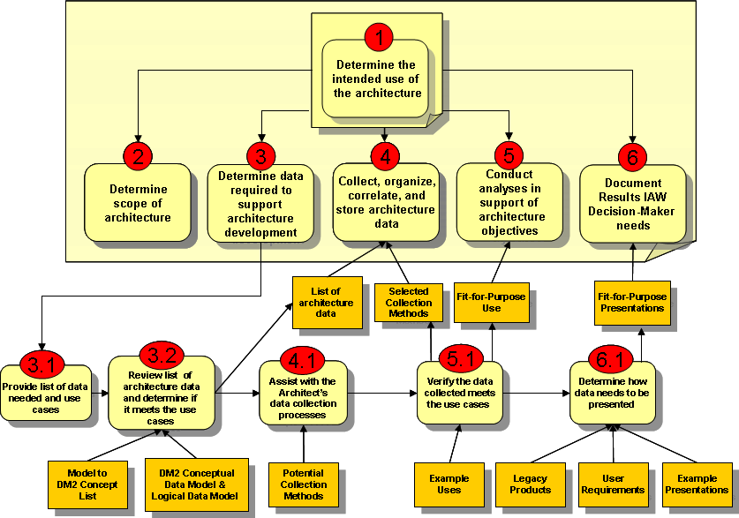
Figure 1.5-1: What the Decision-Maker Needs to Do
Working with the architect and team, the decision-maker has a critical role in ensuring that the architecture not only supports the creation of executable requirements that will achieve the desired outcome, but also that senior executives and managers can view the desired solution in an understandable and logical manner.

DoDAF VOLUMES AND JOURNAL OVERVIEW
Section 3 provides an overview of DoDAF V2.0, both the volumes, and the electronic Journal, and describes the primary reasons for developing and publishing a new version. This section also addresses fundamental principles and guidelines that should be followed when an architecture development effort is initiated. A graphical representation of the breadth and depth of information, users, concepts, and artifacts that can assist in describing an architecture for executives, managers, and other non-technical reviewers and users is also provided.

DoDAF Overview
DoDAF is the structure for organizing architecture concepts, principles, assumptions, and terminology about operations and solutions into meaningful patterns to satisfy specific DoD purposes. DoDAF offers guidance, principles and direction on communicating business, mission needs and capabilities to managers, architects, analysts, and developers who are responsible for developing and building the necessary services, applications and infrastructure to meet stakeholder needs and to manage their expectations.
Architecture frameworks support change in organizations through building and utilization of architectures that:
- Enhance decision making processes by leveraging knowledge and opportunities for reusing existing information assets.
- Respond to stakeholder, customer, and client needs for effective and efficient processes, systems, services, and resource allocation.
- Provide mechanisms to manage configuration of the current state of the enterprise and maintain validity of the expected performance.
- Facilitate the design of future states of the enterprise.
- Establish a baseline architecture for solutions under development.
In DoDAF V2.0, examples provided lean heavily on the major areas of change within the Department, including the Joint Capabilities Integration and Development System (JCIDS), the Defense Acquisition System (DAS), Systems Engineering (SE), the Planning, Programming, Budgeting, and Execution (PPBE) Process, and Portfolio Management (PfM). These key processes produce far-reaching change across all Military Departments, Agencies, the Joint Staff, and other Departmental functions. Architectures developed utilizing the guidance in DoDAF demonstrates how change is documented, and executed through an architecturally based approach that:
- Establishes and documents scope and boundaries.
- Documents best practices.
- Defines and describes generic performance measures (metrics).
- Documents and describes potential solutions for management review and approval.
Data, organized as information, is the critical element of architecture development. DoDAF V2.0 provides a CDM and LDM, along with a PES in the DM2 for use by data managers, tool vendors, and others to facilitate:
- Establishment of areas of discourse and a shared vocabulary.
- Support for data overlap analysis.
- Define and encourage the use of shared information.
- Provide a target for architectural data integration.
The framework is consistent with, and supports DoD policy directives that require programs and components to (a) ensure that their architectures meet stated objectives and Departmental requirements, and, (b) provide the information necessary to support defined decisions at higher tiers. These policies also require consistency across horizontal architecture boundaries within a tier. The guidance and information contained in these volumes also ensures that, when followed, architecture development is consistent with OMB Enterprise Architecture Guidance.
This version of the DoDAF is written to support the Departmental preference for federated architecture development in a tiered environment (Section 4.3). To enable federation and facilitate tiered responsibility and accountability, the framework provides data structures to ensure appropriate touch-points can be compared for consistency across architecture boundaries. Utilization of these data structures ensures that higher tiers have access to data from lower tiers in a form that supports their decision needs. The Framework also includes aids to architects in supporting net-centricity in their architectures and structures that define the management of net-centric architectures (Volume 2).
DoDAF V2.0 also facilitates creation of SOA-based architectures that define solutions specifically in terms of services that can be discovered, subscribed to, and utilized, as appropriate, in executing departmental or joint functions and requirements.

DoDAF Structure
DoDAF V2.0 is organized around data, models, and views. This approach responds to Departmental programs, such as Business Transformation (BT), JCIDS, and other major functions with significant impact throughout the Department that have developed requirements for multiple, custom views. These views use information based on authoritative data, beyond the operational, systems, and technical views of previous versions of DoDAF, and is consistent with DoD Instruction (DoDI) 4630.8 requirements for integrated architectures. The views are based on models that are templates for collecting specific data within the data categories found in Volume 2, and also those views that may be user-defined to more clearly explain specific data. Models that are populated with architectural data are called views. These customized views enable the information, contained in an architecture, to be communicated to, and understood by, stakeholders in diverse functional organizations. The products developed under previous versions of DoDAF, utilized as views, can continue to be used, and continue to be supported in DoDAF V2.0, as described in Volume 2.
A model is a template for collecting data.

A view is a representation of a related set of information using formats or models. A View, as described in DoDAF 2.0, is a representation of data in any understandable format. Formats can include any of the presentation styles (such as dashboards, spreadsheets, diagrams, data models, etc.) that convey the meaning of data.

A viewpoint describes data drawn from one or more perspectives and organized in a particular way useful to management decision-making. More specifically, a viewpoint definition includes the information that should appear in individual views; how to construct and use the views (by means of an appropriate schema or template); the modeling techniques for expressing and analyzing the information; and a rationale for these choices (e.g., by describing the purpose and intended audience of the view).

ISO 42010, 15 July 2007, defines an Architectural Description as “A collection of products to document an architecture.” For DoDAF V2.0, the definition of an Architectural Description is “a collection of views to document an architecture.”

The definitions above are derived from International Standards on Architectural Description and definition. While DoDAF is not completely conformant with those documents, due primarily to the broad perspective of Architectural Description development within the Department, it is the aim of DoDAF development to pursue and achieve conformance over time.

Architectural Data
Architectural data provides for more efficient and flexible use and reuse of the Architectural Description, enabling broader utility for decision makers and process owners. This version of DoDAF emphasizes the collection, organization, and maintenance of architectural data and derived information, as opposed to development of products in previous versions. A technical description of the underlying data can be found in DoDAF Volume 2.
NOTE: DoDAF data can be collected, organized and stored by a wide range of architecture tools developed by commercial sources. Visualization of views, as shown in DoDAF V2.0 is for example purposes only. It should be understood, however, that the creation of a limited set of models, using a range of architecture tools developed by commercial sources, is the typical way an enterprise architect initially captures and collects important architectural data. These models are commonly produced by architects. Development of architectural views is accomplished by collecting and organizing architectural data that must be clearly mapped to the underlying DoDAF Conceptual and Logical Data Models in a standard and consistent way, to capture interoperable architectural data, and to achieve the goal of a federated approach to architecture management.

There is no single, correct way to visualize any view, although the examples present those that are commonly used in the DoD communities. The critical factor in ‘conforming’ to DoDAF practice is that the data represented by the graphical representation is consistent with or mappable to the DoDAF Conceptual and Logical Data models, and the PES described in these volumes.

Architecture Viewpoints and DoDAF-described Models
An architecture viewpoint is a selected set of architectural data that has been organized to facilitate visualization in an understandable way. An Architectural Description can be visualized in a number of formats, such as dashboard, fusion, textual, composite, or graphics, which present data and derived information collected in the course of the development of an Architectural Description. A view is only a presentation of a portion of the architectural data, in the sense that a photograph provides only one view of the object within the picture, not the entire representation of that object. Figure 3.4.2-1 provides a graphical representation of the architecture viewpoints in DoDAF V2.0.
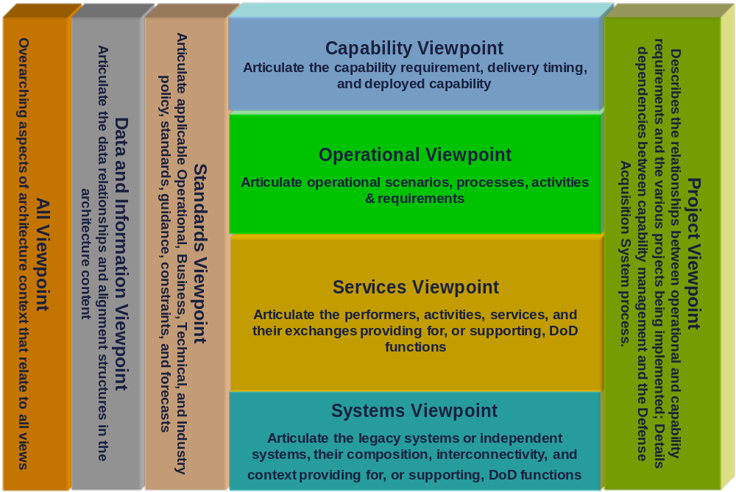
Figure 3.4.2-1: Architecture Viewpoints in DoDAF V2.0

All Viewpoint.
Some overarching aspects of an Architectural Description relate to all the views. The All Viewpoint (AV) models provide information pertinent to the entire Architectural Description, such as the scope and context of the Architectural Description. The scope includes the subject area and time frame for the Architectural Description. The setting in which the Architectural Description exists comprises the interrelated conditions that compose the context for the Architectural Description. These conditions include doctrine; tactics, techniques, and procedures; relevant goals and vision statements; concepts of operations (CONOPS); scenarios; and environmental conditions.

The Capability Viewpoint.
The Capability Viewpoint (CV) captures the enterprise goals associated with the overall vision for executing a specified course of action, or the ability to achieve a desired effect under specific standards and conditions through combinations of means and ways to perform a set of tasks. It provides a strategic context for the capabilities described in an Architectural Description, and an accompanying high-level scope, more general than the scenario-based scope defined in an operational concept diagram. The models are high-level and describe capabilities using terminology, which is easily understood by decision makers and used for communicating a strategic vision regarding capability evolution.

The Data and Information Viewpoint.
The Data and Information Viewpoint (DIV) captures the business information requirements and structural business process rules for the Architectural Description. It describes the information that is associated with the information exchanges in the Architectural Description, such as attributes, characteristics, and inter-relationships. Data is described fully in Volume 2. Where appropriate, the data captured in the models of this Viewpoint needs to be considered by COIs.

The Operational Viewpoint.
The Operational Viewpoint (OV) captures the organizations, tasks, or activities performed, and information that must be exchanged between them to accomplish DoD missions. It conveys the types of information exchanged, the frequency of exchange, which tasks and activities are supported by the information exchanges, and the nature of information exchanges.

The Project Viewpoint.
The Project Viewpoint (PV) captures how programs are grouped in organizational terms as a coherent portfolio of acquisition programs. It provides a way of describing the organizational relationships between multiple acquisition programs, each of which are responsible for delivering individual systems or capabilities.

The Services Viewpoint.
The Services Viewpoint (SvcV) captures system, service, and interconnection functionality providing for, or supporting, operational activities. DoD processes include warfighting, business, intelligence, and infrastructure functions. The SvcV functions and service resources and components may be linked to the architectural data in the OV. These system functions and service resources support the operational activities and facilitate the exchange of information.

The Standards Viewpoint.
The Standards Viewpoint (StdV) is the minimal set of rules governing the arrangement, interaction, and interdependence of system parts or elements. Its purpose is to ensure that a system satisfies a specified set of operational requirements. The StdV provides the technical systems implementation guidelines upon which engineering specifications are based, common building blocks established, and product lines developed. It includes a collection of the technical standards, implementation conventions, standards options, rules, and criteria that can be organized into profile(s) that govern systems and system or service elements in a given Architectural Description.

The Systems Viewpoint.
Systems Viewpoint (SV) captures the information on supporting automated systems, interconnectivity, and other systems functionality in support of operating activities. Over time, the Department’s emphasis on Service Oriented Environment and Cloud Computing may result in the elimination of the Systems Viewpoint.

DoDAF-described Models.
The DoDAF-described Models that are available in DoDAF V2.0 are listed in Table 3.4.2.9-1. The list provides the possible models and is not prescriptive. The Decision-maker and process owners will determine the DoDAF-described Models that are required for their purposes.

Table 3.4.2.9-1: DoDAF V2.0 Models
Models | Descriptions
AV-1: Overview and Summary Information | Describes a Project's Visions, Goals, Objectives, Plans, Activities, Events, Conditions, Measures, Effects (Outcomes), and produced objects.
AV-2: Integrated Dictionary | An architectural data repository with definitions of all terms used throughout the architectural data and presentations.
CV-1: Vision | The overall vision for transformational endeavors, which provides a strategic context for the capabilities described and a high-level scope.
CV-2: Capability Taxonomy | A hierarchy of capabilities which specifies all the capabilities that are referenced throughout one or more Architectural Descriptions.
CV-3: Capability Phasing | The planned achievement of capability at different points in time or during specific periods of time. The CV-3 shows the capability phasing in terms of the activities, conditions, desired effects, rules complied with, resource consumption and production, and measures, without regard to the performer and location solutions.
CV-4: Capability Dependencies | The dependencies between planned capabilities and the definition of logical groupings of capabilities.
CV-5: Capability to Organizational Development Mapping | The fulfillment of capability requirements shows the planned capability deployment and interconnection for a particular capability phase. The CV-5 shows the planned solution for the phase in terms of performers and locations and their associated concepts.
CV-6: Capability to Operational Activities Mapping | A mapping between the capabilities required and the operational activities that those capabilities support.
CV-7: Capability to Services Mapping | A mapping between the capabilities and the services that these capabilities enable.
DIV-1:Conceptual Data Model | The required high level data concepts and their relationships.
DIV-2: Logical Data Model | The documentation of the data requirements and  structural business process (activity) rules. In DoDAF V1.5, this was the OV-7.
DIV-3: Physical Data Model | The physical implementation format of the Logical Data Model entities, e.g., message formats, file structures, physical schema. In DoDAF V1.5, this was the SV-11.
OV-1: High Level Operational Concept Graphic | The high-level graphical/textual description of the operational concept.
OV-2: Operational Resource Flow Description | A description of the resource flows exchanged between operational activities.
OV-3: Operational Resource Flow Matrix | A description of the resources exchanged and the relevant attributes of the exchanges.
OV-4: Organizational Relationships Chart | The organizational context, role or other relationships among organizations.
OV-5a: Operational Activity Decomposition Tree | The capabilities and activities (operational activities) organized in an hierarchal structure.
OV-5b: Operational Activity Model | The context of capabilities and activities (operational activities) and their relationships among activities, inputs, and outputs; Additional data can show cost, performers or other pertinent information.
OV-6a: Operational Rules Model | One of three models used to describe activity (operational activity). It identifies business rules that constrain operations.
OV-6b: State Transition Description | One of three models used to describe operational activity (activity). It identifies business process (activity) responses to events (usually, very short activities).
OV-6c: Event-Trace Description | One of three models used to describe operational activity (activity). It traces actions in a scenario or sequence of events.
PV-1: Project Portfolio Relationships | Describes the dependency relationships between the organizations and projects and the organizational structures needed to manage a portfolio of projects.
PV-2: Project Timelines | A timeline perspective on programs or projects, with the key milestones and interdependencies.
PV-3: Project to Capability Mapping | A mapping of programs and projects to capabilities to show how the specific projects and program elements help to achieve a capability.
SvcV-1 Services Context Description | The identification of services, service items, and their interconnections.
SvcV-2 Services Resource Flow Description | A description of resource flows exchanged between services.
SvcV-3a Systems-Services Matrix | The relationships among or between systems and services in a given Architectural Description.
SvcV-3b Services-Services Matrix | The relationships among services in a given Architectural Description. It can be designed to show relationships of interest, (e.g., service-type interfaces, planned vs. existing interfaces).
SvcV-4 Services Functionality Description | The functions performed by services and the service data flows among service functions (activities)
SvcV-5 Operational Activity to Services Traceability Matrix | A mapping of services (activities) back to operational activities (activities).
SvcV-6 Services Resource Flow Matrix | It provides details of service resource flow elements being exchanged between services and the attributes of that exchange.
SvcV-7 Services Measures Matrix | The measures (metrics) of Services Model elements for the appropriate time frame(s).
SvcV-8 Services Evolution Description | The planned incremental steps toward migrating a suite of services to a more efficient suite or toward evolving current services to a future implementation.
SvcV-9 Services Technology & Skills Forecast | The emerging technologies, software/hardware products, and skills that are expected to be available in a given set of time frames and that will affect future service development.
SvcV-10a Services Rules Model | One of three models used to describe service functionality. It identifies constraints that are imposed on systems functionality due to some aspect of system design or implementation.
SvcV-10b Services State Transition Description | One of three models used to describe service functionality. It identifies responses of services to events.
SvcV-10c Services Event-Trace Description | One of three models used to describe service functionality. It identifies service-specific refinements of critical sequences of events described in the Operational Viewpoint.
StdV-1 Standards Profile | The listing of standards that apply to solution elements.
StdV-2 Standards Forecast | The description of emerging standards and potential impact on current solution elements, within a set of time frames.
SV-1 Systems Interface Description | The identification of systems, system items, and their interconnections.
SV-2 Systems Resource Flow Description | A description of resource flows exchanged between systems.
SV-3 Systems-Systems Matrix | The relationships among systems in a given Architectural Description. It can be designed to show relationships of interest, (e.g., system-type interfaces, planned vs. existing interfaces).
SV-4 Systems Functionality Description | The functions (activities) performed by systems and the system data flows among system functions (activities).
SV-5a Operational Activity to Systems Function Traceability Matrix | A mapping of system functions (activities) back to operational activities (activities).
SV-5b Operational Activity to Systems Traceability Matrix | A mapping of systems back to capabilities or operational activities (activities).
SV-6 Systems Resource Flow Matrix | Provides details of system resource flow elements being exchanged between systems and the attributes of that exchange.
SV-7 Systems Measures Matrix | The measures (metrics) of Systems Model elements for the appropriate timeframe(s).
SV-8 Systems Evolution Description | The planned incremental steps toward migrating a suite of systems to a more efficient suite, or toward evolving a current system to a future implementation.
SV-9 Systems Technology & Skills Forecast | The emerging technologies, software/hardware products, and skills that are expected to be available in a given set of time frames and that will affect future system development.
SV-10a Systems Rules Model | One of three models used to describe system functionality. It identifies constraints that are imposed on systems functionality due to some aspect of system design or implementation.
SV-10b Systems State Transition Description | One of three models used to describe system functionality. It identifies responses of systems to events.
SV-10c Systems Event-Trace Description | One of three models used to describe system functionality. It identifies system-specific refinements of critical sequences of events described in the Operational Viewpoint.

DoDAF META-MODEL
Note: This section describes the DM2, which replaces the Core Architecture Data Model referenced in previous versions of DoDAF.
The DM2 provides a high-level view of the data normally collected, organized, and maintained in an Architectural Description effort. It also serves as a roadmap for the reuse of data under the federated approach to architecture development and management. Reuse of data among communities of interest provides a way for managers in any level or area of the Department to understand what has been done by others, and also what information is already available for use in their Architectural Description, and management decision-making efforts.
The DM2 has several levels, each of which is important to a particular viewer of Departmental processes. A conceptual level or CDM is described in this volume and defines the high-level data constructs from which Architectural Descriptions are created in non-technical terms, so that executives and managers at all levels can understand the data basis of Architectural Description.
The LDM adds technical information, such as attributes to the CDM and, when necessary, clarifies relationships into an unambiguous usage definition. The LDM is described further in Volume 2.
A PES is described in Volume 3, and consists of the LDM with general data types specified and implementation attributes (e.g., source, date) added, and then generated as a set of XSD’s, one schema per DoDAF-described Model.
The DM2 defines architectural data elements and enables the integration and federation of Architectural Descriptions. It establishes a basis for semantic (i.e., understanding) consistency within and across Architectural Descriptions. In this manner, the DM2 supports the exchange and reuse of architectural information among JCAs, Components, and Federal and Coalition partners, thus facilitating the understanding and implementation of interoperability of processes and systems. As the DM2 matures to meet the ongoing data requirements of process owners, decision makers, architects, and new technologies, it will to a resource that more completely supports the requirements for architectural data, published in a consistently understandable way, and will enable greater ease for discovering, sharing, and reusing architectural data across organizational boundaries.
To facilitate the use of information at the data layer, the DoDAF describes a set of models for visualizing data through graphic, tabular, or textual means. These views relate to stakeholder requirements for producing an Architectural Description.

The DoDAF Conceptual Data Model
The CDM defines concepts involving high-level data constructs from which Architectural Descriptions are created, enabling executives and managers at all levels to understand the data basis of Architectural Description. The key concepts are as follows:
- Activity: Work, not specific to a single organization, weapon system or individual that transforms inputs (Resources) into outputs (Resources) or changes their state.
- Resource: Data, Information, Performers, Materiel, or Personnel Types that are produced or consumed.
  - Materiel: Equipment, apparatus or supplies that are of interest, without distinction as to its application for administrative or combat purposes.
  - Information: The state of a something of interest that is materialized -- in any medium or form -- and communicated or received.
    - Data: Representation of information in a formalized manner suitable for communication, interpretation, or processing by humans or by automatic means. Examples could be whole models, packages, entities, attributes, classes, domain values, enumeration values, records, tables, rows, columns, and fields.
    - Architectural Description: Information describing an architecture such as an OV-5b Operational Activity Model.
  - Performer: Any entity - human, automated, or any aggregation of human and/or automated - that performs an activity and provides a capability.
    - Organization: A specific real-world assemblage of people and other resources organized for an on-going purpose.
    - System: A functionally, physically, and/or behaviorally related group of regularly interacting or interdependent elements.
    - Person Type: A category of persons defined by the role or roles they share that are relevant to an architecture.
    - Service: A mechanism to enable access to a set of one or more capabilities, where the access is provided using a prescribed interface and is exercised consistent with constraints and policies as specified by the service description. The mechanism is a Performer. The capabilities accessed are Resources -- Information, Data, Materiel, Performers, and Geo-political Extents.
- Capability: The ability to achieve a Desired Effect under specified (performance) standards and conditions through combinations of ways and means (activities and resources) to perform a set of activities.
- Condition: The state of an environment or situation in which a Performer performs.
- Desired Effect: A desired state of a Resource.
- Measure: The magnitude of some attribute of an individual.
- Measure Type: A category of Measures.
- Location: A point or extent in space that may be referred to physically or logically.
- Guidance: An authoritative statement intended to lead or steer the execution of actions.
  - Rule: A principle or condition that governs behavior; a prescribed guide for conduct or action.
    - Agreement: A consent among parties regarding the terms and conditions of activities that said parties participate in.
    - Standard: A formal agreement documenting generally accepted specifications or criteria for products, processes, procedures, policies, systems, and/or personnel.
- Project: A temporary endeavor undertaken to create Resources or Desired Effects.
- Vision: An end that describes the future state of the enterprise, without regard to how it is to be achieved; a mental image of what the future will or could be like.
- Skill: The ability, coming from one's knowledge, practice, aptitude, etc., to do something well.
Additional CDM concepts are identified and defined in Appendix to this document.
The CDM also describes the relationships among data constructs in relatively non-technically and easily understood terms. Figure 1 is a graphical representation of the CDM.
- Green lines are super-subtype. Read in direction of arrow, “is a type of”
- Blue lines are associations. See notes for key descriptions and examples. Read key in direction of arrow.
- Crows feet are associations between the association at the foot and the arrow, read according to the key.

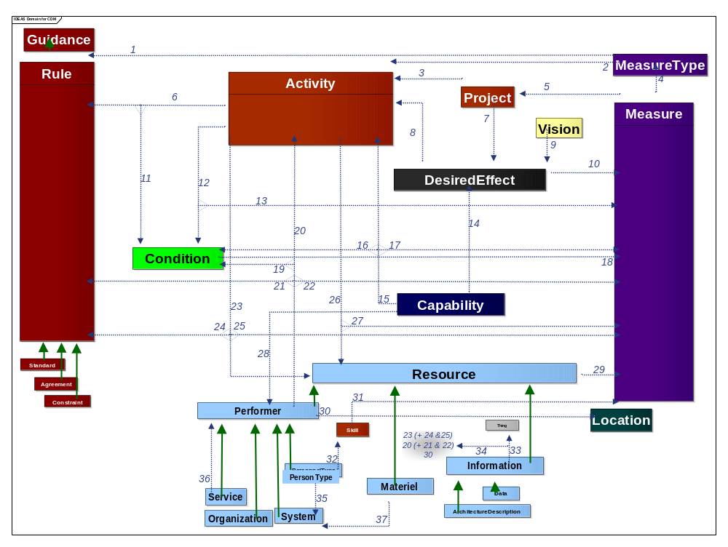
Figure 1. DoDAF Conceptual Data Model (DIV-1) Diagram
The associations between the concepts, are as follows, keyed to the footnote numbers from top to bottom and left to right:
- Measurements are done in accordance with Rules, (e.g., Rules that specify how test measurement equipment must be calibrated before a test).
- Certain types of Measures apply to an Activity, (e.g., how long it takes. This feature was part of the IDEF0 specification).
- A Project consists of several or many Activities (e.g., Tasks).
- Measures can be categorized into Measure Types.
- There are Measures associated with a Project (e.g., time, cost).
- Activities are performed in accordance with Rules (e.g., Controls in IDEF0).
- A Project has Desired Effects (e.g., goals).
- Desired Effects (e.g., goals) guide/drive Activities
- Visions are realized by Desired Effects (e.g., objectives).
- Desired Effects are Measureable; otherwise there wouldn’t be any way to know they were achieved. This statement implies a measure can be constructed for all Desired Effects.
- A Rule applies to an Activity under certain Conditions, (e.g., Rules of Engagement may vary dependent on threat Conditions).
- An Activity is performable under certain Conditions, (e.g., the Conditions applicable to Tasks in the UJTL).
- The performance of Activities under certain Conditions has Measures, (e.g., the Measure Types applicable to Tasks [Activities] in the UJTL).
- Capabilities have Desired Effects, as so stated in the CJCSI 3170.
- A Capability entails performance of Activities (Tasks), as so stated in the CJCSI 3170.
- The performance of Activities as part of a Capability is done under certain Conditions, as so stated in the CJCSI 3170.
- The performance of those Activities as part of a Capability has Measures (metrics) for their performance, as so stated in the CJCSI 3170.
- A Condition has metrics (Measures).
- An Activity is performed by a Performer under certain Conditions.
- Performers perform Activities. This characteristic distinguishes Performers from their superclass, Resources.
- The performance of Activities by Performers is subject to Rules. Even though Rules constrain Activities, there may be tailoring for the performance of those Activities by specific Performers.
- The performance of Activities by Performers is subject to Measures. Activities can have Measures in and of themselves; however there can be additional or tailored Measures associated with the performance of those Activities by specific Performers.
- An Activity consumes or produces Resources. Those Resources can be Materiel, Information, Data, Geo-Political, or other Performers. When the production and consumption is of Information or Data, the DoDAF V1.5 OV-3, OV-5, SV-4, SV-6, and others are partially represented.
- The consumption or production of Resources by Activities is subject to Rules, (e.g., the Information Assurance Rules that are part of the OV-3).
- The consumption and production of Resources by Activities is measureable, (e.g., the Timeliness and Size measures that are part of the OV-3).
- Activities result in effects on Effect Objects (Resources), i.e., a cause-effect chain.
- The effect on Effect Objects by Activities is measureable.
- A Capability is realized by one or more Performers (including configurations of Performer)
- A Resource has Measures, (e.g., mass, size).
- Performers perform at Locations.
- The Skills of a Person Type are measureable, (e.g., Skill level of a Person Type.
- Person Types have Skills).
- Information describes a thing.
- Information Pedigree is a type of Information that describes the production of Information (resources) by Activities, their Performers, and the Rules, Conditions, and Measures that apply to that information production.
- A Person Type can be part of a System, (e.g., a radar operator or, more generally, in a cybernetic sense).
- A Service provides access to Performers. This results from the DoD definition of Service which is verbatim from Organization for the Advancement of Structured Information Standards (OASIS).
- Materiel can be part of a System, the parts and equipment that are part of a System.
These associations are formalized and made explicit (reified) in the LDM.
The DM2 CDM relates to Universal Core and the Zachman Framework interrogatives as shown in Figure 2. Specifically:
- The Data Description — What (we generalize to other Resources besides just Data)
- The Function Description — How (and also the Performer that performs the Function, Measures, Rules, and Conditions associated with)
- The Network Description — Where (generalized)
- The People Description — Who (we include Organizations)
- The Time Description — When
- The Motivation Description — Why (broadened to include Capability requirements)
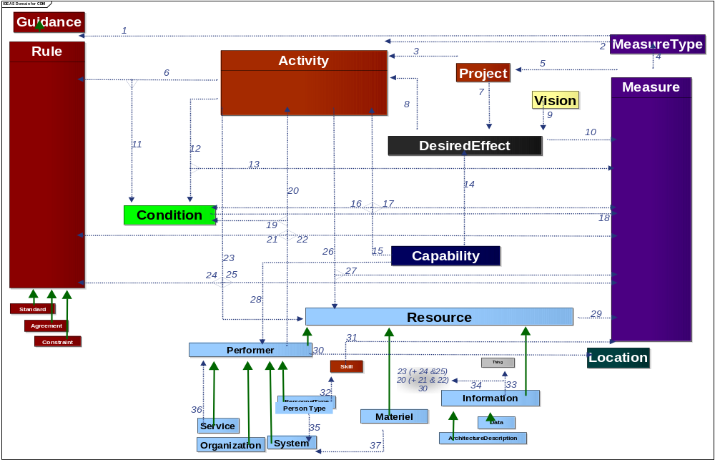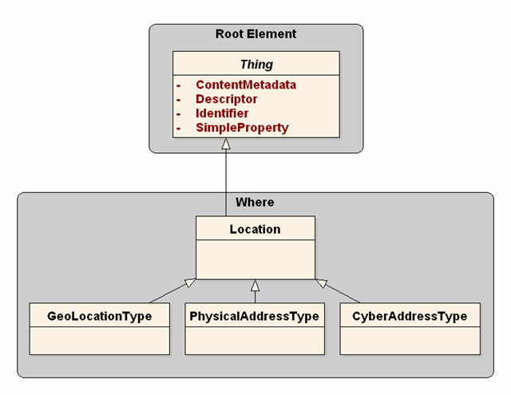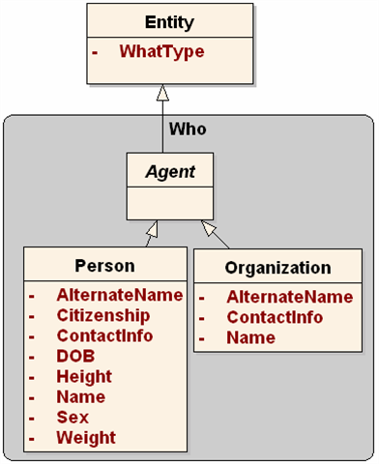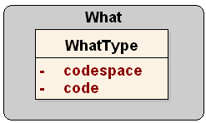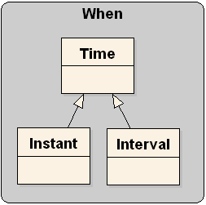
WHY
HOW
WHO
WHAT
WHEN
WHERE
Figure 2. Overlay of UCORE and Zachman Framework Interrogatives with DM2 CDM

DM2 and Core Process Relationships Overview
An overview of the role of the concepts modeled in the DM2 is shown in Table . The key to the symbols in this table are:

Table . Mapping of DM2 CDM Core Concepts to DoD Core Processes DoDAF Supports
DM2 CDM Core Concepts | Core Process Utilization
DM2 CDM Core Concepts | JCIDS Capability Mgmt | JCIDS Interop & Supp | DAS | PPBE | CPM | SE / SOSE | Ops Planning
Activity |  |  | · | · |  | · | 
Agreement |  | · | · | ▪ | ▪ | · | ·
Capability |  | · |  | · |  | · | ·
Condition |  |  |  |  |  |  | 
Data | · |  |  |  | · | · | 
DesiredEffect |  |  | · | ▪ |  |  | 
Guidance |  | · | · |  |  | · | 
Information |  |  |  |  | · | · | 
Location |  |  |  |  |  |  | 
Materiel | · |  | · |  |  |  | 
Measure |  |  |  |  |  | · | 
MeasureType |  |  |  |  |  | · | 
Organization |  |  |  |  |  |  | 
Performer |  |  |  |  |  |  | 
PersonType | · |  |  |  |  |  | 
Project | ▪ | ▪ |  |  | · |  | ·
Resource | · | · |  |  | · | · | 
Rule |  |  | · |  |  |  | 
Service |  | · | · |  | · |  | ▪
Skill | · |  |  |  |  |  | 
Standard |  |  | · |  |  |  | 
System |  |  |  |  |  |  | ·
Vision |  | ▪ |  |  | · | ▪ | 
ArchitecturalDescription |  |  | · |  |  |  | ·

Legend:
 | Critical role
 | Substantial role
 | Significant role
· | Moderate role
 | Supporting role
 | Minor / optional role
blank | Insignificant / no role

OVERVIEW of The DM2 Foundation
Underlying the CDM is a foundation that utilizes common data modeling constructs that facilitate the reuse of common data patterns, an overview of which is shown in Figure 3.
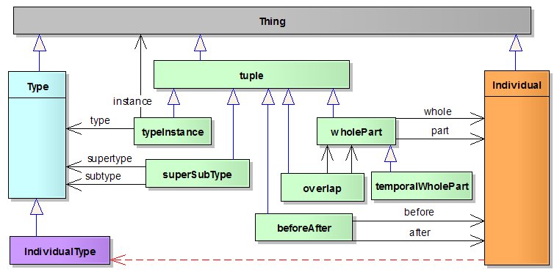
The top-level foundation elements are:
Figure 3. Overview of DM2 Foundation
- Thing, similar to other model’s object.
- Individual, a thing that exists as an indivisible whole, or as a single member of a category.
- Type, a set of individuals or classes of other sets or classes.
- Tuple, ordered places of things (e.g., a block in a spreadsheet or a table).
These foundation elements are similar to many other foundation high-level data constructs that exist in the industry. The common patterns that are reused are:
- Composition (or whole-part).
- Super/Sub Type (or generalization/specialization, e.g., tank or main battle tank).
- Before /After, for things that have time-related relationships in their Type.
- Overlap, e.g., for things that can exchange other things that are parts of themselves, things that occur at overlapping times and overlapping places.
Composition and Super/Sub Type apply to almost all architecture concepts. Before/After is frequently used to model before/after situations, while Interface applies to few concepts, limited at this time to the pattern describing Activity.
The benefits of adopting the IDEAS formal foundation and common patterns are:
- Re-use of common patterns saved a lot of work
- Model compactness through inheritance of superclass properties and common patterns
- Reconciliation and analysis tool. The agreed-upon analysis principles provide a principled basis for issue analysis
- Information pedigree model
- Design reification and requirements traceability
- Services description
- Semantic precision. Improved ability to integrate and analyze multiple heterogeneous EA datasets to fulfill EA purposes.
- Mathematical precision
These benefits are described in detail in the DM2 Physical Exchange Specification description documents.

APPENDIX A

GLOSSARY
This is the integrated DoDAF V2.0 acronyms and their definitions. Some have more than one definition depending on their usage; they could have a specific meaning in Architecture as well as generic English language usage.

Acronym |  | Definition
ADM |  | Architecture Development Method
AMETL |  | Agency Mission Essential Task List
ASD |  | Assistant Secretary of Defense
AT&L |  | Acquisition Technology and Logistics
AV |  | All Viewpoint
BEA |  | Business Enterprise Architecture
BMM |  | Business Motivation Model
BPMN |  | Business Process Modeling Notation
BPR |  | Business Process Reengineering
BRM |  | Business Reference Model
BT |  | Business Transformation
BTA |  | Business Transformation Agency
C4I |  | Command, Control, Communications, Computers and Intelligence
C4ISRAF |  | Command, Control, Communications, Computers, and Intelligence Surveillance Reconnaissance Architecture Framework
CADM |  | Core Architecture Data Model
CCB |  | Configuration Control Board
CCP |  | Configuration Control Plan
CDD |  | Capability Development Document
CDM |  | Conceptual Data Model
CIO |  | Chief Information Officer
CJCSI |  | Chairman of the Joint Chiefs of Staff Instruction
CJCSM |  | Chairman of the Joint Chiefs of Staff Manual
CM |  | Configuration Management
COI |  | Community Of Interest
COMSEC |  | Communications Security
CONOPS |  | Concepts of Operations
CPD |  | Capability Production Document
CPIC |  | Capital Planning and Investment Control
CPM |  | Capability Portfolio Management
CRM |  | Consolidated Reference Model
CV |  | Capability Viewpoint
CWID |  | Coalition Warrior Interoperability Demonstration
DAES |  | DoD Architecture Enterprise Services
DARS |  | DoD Architecture Registry System
DAS |  | Defense Acquisition System
DDMS |  | DoD Discovery Metadata Specification
DIEA |  | DoD Information Enterprise Architecture
DISR |  | DoD Information Technology Standards and Profile Registry
DITPR |  | DoD Information Technology Portfolio Repository
DIV |  | Data and Information Viewpoint
DM2 |  | DoDAF Meta-model
DMR |  | DoD Metadata Registry
DoDAF |  | DoD Architecture Framework
DoDI |  | Department of Defense Instruction
DOTMLPF |  | Doctrine, Organization, Training, Materiel, Leadership and Education, Personnel, and Facilities
DPG |  | Defense Planning Guidance
DRM |  | Data Reference Model
EA |  | Enterprise Architecture
EAAF |  | Enterprise Architecture Assessment Framework
EAMMF |  | Enterprise Architecture Management Maturity Framework
EIA |  | Electronic Industries Alliance
E-ISP |  | Enhanced-Information Support Plan
FEA |  | Federal Enterprise Architecture
FEA-CRM |  | Federated Enterprise Architecture-Consolidated Reference Model
FEA-RM |  | Federal Enterprise Architecture Reference Model
FIPS |  | Federal Information Processing Standard
FISMA |  | Federal Information Security Management Act
GAO |  | Government Accountability Office
GIG |  | Global Information Grid
IC |  | Intelligence Community
ICD |  | Initial Capabilities Document
IDEAS |  | International Defence Enterprise Architecture Specification
IDEF0 |  | Integration Definition for Activity Modeling
IE |  | Information Environment
IEA |  | Information Enterprise Architecture
INFOSEC |  | Information Security
IP |  | Internet Protocol
IRTPA |  | Intelligence Reform and Terrorism Prevention Act of 2004
ISE |  | Information Sharing Environment
ISE-EAF |  | Information Sharing Environment Enterprise Architecture Framework
ISM |  | Information Security Marking
ISO |  | International Standards Organization
IT |  | Information Technology
ITS/NSS |  | Information Technology/National Security Systems
JCA |  | Joint Capability Area
JCIDS |  | Joint Capability Integration and Development System
JCPAT |  | Joint C4I Program Assessment Tool
JCS |  | Joint Chiefs of Staff
JCSFL |  | Joint Common System Function List
JFCOM |  | Joint Forces Command
JMETL |  | Joint Mission Essential Task List
KM/DS |  | Knowledge Management/Decision Support
LDM |  | Logical Data Model
M3 |  | MODAF Meta Model
MDA |  | Milestone Decision Authority
MDR |  | Metadata Registry
MOD |  | Ministry of Defence
MODAF |  | Ministry of Defence Architecture Framework
NAERG |  | Naval Architecture Elements Reference Guide
NATO |  | North Atlantic Treaty Organization
NCDS |  | Net Centric Data Strategy
NCE |  | Net-Centric Environment
NCSS |  | Net-Centric Services Strategy
NII |  | Networks and Information Integration
NIST |  | National Institutes for Standards & Technology
NSS |  | National Security Systems
OASD |  | Office of the Assistant Secretary of Defense
OASIS |  | Organization for the Advancement of Structured Information Standards
OMB |  | Office of Management and Budget
OMG |  | Object Management Group
OO |  | Object-Oriented
OOAD |  | Object-Oriented Analysis & Design
OSD |  | Office of the Secretary of Defense
OUSD |  | Office of the Undersecretary of Defense
OV |  | Operational Viewpoint
PDA |  | Personal Digital Assistant
PDCA |  | Plan, Do, Check, and Act
PDM |  | Physical Data Model
PES |  | Physical Exchange Specification
PFD |  | Process Flow Diagram
PL |  | Public Law
POM |  | Program Objective Memorandum
PPBE |  | Planning, Programming, Budgeting, and Execution
PRM |  | Performance Reference Model
PTD |  | Process Task Dependency
PV |  | Project Viewpoint
RA |  | References Architecture
RM |  | Reference Model
SADT |  | Structured Analysis and Design Technique
SE |  | Systems Engineering
SEP |  | Systems Engineering Plan
SIPRNET |  | Secret IP Router Network
SLC |  | Shelf Life Code
SOA |  | Service-Oriented Architecture
SRM |  | Service Component Reference Model
SV |  | Systems Viewpoint
TA |  | Tiered Accountability
TAFIM |  | Technical Architecture for Information Management
TEMPEST |  | Transient Electromagnetic Pulse Emanation Standard
TOGAF |  | The Open Group Architecture Framework
TRM |  | Technical Reference Model
TV |  | Technical Standards View
TWG |  | Technical Working Groups
U.S. |  | United States
UJTL |  | Universal Joint Task List
UK |  | United Kingdom
UML |  | Unified Modeling Language
UPDM |  | Unified Profile for DoDAF and MODAF
URL |  | Uniform Resource Locator
USD |  | Under Secretary of Defense
V&V |  | Validation & Verification
WBS |  | Work Breakdown Structure
XML |  | eXtensible Markup Language
XSD |  | XML Schema Definition
 | Technical Term |  | Composite Definition | Potentially Related Terms or Aliases
 | Activity |  | Work, not specific to a single organization, weapon system or individual that transforms inputs (Resources) into outputs (Resources) or changes their state. | Action, Process Operational Activity, Processes, Function, System Function, Operation, Task, Plan, Project
 | Adaptability Measure |  | A measure of the ease with which Performers satisfy differing Constraints and Capability and Service needs.
 | Address |  | The name of a location along with the location-finding scheme that allows a location to be found from the name. Examples include postal address, email address, URL, datalink address.
 | Agreement |  | A consent among parties regarding the terms and conditions of activities that said parties participate in.
 | Capability |  | The ability to achieve a Desired Effect under specified [performance] standards and conditions through combinations of ways and means [activities and resources] to perform a set of activities.
 | Condition |  | The state of an environment or situation in which a Performer performs.
 | Constraint |  | The range of permissible states for an object. | Business Rule, Rule, Restraint, Operational Limitation, Guidance
 | Country |  | A political state or nation or its territory.
 | Data |  | Representation of information in a formalized manner suitable for communication, interpretation, or processing by humans or by automatic means. Examples could be whole models, packages, entities, attributes, classes, domain values, enumeration values, records, tables, rows, columns, and fields.
 | Desired Effect |  | The result, outcome, or consequence of an action [activity]. | DesiredEffectType  IndividualDesiredEffect
 | Domain Information |  | Types of information within the scope or domain of the architecture.
 | Effects Measure |  | Category of measures on Effect Objects
 | Facility |  | A real property entity consisting of underlying land and one or more of the following: a building, a structure (including linear structures), a utility system, or pavement.
 | Functional Standard |  | Functional standards set forth rules, conditions, guidelines, and characteristics.
 | GeoFeature |  | An object that encompasses meteorological, geographic, and control features mission significance
 | GeoPolitical Extent |  | A geospatial extent whose boundaries are by declaration or agreement by political parties.
 | Guidance |  | An authoritative statement intended to lead or steer the execution of actions.
 | Information |  | Information is the state of a something of interest that is materialized -- in any medium or form -- and communicated or received.
 | Installation |  | A base, camp, post, station, yard, center, or other activity, including leased facilities, without regard to the duration of operational control. An installation may include one or more sites.
 | Location |  | A point or extent in space that may be referred to physically or logically.
 | Maintainability Measure |  | A category of measures of the amount of time a Performer is able to conduct Activities over some time interval.
 | Materiel |  | Equipment, apparatus or supplies that are of interest, without distinction as to its application for administrative or combat purposes.
 | Measure |  | The magnitude of some attribute of an individual.
 | Measure Type |  | A category of Measures
 | Needs Satisfaction Measure |  | A category of quality measures that address how well a system meets the user's needs and requirements.
 | Organization |  | A specific real-world assemblage of people and other resources organized for an on-going purpose. | Department, Agency, Enterprise
 | Organizational Measure |  | A category of quality measures that address how costly a Performer is to operate and maintain.
 | Performance Measure |  | A category of quality measures that address how well a Performer meets Capability needs.
 | Performer |  | Any entity - human, automated, or any aggregation of human and/or automated - that performs an activity and provides a capability. | Actor, Agent, Capability Configuration (MODAF)
 | Person Type |  | A category of persons defined by the role or roles they share that are relevant to an architecture. | Role
 | Physical Measure |  | A category of measures of spatio-temporal extent of an Individual such as length, mass, energy, velocity
 | Port |  | An interface (logical or physical) provided by a System.
 | Project |  | A temporary endeavor undertaken to create Resources or Desired Effects. | Plan, Tactic, Strategy, Activity
 | Real Property |  | Land and improvements to land (i.e., facilities).
 | Region Of Country |  | A large, usually continuous segment of a political state or nation or its territory.
 | Region Of World |  | A large, usually continuous segment of a surface or space; area.
 | Resource |  | Data, Information, Performers, Materiel, or Personnel Types that are produced or consumed.
 | Rule |  | A principle or condition that governs behavior; a prescribed guide for conduct or action
 | Service |  | A mechanism to enable access to a set of one or more capabilities , where the access is provided using a prescribed interface and is exercised consistent with constraints and policies as specified by the service description. The mechanism is a Performer. The “capabilities” accessed are Resources -- Information, Data, Materiel, Performers, and Geo-political Extents.
 | Service Channel |  | A logical or physical communication path between requisitions and services.
 | Service Description |  | Information necessary to interact with the service in such terms as the service inputs, outputs, and associated semantics. The service description also conveys what is accomplished when the service is invoked and the conditions for using the service. | Service Interface Description (UPDM)
 | Service Level |  | A measurement of the performance of a system or service.
 | Service Port |  | A part of a Performer that specifics a distinct interaction point through which the Performer interacts with other Performers. This isolates dependencies between performers to particular interaction points rather than to the performer as a whole. | Mediator (OASIS SOA RA), Service Interface (UPDM)
 | Site |  | Physical (geographic) location that is or was owned by, leased to, or otherwise possessed. Each site is assigned to a single installation. A site may exist in one of three forms: (1) Land only, where there are no facilities present and where the land consists of either a single land parcel or two or more contiguous land parcels. (2) Facility or facilities only, where the underlying land is neither owned nor controlled by the government. A stand-alone facility can be a site. If a facility is not a stand-alone facility, it must be assigned to a site. (3). Land and all the facilities thereon, where the land consists of either a single land parcel or two or more contiguous land parcels.
 | Skill |  | The ability, coming from one's knowledge, practice, aptitude, etc., to do something well. | Training, Knowledge, Ability
 | Spatial Measure |  | A category of measures of the spatio-temporal location of an Individual.
 | Standard |  | A formal agreement documenting generally accepted specifications or criteria for products, processes, procedures, policies, systems, and/or personnel.
 | System |  | A functionally, physically, and/or behaviorally related group of regularly interacting or interdependent elements.
 | Technical Standard |  | Technical standards document specific technical methodologies and practices to design and implement.
 | Temporal Measure |  | A type of measure of time
 | Vision |  | An end that describes the future state of the enterprise, without regard to how it is to be achieved; a mental image of what the future will or could be like

APPENDIX C

REFERENCES/BIBLIOGRAPHY
Consolidated Reference used in this volume:
ANSI/GEIA Standard EIA 649-A National Consensus Standard for Configuration Management American National Standards Institute. This standard is available at: http://www.techstreet.com/cgi-bin/detail?product_id=1160265

Chairman of the Joint Chiefs of Staff (CJCS) Instruction 3170.01F, Joint Capabilities Integration and Development System (JCIDS), 1 May 2007. A copy of the current version of the instruction can be found at: http://www.dtic.mil/cjcs_directives/cdata/unlimit/3170_01.pdf

Chairman of the Joint Chiefs of Staff (CJCS) Instruction 6212.01E, Interoperability and Supportability of Information Technology and National Security Systems, 15 Dec 2008. A copy of the current version of the instruction can be found at: http://www.dtic.mil/cjcs_directives/cdata/unlimit/6212_01.pdf

Department of Defense Directive (DoDD) 5000.1, The Defense Acquisition System, 12 May 2003 (certified current as of November 20, 2007). A current copy of the directive can be found at: https://akss.dau.mil/dag/DoD5000.asp?view=document&doc=2

Department of Defense Directive (DoDD) 8115.01, Information Technology Portfolio Management, October 10, 2005. Office of the Assistant Secretary of Defense (Networks & Information Integration) (NII)/DoD Chief Information Officer (DoD CIO). The latest copy of this directive can be found at:
http://www.dtic.mil/whs/directives/corres/rtf/811501x.rtf

Department of Defense Instruction 4630.8, Procedures for Interoperability and Supportability of Information Technology (IT) and National Security Systems (NSS) 30 June 2004. Office of the Assistant Secretary of Defense (Networks & Information Integration) (NII)/ DoD Chief Information Officer (DoD CIO). The current version is found at: www.dtic.mil/whs/directives/corres/pdf/463008p.pdf

Department of Defense Instruction (DoDI) 5000.2., Operation of the Defense Acquisition System. (2003) Under-Secretary of Defense (OUSD) AT&L (Acquisition, Technology & Logistics). A current copy of this document can be found at: https://akss.dau.mil/dag/DoD5000.asp?view=document&doc=2

Department of Defense Net-Centric Data Strategy, 9 May, 2003. Office of the Assistant Secretary of Defense (Networks & Information Integration) (NII)/DoD Chief Information Officer (DoD CIO).

DoD Acquisition Guidebook. Office of the Under-Secretary for Acquisition, Technology & Logistics (AT&L). A current copy of the Guidebook can be found at: https://akss.dau.mil/dag/DoD5000.asp?view=document&doc=2

Federal Enterprise Architecture, Executive Office of the President, Office of Management and Budget E-Gov Initiative. The current version of the FEA and its associated reference models can be found at: http://www.whitehouse.gov/omb/e-gov/fea/

Federal Enterprise Architecture Consolidated Reference Model Version 2.3. Executive office of the President, Office of Management and Budget (OMB). A current version can be found at: http://www.whitehouse.gov/omb/assets/fea_docs/FEA_CRM_v23_Final_Oct_2007_Revised.pdf

Federal Enterprise Architecture Program: Enterprise Architecture Assessment Framework, version 2.2, October 2007. Executive Office of the President. Office of Management and Budget. The current version can be found at: http://www.whitehouse.gov/omb/egov/a-2-EAAssessment.html.

Federal Enterprise Architecture Records Management Profile, Version 1.0, December 15, 2005. Executive Office of the President, Office of Management and Budget. A current version of the profile can be found here: http://www.cio.gov/documents/RM_Profile_v1.pdf

Global Information Grid (GIG) Architecture Federation Strategy, 1 August 2007. Office of the Assistant Secretary of Defense (Networks & Information Integration) (NII)/DoD Chief Information Officer (DoD CIO).

Information Sharing Environment Enterprise Architecture Framework (DRAFT) June, 2008. Office of the Program Manager, Information Sharing Environment.

Integrated Defense Acquisition, Technology, & Logistics Life Cycle Management Framework (2005). Defense Acquisition University, Ft. Belvoir, VA. A current copy of the chart is found at: http://www.dau.mil/pubs/IDA/IDA_04.aspx

Intelligence Reform and Terrorism Prevention Act of 2004 (IRTPA), Public Law (PL) 108-458 (December 17, 2004)

Ministry of Defence Architecture Framework. Ministry of Defence of the United Kingdom. The latest electronic version of the MODAF can be found at the MODAF Website: http://www.modaf.org.uk/. An offline (PDF) version can be accessed here for downloading: 20081001-MODAF_Handbook_V1_2_003_Adobe6-U.pdf [5.51MB]

NATO Architecture Framework for C3 Systems (2006). The North Atlantic Treaty Organization. The latest version of the NAF and other associated documents can be found at the NATO Website: http://194.7.80.153/website/book.asp?menuid=15&vs=0&page=volume2%2Fch02s02.html (Requires User Registration)

Office of Management and Budget (OMB) Circular-A-130, Management of Federal Information Resources, February 8, 1996. Executive Office of the President. Office of Management and Budget. The current version can be found at: http://www.whitehouse.gov/omb/circulars/a130/a130trans4.html#2

The Open Group Architecture Framework, Version 8.11 The current version can be found at: http://www.opengroup.org/architecture/togaf/

United States Government Accountability Office (GAO) Report: DoD Business Systems Modernization: Long-standing Weaknesses in Enterprise Architecture Development Need to Be Addressed, July 2005, GAO-05-702. A copy of the report is available at: http://www.gao.gov/new.items/d05702.pdf

United States Government Accountability Office (GAO) Report: Framework for Assessing and Improving Enterprise Architecture Management, version 1.1, April 2003, GAO-03-584G. A copy of the report is available at: www.gao.gov/new.items/d03584g.pdf

Zachman, John. Zachman Framework. © Zachman International. The Zachman Framework can be found at the Zachman International Website: http://zachmaninternational.com/index.php/the-zachman-framework/26-articles/13-the-zachman-framework-a-concise-definition
Bibliography
Dinoli, D. (2008) Enterprise Architecture A to Z: Frameworks, Business Process Modeling, SOA, and Infrastructure Technology. Auerbach Publishing. 504pp.

Grigoriu, A. (2007) An Enterprise Architecture Framework. Privately Published 226.pp.

McGovern, J, Ambler, S, Stevens, M. E., Linn, J, Sharan, V & Jo, E. K. (2004) A Practical Guide to Enterprise Architecture. New Jersey: Prentice-Hall. 306pp.

Ross, J. W., Weill, P., & Robertson, D. C. (2006). Enterprise Architecture as Strategy. Boston, MA: Harvard Business School press. 235pp.

Ross, R. (2005). Business Rule Concepts (2nd. Ed.) Business Rules Forum. 135pp.

Ross, R. (2003). Principles of the Business Rule Approach. Boston, MA: Addison-Wesley Publishing. 372pp.
Schekkerman, Jaap (2004). How to Survive in the Jungle of Enterprise Architecture Frameworks. Victoria, BC: Trafford 222. pp. This volume is particularly valuable for its chart showing the evolution of architecture frameworks

Spewak, Steven H (1992). Enterprise Architecture Planning. New York: John Wiley & Sons. 368 pp.

Department of Defense Instruction 4630.8, Procedures for Interoperability and Supportability of Information Technology (IT) and National Security Systems (NSS) 30 June 2004. Office of the Assistant Secretary of Defense (Networks & Information Integration) (NII)/ DoD Chief Information Officer (DoD CIO). The current version is found at: www.dtic.mil/whs/directives/corres/pdf/463008p.pdf
Department of Defense Instruction 4630.8, Procedures for Interoperability and Supportability of Information Technology (IT) and National Security Systems (NSS) 30 June 2004. Office of the Assistant Secretary of Defense (Networks & Information Integration) (NII)/ DoD Chief Information Officer (DoD CIO). The current version is found at: www.dtic.mil/whs/directives/corres/pdf/463008p.pdf
Office of Management and Budget (OMB) Circular-A-130, Management of Federal Information Resources, February 8, 1996. Executive Office of the President, Office of Management and Budget. The current version can be found at: http://www.whitehouse.gov/omb/circulars/a130/a130trans4.html#2
Office of Management and Budget (OMB) Circular-A-130, Management of Federal Information Resources, February 8, 1996. Executive Office of the President, Office of Management and Budget. The current version can be found at: http://www.whitehouse.gov/omb/circulars/a130/a130trans4.html#2
Derived from Joint Pub 1-02 and Merriam-Webster.com.
International Standards Organization (ISO) Standard 15407:200x, Industrial Automation Systems – Reference base for enterprise architecture and models, dated 10 January 2009; International Standards Organization (ISO) Standard 42010, Systems and Software Engineering – Architecture Description, dated 16 January 2009.

