

DoD Architecture Framework
Version 2.03

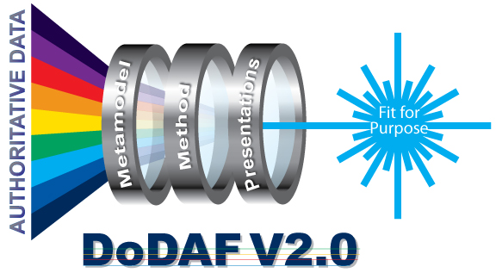

Volume 2: Architectural Data and Models
Architect’s Guide
31 December 2011
Volume 2: Architectural Data and Models
TABLE OF CONTENTS
1 Introduction 6
1.1 How this volume is organized 7
2 DoDAF Data Groups 8
2.1 How to use the DoDAF meta-model (DM2) 8
2.1.1 DoDAF glossary and model files 8
2.1.2 DoDAF diagrams and UML as an ontology diagramming notation 8
2.1.3 Support for DoD key processes through DoDAF viewpoints 10
2.2 Performers 12
2.2.1 Data group description 12
2.2.2 Use in DoD core processes 14
2.3 Resource Flows 16
2.3.1 Data group description 16
2.3.2 Use in DoD core processes 19
2.4 Information and Data 22
2.4.1 Data group description 22
2.4.2 Use in DoD core processes 25
2.5 Rules 28
2.5.1 Data group description 28
2.5.2 Use in DoD core processes 29
2.6 Capabilities 31
2.6.1 Data group description 31
2.6.2 Use in DoD core processes 33
2.7 Services 36
2.7.1 Data group description 36
2.7.2 Use in DoD core processes 40
2.8 Projects 41
2.8.1 Data group description 42
2.8.2 Usage in Core processes 45
2.9 Organizational Structures 47
2.9.1 Data group description 47
2.9.2 Usage in Core processes 49
2.10 Measures 50
2.10.1 Data group description 50
2.10.2 Use in DoD core processes 52
2.11 Locations 54
2.11.1 Data group description 54
2.11.2 Use in DoD core processes 56
2.12 Pedigrees 57
2.12.1 Data group description 57
2.12.2 Use in DoD core processes 57
3 DoDAF Viewpoints and Models 59
3.1 Viewpoint and model descriptions 61
3.2 All Viewpoint (AV) 62
3.2.1 Uses of All Viewpoint models Error! Bookmark not defined.
3.2.2 Executive Summary (AV-1) 62
3.2.3 Dictionary (AV-2) 63
3.3 Capability Viewpoint (CV) 65
3.3.1 Uses of Capability Viewpoint models Error! Bookmark not defined.
3.3.2 Capability Effects (CV-1) 66
3.3.3 Capability Hierarchies (CV-2) 67
3.3.4 Capability Schedules (CV-3) 68
3.3.5 Capability Dependencies (CV-4) 70
3.3.6 Capability Deployments (CV-5) 72
3.3.7 Capability Activities (CV-6) 74
3.3.8 Capabilities and Services (CV-7) 75
3.4 Data and Information Viewpoint (DIV) 78
3.4.1 Uses of Data and Information Viewpoint models Error! Bookmark not defined.
3.4.2 Meta-model data groups used by Data and Information Viewpoint models 78
3.4.3 Conceptual Information (DIV-1) 79
3.4.4 Data Requirements (DIV-2) 80
3.4.5 Data Implementation (DIV-3) 81
3.5 Operational Viewpoint (OV) 83
3.5.1 Uses of Operational Viewpoint models Error! Bookmark not defined.
3.5.2 Operational Concept (OV-1) 84
3.5.3 Organizations and Resources (OV-2) 85
3.5.4 Organizations, Activities, and Resources (OV-3) 86
3.5.5 Organizational Relationships (OV-4) 87
3.5.6 Operational Activity Hierarchy (OV-5a) 89
3.5.7 Operational Activities (OV-5b) 90
3.5.8 Introduction to OV-6 models 91
3.5.9 Operational Rules (OV-6a) 92
3.5.10 Operational State Transitions (OV-6b) 93
3.5.11 Operational Activity Sequences (OV-6c) 95
3.6 Project Viewpoint (PV) 96
3.6.1 Uses of Project Viewpoint models 97
3.6.2 Projects and Portfolios (PV-1) 97
3.6.3 Project Schedules and Dependencies (PV-2) 98
3.6.4 Projects and Capabilities (PV-3) 100
3.7 Service Viewpoint (SvcV) 102
3.7.1 Uses of Service Viewpoint models Error! Bookmark not defined.
3.7.2 Service Composition (SvcV-1) 103
3.7.3 Service Resources (SvcV-2) 105
3.7.4 Services and Systems (SvcV-3a) 107
3.7.5 Service Relationships (SvcV-3b) 108
3.7.6 Service System Activities (SvcV-4) 109
3.7.7 Service Operational Activities (SvcV-5) 110
3.7.8 Service Resources (SvcV-6) 112
3.7.9 Service Measures (SvcV-7) 114
3.7.10 Service Evolution (SvcV-8) 115
3.7.11 Service Technology & Skills (SvcV-9) 116
3.7.12 Introduction to SvcV-10 models 117
3.7.13 Service Rules (SvcV-10a) 118
3.7.14 Service State Transitions (SvcV-10b) 119
3.7.15 Service Activity Sequences (SvcV-10c) 121
3.8 Standards Viewpoint (StdV) 123
3.8.1 Uses of Standards Viewpoint models Error! Bookmark not defined.
3.8.2 Standards Profile (StdV-1) 123
3.8.3 Standards Forecast (StdV-2) 124
3.9 System Viewpoint (SV) 126
3.9.1 Uses of System Viewpoint models Error! Bookmark not defined.
3.9.2 System Interfaces (SV-1) 126
3.9.3 System Interface Protocols (SV-2) 128
3.9.4 System Relationships (SV-3) 130
3.9.5 System Activities (SV-4) 131
3.9.6 System Operational Activities (SV-5a) 133
3.9.7 System Capability Activities (SV-5b) 134
3.9.8 System Resources (SV-6) 135
3.9.9 System Measures (SV-7) 137
3.9.10 System Evolution (SV-8) 139
3.9.11 System Technology & Skills (SV-9) 139
3.9.12 Introduction to SV-10 models 140
3.9.13 System Rules (SV-10a) 141
3.9.14 System State Transitions (SV-10b) 142
3.9.15 System Activity Sequences (SV-10c) 144

LIST OF FIGURES
Figure 2.1.2-1: An IDEAS diagram with color-coding 9
Figure 2.2.1-1: DoDAF meta-model diagram for Performers data group 14
Figure 2.3.1-1: DoDAF meta-model diagram for Resource Flows data group 18
Figure 2.3.2-1: Migrating from legacy to data focused configuration management 20
Figure 2.4.1-1: DoDAF meta-model diagram for Information and Data data group 23
Figure 2.5.1-1: DoDAF meta-model diagram for Rules data group 29
Figure 2.6.1-1: DoDAF meta-model diagram for Capabilities data group 32
Figure 2.7.1-1: DoDAF meta-model diagram for Services data group 39
Figure 2.7.2-1: Evolution of a project WBS 42
Figure 2.8.1-1: DoDAF meta-model diagram for Projects data group 44
Figure 2.8.2-1: Derivation of the materiel portion of a WBS 45
Figure 2.8.2-2: Architecture description used to form project structure reified by a WBS 46
Figure 2.9.1-1: DoDAF meta-model diagram for Organizational Structures data group 48
Figure 2.10.1-1: DoDAF meta-model diagram for Measures data group 51
Figure 2.11.1-1: DoDAF meta-model diagram for Locations data group 55
Figure 2.12.2-1: DoDAF meta-model diagram for Pedigrees data group 58
Figure 2.12.2-1: DoDAF viewpoints 60
Figure 3.2.3-1: DoDAF meta-model diagram for AV-2 models 63
Figure 3.3.2-1: DoDAF meta-model diagram for CV-1 models 67
Figure 3.3.3-1: DoDAF meta-model diagram for CV-2 models 68
Figure 3.3.4-1: DoDAF meta-model diagram for CV-3 models 70
Figure 3.3.5-1: DoDAF meta-model diagram for CV-4 models 72
Figure 3.3.6-1: DoDAF meta-model diagram for CV-5 models 74
Figure 3.3.7-1: DoDAF meta-model diagram for CV-6 models 75
Figure 3.3.8-1: DoDAF meta-model diagram for CV-7 models 77
Figure 3.4.3-1: DoDAF meta-model diagram for DIV-1 models 80
Figure 3.4.4-1: DoDAF meta-model diagram for DIV-2 models 81
Figure 3.4.5-1: DoDAF meta-model diagram for DIV-3 models 82
Figure 3.5.3-1: DoDAF meta-model diagram for OV-2 models 86
Figure 3.5.4-1: DoDAF meta-model diagram for OV-3 models 87
Figure 3.5.5-1: DoDAF meta-model diagram for OV-4 models 89
Figure 3.5.6-1: DoDAF meta-model diagram for OV-5a models 90
Figure 3.5.7-1: DoDAF meta-model diagram for OV-5b models 91
Figure 3.5.9-1: DoDAF meta-model diagram for OV-6a models 93
Figure 3.5.10-1: DoDAF meta-model diagram for OV-6b models 95
Figure 3.5.11-1: DoDAF meta-model diagram for OV-6c models 96
Figure 3.6.2-1: DoDAF meta-model diagram for PV-1 models 98
Figure 3.6.3-1: DoDAF meta-model diagram for PV-2 models 100
Figure 3.6.4-1: DoDAF meta-model diagram for PV-3 models 100
Figure 3.7.2-1: DoDAF meta-model diagram for SvcV-1 models 105
Figure 3.7.3-1: DoDAF meta-model diagram for SvcV-2 models 107
Figure 3.7.4-1: DoDAF meta-model diagram for SvcV-3a models 108
Figure 3.7.5-1: DoDAF meta-model diagram for SvcV-3b models 109
Figure 3.7.6-1: DoDAF meta-model diagram for SvcV-4 models 110
Figure 3.7.7-1: DoDAF meta-model diagram for SvcV-5 models 112
Figure 3.7.8-1: DoDAF meta-model diagram for SvcV-6 models 113
Figure 3.7.9-1: DoDAF meta-model diagram for SvcV-7 models 115
Figure 3.7.10-1: DoDAF meta-model diagram for SvcV-8 models 116
Figure 3.7.11-1: DoDAF meta-model diagram for SvcV-9 models 117
Figure 3.7.13-1: DoDAF meta-model diagram for SvcV-10a models 119
Figure 3.7.14-1: DoDAF meta-model diagram for SvcV-10b models 121
Figure 3.7.15-1: DoDAF meta-model diagram for SvcV-10c models 122
Figure 3.8.2-1: DoDAF meta-model diagram for StdV-1 models 124
Figure 3.8.3-1: DoDAF meta-model diagram for StdV-2 models 125
Figure 3.9.2-1: DoDAF meta-model diagram for SV-1 models 128
Figure 3.9.3-1 DoDAF meta-model diagram for SV-2 models 130
Figure 3.9.4-1: DoDAF meta-model diagram for SV-3 models 131
Figure 3.9.5-1: DoDAF meta-model diagram for SV-4 models 132
Figure 3.9.6-1: DoDAF meta-model diagram for SV-5a models 134
Figure 3.9.7-1: DoDAF meta-model diagram for SV-5b models 135
Figure 3.9.8-1: DoDAF meta-model diagram for SV-6 models 137
Figure 3.9.9-1: DoDAF meta-model diagram for SV-7 models 138
Figure 3.9.10-1: DoDAF meta-model diagram for SV-8 models 139
Figure 3.9.11-1: DoDAF meta-model diagram for SV-9 models 140
Figure 3.9.13-1: DoDAF meta-model diagram for SV-10a models 142
Figure 3.9.14-1: DoDAF meta-model diagram for SV-10b models 144
Figure 3.9.15-1: DoDAF meta-model diagram for SV-10c models 145

LIST OF TABLES
Table 2.10-1: Informative examples of measures and types of measures 52
Table 3.2-1: All Viewpoint models 62
Table 3.3-1: Capability Viewpoint models 65
Table 3.4-1: Data and Information Viewpoint models 78
Table 3.5-1: Operational Viewpoint models 84
Table 3.6-1: Project Viewpoint models 97
Table 3.7-1: Services Viewpoint models 103
Table 3.8-1: Standards Viewpoint models 123
Table 3.9-1: Systems Viewpoint models 126

Introduction
- DoDAF Volume 2 describes the technical aspects of architectural information as organized by the DoDAF meta-model (DM2).
- The DoD requires architects to use DoDAF 2.0 for architecture descriptions because DoDAF provides a standard format for exchanging architectural data. DoDAF concentrates on data; DoDAF does not prescribe architectural methods and techniques. Instead, DoDAF focuses on identifying and describing the data that architecture methods and techniques will create, maintain, and present in architecture descriptions. Architects may choose the methods and techniques they use, but architects must choose their methods and techniques to create, maintain, and present architectural data specified by the DoDAF meta-model.
- For the convenience of architects and owners of architecture descriptions, we describe some conventional views into the DoDAF meta-model of architectural data. We treat these views as models within the discussion of DoDAF viewpoints. The semantics of these views correspond to the semantics of models that architects may generate using their preferred methods and techniques.
- Owners of DoD core processes may determine the architectural data they require from architecture descriptions. Process owners may require that certain DoDAF viewpoint models be included in architecture descriptions prepared for them. Process owners may also negotiate fit-for-purpose views with architects and owners of architecture descriptions in lieu of or in addition to DoDAF viewpoint models. However, current guidance from both DoD and Chairman of the Joint Chiefs of Staff (CJCS) levies views and presentation requirements on architecture descriptions. Architects should review this guidance and comply with these requirements for specific models and views.

How this volume is organized
- This volume contains information for architects and other technical professionals who develop, use, and maintain architectures. Section 1 is the Introduction to this volume. Section 2 presents the DoDAF meta-model data groups; these data groups are the building blocks of architecture descriptions. These data groups cover performers, resource flows, information and data, rules, capabilities, services, projects, organizational structures, measures, locations, and pedigrees.
- The discussion of each data group includes:
- introductory information with an overview of the data group;
- information about the types and relationships incorporated by the data group; and
- a DoDAF meta-model diagram that shows these types and relationships.
- Section 3 describes the viewpoints of the DoD architecture framework. Appropriate models are described for each of these viewpoints.
- Appendices to this volume provide extracts from the DoDAF Glossary. Appendix B identifies and describes the core terms of the DoDAF model as these terms are used here. Appendix C identifies and describes related terms, such as synonyms for core terms and names for patterns of DoDAF elements. Appendix D discusses the sources that were consulted when constructing definitions for core DoDAF terms.

DoDAF Data Groups
  - How to use the DoDAF meta-model (DM2)

DoDAF glossary and model files
- The DM2 provides a standard glossary of terms and definitions for architecture work within the Department of Defense. These terms may be used across the six major processes of the DoD.
- The DM2 itself is available as a Sparx Enterprise Architect model file. A free reader for this model file may be downloaded from the Sparx Systems website. After the SparxEA reader has been installed, the free IDEAS SparxEA profile (a specialized drawing palette for Sparx EA models) add-in should be downloaded from the IDEAS Group website and added-in to the SparxEA tool.
- Since the DM2 is based on IDEAS, not UML, to see the diagrams correctly, an IDEAS profile should be installed.

DoDAF diagrams and UML as an ontology diagramming notation
- The IDEAS model is represented using the UML notation provided by the SparxEA tool and tailored by the IDEAS add-in. The UML language is not ideally suited to ontology specification in its native form. The IDEAS add-in provides IDEAS stereotypes that are used to create IDEAS-based models. Any SparxEA model elements that are not stereotyped as one of the IDEAS foundation elements by the IDEAS add-in will not be considered part of an IDEAS ontology. The IDEAS Foundation specifies the fundamental types that define the profile stereotypes. The super-subtype structure in IDEAS is quite comprehensive, and showing super-type relationships on some diagrams can result in many crossing lines. In these cases, supertypes of a given type are listed in italic text in the top-right-hand corner of a UML element box.
- The stereotype of an element in an IDEAS UML model is shorthand for the element being an instance of the type referred to by the stereotype, though the type must be one defined in the root package of the foundation. Hence, the stereotype «Individual» indicates that an element is an instance of an Individual. These stereotyped, color-coded class symbols are used in the model:
- «Individual» An instance of an Individual - something with spatio-temporal extent [color name: grey(80%), color code: R040 G040 B040]
- «Type» The specification of a Type [color name: pale blue, color code: R153 G204 B255]
- «IndividualType» The specification of a Type whose members are Individuals [color name: light orange, color code: R255 G173 B091]
- «TupleType» The specification of a Type whose members are tuples [color name: light green, color code: R204 G255 B204]
- «Powertype» The specification of a Type that is the set of all subsets of a given Type [color name: lavender, color code: R204 G153 B255]
- «Name» The specification of a name, with the exemplar text provided as a tagged value [color name: tan, color code: R255 G254 B153]
- «NamingScheme» The specification of a Type whose members are names [color name: yellow, color code: R255 G255 B000]
- The following stereotyped relationships are used in the model:
- «typeInstance» A relationship between a type and one of its instances (UML dependency) [color name: red, color code: R255 G000 B000]
- «powertypeInstance» A relationship between a type and its powerset (UML dependency) [color name: red, color code: R255 G000 B000]
- «nameTypeInstance» A relationship between a name and its NameType (UML dependency) [color name: red, color code: R255 G000 B000]
- «super-subtype» A relationship between a type and one of its subtypes (UML generalisation) [color name: blue, color code: R000 G000 B255]
- «wholePart» A relationship between an individual and one of its parts (UML aggregation) [color name: green, color code: R000 G147 B000]
- «namedBy» A relationship between a name and the thing it names [color name: black, color code: R000 G000 B000]
- «tuple»/«couple» A relationship between a things (UML n-ary relationship diamond) [color name: grey (80%), color code: R040 G040 B040]
- Figure 2.1.2-1 illustrates these conventions.
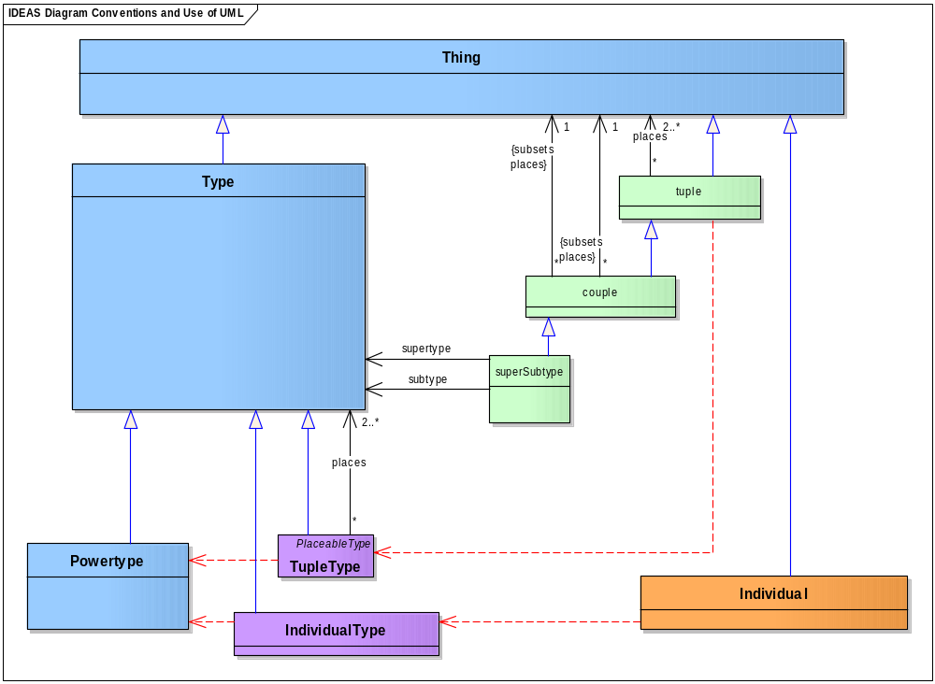
Figure 2.1.2-1: An IDEAS diagram with color-coding
- The DoDAF meta-model follows these naming conventions for types and relationships:
- Names are formed by concatenating words. The initial letter of each word in a multi-word name is capitalized.
- Names of types begin with an uppercase letter (i.e., title-case). Names of types are nouns or noun phrases.
- Names of relationship begin with a lowercase letter (i.e., camel-case). Names of relationships are verbs or verb phrases.
- The size of graphical elements in DoDAF meta-model diagrams does not signify importance. The sizes or these elements are set to make the diagrams easier to read by reducing the visual clutter of crossing lines and by removing unnecessary bends in connecting lines.
- The DoDAF Glossary provide ontic terms as they are defined in the DoDAF meta-model. The Glossary also includes a summary of aliases and other synonyms, composite terms and pattern names, and many reference definitions.
- IDEAS foundational types are generally not shown in data group diagrams. The types not shown include superSubtype, wholePart, temporalWholePart, overlap, typeInstance (memberOf), and beforeAfter patterns.

Support for DoD key processes through DoDAF viewpoints
- The DODAF groups meta-model concepts that are semantically related. These groups include principle and supporting data groups. Principle data groups are building blocks for describing behavior and structure. Supporting data groups provide properties and attributes for the principle data groups.
- These DoDAF 2.0 data groups support both DoDAF viewpoints and the DoD key processes: the Joint Capabilities Integration and Development System (JCIDS), the Defense Acquisition System (DAS), the Planning, Programming, Budgeting, and Execution system (PPBE), systems engineering (SE), operations, and portfolio management (both IT portfolio management and capability portfolio management (CPM)). Table 3.3-1 relates DoDAF data groups to DoDAF viewpoints and DoD key processes.
Table 3.3-1: DoDAF meta-model groups related to viewpoints and DoD key processes
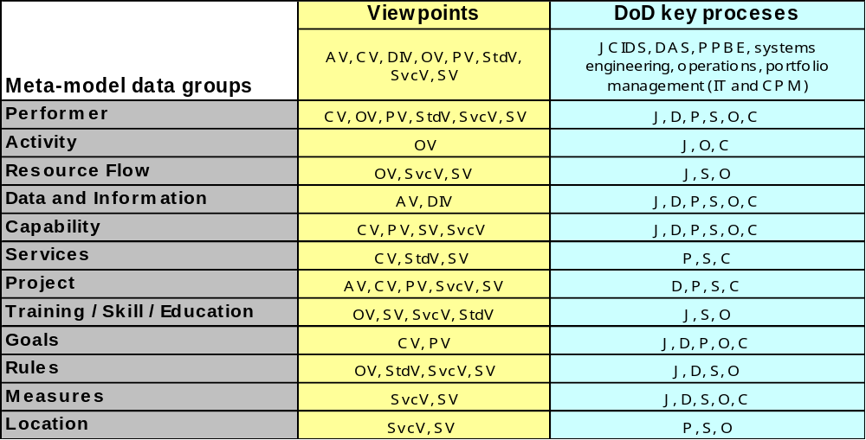
- The principle data groups are:
- Performers. Any entity—human things, automated things, and any assemblage of such things—that performs an activity and provides a capability.
- Resource Flows. The behavioral and structural representation of the interactions between activities (which are performed by performers) that is both temporal and results in the flow or exchange of things such as information, data, materiel, and performers.
- Information and Data. Representations (descriptions) of things of interest and necessary for the conduct of activities. Information is the state of a something of interest that is materialized—in any medium or form—and communicated or received.
- Rules. How rules, standards, agreements, constraints, and regulations and are relevant to architectures. A principle or condition that governs behavior; a prescribed guide for conduct or action.
- Capabilities. The ability to achieve a desired effect under specified standards of performance and specified conditions through combinations of ways (guidance and rules) and means (resources) to perform a specified set of activities.
- Services. A mechanism to enable access to a set of one or more capabilities , where the access is provided using a prescribed interface and is exercised consistent with constraints and policies as specified by the service description. The mechanism is a Performer. The capabilities accessed are resources, that is, information and data, materiel, performers, and geo-political extents.
- Projects. All forms of planned activities that are responsive to visions, goals, and objectives that aim to change the state of some situation. A temporary endeavor undertaken to create resources or desired effects.
- Organizational Structures. Representations of the organization types, organizations, and individuals that are present in the architecture.
- The supporting data groups are:
- Measures. All form of measures (metrics) applicable to architectures including needs satisfaction measures, performance measures, interoperability measures, organizational measures, and resource physical measures (e.g., mass). The magnitude of some attribute of an individual.
- Locations. A point or extent in space that may be referred to physically or logically.
- Pedigrees. The origin and the history of something; broadly: background, history.

Performers
- Performers are central to the description of architecture. They are the who in architecture descriptions. The what—activities—are assigned to performers to produce desired effects. Performers are further subdivided and allocated to organizations, persons in roles, and systems. Locations and measures are then applied to organizations, persons in roles, and systems. Within this assignment and allocation process there are many major tradeoff opportunities. Automation (mechanization versus people) tradeoffs, analysis for items such as performance and cost/benefit are involved in the process. When these tradeoffs and associated decisions are sufficiently mature, an allocated baseline can be declared and an initial work breakdown structure (WBSs) refined.

Data group description
- Figure 2.2.1-2 shows the DoDAF meta-model diagram for the Performers data group.
- A performer may be:
- A person in a role such as the roles described by the Amy’s military occupational specialties (MOS). A person in a role includes materiel assigned and necessary to carry out the role (for example, see the Army’s series of Common Tables of Allowances). A person in a role has temporal whole-parts (states) such as in-garrison or deployed; these temporal parts may have different materiel compositions and other associations.
- A type of organization or a specific organization that has a mission.
- A system in the general sense of any assemblage of components—machine and human—that accomplish a function.
- A service, including software services and business services such as search and rescue.
- Any combination of the above.
- The performance of an activity by a performer occurs in physical space and time. That is, at some place and time, the activity is conducted. This is referred to as a spatial-temporal overlap, simply meaning that the activity and performer overlap in space and time. There are two ways in which a performer spatial-temporally overlaps an activity:
- In the act of performing the activity. This relationship is sometimes called assignedTo for the purposes of traceability.
- The other way is as part of a larger process (aggregated activities). This is sometimes called allocatedTo and forms the initial stages of system or activity decomposition. Allocated performers are assigned to activities in the initial stages of defining performers.
- A standard, which is a sort of rule, constrains an activity in general and may affect how a performer carries out an activity.
- A performer may be related to measures that bear on the performance of an activity (e.g., target tracking accuracy.) A performer may also be related to measures that bear on the performer itself (e.g., operational condition).
- A performer may be at a specific location designated by some set of coordinates within a coordinate system. A performer may also be within a more general location designated by an area, region, installation, site, or facility. Location type requirements/capabilities of a Performer are captured/expressed via the Activities that are performed under certain Conditions (e.g., must be able to perform maneuver under desert conditions).
- Activities performed by a system can be called system or service functions (i.e., activities performed by a system). System or service functions are activities that are allocated to hardware, software, firmware, and persons in roles.
- In typical uses, activities are named by verbs and performers are named by nouns. This distinguishes what from who at the level of names. In typical specification activities, allocation to performers can take place at different levels of abstraction and at different levels of detail within a level of abstraction.
- Performers are represented in many places and stages in a detailed architecture description. A pure requirements architecture description would not show allocations to performers; this allocation would come later in the design process.
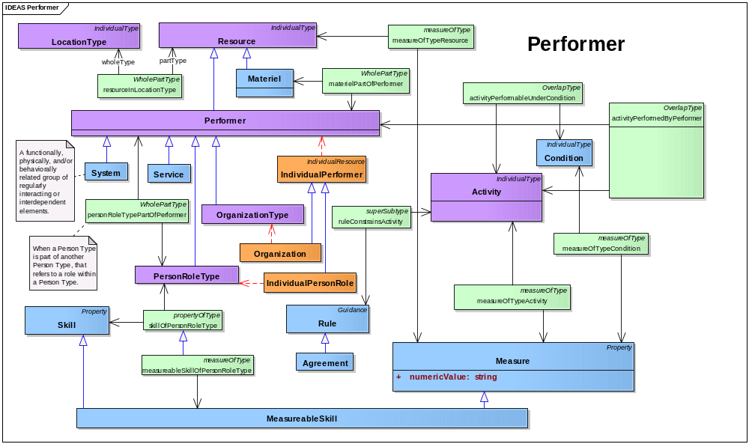
Figure 2.2.1-2: DoDAF meta-model diagram for Performers data group

Use in DoD core processes
- Data for Performers may be used in these ways:
- JCIDS:
- Activities carried by persons in roles may correspond to tactics, techniques, and procedures (TTP), where procedures are sets of activities allocated to performers and tactics and techniques are guidance and rules for those activities as carried out by those performers.
- A pure requirements architecture description would not show allocations to performers. This allocation would come later in the design process.
- PPBE:
- Programs of record are projects that can contain both material and non-material performers. (See DoD 7045.7-H: FYDP Structure Handbook).
- Program of record are linked to the PPBE through the WBS (see DAS) depicting Performers related to cost.
- The Planning and Programming process analyzes and evaluates capabilities, performers, and properties related to performers.
- DAS:
- MIL-STD-881C and DoD 5000.01 provide fundamental guidance for specifications, WBSs, and statements of work within the DAS. Both require the identification of performers and their component parts and types as fundamental elements.
- The acquisition process generally involves performers through the material acquisition of material systems and the acquisition of activities associated with performers.
- The acquisition process can acquire services.
- Systems engineering:
- Activities are assigned to performers—organizations, persons in roles, and systems. Capabilities, measures, conditions, constraints, and other expressions of requirements are assigned to various performers. Allocation occurs from level-to-level as part of structural design decomposition or design refinement.
- Allocation is the term used by architects and engineers to denote the organized cross-association (mapping) of elements within the various structures or hierarchies of a user view regardless of modeling convention or standard. The concept of allocation requires flexibility suitable for abstract system specification, rather than a particular constrained method of system or software design. System modelers often associate various elements in abstract, preliminary, and sometimes tentative ways. Allocations can be used early in the design as a precursor to more detailed rigorous specifications and implementations. As the requirements definition stage gives way to the design stage and actual components become visible, it becomes important to distinguish between allocated to and assigned to.
- Some types of performers under configuration control are called system configuration items (CIs). Software configuration items are termed computer software configuration items in MIL-STD-881C or simply software configuration items (SCIs) in other contexts. Hardware configuration items may follow the MIL-STD-196E taxonomy: central, center, system, subsystem, set, group, and unit.
- Operations planning:
- Determines who is going to accomplish the required tasks (activities), where, under what conditions, and to what measures.
- Capability portfolio management:
- Performers are the major items in the portfolio to be managed and optimized.

Resource Flows
- Resource flows model the flow of resources—materiel, information and data, geo-spatial extents, performers, and any combination thereof. Resource flows are key modeling techniques used to define interfaces and to assure interoperability between activities and their associated performers (e.g., systems and persons in roles). Resource flow models and associated analysis techniques reveal behavior such as:
- The connectivity between resources.
- Resource flow modeling provides an explicit means to describe the behavior of activities, systems, organizations and their composite effects on the overall enterprise.
- The content of the information flowing between resources (e.g., interface definition).
- The order or sequential behavior (parallel or serial) of the resources in relation to one another (e.g., project task execution and critical path).
- The behavior of resource flow between or within organizations (e.g., work flow, information flow).
- The changes in state during the spatial and/or temporal existence of the resource.
- The rules that modify the behavior of the resource flow (e.g., business rules, controls, decisions).
- The measures that define quality, constraints, timing, and other properties. Of the resource flow (e.g., quality of service (QoS), measures of performance, measures of effectiveness).
- The flow of control orchestrating the behavior of a resource flow.

Data group description
- Figure 2.3.1-3 shows the DoDAF meta-model diagram for the Resource Flows data group.
- DoDAF models the consumption and production—the flow—of any sorts of resources, not just flows of information and data exchanges. DoDAF may be used to model:
- Materiel flows such as ammunition and fuel that are important for modeling the fire rate, logistics, and other aspects of a capability solution so it can be compared with other proposed solutions.
- Persons in roles such as military occupational specialty (MOS) that allow representation of the training and education pipeline aspects of doctrine, organization, training, material, leadership and education, personnel, and facilities (DOTMLPF).
- Performers such as organizations, persons in roles, and systems that are produced by a project’s design and build activities. Among other possibilities, this allows an architect to model an acquisition project.
- All exchanges and flows are due to producing or consuming activities. Resource flows are activity-based, not performer-based, because a performer cannot produce or consume a resource other than by carrying out an activity. That is, a performer can only give or get a resource by carrying out an activity. For instance, publication and subscription are modeled as an interaction between the publishing activity, the subscribing activity, and the information or data resource. Publication is typically not at the same time as subscription but the subscriber does have to go to the publication place to retrieve the resource. For example, data might be published at 2:00 GMT on a server located at some URL and the subscriber may not overlap until 10:00 GMT. In the diagram the overlap is a triple: the producing activity, the consuming activity, and the resource.
- The exchange or flow triple may have standards (rules) associated with it such as information assurance and security rules or, for data publication or subscription, data COI and web services standards.
- Rules and measures are applied to specific activities and their performers. Activities, systems, and persons in roles can be assigned to locations and further can be assigned conditions and constraints.
- The term flow implies that something (e.g., materiel, information) is moving from point A to point B, hence the use of the foundation concept of “overlap”.
- The exchange or flow triple may be related to measures such as timeliness, throughput, reliability, or QoS.
- Information inputs and outputs between resources for some levels of decomposition may be at a higher-level of abstraction than the information characteristics represented in the matrix. This is commonly done to simplify graphical representations of information flow or in the initial definition stages where the characteristics are still unknown. In this case, multiple information exchanges will map to a single resource input or output. Similarly, the information inputs and outputs between resources at a low-level of decomposition may be at a higher-level of detail than the information exchanges in the matrix, and multiple information inputs and outputs may map to a single information exchange. In these cases, to provide the necessary clarity and precision, an ontological or taxonomic structure of information aggregation should be developed for use in each level of decomposition of the resource flow models.
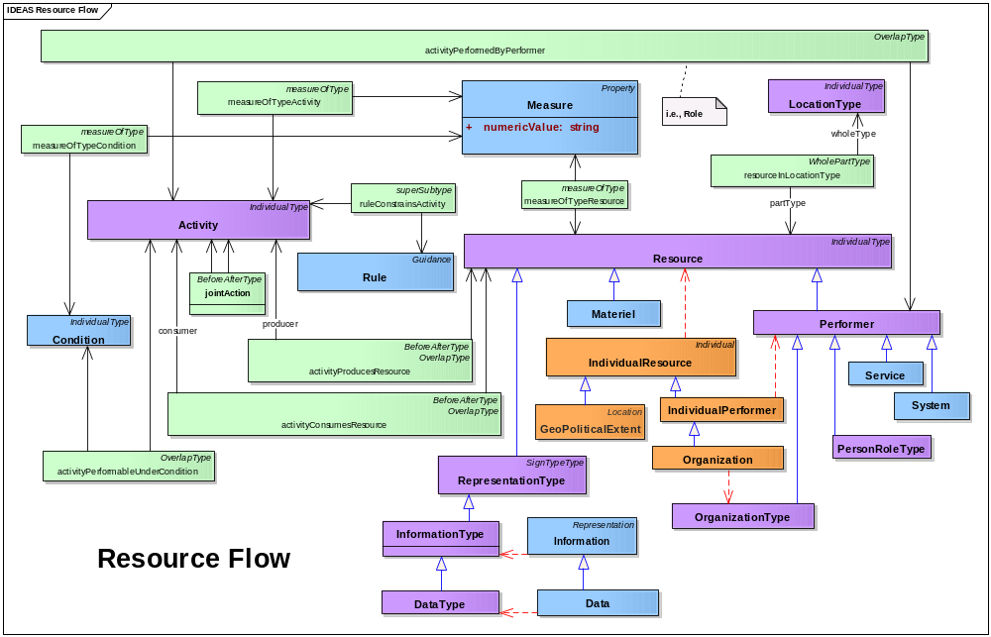
Figure 2.3.1-3: DoDAF meta-model diagram for Resource Flows data group

Use in DoD core processes
- Resource flow modeling is a fundamental engineering based technique used in information technology (IT) architecture, systems engineering, process re-engineering, resource planning, and many other disciplines.
- JCIDS:
- Where are activity bottlenecks?
- Are activities interoperable?
- Identify new and emerging systems interoperability requirements.
- Uncover unnecessary or inefficient operational activities and information flows.
- Evaluate alternative architectures with different connectivity and Resource Flow to maximize capability and minimize automation complexity.
- Identify critical connectivity needs and interfaces (or key interface profiles) between activities and their performers (organizations and persons in roles).
- Critical interfaces are generally documented in formal interface documentation signed by the responsible authorities (both information supplier and information consumer) in charge of each end of the interface.
- Support analysis of alternatives and other systems engineering analyses.
- DAS:
- The interface spans organizational boundaries (may be across instances of the same system but usd by different organizations).
- Support the development of test sequences and procedures.
- The details of resource flow (e.g., of materiel, persons in roles, data) are generally documented in interface control documents (ICDs), interface requirements specifications (IRSs) and interface description documents (IDDs). This data is typically provided to DoD Investment Review Board registry systems for the purpose of milestone reviews and support of acquisition decisions points.
- PPBE:
- Ensure FYDP provides flows needed for operations and missions
- Ensure consumption requirements are met by producers
- Systems engineering:
- Identify new system or service, functions (activities), components, and modifications required.
- Identify new resource flow and system integration requirements.
- Identification of the need for application of new standards.
- Clearly identify the relationship and information flow between systems and system/services in an system of systems (SoS) or between services in a service oriented architecture (SOA) including definition of publish or subscribe requirements
- Interface identification and definition including interoperability analysis and standardization.
- Support configuration management of interfaces. Interfaces are generally documented in interface documentation representing the agreements of the responsible parties in charge of each end of the interface (both information supplier and information consumer). This, in no way implies a point-to-point interface. Interfaces implemented with an enterprise service bus, for example, are defined with appropriate publish/subscribe documentation formalized, if necessary, with contractual agreements between information supplier and consumer.
- Critical interfaces are generally documented in formal interface documentation signed by the responsible authorities (both information supplier and information consumer) in charge of each end of the interface. For legacy point-to-point interfaces this may be in the form of interface control drawings (ICDs), interface requirement documents (IRSs), interface design documents (IDDs), among others. In multiple access or common connectivity (radio communications or bus type connectivity) implementations may be in the form of formal agreements (defined herein as a consent among parties regarding the terms and conditions of activities that said parties participate in) detailing the specific set of implementations (e.g., Tactical Digital Information Links [TADILs]) data elements implementation tables or in the case of a SOA, a publish/subscribe implementation document. These agreements are, in general, managed and controlled by the SoS or system project manager. In new systems, and where possible the interface should be managed and configuration controlled using a common precision data model. Figure 2.3.2-4 illustrates the evolution from configuration control of legacy point-to-point interfaces to a net-centric, distributed processing means of connectivity using carefully managed publish and subscribe agreements and documentation based on formally documented logical and physical data models.
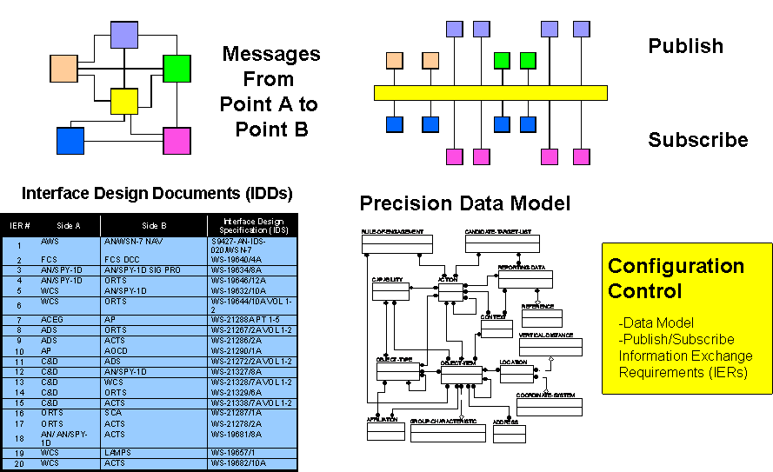
Figure 2.3.2-4: Migrating from legacy to data focused configuration management
- Operations planning:
- Operations utilizing information flows should be technology independent. However, operations and their relationships may be influenced by new technologies. There may be some cases in which it is necessary to document the way activities are performed to examine ways in which new systems could facilitate streamlining the activities
- Mission planning including simulation and training.
- Logistics planning.
- Provide a necessary foundation for depicting information needs and task sequencing to help develop and use procedures, operational plans, and training.
- Identify critical mission threads and operational resource flow exchanges by annotating which activities are critical (i.e., identify the activities in the DoDAF-described model that are critical, such as a project’s critical path).
- Capability portfolio management:
- Resource flows can be used to represent the structural and behavioral relationships between the Activities and Performers within the portfolio including interfaces and interdependencies.

Information and Data
- Information is the state of a something-of-interest that is materialized, in any medium or form, and communicated or received. DoDAF 2.0 emphasizes the identification and description of the information in a semantic form (what it means) and why it is of interest (who uses it). Although this may entail some formality such as describing relationships between concepts, its purpose is to convey the interests in the operator, executive, or business person’s frame of reference.
- Data is the representation of information in a formalized manner suitable for communication, interpretation, or processing by humans or by automatic means, and is concerned with the encoding of information for repeatability, meaning, and proceduralized use. While information descriptions are useful in understanding requirements, e.g., inter-federate information sharing requirements or intra-federate representation strategies, data descriptions are important in responsive implementations of those requirements and assurances of interoperable data sharing within and between federates.

Data group description
- Figure 2.4.1-5 shows the DoDAF meta-model diagram for the Information and Data data group.
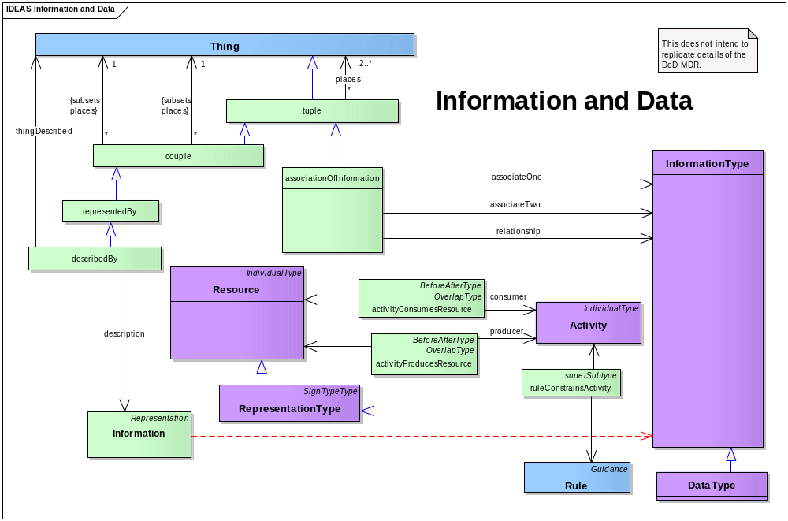
Figure 2.4.1-5: DoDAF meta-model diagram for Information and Data data group
- The key concept in this model is that information describes some real thing: material, temporal, or even abstract, such as a relationship (tuple) or set (type).
- Since information is a thing, information can describe other information (e.g., metadata).
- A name is a type of information in that it describes a thing. A name may be short or long—there is no restriction. A textual description can be thought of a just a long name. Information is more general than text strings and could be structured, formalized, or include other manners of description such as diagrams or images.
- Information, as a sort of resource, inherits whole-part, super-subtype, and before-after relationships.
- Should humans or machines be able to process some information in a repeatable way, such information is called proceduralized. Not all proceduralized information is necessarily computerized; forms are examples of data proceduralized for human repeatable processing.
- Data to be proceduralized has associations such as parts and types as well as other application specific associations. So for an Entity-Relationship model, Attributes are associations with Entities and Entities are related according to verb phrases and cardinalities. In the physical schema, the fields are associated to data types.
- The representation for data is not intended to cover all the details of, for instance, a meta-model underlying a relational database management system (RDBMS) , but just those aspects necessary to support the decision-making of the core processes.
- Architecture descriptions describe architectures. An activity model is an example of an architecture description. Two subtypes of architecture description are called out—the AV-1 and the Manifest—due to their importance in discovery and exchange, respectively. AV-1 information can also be provided in a structured manner, using the Project data group to describe the architecture project’s goals, timeline, activities, resources, productions, rules, and measures.
- All methods, even the most philosophical and methodical, involve the ingestion of some record of the enterprise’s processes, legacy information-keeping systems, and descriptions of what types of things it thinks it deals with. Upon collection of this raw data, terms within it are then:
- Identified. This is done by noting recurring or key terms.
- Understood. Definitions of terms are sought and researched. In most cases, there are multiple authoritative definitions. Definitions selected should be appropriate for the context of use of the term within the enterprise activities.
- Collated and correlated. This is done by grouping seemingly similar or related terms.
- Harmonized. In this step, aliases, near-aliases, and composite terms are identified. A consensus definition is formulated from the authoritative source definitions. Often super-subtype and whole-part relationships begin to emerge.
- The next step is to relate the harmonized terms. Some of the relationships are implicit in the definitions and these definitions may contribute to the relationship description. At this point, the formality can vary. A formal ontological approach will type all relationships to foundational concepts such as whole-part and super-subtype. However, there are many metaphysical challenges with such an approach and it is not necessary for many applications. This constitutes the conceptual-level of modeling, defined and related terms, now considered concepts because the definitions and relationships lend a meaning to the terms. The conceptual model should be understandable by anyone knowledgeable about the enterprise. Super-subtype and whole-part relationships can provide cognitive economy. Conceptual models can be done in Entity-Relationship or UML Class model style although any format that documents definitions and relationships is functionally equivalent. The subtype concept in UML generally results in the subclass inheriting properties from the supertype while in Entity-Relationship (E-R) modeling only the identifying keys are inherited directly; the other supertype properties are available after a join operation.
- At the logical-level, relationships may have cardinalities or other rules added that indicate how many of one instance of something relates to an instance of something else, the necessity of such relations, and so on. The concepts may also be attributed, meaning they will be said to have some other concept, e.g., the concept of eye has the concept of color. Often at the logical-level, the relationships are reified or made concrete or explicit. At the logical-level, this is done in case there is something additional that needs to be stated about the relationship, e.g., the quantity of some part of something or the classification of the related information, which may be different from the classification of the individual elements. There may also be considerations of normalization, meaning that the database structure is modified for general-purpose querying and is free of certain undesirable characteristics during insertion, update, and deletion operations that could lead to a loss of data integrity. The benefits of normalization are to uncover additional business rules that might have been overlooked without the analytical rigor of normalization and ensure the precise capture of business logic. The logical model, though having more parts than the conceptual model, should still be understandable by enterprise experts. At the logical-level, some sort of modeling style is normally used such as Entity-Relationship or UML Class modeling.
- At the physical-level, the exact means by which the information is to be exchanged, stored, and processed is determined. At this level, we are talking about data. The efficiency, reliability, and assured repeatability of the data use are considered. The datatypes, the exact format in which the data is stored are determined. The datatype needs to accommodate all the data that is permissible to store or exchange yet be efficient and disallow formats that are not permissible. The entities may be de-normalized for efficiency so that join operations don’t have to be performed. Logical associations may be replaced with identifiers (e.g., as associative entities or foreign or migrated keys in entity relationship diagrams [ERDs] or explicit identifier attributes or association classes in class models). Keys, identifiers, and other means of lookup are setup. Indexes, hashes, and other mechanisms may be setup to allow data access in accordance with requirements. The physical target may be any of the following:
- Database – relational, object, or flat file.
- Message exchange format – document (e.g., XML), binary (e.g., Interface Definition Language).
- Cybernetic (human – machine), e.g., print or screen formats, such as forms.

Use in DoD core processes
- Information and Data models may be used in these ways:
- Commonality and interoperability between core processes:
- Information models materialize for enterprise participants what things are important to the enterprise and how they are related.
- Information models can serve as a basis for standardization of terminology and concept inter-relationships for human, machine, and human-machine communications.
- Information models can provide cognitive compactness for an enterprise’s personnel through the use of taxonomies and other relationship structures. This can improve clarity, efficiency, accuracy, and interoperability of action within the enterprise.
- Information models document the scope of things the enterprise is concerned with in a form that allows comparison with other communities of interest to reveal common interests.
- COI coordination and harmonization.
- Authoritative sources identification and management.
- JCIDS and PPBE:
- Data and information models can be used to determine if a proposed capability will interoperate, be redundant with, or fill gaps in conjunction with other capabilities.
- Systems engineering and DAS:
- Data models can be used to generate persistent storage of information such as in databases.
- Data models can be used to generate formats for exchanging data between machines, humans, and machine-to-human. For example, an XSD is a physical data model that is generally an exchange format. Web services can be used with an RDBMS to generate XML for exchange in the format of the data model implemented in the RDBMS. The underlying data models (the physical data model and the exchange data format) do not have to be the same; a translator or mediator may be invoked to translate during the exchange.
- Data models can be used to compare whether Performers are compatible for data exchange.
- Interdependent data or information needs.
- Data and information models can be used during milestone reviews to verify interoperability, non-redundancy, and sufficiency of the solution.
- Information models are useful in initial discovery of a service, to know what sorts of information it may provide access to or its accessed capabilities need. An information model is part of a service description.
- Data models are useful in knowing how to interact with a service and the capabilities it provides and for establishing the service contract. A data model is part of a service description and service contract.
- Database/sources consolidation and migration.
- Standards definition and establishment.
- Mediation and cross-COI sharing.
- Operations planning:
- Capability portfolio management:
- Data and information models can be used to determine if components of a portfolio have:
- Overlapping data or information production (an indication of potential unwanted redundancy).
- Data assets management.

Rules
- Rules are prescriptive sets of procedures regarding the execution of activities within an enterprise. Rules exist within the enterprise whether or not they are ever written down, talked about, or even part of an organization’s consciousness. However, it is fairly common practice for organizations to gather rules in a formal manner for specific purposes.
- Business rules are a type of Rule that govern actions and are initially discovered as part of a formal requirement-gathering process during the initial stages of a Project or during activity analysis, or event analysis. In this case, the collecting of the business rules is coincidental to the larger discovery process of determining the workflow of an activity. Projects such as the launching of a new system or service that supports a new or changed business operation might lead to a new body of business rules for an organization that would require employees to conceptualize the purpose of the organization in a new way. This practice of coincidental business rule gathering is vulnerable to the creation of inconsistent or even conflicting business rules within different organizational units, or within the same organizational unit over time.
- The DoDAF meta-model provides a set of clear, concise data about rules. These data help architects create and share rules.
- A rule is not an activity—these two concepts are related but are very different. An activity is a transformation that produces new resources from existing resources. In contrast, a rule prescribes the ways that an activity may be carried out.

Data group description
- Figure 2.5.1-6 shows the DoDAF meta-model diagram for the Rules data group.
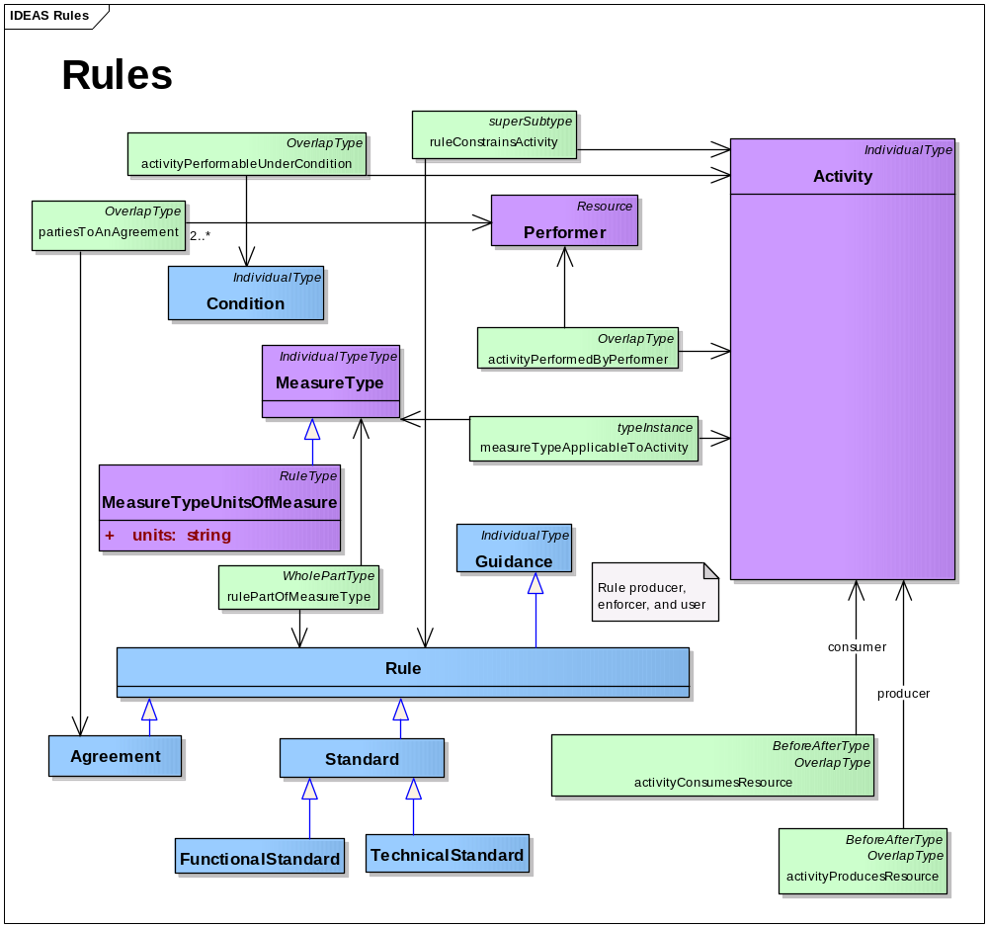
Figure 2.5.1-6: DoDAF meta-model diagram for Rules data group
- A rule constrains activities. For example, a speed limit rule constrains driving activity. Some seemingly static rules have the effect of limiting possible activities. For example, a rule that security fences must be ten feet high constrains the activity of building security fences. This constraint may apply or vary under certain conditions. For example, speed limits can be lower in poor weather conditions.
- Security classification, security marking, and criteria for release of information are types of guidance. Similarly, a rule is a stronger form of guidance.
- An important constraint type is a service policy that constrains access to capability performers.
- By definition, doctrine constrains military action.

Use in DoD core processes
- Rules data are used to create, document, and share rules of all types that support activities. These data can include:
- Activities that define transactions where data must be exchanged or passed to execute activities such as PPBE, CPM, JCIDS, and DAS.
- Rules that define methods of accessing information or services within the net-centric environment, including operations planning, PPBE, CPM, and JCIDS.
- The order of steps that occur in a series of actions that must be performed in a specific order, such as DAS, systems engineering, PPBE, and CPM.
- Rules defining analysis of options or future actions, such as operations planning, JCIDS, PPBE, and CPM.
- Data for Rules may be used in these ways:
- JCIDS:
- For materiel facility, installation, and site trade-offs as part of DOTMLPF analyses.
- For detailing interoperability requirements.
- In constraining requirements dealing with material and non-material solutions.
- In relating doctrine and TTP to material and non-material solutions.
- PPBE:
- In the planning and programming process many rules are applied to cost-benefit tradeoffs, cost estimation, program structure, and program constraints.
- DAS:
- In both technical and programmatic aspects of the DAS.
- In specification, standards, directives, and guidelines.
- Systems engineering:
- In the architecture descriptions of systems describing both structure and behavior.
- In standards applied throughout the design and development process.
- Operations planning:
- Rules are the basic elements contained in doctrine, TTP and training publications. Rules are used throughout the development and architecture descriptions of operational activities.
- Capability portfolio management:
- In describing and governing both the programmatic and technical aspects of the portfolio.
- In describing the standards and constraints applicable to the portfolio.

Capabilities
- The Capabilities data group provides information on the collection and integration of activities that combine to respond to a specific requirement. A capability, as defined here is “the ability to achieve a desired effect under specified standards and conditions through combinations of means and ways to perform a set of tasks.” This definition is consistent with that contained in the JCIDS Instruction published by the Joint Staff.

Data group description
- Figure 2.6.1-7 shows the DoDAF meta-model diagram for the Capabilities data group.
- Ways are interpreted as guidance, rules, and standards. Means are interpreted as resources.
- Because a desired effect is a desired state of a resource (see Goals data group), a capability is about states—the persistence of current states and changes to future states—of resources.
- Capabilities link to measures through the activities they entail as parts and the desired effects sought.
- Capabilities relate to services via the realization of the capability by a performer that is a service. In general, a service would not provide the desired effect(s) but, rather, access to ways and means (activities and resources) that would.
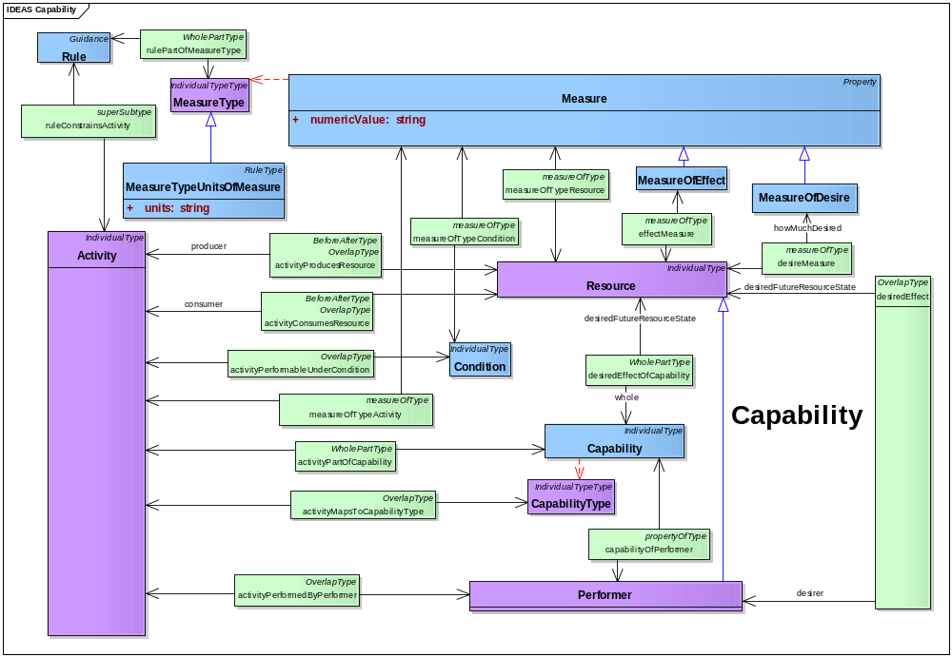
Figure 2.6.1-7: DoDAF meta-model diagram for Capabilities data group

Use in DoD core processes
- The Capabilities data group is used to describe capabilities; define acquisition and development requirements necessary to provide required capabilities; foster understanding of capability execution; develop, update, and improve doctrine and education to support capability execution; and share and reuse data.
The Capabilities data group has a representation at different levels, from enterprise level to solutions and applies to all DoD core processes. This includes enterprise goals associated with the overall vision, that provide a strategic context for the capabilities described by an architecture, and an accompanying high-level scope, more general than the scenario-based scope defined in an operational concept diagram. At this level, the Capabilities data group enables a high-level description of capabilities in decision-makers contexts that can be used for communicating a strategic vision regarding capability evolution. Factors considered in a capability based analysis include the DOTMLPF factors: doctrine, organization, training, materiel, leadership and education, personnel, and facilities. The following paragraphs discuss how the Capabilities data group supports analyses of these factors.
- Doctrine. In Joint Pub 1-02, Dictionary of Military and Associated Terms, “doctrine” is defined as “Fundamental principles by which the military forces or elements thereof guide their actions in support of national objectives. It is authoritative but requires judgment in application.”
- The concept of judgment required in application deals with decision making and cannot be precisely modeled except perhaps as rules affecting the applicability of other rules. The parts of doctrine that can be modeled are included in the Capabilities data group as follows:
- Principles are modeled as rules.
- Military forces and elements thereof are modeled as types of performers and assemblies of performers.
- Actions are modeled as activities.
- Thus, doctrine is contained in the specification of certain fundamental rules, activities, and performers and the relationships among them. These relationships are:
- Each performer must be the performer of one or more activities.
- Each activity must be performed by one or more performers.
- Each rule may be a constraint on one or more activities.
- Each activity may be constrained by one or more rules.
- Thus, since the DM2 contains the entities and relationships listed above it contains the necessary and sufficient set of entities and relationships to permit the modeling of doctrine and a separate data group for doctrine is not required.
- Organization. An organization is a specific real-world assemblage of people and other resources organized for an ongoing purpose. DM2 models organizations as a type of performer.
- Defining an organization as an assemblage means that each organization exhibits a whole/part relationship whereby each organization may be an assembly of other organizations and each organization may also be a component of one or more other organizations. The following DM2 relationships are involved in the capability based analysis of organization where each organization is a type of performer:
- Each Capability must be the result of one or more Activities.
- Each Activity must be performed by one or more Performers, where each Performer must be a type of Organization; therefore, each Capability must be provided by one or more Organizations.
- Each Organization must be the Performer of one or more Activities.
- Each Rule may be a constraint on one or more Activities.
- Each Activity may be constrained by one or more Rules.
- Training. Training is defined as an activity or set of activities to increase the capacity of one or more performers to perform one or more activities under specified conditions to specified standards of performance:
- Each performer may be either an organization or a person in a role.
- Each performer must be of one or more activities.
- Each activity must be performed under one or more conditions.
- Each activity must be completed to meet one or more standards.
- Each standard must be specified by one or more measures.
- Materiel. Materiel is a type of resource. Like organization above, each materiel exhibits a whole/part relationship whereby each materiel may be an assembly of other materiels and each materiel may also be a component of one or more other materiels.
- The following DM2 relationships are involved in the capability based analysis of materiel where each Materiel is a part of a Performer:
- Each performer must be assigned to one or more organizations.
- Each performer must be used by one or more persons in roles, where each person in a role must be a member of only one organization at any one time.
- Each capability must be the result of one or more activities.
- Each activity must be performed by one or more performers, where each performer must be either an organization or a person in a role.
- Each performer must be the performer of one or more activities.
- Each rule may be a constraint on one or more activities.
- Each activity may be constrained by one or more rules.
- Leadership and education. Joint Pub 1-02 does not define leadership. In the context of the DM2, leadership is defined as the ability to lead. Joint Pub 1-02 defines Military Education as the systematic instruction of individuals in subjects that will enhance their knowledge of the science and art of war. Thus, to a certain extent, leadership is a set of skills that can be taught as part of the science and art of war and a smaller set of skills that can be trained as Activities that must be performed under specified conditions to meet specified standards.
- Leadership is about the judgment required in application of doctrine; it deals with decision making and cannot be precisely modeled except perhaps as rules affecting the applicability of other rules.
- Personnel. Personnel refer to persons in roles. Each person in a role is a type of performer.
- The following DM2 relationships are involved in the capability based analysis of materiel where each person in a role is a type of performer:
- Each person in a role must be assigned to only one organization at any one time.
- Each person in a role may the user of one or more materiels.
- Each materiel must be used by one or more persons in a role.
- Each capability must be the result of one or more activities.
- Each activity must be by one or more performers, where each performer must be either an organization or a person in a role using a materiel.
- Each person in a role must be the performer of one or more activities.
- Each rule may be a constraint on one or more persons in a role.
- Each activity may be constrained by one or more rules.
- Facilities. A facility is a real property entity consisting of underlying land and one or more of the following: a building, a structure (including linear structures), a utility system, or pavement. This definition requires that facilities be firmly sited on or beneath the surface of the earth. Things such as tents, aircraft, and satellites that are not fixed to a location on or beneath the surface of the earth are a type of materiel. Materiel are germane to capability-based analyses through the following relationships:
- Each facility may be the site of one or more performers and any materiel that is part-of the performer(s).
- Each performer may be at only one facility or within a materiel enclosure at any one time.
- Because a facility is an individual, it has a spatial and temporal extent.
- An individual instance of materiel has a spatial and temporal extent in contrast to a type which does not. Generally, architecture descriptions deal with types of materiel, not with specific individuals such as serial-numbered items of equipment. However, the DM2 does represent a performer at a location and, consequently, any materiel that is part of the performer would also be at the location.

Services
- A service, in its broadest sense, is a well-defined way to provide a unit of work, through which a provider provides a useful result to a consumer. Services do not necessarily equate to web-based technology or functions, although their use in the net-centric environment generally involves the use of web-based, or network-based, resources.
- Functionally, a service is a set of strictly delineated functionalities, restricted to answering the what-question, independent of construction or implementation issues. Services form a layer, decoupling operational activities from organizational arrangements of resources, such as people and information systems. Finally, Services form a pool that can be orchestrated in support of operational activities, and the operational activities define the level of quality at which the services are offered.
- The Services data group provides those data that support the definition and use of services within the net-centric environment. Section 2.7.1 identifies and describes the data within the group; Section 2.7.2 provides an example method for collecting data on services; Section 2.7.3 provides illustrative uses of the data, and Section 2.7.4 provides presentation examples for using the services-related data for presentation to/for management in decision-making.

Data group description
- Figure 2.7.1-8 shows the DoDAF meta-model diagram for the Services data group.
- Services are activities done by a service provider (performer) to achieve desired results for a service consumer (other performer). A service is a type of performer which means that it executes an activity and provides a capability.
- Capabilities and services are related in two ways. One, the realization or implementation of a capability by a performer (usually a configuration of performers, including locations) may include within the configuration services (or service compositions) to access other performers within the overall performer configuration. Conversely, the realization or implementation of a capability by a performer (configuration, including location) may provide the performers that are accessed by a service (or service composition).
- Services in DoDAF 2.0 include business services such as search and rescue. This is important to keep in mind because much of the SOA literature is IT-oriented.
- Although, in principle, anything has a description, the importance of self-description for discovery and use of Services merits its call-out as a class. Further, because only a public-facing side is described, the Service description needs to represent that it describes the Service Port, not the entire Service. A Service Port is a special type of Port that is self-describing and visible. The Service Description of the Service Port is of all aspects necessary to utilize the Service and no more. As such, it may include visible functionality, QoS, interface descriptions, data descriptions, and references to Standards or other Rules (Service Policy). The inner workings of the Service are not described in a Service Description.
- Since service inherits whole-part, temporal whole-part (and with it before-after), service may refer to an orchestrated or choreographed service, as well as individual service components.
- Since service ports are types of ports and ports are types of performers, they inherit all of performer’s properties, including measures associated with the performer, performance of activities (service functions) with associated measures, and provision of objects (materiel, data, information, performers, geopolitical extents).
- Any performer that consumes a service may have a service port that is described in the service request. This description indicates how the service provider should provide or respond back to the service consumer. That is, service ports are parts of performers that may or may not be services themselves.
- The service port is a special type of port that is the part of a performer that provides access to the performer capabilities and the consumer that participates in the service. The performer capabilities provided access to can be an aggregate (e.g., an orchestration) of performer components. The service port is the service consumer facing part of the service and so has a service description, a type of information.
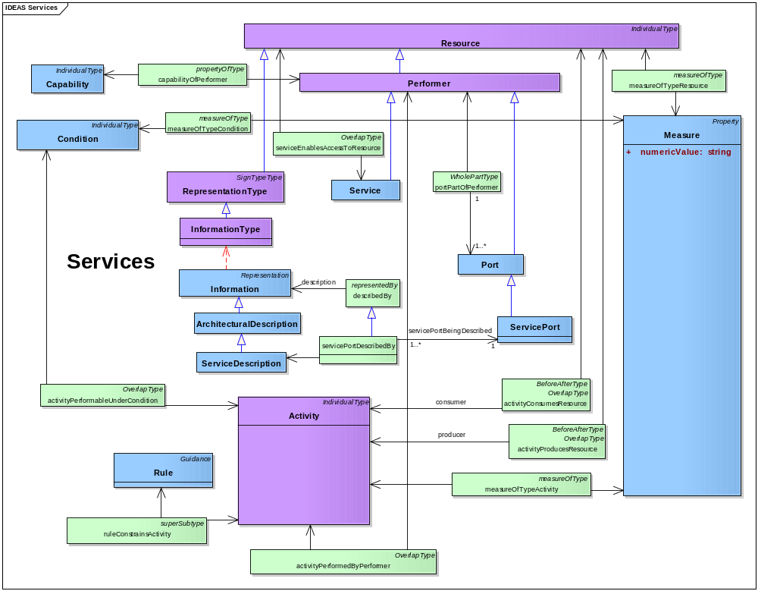
Figure 2.7.1-8: DoDAF meta-model diagram for Services data group

Use in DoD core processes
- The Services Data Group captures service requirements for capabilities, performers and operational activities supporting all the core processes. The DM2 data elements describing Services are linkable to architecture artifacts in the Operational, Capability, System and Project Viewpoints.
- Data for Services may used in these ways:
- JCIDS, PPBE, DAS, and systems engineering:
- Services, such as those reified into web or other computer-based software services are considered performers and are used in the same way (See Performer Use in DoD core processes ‎2.1.2).
- Operations planning:
- Service functions (activities) and resources support operational planning and other activities that foster the exchange of information among performers, aid in decision making, and support training. TTP documents together with training materials generally describe services used in operations.
- Business activities (e.g., writing checks, ordering parts) also can be reified as services both manual and automated.
- Capability portfolio management:
- Services such as software-as-a-service can be part of a portofolio.

Projects
- A Project is a temporary endeavor undertaken to create Resources of Desired Effects. Projects are relevant to all six core processes. Projects form the major elements of the DAS and are the primary focus of the DoD PPBE system.
- The primary construct of the PPBE system is the program element (PE). The PE is defined as:
- program element: “The program element is the basic building block of the Future Years Defense Program. The PE describes the program mission and identifies the organization responsible to perform the mission. A PE may consist of forces, manpower, materiel (both real and personal property), services, and associated costs, as applicable.”Error: Reference source not found
- The key architectural construct within the program element is the WBS subject to DoD Instruction 5000.2. The WBS is the primary instrument connecting an Architecture description to the DAS and the PPBE processes. A WBS is defined as:
- work breakdown structure: “A product-oriented family tree composed of hardware, software, services, data, and facilities. The family tree results from systems engineering efforts during the acquisition of a defense materiel item.”Error: Reference source not found
- MIL-STD-881C provides guidance for constructing the WBS applicable to programs subject to DoD Instruction 5000.2. The WBS is the process necessary for subdividing the major product deliverables and project work into smaller more manageable components and it serves as a valuable framework for the technical objectives, and therefore it is product-oriented. Its elements should represent identifiable work products, whether they are equipment, data, or related service products. A WBS is a product structure, not an organizational structure, providing the complete definition of the work to be performed by all participants and the required interfaces between them.
- Hardware, software, services, data, and facilities are resources in the DM2. The information captured by project administrative tools and techniques (see, for example, the Project Management Institute’s A Guide to the Project Management Body of Knowledge (PMBOK Guide)) provides the basis for resource information in the DM2. The WBS forms the basis of reporting structures used for contracts requiring compliance with ANSI/EIA 748, Earned Value Management Systems, and reports placed on contract such as contractor cost data reports, software resource data reports, contract performance reports, and contract funds status reports.
- MIL-STD-881C states: “The Program WBS and Contract WBS aid in documenting the work effort necessary to produce and maintain architectural products in a system life cycle. The DoD Architecture Framework (DoDAF) … defines a common approach for DoD architecture description development, presentation, and integration for warfighting operations and business operations and processes.”
- Just as the system is defined and developed throughout its lifecycle, so is the WBS. In the early Project phases of concept refinement, system architecture, and technology development, the program WBS is usually in an early stage of development. The results of the analysis of material approaches and the analysis of alternatives provide the basis for the evolution of the WBS at all stages of Project evolution. As the architectural design of the project’s product or service matures, so should the WBS. The WBS is a primary tool in maintaining efficient and cost effective developments of products and services. Figure 2.7.2-9 illustrates the evolution of the WBS during the lifecycle of Project.
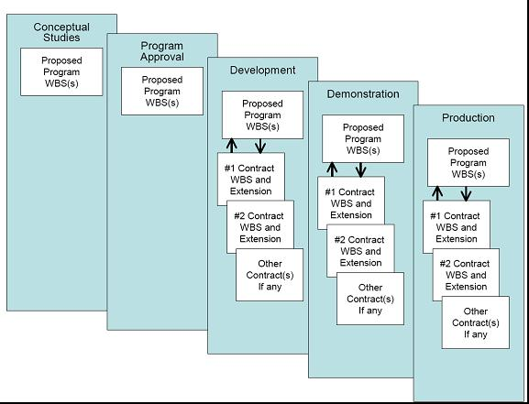
Figure 2.7.2-9: Evolution of a project WBS
- A Project Plan contains the project WBS (including Tasks and responsible Organizations). The Project data group contains the essential data required by DoD 5000.02 to define these parts of a project plan:
- an acquisition strategy;
- a technology development strategy; and
- a systems engineering plan.
- Activities and performers are the essential elements of a project WBS. The use of both activities and performers focusing on products to be delivered (e.g., system, service) in the WBS is the essential premise of the product-oriented WBS defined in MIL-STD-881C.
- The project plan also shows plans and initiatives to coordinate transition planning in a documented program baseline, shows critical success factors, milestones, measures, deliverables, and periodic program reviews.

Data group description
- Figure 2.8.1-10 shows the DoDAF meta-model diagram for the Projects data group.
- Like all concepts in the DM2, projects have whole-part, temporal whole-part, and super-subtype relationships so that major projects can have minor projects within them, projects can have time phases, and projects can be categorized.
- Because a project involves execution of activities, there is a flow of resources into the project’s activities and a flow of products out of them, as described by the Resource Flows data group. So this model can describe a project that results in systems, services, persons in roles (e.g., by training), organizations (e.g., by organizational development), materiels, and locations (e.g., facilities, installations).
- Many kinds of measures may be associated with a project: measures of needs, of satisfaction, of performance, of interoperability, and of cost.
- Measures and rules can be assigned at all levels of the project decomposition. Top-level measures and rules (conditions and constraints) could be assigned to the vision, goals, and objectives. Lower-level measures and rules can then be derived and assigned to compliance criteria and to test criteria. When part of a legal contract, policy, directive, formal agreement, or contractual instrument, rules state requirements for a project.
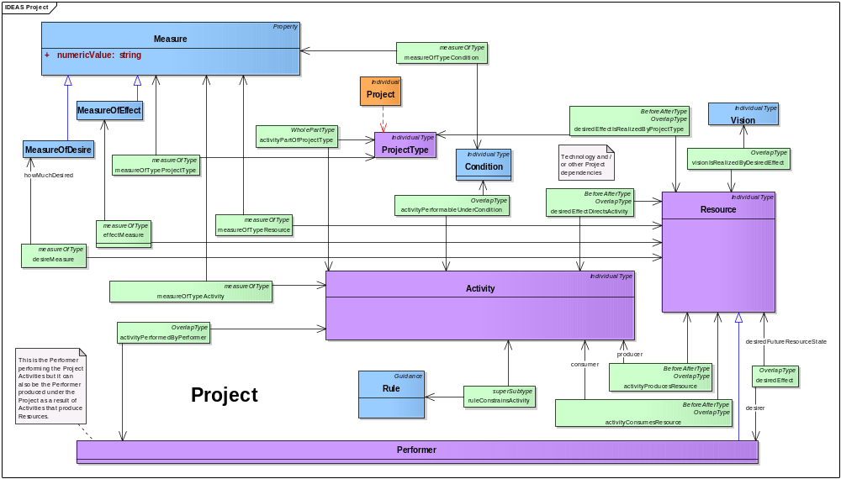
Figure 2.8.1-10: DoDAF meta-model diagram for Projects data group

Usage in Core processes
- JCIDS:
- Project is the typical outcome of the JCIDS process when material solutions are identified.
- Non-material solutions may also result in projects.
- PPBE, DAS, and capability portfolio management:
- Project is the core element of the PPBE, DAS, and CPM processes. The primary construct of project is the WBS. The WBS is the primary artifact within a project that relates performers and activities to cost and milestones. As stated in MIL-STD-881C, the WBS is a continually evolving instrument from project conception to lifecycle management. This tracks closely with the evolution of the architecture. As key activities are refined into primary activities and assigned to or allocated to performers, the WBS should mature and the project definition can gain additional focus.
- Early project WBSs may contain high-level activities (tasks, processes, system functions, or service functions). As a project matures, its WBS identifies system components, such as subsystems and SCIs. These SCIs can be software services or individually testable and deliverable packages of software. Depending on the acquisition strategy, all or part of the project WBS may become the contract WBS and form the basic outline of the requirements in a statement of work and the project statement of objectives or specification. Figure 2.8.2-11 illustrates this method.
Figure 2.8.2-11: Derivation of the materiel portion of a WBS
- The other, non-materiel portions of the WBS (work packages, tasks and activities) are derived in a similar fashion, that is, activities are assigned to or allocated to performers that are, in turn, assigned to organizations, persons in roles, and facilities.
- Systems engineering:
- The data derived from architecture descriptions, derived through the systems engineering process, directly support the definition and structuring of projects. The DoDAF architectural data elements are used in the WBS, in architecture-based and classical specifications, and in the statements of work essential to the systems engineering process. The DoDAF augments classical systems engineering techniques by standardizing the lexicon and relationships. Figure 2.8.2-12 illustrates the typical systems engineering process and its relationship to DODAF constructs. The process shows how operational needs, as described in description documents such as a capabilities description document, are translated into structured requirements and associated project constructs. Further, this shows how capabilities and processes are transformed into solutions through automation tradeoffs and analysis of alternatives. Various alternatives are iterated through the architecture descriptions to meet the required performance, cost, and schedule constraints. From here, functional and allocated baselines can be established. As increased detail is added to the architecture, classical systems engineering and design techniques are increasingly applied.
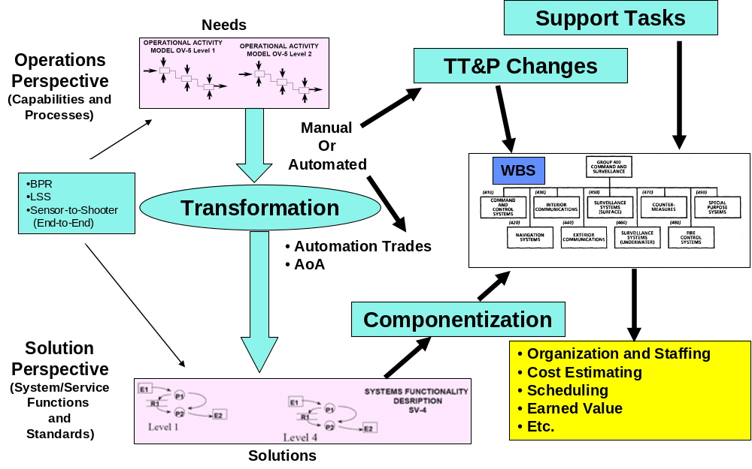
Figure 2.8.2-12: Architecture description used to form project structure reified by a WBS
- Operations planning:
- Project also is used in operational planning in such areas as developing specific mission plans and procedures. Any effort in the operational community requiring identifiable funding and management can be defined as a project.

Organizational Structures

Data group description
- Figure 2.9.1-13 shows the DoDAF meta-model diagram for the Organizational Structures data group.
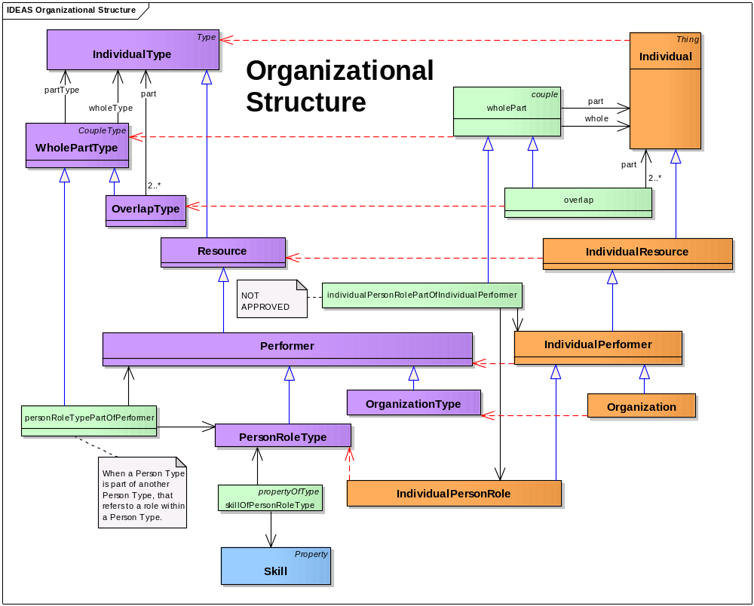
Figure 2.9.1-13: DoDAF meta-model diagram for Organizational Structures data group

Usage in Core processes

Measures
- A measure is the magnitude of some attribute of an object. Measures provide a way to compare things, including projects, services, systems, activities, and capabilities. The comparisons can be among things at a point in time or among temporal parts of the same thing over time. For example, a capability may have different measures when looking at the current baseline and over increments toward some desired end-state.
- There are many sorts of measures that are applicable to many architecture elements. Some of these types of measures are described in the following paragraphs.

Data group description
- Figure 2.10.1-14 shows the DoDAF meta-model diagram for the Measures data group.
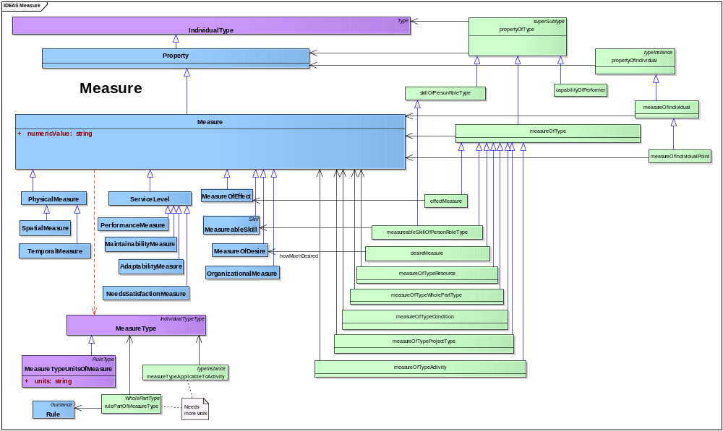
Figure 2.10.1-14: DoDAF meta-model diagram for Measures data group
- The key elements of the Measure data group are measures and types of measures. Measures refers to the actual measured values and their units. They relate to a type of measure that describes what is being measured. Table 2.10-1 gives examples of measures and the types of measures that would be related to these measures.
Table 2.10-1: Informative examples of measures and types of measures
Measure | Measure Type
1 year | timeliness
mach 3 | rate
99 percent | reliability
56K | BAUD
3 meters | target location error accuracy
1,000 liters | capacity
$1M | cost
Level 3 | Capability Maturity Model® Integration maturity level
- Formally, a measure defines membership criteria for a set or class (e.g., the set of all things that have 2 kg mass). The relationship between measure and type of measure is that any particular measure is an instance of all the possible sets that could be taken for a type of measure.
- The lower part of Figure 2.10.1-14 depicts the upper tiers of a taxonomy or classification scheme for sorts of measures. Architects would add more detailed types to specialize such a taxonomy as more particular measures are needed.
- All types of measures have rules that prescribe their measurement (e.g., units of measurement, calibration of instruments). Rules for spatial measures include rules for selecting, specifying, and using coordinate system. For example, latitude and longitude are understood only by reference to a geodetic coordinate system around the Earth.
- As a type of measure, cost may be modeled in architecture descriptions.
- The upper part of Figure 2.10.1-14 shows how measures apply to architecture elements. Measures apply to relationships between things as well as to things themselves, that is, measures apply to a performer performing an activity. An activity has a relationship to a type of measure; this relationship says what type of measure applies to an activity. This represents Universal Joint Task List (UJTL) tasks and their applicable Measure Types, including Conditions, that is, Condition is quantified by a Measure Type. (The whole-part relationship feature of Condition allows it to be singular.) This is accomplished by Condition’s typeInstance association, saying an elementary Condition is a member (instance) of a Measure Type class.

Use in DoD core processes
- Data for Measures may be in these ways:
- PPBE and JCIDS:
- Planning – adequacy analysis. From an adequacy point of view, measures that are associated with a capability (including capability increments, since capabilities have whole-part relationships). Capabilities can be compared with measures associated with performers to see if performer solution(s) are adequate. A set of alternative performers as part of an analysis of alternatives could also be evaluated. Goals or desired effects could be compared with measures associated with performers.
- Programming – overlap analysis. The purpose of an overlap analysis is to determine if there are overlaps, or undesired duplicative capability, in the spending plan, portfolio, capabilities development, or acquisition plan. Similar functionality is often only an indicator of overlapping or duplicative capability. Often performers with similar functionality operate under different measures which are not duplicative or overlapping capability. For example, operational-level situation awareness systems may not be as fast or precise as a tactical-level, but they may handle a larger number of objects over a larger area.
- Goal Setting. Measures are often part of goals such as goals for production and efficiency.
- Requirements. Requirements often have measure elements.
- Capability evolution. Measures are part of capability evolution, showing increments of measurable improvement as the capability evolves and allowing monitoring about when the capability is projected to be achieved or has already been achieved.
- Systems engineering and DAS:
- Systems engineering and design. Measures set design envelope goals, sometimes called performance characteristics or attributes. They can also set constraints (e.g., cost constraints).
- Performance–cost tradeoffs. Measures of performance (e.g., effectiveness) and cost can be compared to evaluate alternative solutions.
- Benchmarking. Measures can be used to establish baselines for performance, such as for skills required of a person in a role or radar tracking accuracy.
- Organizational and personnel development. Organizational and personnel goals are often established and then monitored using measures.
- Capacity planning. Measures can be used to plan for needed capacity (e.g., for networks, training programs).
- QoS description. In SOA, QoS may be expressed as measures (e.g., bit loss rate or jitter). Such measures show up in service descriptions and may be sought during service discovery by users who have service quality requirements.
- Project constraints. Measures such as cost and risk may constrain projects.
- Capability portfolio management:
- Portfolio balancing. Measures may be used to balance a portfolio to achieve an appropriate mix of goals and constraints.
- Operations planning:
- Organizational and personnel development. Organizational and personnel goals may be established and monitored using measures.

Locations
- A location is a point or extent in space. The need to specify or describe Locations occurs in some Architecture descriptions when it is necessary to support decision-making of a core process. Examples of core process analyzes in which locations might have a bearing on the decisions to be made include the following:
- Base realignment and closure (systems engineering process).
- Capability for a new regional command (JCIDS).
- Communications or logistics planning in a mission area (operations process).
- System and equipment installation and assignment of person roles to facilities (operations and systems engineering processes).
- Examples where locations play little, if any, role in the process are:
- Prioritization of precision engagement programs (PPBE and portfolio management processes).
- Streamlining of a business process (systems engineering process).
- Doctrine development (JCIDS and operations processes).

Data group description
- Figure 2.11.1-15 shows the DoDAF meta-model diagram for the Locations data group.
- Addresses such as URLs, universal resource names (URNs), postal addresses, and data link addresses are considered names for locations. For example, a postal address is a naming system for the location of a building. A universal resource locator is a name for a server that is located somewhere on the web.
- The naming pattern works by identifying: 1) a name string, 2) the object being named, and 3) the type of name (e.g., postal address). Name here is used in the broadest sense, and a description is considered a long name.
- The lower left of the diagram is a model of types of location objects. These can be alternatively named using the naming pattern in the upper left and delineated using the Extent pattern in the lower right.
- Minimal parts of spatial extent (e.g., point, line, surface, solid volume) are detailed to satisfy various requirements within a federation. That is, some members of a federation may need to specialize spatial extents. Some common and simple parts are modeled, such as a line described by two points and a planar surface defined by a line and point.
- Facilities are types of locations. To describe the functionality of a facility, the activities performed by the performers located at the facility are described.
- Installation, site, and facility follow Army guidance from the Real Property Inventory Requirements. Similarly, a facility can be a linear structure, such as a road or pipeline.
- Geofeatures cover man-made control features as well as geophysical features (including meteorological and oceanographic phenomena).
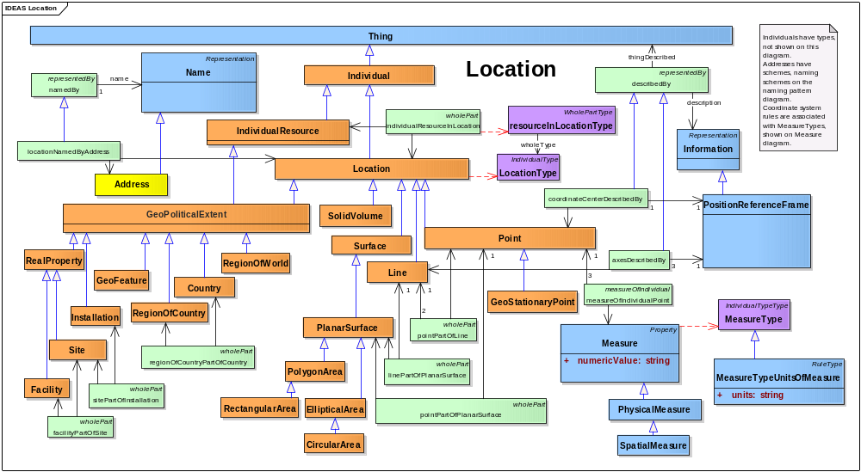
Figure 2.11.1-15: DoDAF meta-model diagram for Locations data group
- For many architecture applications, a locating scheme is some kind of geometric system because many uses (see next paragraph) require geometric calculations.
- Named locations (e.g., facility, base, installation, region names) can be applicable since their use may be merely to describe where performance occurs. In addition, the naming pattern basically can use the name as a surrogate for the geometric location, such as postal addresses are rarely applicable to architectures.
- If a geometric system is needed, coordinate systems, reference frames, and units are chosen. Architects may use public standards such as ISO 19136:2007, Geographic Information—Geography Markup Language (GML), to identify and describe coordinate systems and other information needed to specify the locations of resources.
- The accuracy should be determined. For many uses, locations may not need to be as accurate as some geospatial system can be, since the use calculation may have many approximations, assumptions, and minor influencing variables that are chosen to be ignored.
- In some cases, there may be need for speed and acceleration ranges. Since these are unusual, they are not part of the core DM2 but would be added as extensions for these kinds of models. The speed could be extended as an attribute or as a trajectory consisting of a set of spatial-temporal points, where the trajectory is a whole and the points are parts.

Use in DoD core processes
- Data for locations may be used to describe where resources are and where performers act. Examples of locations include:
- Facility locations allow description that certain systems or organizations are located at a specific facility. The function of a facility is determined by activities performed by performers located at the facility; that is, the facility itself is not a performer.
- Installation locations allow descriptions of certain organizations that operate or use an installation.
- Region locations are used to describe what performers and activities are performed in certain regions.
- A point location can be used to state when a performer is located at a specific point (e.g., latitude and longitude). Regions, countries, and other geometric shapes can be used when a location need not be so specific.
- Line (set of lines) allows description of performers located on, beside, or within some enclosing lines. A line could be described mathematically to specify an orbit (e.g., that some satellite is located in some orbit).
- Volume can be used to designate a three-dimensional space. The volume they cover may characterize some systems, such as air defense systems.
- Addresses (names for locations) allow descriptions of where something is located using the address scheme (e.g., the URL address scheme allows files on a web server to be addressed).

Pedigrees
- The Pedigrees data group represents the workflow for a resource. It describes the activities used to produce a resource, in particular, a resource that is information about an architecture description or architectural data. Architecture descriptions are types of information: information describes some thing and architecture descriptions describe architectures. The production of architecture description information is particularly important for architecture descriptions. All aspects of the production workflow are describable with the Pedigrees data group, including:
- resources consumed to produce a resource;
- performers who act to produce a resource;
- rules that constrain a producing activity;
- measures applied to a producing activity and to resources consumed and produced; and
- where a producing activity occurred.

Data group description
- Figure 2.12.2-16 shows the DoDAF meta-model diagram for the Pedigrees data group.

Use in DoD core processes
- Pedigrees are used to demonstrate the rationale for architecture description choices. In many systems engineering and requirements analysis processes, pedigrees are the means by which traceability information is maintained.
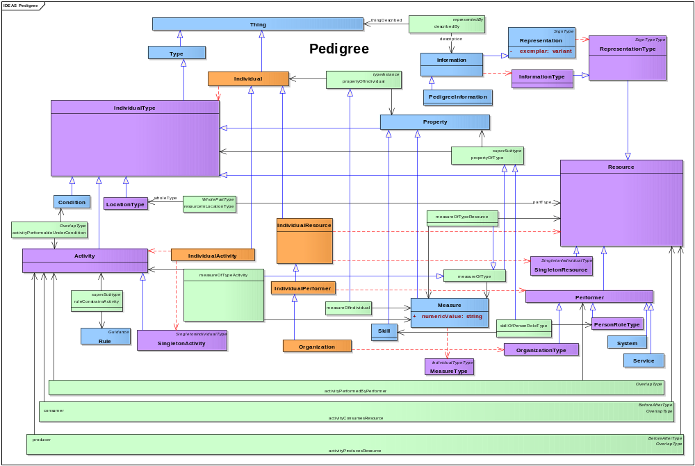
Figure 2.12.2-16: DoDAF meta-model diagram for Pedigrees data group

DoDAF Viewpoints and Models
- The Department of Defense Architecture Framework (DoDAF) has been designed to meet the specific business and operational needs of the Department of Defense. The DoDAF defines a way of representing an enterprise architecture that enables stakeholders to focus on specific areas of interests in the enterprise while retaining sight of the big picture. To help decision-makers, DoDAF provides ways to abstract essential information from underlying complexity and present this information in ways that maintain coherence and consistency. A principal objective of DoDAF is to present this information in ways that can be understood by many stakeholders who develop, deliver, and sustain capabilities that support missions of the DoD. The DoDAF does this by dividing a problem space into manageable pieces that correspond to stakeholder viewpoints, which are further defined as models.
- Each viewpoint has its own purpose. Each viewpoint usually presents information in one or more of these categories:
- information that broadly summarizes the whole enterprise (e.g., high-level operational concepts),
- information that focuses narrowly on a special concern (e.g., low-level implementation details), and
- information that shows how elements of an enterprise are connected (e.g., how an activity is supported by some system).
- However, the DoDAF is fundamentally structured to create a coherent enterprise model that may be effectively used by decision-makers. A DoDAF-based architecture description should not emphasize pretty pictures at the expense of clear, consistent, necessary, and sufficient data, which underlies the architecture.
- DoDAF organizes models into these viewpoints:
- The All Viewpoint describes overarching aspects of an architecture context that relate to all viewpoints appropriate for the architecture.
- The Capability Viewpoint describes capability requirements, delivery timing, and deployed capabilities.
- The Data and Information Viewpoint describes data relationships and alignment structures in the architecture content for the capability and operational requirements, systems engineering processes, and systems and services.
- The Operational Viewpoint describes operational scenarios, activities, and requirements that support capabilities.
- The Project Viewpoint describes relationships between operational and capability requirements and various projects to deliver capabilities. The Project Viewpoint also details dependencies among capability and operational requirements, systems engineering processes, systems design, and services design within the Defense Acquisition System process.
- The Service Viewpoint describes the performers, activities, services, and resources that provide or support operational, capability, and system functions.
- The Standards Viewpoint describes applicable policies, standards, guidance, constraints, and forecasts that shape capability and operational requirements, systems engineering processes, systems, and services.
- The System Viewpoint describes systems, their composition, connections, and contexts that provide or support operational and capability functions.
- Figure 2.12.2-17 illustrates these viewpoints.
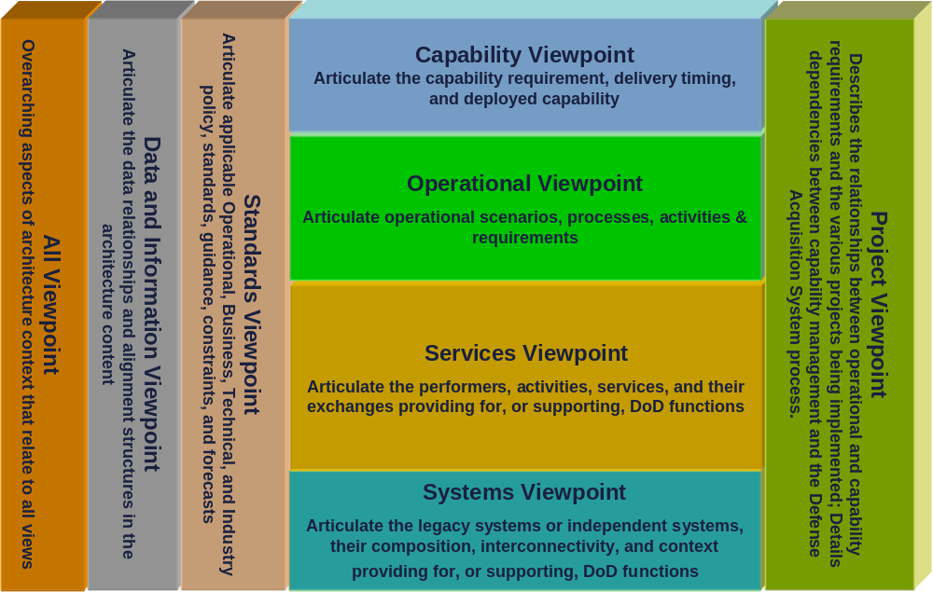
Figure 2.12.2-17: DoDAF viewpoints

Viewpoint and model descriptions
- The DoDAF’s viewpoint models may be taken as examples of ways to present architectural data to specific audiences for specific purposes.
- DoDAF must be used to develop architecture descriptions for the Department of Defense. Owners of specific DoDAF architectures may require viewpoint models for their particular purposes. Only rarely would all viewpoint models be required for any complete DoDAF architecture; rather, the DoDAF is fit-for-purpose: presentation requirements are to be based on decision-maker needs, not on any set of viewpoint models prescribed by DoDAF fiat. DoDAF does not require architects to use any DoDAF viewpoint models; instead, the DoDAF requires architects to focus on architectural data as the foundation for their architectures.
- Each section that follows discusses a DoDAF viewpoint and describes models that may be appropriate for that viewpoint.

All Viewpoint (AV)
- All Viewpoint models capture overarching aspects of an architecture description. These models provide information about the entire architecture description. AV models provide an overview of the architectural effort and may consider such things as the scope, context, rules, constraints, assumptions, and derived vocabulary for an architecture description. These models may document the intent of an architecture description to help preserve its continuity in spite of leadership, organizational, and other changes that often occur during a persistent architecture effort.
- All Viewpoint models are used to register architecture descriptions with the Defense of Defense Architecture Repository System (DARS).
- Table 3.2-2 names and describes All Viewpoint models.
Table 3.2-2: All Viewpoint models
Models | Descriptions
AV-1: Executive Summary | Presents the purpose, scope, and subjects of an architecture effort.
AV-2: Dictionary | Presents terms needed to understand an architecture description, their definitions, and their associations.

Executive Summary (AV-1)
- Description. This model identifies an architecture description and describes the purpose, scope, and subjects of an architecture description project.
- Narrative. An AV-1 model provides executive-level summary information about the described architecture in a consistent form that allows quick reference and comparison between architecture descriptions. At a minimum, AV-1 models should identify the architecture description and describe the purpose, scope, and subjects of an architecture description project. An AV-1 model may include assumptions and constraints that may affect high-level decisions relating to architecture-based projects. An AV-1 model may also put an architecture description into the context of the architecture it describes and the organizations that are significant to the architecture. An AV-1 model may describe the period of time the architecture description covers. Such information should support registration and discovery of architecture descriptions.
- Meta-model. None.
- Alternative names: Overview and Summary Information; Architecture Executive Summary.
- Notes. The DoDAF does not specifically require any content for AV-1 models nor does the DoDAF specifically exclude any content from AV-1 models. However, the DoD Architecture Registry System (DARS) does impose some information and format requirements on an AV-1 model that is submitted to register an architecture description.

Dictionary (AV-2)
- Description. This model identifies and describes the terms that are needed to discuss a described architecture and to understand its architecture-description, as well as describing architecturally significant relationships among concepts signified by these terms.
- Narrative. Terms are names that signify things within a described architecture. Descriptions are a sort of information about those things; descriptions are statements that represent things in words. In turn, definitions are descriptions that are related to specific names for described things. Several sorts of things are commonly found in architecture descriptions prepared for the Department of Defense; these things include activities, resources, and projects, as well as guidance for and locations of these things. DoDAF provides the terms "activity", "resource", "project", "location", "guidance", "vision", and "property" as basic resources for preparing architecture descriptions. Each of these terms names a primary category of concepts that are required for a sufficient architecture description. Each term heads a taxonomy of further terms that may be refined and specialized to meet the needs of specific architecture descriptions. These terms are organized within these categories by the supertype-subtype relationships and the whole-part relationships that characterize the things that are named by these defined terms.
- Meta-model. Figure 3.2.2-18 shows the DoDAF meta-model for AV-2 models.
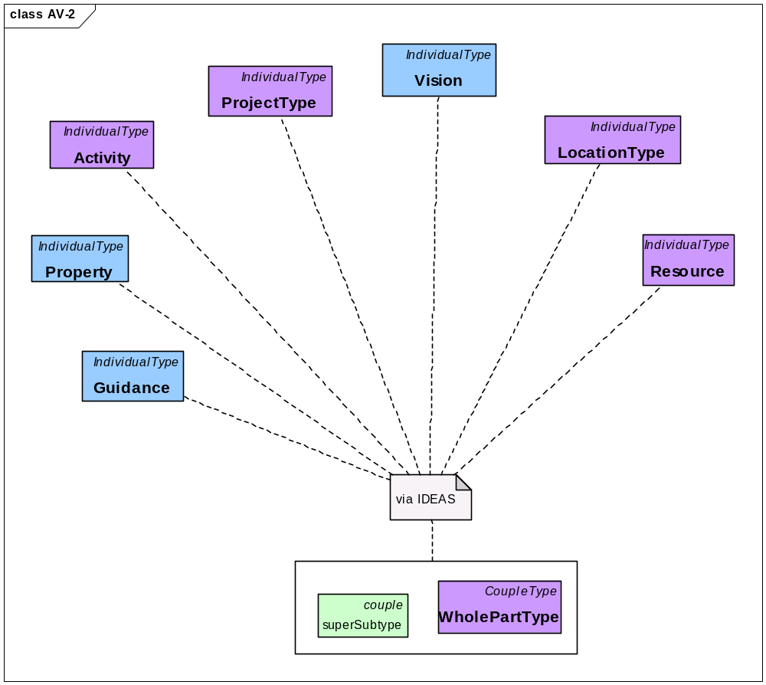
Figure 3.2.2-18: DoDAF meta-model diagram for AV-2 models
- Alternative names: Integrated Dictionary; Architecture Dictionary.
- Notes. Authoritative sources may be given by the AV-2 model for the meanings of words that are not described by the AV-2 model itself. Data elements and their definitions are not within the scope of AV-2 models; data element names and definitions are subjects of DIV-3 models.
- Technical note: DoDAF provides genus terms for taxonomical classification of things within the scope of an architecture description. This supports the classical sort of definition called genus-differentia definition. In this sort of definition, a definitional statement opens with a statement of the genus of a term, that is, the broader concept that incorporates the concept signified by the term. Such a definitional statement then adds a statement of the differentia of a term, that is, how the concept signified by the term differs from other concepts within the term's genus. A classic example of genus-differentia definition is: "a human being is a featherless biped." In this definitional statement, the genus is "biped" and the differentia is "featherless."

Capability Viewpoint (CV)
- The Capability Viewpoint addresses the concerns of capability portfolio managers.
- A capability is the ability to cause a change in the set of states of some resources. The initial set of states is thought to be less desirable than the set of states that could be brought about (i.e., a desired effect), where the difference is desired by a performer who is capable of responsibility (e.g., an organization; a person in a role such as a mission commander) and who has a vision of the resource states to be achieved. Both the less desired set of states and the more desired set of states should be measurable in some way; a measure of effect is a measure of the difference between a measurable less-desired state and a measurable more-desired state. How badly a performer wants such a change in the states of these resources (that is, a measured, desired effect) should also be measurable (e.g., priority; willingness to commit money; risk calculus).
- Changes in the states of resources are caused by activities; a resource in some desired state can only be produced by specified, trainable activities. Such activities are constrained by appropriate guidance and by rules for carrying out these activities under specified conditions that overlap (co-exist with) them. These conditions may be multifaceted; for example, a condition might be some set of measurements of elevation, humidity, ground cover, available daylight, temperature, air flow, density and distribution of opposing forces, density and distribution of non-combatants, and lethality of weaponry of opposing forces. Different conditions call for different activities carried out by different performers guided by different rules to achieve a given desired effect.
- Specific activities are chosen to achieve effects by balancing measures of effect, measures of desire, conditions, rules, and available resources across all desirable effects. This model focuses on understanding the capabilities presented by a described architecture in terms that support strategic choices among possible capabilities.
- Table 3.3-3 names and describes Capability Viewpoint models.
Table 3.3-3: Capability Viewpoint models
Model | Description
CV-1: Capability Effects | Presents effects caused by capabilities and measures for these effects.
CV-2: Capability Hierarchies | Presents one or more hierarchies of capabilities and the types of hierarchical relationships between these capabilities.
CV-3: Capability Schedules | Presents schedules for the deployment of capabilities in terms of timelines.
CV-4: Capability Dependencies | Presents dependencies among effects caused by capabilities.
CV-5: Capability Deployments | Presents schedules for the deployment of capabilities in terms of organizations and locations.
CV-6: Capability Activities | Presents activities that are performed to cause the desired effects of a capability.
CV-7: Capabilities and Services | Presents a mapping of capabilities to services.

Capability Effects (CV-1)
- Description. This model identifies and describes effects caused by capabilities within a described architecture and specifies measures for these effects.
- Narrative. This model emphasizes the desired effects of capabilities provided by a described architecture. A capability comprises activities and resources, which includes resources that are consumed by activities, resources that are produced by activities, and resources that perform activities. A capability is distinguished from other collections of activities and resources by (a) the explicit presence of a performer who is capable of responsibility and who envisions a desired effect, (b) explicit statement and measures of such desired effects, (c) and explicit consideration of conditions under which activities entailed by a capability may be successfully carried out.
- A responsible performer envisions a desired effect, which may be documented by a vision statement. Responsible performers include types of organizations and types of persons in organizational roles. In a CV-1 model, the emphasis is on desired effects, which are articulated by responsible performers, but details of organizations and organization types are not modeled.
- An effect desired by a responsible performer is some desired resource state, that is, some resource state to be achieved by specified changes to some set of resources that are not initially in the desired state. A desired effect incorporates three things: (a) some collection of resources in some initial state, (b) that collection of resources in some desired state, and (c) measures of the differences between resources in their initial state and their desired state. A capability is also associated with a measure of desire to express how important it is to a responsible performer to achieve a desired effect. (Measures of desire may be expressed in ways as varied as priorities, wagers, and budgets.)
- A capability plays out over space and time: resources in one state are transformed into resources in another state. The location of activities and resources must be knowable to ensure that resources are available to activities as they are needed; this model may look at the types of these locations.
- Activities are seen in CV-1 models just they are in other DoDAF models. An activity consumes resources to produce resources. Performers, themselves resources, follow guidance, rules, and standards to carry out activities. In this model, the emphasis is on the relationship between activities and capabilities in the production of desired effects.
- Capabilities, responsible performers, desired effects, resources, activities, conditions, measures of effects, and measures of desire shall be modeled. Vision statements, types of locations of resources and activities, rules constraining activities, and additional sorts of measures may be modeled. Performers other than responsible performers shall not be modeled.
- Meta-model. Figure 3.3.1-19 shows the DoDAF meta-model for CV-1 models.
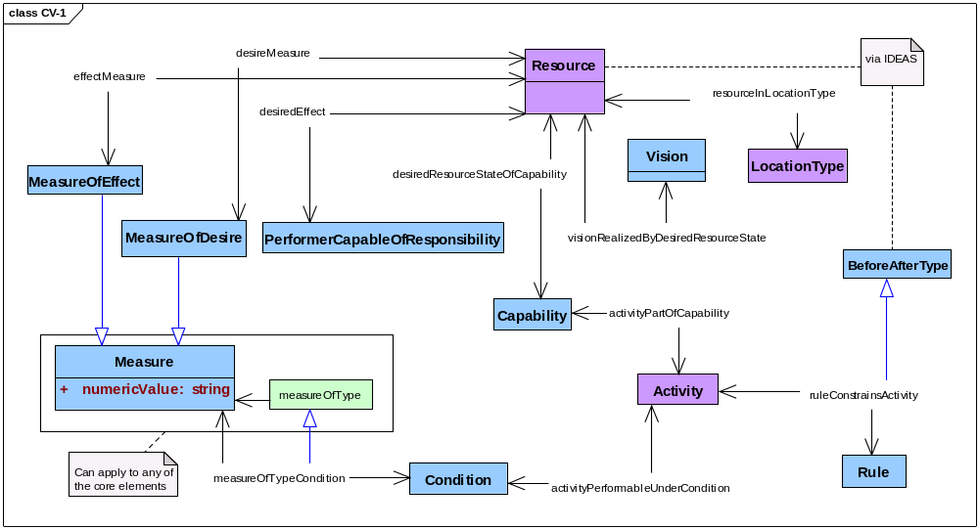
Figure 3.3.1-19: DoDAF meta-model diagram for CV-1 models
- Alternative names: Vision; Capability Desired Effects.
- Notes. To support risk management and portfolio management, a CV-1 model should examine effects that are not desired as well as effects that are desired.

Capability Hierarchies (CV-2)
- Description. This model identifies and describes one or more hierarchies of capabilities provided by an architecture and specifies the types of hierarchical relationships between these capabilities.
- Narrative. This model emphasizes relations among capabilities and among the parts of capabilities. A capability comprises activities and resources, which includes resources that are consumed by activities, resources that are produced by activities, and resources that perform activities. A capability is distinguished from other collections of activities and resources by (a) the explicit presence of a performer who is capable of responsibility and who envisions a desired effect, (b) explicit statement and measures of such desired effects, (c) and explicit consideration of conditions under which activities entailed by a capability may be successfully carried out.
- A responsible performer envisions a desired effect. Responsible performers include types of organizations and types of persons in organizational roles. An effect desired by a responsible performer is some desired resource state, that is, some resource state to be achieved by specified changes to some set of resources that are not initially in the desired state. A desired effect incorporates three things: (a) some collection of resources in some initial state, (b) that collection of resources in some desired state, and (c) measures of the differences between resources in their initial state and their desired state. A capability is also associated with a measure of desire to express how important it is to a responsible performer to achieve a desired effect. (Measures of desire may be expressed in ways as varied as priorities, wagers, and budgets.)
- A capability plays out over space and time: resources in one state are transformed into resources in another state. The location of activities and resources must be knowable to ensure that resources are available to activities as they are needed; this model may look at the types of these locations.
- Activities are seen in CV-2 models just they are in other DoDAF models. An activity consumes resources to produce resources. Performers, themselves resources, follow guidance, rules, and standards to carry out activities. Activities are to be measured; collections of measures that are applicable to activities should be grouped as types of measures of activities.
- A CV-2 model shows (a) the parts that make up a whole capability and (b) the capabilities that are subtypes and subtypes of the capabilities described by an architecture description. A capability may be examined in terms of its parts (e.g., activities and resources; temporal and spatial states) using whole-part relationships. For example, understanding capabilities can be approached by composition and by decomposition of activities and of resources. A capability may also be examined in terms of its similarity and differences with other capabilities using super-subtype relationships. For example, understanding capabilities can be approached by comparing activities, conditions, resources, desired effects, their measures, their locations, and other sorts of properties shared by different capabilities across their different states. Capabilities should be categorized into types by such analyses.
- Capabilities, types of capabilities, responsible performers, desired effects, resources, activities, conditions, types of measures that apply to activities, measures of effects, and measures of desire shall be modeled. Types of locations of resources and activities, rules constraining activities, and additional sorts of measures may be modeled. Performers other than responsible performers shall not be modeled.
- Meta-model. Figure 3.3.2-20 shows the DoDAF meta-model for CV-2 models.
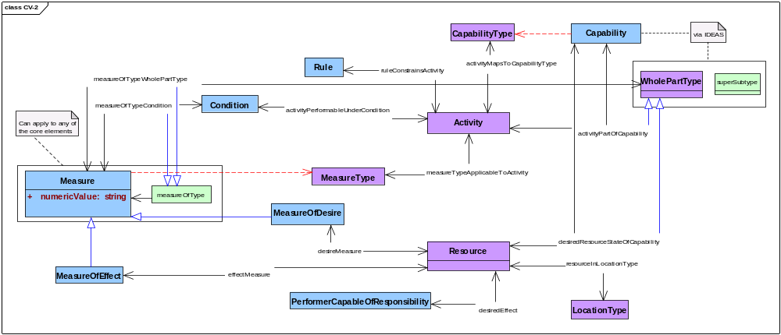
Figure 3.3.2-20: DoDAF meta-model diagram for CV-2 models
- Alternative names: Capability Taxonomy; Capability Hierarchy.

Capability Schedules (CV-3)
- Description. This model identifies and describes schedules for the deployment of resources needed to realize capabilities provided by an architecture; these schedules are given in terms of timelines.
- Narrative. This model emphasizes the temporal parts of capabilities, specifically the time-ordering of activities that are parts of projects and temporal measures of the availability of resources. A capability comprises activities and resources, which includes resources that are consumed by activities, resources that are produced by activities, and resources that perform activities. A capability is distinguished from other collections of activities and resources by (a) the explicit presence of a performer who is capable of responsibility and who envisions a desired effect, (b) explicit statement and measures of such desired effects, (c) and explicit consideration of conditions under which activities that are part of a capability may be successfully carried out.
- A responsible performer envisions a desired effect, which may be documented by a vision statement. Responsible performers include types of organizations and types of persons in organizational roles. In a CV-3 model, the emphasis may be on particular organizations that desire specified effects and, similarly, particular organizations that may be critical to achieving those effects. Such particular organizations should be organizations of the sort that may have responsibility for those effects.
- An effect desired by a responsible performer is some desired resource state, that is, some resource state to be achieved by specified changes to some set of resources that are not initially in the desired state. A desired effect incorporates three things: (a) some collection of resources in some initial state, (b) that collection of resources in some desired state, and (c) measures of the differences between resources in their initial state and their desired state. A capability is also associated with a measure of desire to express how important it is to a responsible performer to achieve a desired effect. (Measures of desire may be expressed in ways as varied as priorities, wagers, and budgets.)
- A capability plays out over space and time: resources in one state are transformed into resources in another state. The location of activities and resources must be knowable to ensure that resources, including performers, are available to activities as they are needed. In a CV-3 model, the emphasis is on the sorts of locations where activities will be carried out to produce desired effects and the sorts of locations where resources involved as desired effects will be found. While a CV-3 model does not require exhaustive enumeration of all possible actual locations for all possible resources constituting a desired effect, specific known locations of more-or-less fixed resources may be modeled.
- Activities are seen in a CV-3 model just they are in other DoDAF models. An activity consumes resources to produce resources. Performers, themselves resources, follow guidance, rules, and standards to carry out activities.
- A CV-3 model considers cases where resources, particularly performers, may not be readily available to activities that produce desired effects. Sets of activities may be grouped as projects to ensure that certain resources are available where and when they are needed. In a CV-3 model, the emphasis is on the sorts of projects that will be involved in delivering capabilities. (To examine specific projects within an architecture description, use the Project Viewpoint.)
- A CV-3 model emphasizes looking at a capability in terms of the ordering of its temporal parts using happensIn and beforeAfter relationships. For example, understanding capabilities can be approached by comparing when things happen in relation to when other things happen: what things come before and what things come after, and what things happen in synchrony or during the same period of time (e.g., concurrency; serial and parallel execution and existence). In a CV-3 model, the emphasis is on the temporal parts of activities and resources that constitute capabilities—on successive state changes over time—and that lead from some initial resource state to a desired resource state.
- Capabilities, responsible performers, desired effects, resources, activities, performers, conditions, measures of effects, measures of desire, types of projects, and temporal measures shall be modeled. Types of locations of resources and activities, specific locations of resources and activities, rules constraining activities, types of organizations, specific organizations, and additional sorts of measures may be modeled.
- Meta-model. Figure 3.3.3-21 shows the DoDAF meta-model for CV-3 models.
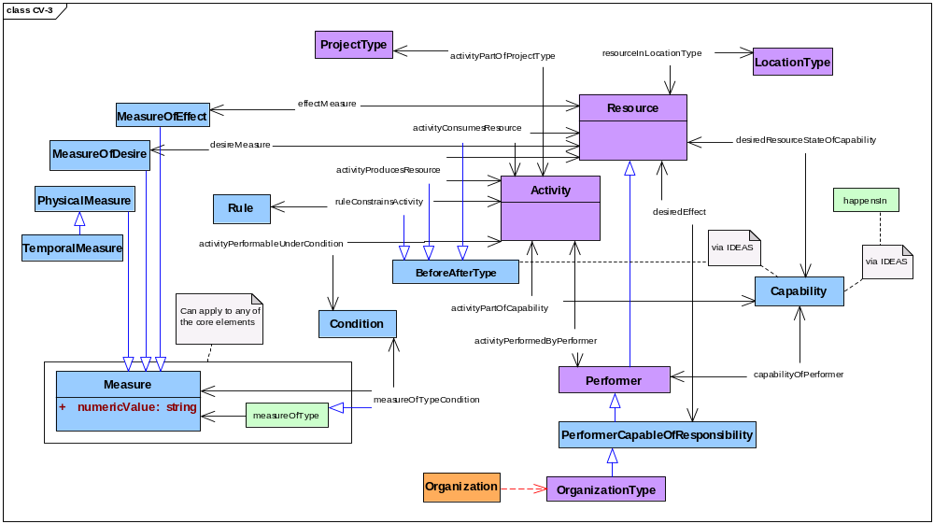
Figure 3.3.3-21: DoDAF meta-model diagram for CV-3 models
- Alternative names: Capability Phasing; Capability Deployment Phasing; Capability Resource Deployment Phasing; Capability Resource Deployment.

Capability Dependencies (CV-4)
- Description. This model identifies and describes the dependencies among the effects caused by capabilities provided by an architecture.
- Narrative. This model emphasizes spatial and temporal dependencies of activities and resources that constitute capabilities described by an architecture description. A capability comprises activities and resources, which includes resources that are consumed by activities, resources that are produced by activities, and resources that perform activities. A capability is distinguished from other collections of activities and resources by (a) the explicit presence of a performer who is capable of responsibility and who envisions a desired effect, (b) explicit statement and measures of such desired effects, (c) and explicit consideration of conditions under which activities entailed by a capability may be successfully carried out.
- A responsible performer envisions a desired effect. Responsible performers include types of organizations and types of persons in organizational roles. A VC-4 model may emphasize dependencies among responsible performers
- An effect desired by a responsible performer is some desired resource state, that is, some resource state to be achieved by specified changes to some set of resources that are not initially in the desired state. A desired effect incorporates three things: (a) some collection of resources in some initial state, (b) that collection of resources in some desired state, and (c) measures of the differences between resources in their initial state and their desired state. A capability is also associated with a measure of desire to express how important it is to a responsible performer to achieve a desired effect. (Measures of desire may be expressed in ways as varied as priorities, wagers, and budgets.)
- A capability plays out over space and time: resources in one state are transformed into resources in another state. The location of activities and resources must be knowable to ensure that resources are available to activities as they are needed. A CV-4 model may emphasize dependencies among the sorts of locations where activities will be carried out to produce desired effects and the sorts of locations where resources involved as desired effects will be found.
- Activities are seen in a CV-4 model just they are in other DoDAF models. An activity consumes resources to produce resources. Performers, themselves resources, follow guidance, rules, and standards to carry out activities. Activities are to be measured; collections of measures that may be applicable to activities may be grouped as types of measures of activities. Guidance of various sorts may refer to types of applicable measures, and specific measures for specific activities may be drawn from such guidance.
- A CV-4 model may look at capabilities terms of dependencies among its parts (e.g., activities and resources; temporal and spatial states) using whole-part relationships. For example, understanding capabilities can be approached by composition and by decomposition of activities and of resources across capabilities.
- A CV-4 model may examine capabilities in terms of the ordering of their temporal parts using happensIn and beforeAfter relationships. For example, understanding capabilities can be approached by comparing when things happen in relation to when other things happen: what things come before and what things come after, and what things happen in synchrony or during the same period of time (e.g., concurrency; serial and parallel execution and existence). In a CV-4 model, the emphasis may be on the temporal parts of the activities and resources of related capabilities—on successive state changes over time—that flow from initial resource states to desired resource states.
- Capabilities, responsible performers, desired effects, resources, activities, conditions, measures of effects, measures of desire, and temporal measures shall be modeled. Types of locations of resources and activities, rules constraining activities, happens-in relationships, whole-part relationships, and additional sorts of measures may be modeled. Performers other than responsible performers shall not be modeled.
- Meta-model. Figure 3.3.4-22 shows the DoDAF meta-model for CV-4 models.
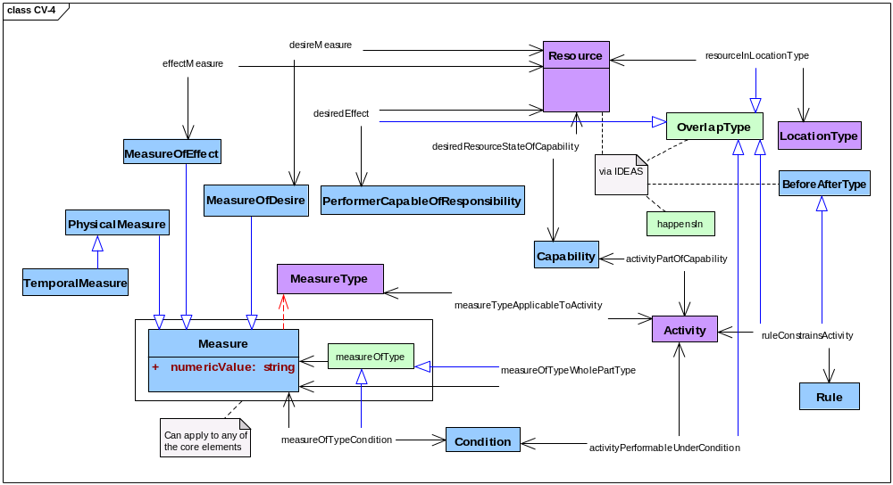
Figure 3.3.4-22: DoDAF meta-model diagram for CV-4 models
- Alternative names.

Capability Deployments (CV-5)
- Description. This model identifies and describes schedules for deployment of resources needed to realize capabilities provided by an architecture; these schedules are given in terms of organizations and locations.
- Narrative. This model emphasizes the deployment of resources produced by project activities so that those resources are available to a responsible performer to achieve a desired effect. A capability comprises activities and resources, which includes resources that are consumed by activities, resources that are produced by activities, and resources that perform activities. A capability is distinguished from other collections of activities and resources by (a) the explicit presence of a performer who is capable of responsibility and who envisions a desired effect, (b) explicit statement and measures of such desired effects, (c) and explicit consideration of conditions under which activities entailed by a capability may be successfully carried out.
- A responsible performer envisions a desired effect. Responsible performers include types of organizations and types of persons in organizational roles. In the Capability Viewpoint, the emphasis may be on particular organizations that desire specified effects and, similarly, particular organizations that may be critical to achieving those effects. Such particular organizations should be organizations of the sort that may have responsibility for those effects.
- An effect desired by a responsible performer is some desired resource state, that is, some resource state to be achieved by specified changes to some set of resources that are not initially in the desired state. A desired effect incorporates three things: (a) some collection of resources in some initial state, (b) that collection of resources in some desired state, and (c) measures of the differences between resources in their initial state and their desired state. A capability is also associated with a measure of desire to express how important it is to a responsible performer to achieve a desired effect. (Measures of desire may be expressed in ways as varied as priorities, wagers, and budgets.)
- A capability plays out over space and time: resources in one state are transformed into resources in another state. The location of activities and resources must be knowable to ensure that resources, including performers, are available to activities as they are needed. In a CV-5 model, the emphasis may be on the sorts of locations where activities will be carried out to produce resources needed to achieve desired effects and the sorts of locations where such resources will be delivered or otherwise transported. While a CV_5 model does not require exhaustive enumeration of all possible actual locations for all possible resources constituting a desired effect, specific known locations of more-or-less fixed resources may be modeled.
- Activities are seen in a CV-5 model just they are in other DoDAF models. An activity consumes resources to produce resources. Performers, themselves resources, follow guidance, rules, and standards to carry out activities. Activities are to be measured; collections of measures that may be applicable to activities may be grouped as types of measures of activities. Guidance of various sorts may refer to types of applicable measures, and specific measures for specific activities may be drawn from such guidance.
- A CV-5 model considers cases where resources, particularly performers, may not be readily available to activities that produce desired effects. Sets of activities may be grouped as projects to ensure that certain resources are available where and when they are needed. In a CV-5 model, the emphasis is on the sorts of projects that might be involved in delivering the resources that are parts of a capability and on temporal measures appropriate to understanding the delivery of such resources (e.g., schedules; time-lines; budget cycles). (To examine specific projects within an architecture description, use the Project Viewpoint.)
- A CV-5 model may examine a capability in terms of the ordering of the temporal parts of projects using happens-in and before-after relationships. For example, understanding capabilities can be approached by comparing when things happen in relation to when other things happen: what things come before and what things come after, and what things happen in synchrony or during the same period of time (e.g., activity A of project Y occurs before activity B of project Z; resource M is produced at location N in period Q by project R). In a CV-5 model, the emphasis is on the temporal parts of activities—on successive state changes over time—that produce (a) resources that are consumed to achieve a capability and (b) resources that perform activities to achieve a capability.
- Capabilities, responsible performers, desired effects, resources, activities, performers, conditions, types of projects, measures of effects, measures of desire, and temporal measures shall be modeled. Types of locations of resources and activities, actual locations of resources and activities, rules constraining activities, types of organizations, specific organizations, happens-in relationships, and additional sorts of measures may be modeled.
- Meta-model. Figure 3.3.5-23 shows the DoDAF meta-model for CV-5 models.
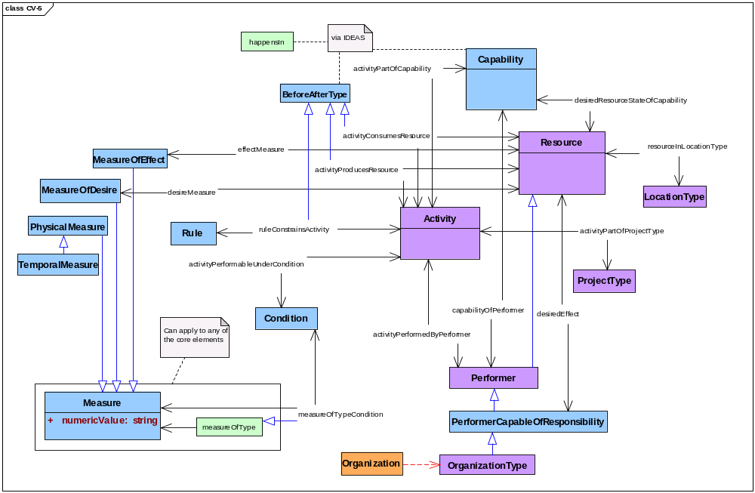
Figure 3.3.5-23: DoDAF meta-model diagram for CV-5 models
- Alternative names: Capability to Organizational Development Mapping; Organizational Deployment of Capabilities; Capability Resource Deployment.

Capability Activities (CV-6)
- Description. This model identifies and describes activities that are performed to cause the desired-effects of a capability provided by a described architecture.
- Narrative. This model emphasizes the activities that are parts of capabilities. A capability comprises activities and resources, which includes resources that are consumed by activities, resources that are produced by activities, and resources that perform activities. A capability is distinguished from other collections of activities and resources by (a) the explicit presence of a performer who is capable of responsibility and who envisions a desired effect, (b) explicit statement and measures of such desired effects, (c) and explicit consideration of conditions under which activities entailed by a capability may be successfully carried out.
- A responsible performer envisions a desired effect. Responsible performers include types of organizations and types of persons in organizational roles. An effect desired by a responsible performer is some desired resource state, that is, some resource state to be achieved by specified changes to some set of resources that are not initially in the desired state. A desired effect incorporates three things: (a) some collection of resources in some initial state, (b) that collection of resources in some desired state, and (c) measures of the differences between resources in their initial state and their desired state. A capability is also associated with a measure of desire to express how important it is to a responsible performer to achieve a desired effect. (Measures of desire may be expressed in ways as varied as priorities, wagers, and budgets.)
- A capability plays out over space and time: resources in one state are transformed into resources in another state. The location of activities and resources must be knowable to ensure that resources are available to activities as they are needed. In a CV-6 model, the emphasis is on the sorts of locations where activities will be carried out. While CV-6 model does not require exhaustive enumeration of all possible actual locations for all possible activities that are part of a capability, specific known locations of activities may be modeled.
- Activities are seen in a CV-6 model just they are in other DoDAF models. An activity consumes resources to produce resources. Performers, themselves resources, follow guidance, rules, and standards to carry out activities.
- A CV-6 model may use whole-part relationships to examine a capability in terms of its parts that are activities. For example, understanding capabilities can be approached by composition and by decomposition of activities. These activities may be related to types of capabilities that include the capabilities described by an architecture description.
- Capabilities, types of capabilities, responsible performers, desired effects, resources, activities, conditions, measures of effects, and measures of desire shall be modeled. Types of locations of resources and activities, actual known locations of resources and activities, rules constraining activities, and additional sorts of measures may be modeled. Performers other than responsible performers shall not be modeled.
- Meta-model. Figure 3.3.6-24 shows the DoDAF meta-model for CV-6 models.
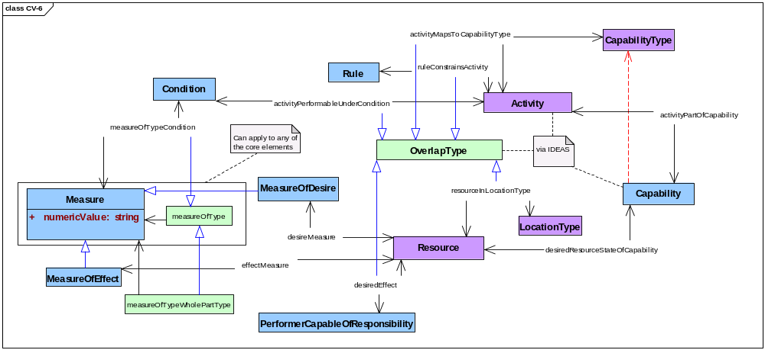
Figure 3.3.6-24: DoDAF meta-model diagram for CV-6 models
- Alternative names: Capability to Operational Activities Mapping.
- Note. The activities of CV-6 models are a subset of the activities identified by the OV-5b models of a described architecture. All activities that appear in the Capability Viewpoint must appear within the Operational Viewpoint.

Capabilities & Services (CV-7)
- Description. This model identifies and describes relationships among services and the capabilities accessed via these services as provided by an architecture.
- Narrative. This model emphasizes services that enable a responsible performer to access resources needed to achieve a desired effect. A capability comprises activities and resources, which includes resources that are consumed by activities, resources that are produced by activities, and resources, such as services, that perform activities. A capability is distinguished from other collections of activities and resources by (a) the explicit presence of a performer who is capable of responsibility and who envisions a desired effect, (b) explicit statement and measures of such desired effects, (c) and explicit consideration of conditions under which activities entailed by a capability may be successfully carried out.
- A responsible performer envisions a desired effect. Responsible performers include types of organizations and types of persons in organizational roles. An effect desired by a responsible performer is some desired resource state, that is, some resource state to be achieved by specified changes to some set of resources that are not initially in the desired state. A desired effect incorporates three things: (a) some collection of resources in some initial state, (b) that collection of resources in some desired state, and (c) measures of the differences between resources in their initial state and their desired state. A capability is also associated with a measure of desire to express how important it is to a responsible performer to achieve a desired effect. (Measures of desire may be expressed in ways as varied as priorities, wagers, and budgets.)
- A capability plays out over space and time: resources in one state are transformed into resources in another state. The location of activities and resources must be knowable to ensure that resources, including performers, are available to activities as they are needed. In a CV-7 model, the emphasis is on the sorts of locations where activities will be carried out to produce desired effects and the sorts of locations where resources involved as desired effects will be found.
- Activities are seen in a CV-7 model just they are in other DoDAF models. An activity consumes resources to produce resources. Performers, including services, follow guidance, rules, and standards to carry out activities.
- Services appear in a CV-7 model as performers, but services are not responsible performers. Services are used by responsible performers and by other performers to carry out activities. As elsewhere in DoDAF viewpoints, a service enables access to some set of resources and a service is to be described by a service description. Of particular interest in a CV-7 model are services that give responsible performers access to those resources that constitute the responsible performer’s desired effects.
- Capabilities, responsible performers, desired effects, resources, activities, services, service descriptions, conditions, measures of effects, and measures of desire shall be modeled. Types of locations of resources and activities, rules constraining activities, and additional sorts of measures may be modeled. Performers other than responsible performers and services may be modeled.
- Meta-model. Figure 3.3.7-25 shows the DoDAF meta-model for CV-7 models.
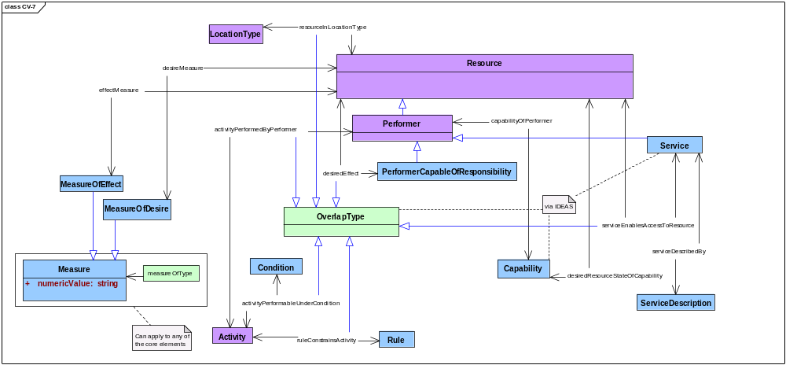
Figure 3.3.7-25: DoDAF meta-model diagram for CV-7 models
- Alternative names: Capability to Services Mapping; Capability Services.

Data and Information Viewpoint (DIV)
- Data and Information Viewpoint models portray operational and business information requirements and rules that are managed within and used as constraints on operational and business activities. Experience gained from many enterprise architecture efforts within the DoD led to the identification of several levels of abstraction necessary to accurately communicate the information needs of an organization or enterprise. Audience and purpose determine the levels of abstraction that are appropriate for an architecture description. DIV models provide three levels of abstraction—conceptual information, data requirements, and data implementation—that correspond to the conceptual, logical, and physical models familiar to DoD architects.
- Table 3.4-4 names and describes Data and Information Viewpoint models.
Table 3.4-4: Data and Information Viewpoint models
Models | Descriptions
DIV-1: Conceptual Information | Presents concepts that must be understood by decision makers to make decisions within the scope of the described architecture.
DIV-2: Data Requirements | Presents data requirements that reify the information concepts identified by corresponding DIV-1 Conceptual Information models
DIV-3: Data Implementation | Presents data-elements and data-structures that reify the data requirements specified by corresponding DIV-2 Data Requirements models.

Meta-model data groups used by Data and Information Viewpoint models
- The Data and Information Viewpoint models differ from the models of the other viewpoints. Other viewpoints focus on information and data that are largely contained within corresponding meta-model data groups, and each model within a viewpoint examines a somewhat different set of information and data. For example, Capability Viewpoint models are in large part based upon information and data found in the Capabilities meta-model data group, but each Capability Viewpoint model looks at a different set of information and data from that meta-model data group.
- In contrast, the content of Data and Information Viewpoint models may include information and data from any combination of meta-model data groups. Further, the three sorts of DIV models look at the same, perhaps enterprise-wide, set of information and data, but each DIV model looks at this data at a different level of abstraction. For example, a DIV-1 model might introduce notions of measures of capability effects suitable for use by portfolio managers when selecting candidate performers. A corresponding DIV-2 model might reify this decision-making concept into an information requirement by specifying what exactly will constitute an acceptable measure of an effect (e.g., what will be measured? How will it be measured? Who will measure it? When will it be measured? How accurate must this measure be? How much confidence must we have in this measure?). In turn, a corresponding DIV-3 model might reify this information requirement into an implementation specification (e.g., data element metadata for a data element named ‘measureOfEffect’, which is to be stored in a specified column of a specified table in a specified sort of data store; a registry specification of ‘measure of effect’ as an XML tag).

Conceptual Information (DIV-1)
- Description. This model identifies and describes the concepts that must be understood by decision makers within the scope of a described architecture.
- Narrative. This model emphasizes that information and data are resources that guide activities and that are consumed and produced by activities. Resources are things that can be located in space and time and whose state can be described by an architecture description. Performers are resources that carry out activities; decision makers are performers that carry out decision-making activities. Performers as decision makers carry out activities that decide the state and location of resources.
- The focus of this model is on the needs of performers as decision makers within the scope of a described architecture. Decisions within the scope of a described architecture are decisions about activities, resources that activities consume and produce, resources that perform activities, rules that constrain activities, conditions under which activities are performed, and locations of resources. This model identifies and describes these concepts, the sorts of resources, activities, rules, conditions, and locations about which performers will make decisions. In particular, this model identifies and describes the sorts of measures of resources, activities, locations, and conditions that are need to be known by decision makers and the sorts of measures that rules impose on activities known to decision makers.
- This model organizes and relates these concepts to each other in at least two ways: first, by identifying and describing their similarities and differences and, second, by identifying and describing the parts that make up whole things. The first way uses super-subtype relationships to show that this concept comprises these similar but differentiated concepts. In a DIV-1 model, this taxonomic organization of concepts must be rooted by the fundamental DoDAF concepts and terminology of resource, activity, rule, condition, location, and measure. The second way uses whole-part relationships to show that this concept is a whole that comprises these concepts as its parts. In a DIV-1 model, this mereological organization of concepts considers temporal parts and spatial parts as well as compositional parts.
- Resources, activities, rules, conditions, locations, and measures shall be modeled using the structure (i.e., relationships and subtyping) and terminology of the DoDAF meta-model. These concepts shall be specialized or otherwise extended as required by decision-making activities within the scope of a described architecture. Properties other than measures may be modeled. Terminology peculiar to audiences of a described architecture may be provided as synonyms for DoDAF terms if and only if the meanings of such synonyms are exactly the same as the corresponding DoDAF terms.
- Meta-model. Figure 3.4.2-26 shows the DoDAF meta-model for DIV-1 models.
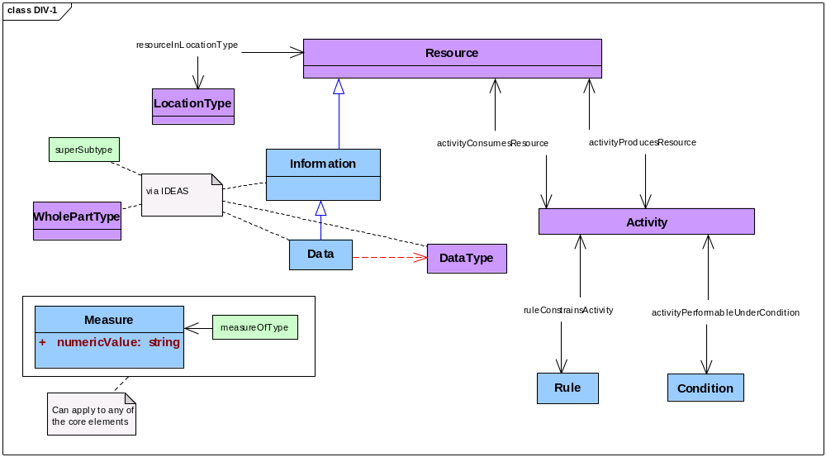
Figure 3.4.2-26: DoDAF meta-model diagram for DIV-1 models
- Alternative names: Conceptual Data Model; Conceptual Information/Data.

Data Requirements (DIV-2)
- Description. This model identifies and describes data requirements that reify the information concepts identified by corresponding DIV-1 Conceptual Information models.
- Narrative. This model emphasizes information that performers as decision makers need to carry out activities within the scope of a described architecture. While a DIV-1 model focuses on concepts important for decision making within the scope of a described architecture, a DIV-2 model focuses the specific sorts of things that decision makers need to know about those concepts to make specific sorts of decisions. A DIV-2 model identifies and describes information as resources consumed by activities within a described architecture and beyond its boundaries.
- Decision makers in the act of making a decision require information resources that provide specific data about resources, activities, and other fundamental things, including their states, locations, measures, and properties of other sorts. An information resource may also provide data about its internal structure (e.g., mesodata), data about its relationships with other information resources (e.g., versioning), data to guide the interpretation of data values (e.g., metadata), and data that characterize the integrity of specific data values (e.g., microdata, pedigree).
- DIV-2 models identify and describe the things that decision makers need to know about and what they need to know about those things. DIV-2 models express these requirements for data to assure completeness, correctness, and consistency. DIV-2 models identify and describe the data that is necessary and sufficient to support the decisions that must be made within the scope of a described architecture. A DIV-2 model does not imply physical implementation; implementation of data is the subject of DIV-3 models.
- DIV-2 models should address how information is made available to decision makers. DIV-2 models should show how the right data is made available to the right decision maker at the right time and the right place and in the right way.
- Resources, activities, rules, conditions, locations, and measures shall be modeled using the structure and terminology established by corresponding DIV-1 models. Properties other than measures may be modeled. Mesodata, metadata, and microdata requirements may be modeled.
- Meta-model. Figure 3.4.3-27 shows the DoDAF meta-model for DIV-2 models.
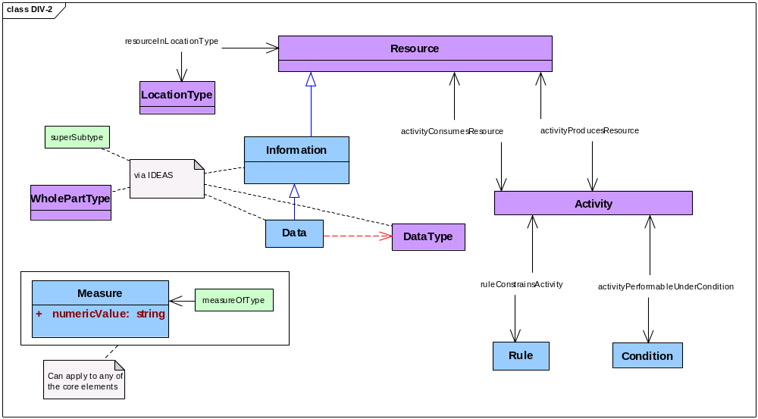
Figure 3.4.3-27: DoDAF meta-model diagram for DIV-2 models
- Alternative names: Logical Data Model; Logical Information/Data; Logical Data; Logical Data Requirements; Data Architecture.

Data Implementation (DIV-3)
- Description. This model identifies and describes data-structures and data-elements that reify the data requirements specified by corresponding DIV-2 Data Requirements models.
- Narrative. This model emphasizes the specification of data structures and data elements that satisfy data requirements given by corresponding DIV-2 models. DIV-3 models specify the physical representation of data in data stores (e.g., database schemas), in data communication (e.g., message formats), in data processing (e.g., class specifications), and in data presentation (e.g., web pages). DIV-3 models should demonstrate how the integrity of data values is preserved throughout the lives of data elements.
- Each implementation construct (e.g., data element, file, message) in DIV-3 models shall be identified and described to comply with metadata standards established in the Standards Viewpoint for a described architecture. DIV-3 models should specify the rules that are used to preserve the meaning of required data in their physical implementations.
- DIV-3 models shall show the satisfaction of every data requirement expressed by DIV-2 models for a described architecture. DIV-3 models may not introduce concepts or requirements unrelated to specific implementations.
- Meta-model. Figure 3.4.4-28 shows the DoDAF meta-model for DIV-3 models.
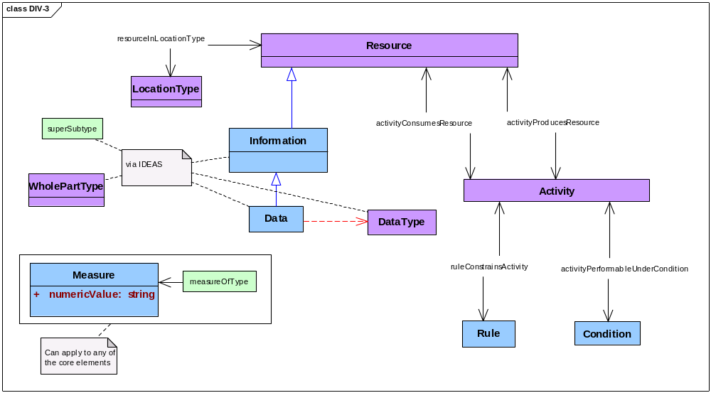
Figure 3.4.4-28: DoDAF meta-model diagram for DIV-3 models
- Alternative names: Physical Data Model; Physical Information/Data; Physical Data; Physical Data Implementation.

Operational Viewpoint (OV)
- The Operational Viewpoint looks at activities and resources, especially at resources that are performers who are organizations and how these performers work together to do something. This viewpoint focuses on who needs to do what rather than on the means that performers might use to carry out their activities.
- The Operational Viewpoint looks at means—materiel, systems, and services—as constraints. A description of an existing architecture will identify and describe materiel, systems, and services that performers use to carry out activities because an existing architecture is completely constrained by these means. A description of a possible architecture will incorporate materiel, systems, and services only as these means limit possible activities, that is, only insofar as materiel, systems, and services constrain the design of an architecture.
- Activities are seen in OV models just they are in other DoDAF models. An activity consumes resources to produce resources. Performers, themselves resources, follow guidance, rules, and standards to carry out activities. Activities are carried out under conditions that affect their performance. Activities are to be measured; collections of measures that may be applicable to activities may be grouped as types of measures of activities. Guidance of various sorts may refer to types of applicable measures, and specific measures for specific activities may be drawn from such guidance.
- Activities, resources, and performers who are capable of responsibility—organizations and persons in roles—are represented by OV models. Locations and measures of modeled activities, resources, and performers are also represented by OV models. Rules and conditions are represented by OV models that represent activities. Skills needed by a person in a role may be represented by OV models that represent persons in roles.
- Table 3.5-5 names and describes Operational Viewpoint models.
Table 3.5-5: Operational Viewpoint models
Model | Description
OV-1: Operational Concept | Presents the concepts of operation of a described architecture.
OV-2: Organizations and Resources | Presents resources that are used by organizational performers.
OV-3: Organizations, Activities, and Resources | Presents resources that are consumed and produced by activities performed by organizational performers.
OV-4: Organizational Relationships | Presents the composition and relationships among organizational performers.
OV-5a: Operational Activity Hierarchy | Presents the hierarchical structure of organizational activities.
OV-5b: Operational Activities | Presents activities performed by organizational performers to consume and produce resources.
OV-6a: Operational Rules | Presents rules that constrain organizational activities.
OV-6b: Operational State Transitions | Presents the states of resources consumed and produced by activities performed by organizational performers.
OV-6c: Operational Activity Sequences | Presents sequences of activities performed by organizational performers.

Operational Concept (OV-1)
- Description. This model describes the purpose of a described architecture.
- Narrative. The operational concept of an architecture is just what a described architecture is intended to do. OV-1 models may summarize the purpose of a described architecture and what is done by a described architecture to achieve that purpose. These models may describe activities, resources, organizations and other performers, their spatial and temporal locations, and their spatial and temporal relations. OV-1 models may describe resource flows between a described architecture and activities in its environment.
- OV-1 models are not an integral part of an architecture description; that is, OV-1 models do not contribute to the description of an architecture. Instead, OV-1 models provide fit-for-purpose glimpses of architectural data. OV-1 models should be considered as reports prepared for stakeholders of a described architecture. OV-1 models are fit-for-purpose because different stakeholders at different times have different interests and different purposes with respect to a described architecture. In particular, OV-1 models may address stakeholders who are not themselves architects. OV-1 models should report on just those aspects of a described architecture that address the expressed interests and purposes of an identified stakeholder audience.
- The content of OV-1 models may be related to the content of AV-1 models for a described architecture.
- Meta-model. None.
- Alternative names: High-Level Operational Concept; High-Level Operational Concept Graphic.
- Notes. DoDAF does not require any specific content for an OV-1 model nor does DoDAF specifically exclude any content from an OV-1 model. However, the DoD Architecture Registry System (DARS) does impose some information and format requirements on an AV-1 model that is submitted to register an architecture description. An OV-1 model of a described architecture should be consistent with the described architecture’s AV-1 model as submitted to DARS.

Organizations & Resources (OV-2)
- Description. This model identifies and describes resources consumed and produced by activities performed by organizational-performers.
- Narrative. This model emphasizes the exchange of resources among organizational performers, that is, performers capable of responsibility. These resources include information, materiel, and performers. The dependency between a resource to be consumed by one activity and a resource produced by another activity may be described as the flow of resources from producer to consumer. Activities are modeled in OV-2 models only in detail sufficient to show the relationships between resources produced by the activities of one organizational performer and the resources consumed by the activities of other organizational performers.
- Activities are seen in OV-2 models much as they are in other DoDAF models. An activity consumes resources to produce resources. Performers in OV-2 models are resources who are capable of responsibility rather than resources that are materiel, systems, or services. Such performers—organizations and persons in roles—follow guidance, rules, and standards to carry out their activities. Performers carry out their activities under conditions that affect their performance.
- Performers and other resources are related to their locations to ensure that resources to be consumed are available to activities when and where those resources are needed and that performers are there to carry out those activities when those resources are available.
- Activities and resources may be measured. Guidance of various sorts may refer to types of applicable measures, and specific measures for specific activities may be drawn from such guidance.
- Activities and resources shall be modeled. In particular, resources that are information shall be modeled. Types of organizations shall be modeled; specific organizations may be modeled. Persons in roles may be modeled. Types of locations of resources may be modeled, and specific locations may also be modeled. Rules and conditions may be modeled. Measures related to activities, resources, performers, locations, rules, and conditions may be modeled.
- Meta-model. Figure 3.5.2-29 shows the DoDAF meta-model for OV-2 models.
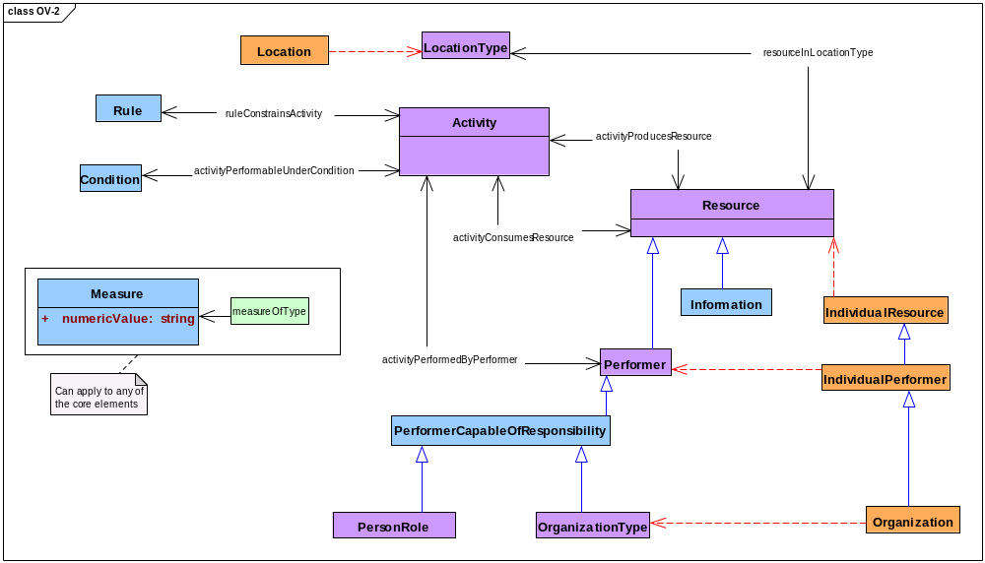
Figure 3.5.2-29: DoDAF meta-model diagram for OV-2 models
- Alternate names: Operational Resource Flow Description; Organizational Resource Flows Identification.
- Notes. (a) The architectural data of an OV-2 model may be grouped and ordered by organizational-performers who perform activities that produce resources. (b) The architectural data presented by an OV-2 artifact is typically a subset of the architectural data presented by an OV-3 artifact. Activities and measures may be de-emphasized by an OV-2 presentation.

Organizations, Activities, & Resources (OV-3)
- Description. This model identifies and describes resources consumed and produced by activities performed by organizational-performers.
- Narrative. This model emphasizes the exchange of resources among organizational performers, that is, performers capable of responsibility. These resources include information, materiel, and performers. A dependency between a resource to be consumed by one activity and a resource produced by another activity may be described as a flow of resources from producer to consumer. Activities are modeled in OV-3 models only in detail sufficient to show the relationships between resources produced by the activities of one organizational performer and the resources consumed by the activities of other organizational performers.
- Activities are seen in OV-3 models much as they are in other DoDAF models. An activity consumes resources to produce resources. Performers in OV-3 models are resources who are capable of responsibility rather than resources that are materiel, systems, or services. Such performers—organizations and persons in roles—follow guidance, rules, and standards to carry out their activities. Performers carry out their activities under conditions that affect their performance.
- Performers and other resources may be related to their locations to ensure that resources to be consumed are available to activities when and where those resources are needed and that performers are there to carry out those activities when those resources are available.
- In contrast to OV-2 models, OV-3 models identify and describe measures that apply to activities and resources. OV-3 models provide physical and temporal measures that are related to resources. OV-3 models also provide measures of performance and of the satisfaction of needs that are related to activities. Guidance of various sorts may refer to types of applicable measures, and specific measures for specific activities may be drawn from such guidance.
- Activities and resources shall be modeled. In particular, resources that are information shall be modeled. Types of organizations shall be modeled; specific organizations may be modeled. Persons in roles may be modeled. Types of locations of resources may be modeled, and specific locations may also be modeled. Rules and conditions may be modeled. Measures related to activities, resources, performers shall be modeled. Measures related to rules, conditions, and locations may be modeled.
- Meta-model. Figure 3.5.3-30 shows the DoDAF meta-model for OV-3 models.
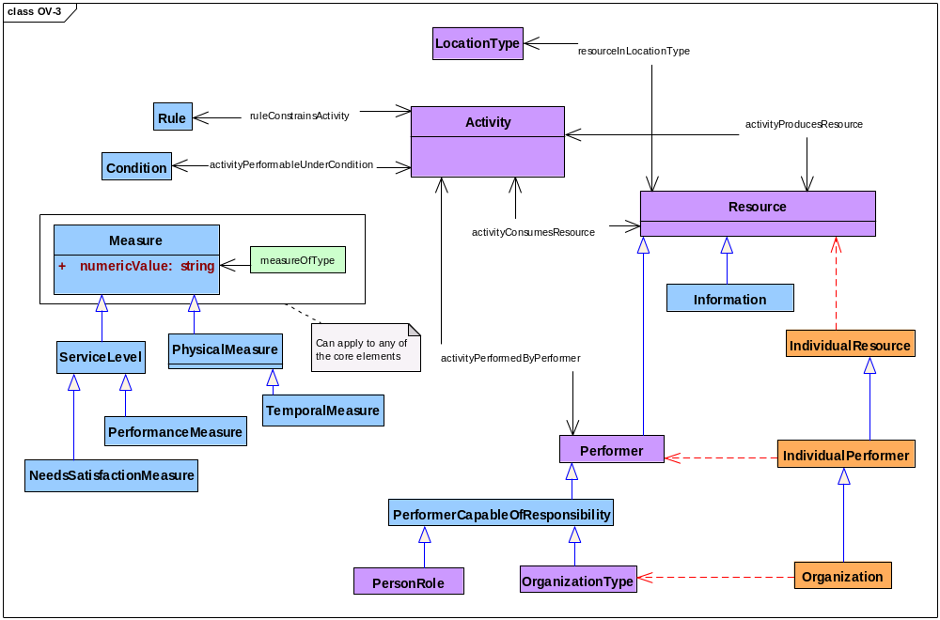
Figure 3.5.3-30: DoDAF meta-model diagram for OV-3 models
- Alternate names: Operational Resource Flow Matrix; Organizational and Activity Resource Flows.
- Notes. (a) The architectural data of an OV-3 model may be grouped and ordered by organizational-performers who perform activities that produce resources. (b) The architectural data presented by an OV-3 artifact is typically a superset of the architectural data presented by an OV-2 artifact. Measures of activities and resources may be emphasized by an OV-3 presentation.

Organizational Relationships (OV-4)
- Description. This model identifies and describes relationships among organizational-performers within a described architecture.
- Narrative. This model emphasizes relationships among organizations as wholes and among the parts of whole organizations. An OV-4 model describes how organizations relate to one another through the resources that they produce and consume. This model focuses on the exchange of resources among organizational performers, that is, performers who are capable of responsibility. Organizational performers include both organizations and persons in roles. Resources exchanged by organizational performers include information, materiel, and performers.
- The dependency between a resource to be consumed by one activity carried out by one performer and a resource produced by another activity carried out by another performer may be described as the flow of resources from producer to consumer. Performers and other resources may be related to locations, that is, flow from a performer who is here to another performer who is there.
- Activities themselves are not modeled in OV-4 models.
- OV-4 models may identify and describe types of measures that apply to performers and other resources. In particular, OV-4 models that include persons in roles may model the skills required by persons in those roles and may model measures of those skills.
- In OV-4 models, organizational structures may be modeled using whole-part relationships between an organizational whole and its parts. Both types of organizations and specific organizations may be modeled using whole-part relationships.
- Performers and other resources shall be modeled. Types of organizations shall be modeled; specific organizations may be modeled. The structure of organizations may be modeled using whole-part relationships. Persons in roles may be modeled. Should persons in roles be modeled, skills related to those roles and measures of those skills may also be modeled. Types of locations of resources may be modeled. Measures related to resources and locations may be modeled. Activities shall not be modeled.
- Meta-model. Figure 3.5.4-31 shows the DoDAF meta-model for OV-4 models.
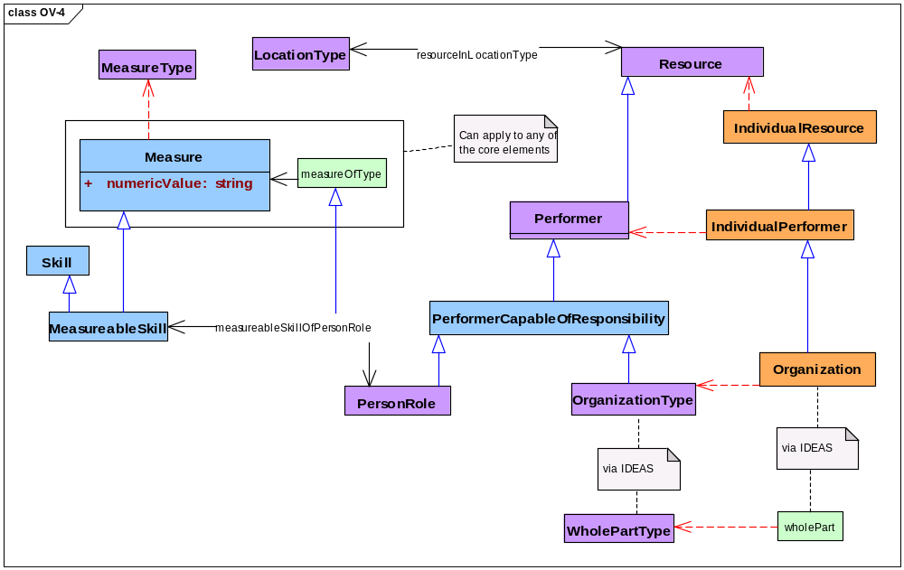
Figure 3.5.4-31: DoDAF meta-model diagram for OV-4 models
- Alternative names: Organizational Relationships Chart.

Operational Activity Hierarchy (OV-5a)
- Description. This model describes the hierarchical structure of activities identified by a corresponding OV-5b Operational Activities model.
- Narrative. This model emphasizes the activities carried out within the scope of a described architecture. In OV-5a and OV-5b models, any activity comprises other activities. Hierarchical recursive decomposition of activities into activity parts may be modeled using whole-part relationships between activity wholes and their activity parts. Activities may also be related by their similarities and their differences using super-subtype relationships.
- Activities are seen in OV-5a models much as they are in other DoDAF models. Activities are constrained by guidance, rules, and standards, and activities are carried out under conditions that affect their performance. However, performers, resources, and locations are not included in OV-5a models; in contrast, OV-5b models do include performers, resources, and locations. The information in an OV-5a model is a proper subset of the information in a corresponding OV-5b model. An OV-5a model may not add to nor alter the information in its corresponding OV-5b model.
- OV-5a models may identify and describe measures that apply to activities, rules, and guidance. Guidance of various sorts may refer to measures applicable to activities, and specific measures for activities may be drawn from such guidance.
- Activities shall be modeled. Rules and conditions may be modeled. The hierarchical structure of activities may be modeled using whole-part relationships. Activities may be categorized using super-subtype relationships. Measures related to activities, rules, and conditions may be modeled.
- Meta-model. Figure 3.5.5-32 shows the DoDAF meta-model for OV-5a models.
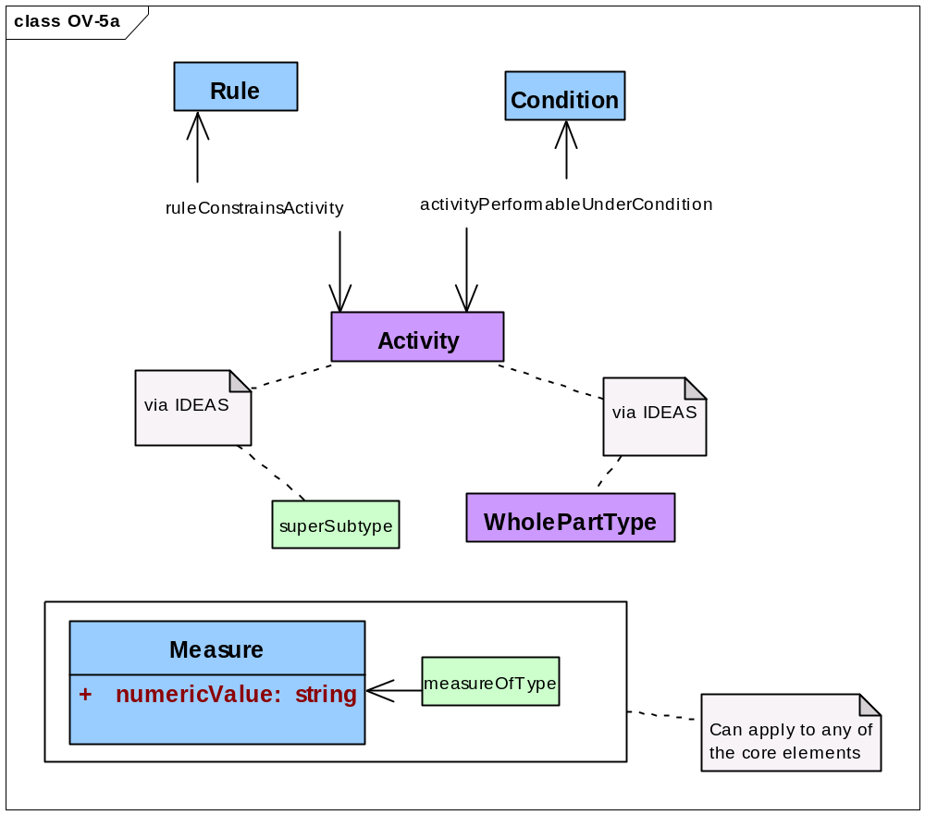
Figure 3.5.5-32: DoDAF meta-model diagram for OV-5a models
- Alternative names: Operational Activity Decomposition Tree; Activity Hierarchy.

Operational Activities (OV-5b)
- Description. This model identifies and describes the activities required by a described architecture.
- Narrative. This model emphasizes the activities carried out within the scope of a described architecture. In OV-5a and OV-5b models, any activity comprises other activities. Hierarchical recursive decomposition of activities into activity parts may be modeled using whole-part relationships between activity wholes and their activity parts. Activities may also be related by their similarities and their differences using super-subtype relationships.
- Activities are seen in OV-5b models as they are in other DoDAF models. An activity consumes resources to produce resources. Performers in OV-5b models are resources that are capable of responsibility—organizations and persons in roles—rather than resources that are materiel, systems, or services. Activities are constrained by guidance, rules, and standards, and activities are carried out under conditions that affect their performance.
- An OV-5b model identifies and describes measures that are related to activities. OV-5b models may also identify and describe measures that apply to rules, conditions, resources, performers, and locations. Guidance of various sorts may refer to measures applicable to activities, and specific measures for activities may be drawn from such guidance.
- Activities, resources, and performers shall be modeled. Rules, conditions, and types of locations may be modeled. The hierarchical structure of activities may be modeled using whole-part relationships. Activities may be categorized using super-subtype relationships. Types of organizations and specific organizations may be modeled, and persons in roles may also be modeled. Measures related to activities shall be modeled. Measures related to rules, conditions, resources, performers, and locations may be modeled.
- Meta-model. Figure 3.5.6-33 shows the DoDAF meta-model for OV-5b models.
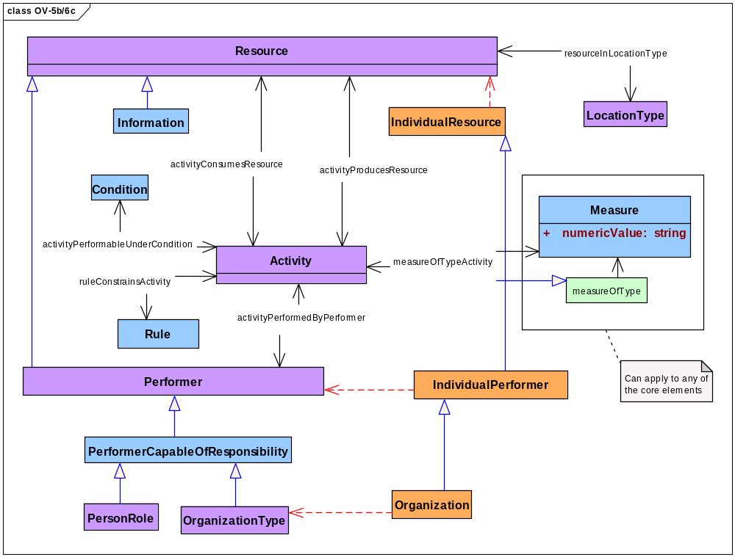
Figure 3.5.6-33: DoDAF meta-model diagram for OV-5b models
- Alternative names: Operational Activity Model; Activity Resource Flows; Process Architecture.
- Notes. The information in an OV-5b model is a proper superset of the information in a corresponding OV-5a model. An OV-5a model may not add to nor alter the information in a corresponding OV-5b model.

Introduction to OV-6 models
- OV-5 models examine the static relationships of activities. OV-6 models examine the dynamic behavior of activities identified and described by OV-5b models. OV-6 models look at the temporal parts of the activities of a described architecture, including the sequencing and duration of these activities.
- OV-6 models emphasize the behavior through time of a described architecture. OV-6 models help us answer questions such as: when should a response be expected after sending message X to activity Y at location A?
- OV-6 models include:
- Operational Rules (OV-6a),
- Operational State Transitions (OV-6b), and
- Operational Sequences (OV-6c).
- OV-6 models cover much of the same architectural data, but each model looks at these data from a different perspective. OV-6b and OV-6c models describe timing and sequencing behavior. These OV-6 models describe activities that respond to sequences of resource states. Such resource states may be called inputs, transactions, triggers, and events by different modeling methods and techniques. Resource states include such things as the state of a message being received, the state of a timer whose time has been exhausted, or the state of satisfaction of conditional criteria. When a resource state is detected, an activity to be carried out may be constrained by rules and the activity may need to be performed under certain conditions; such rules and conditions are described by OV-6a models.

Operational Rules (OV-6a)
- Description. This model identifies and describes the rules and conditions that constrain activities within a described architecture.
- Narrative. This model emphasizes (a) rules and other guidance that constrain activities and (b) conditions under which activities are performed. Rules themselves are not four-dimensional; thus, performers require descriptions of applicable rules—such descriptions do exist in space and time. Such descriptions are a sort of information, which is a sort of resource that may be consumed and produced by real activities for real performers.
- Conditions exist within the four-dimensional environment of activities but are not necessarily four-dimensional things within that context. Conditions such as adversary morale and unit cohesion may be real but they are not immediately accessible as architectural data; thus, performers, as with rules, require descriptions of applicable conditions—such descriptions are accessible in space and time. As with rules, such descriptions are a sort of information, which is a sort of resource that may be consumed and produced by real activities for real performers.
- Rules and conditions are considered together in OV-6a models because both impose constraints on the performance of activities. In particular, different rules may apply to an activity under different conditions. Rules may be related to measures; for example, rules that are criteria of UJTL task performance standards are to be related to corresponding measures. Similarly, conditions affecting UJTL task performance are to be related to corresponding measures. Measures related to rules and conditions may include physical and temporal measures.
- Activities are seen in OV-6a models as they are in other DoDAF models. An activity consumes resources to produce resources. An activity is constrained by guidance, rules, and standards, and performers carry out an activity under conditions that affect its performance.
- Rules and conditions for activities may depend upon the location of those activities. Resources are related to their locations and the location of these resources determines the location of activities that consume and produce them.
- Performers that are capable of responsibility may be related to activities they perform. Systems and services are not to be modeled.
- Activities, rules, conditions, measures, and resources shall be modeled. In particular, information resources that describe rules shall be modeled and information resources that describe conditions may be modeled. Rules shall be modeled for each activity identified in the corresponding OV-5b models of an architectural description. Performers that are persons in roles, types of organizations, and specific organizations may be modeled. Types of locations may be modeled. Measures for rules and conditions may include physical measures and temporal measures. Measures related to activities, performers, and locations may be modeled. Systems and services shall not be modeled.
- Meta-model. Figure 3.5.8-34 shows the DoDAF meta-model for OV-6a models.
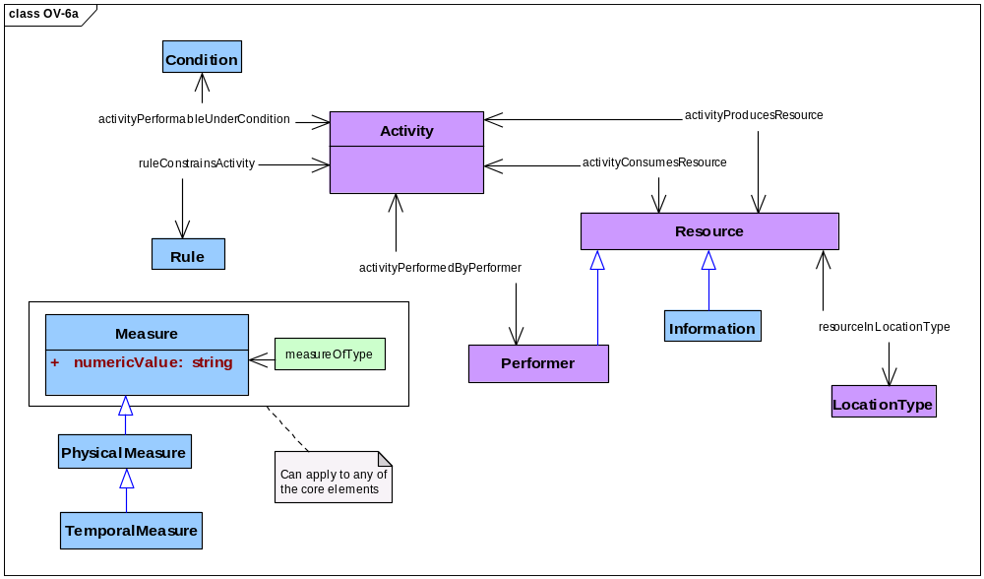
Figure 3.5.8-34: DoDAF meta-model diagram for OV-6a models
- Alternative names: Operational Rules Model; Organizational Rules.
- Note. Technical and functional standards are the subject of the Standards Viewpoint.
- The term standards is also used when discussing capabilities. In the context of capabilities, a standard indicates a level of performance that is a taken as the threshold for acceptable performance of an activity by a performer. Such a standard consists of a measure—the level of performance— and a criterion—the threshold of acceptable performance. In an OV-6a model and in the Capabilities Viewpoint, such a standard is seen as a pairing of a sort of measure that applies to an activity and a rule that expresses a criterion for applying that sort of measure to that activity.

Operational State Transitions (OV-6b)
- Description. This model identifies and describes changes in the states of resources that are consumed and produced by activities within a described architecture.
- Narrative. This model emphasizes certain interesting temporal parts of a resource, specifically those temporal parts that are distinguished by the attainable states of the resource. Each interesting temporal part is related to a property that distinguishes these temporal parts from one another across the whole-life of a resource. These properties are related to activities because an activity transforms an earlier temporal part of a resource with certain properties (input) into a later temporal part with altered properties (output).
- A resource with states (i.e., temporal parts observed as resources with properties that may change) generally does not play the role of a trigger for an activity that changes the state of that resource (see note). Therefore, an OV-6b model may want to identify other resources that do play the role of a trigger for activities that change the properties of the resource that is the subject of a model.
- A measure is the sort of property that characterizes the state of a resource. In particular, OV-6b models examine physical measures and temporal measures to characterize resource states, and they use before-after relationships to order the changes in these measures, that is, the state transitions of a resource.
- An OV-6b model focuses on some selected resource whose properties may change in interesting ways. In contrast, an OV-5b model covers all resources within the scope of a specific OV-5b model. Performers are resources that frequently exhibit state transitions that are interesting for OV-6b models because performers in different states can carry out different activities.
- Activities are seen in OV-6b models as they are in other DoDAF models. An activity consumes resources to produce resources. An activity is constrained by guidance, rules, and standards, and performers carry out an activity under conditions that affect its performance. Rules and conditions are seen in OV-6b models as they are in OV-6a models. Descriptions of rules and conditions are sorts of information, and information is a sort of resource that may be consumed and produced by real activities for real performers. Thus, OV-6b models may look at changes in rules and conditions by examining the state transitions of their descriptions.
- Activities, resources, physical measures, and temporal measures shall be modeled. Information resources that describe rules and conditions shall be modeled. Before-after relationships among activities and between resources in sequential states shall be modeled. Types of locations of activities and resources may be modeled. Performers whose state transitions are the subject of an OV-6b model shall be modeled; other performers may be modeled. Measures related to activities, rules, performers, conditions, and locations may be modeled.

- Meta-model. Figure 3.5.9-35 shows the DoDAF meta-model for OV-6b models.
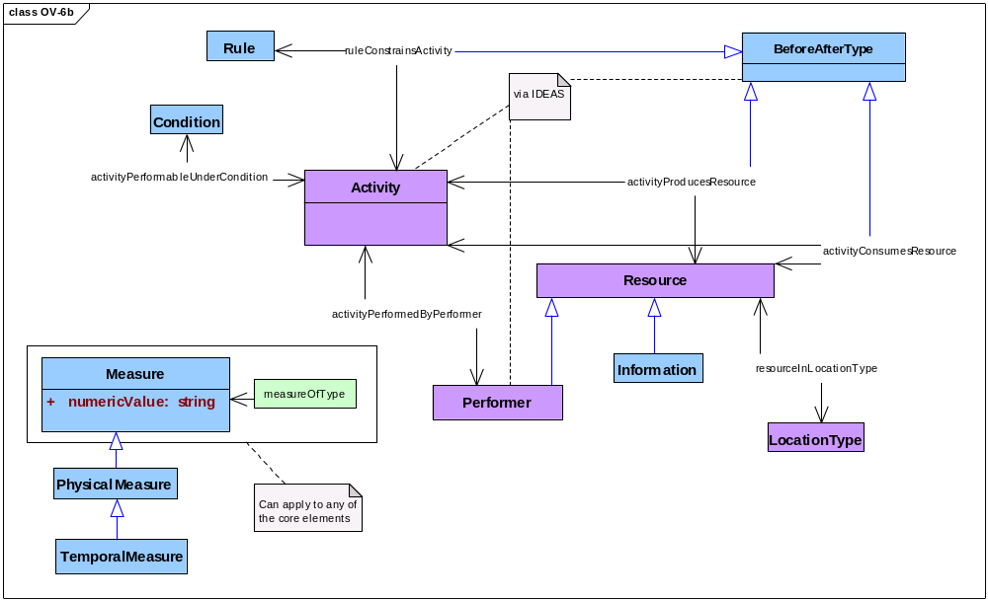
Figure 3.5.9-35: DoDAF meta-model diagram for OV-6b models
- Alternative names: State Transition Description; Organizational State Transitions.
- Note. Technically, resources may trigger their own state transitions, that is, a resource may be produced by one activity with a property that another activity immediately consumes just because that resource with that property triggers the subsequent consuming activity. Clearly, a resource state that triggers an activity to consume that resource itself does not persist and may, in practice, either (a) be physically not observable or (b) not sufficiently interesting to dwell on. In either case, such an instantaneously transient resource state would be treated as embedded within the black box of an activity that is not further decomposed.
- The activities and resources examined by an OV-6b model must be a subset of those activities identified by OV-5b models.

Operational Activity Sequences (OV-6c)
- Description. This model identifies and describes a sequence of activities within a described architecture.
- Narrative. This model emphasizes some interesting sequence of activities taken from the set of all activities within an architecture description. The DoDAF meta-model does not prescribe what ought to be interesting. OV-6c models specify sequence using before-after relationships.
- Activities are seen in OV-6c models as they are in other DoDAF models. An activity consumes resources to produce resources. An activity is constrained by guidance, rules, and standards, and performers carry out an activity under conditions that affect its performance. Performers in OV-6c models are resources that are capable of responsibility—organizations and persons in roles—rather than resources that are materiel, systems, or services. Rules and conditions are seen in OV-6c models as they are in OV-6a models. Descriptions of rules and conditions are sorts of information, and information is a sort of resource that may be consumed and produced by real activities for real performers. Thus, OV-6c models may examine the production of rules descriptions and condition descriptions.
- An OV-6c model identifies and describes measures that are related to activities. OV-6c models may also identify and describe measures that apply to rules, conditions, resources, performers, and locations. Guidance of various sorts may refer to measures applicable to activities, and specific measures for activities may be drawn from such guidance.
- Activities, resources, and performers shall be modeled. Rules, conditions, and types of locations may be modeled. The sequential structure of activities shall be modeled using before-after relationships. Types of organizations and specific organizations may be modeled, and persons in roles may also be modeled. Measures related to activities shall be modeled. Measures related to rules, conditions, resources, performers, and locations may be modeled. Performers other than performers capable of responsibility shall not be modeled.
- An OV-6c model may consider individual performers and specific organizations.
- Meta-model. Figure 3.5.10-36 shows the DoDAF meta-model for OV-6c models.
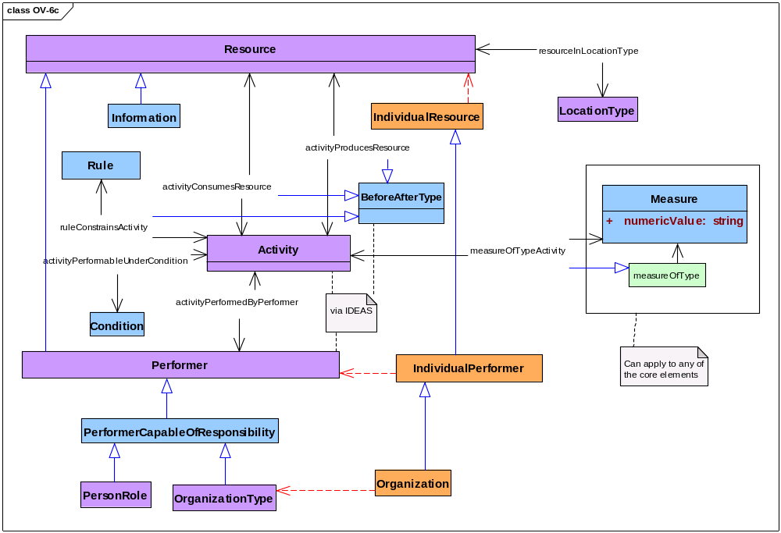
Figure 3.5.10-36: DoDAF meta-model diagram for OV-6c models
- Alternative names: Event-Trace Description; Operational Event-Trace; Sequence Diagram.
- Notes: The activities and resources examined by an OV-6c model must be a subset of those activities identified by OV-5b models.

Project Viewpoint (PV)
- Project Viewpoint models describe how programs, projects, portfolios, and initiatives deliver capabilities, the organizations contributing to them, and dependencies among them.
- The integration of project models (organizational and project-oriented) with more traditional architecture models is a characteristic aspect of DoDAF enterprise architecture descriptions. These models expand the use of the DoDAF by including information about programs, projects, portfolios, and initiatives and relating that information to capabilities and other programs, projects, portfolios, and initiatives; this expands DoDAF’s support to the portfolio management (PfM) process. For example, different levels of cost data might be captured in an architecture as required by process owners. This data might be presented by a WBS in a Gantt chart.
- Table 3.6-6 names and describes Project Viewpoint models.
Table 3.6-6: Project Viewpoint models
Models | Descriptions
PV-1: Projects and Organizations | Presents relationships between projects and organizations that perform them.
PV-2: Project Schedules | Presents schedules for projects, project milestones, and schedule dependencies
PV-3: Projects and Capabilities | Presents relationships between projects and capabilities.

Projects & Organizations (PV-1)
- Description. This model identifies and describes the dependencies among organizations, projects, and organizational-structures used to manage projects.
- Narrative. This model emphasizes relationships between organizations and projects in the production of resources within the scope of a described architecture. A project is an individual activity that produces guidance and resources that are used to perform types of activities. Performers carry out all activities, and individual performers carry out individual projects. The individual performers of interest in PV-1 models are individual organizations.
- Projects are activities and are seen in PV-1 models much as they are in other DoDAF models. An activity consumes resources to produce other resources. At least one performer carries out an activity. An activity is constrained by guidance, rules, and standards. Performers may carry out activities under conditions that affect its performance. The sorts of locations where resources are produced and consumed by these activities may affect the specification of performers to carry out those activities and measures of performance.
- Any organization has parts and any organization can be a part of an encompassing organization. Whole-part relationships relate a whole organization to its parts. Similarly, any project has parts, and any project can be a part of an encompassing project. Whole-part relationships relate a whole project to its parts. Thus, PV-1 models may represent hierarchical organizational structures and hierarchical project structures using whole-part relationships.
- The focus of PV-1 models is to identify individual organizations and their parts that perform individual projects and their parts to produce guidance and resources, including resources that are themselves performers (e.g., systems), that are used to carry out types of activities within the scope of a described architecture.
- Individual organizations may perform more than one individual project, and individual projects may be performed by more than one individual organization. PV-1 models may emphasize the temporal parts of individual organizations and individual projects.
- Beyond an existence predicate, the DoDAF does not prescribe nor limit relationships that may be examined by PV-1 models. However, the existence predicate must be true for all pairs of an individual organization and an individual project considered by PV-1 models: the individual organization performs an individual project that produces some guidance or some resource that has been identified by models within other DoDAF viewpoints. PV-1 models may not themselves introduce guidance or resources into the scope of a described architecture.
- The DoDAF does not prescribe nor limit the details or levels of composition of organizations and projects that PV-1 models may provide.
- Individual projects and individual organizations shall be modeled. Types of organizations may be modeled. Locations of organizations and projects shall be modeled; types of locations may be modeled. Activities, guidance, and resources may be modeled. Whole-part relationships may be used to model organizations and projects. Measures of projects, organizations, activities, locations, guidance, and resources may be modeled. Rules that constrain projects and conditions under which projects are performed may be modeled; rules and conditions related to activities within the scope of the described architecture shall not be modeled.
- Meta-model. Figure 3.6.1-37 shows the DoDAF meta-model for PV-1 models.
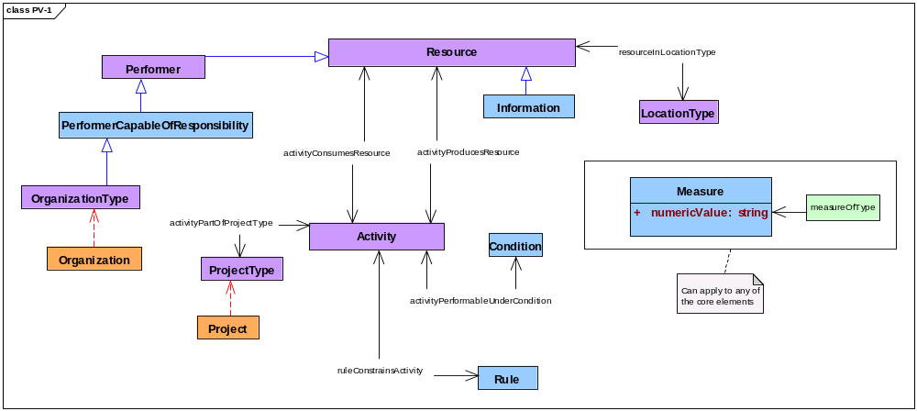
Figure 3.6.1-37: DoDAF meta-model diagram for PV-1 models
- Alternative names: Project Portfolio Relationships; Projects and Portfolios.
- Note: A work breakdown structure (WBS) is one sort of PV-1 model.

Project Schedules (PV-2)
- Description. This model identifies and describes the schedules of projects, their milestones, and their schedule dependencies.
- Narrative. This model emphasizes project schedules, that is, the before-after related temporal parts of projects. A project is an individual activity that produces guidance and resources that are used to perform types of activities. Whole projects considered by PV-2 models are those identified by corresponding PV-1 models; PV-2 models may not introduce projects into the Project Viewpoint.
- Any project has parts, and any project can be a part of an encompassing project. Whole-part relationships relate a whole project to its parts. Thus, while PV-1 models may focus on hierarchical project structures using whole-part relationships. PV-2 models emphasize the temporal parts of these projects using temporal whole-part relationships.
- Using before-after relationships and overlap relationships, PV-2 models may identify guidance and resources to be produced by one project part and consumed by another project part, including resources that are themselves performers (e.g., systems) of activities within the scope of a described architecture. Using happens-in relationships, such schedule dependencies may be related to interesting temporal periods such as budget years.
- End boundaries of project temporal parts and start boundaries of project temporal parts may be treated as milestones by PV-2 models, that is, as an overlap between a project temporal boundary and a resource state produced by a project part. At a milestone, the end boundary of one temporal part may overlap the start boundary of another temporal part. PV-2 models examine measures of whole-part composition (i.e., cardinal measures) as well as physical measures of resources related to milestones.

- The DoDAF does not prescribe nor limit the details or levels of temporal composition of projects that PV-2 models may provide.
- Organizations and organization structures related to projects and project structures and modeled by PV-1 models may be incorporated by PV-2 models.
- Projects and their temporal parts shall be modeled. Temporal measures of temporal parts shall be modeled. Resources related to milestones shall be modeled; physical measures and cardinal measures shall be modeled for such resources. Measures of other resources may be modeled. Activities that produce or consume resources related to milestones may be modeled. Locations of projects and their temporal parts shall be modeled; types of locations of projects may be modeled. Before-after relationships and overlap relationships shall be used to model schedules. Organizations and type of organizations may be modeled. Rules that constrain projects and conditions under which projects are performed may be modeled; activities, rules, and conditions related to activities within the scope of the described architecture shall not be modeled.
- Meta-model. Figure 3.6.2-38 shows the DoDAF meta-model for PV-2 models.
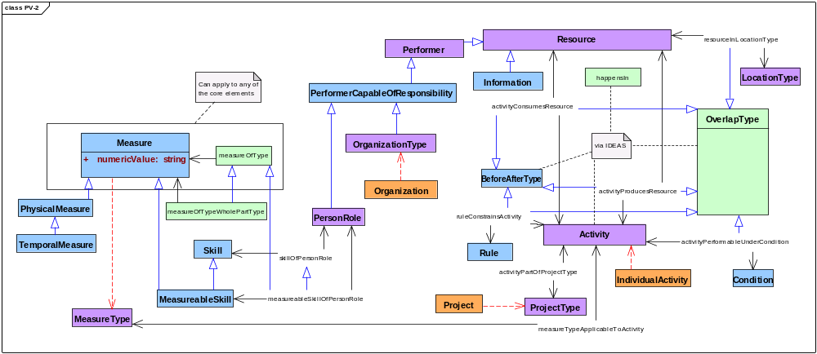
Figure 3.6.2-38: DoDAF meta-model diagram for PV-2 models
- Alternative names: Project Timelines; Project Timelines and Dependencies; Project Schedules and Dependencies.
- Note: A Gantt Chart is one sort of PV-2 model.

Projects & Capabilities (PV-3)
- Description. This model identifies and describes relationships among projects and capabilities to show how specific projects and program elements help to achieve a capability provided by an architecture.
- Narrative.
- Meta-model. Figure 3.6.3-39 shows the DoDAF meta-model for PV-3 models.
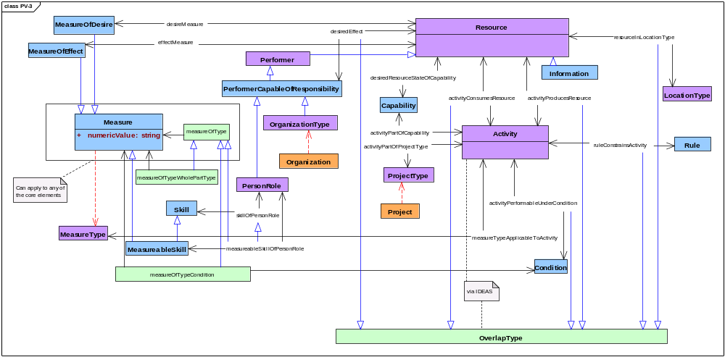
Figure 3.6.3-39: DoDAF meta-model diagram for PV-3 models
- Alternative names: Project to Capability Mapping; Capabilities Achieved by Projects.

Service Viewpoint (SvcV)
- Service Viewpoint models describe service composition (parts of services), service resources, interfaces and de systems, interface, technical dependency, and functional dependency relationships, activities performed by services, resources produced and consumed by services, measures associated with services, the time-evolution of services, technologies and skills employed by services, rules applicable to services, state transitions of services, and temporal sequences of services Services providing or supporting both warfighting and business functions.

- Services are not limited to internal system functions and can include human computer interface and graphical user interface functions or functions that consume or produce service data to or from service functions. The external service data providers and consumers can be used to represent the human that interacts with the service.
- Table 3.7-7 names and describes Service Viewpoint models.
Table 3.7-7: Services Viewpoint models
Models | Descriptions
SvcV-1 Service Composition | Compostional and taxononomic structure services
SvcV-2 Service Resources | Identification of resource flows between services.
SvcV-3a Services and Systems | Interface relationships between services and systems
SvcV-3b Service Relationships | Interface relationships among services
SvcV-4 Service System Activities | The functions (activities) performed by services and the resource flows among those functions
SvcV-5 Service Operational Activities | A mapping of services activities that support or provide operational activities.
SvcV-6 Service Resources | Details of service resource flows and associated attributes (rules and measures)
SvcV-7 Service Measures | Measures (metrics) of Services Model elements for the appropriate time frame(s)
SvcV-8 Service Evolution | The planned incremental steps toward migrating a suite of services to a more efficient suite or toward evolving current services to a future implementation
SvcV-9 Service Technology & Skills | The emerging technologies, software/hardware products, and skills that are expected to be available in a given set of time frames and that will affect future service development.
SvcV-10a Service Rules | Rules that constrain services
SvcV-10b Service State Transitions | Responses (changes of state) of services to events
SvcV-10c Service Activity Sequences | Sequences of services and events

Services (SvcV-1)
- Description. This model identifies and describes resources consumed and produced by activities performed by services within a described architecture; in presentation, architectural-data are grouped by service.
- Narrative. This model emphasizes performers that are services and interfaces between these performers, specifically, the overlaps between services or systems performing activities that produce resources and services or systems performing other activities that consume those resources. The role of a resource with respect to these activities changes from resource produced to resource consumed at such an interface.
- Activities are seen in SvcV-1 models much as they are in other DoDAF models. An activity consumes resources to produce other resources. At least one performer carries out an activity. An activity is constrained by guidance, rules, and standards. Performers may carry out activities under conditions that affect its performance. The sorts of locations where resources are produced and consumed by these activities may affect the specification of performers to carry out those activities.
- Resources produced and resources consumed include information, performers, and materiel. In SvcV-1 models, resources are produced by activities that are performed by services and performers capable of responsibility; these performers include organizations and persons in roles. These produced resources are consumed by other activities similarly carried out by other services or systems and other performers capable of responsibility.
- As in other models within the Service Viewpoint, an SvcV-1 model relates each service to a description of that service. SvcV-1 models may focus on relationships among services, computational resources, performers capable of responsibility, and resources produced.
- SvcV-1 models may use whole-part relationships to examine the composition of performers. A service may be considered as a part of encompassing performers, which may be systems or other services. Similarly, a service may be considered as a whole whose parts comprise resources of all sorts, including information, materiel, performers capable of responsibility, systems, and other services. The DoDAF does not prescribe nor limit the details or levels of composition that SvcV-1 models may provide.
- Services, their descriptions, and the activities that services perform shall be modeled. The resources produced and consumed by these activities as performed by these services shall be modeled. Performers capable of responsibility, including persons in roles and types of organizations as well as specific organizations, may be modeled. The types of locations and the specific locations of resources may be modeled. The composition of services as performers may be modeled: thus, resources that include these services may be modeled, and resources that are included in the composition of services, such as information, materiel, types of organizations, and persons in roles may be modeled. Measures of services, systems, activities, resources, other performers, materiel, types of locations, rules, and conditions may be modeled. Systems may be modeled by SvcV-1 models.
- Meta-model. Figure 3.7.1-40 shows the DoDAF meta-model for SvcV-1 models.
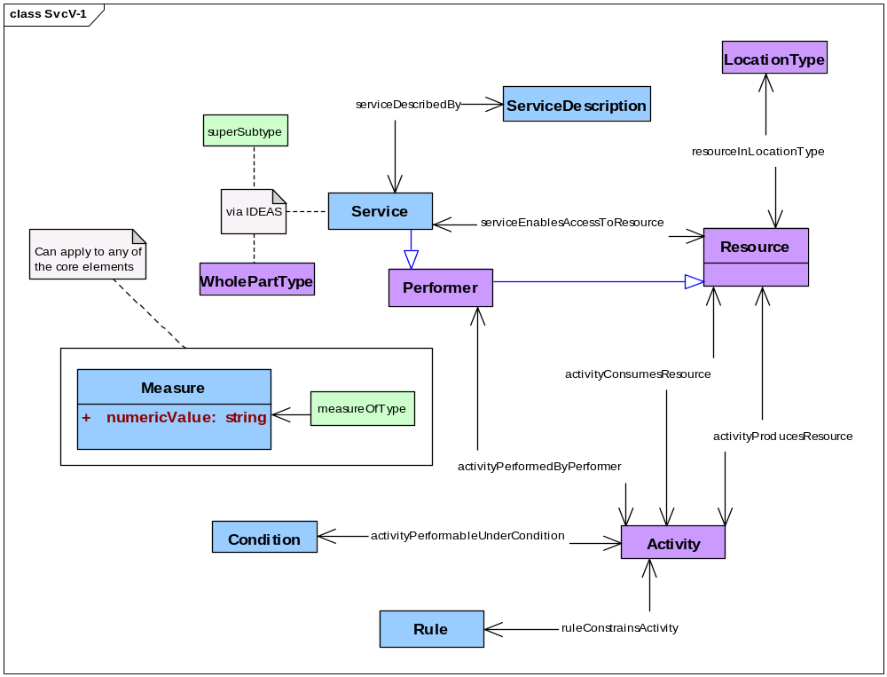
Figure 3.7.1-40: DoDAF meta-model diagram for SvcV-1 models
- Alternative names: Services Context Description; Services Composition Model.
- Notes. In substance, SvcV-1 models and Svc-2 models examine the same subjects: performers and their interfaces. Some organizations may give less emphasis to performer composition and activity guidance in SvcV-1 models and more emphasis on composition and guidance in SvcV-2 models. The DoDAF does not prescribe these emphases. Similarly, SV-1 models and SvcV-1 models examine the same topic. Some organizations may emphasize performers as systems in SV-1 models while others may emphasize performers as services in SvcV-1 models. The DoDAF does not prescribe these emphases.

Service Interfaces (SvcV-2)
- Description. This model identifies and describes resources consumed and produced by services within a described architecture; in presentation, architectural-data are grouped by service and, within service, by service parts.
- Narrative. This model emphasizes performers that are services and interfaces between these performers, specifically, the overlaps between services performing activities that produce resources and services performing other activities that consume those resources. The role of a resource with respect to these activities changes from resource produced to resource consumed at such an interface.
- SvcV-2 models consider services and activities introduced by corresponding SvcV-1 models. SvcV-2 models may not introduce services or activities that have not already been identified and described by corresponding SvcV-1 models. However, SvcV-2 models may look more closely at the parts of these services or activities.
- Activities are seen in SvcV-2 models much as they are in other DoDAF models. An activity consumes resources to produce other resources. At least one performer carries out an activity. An activity is constrained by guidance, rules, and standards; SvcV-2 models may pay particular attention to guidance. Performers may carry out activities under conditions that affect their performance. The sorts of locations where resources are produced and consumed by these activities may affect the specification of performers to carry out those activities.
- Resources produced and resources consumed include information, performers, and materiel. In SvcV-2 models, resources are produced by activities that are performed by services and performers capable of responsibility; these performers include organizations and persons in roles. These produced resources are consumed by other activities similarly carried out by other services, systems, and other performers capable of responsibility.
- SvcV-2 models may use whole-part relationships to examine the composition of performers; SvcV-2 models may pay particular attention to service parts that constitute overlaps and to rules that constrain the activities performed by these service parts. A service may be considered as a part of encompassing performers. Similarly, a service may be considered as a whole whose parts comprise resources of all sorts, including information, materiel, performers capable of responsibility, systems, and other services. The DoDAF does not prescribe nor limit the details or levels of composition that SvcV-2 models may provide.
- Services and the activities they perform shall be modeled. The resources produced and consumed by these activities as performed by these services shall be modeled. Performers capable of responsibility, including persons in roles and types of organizations, may be modeled. Guidance for activities carried out by services as performers and conditions that affect the performance of these activities may be modeled. The types of locations of resources may be modeled. The composition of services as performers may be modeled: thus, resources that include these interfacing services may be modeled, and resources that are included in the composition of interfacing services, such as information, materiel, types of organizations, and persons in roles may be modeled. Measures of services, activities, resources, other performers, materiel, types of locations, rules, and conditions may be modeled. Systems may be modeled by SV-2 models.
- Meta-model. Figure 3.7.2-41 shows the DoDAF meta-model for SvcV-2 models.
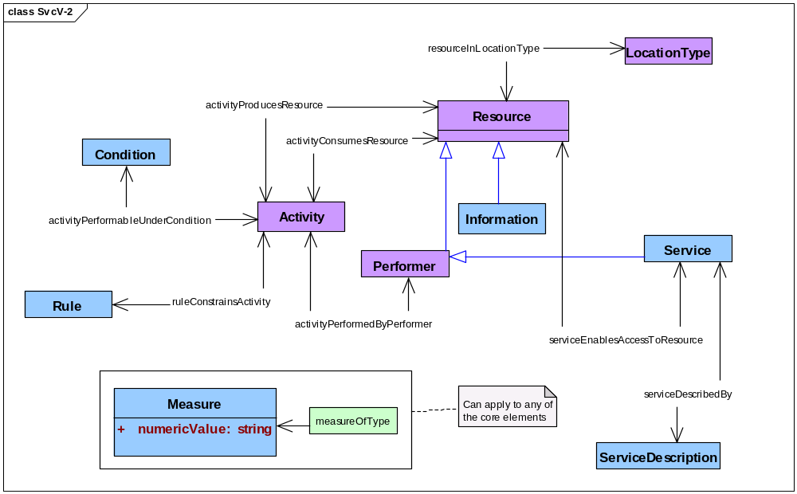
Figure 3.7.2-41: DoDAF meta-model diagram for SvcV-2 models
- Alternative names: Services Resource Flow; Services Resource Flow Description.
- Notes. In substance, SvcV-1 models and Svc-2 models examine the same subjects: performers and their interfaces. Some organizations may give less emphasis to performer composition and activity guidance in SvcV-1 models and more emphasis on composition and guidance in SvcV-2 models. The DoDAF does not prescribe these emphases. Similarly, SV-2 models and SvcV-2 models examine the same topic. Some organizations may emphasize performers as systems in SV-2 models while others may emphasize performers as services in SvcV-2 models. The DoDAF does not prescribe these emphases.

Services and Systems (SvcV-3a)
- Description. This model identifies and describes relationships between services and systems within a described architecture.
- Narrative. This model emphasizes relationships between systems and services that are the subject of SvcV-1 models and SV-1 models. The DoDAF does not prescribe service-to-system relationships that must be examined by SvcV-3a models. However, relationships considered by SvcV-3a models must be established by other models within the Service Viewpoint; SvcV-3a models may not themselves introduce service-to-system relationships.
- Services and systems shall be modeled. Service-to-system relationships shall be modeled. Composition of services and systems may be modeled and interfaces between services and systems may be modeled. Activities, rules, conditions, resources, and types of locations may be modeled. Measures of services, systems, activities, rules, conditions, resources, and types of location may be modeled.
- Meta-model. Figure 3.7.3-42 shows the DoDAF meta-model for SvcV-3a models.
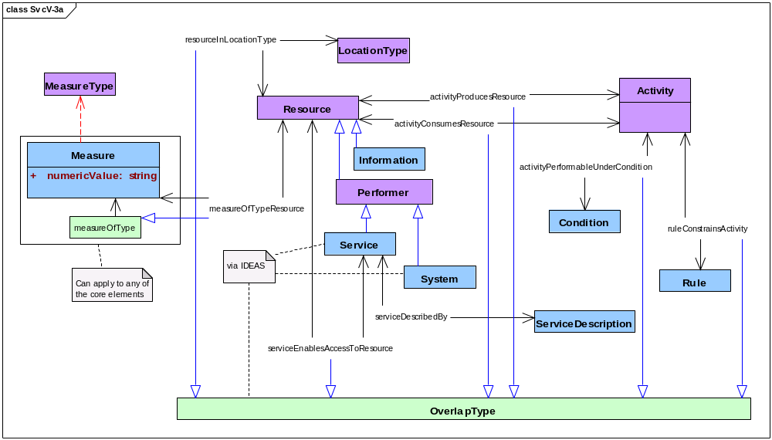
Figure 3.7.3-42: DoDAF meta-model diagram for SvcV-3a models
- Alternative names: Systems-Services Matrix.
- Note. An SvcV-3a model may be considered simply as a report that presents interesting system-to-service relationships that have been captured as architectural data by other Service Viewpoint models within an architectural description.

Service Relationships (SvcV-3b)
- Description. This model identifies and describes relationships among services within a described architecture.
- Narrative. This model emphasizes relationships among services that are the subject of SvcV-1 models. The DoDAF does not prescribe service-to-service relationships that must be examined by SvcV-3b models. However, relationships considered by SvcV-3b models must be established by other models within the Service Viewpoint; SvcV-3b models may not themselves introduce service-to-service relationships.
- Services shall be modeled. Service-to-service relationships shall be modeled. Composition of services may be modeled and interfaces between services may be modeled. Activities, rules, conditions, resources, and types of locations may be modeled. Measures of systems, activities, rules, conditions, resources, and types of location may be modeled. Systems shall not be modeled.
- Meta-model. Figure 3.7.4-43 shows the DoDAF meta-model for SvcV-3b models.
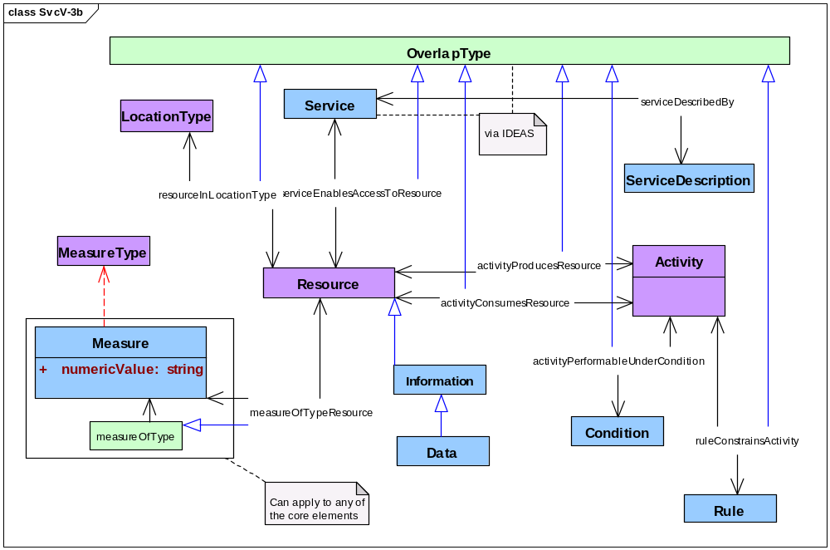
Figure 3.7.4-43: DoDAF meta-model diagram for SvcV-3b models
- Alternative names: Services-Services Matrix.
- Note. An SvcV-3b model may be considered simply as a report that presents interesting service-to-service relationships that have been captured as architectural data by other Service Viewpoint models within an architectural description.

Service Functions (SvcV-4)
- Description. This model identifies and describes activities performed by services within a described architecture.
- Narrative. This model emphasizes the activities carried out by services as performers within the scope of a described architecture. Any activity comprises other activities. Hierarchical recursive decomposition of activities into activity parts may be modeled using whole-part relationships between activity wholes and their activity parts. Activities may also be related by their similarities and their differences using super-subtype relationships.
- Activities are seen in SvcV-4 models as they are in other DoDAF models. An activity consumes resources to produce resources. Performers in SvcV-4 models are services; these services may have parts that are resources that are capable of responsibility—organizations and persons in roles—as well as materiel, systems, and other services. Activities are constrained by guidance, rules, and standards, and activities are carried out under conditions that affect their performance.
- SvcV-4 models examine information and data as resources that are consumed and produced by activities performed by services.
- An SvcV-4 model identifies and describes measures that are related to activities; in particular, an SvcV-4 model may examine measures that relate services to the performance of activities carried out by those services. SvcV-4 models may also identify and describe measures that apply to rules, conditions, resources, performers, and locations. Guidance of various sorts may refer to measures applicable to activities, and specific measures for activities may be drawn from such guidance.
- Services, their descriptions, and other performers that are parts of services shall be modeled. Activities performed by services shall be modeled. Resources, especially data and other information consumed and produced by activities performed by services within an SvcV-4 model, shall be modeled. Rules, conditions, and types of locations may be modeled. The hierarchical structure of activities and the hierarchical structure of services may be modeled using whole-part relationships. Activities and services may be categorized using super-subtype relationships. Types of organizations and specific organizations may be modeled, and persons in roles may also be modeled. Measures related to services, activities, rules, conditions, resources, constituent performers, and locations may be modeled. Systems may not be modeled except as parts of services.
- Meta-model. Figure 3.7.5-44 shows the DoDAF meta-model for SvcV-4 models.
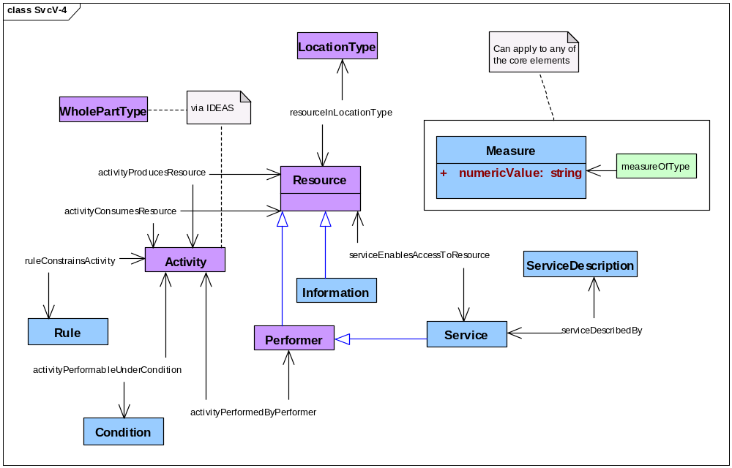
Figure 3.7.5-44: DoDAF meta-model diagram for SvcV-4 models
- Alternative names: Services Functionality Description.

Services & Operational Activities (SvcV-5)
- Description. This model identifies and describes relationships between services and operational activities within a described architecture.
- Narrative. This model focuses on relationships between services identified by SvcV-1 models and operational activities identified by OV-5b models. Services perform service functions and service functions overlap operational activities.
- Operational activities considered by SvcV-5 models must be identified by OV-5b models; SvcV-5 models may not introduce operational activities into an architecture description. Service functions considered by SvcV-5 models must be identified by corresponding SvcV-4 models; SvcV-5 models may not introduce activities performed by services into an architecture description. Operational activities considered by SvcV-5 models must overlap service functions identified by corresponding SvcV-4 models.
- Services considered by SvcV-5 models must be identified by SvcV-1 models; SvcV-5 models may not introduce services into an architecture description. All services identified by SvcV-1 models are to be related by SvcV-5 models to operational activities identified by corresponding OV-5b models. However, the converse does not necessarily hold: there may be activities identified by OV-5b models that have no part that is performed by a service. Further, a service may perform a service function that overlaps with more than one operational activity within a described architecture, and an operational activity may overlap with service functions that are performed by more than one service within a described architecture.
- Beyond an existence predicate, the DoDAF does not prescribe relationships that must be examined by SvcV-5 models. However, the existence predicate must be true for all pairs of an operational activity and a service considered by SvcV-5 models: the service performs a service function that overlaps the operational activity.
- Services, their descriptions, and activities shall be modeled. Relationships between services and activities shall be modeled. Composition of services, composition of activities, and overlap of activities may be modeled. Rules, conditions, resources, and types of locations may be modeled. Measures of services, activities, rules, conditions, resources, and types of location may be modeled. Systems may also be modeled.
- Meta-model. Figure 3.7.6-45 shows the DoDAF meta-model for SvcV-5 models.
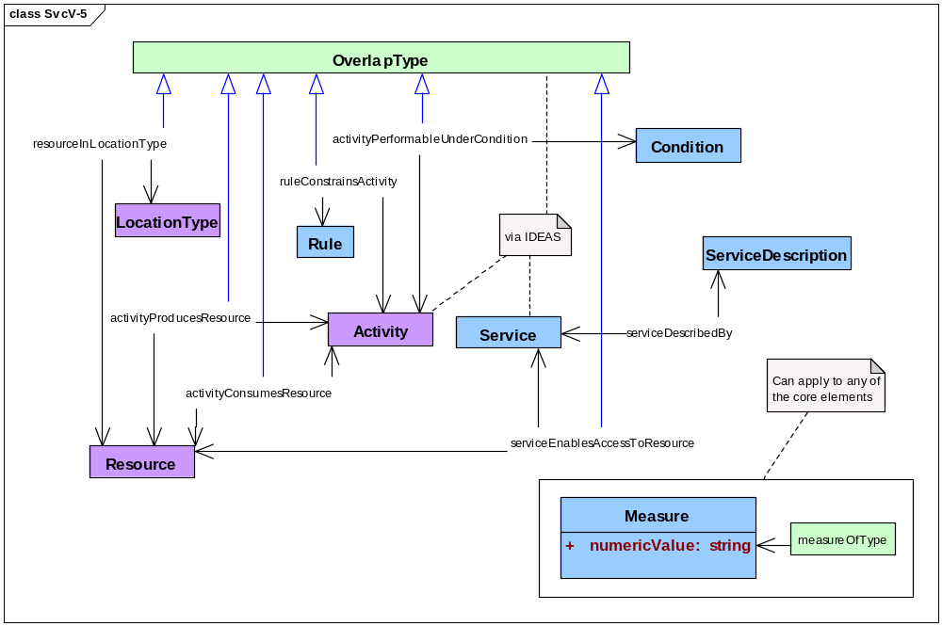
Figure 3.7.6-45: DoDAF meta-model diagram for SvcV-5 models
- Alternative names: Operational Activity to Services Traceability Matrix.

Services, Activities, & Resources (SvcV-6)
- Description. This model identifies and describes resources consumed and produced by services within a described architecture.
- Narrative. This model emphasizes the exchange of resources among services; in particular, these resources include data. A dependency between a resource to be consumed by one activity and a resource produced by another activity may be described as a flow of resources from producer to consumer. Activities are modeled in SvcV-6 models only in detail sufficient to show the relationships between resources produced by activities performed by one service and the resources consumed by activities performed by other services.
- Activities are seen in SvcV-6 models much as they are in other DoDAF models. An activity consumes resources to produce resources. Performers in SvcV-6 models are services. Services follow guidance, rules, and standards to carry out their activities, and services carry out their activities under conditions that affect their performance.
- Services and other resources may be related to their locations to ensure that resources to be consumed are available to activities when and where those resources are needed and that services are there to carry out those activities when those resources are available.
- In contrast to SvcV-4 models, SvcV-6 models identify and describe measures that apply to activities and resources. SvcV-6 models provide physical and temporal measures that are related to resources. SvcV-6 models also provide measures of performance and of the satisfaction of needs that are related to activities. Guidance of various sorts may refer to types of applicable measures, and specific measures for specific activities may be drawn from such guidance.
- Services, activities, and resources shall be modeled. In particular, resources that are data shall be modeled. Types of organizations shall be modeled; specific organizations may be modeled. Persons in roles may be modeled as parts of services. Types of locations of resources and services may be modeled, and specific locations may also be modeled. Rules and conditions may be modeled. Measures related to services, activities, resources shall be modeled; these measures shall include physical measures, temporal measures, performance measures, and measures of need satisfaction. Measures related to rules, conditions, and locations may be modeled. Systems may be modeled.
- Meta-model. Figure 3.7.7-46 shows the DoDAF meta-model for SvcV-6 models.
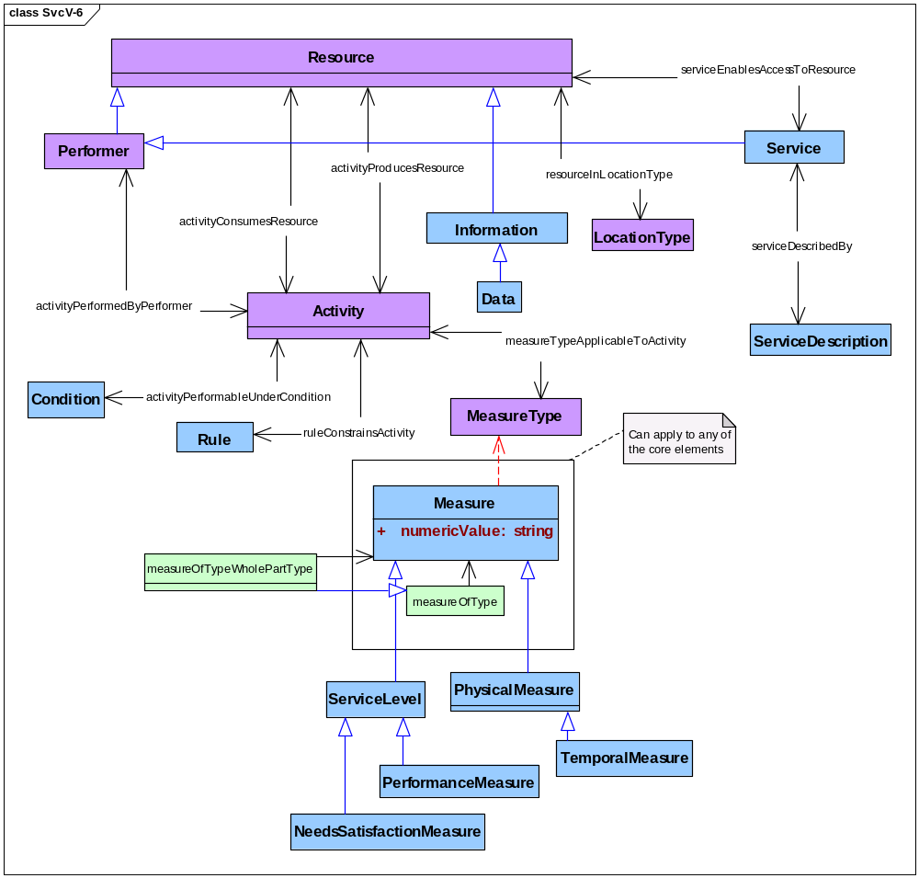
Figure 3.7.7-46: DoDAF meta-model diagram for SvcV-6 models
- Alternative names: Services Resource Flow Matrix.

Service Measures (SvcV-7)
- Description. This model identifies and describes measures for evaluating services within a described architecture.
- Narrative. This model emphasizes measures and focuses on measures applicable to services that enable access to resources used by activities. A measure is the sort of property that characterizes the state of a resource. In particular, SvcV-7 models examine performance measures and maintainability measures to characterize changes in service states.
- As in other models within the Service Viewpoint, an SvcV-7 model relates a service description to each service.
- SvcV-7 models may examine both static properties of services and their parts and dynamic properties of services and their parts. SV-7 models may quantitatively examine the composition of measured resources using whole-part relationships. In particular, SV-7 models may examine the measurable skills of persons in roles in performing services. SV-7 models may examine a service and its parts as resources—things produced or consumed—and SV-7 models may examine a service and its parts as performers performing an activity that consumes and produces other resources.
- An SvcV-7 model may focus on some selected resource whose properties may change in interesting ways. Performers that are services are resources that frequently exhibit state transitions that are interesting for SvcV-7 models because services in different states can do different things.
- Activities are seen in SvcV-7 models as they are in other DoDAF models. An activity consumes resources to produce resources. An activity is constrained by guidance, rules, and standards, and performers carry out an activity under conditions that affect its performance. In addition, SV-7 models look at sorts of measures that are applicable to activities and specify those sorts of measures that are appropriate for activities within the scope of the described architecture.
- Services, their descriptions, persons in roles, activities, skills, performance measures, maintainability measures, and types of measures for activities shall be modeled. Other measures of services, their descriptions, persons in roles, activities, and skills may be modeled. Measures related to activities, rules, performers, conditions, and locations may be modeled. Types of locations of activities, services, persons in roles, and other resources may be modeled. Performers that are systems, organizations, or types of organizations shall not be modeled as performers in SvcV-7 models.
- Meta-model. Figure 3.7.8-47 shows the DoDAF meta-model for SvcV-7 models.
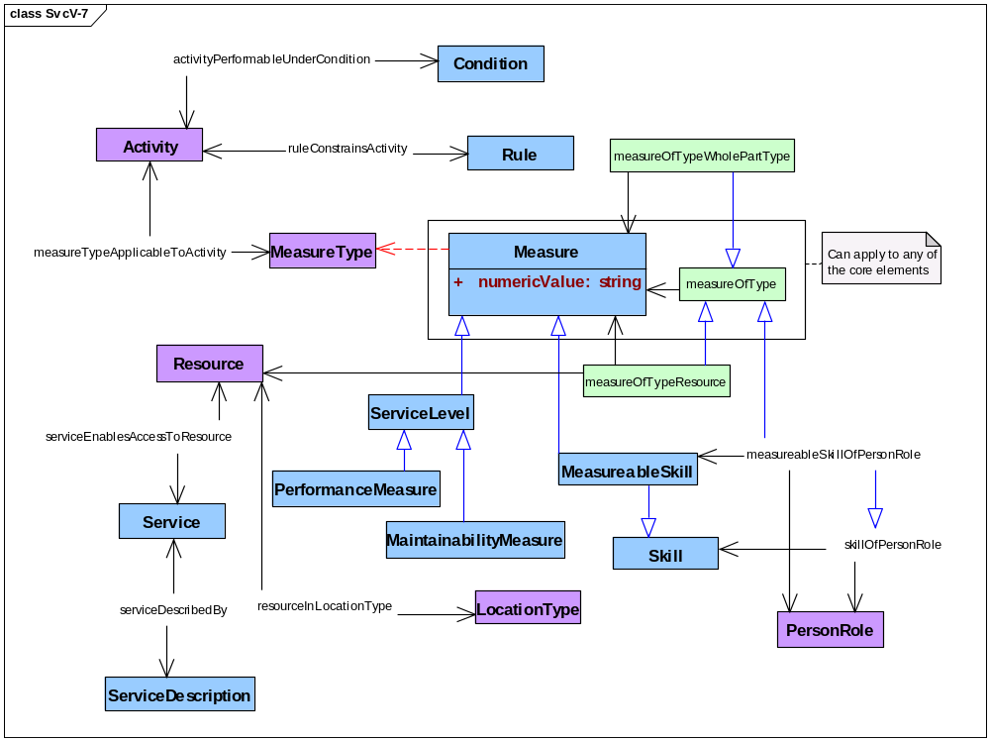
Figure 3.7.8-47: DoDAF meta-model diagram for SvcV-7 models
- Alternative names: Services Measures Matrix.
- Note: An SvcV-7 model differs from an SV-7 model in these ways: first, services along with their descriptions are modeled by SvcV-7 models while SV-7 models look instead at systems and, second, SvcV-7 models must include maintainability measures within the measures that are modeled.

Service Evolution (SvcV-8)
- Description. This model identifies and describes the temporal-states of services within a described architecture.
- Narrative. This model emphasizes the changes in the states of services and focuses those changes taking place with variations in the sequence of time (temporal state changes).
- Temporal state changes are identified to be of or relating to the sequence of or relating to variations in time or to a particular time
- The service is mechanism to enable access to a set of one or more capabilities, where the access is provided using a prescribed interface and is exercised consistent with constraints and policies as specified by the service description. The capabilities accessed are resources, that is, information and data, materiel, performers, and geo-political extents.
- As in other models within the Service Viewpoint, a SvcV-8 model relates a service description to each service.
- SvcV-8 models examine the changing of resources, mapping the temporal state changes to allow comparison and examination of the resource and resource alternatives over time.
- SvcV-8 models allow comparison between historical (legacy), current (as-is), and future (to-be) capabilities to permit evaluation of change and the measure of the impact will have on the current service. This comparison is to be in the observation of service over a unit of time that will allow compare and contrast of other services during the same period. The model shows the structure of each resource, using similar modeling elements as those used in SvcV-1.
- The SvcV-8, when linked together with other evolution Models such as CV-2 Capability Taxonomy, CV-3 Capability Phasing and StdV-2 Standards Forecast, provides a rich definition of how the Enterprise and its capabilities are expected to evolve over time. These interactions will allow that the model can be used to support an architecture evolution project plan or transition plan.
- Changes depicted in the SvcV-8 DoDAF-described Model are derived from the project milestones that are shown in a PV-2 Project Timelines model. The PV-2 Project Timelines model is used for capability acquisition projects, there is likely to be a close relationship between these two models. The PV-3 will also be instrumental as it will provide the mapping of programs (services) and projects to show how specific projects and program elements help achieve a capability.
- Meta-model. Figure 3.7.9-48 shows the DoDAF meta-model for SvcV-8 models.
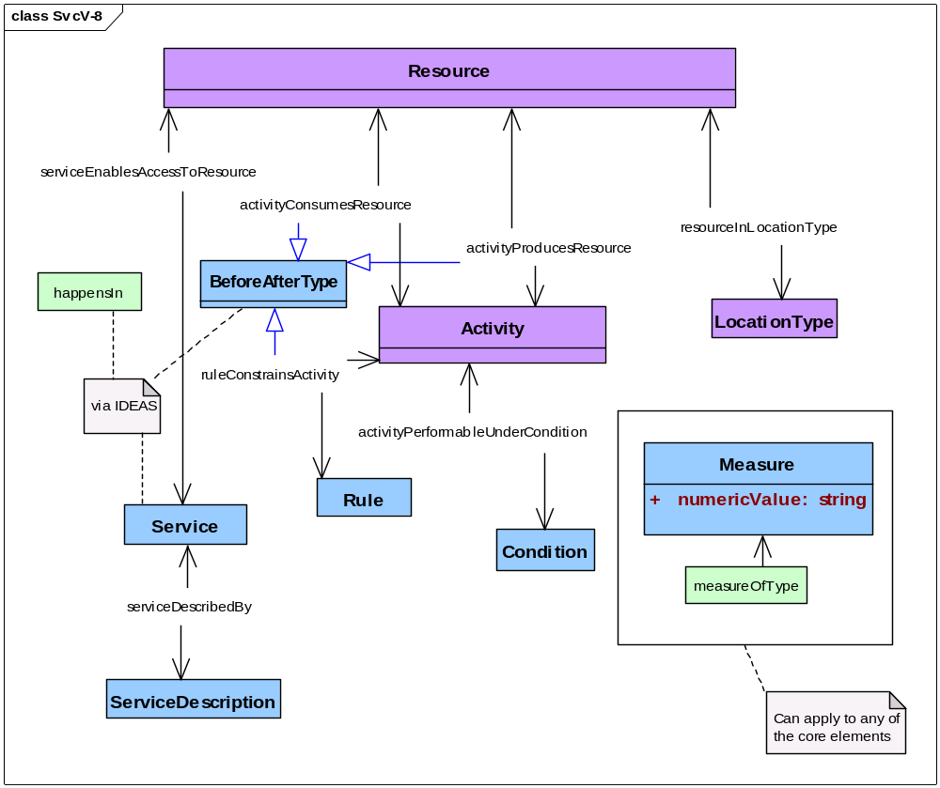
Figure 3.7.9-48: DoDAF meta-model diagram for SvcV-8 models
- Alternative names: Services Evolution Description, SoA Roadmap, Plan of Action and Milestones (POA&M), Integrated Master Plan (IMP), Services Deployment Plan, Services Lifecycle Management Plan, Enterprise Transition Plan.

Service Technology & Skills (SvcV-9)
- Description. This model identifies and describes the precursors of temporal-states of services within a described architecture.
- Narrative. The service is mechanism to enable access to a set of one or more capabilities, where the access is provided using a prescribed interface and is exercised consistent with constraints and policies as specified by the service description. The capabilities accessed are resources, that is, information and data, materiel, performers, and geo-political extents.
- As in other models within the Service Viewpoint, a SvcV-9 model relates a service description to each service.
- SvcV-9 includes the precursors that record the services that are active in the architecture prior (legacy), currently (as-is), and future (to-be) to allow examination of the compare and contrast between them.
- SvcV-9 defines the underlying current and expected supporting resources (technologies and skills) are those that can be reasonably forecast given the current state of technology and skills, and expected improvements or trends. New technologies and skills are tied to specific time periods, which can be correlated against the time periods used in SvcV-8 Service Evolution model milestones and linked to Capability Phases. Additionally, the technologies and skills can also be coordinated with the StdV-2, Standards Forecast, that will contain expected changes in technology the model will allow looking at historical successions of standards as well as anticipated future successions of standards.
- SvcV-9 model may focus on a selected temporal time states in which a resource or a selection of resources will have their properties change in a particular way that will provide interesting variations for possible implementations.
- Alternatively, the SvcV-9 may relate forecasts to Service Model elements (e.g., Services) where applicable. The list of resources potentially impacted by the forecasts can also be summarized as additional information in SvcV-9.
- Meta-model. Figure 3.7.10-49 shows the DoDAF meta-model for SvcV-9 models. [MISSING SKILLS]
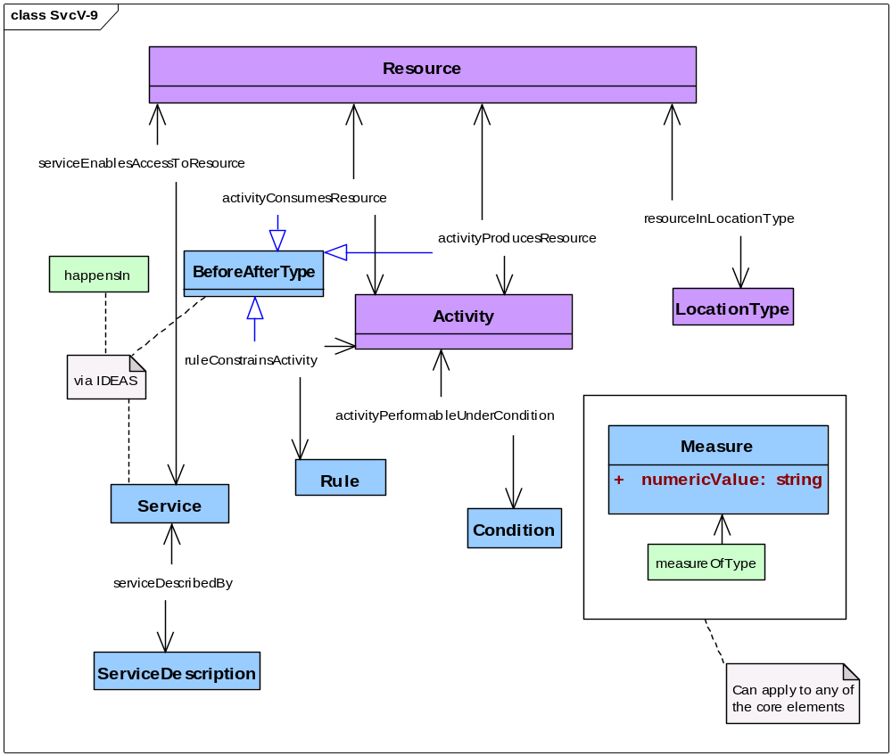
Figure 3.7.10-49: DoDAF meta-model diagram for SvcV-9 models
- Alternative names: Services Technology & Skills Forecast, S&T Roadmap S&T Master Plan.

Introduction to SvcV-10 models
- Many of the critical characteristics of an architecture are only discovered when an architecture’s dynamic behaviors are defined and described. These dynamic behaviors concern the timing and sequencing of events that capture resource performance characteristics (e.g., a performer executing service functions described by an SvcV-4 Service System Activities model).
- Behavioral modeling and documentation are key to successful architecture description because understanding how an architecture behaves is often crucial. Although knowledge of the functions and interfaces is also crucial, knowing whether, for example, a response should be expected after sending message X to service Y can be crucial to successful overall operations.
- The SvcV-10 models support net-centric (service-oriented) implementation of services as orchestrations of services. The SvcV-3 Service Relationships model can provide input for the SvcV-10 models. Three types of models may be used to adequately describe the dynamic behavior and performance characteristics of services. These three models are:
- Service Rules (SvcV-10a),
- Service State Transitions (SvcV-10b), and
- Service Sequences (SvcV-10c).
- SvcV-10b and SvcV-10c models may be used separately or together to describe timing and sequencing behavior.
- Both SvcV-10b and SvcV-10c models describe functional responses to sequences of events. Events may also be referred to as inputs, transactions, or triggers. When an event occurs, the action to be taken may be subject to a rule or set of rules described in an SvcV-10a model.

Service Rules (SvcV-10a)
- Description. This model identifies and describes the rules that guide activities performed by services within a described architecture.
- Narrative. This model emphasizes (a) rules and other guidance that constrain activities and (b) conditions under which activities are performed. Rules themselves are not four-dimensional; thus, performers require descriptions of applicable rules—such descriptions do exist in space and time. Such descriptions are a sort of information, which is a sort of resource that may be consumed and produced by real activities for real performers.
- Conditions exist within the four-dimensional environment of activities but are not necessarily four-dimensional things within that context. Conditions such as adversary morale and unit cohesion may be real but they are not immediately accessible as architectural data; thus, performers, as with rules, require descriptions of applicable conditions—such descriptions are accessible in space and time. As with rules, such descriptions are a sort of information, which is a sort of resource that may be consumed and produced by real activities for real performers.
- Rules and conditions are considered together in SvcV-10a models because both impose constraints on the performance of activities. In particular, different rules may apply to an activity under different conditions. Rules may be related to measures; for example, rules that are criteria of UJTL task performance standards are to be related to corresponding measures. Similarly, conditions affecting UJTL task performance are to be related to corresponding measures. Measures related to rules and conditions may include physical and temporal measures.
- Activities are seen in SvcV-10a models as they are in other DoDAF models. An activity consumes resources to produce resources. An activity is constrained by guidance, rules, and standards, and performers carry out an activity under conditions that affect its performance.
- Rules and conditions for activities may depend upon the location of those activities. Resources are related to their locations and the location of these resources determines the location of activities that consume and produce them.
- In contrast to OV-6a models and SV-10a models, services are to be related to activities that these services perform following these rules and under these conditions. In addition to services, other performers, including performers capable of responsibility and systems, may be addressed by SvcV-10a models. Services may be related to resources produced by activities as well as related to those resources through the activities that produce them.
- In SvcV-10a models, each service is described by a service description; a service description is a sort of information, which is a sort of resource that may be consumed and produced by real activities for real performers.
- Services, service descriptions, activities, rules, conditions, measures, and resources shall be modeled. In particular, information resources that describe rules shall be modeled and information resources that describe conditions may be modeled. In addition, a service description shall be modeled for each modeled service. Rules shall be modeled for each activity identified in the corresponding SvcV-4 models of an architectural description that a service performs. Performers that are services shall be modeled. Other performers, including performers that are systems, may be modeled. Types of locations may be modeled. Measures for rules and conditions may include physical measures and temporal measures. Measures related to activities, performers, and locations may be modeled.
- Meta-model. Figure 3.7.12-50 shows the DoDAF meta-model for SvcV-10a models.
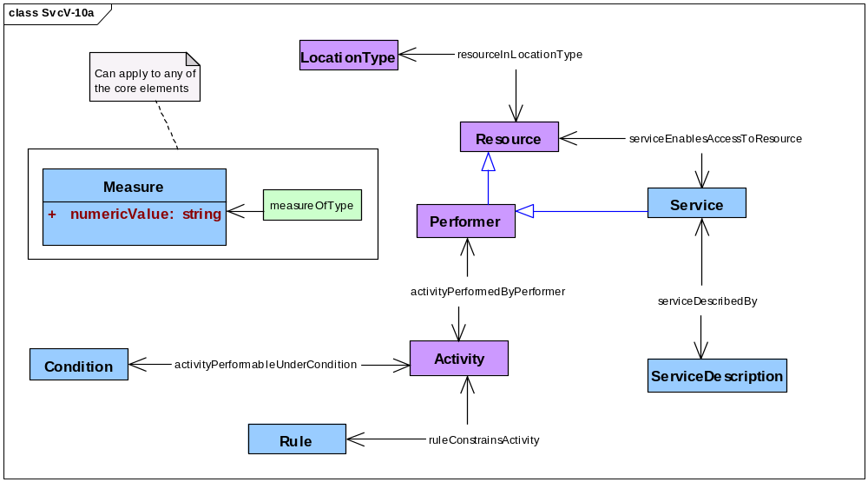
Figure 3.7.12-50: DoDAF meta-model diagram for SvcV-10a models
- Alternative names: Services Rules Model, SoA Framework, SoA Standards, SoA Business Rules.

Service State Transitions (SvcV-10b)
- Description. This model identifies and describes changes in the states of resources that are consumed and produced by activities performed by services within a described architecture.
- Narrative. This model emphasizes certain interesting temporal parts of a resource, specifically those temporal parts that are distinguished by the attainable states of the resource. Each interesting temporal part is related to a property that distinguishes these temporal parts from one another across the whole-life of a resource. These properties are related to activities because an activity transforms an earlier temporal part of a resource with certain properties (input) into a later temporal part with altered properties (output).
- A resource with states (i.e., temporal parts observed as resources with properties that may change) generally does not play the role of a trigger for an activity that changes the state of that resource (see note for OV-6b). Therefore, an SvcV-10b model may want to identify other resources that do play the role of a trigger for activities that change the properties of the resource that is the subject of a model.
- A measure is the sort of property that characterizes the state of a resource. In particular, SvcV-10b models may examine physical measures and temporal measures to characterize resource states, and they use before-after relationships to order the changes in these measures, that is, the state transitions of a resource.
- An SvcV-10b model focuses on some selected resource whose properties may change in interesting ways. In contrast, an SV-4 model covers all resources within the scope of a specific SV-4 model. Performers that are services are resources that frequently exhibit state transitions that are interesting for SvcV-10b models because services in different states could perform different activities or access different resources through different activities. SvcV10-b models relate each service to a description of that service. Services may be analyzed
- Activities are seen in SvcV-10b models as they are in other DoDAF models. An activity consumes resources to produce resources. An activity is constrained by guidance, rules, and standards, and performers carry out an activity under conditions that affect its performance. Rules and conditions are seen in SvcV-10b models as they are in SvcV-10a models. Descriptions of rules and conditions are sorts of information, and information is a sort of resource that may be consumed and produced by real activities for real performers. Thus, SvcV-10b models may look at changes in rules and conditions by examining the state transitions of their descriptions.
- Services, service descriptions, activities, and resources shall be modeled. Physical measures and temporal measures shall be modeled. Information resources that describe rules shall be modeled and information resources that describe conditions may be modeled. Before-after relationships among activities and between resources in sequential states shall be modeled. Types of locations of activities and resources may be modeled. Services that are performers whose state transitions are the subject of an SvcV-10b model shall be modeled. Performers that are capable of responsibility may be modeled. Performers that are systems may be modeled as performers in SvcV-10b models. Measures related to activities, rules, performers, conditions, and locations may be modeled.
- Meta-model. Figure 3.7.13-51 shows the DoDAF meta-model for SvcV-10b models.
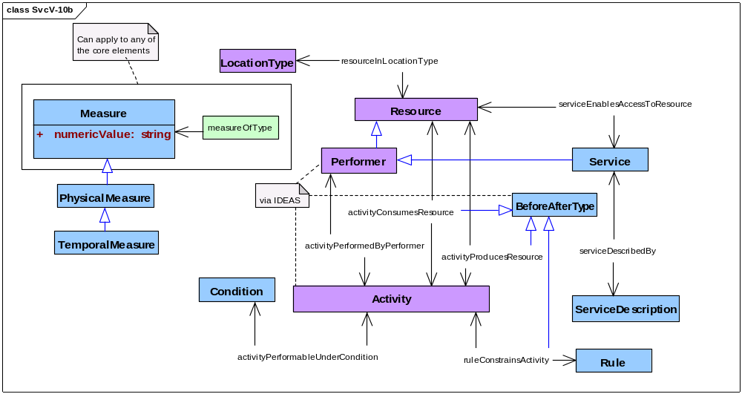
Figure 3.7.13-51: DoDAF meta-model diagram for SvcV-10b models
- Alternative names: Services State Transition Description.

Service Activity Sequences (SvcV-10c)
- Description. This model identifies and describes sequences of activities performed by services within a described architecture..
- Narrative. This model emphasizes some interesting sequence of activities taken from the set of all activities within an architecture description. The DoDAF meta-model does not prescribe what ought to be interesting. SvcV-10c models specify sequence using before-after relationships. Thus, SvcV-10c models are concerned with temporal measures related to the succession of activities and with physical measures related to changes in the states of resources. The focus of SvcV-10c models is on activities performed by services.
- Activities are seen in SvcV-10c models as they are in other DoDAF models. An activity consumes resources to produce resources. An activity is constrained by guidance, rules, and standards, and performers carry out an activity under conditions that affect its performance. Performers in SvcV-10c models are services, systems, and performers capable of responsibility. Rules and conditions are seen in SvcV-10c models as they are in SvcV-10a models. Descriptions of rules and conditions are sorts of information, and information is a sort of resource that may be consumed and produced by real activities for real performers. Thus, SvcV-10c models may examine the production of rules descriptions and condition descriptions.
- An SvcV-10c model identifies and describes measures that are related to services and activities. SvcV-10c models may also identify and describe measures that apply to rules, conditions, resources, other performers, and locations. Guidance of various sorts may refer to measures applicable to activities, and specific measures for activities may be drawn from such guidance.
- Services, service descriptions, activities, and resources shall be modeled. Rules, conditions, and types of locations may be modeled. The sequential structure of activities shall be modeled using before-after relationships. Systems and performers capable of responsibility may be modeled. Specific organizations may be modeled. Measures related to services, activities, rules, conditions, resources, other performers, and locations may be modeled.
- Meta-model. Figure 3.7.14-52 shows the DoDAF meta-model for SvcV-10c models.
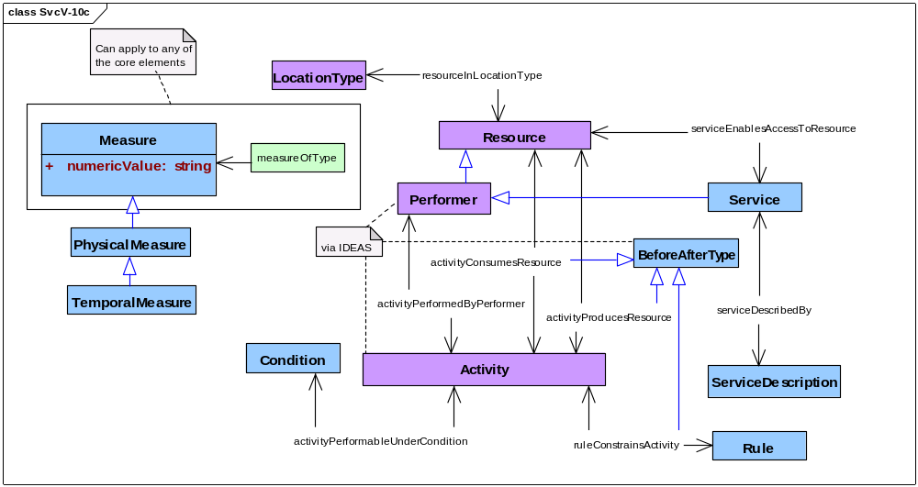
Figure 3.7.14-52: DoDAF meta-model diagram for SvcV-10c models
- Alternative names: Services Event-Trace Description.

Standards Viewpoint (StdV)
- The Standards Viewpoint looks at the sets of rules governing the arrangement, interaction, and interdependence of parts or elements of a described architecture. These sets of rules can be captured at the organizational level and applied to each solution, while each solution’s architecture description shows just those rules pertinent to the described architecture. Its purpose is to ensure that a solution satisfies a specified set of operational or capability requirements. Standards Viewpoint models shows the doctrinal, operational, business, technical, and industry guidelines upon which engineering specifications are based, common building blocks are established, and solutions are developed. It includes a collection of the doctrinal, operational, business, technical, or industry standards, implementation conventions, standards options, rules, and criteria that can be organized into profiles that govern solution elements for a given architecture. Current DoD guidance requires the technical standards portions of models be produced from the DoD Information Technology Standards and Profile Registry (DISR) to determine the minimum set of standards and guidelines for the acquisition of all DoD systems that produce, use, and exchange information.
- Table 3.8-8 names and describes Standards Viewpoint models.
Table 3.8-8: Standards Viewpoint models
Models | Descriptions
StdV-1 Standards Profile | Presents rules that constrain activities and their performers.
StdV-2 Standards Forecast | Presents rules that will constrain activities and their performers in the future.

Standards Profile (StdV-1)
- Description. This model identifies and describes the rules that constrain activities and their performers within a described architecture.
- Narrative. Activities are guided and constrained by rules. Such rules include standards of many kinds, including technical standards. Standards and other rules affect performers of activities; these performers must abide by the rules that apply to specific activities. Conditions under which specific rules apply to an activity may be modeled. Measures may be related to modeled activities; performers; rules, standards, and technical standards; and conditions. This model focuses on rules that currently (at some specified time) apply to activities within a described architecture.
- Meta-model. Figure 3.8.1-53 shows the DoDAF meta-model for StdV-1 models.
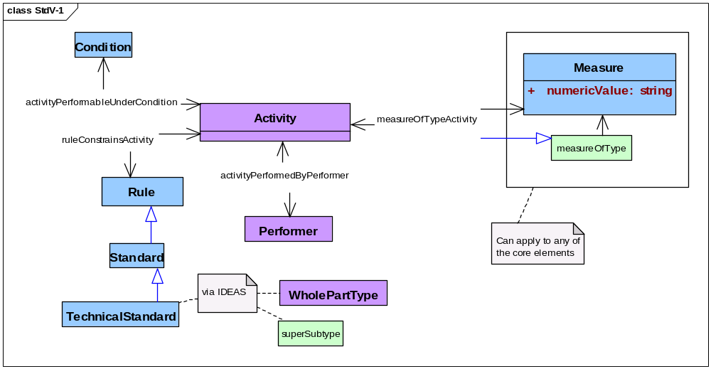
Figure 3.8.1-53: DoDAF meta-model diagram for StdV-1 models
- Alternative names: Technical View; Technical Standards.
- Notes. In the Standards Viewpoint, standards are called into play by the activities to be performed and they apply to performers only in virtue of the roles performers enact when they perform a given activity. The same performer in different roles with respect to different activities may be governed by different standards for these different activities. Conversely, the same standards may apply to different performers of a given activity. Therefore, rules are directly related to activities with their conditions, and performers are related to rules through the activities that performers carry out.

Standards Forecast (StdV-2)
- Description. This model identifies and describes the rules that will constrain activities and their performers within a described architecture in the future.
- Narrative. Activities are guided and constrained by rules. Such rules include standards of many kinds, including technical standards. Standards and other rules affect performers of activities; these performers must abide by the rules that apply to specific activities. Conditions under which specific rules apply to an activity may be modeled. Measures may be related to modeled activities; performers; rules, standards, and technical standards; and conditions. An StdV-2 model differs from an StdV-1 model by modeling foreseeable successions of standards that might apply to modeled activities in the future, that is, after the time specified by a corresponding StdV-1 model.
- Meta-model. Figure 3.8.2-54 shows the DoDAF meta-model for StdV-2 models.
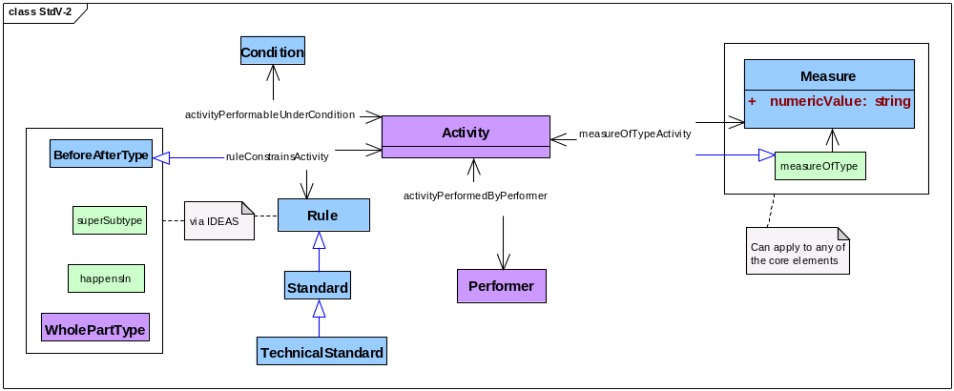
Figure 3.8.2-54: DoDAF meta-model diagram for StdV-2 models
- Alternative names: none.
- Notes. See Notes for StdV-1. In principle, an StdV-2 model can look at historical successions of standards as well as anticipated future successions of standards.

System Viewpoint (SV)
- System Viewpoint models identify and describe system resource flows, the means by which they occur, and rules and metrics associated with those resource flow, describe the composition (parts) of systems, the technical dependency, interface relationships among systems, the hierarchical structure of system activities (system functions) and their resource flows, organizational activities performed or supported by system functions, the mapping of systems to capabilities whose achievement they contribute toward, activities supported by a system, the measures (metrics) associated with systems, the system evolution plan, the emerging technologies, software/hardware products, and skills that are expected to be available in a given set of time frames and that will affect future system development, rules that constrain systems, the states systems transition to in response to events, and the sequences of triggering events and systems and services
- Systems provide or support both warfighting and business functions.

- Table 3.9-9 names and describes System Viewpoint models.
Table 3.9-9: Systems Viewpoint models
Models | Descriptions
SV-1 Systems Composition and Interface Identification | The identification of system resource flows and their composition
SV-2 Systems Interface Means | The means by which resource flows between systems occur
SV-3 Systems-Systems Matrix | The interface relationships among systems
SV-4 Systems and Services Functionality Description | The hierarchical structure of system activities and their resource flows
SV-5a Organizational Activities Supported by System and Service Functions | Organizational activities performed or supported by system functions
SV-5b Organizational Activities Supported by Systems and Services | A mapping of systems to capabilities whose achievement they contribute toward or activities supported by the system.
SV-6 Systems and Services Resource Flows | The details of resource flows among systems; the activities performed; the resources exchanged; and the attributes (rules and measures) associated with these exchanges
SV-7 Systems Measures Matrix | The measures (metrics) of systems
SV-8 Systems Evolution Description | The planned incremental steps toward migrating a suite of systems to a more efficient suite, or toward evolving a current system to a future implementation
SV-9 Systems Technology & Skills Forecast | The emerging technologies, software/hardware products, and skills that are expected to be available in a given set of time frames and that will affect future system development
SV-10a System and Service Rules | Rules that constrain systems and the activities they perform
SV-10b System and Service State Transition | The states systems transition to in response to events
SV-10c Systems and Services Event-Trace | A sequence of triggering events associated with resource flows and systems

Systems (SV-1)
- Description. This model identifies system resource flows and describes the composition (parts) of systems.
- Narrative. This model emphasizes performers that are systems and interfaces between these performers, specifically, the overlaps between systems performing activities that produce resources and systems performing other activities that consume those resources. The role of a resource with respect to these activities changes from resource produced to resource consumed at such an interface.
- Activities are seen in SV-1 models as they are in other DoDAF models. An activity consumes resources to produce other resources. At least one performer carries out an activity. An activity is constrained by guidance, rules, and standards. Performers may carry out activities under conditions that affect its performance. The sorts of locations where resources are produced and consumed by these activities may affect the specification of performers to carry out those activities.
- Resources produced and resources consumed include information, performers, and materiel. In SV-1 models, resources are produced by activities that are performed by systems and performers capable of responsibility; these performers include organizations and persons in roles. These produced resources are consumed by other activities similarly carried out by other systems and other performers capable of responsibility.
- SV-1 models may use whole-part relationships to examine the composition of performers. A system may be considered as a part of encompassing performers. Similarly, a system may be considered as a whole whose parts comprise resources of all sorts, including information, materiel, performers capable of responsibility, and other systems. The DoDAF does not prescribe nor limit the details or levels of composition that SV-1 models may provide.
- Interfacing systems and the activities they perform shall be modeled. The resources produced and consumed by these activities as performed by these interfacing systems shall be modeled. Performers capable of responsibility, including persons in roles and types of organizations, may be modeled. Guidance for activities carried out by systems as performers and conditions that affect the performance of these activities may be modeled. The types of locations of resources may be modeled. The composition of systems as performers may be modeled: thus, resources that include these interfacing systems may be modeled, and resources that are included in the composition of interfacing systems, such as information, materiel, types of organizations, and persons in roles may be modeled. Measures of systems, activities, resources, other performers, materiel, types of locations, rules, and conditions may be modeled. Services shall not be modeled by SV-1 models.

- Meta-model. Figure 3.9.1-55 shows the DoDAF meta-model for SV-1 models.
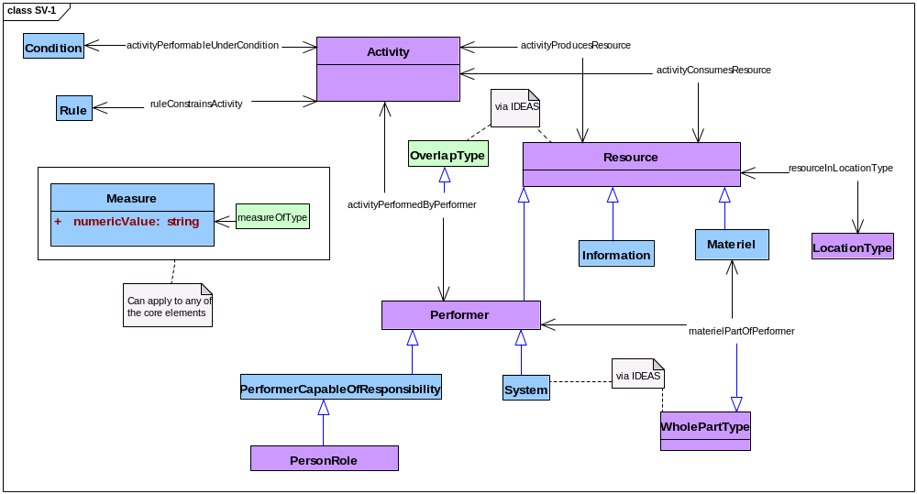
Figure 3.9.1-55: DoDAF meta-model diagram for SV-1 models
- Alternative names: Systems Interface Description; Systems and Services Composition and Interface Identification; Service Composition.
- Notes. In substance, SV-1 models and SV-2 models examine the same subjects: performers and their interfaces. Some organizations may give less emphasis to performer composition and activity guidance in SV-1 models and more emphasis on composition and guidance in SV-2 models. The DoDAF does not prescribe these emphases. Similarly, SV-1 models and SvcV-1 models examine the same topic. Some organizations may emphasize performers as systems in SV-1 models while others may emphasize performers as services in SvcV-1 models. The DoDAF does not prescribe these emphases.

System Interfaces (SV-2)
- Description. This model identifies and describes resources consumed and produced by activities performed by systems within a described architecture; in presentation, architectural-data are grouped by system and, within system, by system parts.
- Narrative. This model emphasizes performers that are systems and interfaces between performers, specifically, the overlaps between systems performing activities that produce resources and systems performing other activities that consume those resources. The role of a resource with respect to these activities changes from resource produced to resource consumed at such an interface.
- SV-2 models may consider any systems introduced by corresponding SV-1 models. SV-2 models may not introduce systems or activities that have not already been identified and described by corresponding SV-1 models. However, SV-2 models may look more closely at the parts of these services or activities.
- Activities are seen in SV-2 models much as they are in other DoDAF models. An activity consumes resources to produce other resources. At least one performer carries out an activity. An activity is constrained by guidance, rules, and standards; SV-2 models may pay particular attention to guidance. Performers may carry out activities under conditions that affect their performance; however. The sorts of locations where resources are produced and consumed by these activities may affect the specification of performers to carry out those activities.
- Resources produced and resources consumed include information, performers, and materiel. In SV-2 models, resources are produced by activities that are performed by systems and performers capable of responsibility; these performers include organizations and persons in roles. These produced resources are consumed by other activities similarly carried out by other systems and other performers capable of responsibility.
- SV-2 models may use whole-part relationships to examine the composition of performers; SV-2 models may pay particular attention to system parts that constitute overlaps and to rules that constrain the activities performed by these system parts. A system may be considered as a part of encompassing performers. Similarly, a system may be considered as a whole whose parts comprise resources of all sorts, including information, materiel, performers capable of responsibility, and other systems. The DoDAF does not prescribe nor limit the details or levels of composition that SV-2 models may provide.
- Systems and the activities they perform shall be modeled. The resources produced and consumed by these activities as performed by these systems shall be modeled. Performers capable of responsibility, including persons in roles and types of organizations, may be modeled. Guidance for activities carried out by systems as performers and conditions that affect the performance of these activities may be modeled. The types of locations of resources may be modeled. The composition of systems as performers may be modeled: thus, resources that include these systems may be modeled, and resources that are included in the composition of systems, such as information, materiel, types of organizations, and persons in roles may be modeled. Measures of systems, activities, resources, other performers, materiel, types of locations, rules, and conditions may be modeled. Services shall not be modeled by SV-2 models.
- Meta-model. Figure 3.9.2-56 shows the DoDAF meta-model for SV-2 models.
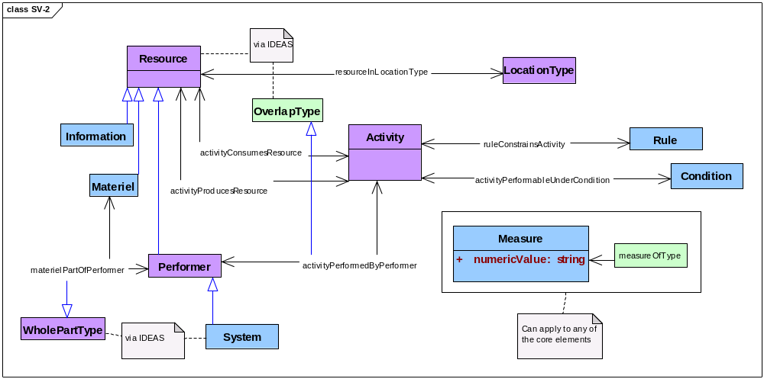
Figure 3.9.2-56 DoDAF meta-model diagram for SV-2 models
- Alternative names: Systems Resource Flow Description; Systems and Services Interface Means.
- Notes. In substance, SV-1 models and SV-2 models examine the same subjects: performers and their interfaces. Some organizations may give less emphasis to performer composition and activity guidance in SV-1 models and more emphasis on composition and guidance in SV-2 models. The DoDAF does not prescribe these emphases. Similarly, SV-2 models and SvcV-2 models examine the same topic. Some organizations may emphasize performers as systems in SV-2 models while others may emphasize performers as services in SvcV-2 models. The DoDAF does not prescribe these emphases.

System Relationships (SV-3)
- Description. This model identifies and describes relationships among systems within a described architecture.
- Narrative. This model emphasizes relationships among systems that are the subject of SV-1 models. The DoDAF does not prescribe system-to-system relationships that must be examined by SV-3 models. However, relationships considered by SV-3 models must be established by other models within the Service Viewpoint; SV-3 models may not themselves introduce system-to-system relationships.
- Systems shall be modeled. System-to-system relationships shall be modeled. Composition of systems may be modeled and interfaces between systems may be modeled. Activities, rules, conditions, resources, and types of locations may be modeled. Measures of systems, activities, rules, conditions, resources, and types of location may be modeled. Services shall not be modeled.
- Meta-model. Figure 3.9.3-57 shows the DoDAF meta-model for SV-3 models.
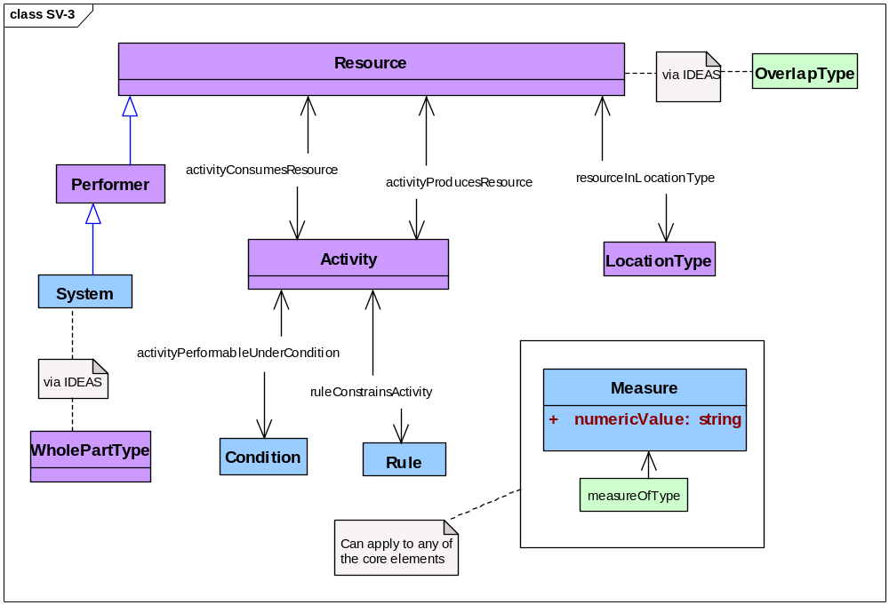
Figure 3.9.3-57: DoDAF meta-model diagram for SV-3 models
- Alternative names: Systems-Systems Matrix.
- Note. An SV-3 model may be considered simply as a report that presents interesting system-to-system relationships that have been captured as architectural data by other Service Viewpoint models within an architectural description.

System Functions (SV-4)
- Description. This model identifies and describes resources consumed and produced by activities performed by systems within a described architecture.
- Narrative. This model emphasizes the activities carried out by systems as performers within the scope of a described architecture. Any activity comprises other activities. Hierarchical recursive decomposition of activities into activity parts may be modeled using whole-part relationships between activity wholes and their activity parts. Activities may also be related by their similarities and their differences using super-subtype relationships.
- Activities are seen in SV-4 models as they are in other DoDAF models. An activity consumes resources to produce resources. Performers in SV-4 models are systems; these systems may have parts that are resources that are capable of responsibility—organizations and persons in roles—as well as materiel, systems, and services. Activities are constrained by guidance, rules, and standards, and activities are carried out under conditions that affect their performance.
- SV-4 models examine information and data as resources that are consumed and produced by activities performed by systems.
- An SV-4 model identifies and describes measures that are related to activities; in particular, an SV-4 model may examine measures that relate systems to the performance of activities carried out by those systems. SV-4 models may also identify and describe measures that apply to rules, conditions, resources, performers, and locations. Guidance of various sorts may refer to measures applicable to activities, and specific measures for activities may be drawn from such guidance.
- Systems and other performers that are parts of systems shall be modeled. Activities performed by systems shall be modeled. Resources, especially data and other information consumed and produced by activities performed by systems within an SV-4 model, shall be modeled. Rules, conditions, and types of locations may be modeled. The hierarchical structure of activities and the hierarchical structure of systems may be modeled using whole-part relationships. Activities and systems may be categorized using super-subtype relationships. Types of organizations and specific organizations may be modeled, and persons in roles may also be modeled. Measures related to systems, activities, rules, conditions, resources, constituent performers, and locations may be modeled. Services may not be modeled except as parts of systems.
- Meta-model. Figure 3.9.4-58 shows the DoDAF meta-model for SV-4 models.
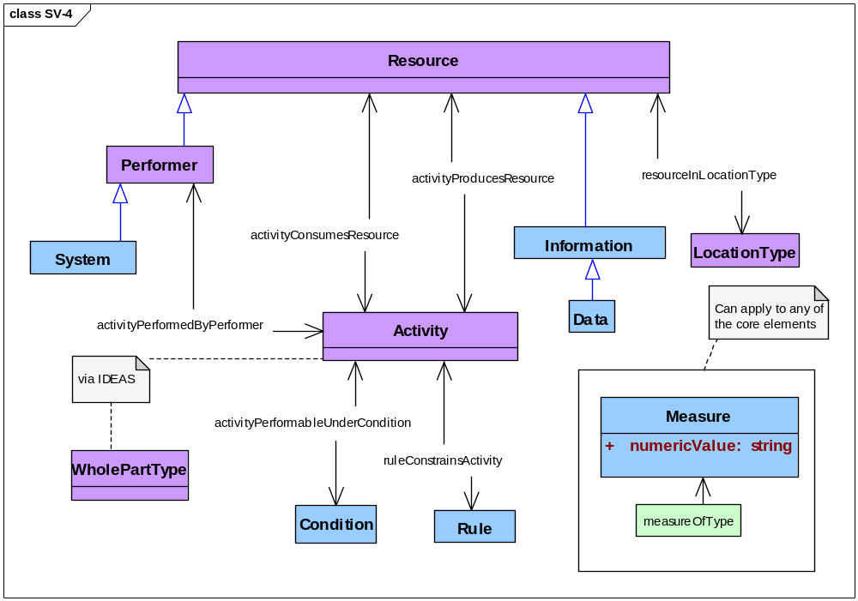
Figure 3.9.4-58: DoDAF meta-model diagram for SV-4 models
- Alternative names: Systems Functionality Description; Systems and Services Functionality Description.

Systems & Operational Activities (SV-5a)
- Description. This model identifies and describes relationships between systems and operational activities within a described architecture.
- Narrative. This model focuses on relationships between systems identified by SV-1 models and operational activities identified by OV-5b models. Systems perform system functions and system functions overlap operational activities.
- Operational activities considered by SV-5a models must be identified by OV-5b models; SV-5a models may not introduce operational activities into an architecture description. System functions considered by SV-5a models must be identified by corresponding SV-4 models; SV-5a models may not introduce activities performed by systems into an architecture description. Operational activities considered by SV-5a models must overlap system functions identified by corresponding SV-4 models.
- Systems considered by SV-5a models must be identified by SV-1 models; SV-5a models may not introduce systems into an architecture description. All systems identified by SV-1 models are to be related by SV-5a models to operational activities identified by corresponding OV-5b models. However, the converse does not necessarily hold: there may be activities identified by OV-5b models that have no part that is performed by a system. Further, a system may perform a system function that overlaps with more than one operational activity within a described architecture, and an operational activity may overlap with system functions that are performed by more than one system within a described architecture.
- Beyond an existence predicate, the DoDAF does not prescribe relationships that must be examined by SV-5a models. However, the existence predicate must be true for all pairs of an operational activity and a system considered by SV-5a models: the system performs a system function that overlaps the operational activity.
- Systems and activities shall be modeled. Relationships between systems and activities shall be modeled. Composition of systems, composition of activities, and overlap of activities may be modeled. Rules, conditions, resources, and types of locations may be modeled. Measures of systems, activities, rules, conditions, resources, and types of location may be modeled. Services shall not be modeled.
- Meta-model. Figure 3.9.5-59 shows the DoDAF meta-model for SV-5a models.
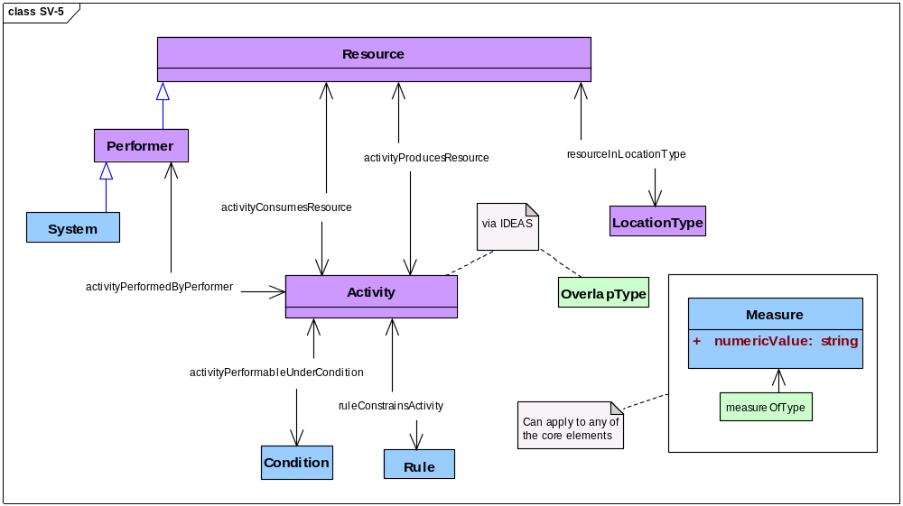
Figure 3.9.5-59: DoDAF meta-model diagram for SV-5a models
- Alternative names: Operational Activity to Systems Function Traceability Matrix; Organizational Activities Supported by System and Service Functions.

Systems & Capabilities (SV-5b)
- Description. This model identifies and describes relationships between systems and capabilities within a described architecture.
- Narrative. This model focuses on relationships between systems identified by SV-1 models and capabilities identified by CV-1 models. Systems perform system functions, system functions overlap operational activities, and operational activities produce those resources that constitute desired effects.
- Capabilities considered by SV-5b models must be identified by CV-1 models; SV-5b models may not introduce capabilities into an architecture description. The operational activities that produce the resources that constitute the desired effects of these capabilities are identified by CV-6 models.
- Operational activities considered by SV-5b models must be identified by CV-6 models; SV-5b models may not introduce operational activities into an architecture description. System functions considered by SV-5b models must be identified by corresponding SV-4 models; SV-5b models may not introduce activities performed by systems into an architecture description. Operational activities considered by SV-5b models must overlap system functions identified by corresponding SV-4 models.
- Systems considered by SV-5b models must be identified by SV-1 models; SV-5b models may not introduce systems into an architecture description. All systems identified by SV-1 models are to be related by SV-5b models to operational activities identified by corresponding CV-6 models. However, the converse does not necessarily hold: there may be activities identified by CV-6 models that have no part that is performed by a system. Further, a system may perform a system function that overlaps with more than one operational activity within a described architecture, and an operational activity may overlap with system functions that are performed by more than one system within a described architecture.
- Beyond an existence predicate, the DoDAF does not prescribe relationships that must be examined by SV-5b models. However, the existence predicate must be true for all pairs of a capability and a system considered by SV-5b models: the system identified by a SV-1 model performs a system function that overlaps an operational activity that produces a resource that is a constituent of a desired effect identified by a CV-1 model.
- Systems and capabilities shall be modeled. Relationships between systems and capabilities shall be modeled. Composition of systems, composition of activities, and overlap of activities may be modeled. Resources that constitute desired effects may be modeled. Rules, conditions, other resources, and types of locations may be modeled. Measures of systems, capabilities, activities, rules, conditions, resources, and types of location may be modeled. Services shall not be modeled.
- Meta-model. Figure 3.9.6-60 shows the DoDAF meta-model for SV-5b models.
Figure 3.9.6-60: DoDAF meta-model diagram for SV-5b models
- Alternative names: Operational Activity to Systems Traceability Matrix; Organizational Activities Supported by Systems and Services.
- Note. The activities identified by CV-6 models are a proper subset of the activities identified by OV-5b models.

Systems, Activities, & Resources (SV-6)
- Description. This model identifies and describes resources consumed and produced by activities performed by systems within a described architecture.
- Narrative. This model emphasizes the exchange of resources among systems. These resources include information, materiel, and performers. A dependency between a resource to be consumed by one activity and a resource produced by another activity may be described as a flow of resources from producer to consumer. Activities are modeled in SV-6 models only in detail sufficient to show the relationships between resources produced by activities performed by one system and the resources consumed by activities performed by other systems.
- Activities are seen in SV-6 models much as they are in other DoDAF models. An activity consumes resources to produce resources. Performers in SV-6 models are systems. Systems follow guidance, rules, and standards to carry out their activities, and systems carry out their activities under conditions that affect their performance.
- Systems and other resources may be related to their locations to ensure that resources to be consumed are available to activities when and where those resources are needed and that systems are there to carry out those activities when those resources are available.
- In contrast to SV-4 models, SV-6 models identify and describe measures that apply to activities and resources. SV-6 models provide physical and temporal measures that are related to resources. SV-6 models also provide measures of performance and of the satisfaction of needs that are related to activities. Guidance of various sorts may refer to types of applicable measures, and specific measures for specific activities may be drawn from such guidance.
- Systems, activities, and resources shall be modeled. In particular, resources that are data shall be modeled. Types of organizations shall be modeled; specific organizations may be modeled. Persons in roles may be modeled as parts of systems. Types of locations of resources and systems may be modeled, and specific locations may also be modeled. Rules and conditions may be modeled. Measures related to systems, activities, resources shall be modeled; these measures shall include physical measures, temporal measures, performance measures, and measures of need satisfaction. Measures related to rules, conditions, and locations may be modeled. Services shall not be modeled.
- Meta-model. Figure 3.9.7-61 shows the DoDAF meta-model for SV-6 models.
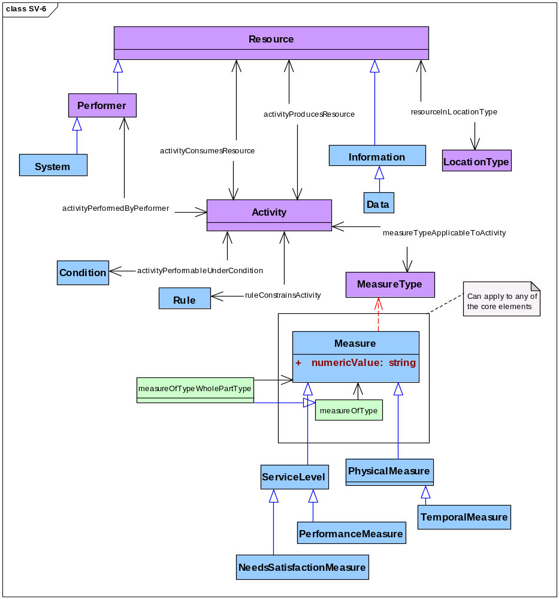
Figure 3.9.7-61: DoDAF meta-model diagram for SV-6 models
- Alternative names: Systems Resource Flow Matrix; Systems and Services Resource Flows.

System Measures (SV-7)
- Description. This model identifies and describes measures for evaluating systems within a described architecture.
- Narrative. This model emphasizes measures and focuses on measures applicable to systems that perform activities. A measure is the sort of property that characterizes the state of a resource. In particular, SV-7 models examine performance measures to characterize changes in system states.
- SV-7 models may examine both static properties of systems and their parts and dynamic properties of systems and their parts. SV-7 models may quantitatively examine the composition of measured resources using whole-part relationships. In particular, SV-7 models may examine the measurable skills of persons in roles in performing systems. SV-7 models may examine a system and its parts as resources—things produced or consumed—and SV-7 models may examine a system and its parts as performers performing an activity that consumes and produces other resources.
- An SV-7 model may focus on some selected resource whose properties may change in interesting ways. Performers that are systems are resources that frequently exhibit state transitions that are interesting for SV-7 models because systems in different states can perform different activities.
- Activities are seen in SV-7 models as they are in other DoDAF models. An activity consumes resources to produce resources. An activity is constrained by guidance, rules, and standards, and performers carry out an activity under conditions that affect its performance. In addition, SV-7 models look at sorts of measures that are applicable to activities and specify those sorts of measures that are appropriate for activities within the scope of the described architecture.
- Systems, persons in roles, activities, skills, performance measures, and types of measures for activities shall be modeled. Other measures of systems, persons in roles, activities, and skills may be modeled. Measures related to activities, rules, performers, conditions, and locations may be modeled. Types of locations of activities, systems, persons in roles, and other resources may be modeled. Performers that are services, organizations, or types of organizations may not be modeled as performers in SV-7 models.
- Meta-model. Figure 3.9.8-62 shows the DoDAF meta-model for SV-7 models.
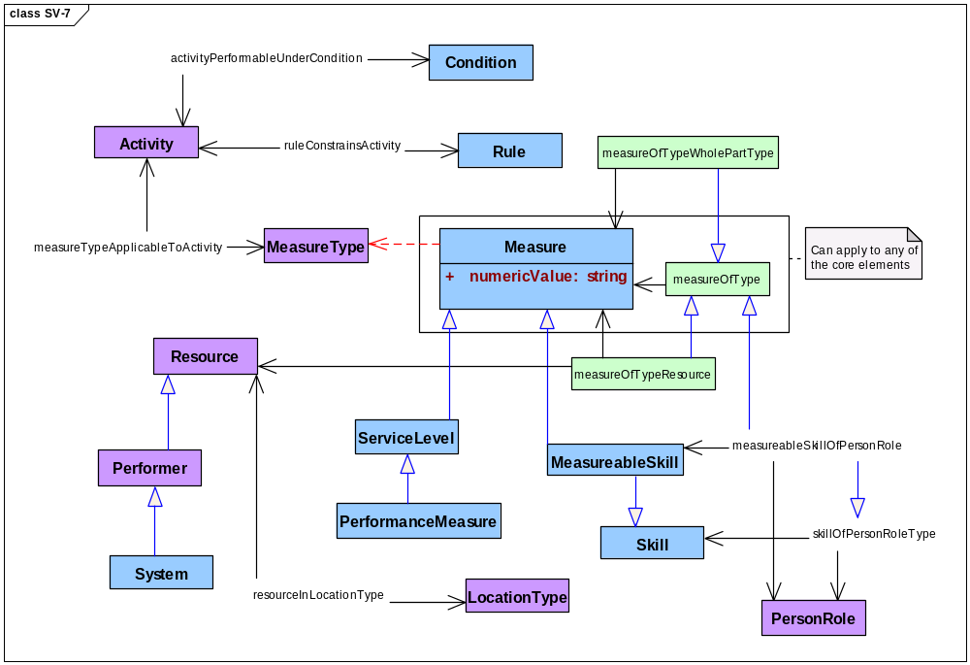
Figure 3.9.8-62: DoDAF meta-model diagram for SV-7 models
- Alternative names: Systems Measures Matrix.
- Note: An SvcV-7 model differs from an SV-7 model in these ways: first, services along with their descriptions are modeled by SvcV-7 models while SV-7 models look instead at systems and, second, SvcV-7 models must include maintainability measures within the measures that are modeled while SV-7 models do not have this requirement.

System Evolution (SV-8)
- Description. This model identifies and describes the temporal-states of systems within a described architecture.
- Narrative. The system is a functionally, physically, and/or behaviorally related group of regularly interacting or interdependent elements. As in other models within the System Viewpoint, a SV-8 model relates a system description to each system.
- SV-8 models examine the changing of resources, mapping the temporal state changes to allow comparison and examination of the resource and resource alternatives over time.
- SV-8 models allow comparison between historical (legacy), current (as-is), and future (to-be) capabilities to permit evaluation of change and the measure of the impact will have on the current system. This comparison is to be in the observation of system over a unit of time that will allow compare and contrast of other systems during the same period. The model shows the structure of each resource, using similar modeling elements as those used in SV-1.
- The SV-8, when linked together with other evolution Models such as CV-2 Capability Taxonomy, CV-3 Capability Phasing, and StdV-2 Standards Forecast, provides a rich definition of how the Enterprise and its capabilities are expected to evolve over time. These interactions will allow that the model can be used to support an architecture evolution project plan or transition plan.
- Changes depicted in the SV-8 DoDAF-described Model are derived from the project milestones that are shown in a PV-2 Project Timelines model. The PV-2 Project Timelines model is used for capability acquisition projects, there is likely to be a close relationship between these two models. The PV-3 will also be instrumental as it will provide the mapping of systems and projects to show how specific projects and program elements help achieve a capability.
- An SV-8 can either describe historical (legacy), current, and future capabilities against a timeline. The model shows the structure of each resource, using similar modeling elements as those used in SV-1. Interactions which take place within the resource may also be shown.
- The changes depicted in the SV-8 are derived from the project milestones that are shown in a PV-2 Project Timelines. When the PV-2 Project Timelines is used for capability acquisition projects, there is likely to be a close relationship between these two models.
- SvcV-8 models examine the changing of resources, mapping the temporal state changes to allow comparison and examination of the resource and resource alternatives over time.
- Meta-model. Figure 3.9.9-63 shows the DoDAF meta-model for SV-8 models.
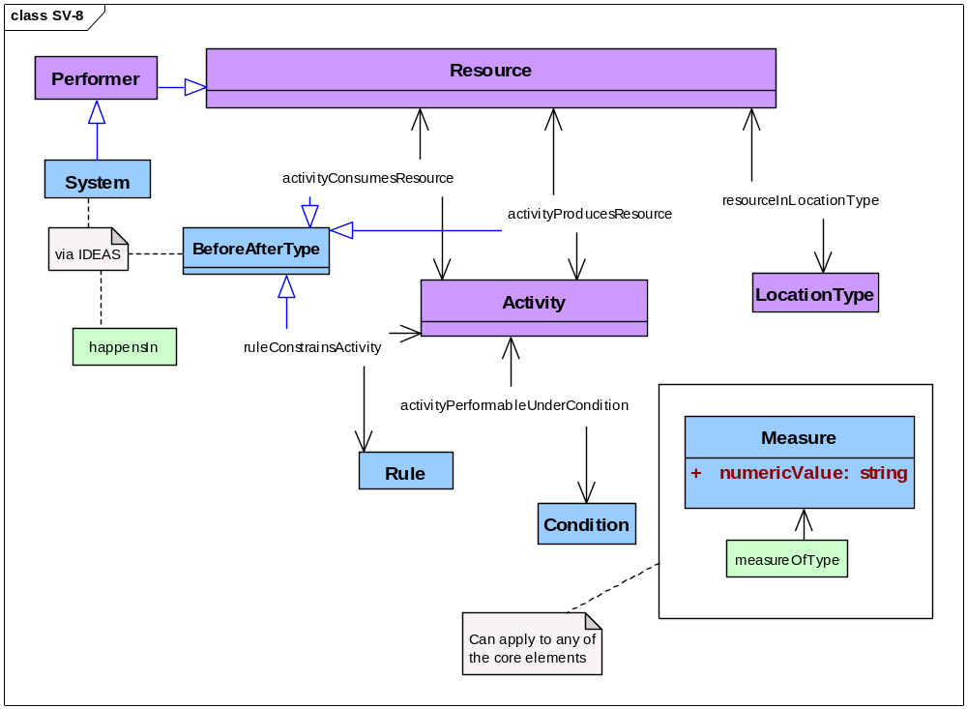
Figure 3.9.9-63: DoDAF meta-model diagram for SV-8 models
- Alternative names: Systems Evolution Description, System of Systems Roadmap,
- Plan of Action and Milestones (POA&M), Integrated Master Plan (IMP), System Deployment Plan, Services Lifecycle Management Plan, Enterprise Transition Plan.

System Technology & Skills (SV-9)
- Description. This model identifies and describes the precursors of temporal-states of systems within a described architecture.
- Narrative. The system is a functionally, physically, and/or behaviorally related group of regularly interacting or interdependent elements. The capabilities accessed are resources, that is, information and data, materiel, performers, and geo-political extents.
- As in other models within the System Viewpoint, a SV-9 model relates a system description to each system.
- SV-9 includes the precursors that record the systems that are active in the architecture prior (legacy), currently (as-is), and future (to-be) to allow examination of the compare and contrast between them.
- SV-9 defines the underlying current and expected supporting resources (technologies and skills) are those that can be reasonably forecast given the current state of technology and skills, and expected improvements or trends. New technologies and skills are tied to specific time periods, which can be correlated against the time periods used in SV-8 System Evolution model milestones and linked to Capability Phases. Additionally, the technologies and skills can also be coordinated with the StdV-2, Standards Forecast, that will contain expected changes in technology the model will allow looking at historical successions of standards as well as anticipated future successions of standards.
- A SV-9 summarizes predictions about trends in technology and personnel. Architects may produce separate SV-9 products for technology and human resources. The forecast includes potential impacts on current architectures and thus influences the development of transition and target architectures. The forecast is focused on technology and human resource areas that are related to the purpose for which a given architecture is being described and identifies issues affecting that architecture.
- SV-9 model may focus on a selected temporal time states in which a resource or a selection of resources will have their properties change in a particular way that will provide interesting variations for possible implementations.
- Alternatively, the SV-9 may relate forecasts to System Model elements (e.g., Services) where applicable. The list of resources potentially impacted by the forecasts can also be summarized as additional information in SV-9.
- Meta-model. Figure 3.9.10-64 shows the DoDAF meta-model for SV-9 models.
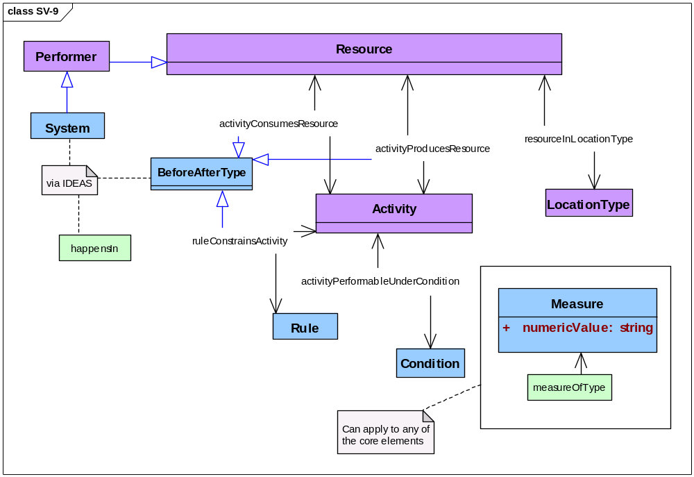
Figure 3.9.10-64: DoDAF meta-model diagram for SV-9 models
- Alternative names.

Introduction to SV-10 models
- Many of the critical characteristics of an architecture are only discovered when an architecture’s dynamic behaviors are defined and described. These dynamic behaviors concern the timing and sequencing of events that capture resource performance characteristics (e.g., a performer executing the system activities described in SV-4 models).
- Behavioral modeling and documentation are key to a successful architecture description, because it describes how the architecture behaves which is crucial in many situations. Although knowledge of the functions and interfaces is also crucial, knowing whether, for example, a response should be expected after sending message X to system activity Y can be crucial to successful overall operations.
- The SV-10 models are useful in support of net-centric (service-oriented) implementation of services as orchestrations of services. The SV-3 System Relationships model can provide input for the SV-10 models. Three types of models may be used to adequately describe the dynamic behavior and performance characteristics of system elements. These three models are:
- System Rules (SV-10a),
- Systems State Transitions (SV-10b), and
- System Sequences (SV-10c).
- SV-10b and SV-10c models may be used separately or together, as necessary, to describe critical timing and sequencing behavior in the System Viewpoint. Both types of diagrams are used by a wide variety of different systems methodologies.
- Both SV-10b and SV-10c models describe functional responses to sequences of events. Events may also be referred to as inputs, transactions, or triggers. When an event occurs, the action to be taken may be subject to a rule or set of rules as described in SV-10a models.

System Rules (SV-10a)
- Description. This model identifies and describes the rules that guide activities performed by systems within a described architecture.
- Narrative. This model emphasizes (a) rules and other guidance that constrain activities and (b) conditions under which activities are performed. Rules themselves are not four-dimensional; thus, performers require descriptions of applicable rules—such descriptions do exist in space and time. Such descriptions are a sort of information, which is a sort of resource that may be consumed and produced by real activities for real performers.
- Conditions exist within the four-dimensional environment of activities but are not necessarily four-dimensional things within that context. Conditions such as adversary morale and unit cohesion may be real but they are not immediately accessible as architectural data; thus, performers, as with rules, require descriptions of applicable conditions—such descriptions are accessible in space and time. As with rules, such descriptions are a sort of information, which is a sort of resource that may be consumed and produced by real activities for real performers.
- Rules and conditions are considered together in SV-10a models because both impose constraints on the performance of activities. In particular, different rules may apply to an activity under different conditions. Rules may be related to measures; for example, rules that are criteria of UJTL task performance standards are to be related to corresponding measures. Similarly, conditions affecting UJTL task performance are to be related to corresponding measures. Measures related to rules and conditions may include physical and temporal measures.
- Activities are seen in SV-10a models as they are in other DoDAF models. An activity consumes resources to produce resources. An activity is constrained by guidance, rules, and standards, and performers carry out an activity under conditions that affect its performance.
- Rules and conditions for activities may depend upon the location of those activities. Resources are related to their locations and the location of these resources determines the location of activities that consume and produce them.
- In contrast to OV-6a models and SvcV-10a models, systems are to be related to activities that these systems perform following these rules and under these conditions. Performers that are persons in roles may be included in OV-10a models, but neither types of organizations nor specific organizations are to be included. Services are not addressed by SV-10a models.
- Systems, activities, rules, conditions, measures, and resources shall be modeled. In particular, information resources that describe rules shall be modeled and information resources that describe conditions may be modeled. Rules shall be modeled for each activity identified in the corresponding SV-4 models of an architectural description that a system performs. Performers that are systems shall be modeled. Performers that are persons in roles may be modeled. Performers that are organizations, types of organizations, or services shall not be modeled. Types of locations may be modeled. Measures for rules and conditions may include physical measures and temporal measures. Measures related to activities, performers, and locations may be modeled.
- Meta-model. Figure 3.9.12-65 shows the DoDAF meta-model for SV-10a models.
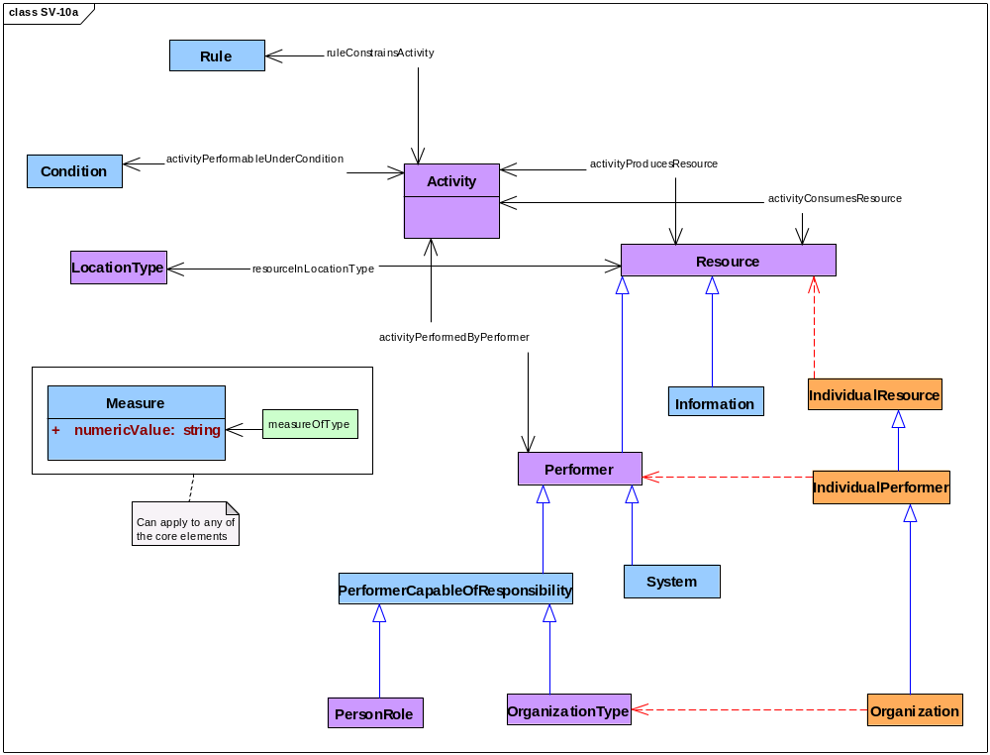
Figure 3.9.12-65: DoDAF meta-model diagram for SV-10a models
- Alternative names: Systems Rules Model; System and Service Rules.

System State Transitions (SV-10b)
- Description. This model identifies and describes changes in the states of resources that are consumed and produced by activities performed by systems within a described architecture.
- Narrative. This model emphasizes certain interesting temporal parts of a resource, specifically those temporal parts that are distinguished by the attainable states of the resource. Each interesting temporal part is related to a property that distinguishes these temporal parts from one another across the whole-life of a resource. These properties are related to activities because an activity transforms an earlier temporal part of a resource with certain properties (input) into a later temporal part with altered properties (output).
- A resource with states (i.e., temporal parts observed as resources with properties that may change) generally does not play the role of a trigger for an activity that changes the state of that resource (see note for OV-6b). Therefore, an SV-10b model may want to identify other resources that do play the role of a trigger for activities that change the properties of the resource that is the subject of a model.
- A measure is the sort of property that characterizes the state of a resource. In particular, SV-10b models may examine physical measures and temporal measures to characterize resource states, and they use before-after relationships to order the changes in these measures, that is, the state transitions of a resource.
- An SV-10b model focuses on some selected resource whose properties may change in interesting ways. In contrast, an SV-4 model covers all resources within the scope of a specific SV-4 model. Performers that are systems are resources that frequently exhibit state transitions that are interesting for SV-10b models because systems in different states can perform different activities.
- Activities are seen in SV-10b models as they are in other DoDAF models. An activity consumes resources to produce resources. An activity is constrained by guidance, rules, and standards, and performers carry out an activity under conditions that affect its performance. Rules and conditions are seen in SV-10b models as they are in SV-10a models. Descriptions of rules and conditions are sorts of information, and information is a sort of resource that may be consumed and produced by real activities for real performers. Thus, SV-10b models may look at changes in rules and conditions by examining the state transitions of their descriptions.
- Systems, activities, and resources shall be modeled. Physical measures and temporal measures may be modeled. Information resources that describe rules shall be modeled and information resources that describe conditions may be modeled. Before-after relationships among activities and between resources in sequential states shall be modeled. Types of locations of activities and resources may be modeled. Systems that are performers whose state transitions are the subject of an SV-10b model shall be modeled. Performers that are persons in roles may be modeled. Performers that are services, organizations, or types of organizations may not be modeled as performers in SV-10b models. Measures related to activities, rules, performers, conditions, and locations may be modeled.
- Meta-model. Figure 3.9.13-66 shows the DoDAF meta-model for SV-10b models.
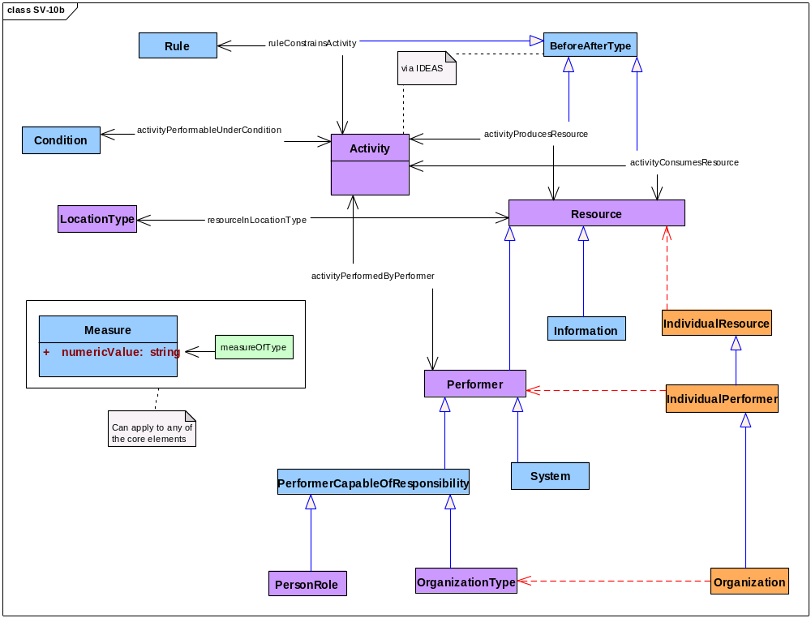
Figure 3.9.13-66: DoDAF meta-model diagram for SV-10b models
- Alternative names: Systems State Transition Description; System and Service State Transition.

System Activity Sequences (SV-10c)
- Description. This model identifies and describes sequences of activities performed by systems within a described architecture.
- Narrative. This model emphasizes some interesting sequence of activities taken from the set of all activities within an architecture description. The DoDAF meta-model does not prescribe what ought to be interesting. SV-10c models specify sequence using before-after relationships. Thus, SV-10c models are concerned with temporal measures related to the succession of activities and with physical measures related to changes in the states of resources. The focus of SV-10c models is on activities performed by systems.
- Activities are seen in SV-10c models as they are in other DoDAF models. An activity consumes resources to produce resources. An activity is constrained by guidance, rules, and standards, and performers carry out an activity under conditions that affect its performance. Performers in SV-10c models are systems and persons in roles. Rules and conditions are seen in SV-10c models as they are in SV-10a models. Descriptions of rules and conditions are sorts of information, and information is a sort of resource that may be consumed and produced by real activities for real performers. Thus, SV-10c models may examine the production of rules descriptions and condition descriptions.
- An SV-10c model identifies and describes measures that are related to systems and activities. SV-10c models may also identify and describe measures that apply to rules, conditions, resources, other performers, and locations. Guidance of various sorts may refer to measures applicable to activities, and specific measures for activities may be drawn from such guidance.
- Systems, activities, resources, and performers shall be modeled. Rules, conditions, and types of locations may be modeled. The sequential structure of activities shall be modeled using before-after relationships. Services, types of organizations, and specific organizations shall not be modeled, but persons in roles may be modeled. Measures related to systems, activities, rules, conditions, resources, other performers, and locations may be modeled. Performers that are services or types of organizations shall not be modeled; specific organization shall not be modeled.
- Meta-model. Figure 3.9.14-67 shows the DoDAF meta-model for SV-10c models.
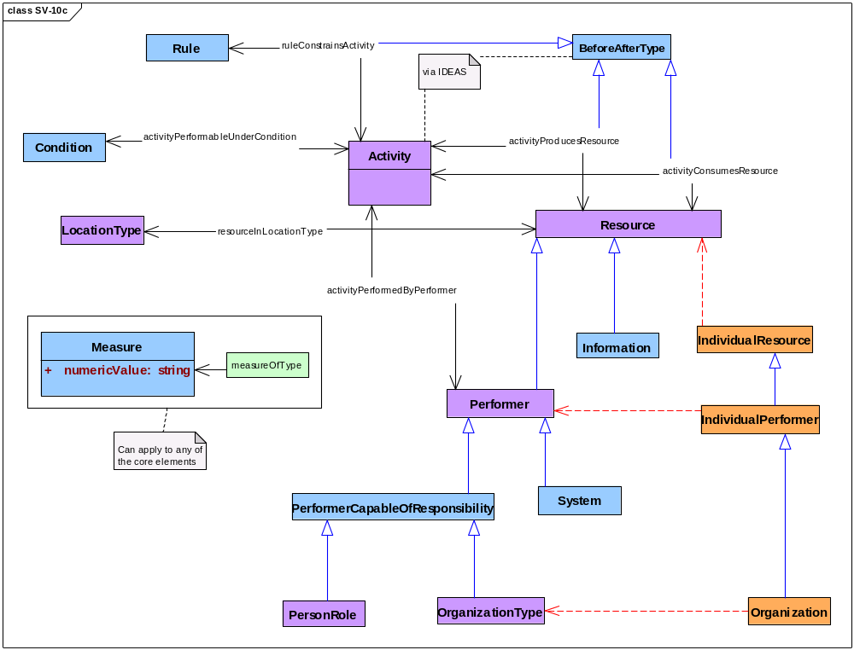
Figure 3.9.14-67: DoDAF meta-model diagram for SV-10c models
- Alternative names: Systems Event-Trace Description; Systems and Services Event-Trace, Operational Sequence Diagram.

Appendix A
Acronyms & Abbreviations

Acronym | Definition
AV | All Viewpoint
BPMN | Business Process Modeling Notation
CDM | conceptual data model
CM | configuration management
COI | community of interest
CPD | capability production document
CPM | capability portfolio management
CRD | capstone requirements document
CV | Capability Viewpoint
DAS | Defense Acquisition System
DDMS | Department of Defense Discovery Metadata Specification
DIV | Data and Information Viewpoint
DM2 | DoDAF meta-model
DoD | Department of Defense
DoDAF | Department of Defense Architecture Framework
DOTMLPF | doctrine, organization, training, material, leadership and education, personnel, and facilities
E-R | entity-relationship
EA | enterprise architecture
ERD | entity relationship diagram
IC-ISM | Intelligence Community – Intelligence Standard Markings
ICD | initial capabilities document
IDEAS | International Defence Enterprise Architecture Specification
IT | information technology
JCA | joint capability areas
JCIDS | Joint Capabilities Integration and Development System
OV | Operational Viewpoint
PE | program element
POM | Program Objective Memorandum
PPBE | Planning, Programming, Budgeting, and Execution
PV | Project Viewpoint
QoS | Quality of service
RDBMS | relational database management system
SCI | software configuration item
SE | systems engineering
SOA | service oriented architecture
SoS | system of systems
SV | Systems Viewpoint
SvcV | Services Viewpoint
StdV | Standards Viewpoint
TTP | tactics, techniques, and procedures
UJTL | Universal Joint Task List
UML | Unified Modeling Language
URL | universal resource locator
WBS | work breakdown structure
XML | eXtensible Markup Language
XSD | XML schema definition

Appendix B
Glossary of Core Terms

Appendix C
Glossary of Alias Terms

Appendix D
Source Definitions for Terms

Appendix E
Terms Applicable to DoDAF Viewpoints and their Models
- A mapping of the DM2 Concepts (classes), Associations (relationships), and Attributes to DoDAF-described Models, is shown in Table B-1. In the DM2 Concept, Association, or Attribute column, the Black text is a concept or attribute, the Red text is an association, and the Green Text is the security attributes in the DM2.
Table B-1: DM2 concepts, associations, and attributes mapping to DoDAF viewpoint models

Legend:
N = necessary data in this DoDAF-described Model
O = optional data in this DoDAF-described Model
Blank = cannot be a part of this DoDAF-described Model
F = IDEAS foundation common to all DoDAF-described Models
S = Classification markings common to all DoDAF-described Models
M = Metadata common to all DoDAF-described Models

Light Green background indicates this concept pertains to Architecture Metadata.
Grey background with green text indicates this concept is a security classification markings concept.

Appendix F
References and Bibliography
ANSI/EIA 748. Earned Value Management Systems.1998.
ANSI/GEIA 649-A. National Consensus Standard for Configuration Management American National Standards Institute.
CJCSI 3170.01G. Joint Capabilities Integration and Development System. Chairman of the Joint Chiefs of Staff, Department of Defense. 2009.
CJCSI 6212.01E, Interoperability and Supportability of Information Technology and National Security Systems. Chairman of the Joint Chiefs of Staff, Department of Defense. 2008.
CJCSM 3500.04F, Universal Joint Task Manual, Chairman of the Joint Chiefs of Staff, Department of Defense. 2011.
CTA 50-900. Common Table of Allowances: Clothing and Individual Equipment. U.S. Army. 2008.
CTA 50-909. Common Table of Allowances: Field And Garrison Furnishings And Equipment. 1993.
CTA 50-970. Common Table of Allowances: Expendable/Durable Items. U.S. Army. 2005.
DoDI 4630.8. Procedures for Interoperability and Supportability of Information Technology (IT) and National Security Systems (NSS). Office of the Assistant Secretary of Defense (OASD) Networks & Information Integration (NII)/ DoD Chief Information Officer (CIO). 30 June 2004.
DoDD 5000.01, The Defense Acquisition System, Department of Defense. 12 May 2003 (certified current as of November 20, 2007).
DoDI 5000.02. Operation of the Defense Acquisition System. Under-Secretary of Defense (OUSD) AT&L (Acquisition, Technology & Logistics). 2003.
DoDD 8115.01. Information Technology Portfolio Management. Office of the Assistant Secretary of Defense (OASD) Networks & Information Integration (NII)/DoD Chief Information Officer (CIO). October 10, 2005.
GAO-05-702. DoD Business Systems Modernization: Long-standing Weaknesses in Enterprise Architecture Development Need to Be Addressed. U.S. Government Accountability Office (GAO). July 2005.
GAO-03-584G. Framework for Assessing and Improving Enterprise Architecture Management, Version 1.1. U.S. Government Accountability Office (GAO). April 2003.
ISO 19136:2007. Geographic Information—Geography Markup Language (GML).
JP 1-02, Department of Defense Dictionary of Military and Associated Terms. Joint Staff, Department of Defense. 2011.
MIL-STD-196E. Joint Electronics Type Designation System. Department of Defense. 1998.
MIL-STD-881C: Work Breakdown Structures for Defense Materiel Items. Department of Defense. 2011.
Department of Defense Net-Centric Data Strategy, 9 May, 2003. Office of the Assistant Secretary of Defense (Networks & Information Integration) (NII)/DoD Chief Information Officer (DoD CIO).
DoD Acquisition Guidebook. Office of the Under-Secretary of Defense (OUSD) for Acquisition, Technology & Logistics (AT&L).
Global Information Grid (GIG) Architecture Federation Strategy, 1 August 2007. Office of the Assistant Secretary of Defense (Networks & Information Integration) (NII)/DoD Chief Information Officer (DoD CIO).
Information Sharing Environment Enterprise Architecture Framework (DRAFT) June, 2008. Office of the Program Manager, Information Sharing Environment.
Integrated Defense Acquisition, Technology, & Logistics Life Cycle Management Framework (2005). Defense Acquisition University, Ft. Belvoir, VA.
The Open Group Architecture Framework (TOGAF), Version 9.1. The Open Group. 2011.
A Guide to the Project Management Body of Knowledge (PMBOK Guide), 4th ed. Program Management Institute. 2008.

Planning and Programming: Planning includes the definition and examination of alternative strategies, the analysis of changing conditions and trends, threat, technology, and economic assessments in conjunction with efforts to understand both change and the long-term implications of current choices. Basically, it is a process for determining requirements. Programming includes the definition and analysis of alternative force structures, weapon systems, and support systems together with their multi-year resource implications and the evaluation of various tradeoff options. Basically, it is a process for balancing and integrating resources among the various programs according to certain priorities.

