

DoD Architecture Framework
Version 2.03
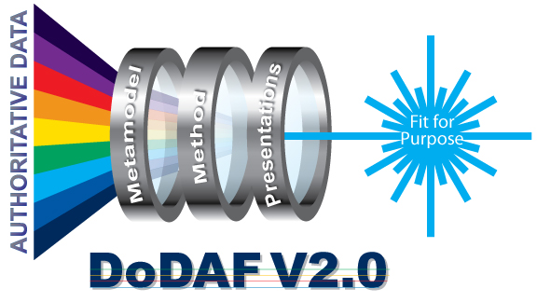

Volume 3: DoDAF Meta-model

Ontology Foundation and Physical Exchange Specification

Developer’s Guide

31 December 2011

This page left intentionally blank

TABLE OF CONTENTS

SECTION PAGE

1. INTRODUCTION 1
2. Purpose 1
3. DoDAF Physical Exchange Specification Error! Bookmark not defined.
4. EXCHANGE OF DM2 PES XML DOCUMENTS 1
5. DODAF V1.5 and DoDAF V2.0 Error! Bookmark not defined.

APPENDIX A - ACRONYMS A-1

List of Figures

FIGURE PAGE

Figure 4-1: Illustration of DM2 Role in Providing a Neutral Model for Data Exchange Error! Bookmark not defined.
Figure 4-2: PES XSD, PES XML, XMI, UML, and SysML Relationships Error! Bookmark not defined.

List of TABLES

TABLE PAGE

Table 3-1: List of Models and XSDs Error! Bookmark not defined.
Table 5-2: Exchange Actions betweens Architectures Error! Bookmark not defined.

Introduction
Department of Defense Architecture Framework (DoDAF) Version 2.0 introduces a DoDAF Meta-model (DM2), consisting of a Conceptual Data Model (CDM), Logical Data Model (LDM), and Physical Exchange Specification (PES) as an integral part of the architecture framework. Volume 3 introduces the DM2, which replaces the Core Architecture Data Model (CADM) referenced in previous versions of DoDAF.
The DM2 provides a means to collect architecture-related data, organize the data into useful information by architects and architecture Development Teams, store the information for later reuse, and facilitate management analysis of architectural data and information for decision-making purposes, as further described below.
This volume provides links for DoDAF PES files, the role of the PES and its’ relationships, and guidance for actions that need to be taken when exchanging architectural data between architectures developed using the same or different versions of DoDAF.

DoDAF Formal Ontology
The DM2 is founded upon the International Defence Enterprise Architecture Specification (IDEAS), a formal ontology foundation developed by the defense departments and ministries of the United States, United Kingdom, Canada, Australia, and Sweden in coordination the North Atlantic Treaty Organization (NATO). All DoDAF concepts and concept relationships inherit several rigorously defined mathematical properties from the IDEAS Foundation. A view of the upper levels of the IDEAS Foundation is shown in Figure 1.
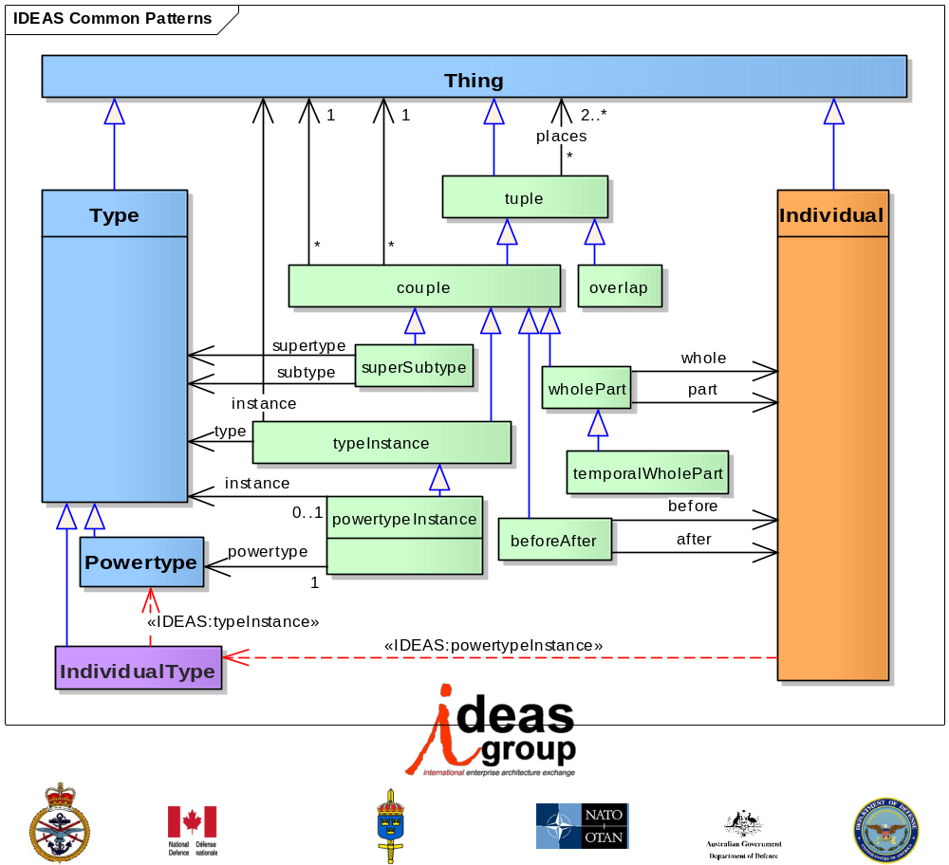
Figure 1. IDEAS Foundation Top-Level
The IDEAS Foundation is higher-order. It is extensional (see Extension [metaphysics]), using physical existence as its criterion for identity. In practical terms, this means the ontology is well suited to managing change-over time and identifying elements with a degree of precision that is not possible using names alone. The methodology for defining the ontology is very precise about criteria for identity by grounding reasoning about whether two things are the same using something that can be accurately identified. So, comparing two individuals, if they occupy precisely the same space at the same time, they are the same. Clearly this only works for individuals, but the principle can be used to compare types too. For two types to be the same, they must have the same members. If those members are individuals, their physical extents can be compared. If the members are types, then the analysis continues until individuals are reached, then they can be compared. The advantage of this methodology is that names are separated from things and so there is no possibility of confusion about what is being discussed. It is also four dimensionalist so that temporal parts (or states) can be represented, along with before-after behaviors. A partial bibliography of research and reference material used in deriving the IDEAS Foundation is included in the appendix to this document.
None of these foundation properties are unusual; they are all used in reasoning everyday. The basic concepts are:
- Three basic types of Things:
  - Individuals are Things that exist in 3D space and time, i.e., have 4D spatial-temporal extent.
  - Types, sets or collections of things. Two important Types are distinguished – ones whose members are Individuals and those whose members are other than Individuals. This is an important distinction between naïve set theory and type theory.
  - Tuples, ordered relations between things, e.g., ordered pairs in 2D analytic geometry, rows in relational database tables, and subject-verb-object triples in Resource Description Framework.
- Basic relationships:
  - Set theoretic:
    - Super-subtype; e.g., a type of system or service, capability, materiel, organization, or condition.
    - Type-instance, similar to “element of” in set theory
  - Mereologic:
    - Whole-part; e.g., components of a service or system, parts of the data, materiel parts, subdivisions of an activity, and elements of a measure.
    - Temporal whole-part; e.g., the states or phases of a performer, the increments of a capability or projects, the sequence of a process (activity).
  - 4D Topologic:
    - Overlap
    - Before-after
Several items are notable:
- Types include sets of Tuples and sets of sets.
- Tuples can have other Tuples in their tuple places.
- The participants in a super-subtype relationship can be from the same class, e.g., the supertype can be an instance of Measure Type as well as the subtype. This allows for representation of as much of a super-subtype taxonomy as is needed.
- Power Type members are generated from some Type by taking all the possible subsets of the members of the Type. For example consider the Type whose members are a, b, c. The powerset would be:
- For example, take the Individual Type AIRCRAFT, whose members include all the aircraft of the world. The powerset generated from this set would have:
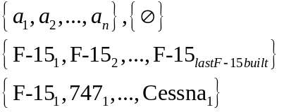
- Some of these subsets are not used by anyone, e.g., the full set, the null set, or just some random subset. However, the second one, which might be name F-15 Type, is quite useful. The last example is not useful to most unless you are interested in the first (assuming the subscript 1 means first) of any particular aircraft type, e.g., if you were doing a study of first-off-the-line aircraft production lessons-learned. This is the usefulness of Power Types and why they are employed in DM2: they allow for multiple categorization schemes, according to someone else’s use, yet traceability back to the common elements so that the relationships between multiple categorization schemes can be understood. This was a DM2 requirement – multiple categorization schemes or taxonomies – because across a large enterprise it is not possible to employ a single categorization scheme; rather schemes vary depending on function. For example, a weaponeer’s classifies ordnance is naturally different from a logistician’s, the former concerned with delivery means, lethality, etc. and the latter with weight, size, and other transportation issues.
- Note also that a powerset can then be taken of the powerset. This allows for build up of what is often called a taxonomic hierarchy. These are quite useful in enterprise Architectural Descriptions.
The DM2 utilizes the formal ontology of IDEAS because it provides:
- Mathematical rigor needed for precision Architectural Descriptions that can be analyzed and used in detailed processes such as Systems Engineering and Operations Planning.
  - type (~set) theory
  - 4D mereotopology
- Deals with issues of states, powertypes, measures, space -- what is truly knowable vs. what is assumed
- Separates signs and representations from referents
- DM2 domain concepts are extensions to the formal foundation
  - Rigorously worked-out common patterns are reused: Super-subtype, whole-part, temporal whole-part, type-instance, before-after, overlap
  - Saved a lot of repetitive work – “ontologic free lunch”
  - Model compactness through inheritance of superclass properties and common patterns.
  - Economizes implementations
  - Higher quality and consistency throughout due reuse of the rigorously worked-out common patterns
- Improved interoperation with Unified Profile for DoDAF and MODAF (UPDM)-SysML tools which are following IDEAS concepts.
- Improved opportunities for Coalition and NATO data exchange since MODAF is following IDEAS and NAF is interested in following IDEAS.
- Agreed-upon analysis principles that provide a principled basis for issue analysis
- Better ability to integrate and analyze EA data for EA purposes.
The advantage over free-text, structured documents, and databases in using this type of mathematically structured information is somewhat explained by Figure 2 that shows a spectrum of information structuring.
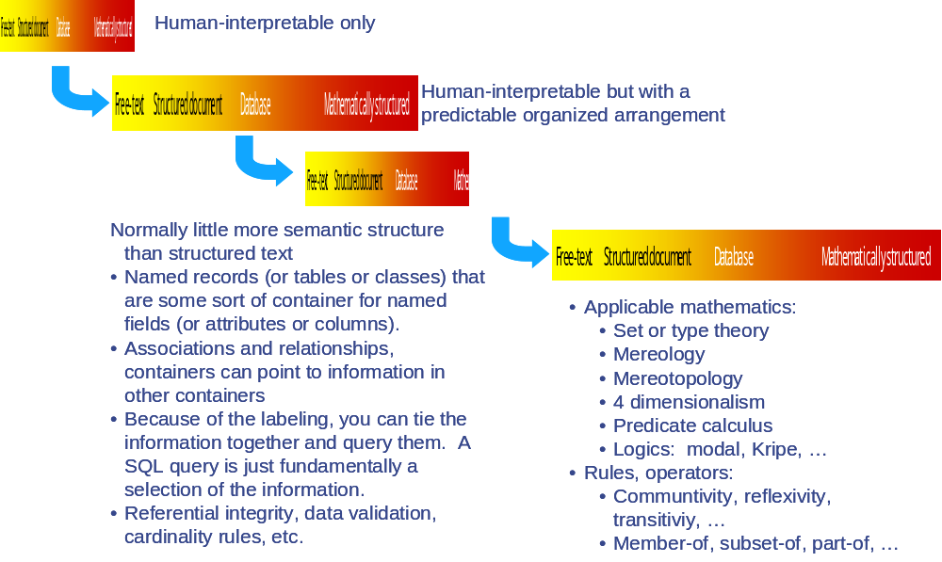
Figure 2. A Spectrum of Information Structuring
This shows that databases are really just storage and retrieval with connections only for exactly matching pieces of information (e.g., "keys" or exactly matching strings). The nature and purposes of EA require more than just storage, retrieval, and exchange, e.g., integration, analysis, and assessment across datasets. Founding DM2 on IDEAS provides the ontologic foundation supports entailment and other sorts of mathematical understanding of the data with membership (~ set theory) and 4D mereotopology (parts and boundaries). Some of these structures are so fundamental in human reasoning that it's hard to see that computers don't have it at all. But they are needed if we want to use them for something more than just storage and retrieval. They have to be encoded it into them with formal methods
The re-use patterns useful to Architectural Descriptions are shown in Figure 3
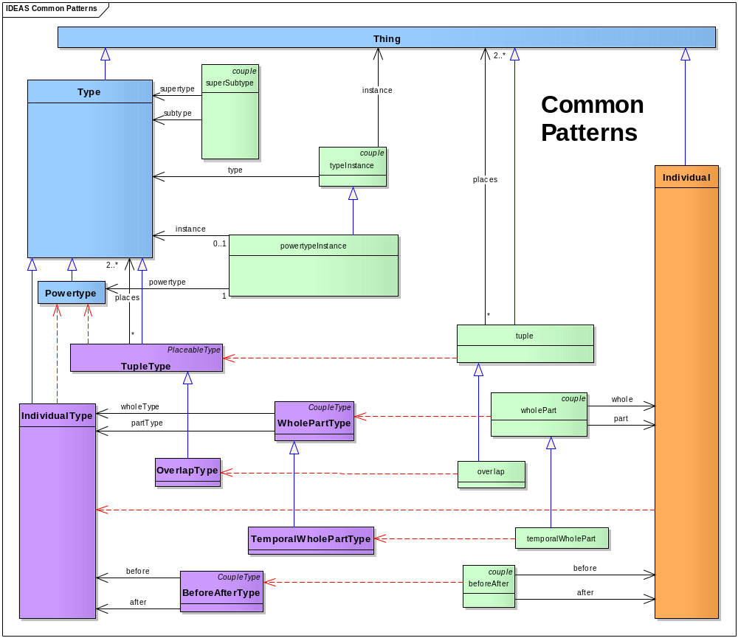
Figure 3. DM2 Common Patterns
The IDEAS foundation concepts, common to all data groups are shown in Table 1. It is important to remember that even though these are not repeated in the descriptions of the data groups, they are nevertheless present in the model and apply to the data group concepts according to the Doman Class Hierarchy shown in Figure 4 and Figure 5.
Table 1. IDEAS Foundation Concepts Applicable to all DoDAF Data Groups
IDEAS Concept | Definition
Classes
DescriptionScheme | A RepresentationScheme and DescriptionType whose members are intentionally descriptions
IndividualPerformer | A specific thing that can perform an action
Information | Information is the state of a something of interest that is materialized -- in any medium or form -- and communicated or received.
InformationType | Category or type of information
Location | A point or extent in space that may be referred to physically or logically.
LocationType | The powertype of Location
Measure | The magnitude of some attribute of an individual.
MeasureType | A category of Measures
Performer | Any entity - human, automated, or any aggregation of human and/or automated - that performs an activity and provides a capability.
Representation | A SignType where all the individual Signs are intended to signify the same Thing.
RepresentationScheme | A RepresentationType that is a collection of Representations that are intended to be the preferred Representations in certain contexts.
Resource | Data, Information, Performers, Materiel, or Personnel Types that are produced or consumed.
Rule | A principle or condition that governs behavior; a prescribed guide for conduct or action
ServiceLevel | A measurement of the performance of a system or service.
Thing | The union of Individual, Type, and tuple.
Associations
beforeAfter | A couple that represents that the temporal extent end time for the individual in place 1 is less than temporal extent start time for the individual in place 2.
BeforeAfterType | An association between two Individual Types signifying that the temporal end of all the Individuals of one Individual Type is before the temporal start of all the Individuals of the other Individual Type.
describedBy | A tuple that asserts that Information describes a Thing.
descriptionSchemeInstance | A representationSchemeInstance that asserts a Description is a member of a DescriptionScheme.
endBoundary | A temporal whole part couple that relates the temporal boundary to the whole.
EndBoundaryType | A temporal whole part couple that relates the temporal boundary to the whole taken over a Type.
measureOfIndividualEndBoundary | endBoundary is a member of Measure
measureOfIndividualStartBoundary | startBoundary is a member of Measure
measureOfTypeEndBoundaryType | endBoundaryType is a member of Measure
measureOfTypeStartBoundaryType | startBoundaryType is a member of Measure
namedBy | A couple that asserts that a Name describes a Thing.
namingSchemeInstance | A representationSchemeInstance that asserts a Name is a member of a NamingScheme.
overlap | A couple of wholePart couples where the part in each couple is the same.
OverlapType | An overlap in which the places are taken by Types only.
representationSchemeInstance | A typeInstance that asserts a Representation is a member of a RepresentationScheme.
representedBy | A couple that asserts that a Representation represents a Thing.
startBoundary | The beginning of a temporalBoundary.
StartBoundaryType | The beginning of a temporalBoundaryType.
superSubType | An association in which one Type (the subtype) is a subset of the other Type (supertype).
temporalBoundary | The start and end times for the spatio-temporal extent of an Individual
TemporalBoundaryType | The start and end times for the Individual members of a Type.
temporalWholePart | A wholePart that asserts the spatial extent of the (whole) individual is co-extensive with the spatial extent of the (part) individual for a particular period of time.
TemporalWholePartType | A couple between two Individual Types where for each member of the whole set, there is a corresponding member of the part set for which a wholePart relationship exists, and conversely
typeInstance | A Thing can be an instance of a Type - i.e. set membership. Note that IDEAS is a higher-order model, hence Types may be instances of Types.
wholePart | A couple that asserts one (part) Individual is part of another (whole) Individual.
WholePartType | A coupleType that asserts one Type (the part) has members that have a whole-part relation with a member of the other Type (whole).

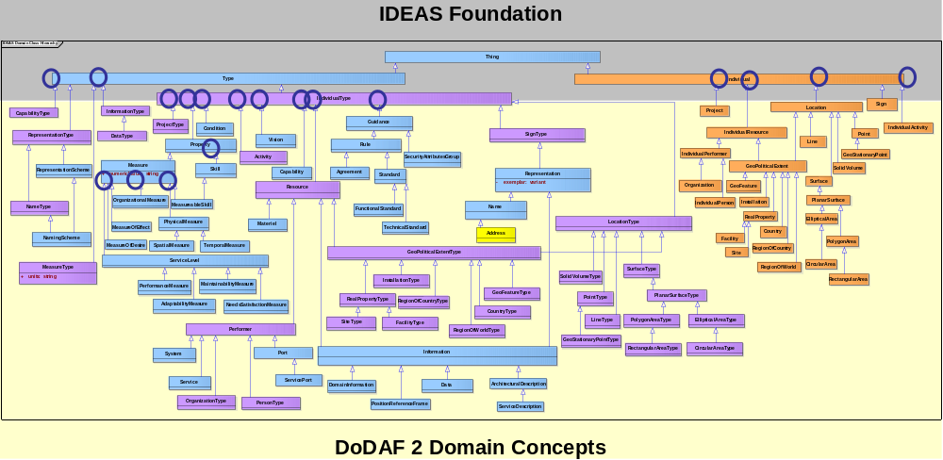
Figure 4. DM2 Domain Concepts are Subtypes (Extensions) of IDEAS Foundation Concepts
Figure 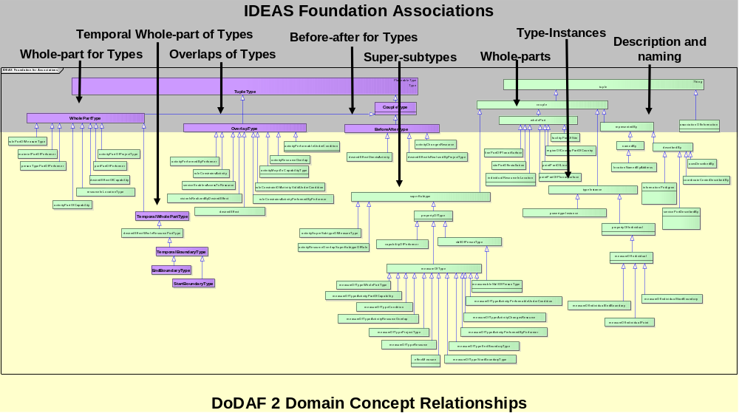
Figure 5. DM2 Associations are Subtyped to IDEAS Mathematical Associations

IDEAS Foundation Mathematics
When creating or analyzing DM2 data, the following mathematical properties should be followed. (Note, this material is incomplete and will be provided in later versions of either DM2 or IDEAS documentation. Additional sources for ontologic mathematics include: 1) National Center for Ontologic Research (NCOR), http://ontology.buffalo.edu/smith/; 2) Direct Model-Theoretic Semantics for OWL 2, http://www.w3.org/TR/2009/REC-owl2-direct-semantics-20091027/)

Type Theory Math
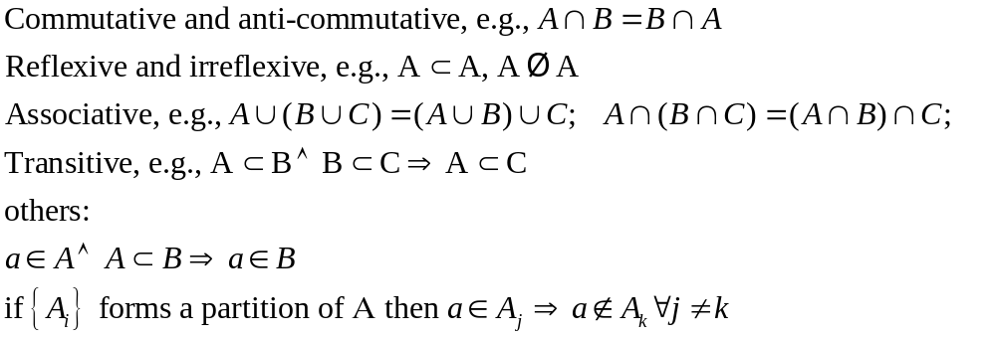

Mereotopologic Math
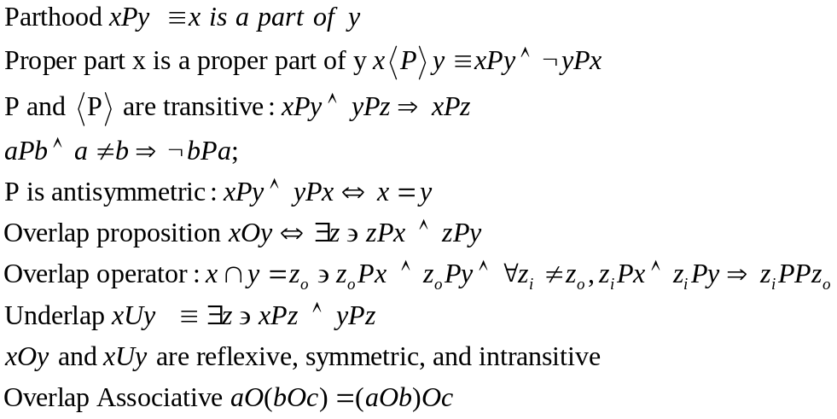
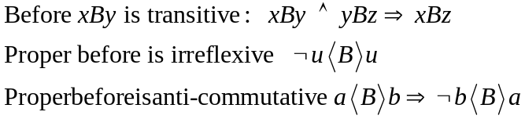

Superclass Association Usage

Elements designated as "if" common to all views:
- couple | - CoupleType
- Individual | - IndividualType
- Powertype | - powertypeInstance
- tuple | - TupleType
- Type
Elements designated as "df" common to all views:
- GeoPoliticalExtent | - GeoPoliticalExtentType
- Guidance | - IndividualResource
- measureOfIndividual | - measureOfType
- NameType | - Property
- propertyOfIndividual | - propertyOfType
- RealProperty | - RealPropertyType
- RepresentationType | - Sign
- SignType | - Standard

Rule:
Elements categorized as "if" or "df" cannot be used in any view directly. The above elements are therefore excluded from direct use.
Rule:
Elements categorized as "ifo" or "dfo" can however be used directly within views:
Elements designated as "ifo" common to all views:
- superSubType | - Thing
- typeInstance | - wholePart
- WholePartType
Elements designated as "dfo" common to all views:
- beforeAfter | - BeforeAfterType
- describedBy | - DescriptionScheme
- descriptionSchemeInstance | - endBoundary
- EndBoundaryType | - IndividualPerformer
- Information | - InformationType
- Location | - LocationType
- Measure | - measureOfIndividualEndBoundary
- measureOfIndividualStartBoundary | - measureOfTypeEndBoundaryType
- measureOfTypeStartBoundaryType | - MeasureType
- namedBy | - namingSchemeInstance
- overlap | - OverlapType
- Performer | - Representation
- RepresentationScheme | - representationSchemeInstance
- representedBy | - Resource
- Rule | - ServiceLevel
- startBoundary | - StartBoundaryType
- temporalBoundary | - TemporalBoundaryType
- temporalWholePart | - TemporalWholePartType

The elements categorized as "ifo" yield the following rules:
Rule:
All elements that descend from Type can have subtypes of the same kind as the original element itself (superSubtype principle). (It should be noted that IndividualType descends from Type, i.e. this principle also applies to all that descend from IndividualType.)
Rule:
All elements that descend from IndividualType can have whole-parts of the same kind as the original element itself (WholePartType principle).
Rule:
All elements that descend from Individual can have whole-parts of the same kind as the original element itself (wholePart principle).
Rule:
All elements that descend from Type can have instances of themselves created based on instantiation provided that these instances have already bee recognised as distinct elements within DM2. (This is a form of deviation from the general principle and would imply that there could never be an instance of Capability in a DM2 compliant model unless an IndividualCapability element turned up in the DM2 model. It could be argued that this principle would automatically be applicable if typeInstance was placed in the "if" category. This may have unfortunate consequences for PES however.)
The above set of principles would seem to have direct consequences as far as the "dfo" elements are concerned:
The following "dfo" elements descend from Individual, i.e. the wholePart principle can be applied to them:
- IndividualPerformer
- Location
The following "dfo" elements descend from Type, i.e. the superSubType principle and the WholePartType principle can be applied to them:
- DescriptionScheme
- Information
- InformationType
- LocationType
- Measure
- MeasureType
- Performer
- Representation
- RepresentationScheme
- Resource
- Rule
- ServiceLevel
The following "dfo" elements descend from wholePart and they can therefore be used on all elements where the wholePart principle applies:
- endBoundary
- startBoundary
- temporalBoundary
- temporalWholePart
The following "dfo" elements descend from WholePartType and they can therefore be used on all elements where the WholePartType principle applies:
- TemporalWholePartType
- EndBoundaryType
- StartBoundaryType
- TemporalBoundaryType
In addition to this some of the remaining elements in the "dfo" category establishes a few additional principles.
Rule:
A Name element can be attached to anything by means of namedBy (namedBy principle).
Rule:
An Information element can be attached to anything by means of describedBy (describedBy principle).
Rule:
A representation element can be attached to anything by means of representedBy (representedBy principle).
Rule:
A beforeAfter relationship can be created between any elements that descend from Individual (beforeAfter principle) that are of the same kind. (The same kind restriction does not follow explicitly but represents an imposed constraint.)
Rule:
A BeforeAfterType relationship can be created between any element that descend from IndividualType (BeforeAfterType principle) ) that are of the same kind. (The same kind restriction does not follow explicitly but represents an imposed constraint.)
Rule:
An overlap n-ary relationship can be established between elements that descend from Individual (overlap principle) that are of the same kind. (The same kind restriction does not follow explicitly but represents an imposed constraint.)
Rule:
An OverlapType n-ary relationship can be established between any items that descend from Type (OverlapType principle) that are of the same kind. (The same kind restriction does not follow explicitly but represents an imposed constraint.)

DoDAF Physical Exchange Specification (PES)
Collection, management, utilization, and reuse of architectural data and information are a complex task. Successful execution of that task requires knowledge of both data structures and the body of knowledge related to the purpose for which an architecture is being created i.e., “Fit-for-Purpose” as described in Section 2 of Volume 1.
If exchanging architectural data, the PES is the specification for the exchange. The PES provides an efficient and standard means to ensure that data sharing can occur in a toolset-agnostic, methodology-agnostic environment. Use of the eXtensible Markup Language (XML) Schema Definitions (XSDs) by architects to document architectural data and information in tools, through spreadsheets, or other means, and deposit that data and organized information into federated repositories is facilitated by the common understanding underlying the use of the PES.
In the support of these, EA data must be exchanged and shared. The general pattern for this exchange is shown in Figure 6.
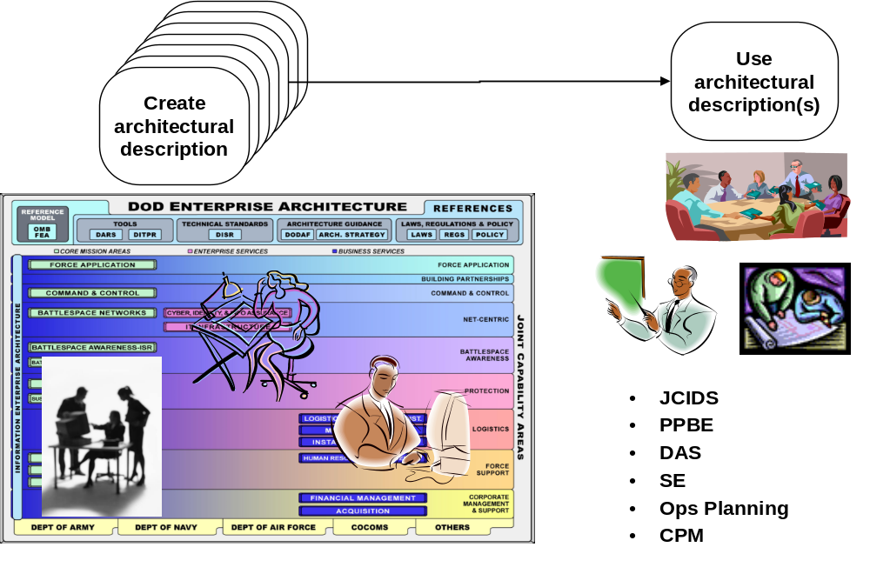
Figure 6. General Pattern for EA Information Sharing and Data Exchange
The information to be shared varies across the core processes and is determined by the information needs of specific use cases within those core processes. Notional examples of such use cases are shown in Figure 7. Core process use case stakeholders work with EA data developers to determine what information needs to be shared when in order to support the core process. A notional example of the resultant information exchange in shown in Figure 8. Note that in this case, the data presented for decisions may not be EA data, but, rather, the analysis results from analyzing EA data.
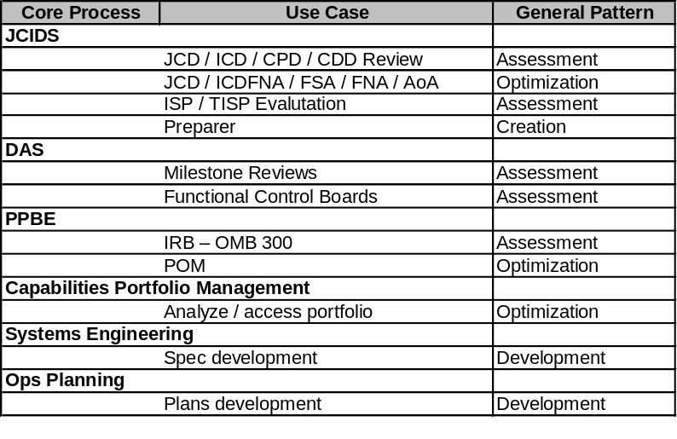
Figure 7. Notional EA Information Sharing Use Cases
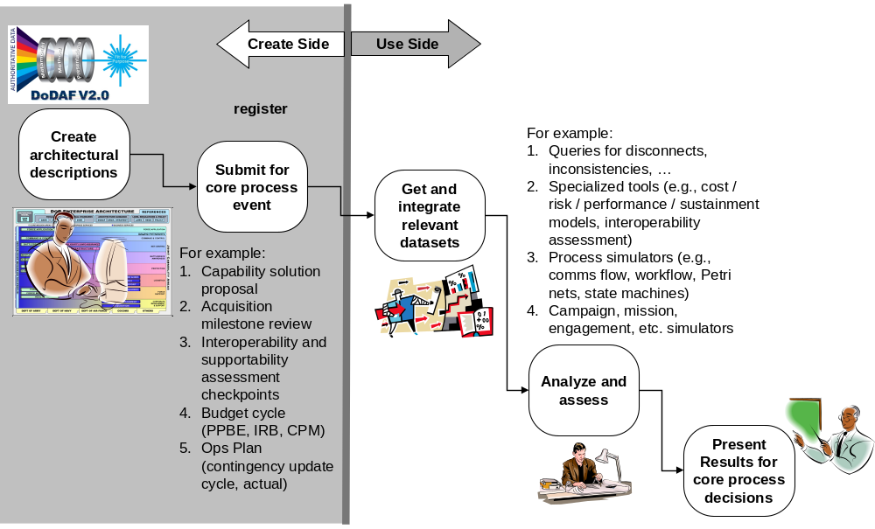
Figure 8. Notional Pattern of EA Information Sharing for Assessment Processes
When exchanging architectural data, the PES is the specification for the exchange. The PES provides an efficient and standard means to ensure that data sharing can occur in a toolset-agnostic, methodology-agnostic environment. Use of the by architects to document architectural data and information in tools, through spreadsheets, or other means, and deposit that data and organized information into federated repositories is facilitated by the common understanding underlying the use of the PES.
The DM2 PES XML schema (XSD) provides a neutral format for data exchange between EA data and data sources including:
- EA databases.
- DoD Authoritative Source Databases (e.g., DoD Information Technology Portfolio Repository [DITPR]).
- Unified Profile for DoDAF and Ministry of Defence Architecture Framework (MODAF) (UPDM) and SysML-based Unified Markup Language (UML) Tools.
- Other Information Technology (IT) and enterprise architecture Tools.
- Modeling and Simulation Tools that are used in EA assessments, e.g., AoA’s.
- Reporting Tools, e.g., for Chairman of the Joint Chief of Staff Instruction (CJCSI) or Department of Defense Instruction (DoDI) submission.
- Systems Engineering Tools.
- Other Federal agencies (e.g., Department of Homeland Security (DHS), Department of Justice (DoJ).
- Coalition partners and North Atlantic Treaty Organization (NATO).
- Other organizations with which DoD exchanges Enterprise Architecture (EA) data (e.g., industry, States, National Government Organizations [NGO’s]).
This role is illustrated in Figure 9.
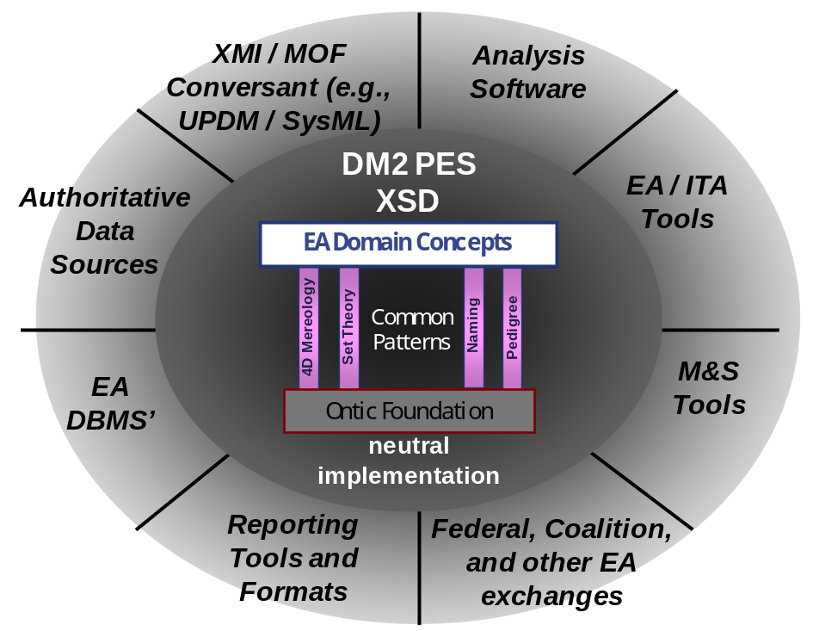
Figure 9. Illustration of DM2 Role in Providing a Neutral Model for Data Exchange
Note that within any particular community above, there may be a data exchange format particular to that community. A particularly important case is the UPDM-SysML XML Metadata Interchange (XMI) format for data exchange of UML models. XMI provides a neutral way to exchange model data, including diagram data, between UML tools. A universal DM2 PES to XMI translation will allow UPDM-SysML tools to interoperate with the other tools and data sources used in DoD EA.
The DM2 PES eXtensible Markup Language (XML) Schema Definitions (XSDs) is auto-generated from the DM2 Logical Data Model. No additional semantics are added or changed
There are four DM2 PES XSD’s:
- IDEAS Foundation, version 1.0
- DM2 additional foundation
- Classification marking (externally controlled)
- DM2 exchange data
The DM2 PES XSD used for data exchange has a very simple structure as shown in .
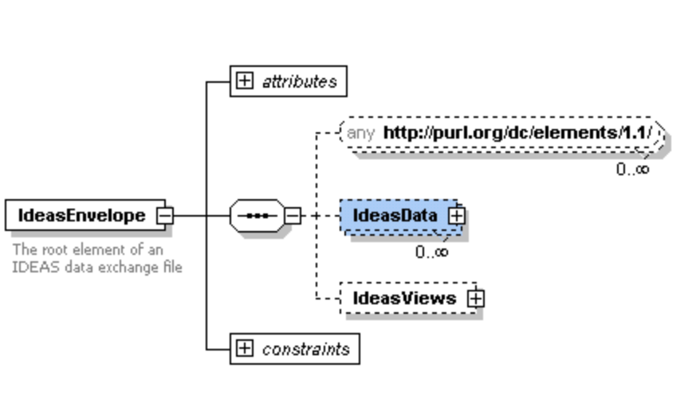
Figure 10. Top-Level Structure of a the DM2 PES XSD for Exchange
The IdeasData section contains all the DM2 domain data in a flat structure with elements linked together using standard XML document IDref’s. A piece of this flat structure is shown in Figure 11.All of the DM2 data that is to be exchanged is contained in this section.
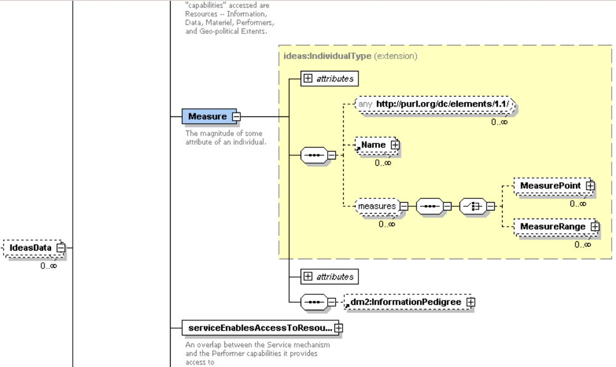
Figure 11. Sample of the IdeasData Section of the DM2 PES XSD for Data Exchange
The IdeasViews section then specifies what DoDAF views this data pertains to. A sample of this section is shown in Figure 12. If a DM2 PES XML document is received and these views are indicated as being represented in the dataset, this XSD can be used to validate the document, to see that the mandatory data is present and that data that is not optional is not contained.
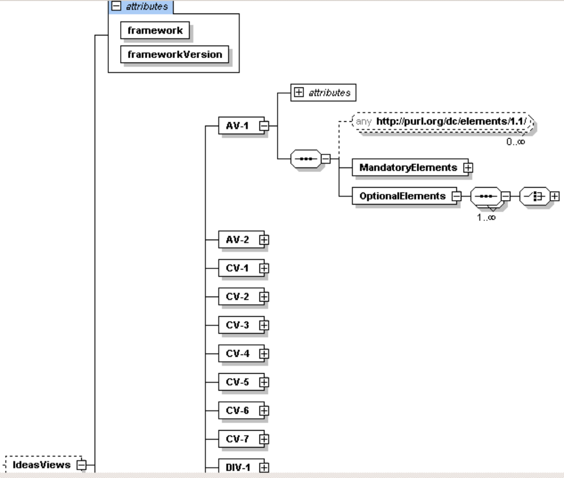
Figure 12. Sample of the IdeasViews Section of the DM2 PES XSD for Data Exchange
In-progress examples of DM2 PES XML documents are available to DM2 Working Group members on the DM2 Collaboration Site (www.silverbulletinc.com/dm2, send email to David.McDaniel@SilverBulletInc.com for access credentials) and will be made available to the entire EA community on the DoDAF Journal.

This page left intentionally blank

APPENDIX A

GLOSSARY OF FOUNDATION TERMS

Acronym | Definition
CADM | Core Architecture Data Model
CDM | Conceptual Data Model
CJCSI | Chairman of the Joint Chief of Staff Instruction
DHS | Department of Homeland Security
DITPR | DoD Information Technology Portfolio Repository
DM2 | DoDAF Meta-model
DoDAF | Department of Defense Architecture Framework
DoDI | Department of Defense Instruction
EA | Enterprise Architecture
IT | Information Technology
LDM | Logical Data Model
MODAF | Ministry of Defence Architecture Framework
NATO | North Atlantic Treaty Organization
NGO | National Government Organizations
PES | Physical Exchange Specification
UML | Unified Markup Language
UPDM | Unified Profile for DoDAF and MODAF
XMI | XML Metadata Interchange
XML | eXtensible Markup Language
XSD | XML Schema Definition

APPENDIX C

IDEAS Foundation Partial Bibliography
- Berger, Peter L, and Thomas Luckmann; The Social Construction of Reality; Doubleday & Company, Garden City, New York; 1966.
- Casati, Roberto, and Achille C Varzi; Holes and other Superficialities; The MIT Press, Cambridge, Massachusetts; 1995.
- Casati, Roberto, and Achille C Varzi; Parts and Places: The Structure of Spatial Representation; The MIT Press, Cambridge, Massachusetts; 1999.
- Clark, Bowman L; “Individuals and Points”; Notre Dame Journal of Formal Logic, Vol. 26; 1985.
- Coquand, Thierry; “Type Theory”; Stanford Encyclopedia of Philosophy; 2006.
- Davenport, Thomas H, and Laurence Prusak; Working Knowlege: How Organizations Manage What They Know; Harvard Business School Press, Boston, Massachusetts; 1998.
- Gilbert, Margaret; On Social Facts; Princeton University Press, Princeton, New Jersey; 1992.
- Grenon, Pierre, and Barry Smith; “The Cornucopia of Formal-Ontological Relations”; Dialectica. Vol. 58; 2004
- Grenon, Pierre, and Barry Smith; “Snap and Span: Toward Dynamic Spatial Ontology”; Spatial Cognition and Computation; Lawrence Erlbaum Assosiates, Inc, Leipzig, Germany.
- Hacking, Ian; Historical Ontology; Harvard University Press, Cambridge, Massachusetts; 2002.
- Hawley, Katherine; How Things Persist; Oxford University Press, Oxford; 2001
- Janssen, Terry, et al; A Multi- INT Sematic Reasoning Framework for Intelligence Analysis Support
- Kay, Paul; “Taxonomy and Semantic Contrast”; Language; Vols. 47, number4; University of California, Berkeley, CA, 1971.
- Kempson, Ruth M; Semantic Theory; Cambridge University Press, Cambridge; 1977.
- Levinson, Stephen C; Pragmatics; Cambridge University Press, Cambridge; 1984.
- Lyons, John; Language, Meaning, & Context; Fontana Paperbacks, Great Britain; 1981.
- Nerlich, Graham; The Shape of Space; Second ed; Cambridge University Press,New York, NY; 1994.
- Partee, Barbara H, Alice Ter Meulen, and Robert E Wall; Mathematical Methods in Linguistics, Vol. 30; Kluwer Academic Publishers, Dordrecht; 1990.
- Partridge, Chris; Business Objects: Re-Engineering for Re-Use; The Boro Centre; 2005.
- Potter, Michael; Set Theory and its Philosophy; Oxford University Press, Oxford; 2004.
- Pulman, S G; Word Meaning and Belief; Ed. James R Hurford and John A Hawkins; Croom Helm Linguistics Series; Billing & Sons Limited, Great Britain; 1983.
- Rea, M. C., “Four Dimensionalism” in The Oxford Handbook for Metaphysics. Oxford Univ. Press
- Sider, Theodore; Four Dimensionalism: An Ontology of Persistence and Time; Oxford University Press, Oxford; 2001.
- Simons, Peter; Parts: A Study in Ontology; Oxford University Press, Oxford; 1987.
- Smith, Barry; “Against Fantology”; Experience and Analysis; By M E Reicher and J C Marek; 2005.
- Smith, Barry; “The Basic Tools of Formal Ontology”; Formal Ontology in Information Systems; IOS Press, Amsterdam; Frontiers in Artifitial Intellegence and Applications; 1998
- Smith, Barry; “Mereotopology: A Theory of Parts and Boundaries”; Data and Knowledge Engineering; Department of Philosophy, Buffalo, New York; 1996.
- Smith, Barry, and David M Mark; “Do Mountains Exist? Toward an Ontology of Landforms.” Enviorment & Planning B (Planning and Design); National Center for Geographic Information and Analysis, Buffalo, New York; 2009.
- Stein, Lynn Andrea; “Imagination and Situated Cognition”; Thinking about Android Epistemology; Ed. Kenneth M Ford, Clark Glymour, and Partick J Hayes; AAAI Press, Menlo Park; 2006. Sider, Theodore. “Four Dimensionalism”. Philosophical Review. pp. 197-231
- W3C; OWL Web Ontology Language, Semantics and Abstract Syntax, Section 3. Direct Model-Theoretic Semantics

http://www.ideasgroup.org or http://en.wikipedia.org/wiki/IDEAS_Group

