Analysis of Midterm 1

1. Code Analysis

We performed the following three steps in our code to estimate the Dichromatic Reflection Model (DRM):

1. Image reading: currently only rgb image in .pbm format can be processed.
2. Image segmentation: At the beginning, we only used the SLIC code from VLFeat to extract superpixels from the image. Then we found that the Cd of same-color pixels in different superpixels are different. Thus we implemented a very simple region-growing based image segmentation algorithm to get bigger segmentations. However, this algorithm is still not good enough to get a satisfactory result because it tends mix close but different colors into a single segmentation. Finally, based on our previous researching experience, we found that a graph-cut based image segmentation algorithm can lead to a satisfactory result. Table 1 is a summary of the algorithms we have tested.

Table 1

|  |  |  |  |
| --- | --- | --- | --- |
| Algorithm | Different Color Mixing | Same Color Separating | Speed |
| SLIC | No | Yes | fast |
| Region Grow | Yes | No | fast |
| Graph Cut | No | No | fast |
| Normalized Cut | Too slow to be used | | |

1. Solving: We solved the problem via Gaussian-Seidel iteration. Generally within 5-10 iterations, the result will reach convergence.
2. Observations
3. The most important thing in superpixel/segmentation based DRM estimation is making sure that same-color pixels should be segmented into the same superpixel/segment, which however is a dilemma because we need the DRM to eliminate the influence of light source to get better superpixels/segments.
4. Superpixel based methods have the advantage in preventing different colors to be mixed into a single segment, while suffer from the shortage that same-color pixels may be divided into several fragments.
5. Segmentation based methods perform better than superpixel based methods in preserving the integrity of the same-color pixels, but often fail in telling close-color pixels from different objects apart.
6. Finally, we found the graph-based segmentation method proposed in paper “*Efficient Graph-Based Image Segmentation Pedro F. Felzenszwalb and Daniel P. Huttenlocher*

*International Journal of Computer Vision, 59(2) September 2004*” can achieve very good image segmentation result, which leads to the best DRM estimation result among all those three methods.

1. Explanations
2. As we can see from Figure 1(a), the bird is segmented into a same segment with the background, thus their Cd values are the same, and its feather is turned into the same color as the background. While in Figure 1(b), the dome of the build is segmented into many small superpixels, as a result, their Cd values are different even though they are in the same color in reality.

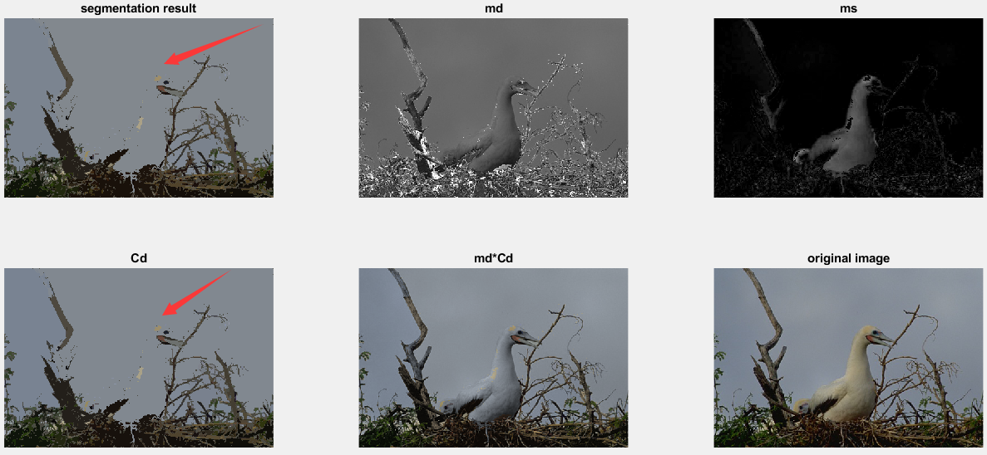

1. Different Color Mixing (Region Grow Result)

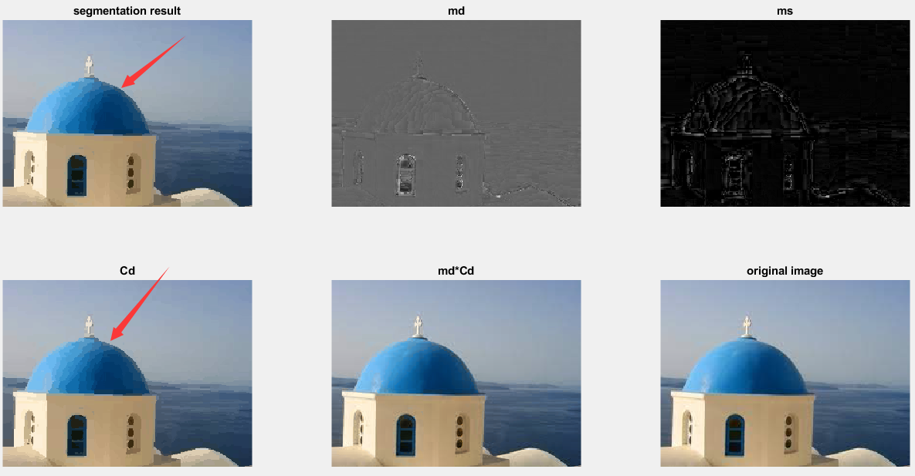

1. Same Color Separating (SLIC Result)

Figure 1 Two problems of segmentation/superpixel based DRM estimation.

1. The Graph Cut based method achieved the best performance in almost all the images tested.

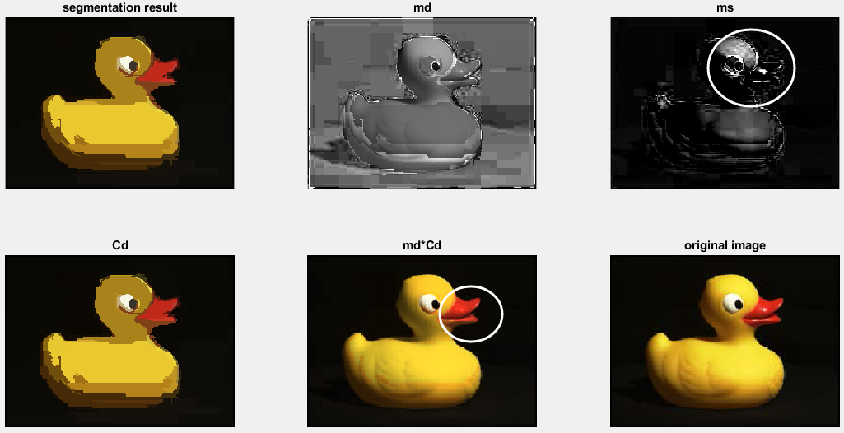

1. Notice the beak and head of the duck

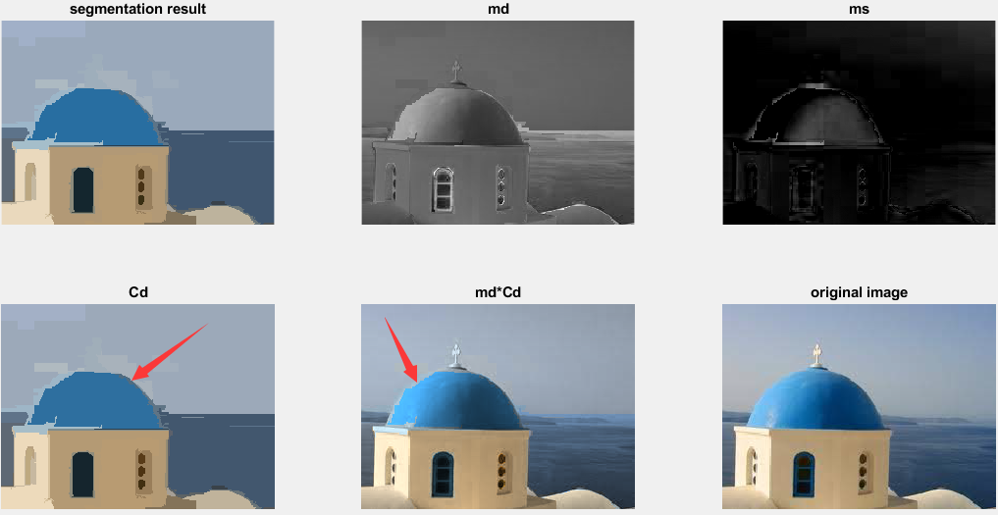

1. Notice the left boundary of the dome on md*Cd is now distinguishable with the background.

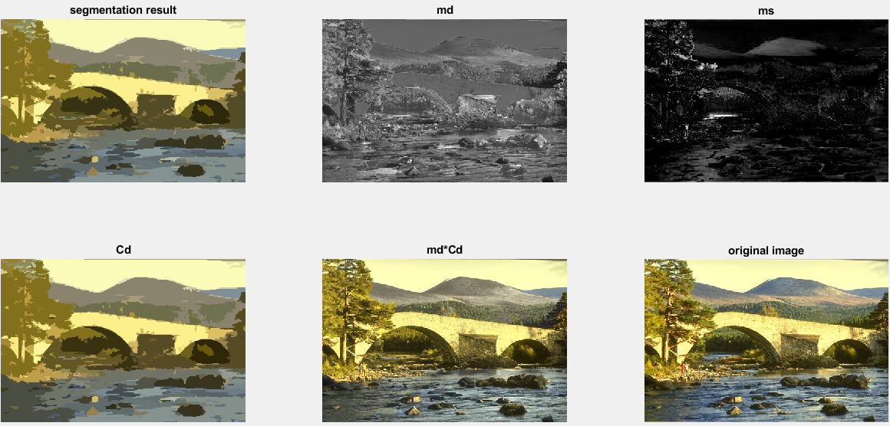

1. Result on natural scene