function Parent() {
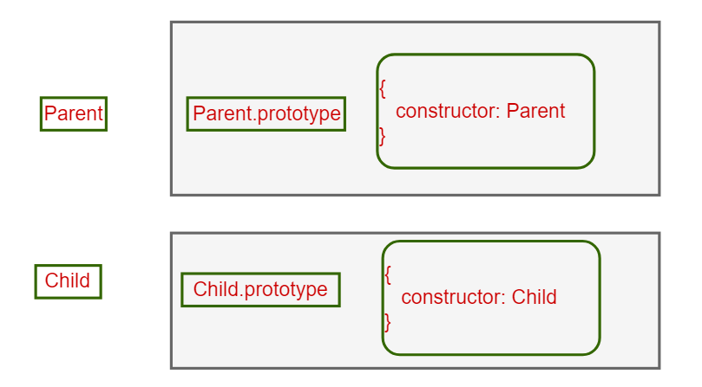
this.a = 1;
this.b = [1, 2, this.a];
this.c = {
demo: 5
};
this.show = function () {
console.log(this.a, this.b, this.c.demo);
}
}

function Child() {
this.a = 2;
this.change = function () {
this.b.push(this.a);
this.a = this.b.length;
this.c.demo = this.a++;
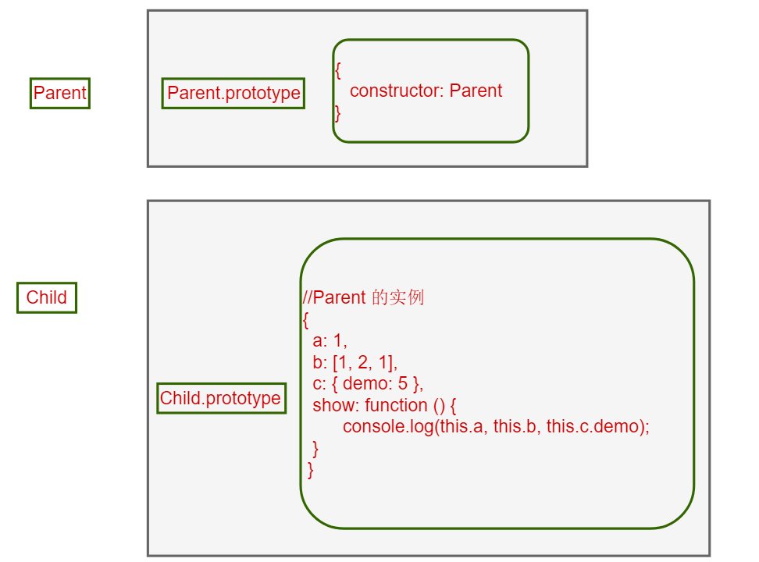
}
}

Child.prototype = new Parent();

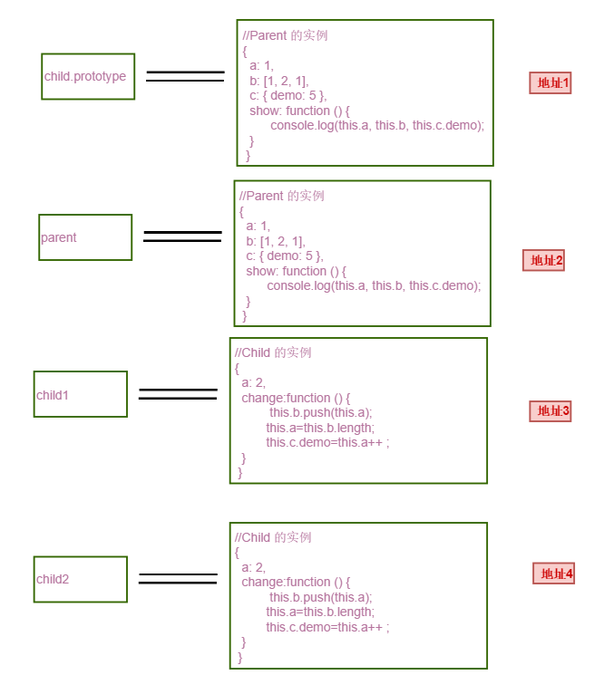
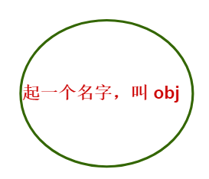

var parent = new Parent();
var child1 = new Child();
var child2 = new Child();


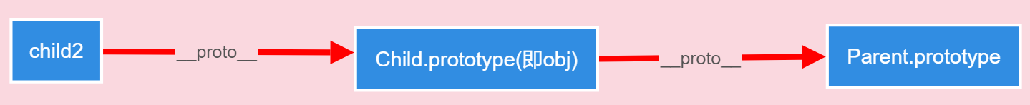
此时的原型链：

child1 = {
a: 11,
change: function () {
this.b.push(this.a);
this.a = this.b.length;
this.c.demo = this.a++;
}
};

Child2 = {
a: 12,
change: function () {
this.b.push(this.a);
this.a = this.b.length;
this.c.demo = this.a++;
}
};

child1.a = 11;
child2.a = 12;

//Parent 的实例
parent = {
a: 1,
b: [1, 2, 1],
c: { demo: 5 },
show: function () {
console.log(this.a, this.b, this.c.demo);
}
}

parent.show(); //1,[1,2,1],5

child1 = {
a: 11,
change: function () {
this.b.push(this.a);
this.a = this.b.length;
this.c.demo = this.a++;
}
};

Child.prototype = {
a: 1,
b: [1, 2, 1],
c: { demo: 5 },
show: function () {
console.log(this.a, this.b, this.c.demo);
}
}

child1.show();// 11,[1,2,1],5

Child2 = {
a: 12,
change: function () {
this.b.push(this.a);
this.a = this.b.length;
this.c.demo = this.a++;
}
};

Child.prototype = {
a: 1,
b: [1, 2, 1],
c: { demo: 5 },
show: function () {
console.log(this.a, this.b, this.c.demo);
}
}

child2.show();//12,[1,2,1],11

child1 = {
a: 5,
change: function () {
this.b.push(this.a);
this.a = this.b.length;
this.c.demo = this.a++;
}
};

Child.prototype = {
a: 1,
b: [1, 2, 1],
c: { demo: 5 },
show: function () {
console.log(this.a, this.b, this.c.demo);
}
}
child1 = {
a: 11,
change: function () {
this.b.push(this.a);
this.a = this.b.length;
this.c.demo = this.a++;
}
};

Child.prototype = {
a: 1,
b: [1, 2, 1, 11],
c: { demo: 4 },
show: function () {
console.log(this.a, this.b, this.c.demo);
}
}

child1.change();

Child2 = {
a: 6,
change: function () {
this.b.push(this.a);
this.a = this.b.length;
this.c.demo = this.a++;
}
};

Child.prototype = {
a: 1,
b: [1, 2, 1, 11],
c: { demo: 4},
show: function () {
console.log(this.a, this.b, this.c.demo);
}
}

Child2 = {
a: 12,
change: function () {
this.b.push(this.a);
this.a = this.b.length;
this.c.demo = this.a++;
}
};

Child.prototype = {
a: 1,
b: [1, 2, 1, 11, 12],
c: { demo: 5 },
show: function () {
console.log(this.a, this.b, this.c.demo);
}
}

child2.change();

//Parent 的实例
parent = {
a: 1,
b: [1, 2, 1],
c: { demo: 5 },
show: function () {
console.log(this.a, this.b, this.c.demo);
}
}

parent.show();//1,[1,2,1],5

child1 = {
a: 5,
change: function () {
this.b.push(this.a);
this.a = this.b.length;
this.c.demo = this.a++;
}
};

Child.prototype = {
a: 1,
b: [1, 2, 1, 11, 12],
c: { demo: 5 },
show: function () {
console.log(this.a, this.b, this.c.demo);
}
}

child1.show();//5,[1, 2, 1, 11, 12],5

Child2 = {
a: 6,
change: function () {
this.b.push(this.a);
this.a = this.b.length;
this.c.demo = this.a++;
}
};

Child.prototype = {
a: 1,
b: [1, 2, 1, 11, 12],
c: { demo: 5 },
show: function () {
console.log(this.a, this.b, this.c.demo);
}
}

child2.show();//6,[1, 2, 1, 11, 12],5

