ACM Word Template for SIG Site

Jessica Chayavichitsilp
chayaj@uw.edu
Tobias Kahan
tobyk100@uw.edu
Xiaoxia Jian
xiaoxiaj@uw.edu

ABSTRACT
Nurses working in Neonatal Intensive Care Units (NICUs) perform complex procedures and assessments and turn to a variety of resources to aid them in their daily work. The resources they turn to are often desktop applications or web searches, causing the nurses to return to their station to look for information. To complicate matters, many of the procedures and diagnostics are based on an infant's weight and so the nurses must remember or look up various formulae throughout the day. Fortunately, more and more nurses carry smartphones and we intend to leverage this technology, already in the hands of nurses, to provide the information and computing power they need.

Mobile apps for neonatal nurses already exist, as a search for “neonatal” in the Apple App Store will indicate. However, we have found that none of these apps contain the right blend of information for neonatal nurses. Some have too much information, which makes navigating the app difficult, and some are specific to a single procedure, which causes the nurse to flip through multiple apps to get all of the information they need. We have designed an app in close coordination with a team of neonatal nurses from the University of Washington, which provides information on the most frequently used procedures. Our final evaluation will be if our app can save the nurses time and reduce memory-based errors.

INTRODUCTION
Neonatology is a subspecialty of pediatrics that consists of the medical care of newborn infants, especially ill or premature newborn infants. Neonatal nurses work with very tiny patients that require special care, performing procedures quite differently than when done on older and larger patients. To account for the unique procedures performed by neonatal nurses, NICUs have developed their own internal resources. Along with these internal resources, generally desktop applications, neonatal nurses turn to Internet searches for information. There are various problems with these resources and a group of nurses at the University of Washington Medical Center has asked us to design an application that will solve the limitations of the existing technology.

To understand the problems, which exist in the current solutions, we can imagine a nurse caring for their patient. The nurse is about to perform a procedure, such as administering medication, but they forget the exact ratio of medicine to weight. To figure out this information they turn to their internal neonatal care website. At this point they encounter two problems; first, the internal website is desktop based and so the nurse must return to the station before continuing with patient care. Second, the abundance of information on the site impedes the nurse from finding the most commonly used material; the site it is cluttered. Either the nurse wastes valuable time returning to their station or they choose to avoid using the website and instead they rely on memory to perform the procedure. Often times a nurse remember the correct dosage but they may want to confirm as an extra precaution. In this case the time spent confirming their recollection might not be worth it and they proceed with administering the medicine. We want to help in both cases, providing information that nurses have completely forgotten as well as quick refreshers for something the nurse wants to confirm.

As stated above the existing solutions are desktop based and cluttered; we intend to solve both of these problems. To solve the first problem, we will create an app optimized for smartphone devices, allowing the nurse to seamlessly continue with patient care. To solve the second problem, we will include only the most used procedures, keeping the app easy to navigate. However, our solution immediately runs into problems of its’ own. First, the smartphones, which nurses, are carrying run on different operating systems and thus we must design a solution, which is cross-platform compatible. Second, how do we know which procedures to include and how to we organize the app to make accessing this information painless for the nurses? We will tackle each of the issues in turn.

To make our app cross-platform compatible we will use the Open-Data-Kit (ODK) framework developed by the Computer Science department at The University of Washington. The ODK platform lets developers create an ODK Survey within a XLSX spreadsheet, which is transformed into a working mobile app. This mobile app is built on top of jQuery Mobile, a platform which allows developers to write a javascript app and have it render and function consistently on a wide range of platforms, including the two most popular mobile platforms: iOS and Android. There are drawbacks to using jQuery Mobile, it feels slightly less native and is a good deal slower than native apps. However the opportunity to write one app and have it work on multiple devices outweighs this drawback. There are also drawbacks to using ODK, it doesn’t support everything we need in our app. Fortunately, ODK allows you to edit the HTML and Javascript underneath the hood, so it is really as extensible as you want.

RELATED WORK
The ground is set for mobile technology to revolutionize the nursing field. In fact, the hardware is already in the right hands: seventy-nine percent of health care professionals report using a smartphone in clinical practice [1]. Seventy-seven percent of current students in medical professions own a smartphone and a similar percentage of those that own smartphones already use medical apps [2]. The two most common uses of medical smartphone apps are medication guides and discipline specific guides [2]. A search of the iTunes app store reveals over 1000 medically related apps, and the search ‘NICU’ (Neonatal Intensive Care Unit) returns 30 hits. Among these NICU results there are two general categories of app, procedure specific apps and general neonatal reference apps. One such specific app is NeoTube, which allows the user to enter a baby’s weight and outputs measurements and dosages specific to that weight [3]. Another procedure specific app is Multidrip Glucose Infusion Rate Calculator, which, like NeoTube, starts with the nurse entering the baby’s weight and outputs the dextrose percentage and rate of infusion for the five drips, which constitute the treatment [4]. A benefit of these procedure specific apps is that their interface is simple and they can provide detailed information on the procedure. Additionally, a nurse can compose a unique set of procedure specific apps. Of course, the downside is that a nurse has to switch through many apps in the course of her or his work. The benefit of a general neonatal reference app is that a nurse sees a hierarchical display of the resources and can even enter the baby’s weight once and have that propagate to multiple calculations. One general app is Neonatal Calculator, which lets the user enter the baby’s weight and outputs drug dosages, infusion rates, apgar score, and numerous other calculations [3]. This app is extremely useful and popular however it doesn’t include any reference material on how to perform the procedures. SimNICU provides a wealth of reference material and calculators [7] as does Pedi STAT [8], however both apps are missing certain common procedures and resources. Our app follows in the footsteps of these established apps, however, our design is based on the experience and feedback of multiple nurses currently working in neonatal units. We believe that our close collaboration with experienced neonatal nurses will generate an app that contains the most utilized resources while omitting less popular information that would clutter the interface. We have included a comparative list of features, which shows how our app is different from what is out there (see Table 1)

APPROACH

Figure 1: System Architecture

There are two general paths to take when creating a mobile app. The first is to create a distinct app for each platform you are supporting. This means coding the app in the language and using APIs native to that device. The other path is to code the app in HTML and Javascript, two languages which most modern browsers -- including mobile browsers -- support. The user then loads the url of the app in a browser and it will render on multiple devices. Each method has its’ pros and cons and for the sake of time we chose to develop our app in HTML and Javascript.
You can break our code base into two parts, which are both shown in the above figure. The first part is an XLSX spreadsheet and the second is our custom HTML and Javascript code. We will explain each part below but for now notice that both parts are eventually combined into a single ODK app. This ODK app is hosted on Heroku but it could be hosted on any server that can serve HTTP requests.

The first part of our code is an XLSX spreadsheet written in the ODK Survey language. ODK Survey defines syntax within a spreadsheet; the XLSX converter, also part of the ODK suite, can compile this spreadsheet. The output of the XLSX converter is a json object, as shown in the above figure. The next step is to set ODK to load the json object and host ODK on a server. For some applications these steps are sufficient, however our app needed more customization.

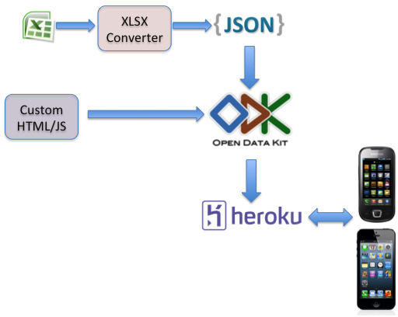
To realize the requirements, which ODK does not support, we implemented some custom HTML and Javascript, the second part of our code base. The custom code was itself split in two parts: first, custom HTML and Javascript pages; second, modifications to the ODK source code. ODK is incredibly extensible and allows for custom web pages to be inserted and to attach Javascript controllers to those pages. This means that any functionality that can be implemented in HTML and Javascript can be inserted arbitrarily into an ODK app. An example from our app is the image slider (more details below), which allows the user to scroll through images and select one, functionality not supported by ODK but easy to add as a custom HTML and Javascript page. The ability to add custom web pages does not allow for changing the navigation flow of ODK so we also needed to modify the ODK source code. Modifying the ODK source code is to be avoided since it makes upgrading to new versions of ODK more difficult. However, if an app needs different navigation than ODK provides the source code must be edited. Understanding the ODK source code is difficult because it does not have complete documentation. Therefore we needed to consult the lead engineer, Mitch, on many of these changes.

With the json object created by the XLSX converter, our custom pages, and our modifications to ODK we have our complete app. At this point, there are two options for deploying our application. The first is to host it on the web, which allows cell phones to access it through their web browser. The second is to create a native app wrapper around our project -- so that the core code remains the same but the user accesses it by downloading an app from their device’s app store. The first option is trivial, the app can be hosted on any server that serves HTTP requests, but the second option is more difficult. Despite the added complexity the payoff of creating a native wrapper is high: it would decrease the latency of pulling pages from our server and it would let users find our app by searching the app store. For these reasons we decided to wrap our app in Android. We chose Android over iOS because Apple frowns on wrapping a web app in an iOS app -- exactly what we intended to do.

TODO [Here we will add info about wrapping the app in Android which we are still working on]

The HCDE team in response to feedback from usability testing designed the information architecture, i.e. the content hierarchy, of our app. The initial design consisted of a main menu with nine categories. The nurses responded that the main menu was too cluttered and so the HCDE team reduced the items on the main menu. This resulted in deeper paths from main menu to desired content, meaning that the nurse has to navigate through more screens to get the desired content. However, the main menu is simpler and easier to read which hopefully speeds up the time from opening the app to finding the desired content. We have included a diagram of the information architecture as reference.

Another design decision was whether to include duplicate paths to certain resources. For instance, the nurse can find the weight loss calculator in either Nutrition Tools or Calculators. This has the downside of adding more total buttons to the app and possibly causing the confusion that the two calculators are different. However, the benefit is that nurses who forget where a certain item is located will be able to find it easier. For instance, most of our calculators fall under some category but we have also listed them under “Calculators” which makes any calculator easy to find.

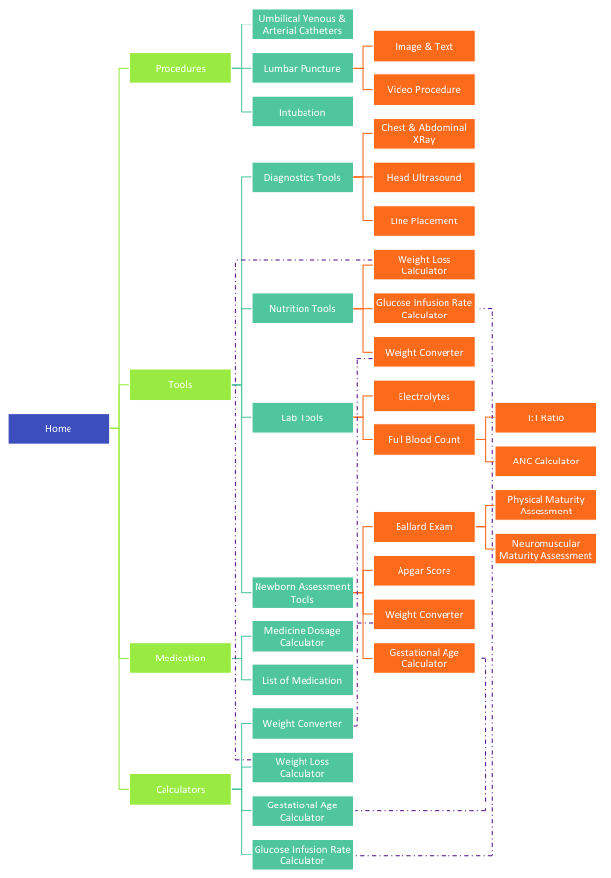
Figure 2: Information Architecture of Neonatal App

IMPLEMENTATIONS
Gaetano Borriello, founder of ODK and our advisor have described using ODK for our project as a “stress test” on this project. This is because our project does not conform to the primary use case of ODK: to support mobile surveys. While surveys are the main purview of ODK it has been equipped with navigation controls and database support that make it attractive to any app designer. The idea behind our project was to see if ODK code be tweaked enough to support non-survey apps. In this section we will discuss the process of modifying ODK to suite our needs. As we will see, some things could be achieved by inserting our custom pages into ODK while some things required a change to ODK source code. In the end, we have shown that ODK can be used for a menu-based app.

Linear Image Selector
First we will look at a feature that was implemented with custom HTML and JavaScript, no change to ODK source code was needed. As we stated above this is preferable since it makes upgrading to new versions of ODK easier. The feature we added was a linear image selector. ODK already supported image selection, but only through a grid layout. On a mobile device the images, which rendered were small and there was no way to enlarge them. In our use case a nurse is comparing some visual evidence to the images and needs to be able to see as large a picture as possible. Our solution is to add a new prompt type which displays the images, taking up as much of device’s screen space as possible. ODK allows a developer to add a new handlebar, a template HTML page, and attach JavaScript to control the page. We used this feature along with ODK’s database layer to complete our linear image selector. In this case we were able to add our feature without changing ODK’s source code, however modifying the ODK navigation controller required a change to the ODK source code.

4.2 Navigation Changes
ODK provides a simple and elegant navigation controller. The XLSX spreadsheet defines an ordered list of prompts; prompts may become pages that the user interacts with or they may be control elements like gotos and grouping statements. The application flow begins at the top of the spreadsheet and moves linearly down based on user input, interpreting each new prompt it encounters. The control flow can be interrupted by gotos, which may send the user to arbitrary points in the spreadsheet. Also, multiple prompts may be grouped into a “screen” which aggregates the prompts vertically, the first prompt appearing above the second prompt and so on. There are only two navigation controls available to the user: forward and backward. Backward navigation moves to the previous prompt that the user experienced, not the previous prompt on the spreadsheet (remember the nonlinear application flow). Forward begins a linear search of the spreadsheet, looking for the next applicable prompt. A prompt is applicable if it has no condition or its’ condition evaluates to true. This navigation flow works well for surveys, which inherently have a beginning and end and some semblance of order, it did not work well for our app, which is menu, based.

To provide a menu based app experience to our users we had to substitute our navigation for ODK’s stock navigation. To this end, we created our own prompt type and modified the ODK source code. As an example of adding custom code and modifying the source code, the menu navigation is a good case study of implementing a new feature in ODK. The custom code involved extending an existing prompt type in ODK (the select_one prompt) and changing some of the behavior: removing the stock ODK next button and rendering the next screen when the menu item is selected. The fact that we could easily add a new feature by extending an existing prompt is testament to ODK’s extensibility. At this point, however, we encountered a new problem. Once the user arrived at a non-menu page they could still press the next button taking them out of our desired navigation and back to ODK’s stock navigation. Thus we had to modify the ODK source code to remove, completely, the next button, giving us full control of the user’s experience navigating our app. In light of our implementation of menu navigation, ODK appears highly extensible and applicable to problems outside of traditional survey. More extreme extensions to ODK should be done to see just how far it could be pushed.

EVALUATION
We have three levels of evaluation for our app. The first level is the HCDE design team. They have designed the app so they have a good idea of what to expect. For this reason, they cannot give unbiased feedback on the overall design of the app but they can give feedback on small design decisions we made. For instance, we might decide to veer from their design because some other implementation was far easier or they may have left out some details of the design, which we decided to fill in on our own. In both cases we would run the decision by HCDE first, before showing the app to outside testers.

The next level of evaluation is the originator of the idea, Jocelyn Kirk. Jocelyn can provide feedback almost as good as the target client since she is herself a neonatal nurse. She knows what nurses need and can role play the part of a nurse during testing. However, since her previous experience with the app may color her feedback, she cannot be relied upon as much as a neonatal nurse who has never seen the app. Despite this downside she is a valuable resource as she is a neonatal nurse who is readily available to us.

The third and most important level of feedback comes from neonatal nurses, they are the intended client of the app. Finding nurses to test our app can be difficult. Since we cannot impose on their private lives, we have to schedule tests while the nurses are at work, which means getting permission to conduct the test in a hospital. We have managed to do this once -- we discuss the results below -- and believe we could do more tests in the future. The next challenge is finding the right metrics to evaluate the app. The testers will need some direction and so we decided to create three tasks for them to complete: administer the Ballard Exam, calculate the gestational age of an infant, and find resources for chest x-rays. To gather quantitative data, we will record three metrics for each task: time to complete task, unnecessary clicks, and the number of time we had to help them through the task. The goal is to design an app, which minimizes all three of these metrics. As for qualitative data, we are using some of the questions generated by the HCDE team:

- Was there something missing you were expecting to see? If so, can you tell us what was missing and, if possible, why it should be there?
- Were any features or labels confusing to you? If so, which ones were confusing?
- Did you understand how to navigate through the app?
- How intuitive is the navigation system from 1 to 10?
- Would you use an app like this if one were available? Why? If you would use the app, would you use it at work?
- What did you like most about the app? Why?
- What did you like least about the app? Why?
- If you could change one thing on the app, whether it is major or minor, what would be at the top of the to do list?
- Do you have any feedback or suggestions you would like to give us regarding the app?

TODO [Include information on feedback from Jocelyn]

As we noted above, we have conducted a single usability test with neonatal nurses. The results of this test caused the HCDE team to redesign the layout of the app. We will note two examples of design features that changed based on the feedback from the usability tests. The first is the main menu, which originally had 8 categories. The nurses commented that it was too cluttered and confusing so we reduced the number to four categories. Also, the nurses did not like the text menu buttons so the HCDE designed graphical elements to serve as the menu items. The pretest and posttest menus are shown below (see Figure 3). The second change made with the feedback from nurses was the direction in which to present images. We originally presented images horizontally, allowing the user to swipe left or right to see new images. The nurses preferred all images on a single page with vertical swiping. Again, the pretest and posttest designs are below.

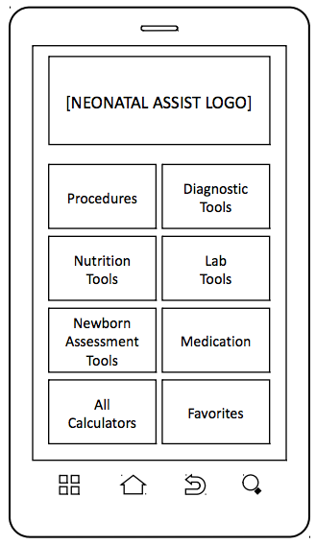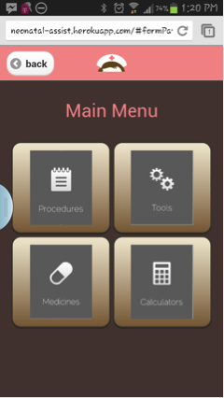

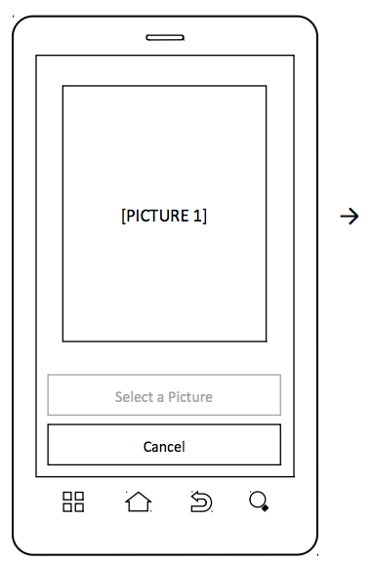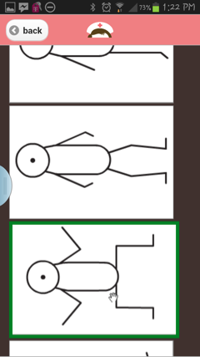

Figure 3: Pretest and Posttest Design.

CONCLUSION AND FUTURE WORK
As a conclusion, we will examine how far we have come in completing our goals, what is left to be done, and what we learned along the way. Our main goal was to provide a resource to neonatal nurses that would provide the right blend of content in an app that would be easy to navigate. To provide an example of the apps potential we implemented representative components. For instance we provided calculators for a few of the medications that the nurses need, an exam, and some reference material including text and video. These examples together do not constitute an app that nurses would want to use since they are not a complete reference. However, they can provide enough information for us to make changes along the way to finishing the app. With that in mind, our team conducted in person usability tests with neonatal nurses at the University of Washington Medical Center. We used their feedback to redesign our app; the redesign has not been tested and this would be an important next step. Have we created a usable resource for neonatal nurses? Not yet, but we have created a valuable prototype.

One sub goal of our project was to test the ODK framework and provide feedback on ODK. The test we were conducting was to see if ODK could be extended to fit a non-survey app and what roadblocks we would run into. We have already discussed some of these issues like the navigation controller. However, another issue was bypassing the first couple screens of ODK, which set up an instance of the survey. This was not at all simple to do and required changing some of the builder code for ODK. In the end, we believe that ODK can be extended to apps, which are not surveys however if this is a goal of ODK, it should provide more customizability.

These exists plenty of work to be done for our app. First of all, there is a lot more content to add, including medicines, procedures, and exams. This task is easy, we have already implemented examples of each category, but time consuming, i.e. not the most exciting for future groups. However, there exist technical challenges that we have not solved. For one, how to use the ODK url routing to port the app to iOS and Android. A second challenge is to upgrade to the new version of ODK, which should be educational since ODK uses an asynchronous callback structure very common in real web apps. Yet another challenge, this one much more interesting, would be how to compensate for the different protocols at different hospitals. There are a few options that come immediately to mind: a wiki which users can update, a comment section at the bottom of each page, a control panel for authorized contributors to modify the pages to fit their hospital.

ACKNOWLEDGMENTS
We would like to express our gratitude to the many people who helped us through this project -- to all those who provided support, assistance, advice, and allowed us to successfully complete our work. We would like to thank our advisors, Gaetano Borriello, Ruth Anderson, and Rohit Chaudhri for providing us with an opportunity to work on this project and giving us advice throughout the process. We would also like to thank Mitch Sundt, Lead Engineer of ODK, for helping us to understand ODK and for solving technical issues related to our application development using ODK Survey. Above all, we would like to thank Jocelyn Kirk, neonatal nurse at the University of Washington, for coming up with the idea of this project, giving us advice on the design of the app, providing us with the content, and connecting us with her neonatal nurse colleagues. Last and not least, thanks to our design team, Rosemary Le and Emily Bulajewski, for helping us in the process of design work including application architecture, poster, and conducting usability testing.

REFERENCES
- Koehler, Vujovic, McMenamin. Healthcare Professionals’ use of Mobile Phones and the Internet in Clinical Practice. Journal of Mobile Technology in Medicine. 2.1 (2013): 3-13. Web.
- Koehler, Yao, Vujovic, McMenamin. Medical Students’ Use of and Attitudes Towards Medical Applications. Journal of Mobile Technology in Medicine. 1.4 (2012): 16-21. Web.
- Woodworth, Simon. NeoTube. Computer software. Apple App Store. Vers. 1.2. Cork University Maternity Hospital / University College Cork, 15 April 2011. Web. 10 May 2013. <https://itunes.apple.com/us/app/neotube/id417628967?mt=8>
- Vidwans, Aniruddha. Multidrip Glucose Infusion Rate Calculator. Computer software. Apple App Store. Vers 1.0. 16 Sep 2011. Web 10 May 2013. <https://itunes.apple.com/us/app/multidrip-glucose-infusion/id464269498?mt=8>
- QxMD Software Inc. Pedi STAT. Computer Software. Apple App Store. Vers. 2.4. 06 Mar 2013. Web. 10 May 2013. <https://itunes.apple.com/us/app/pedi-stat/id327963391?mt=8>
- Davis, Tess. Neonatal Calculator. Computer Software. Apple App Store. Vers. 1.6. iClinical Apps and Podmedics, 01 Mar 2013. Web. 10 May 2013. <https://itunes.apple.com/us/app/neonatal-calculator/id509397402?mt=8>
- Bosman, Conrad. SimNICU. Computer Software. Apple App Store. Vers. 1.3.1. 22 Feb 2013. Web. 10 May 2013. <https://itunes.apple.com/us/app/simnicu/id518447654?mt=8>

APPENDICES
Included as separate documents in project, included here is a table of contents.
- Reconstruct Neonatal Assist
- Layout of XLSX Spreadsheet
- Create Menu Based ODK App
- Add New Calculator
- Add New Page
- Debug ODK with Chrome
- Vertical Image Selector
- Information for Making Tab Based ODK Page
- Changes to ODK Source Code

