### **Shenma & Gemini CLI User Guide**

**Configuration Steps**

1. **Google Gemini CLI Installation**

Refer to the official Google Gemini CLI documentation（<https://github.com/google-gemini/gemini-cli>）， install and log in first.

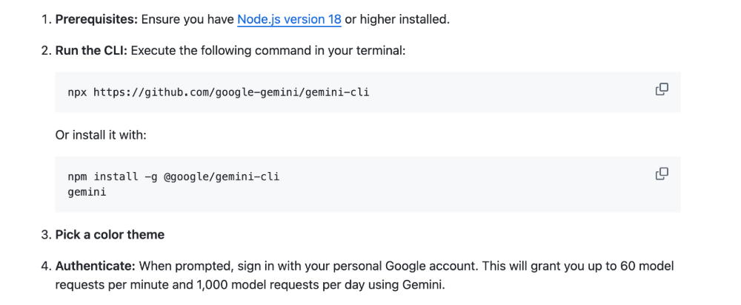

Video Tutorial：

<https://www.bilibili.com/video/BV1GFKBzbE7w?vd_source=e6f596d697180964811dd541f1b5fcc0&spm_id_from=333.788.videopod.sections>

1. **How to use the Gemini CLI with the Shenma**

2.1 Open the VSCode, click the extension store, search for "shenma", install and log in.

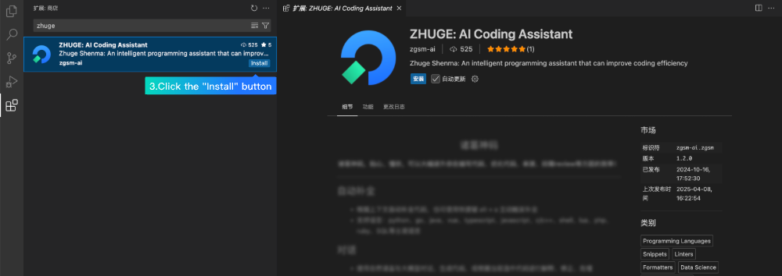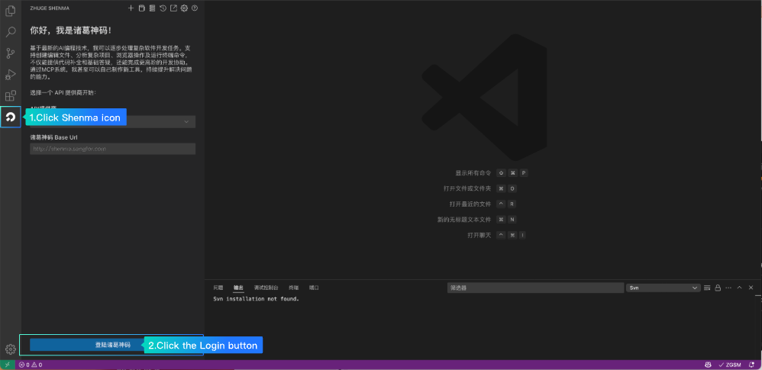

2.2 Open Settings > API Provider page, select Gemini CLI and click “Down” button.

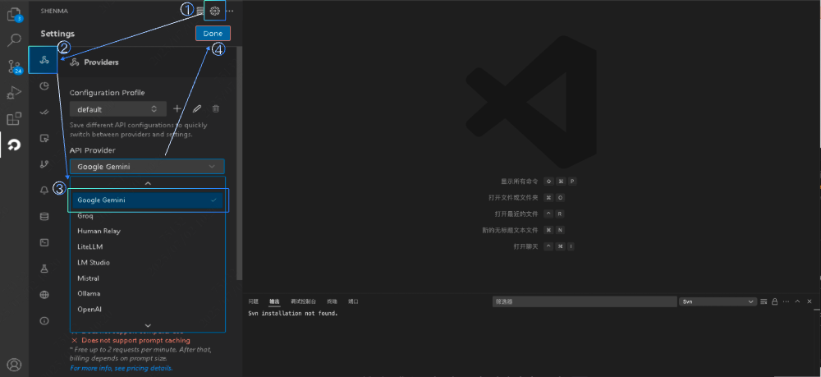

Video Tutorial：

<https://www.bilibili.com/video/BV1GFKBzbE7w?vd_source=e6f596d697180964811dd541f1b5fcc0&spm_id_from=333.788.videopod.sections>