十二周课外作业

1. 源代码

1.

import numpy as np

c = np.array([[1,2,3]],np.int32)

d = c.transpose()

print(d)

from numpy.linalg import inv

e = np.array([[1,0.5,5],[2.3,2,3],[4,1,1.7]])

print(e)

al = inv(e)

print(al)

m = np.matmul(al,d)

print(m)

2.

from PIL import Image

import numpy as np

vec_el = np.pi/2.2

vec_az = np.pi/4.

depth = 10.

im = Image.open('psb.jpg4.jpg').convert('L')

a = np.asarray(im).astype('float')

grad = np.gradient(a)

grad_x, grad_y = grad

grad_x = grad_x*depth/100.

grad_y = grad_y*depth/100.

dx = np.cos(vec_el)*np.cos(vec_az)

dy = np.cos(vec_el)*np.sin(vec_az)

dz = np.sin(vec_el)

A = np.sqrt(grad_x**2 + grad_y**2 + 1.)

uni_x = grad_x/A

uni_y = grad_y/A

uni_z = 1./A

a2 = 255*(dx*uni_x + dy*uni_y + dz*uni_z)

a2 = a2.clip(0,255)

im2 = Image.fromarray(a2.astype('uint8'))

im2.save('psb.jpg4.jpg')

im2.show()

1. 运行情况

1.

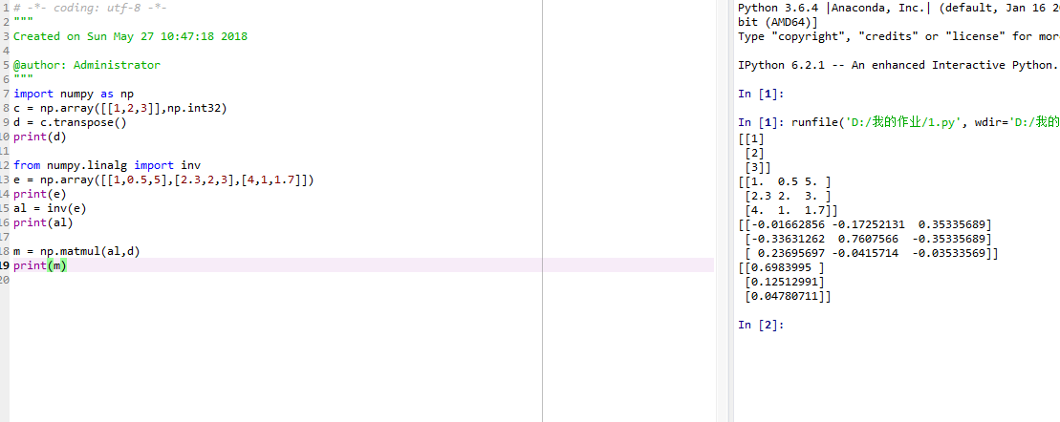

2.

