Week 4

Xiaokuan Zhao

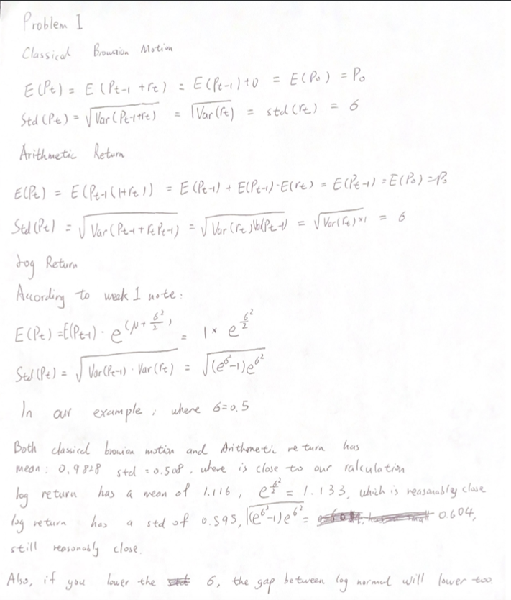

Problem2

Calculate VAR using a normal distribution and the result is 6.41%

Calculate VAR using a normal distribution with an Exponentially Weighted variance lambda = 0.94, and the result is 9.30%

Calculate VAR using an MLE fitted T distribution and the result is 5.69%

Calculate VAR using a fitted AR (1) model and the result is 6.26%

Calculate VAR using a Historic Simulation and the result is 5.46%

Among the five values, the result of normal distribution and MLE fitted T distribution and AR(1) and Historic Simulation are pretty similar. The result of distribution with an Exponentially Weighted variance is 9.30%, which is significantly higher. The result may be because less information is fed to the model because of lambda.

Problem3

I used discrete returns. For VaR method, I use normal distribution with an Exponentially Weighted variance lambda = 0.94 as suggested by the instruction.

There are other assumptions used.

1. The holding is treated as how many lots you have, which means 58 is treated as 5800
2. The present price is the last day price in DailyPrices.csv
3. The portfolio VaR is calculated as (Portfolio Value) x (z-score) x (Portfolio Standard Deviation)
4. z-score is set to be 1.645 as in the Delta normal assumption

The result is as follows.

VaR for portfolio A is $ 567070.75

VaR for portfolio B is $ 449499.84

VaR for portfolio C is $ 378692.6

VaR for total portfolio is $ 1395263.19

The other way I choose is the historical VaR, and the reason I choose it because it can address the problem that returns are not normal and asset prices are not always linear. The result is as follows.

VaR for portfolio A is $ 482785.48

VaR for portfolio B is $ 406016.58

VaR for portfolio C is $ 342785.35

VaR for total portfolio is $ 1231587.41

We can see the result of historical VaR is different than the VaR with normal distribution with EW. I think it is because it includes more price day information and the very old data points influences the result.