EBU6304 Software Engineering Group Project

2025-26
Group number | 19
member 1 | QM no: 231220138 | Name: Yixuan Guo
member 2 | QM no: 231220622 | Name: Penglong Zhao
member 3 | QM no: 231221076 | Name: Shengkai Sun
member 4 | QM no: 231221375 | Name: Jianing Wei
member 5 | QM no: 231221618 | Name: Pengzhi Wang
member 6 | QM no: 231222903 | Name: Dahong Chen

First report

Requirements

1. Fact-gathering techniques
In this project, fact gathering was a crucial step in ensuring accurate requirements. By employing various fact-gathering techniques, the team was able to gain a comprehensive understanding of the system requirements from multiple perspectives. Below are some core fact-gathering techniques and their specific application in this project.

1.1 Background Reading
Background reading typically refers to reading existing literature, market research reports, competitive analyses, and related documents. This method helps in understanding industry trends, competitor products, and the application of existing technologies.
In the early stages of system development, the team conducted in-depth research into existing systems, technical architectures, and market trends in the recruitment management field. For example, by reading white papers and industry reports on recruitment management systems both domestically and internationally, the team was able to identify existing technological gaps and user needs in the market, thus providing a theoretical basis for the requirements analysis of the new system. In practice, the team analyzed the recruitment management systems of several major competitors (such as linkedin.com and passport.lagou.com) to identify shortcomings in existing products and discover commonly concerned functional requirements, such as the accuracy of resume screening and job matching algorithms. This provided valuable reference for defining the functional requirements of this project.

1.2 Interviewing
During the interviews, the team designed specific questions for different user groups. For example, for recruitment managers, the focus was on the difficulties they encountered when screening resumes and posting job information. For marketing TAs, the discussion explored their desire to simplify the application process and improve job matching.
Interviews are a form of in-depth communication, typically used to gather detailed information about a specific interviewee (such as a stakeholder or end-user). It is a highly flexible technique suitable for gathering information with complex contexts or high-level implications. The project team interviewed relevant personnel, teaching assistants (TAs), management teams (MOs), and other potential users at BUPT International School to gain a deeper understanding of their needs and pain points when using the recruitment system. The interviews also helped the team clarify the school's expectations for advanced features such as automated screening and job recommendations.

1.3 Questionnaires
Questionnaire surveys are a quick way to collect feedback from a large number of users, and are suitable for scenarios that require gathering a wide range of opinions or understanding the needs of a large number of users.
To understand the experience of BUPT International School students and applicants when using the recruitment system, the team designed questionnaires for students and applicants. These questionnaires investigated their needs and feedback on aspects such as resume submission, job application, and interview scheduling. In practice, the team collected feedback from students and applicants through an online questionnaire. The survey results showed that most students wanted to be able to quickly search for positions matching their majors and interests within the system, and desired a simplified resume submission process. Based on this feedback, the team decided to optimize the job filtering function and streamline the application process. The questionnaire also revealed time conflicts encountered by applicants in interview scheduling, prompting the team to consider adding a smarter automatic interview time coordination function.

1.4 Focus Groups
Focus groups involve organizing a small group of representative users for discussion, gathering their perspectives and opinions on specific issues. This method is particularly suitable for exploring specific features or needs and obtaining diverse feedback from multiple user perspectives.
In the early stages of development, the project team organized a focus group, inviting recruiters and applicants from different positions to discuss the functional requirements of the recruitment system, especially modules such as resume screening, job matching, and interview scheduling. In practice, during a focus group discussion, the team presented an initial prototype design and collected feedback from various participants. Recruiters expressed a desire for the system to automatically analyze key skills in resumes and match suitable positions based on those skills. Applicants, on the other hand, wanted to be able to view the status of all their job applications on a single platform and receive timely interview notifications. The focus group feedback helped the team further optimize the feature design, ensuring the system meets the needs of diverse users.

1.5 Document Analysis
Document analysis involves a detailed review of existing documents, records, and reports to identify information needs or deficiencies in the existing system. This method is particularly suitable for extracting requirements from historical records and using them as a basis for system design.The team conducted a detailed analysis of the recruitment documents currently used by the school (such as job descriptions, applicant resumes, interview feedback forms, etc.). By analyzing the field settings, information flow, and approval processes in these documents, the team was able to identify missing or inconsistent information in the existing system and processes.

1.6 Observation
Observation refers to gathering requirements by personally observing users' behavior in their natural work environment. This method is particularly suitable for understanding the difficulties users encounter when actually using the system and the needs that have not been made explicit.By observing how recruitment staff at BUPT International School use the existing recruitment system (e.g manually screening resumes and recording interview results using Excel spreadsheets), the team was able to identify inefficiencies in the existing system and further optimize the user experience.
In practice, due to a combination of factors such as missing materials and small sample sizes, document analysis and observation methods did not achieve the expected results, therefore they were placed last.

2. Iteration plan
This summary is based on the Iteration number in the product backlog, covering the core objectives, selected user stories, workload estimates, key time nodes, and core deliverable of the four iterations, clearly presenting the development focus and iteration connection logic of each stage.

Iteration 1: Implementation of core MVP basic functions
Build the core framework of the minimum viable product (MVP) of the system, implement the basic operation process of teaching assistants (TA) and module owners (MO), provide functional support for subsequent iterations, and all functions are of must priority.
Start: March 8, 2026 | Completion: March 22, 2026
Core deliverables：
• TA side: core modules of file management, resume upload, job search, and job application;
• MO side: core module of job posting;
• Basic data linkage mechanism (file - resume - application - position);
• Iteration 1 Test Report + Deployable MVP Prototype;
Complete the development of core front-end features in all subsequent iterations.

Iteration 2: Core process improvement + AI basic function implementation
Complete the core business processes of TA and MO, realize key functions such as application status tracking and candidate review, implement AI-based enhancement functions with priority, and improve the efficiency of core recruitment processes. It relies entirely on all the features of Iteration 1 and requires development based on the published job postings, submitted applications, and uploaded resumes/files.
Start: March 23, 2026 | Completion: April 12, 2026
Core deliverables：
• TA side: real-time tracking of application status, automatic resume filling file function;
• MO side: centralized candidate review, skill matching score viewing, application status management module;
• The first AI basic functions (resume analysis, skill matching);
• The core recruitment process (release - application - review - status update) is implemented in a closed loop;

Iteration 3: Implementation of administrator functions + process optimization
The addition of a core administrator user role addresses management pain points such as workload allocation and scheduling conflicts, implements Must's basic administrator functions and Should's process optimization functions, and ensures the rational allocation of recruitment resources. Based on the functional results of Iteration 1 + Iteration 2, load statistics and conflict detection need to be carried out based on the assigned TA positions and the approved application data.
Start Date: April 13, 2026 | Completion Date: May 3, 2026
Core deliverables：
• Administrator side: Core modules for TA workload statistics and scheduling conflict/overload detection;
• TA side: Optimized job collection function to improve user experience;
• System resource management mechanism implemented to achieve reasonable allocation of recruitment work and risk warning;

Iteration 4: Advanced AI features + Experience optimization + Notification mechanism
Implement advanced features that could be prioritized, including AI-powered intelligent recommendations and multi-role message notifications, to complete the final refinement of the system's user experience and add features, thereby achieving comprehensive product functionality improvement. Relying on the full functional data from Iteration 1 + Iteration 2 + Iteration 3, intelligent recommendations and notification triggers need to be carried out based on TA skills, workload, application status, and job information.
May 4, 2026 | Completed: May 24, 2026
Core deliverables：
• Administrator side: AI-powered intelligent TA recommendation function to improve resource allocation efficiency;
• Message notification and to-do reminder mechanism for all roles (TA/MO/administrator);
• System AI function upgrade (from basic analysis/matching to advanced intelligent recommendation);
• Full-function closed loop implementation of the product, completing the final experience refinement;

3. Prioritization methods
In this project, prioritization methods are crucial for ensuring features are implemented in order of importance and resource availability. We used the following methods to prioritize user stories in the Product Backlog:

3.1 MoSCoW Method
The MoSCoW method is a commonly used prioritization technique in Agile development. It categorizes user stories into four different categories to ensure that the most important features are implemented first, given limited time and resources. The specific categories are as follows: Must Have: Features that must be implemented. If these features are not implemented, the system will not function properly. For example, "creating user profiles" and "uploading resumes" in a recruitment system are basic functions that must be completed before system delivery. Should Have: Important but deferable features. The absence of these features will not affect the core operation of the system, but they are crucial to the system's improvement. For example, the "resume screening function" is crucial for improving work efficiency, but its implementation can be postponed if time is tight. Could Have: Features that can be added to improve the user experience, but do not directly affect the core functionality of the system. For example, the "job recommendation system" adds intelligence to the system, but it is not essential.

3.2 Prioritization based on business value
The priority of each user story is also evaluated based on its value to the business. This approach focuses on assessing the return on investment (ROI) of each feature, i.e., whether the implementation of the feature can bring significant business benefits or cost savings. For example, the "automatic job matching" feature in the recruitment system improves recruitment efficiency and reduces the time spent on manual screening, so it is considered to have high business value, while "custom job application forms," although somewhat usable, have relatively low value.

3.3 Risk Assessment Method
In the prioritization process, the team also considered risk factors, i.e., the technical difficulties or unforeseen obstacles that may be encountered in implementing certain features. Low-risk, high-return features are prioritized. For example, the resume upload function, although technically simple, may cause the entire system to malfunction if its development is delayed, so it is given priority. Some complex AI features, such as "automatic skills gap detection," are classified as features for later versions due to their high technical difficulty and long implementation time.

3.4 User Feedback
In addition to the above methods, the team also collected feedback from BUPT International School staff and potential users (such as recruiters, students, etc.). Through focus groups and questionnaires, the team understood the needs and expectations of all parties regarding the system. By analyzing user needs and feedback, the team adjusted priorities accordingly. For example, students and applicants paid particular attention to the application status check and job recommendation functions, so these two functions were given higher priority.

4. Estimation methods
In this project, the team used several estimation methods to predict the workload and development time required for user stories. The specific estimation methods are as follows:

4.1 Story Points Estimating
Story point estimation is the primary estimation method we use. It quantifies workload by assigning story points to each user story. Each story point represents the relative effort, complexity, and uncertainty required to complete the task. The team determines the appropriate story points by discussing the complexity and workload of each user story.
The Fibonacci sequence (1, 2, 3, 5, 8, 13, 21) is used to assign story points to each user story, with more complex tasks receiving a larger number of story points. For example, the resume upload function, due to its simplicity, is estimated to have 3 story points, while more complex functions such as automatic job matching are assigned 5 story points.
In our table, the team estimated story points for each functional task. For example, the job application function was assigned 5 story points because it is relatively complex and involves permission management for different user roles, while the job search function was assigned 3 story points, with a lower expected development workload.

4.2 Hours Estimating
Hour estimation is a straightforward estimation method where teams predict the required man-hours based on the actual amount of work each task will have. This approach is particularly useful for tasks that are already well-defined and of relatively low complexity.
Teams use hourly estimates to handle specific development tasks, especially when functional modules are clearly defined and task details are complete. For example, implementing resume uploads is estimated at 16 hours, while designing the job listing page is estimated at 8 hours. These estimates, based on actual development time predictions, help teams allocate resources more accurately.
The table lists the estimated time-frames for each user story. For example, creating a user profile for a TA applicant is estimated to take 8 hours, while the job posting feature is estimated to take 12 hours. This granular estimation allows the team to better manage the development process and ensure on-time delivery of each module.

4.3 Prioritization and estimation combined
In this project, we not only considered the technical complexity of the tasks, but also adjusted the workload estimates based on the priority of each function. By combining the MoSCoW prioritization method, the team prioritized each user story, thereby allocating the estimated time reasonably.
Higher-priority features (such as resume upload and job application functions) are assigned higher estimated values, while lower-priority features (such as skills matching functions) are scheduled for later development. This allows the team to flexibly adjust based on priority and workload, ensuring that the most important features are developed in a timely manner.
In the table, the resume upload function and the job application function are listed as high-priority tasks and are assigned relatively high time estimates, while later functions (such as workload balancing) are assigned to lower priority and have relatively lower time estimates.

Supporting material

2.1 Two Websites We Analyzed

linkedin.com
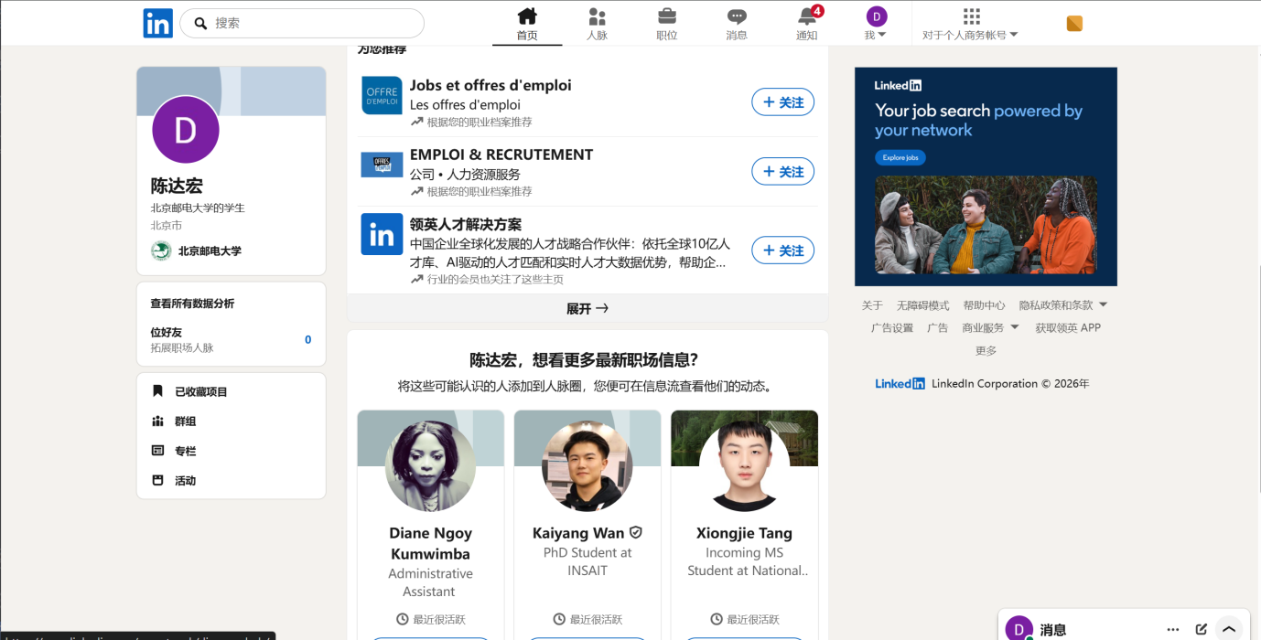
Analysis focus: Job posting process, CV screening mechanism, and candidate matching presentation.
Key findings:
- The system automatically highlights the skill match between job requirements and candidate profiles, displaying a match score prominently in the candidate list.
- Applicants can track application status (e.g., “CV viewed”, “Interview invited”), reducing information gaps.

passport.lagou.com
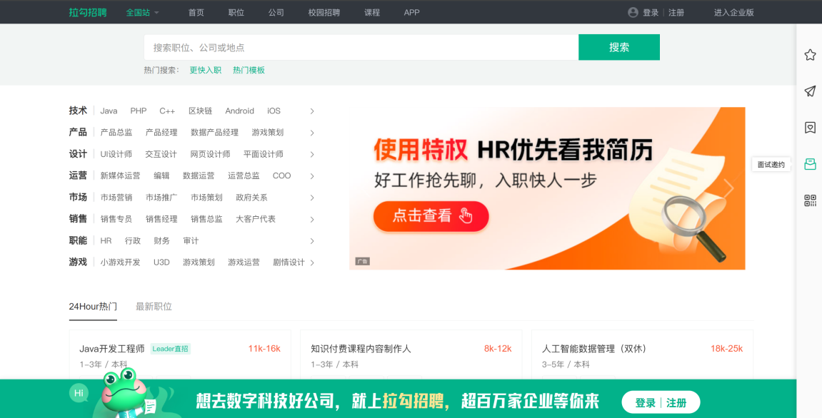
Analysis focus: Recruiter (MO) candidate management interface, sorting/filtering functions, and notification mechanisms.
Key findings:
- Recruiters can sort applicants by dimensions such as “match score”, “application date”, or “education level”, significantly improving screening efficiency.
- The system pushes notifications like “job update reminders” and “interview invitations” to applicants.

2.2 Q&A from Interviews

Interview 1: TA Applicant (applied for TA positions 3 times)
Q: What was the most inconvenient part when you applied for TA positions before?
A: The most inconvenient part was not knowing the progress of my applications. After submitting my CV, I had no idea whether it had been reviewed, whether I was shortlisted, or if I was rejected. Sometimes I would receive a notification after a long time, but in between it was a blind spot. I think the system should show the status of each application, such as “Submitted”, “Under Review”, “Shortlisted”, “Accepted”, or “Rejected”.

Interview 2: Module Organiser (recruited TAs for 3 modules)
Q: How do you currently select TAs, and what would you most like a system to help you with?
A: I currently go through CVs and Excel sheets one by one. The most time‑consuming part is matching the job requirements against each TA’s CV. I wish the system could automatically calculate how well a TA matches a position, give a score, and highlight what skills are missing. That way I could quickly filter out obviously unsuitable candidates and save a lot of time.

Interview 3: TA Applicant (currently applying for TA positions)
Q: What would you like to be able to do first when using a system to apply for TA jobs?
A: I hope I don’t have to fill in all my information manually, especially my major, courses, and skills. It would be great if the system could extract those directly from my CV. Also, I would like the job list to be filtered by my major or skills, so I only see positions that match my background or time availability.

Interview 4: Administrator (coordinates TA workload across modules)
Q: What difficulties have you encountered when allocating TAs across modules?
A: The main difficulty is avoiding overloading a single TA. Sometimes one TA is selected by multiple modules, and later they cannot handle the schedule, forcing us to find replacements. I would like to see, in one place, how many hours each TA has already been assigned. Ideally, the system would automatically warn me if a TA exceeds the limit or if there is a time conflict between two jobs.

Interview 5: Module Organiser (concerned with long‑term recruitment efficiency)
Q: If the system could reduce your repetitive work, what would you want it to do?
A: Every time I post a job, I have to fill in many fields, though many modules have similar requirements. It would be convenient if I could duplicate a previous job and then modify it. Also, I would like to receive a simple notification whenever a student applies, so I don’t have to keep refreshing the page to see new applications.

2.3 Survey by Online Questionnaire
An online questionnaire was distributed to students at BUPT International School. A total of 42 valid responses were collected. The survey aimed to understand user expectations, pain points, and desired features for the new TA Recruitment System.

Questionnaire
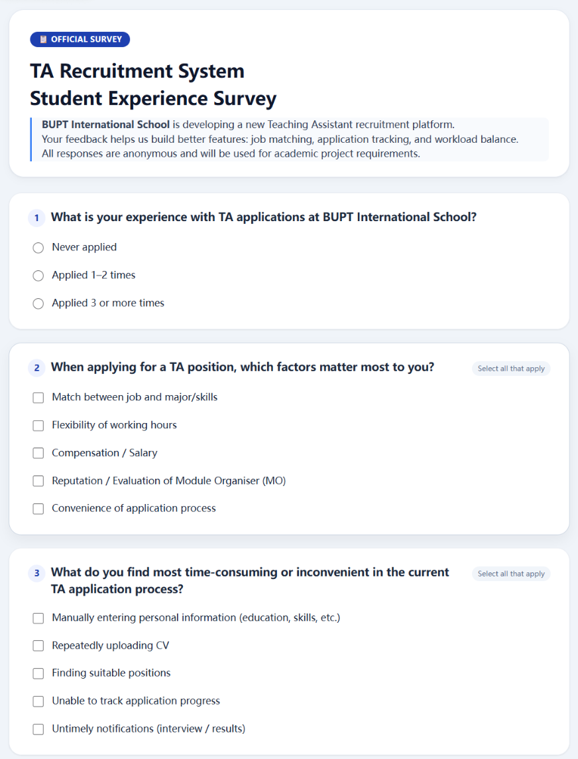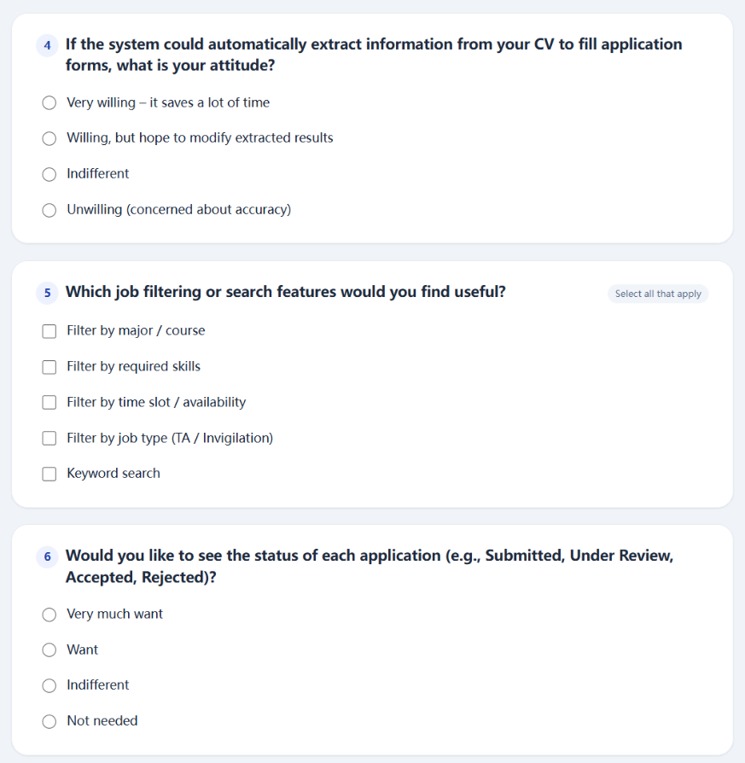
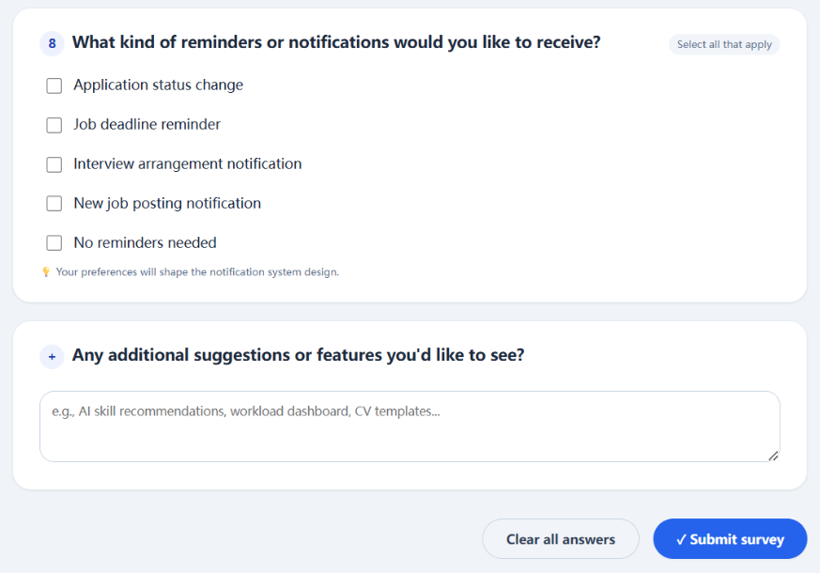

Survey Results

Q1. What is your experience with TA applications at BUPT International School?
Option | Count | Percentage
Never applied | 8 | 19%
Applied 1–2 times | 24 | 57%
Applied 3 or more times | 10 | 24%
Insight: The majority (81%) have applied at least once, providing relevant experience for feedback.

Q2. When applying for a TA position, which factors matter most to you? (Multiple selection)
Factor | Count | Percentage
Match between job and major/skills | 37 | 88%
Flexibility of working hours | 29 | 69%
Compensation / Salary | 18 | 43%
Reputation / Evaluation of Module Organiser (MO) | 12 | 29%
Convenience of application process | 33 | 79%
Insight: Skill matching (88%) and process convenience (79%) are top priorities. This supports the need for US04 (job filtering) and US10 (match score).

Q3. What do you find most time-consuming or inconvenient in the current TA application process? (Multiple selection)
Inconvenience | Count | Percentage
Manually entering personal information | 34 | 81%
Repeatedly uploading CV | 22 | 52%
Finding suitable positions | 29 | 69%
Unable to track application progress | 31 | 74%
Untimely notifications | 25 | 60%
Insight: Manual data entry (81%) and lack of progress tracking (74%) are the biggest frustrations, directly supporting US03 (auto-fill from CV) and US07 (application status tracking).

Q4. If the system could automatically extract information from your CV to fill application forms, what is your attitude?
Attitude | Count | Percentage
Very willing | 20 | 48%
Willing, but hope to modify extracted results | 18 | 43%
Indifferent | 3 | 7%
Unwilling | 1 | 2%
Insight: 91% are willing or conditionally willing to use auto-fill. This strongly validates US03 (auto-fill profile from CV).

Q5. Which job filtering or search features would you find useful? (Multiple selection)
Filter type | Count | Percentage
Filter by major / course | 36 | 86%
Filter by required skills | 32 | 76%
Filter by time slot / availability | 28 | 67%
Filter by job type (TA / Invigilation) | 24 | 57%
Keyword search | 30 | 71%
Insight: High demand for filtering by major (86%) and skills (76%) confirms the importance of US04 (browse, search, filter jobs).

Q6. Would you like to see the status of each application (e.g., Submitted, Under Review, Accepted, Rejected)?
Attitude | Count | Percentage
Very much want | 28 | 67%
Want | 12 | 29%
Indifferent | 2 | 5%
Not needed | 0 | 0%
Insight: 96% of respondents want status visibility. This is a direct validation of US07 (view application status timeline).

Q7. Have you ever experienced schedule conflicts when applying for multiple positions?
Frequency | Count | Percentage
Often | 8 | 19%
Occasionally | 22 | 52%
Rarely | 10 | 24%
Never | 2 | 5%
Insight: 71% have experienced time conflicts at least occasionally, supporting the need for US13 (detect schedule conflict or overload).

Q8. What kind of reminders or notifications would you like to receive? (Multiple selection)
Notification type | Count | Percentage
Application status change | 36 | 86%
Job deadline reminder | 29 | 69%
Interview arrangement notification | 34 | 81%
New job posting notification | 21 | 50%
No reminders needed | 2 | 5%
Insight: Strong demand for status change (86%) and interview notifications (81%) validates US15 (receive notifications and reminders).

