Case 1: Iterations Checking Palindromes (efter tirsdag)

A string is a palindrome if it reads the same forward and backward. The words “mom,” “dad,” and “noon,” for instance, are all palindromes.
think before you code
The problem is to write a program that prompts the user to enter a string and reports whether the string is a palindrome. One solution is to check whether the first character in the string is the same as the last character. If so, check whether the second character is the same as the second-to-last character. This process continues until a mismatch is found or all the characters in the string are checked, except for the middle character if the string has an odd number of characters.
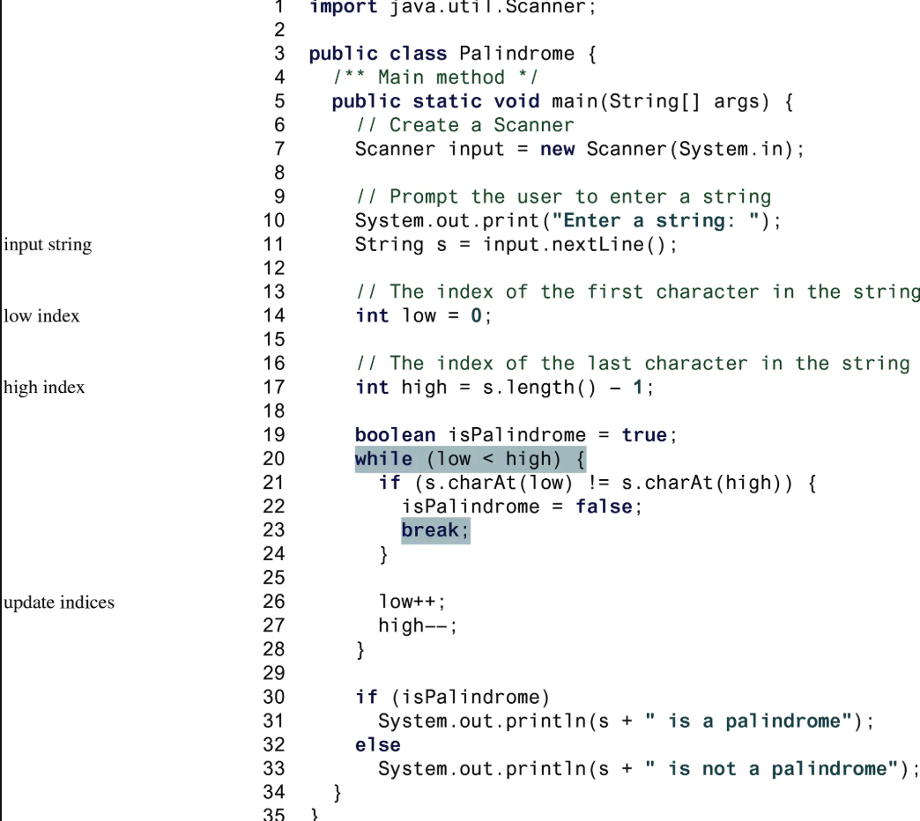
Hint

https://www.codecademy.com/courses/learn-java/lessons/java-string-methods/exercises/charat

