# 垃圾分类：

<https://api.66mz8.com/api/garbage.php?name=name>

# 快递单号：

[**https://api.66mz8.com/api/yto.php?num=2100225068**](https://api.66mz8.com/api/yto.php?num=2100225068)

# 一言：

[**https://v1.alapi.cn/api/hitokoto?type=b**](https://v1.alapi.cn/api/hitokoto?type=b)

**type ：**一言的类型(a动画，b漫画，c游戏，d小说，e原创，f来自网络，g其他)

# 网易云热歌：

**https://api.uomg.com/api/rand.music?sort=热歌榜&format=json**

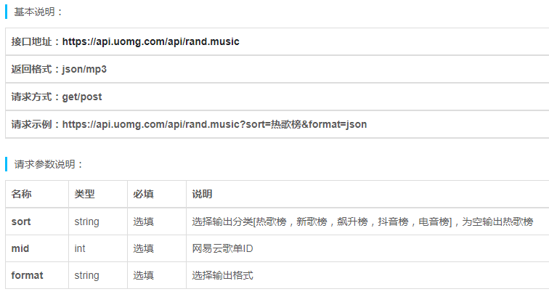

{

"code": 1,

"data": {

"name": "隔壁泰山",

"url": "http:\/\/music.163.com\/song\/media\/outer\/url?id=862101001.mp3",

"picurl": "http:\/\/p1.music.126.net\/pbT0ag5PXJwYzFJ7YklMCA==\/109951163386629013.jpg"

}

}

实时段子：

[**https://api.apiopen.top/getJoke?page=1&count=2&type=video**](https://api.apiopen.top/getJoke?page=1&count=2&type=video)

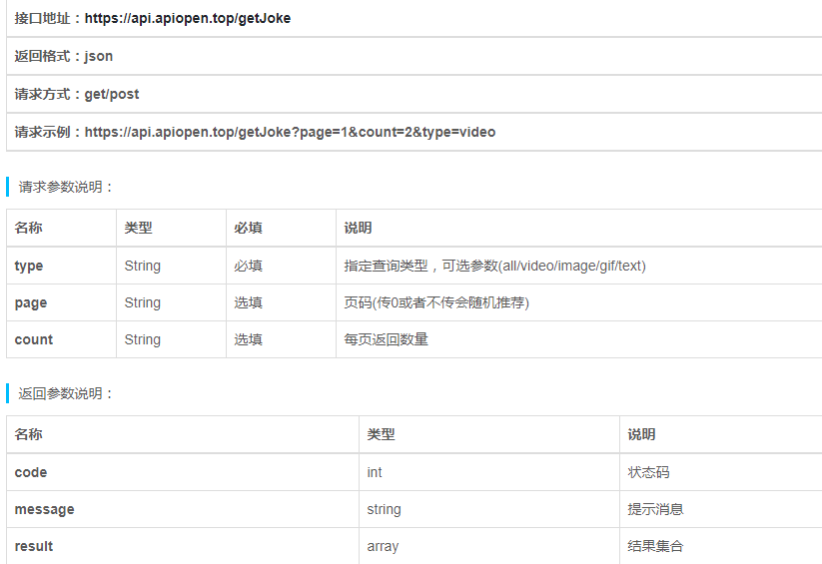

{

"code": 200,

"message": "成功!",

"result": [{

"sid": "29601022",

"text": "哈哈哈原谅我不厚道的笑了",

"type": "video",

"thumbnail": "http://wimg.spriteapp.cn/picture/2019/0617/205fb4bc-90e3-11e9-96bf-1866daeb0df1_wpd.jpg",

"video": "http://wvideo.spriteapp.cn/video/2019/0617/205fb4bc-90e3-11e9-96bf-1866daeb0df1_wpd.mp4",

"images": null,

"up": "95",

"down": "6",

"forward": "1",

"comment": "8",

"uid": "20746551",

"name": "温柔尝尽了吗",

"header": "http://wimg.spriteapp.cn/profile/large/2019/03/26/5c99f6e152ea2_mini.jpg",

"top_comments_content": "人没事就万幸了，听话女士，以后不要碰车了，不管四个轮还是两个轮的",

"top_comments_voiceuri": "",

"top_comments_uid": "20782663",

"top_comments_name": "拾歡7XE",

"top_comments_header": "http://wx.qlogo.cn/mmopen/2EzJggZltBP54y2zB04fSVESdBB1DicpJuJSRhGAUUmvxvrypibvHOt3DpSqLUdic917kZzVppAbO7o45bI7jHhfOQDmLF4EBHt/0",

"passtime": "2019-06-19 02:51:01"

}]

}

# 网易云音乐接口：

**https://v1.alapi.cn/api/music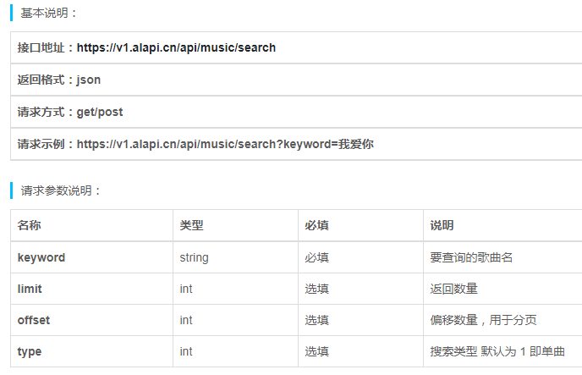/search?keyword=我爱你**

{

"code": 200,

"msg": "success",

"data": {

"songs": [{

"id": 458231315,

"name": "我愛你",

"artists": [{

"id": 1193188,

"name": "Ayasa绚沙",

"picUrl": null,

"alias": [],

"albumSize": 0,

"picId": 0,

"img1v1Url": "https://p2.music.126.net/6y-UleORITEDbvrOLV0Q8A==/5639395138885805.jpg",

"img1v1": 0,

"trans": null

}],

"album": {

"id": 35157350,

"name": "BEST I",

"artist": {

"id": 0,

"name": "",

"picUrl": null,

"alias": [],

"albumSize": 0,

"picId": 0,

"img1v1Url": "https://p2.music.126.net/6y-UleORITEDbvrOLV0Q8A==/5639395138885805.jpg",

"img1v1": 0,

"trans": null

},

"publishTime": 1485273600000,

"size": 16,

"copyrightId": -1,

"status": 0,

"picId": 109951163984548450,

"mark": 0

},

"duration": 230826,

"copyrightId": 739012,

"status": 0,

"alias": [],

"rtype": 0,

"ftype": 0,

"mvid": 0,

"fee": 1,

"rUrl": null,

"mark": 139264

}],

"songCount": 600

},

"Author": {

"name": "Alone88",

"desc": "由Alone88提供的免费API 服务，官方文档：www.alapi.cn"

}

}