Supplementary material
Decision support for durian disease diagnosis from field photographs: grouped validation, backbone choice and referral to the grower
Lin Ding Shan (Independent researcher, Malaysia)
All tables and figures are generated by paper/make_supplement.py from the released result files (results/preds.csv, results/results.csv, results/v2/results.csv, results/v3/*, results/numbers.json, paper/numbers.json and paper/numbers_v3.json). The single-channel spatial gate (SG) is labelled lfa / LFA in the code, the result files and Figs. S1–S2, and the leaf blight complex is labelled Leaf_rot.

Table S1. Per-class precision, recall and F1 (%, mean ± SD over runs in which the class was present), all test images
Class | Configuration | Precision | Recall | F1
Algal leaf spot | None | 72.9 ± 25.5 | 63.7 ± 18.4 | 65.3 ± 19.3
 | SG | 73.8 ± 25.9 | 61.1 ± 21.2 | 63.6 ± 21.0
 | SE | 72.8 ± 25.2 | 59.9 ± 20.6 | 62.5 ± 19.9
 | CBAM | 74.1 ± 24.1 | 60.7 ± 21.8 | 63.6 ± 21.1
Leaf blight complex | None | 66.6 ± 15.4 | 78.9 ± 16.0 | 70.7 ± 12.3
 | SG | 66.9 ± 16.2 | 82.9 ± 15.1 | 71.8 ± 11.1
 | SE | 64.8 ± 17.9 | 79.3 ± 20.1 | 69.4 ± 15.5
 | CBAM | 66.0 ± 14.5 | 82.2 ± 12.3 | 71.8 ± 9.9
Phomopsis leaf spot | None | 77.2 ± 20.5 | 78.6 ± 19.0 | 74.2 ± 13.4
 | SG | 77.7 ± 20.2 | 76.7 ± 19.4 | 73.5 ± 13.9
 | SE | 78.3 ± 20.9 | 78.9 ± 18.8 | 74.9 ± 14.7
 | CBAM | 77.0 ± 21.0 | 78.1 ± 20.4 | 73.4 ± 14.9
Root and collar rot | None | 91.0 ± 18.3 | 99.3 ± 2.1 | 93.6 ± 14.2
 | SG | 92.3 ± 16.2 | 99.0 ± 2.2 | 94.6 ± 11.6
 | SE | 91.2 ± 18.3 | 99.3 ± 1.5 | 93.8 ± 14.2
 | CBAM | 91.5 ± 17.3 | 99.2 ± 2.0 | 94.0 ± 13.1

Table S2. Accuracy (%, mean ± SD over 40 runs) and paired difference from the plain network over 20 folds (corrected resampled t-test)
Configuration | Accuracy | Difference (pp) [95% CI] | p, corrected | Folds higher
None | 75.95 ± 9.33 | – | – | –
SG | 75.47 ± 10.09 | −0.49 [−4.67, 3.70] | 0.811 | 9/20
SE | 74.75 ± 10.93 | −1.20 [−8.79, 6.39] | 0.744 | 10/20
CBAM | 75.78 ± 9.66 | −0.17 [−4.82, 4.47] | 0.939 | 10/20

Table S3. Preliminary experiment: eight runs per configuration on one fixed five-class split (earlier code; training randomness not controlled by the seed, so replicates are unpaired)
Configuration | Macro F1, mean ± SD | Difference from none (pp) | p, Welch t | p, Mann–Whitney
None | 77.55 ± 1.91 | – | – | –
SG | 78.05 ± 2.61 | +0.50 | 0.671 | 0.958
SE | 76.63 ± 3.75 | −0.92 | 0.551 | 0.752
CBAM | 77.10 ± 2.86 | −0.45 | 0.718 | 0.833

Table S4. Macro F1 averaged over all four classes (an absent class scored as zero), as stored by the training notebooks and used in the pre-specified decision rule
Configuration | Macro F1 (%), mean ± SD | Paired difference (pp) [95% CI] | p, corrected | Meets rule (≥ 2 pp and CI > 0)
None | 72.44 ± 13.05 | – | – | –
SG | 72.32 ± 13.08 | −0.12 [−4.54, 4.30] | 0.954 | no
SE | 71.63 ± 13.45 | −0.82 [−7.63, 6.00] | 0.805 | no
CBAM | 72.18 ± 13.43 | −0.27 [−5.11, 4.57] | 0.909 | no

Table S5. Training settings (identical for all configurations)
Item | Setting
Backbone | EfficientNet-B0, torchvision ImageNet weights (IMAGENET1K_V1)
Input | Train: RandomResizedCrop(224, scale 0.7–1.0). Evaluation: Resize(256) on the short side, CenterCrop(224)
Augmentation | Horizontal flip p = 0.5; vertical flip p = 0.3; RandomAffine (rotation ±20°, translation 5 %, scale 0.95–1.05); ColorJitter (brightness 0.3, contrast 0.3, saturation 0.2, hue 0.05); GaussianBlur (kernel 3–7, σ 0.1–1.5); ImageNet normalisation; RandomErasing p = 0.3, 2–10 % of the image
Classifier head | Dropout p = 0.3, Linear(1280, 4)
Stage 1 | 15 epochs, backbone frozen (BatchNorm statistics still updating), Adam, lr 1e-3, attention module + head trained
Stage 2 | 15 epochs, all parameters trainable, Adam, lr 1e-5, starting from the best stage-1 checkpoint
Checkpoint selection | Highest inner-validation macro F1 over both stages; inner validation ≈ 10 % of the training part, by whole groups
Loss and sampling | Cross-entropy with inverse-frequency class weights; WeightedRandomSampler with class weights
Batch size | 16
Precision | Mixed precision (torch.autocast with a gradient scaler)
Seeds | 0 and 1 per fold; Python, NumPy, PyTorch, sampler and data-loader workers seeded; cuDNN deterministic
Hardware | Google Colab GPU runtime; PyTorch and torchvision

Table S6. Paired comparisons of macro F1 with the plain network under three tests over the 20 folds
Configuration | Mean difference (pp) | p, corrected resampled t | p, uncorrected paired t | p, Wilcoxon signed-rank
SG | −0.13 | 0.953 | 0.870 | 0.898
SE | −0.77 | 0.816 | 0.521 | 0.956
CBAM | −0.38 | 0.879 | 0.675 | 0.277

Table S7. Sensitivity to the grouping of video frames (Section 2.3 of the manuscript)
Test images scored | Mean test images per fold | Configuration | Macro F1 (%), mean ± SD | Paired difference (pp) [95% CI] | p, corrected
All test images | 137.5 | None | 75.06 ± 10.86 | – | –
 |  | SG | 74.93 ± 10.95 | −0.13 [−4.56, 4.31] | 0.953
 |  | SE | 74.29 ± 11.80 | −0.77 [−7.62, 6.08] | 0.816
 |  | CBAM | 74.68 ± 10.78 | −0.38 [−5.48, 4.73] | 0.879
Video frames excluded | 121.8 | None | 66.60 ± 12.04 | – | –
 |  | SG | 66.46 ± 12.15 | −0.13 [−4.55, 4.28] | 0.950
 |  | SE | 65.34 ± 12.74 | −1.26 [−10.28, 7.76] | 0.773
 |  | CBAM | 66.37 ± 13.06 | −0.23 [−5.83, 5.37] | 0.933
Only images whose video-linked group was not split | 87.0 | None | 67.36 ± 12.17 | – | –
 |  | SG | 66.54 ± 12.34 | −0.83 [−6.09, 4.44] | 0.746
 |  | SE | 64.54 ± 14.16 | −2.83 [−11.70, 6.04] | 0.512
 |  | CBAM | 66.19 ± 14.53 | −1.17 [−7.96, 5.62] | 0.722
Without the video frames the mean seed difference was 5.67 points, and the SG was at least 3 points ahead of the plain network in 20.0 % of seed-matched pairs and at least 3 points behind in 22.5 %.

Table S8. Model size, computation and CPU latency for one 224 × 224 image (median and 90th percentile of 200 passes, Colab CPU)
Configuration | Parameters (M) | Added parameters | GMACs | 1 thread, median (ms) | 1 thread, p90 (ms) | 12 threads, median (ms) | 12 threads, p90 (ms)
None | 4.0127 | 0 | 0.3845 | 34.29 | 35.38 | 22.46 | 46.40
SG | 4.0140 | 1,281 | 0.3846 | 34.18 | 35.39 | 22.65 | 23.92
SE | 4.2175 | 204,800 | 0.3847 | 34.21 | 35.17 | 22.54 | 24.78
CBAM | 4.2176 | 204,898 | 0.3850 | 35.20 | 35.86 | 23.29 | 27.03

Table S9. Fold sizes and macro F1 per fold (%, mean of two seeds; † no root and collar rot image in the test fold)
Repeat | Fold | Train | Validation | Test | None | SG | SE | CBAM
0 | 0 | 440 | 58 | 52 | 94.40 | 93.28 | 88.25 | 95.07
0 | 1 | 386 | 41 | 123 | 75.76 | 77.22 | 78.18 | 75.87
0 | 2 | 275 | 28 | 247 | 63.87 | 58.34 | 62.51 | 61.07
0 | 3 | 388 | 34 | 128 | 82.14 | 81.89 | 77.97 | 81.90
1 | 0 | 453 | 42 | 55 | 79.10 | 71.19 | 75.34 | 71.92
1 | 1 | 395 | 46 | 109 | 76.57 | 81.34 | 80.37 | 75.90
1 | 2† | 296 | 30 | 224 | 49.82 | 50.38 | 50.71 | 49.08
1 | 3 | 348 | 40 | 162 | 74.04 | 74.75 | 73.69 | 73.77
2 | 0† | 419 | 51 | 80 | 72.23 | 70.65 | 72.16 | 72.86
2 | 1 | 256 | 35 | 259 | 66.89 | 68.65 | 68.43 | 66.97
2 | 2 | 443 | 46 | 61 | 82.37 | 81.21 | 84.31 | 80.29
2 | 3 | 358 | 42 | 150 | 81.42 | 75.09 | 80.30 | 80.01
3 | 0 | 393 | 61 | 96 | 69.43 | 74.90 | 50.39 | 80.74
3 | 1 | 424 | 46 | 80 | 70.07 | 70.00 | 70.57 | 69.69
3 | 2 | 247 | 23 | 280 | 69.88 | 71.23 | 70.92 | 67.90
3 | 3 | 417 | 39 | 94 | 87.54 | 87.58 | 88.28 | 88.29
4 | 0† | 459 | 50 | 41 | 87.21 | 88.04 | 89.95 | 78.82
4 | 1 | 381 | 34 | 135 | 82.71 | 80.84 | 82.08 | 81.72
4 | 2 | 309 | 31 | 210 | 56.47 | 59.59 | 64.50 | 61.42
4 | 3 | 342 | 44 | 164 | 79.27 | 82.45 | 76.84 | 80.39

Figures S1 and S2
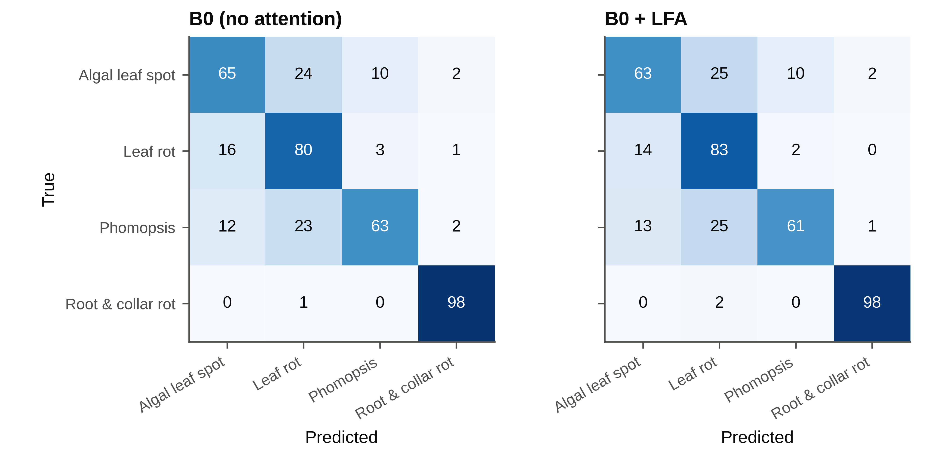
Confusion matrices of the plain network and the SG (labelled LFA), pooled over the 40 runs of each configuration and normalised by row (%), all test images.
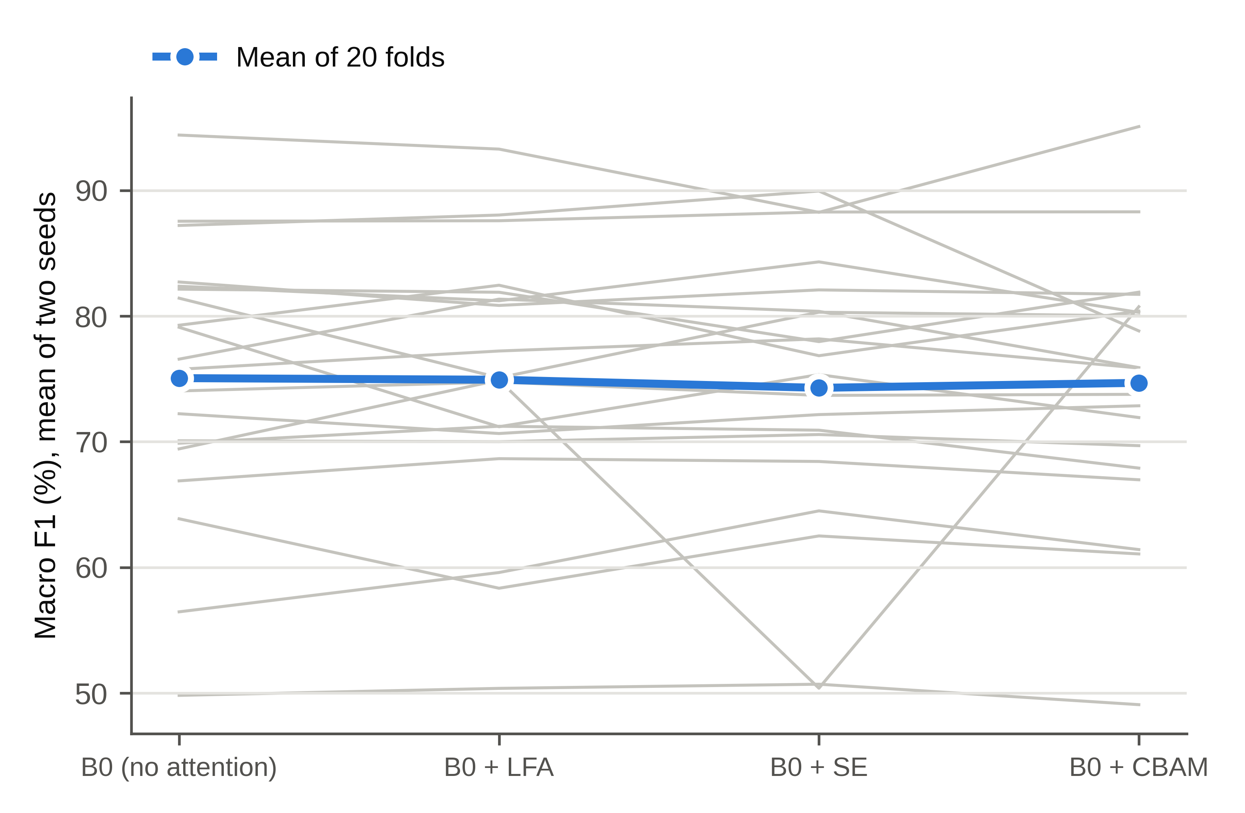
Macro F1 of each configuration on each of the 20 folds (grey lines, mean of two seeds) and the mean over folds (blue), all test images.

Table S10. Per-class precision, recall and F1 (%, mean ± SD over runs in which the class was present), video frames excluded (primary scoring)
Class | Configuration | Precision | Recall | F1 | Runs
Algal leaf spot | None | 73.1 ± 25.5 | 63.7 ± 18.4 | 65.4 ± 19.3 | 40
 | SG | 74.1 ± 26.0 | 61.1 ± 21.2 | 63.7 ± 21.1 | 40
 | SE | 73.1 ± 25.3 | 59.9 ± 20.6 | 62.5 ± 19.9 | 40
 | CBAM | 74.6 ± 24.4 | 60.7 ± 21.8 | 63.7 ± 21.1 | 40
Leaf blight complex | None | 67.5 ± 15.8 | 78.9 ± 16.0 | 71.1 ± 12.3 | 40
 | SG | 68.0 ± 16.4 | 82.9 ± 15.1 | 72.5 ± 11.0 | 40
 | SE | 65.9 ± 18.5 | 79.3 ± 20.1 | 69.9 ± 15.5 | 40
 | CBAM | 66.7 ± 14.7 | 82.2 ± 12.3 | 72.2 ± 9.9 | 40
Phomopsis leaf spot | None | 44.3 ± 44.2 | 29.4 ± 27.8 | 32.0 ± 31.6 | 32
 | SG | 44.4 ± 45.0 | 27.0 ± 27.3 | 30.9 ± 31.7 | 32
 | SE | 44.1 ± 44.0 | 31.0 ± 28.2 | 32.8 ± 32.3 | 32
 | CBAM | 44.2 ± 44.4 | 28.6 ± 28.2 | 31.4 ± 31.7 | 32
Root and collar rot | None | 91.0 ± 18.3 | 99.3 ± 2.1 | 93.6 ± 14.2 | 34
 | SG | 92.3 ± 16.2 | 99.0 ± 2.2 | 94.6 ± 11.6 | 34
 | SE | 91.2 ± 18.3 | 99.3 ± 1.5 | 93.8 ± 14.2 | 34
 | CBAM | 91.5 ± 17.3 | 99.2 ± 2.0 | 94.0 ± 13.1 | 34

Table S11. Backbone comparison: macro F1 and accuracy (%, mean ± SD over 40 runs) and paired difference from EfficientNet-B0 over 20 folds
Corrected resampled t-test (factor 0.383); Holm adjustment over the four comparisons; “rule” is the pre-specified criterion (difference of at least 2 pp and Holm p < 0.05).
Scoring | Backbone | Macro F1 | Accuracy | Difference (pp) [95% CI] | p, corrected | p, Holm | p, uncorrected t | p, Wilcoxon | Folds higher | Rule met | Mean seed difference (pp)
video frames excluded (primary) | EfficientNet-B0 | 66.65 ± 12.20 | 72.82 | – | – | – | – | – | – | – | 5.61
 | MobileNetV3-Large | 64.39 ± 14.42 | 72.15 | −2.26 [−9.47, 4.95] | 0.520 | 0.520 | 0.0851 | 0.1327 | 8/20 | no | 5.94
 | MobileNetV4-Conv-Medium | 58.30 ± 12.67 | 66.53 | −8.36 [−16.38, −0.33] | 0.042 | 0.126 | < 0.0001 | < 0.0001 | 2/20 | no | 7.42
 | ConvNeXt V2-Tiny | 74.81 ± 12.10 | 82.89 | +8.16 [1.87, 14.45] | 0.014 | 0.055 | < 0.0001 | < 0.0001 | 18/20 | no | 3.79
 | ViT-S/16 | 74.96 ± 12.20 | 82.32 | +8.30 [−0.19, 16.80] | 0.055 | 0.126 | < 0.0001 | < 0.0001 | 18/20 | no | 4.68
all test images | EfficientNet-B0 | 75.19 ± 11.20 | 75.87 | – | – | – | – | – | – | – | 5.15
 | MobileNetV3-Large | 73.68 ± 12.55 | 75.38 | −1.52 [−8.23, 5.19] | 0.641 | 0.641 | 0.2055 | 0.2305 | 8/20 | no | 5.49
 | MobileNetV4-Conv-Medium | 68.50 ± 10.90 | 70.47 | −6.69 [−14.34, 0.96] | 0.083 | 0.166 | < 0.0001 | < 0.0001 | 3/20 | no | 6.69
 | ConvNeXt V2-Tiny | 84.10 ± 9.83 | 84.88 | +8.91 [1.65, 16.17] | 0.019 | 0.075 | < 0.0001 | < 0.0001 | 19/20 | no | 3.51
 | ViT-S/16 | 83.67 ± 8.69 | 84.59 | +8.48 [0.18, 16.77] | 0.046 | 0.137 | < 0.0001 | < 0.0001 | 19/20 | no | 4.94
ConvNeXt V2-Tiny minus ViT-S/16 (exploratory, video frames excluded): −0.15 pp [−5.65, 5.36], corrected p = 0.956.

Table S12. Per-class precision, recall and F1 (%, mean ± SD over runs in which the class was present), backbone experiment, video frames excluded
Class | Backbone | Precision | Recall | F1 | Runs
Algal leaf spot | EfficientNet-B0 | 73.4 ± 25.6 | 62.7 ± 20.4 | 64.4 ± 20.0 | 40
 | MobileNetV3-Large | 69.5 ± 24.3 | 61.2 ± 23.3 | 63.3 ± 23.0 | 40
 | MobileNetV4-Conv-Medium | 64.5 ± 27.9 | 53.0 ± 21.9 | 54.6 ± 21.2 | 40
 | ConvNeXt V2-Tiny | 74.1 ± 25.5 | 85.4 ± 13.0 | 77.0 ± 20.8 | 40
 | ViT-S/16 | 76.3 ± 24.6 | 80.4 ± 16.3 | 76.1 ± 20.4 | 40
Leaf blight complex | EfficientNet-B0 | 67.8 ± 14.6 | 80.3 ± 16.2 | 72.0 ± 12.2 | 40
 | MobileNetV3-Large | 67.1 ± 15.0 | 74.8 ± 17.0 | 68.8 ± 12.1 | 40
 | MobileNetV4-Conv-Medium | 58.5 ± 14.7 | 70.7 ± 22.0 | 61.2 ± 15.0 | 40
 | ConvNeXt V2-Tiny | 83.7 ± 9.5 | 79.4 ± 14.9 | 80.7 ± 10.8 | 40
 | ViT-S/16 | 81.0 ± 14.6 | 78.3 ± 13.2 | 78.6 ± 11.2 | 40
Phomopsis leaf spot | EfficientNet-B0 | 45.0 ± 45.0 | 28.5 ± 26.9 | 31.9 ± 31.7 | 32
 | MobileNetV3-Large | 39.0 ± 41.0 | 28.2 ± 32.4 | 30.9 ± 33.8 | 32
 | MobileNetV4-Conv-Medium | 46.4 ± 44.9 | 25.4 ± 25.9 | 30.6 ± 30.2 | 32
 | ConvNeXt V2-Tiny | 47.2 ± 46.7 | 33.6 ± 33.6 | 38.6 ± 38.0 | 32
 | ViT-S/16 | 44.3 ± 44.4 | 41.5 ± 39.6 | 41.4 ± 40.8 | 32
Root and collar rot | EfficientNet-B0 | 91.8 ± 17.6 | 99.7 ± 1.0 | 94.4 ± 12.8 | 34
 | MobileNetV3-Large | 87.0 ± 22.4 | 98.8 ± 2.3 | 90.3 ± 18.2 | 34
 | MobileNetV4-Conv-Medium | 78.3 ± 25.1 | 95.2 ± 17.1 | 83.9 ± 22.4 | 34
 | ConvNeXt V2-Tiny | 99.8 ± 1.4 | 97.0 ± 10.2 | 98.0 ± 6.6 | 34
 | ViT-S/16 | 99.4 ± 2.0 | 100.0 ± 0.0 | 99.7 ± 1.0 | 34

Table S13. Recall (%) for Phomopsis leaf spot, still photographs against video frames, pooled over the 40 runs of each backbone (all test images)
Backbone | Still photographs | Video frames
EfficientNet-B0 | 42.9 | 96.2
MobileNetV3-Large | 46.3 | 97.6
MobileNetV4-Conv-Medium | 43.8 | 94.8
ConvNeXt V2-Tiny | 58.4 | 97.8
ViT-S/16 | 71.7 | 98.9

Table S14. Referral to the grower: the threshold on the maximum softmax probability is chosen on the inner-validation images only (smallest threshold at which the accepted validation images reach the target accuracy; all images are referred if none does)
Coverage: share of test images decided by the model. Accuracy decided: mean over runs with at least one decided image (pooled over images in brackets). Accuracy, no referral: accuracy if every image were decided (pooled). Below target: runs in which the accuracy on decided images was below the target. All decided: runs in which every test image was decided. Referral shares are means over runs in which the class was present.
Scoring | Target | Backbone | Coverage (%) | Accuracy decided (%) | Accuracy, no referral (%) | Below target | All decided | Referred: Algal | Referred: Leaf blight | Referred: Phomopsis | Referred: Root rot
video frames excluded (primary) | 90 % | EfficientNet-B0 | 65.0 ± 33.5 | 83.3 ± 12.1 (79.0) | 70.8 | 22/39 | 3/40 | 42.3 | 33.1 | 51.6 | 10.3
 |  | MobileNetV3-Large | 54.3 ± 34.4 | 84.4 ± 12.1 (78.6) | 69.8 | 24/38 | 2/40 | 50.6 | 49.7 | 57.8 | 16.7
 |  | MobileNetV4-Conv-Medium | 57.8 ± 30.8 | 79.4 ± 13.3 (73.6) | 64.8 | 29/37 | 0/40 | 48.8 | 41.7 | 62.7 | 16.7
 |  | ConvNeXt V2-Tiny | 89.1 ± 18.9 | 86.4 ± 9.0 (83.6) | 80.5 | 21/40 | 9/40 | 12.0 | 11.5 | 14.4 | 3.3
 |  | ViT-S/16 | 87.5 ± 17.8 | 86.1 ± 7.7 (84.6) | 81.1 | 24/40 | 8/40 | 12.8 | 14.0 | 12.3 | 0.3
video frames excluded (primary) | 95 % | EfficientNet-B0 | 52.5 ± 32.0 | 87.2 ± 11.0 (81.5) | 70.8 | 29/39 | 2/40 | 53.9 | 48.7 | 65.4 | 13.2
 |  | MobileNetV3-Large | 39.8 ± 28.3 | 90.4 ± 11.0 (85.2) | 69.8 | 19/37 | 0/40 | 68.8 | 65.8 | 78.8 | 20.6
 |  | MobileNetV4-Conv-Medium | 44.9 ± 27.4 | 84.0 ± 13.1 (77.1) | 64.8 | 27/37 | 0/40 | 64.3 | 56.3 | 76.7 | 18.4
 |  | ConvNeXt V2-Tiny | 83.2 ± 23.9 | 88.4 ± 8.5 (85.6) | 80.5 | 30/40 | 8/40 | 18.2 | 19.4 | 22.8 | 5.0
 |  | ViT-S/16 | 75.9 ± 25.7 | 89.6 ± 7.3 (86.7) | 81.1 | 29/40 | 4/40 | 24.7 | 27.2 | 29.4 | 0.5
all test images | 90 % | EfficientNet-B0 | 72.6 ± 27.8 | 84.0 ± 10.9 (80.9) | 73.7 | 22/39 | 3/40 | 37.0 | 26.4 | 22.2 | 3.3
 |  | MobileNetV3-Large | 61.1 ± 33.3 | 85.6 ± 11.2 (80.3) | 73.0 | 23/39 | 2/40 | 44.3 | 43.1 | 37.7 | 16.4
 |  | MobileNetV4-Conv-Medium | 67.0 ± 28.0 | 81.1 ± 11.7 (76.2) | 68.2 | 28/38 | 0/40 | 42.3 | 35.7 | 25.1 | 12.7
 |  | ConvNeXt V2-Tiny | 90.8 ± 16.4 | 88.0 ± 8.1 (85.2) | 82.5 | 20/40 | 8/40 | 11.5 | 10.6 | 7.1 | 3.3
 |  | ViT-S/16 | 92.4 ± 9.7 | 87.0 ± 7.2 (85.5) | 83.1 | 22/40 | 10/40 | 9.3 | 9.7 | 3.8 | 0.3
all test images | 95 % | EfficientNet-B0 | 60.8 ± 30.2 | 87.6 ± 10.5 (82.8) | 73.7 | 25/39 | 2/40 | 49.0 | 41.6 | 34.0 | 10.9
 |  | MobileNetV3-Large | 47.5 ± 30.3 | 89.7 ± 10.7 (85.3) | 73.0 | 22/39 | 1/40 | 62.8 | 60.1 | 51.8 | 17.9
 |  | MobileNetV4-Conv-Medium | 56.7 ± 26.9 | 84.7 ± 12.3 (78.6) | 68.2 | 26/38 | 0/40 | 55.7 | 47.6 | 31.9 | 16.1
 |  | ConvNeXt V2-Tiny | 86.1 ± 21.6 | 89.5 ± 7.5 (86.8) | 82.5 | 31/40 | 8/40 | 17.3 | 16.4 | 11.3 | 3.4
 |  | ViT-S/16 | 82.3 ± 21.9 | 89.8 ± 6.8 (87.6) | 83.1 | 33/40 | 5/40 | 20.3 | 22.6 | 11.0 | 0.5

Table S15. Threshold-free confidence ranking: accuracy on the most confident images at fixed coverage, area under the risk–coverage curve (AURC, lower is better) and top-2 accuracy (%, mean over 40 runs; video frames excluded)
Backbone | 50 % coverage | 70 % coverage | 80 % coverage | 100 % (accuracy) | AURC (mean ± SD) | Top-2 accuracy (mean ± SD)
EfficientNet-B0 | 87.3 | 80.9 | 78.5 | 72.8 | 13.27 ± 8.91 | 93.48 ± 5.09
MobileNetV3-Large | 86.4 | 81.2 | 77.5 | 72.1 | 13.80 ± 9.20 | 92.83 ± 5.83
MobileNetV4-Conv-Medium | 82.6 | 75.7 | 73.1 | 66.5 | 17.80 ± 9.77 | 91.60 ± 5.86
ConvNeXt V2-Tiny | 94.3 | 90.7 | 88.8 | 82.9 | 6.47 ± 6.80 | 96.90 ± 2.59
ViT-S/16 | 94.2 | 91.2 | 89.2 | 82.3 | 6.32 ± 5.82 | 96.13 ± 2.33
Exploratory paired comparisons with EfficientNet-B0 over 20 folds (corrected resampled t-test, Holm over four comparisons; no test of these quantities was pre-specified):
Backbone | AURC difference [95% CI] | p | p, Holm | Top-2 difference (pp) [95% CI] | p | p, Holm
MobileNetV3-Large | +0.53 [−6.67, 7.73] | 0.879 | 0.879 | −0.65 [−3.65, 2.35] | 0.655 | 0.815
MobileNetV4-Conv-Medium | +4.53 [−2.62, 11.68] | 0.201 | 0.401 | −1.88 [−6.12, 2.35] | 0.364 | 0.815
ConvNeXt V2-Tiny | −6.80 [−12.54, −1.07] | 0.023 | 0.079 | +3.42 [−1.61, 8.45] | 0.171 | 0.683
ViT-S/16 | −6.95 [−12.67, −1.24] | 0.020 | 0.079 | +2.64 [−2.25, 7.54] | 0.272 | 0.815

Table S16. Rerun agreement, model size and CPU latency
EfficientNet-B0 was retrained in the backbone experiment (same folds, seeds and schedule; drop_last in the training loader, as required by MobileNetV4). Its mean macro F1 was 66.65 % (video frames excluded) against 66.60 % in the first experiment; the mean absolute difference between matching runs was 3.02 points (correlation 0.93). On all test images the values were 75.19 % and 75.06 % (mean absolute difference 2.63 points).
Backbone | Parameters (M) | CPU latency, 1 thread, median (ms) | p90 (ms) | Mean training time per run (min)
EfficientNet-B0 | 4.013 | 36.71 | 50.15 | 2.74
MobileNetV3-Large | 4.207 | 29.05 | 32.63 | 2.65
MobileNetV4-Conv-Medium | 8.440 | 43.25 | 68.56 | 2.72
ConvNeXt V2-Tiny | 27.870 | 163.44 | 219.13 | 2.96
ViT-S/16 | 21.667 | 100.82 | 113.68 | 2.63

Table S17. Sensitivity to the grouping of video frames: backbone comparison on test images whose video-linked group was not split
Mean test images per fold: 87.0. Corrected resampled t-test over 20 folds; Holm adjustment over the four comparisons.
Backbone | Macro F1 (%), mean ± SD | Difference from EfficientNet-B0 (pp) [95% CI] | p, corrected | p, Holm | Folds higher
EfficientNet-B0 | 67.00 ± 13.29 | – | – | – | –
MobileNetV3-Large | 63.25 ± 12.51 | −3.74 [−13.10, 5.61] | 0.413 | 0.413 | 6/20
MobileNetV4-Conv-Medium | 56.87 ± 14.10 | −10.13 [−21.07, 0.81] | 0.068 | 0.149 | 3/20
ConvNeXt V2-Tiny | 74.04 ± 13.94 | +7.04 [0.68, 13.40] | 0.032 | 0.127 | 18/20
ViT-S/16 | 73.82 ± 14.15 | +6.82 [0.01, 13.64] | 0.050 | 0.149 | 18/20

Table S18. Optimism of the inner-validation images used for the referral threshold (video frames excluded)
Mean accuracy without any referral on the validation images and on the test folds (means of per-run values), and the number of runs (of 40) in which the validation accuracy was already at or above the target.
Backbone | Validation accuracy (%) | Test accuracy (%) | Runs with validation accuracy ≥ 90 % | Runs with validation accuracy ≥ 95 %
EfficientNet-B0 | 81.0 | 72.8 | 16 | 11
MobileNetV3-Large | 77.7 | 72.1 | 11 | 4
MobileNetV4-Conv-Medium | 79.8 | 66.5 | 11 | 5
ConvNeXt V2-Tiny | 93.2 | 82.9 | 32 | 25
ViT-S/16 | 91.9 | 82.3 | 29 | 18

