Supplementary material
Seed-to-seed variation outweighs lightweight attention gains: a grouped, repeated cross-validation study on field durian disease images
Lin Ding Shan (UCSI University)
All tables and figures are generated by paper/prl/make_supplement_prl.py from the released result files (results/preds.csv, results/results.csv, results/v2/results.csv and the derived numbers.json).

Table S1. Per-class precision, recall and F1 (%, mean ± SD over runs in which the class was present), all test images
Class | Configuration | Precision | Recall | F1
Algal leaf spot | None | 72.9 ± 25.5 | 63.7 ± 18.4 | 65.3 ± 19.3
 | LFA | 73.8 ± 25.9 | 61.1 ± 21.2 | 63.6 ± 21.0
 | SE | 72.8 ± 25.2 | 59.9 ± 20.6 | 62.5 ± 19.9
 | CBAM | 74.1 ± 24.1 | 60.7 ± 21.8 | 63.6 ± 21.1
Leaf rot | None | 66.6 ± 15.4 | 78.9 ± 16.0 | 70.7 ± 12.3
 | LFA | 66.9 ± 16.2 | 82.9 ± 15.1 | 71.8 ± 11.1
 | SE | 64.8 ± 17.9 | 79.3 ± 20.1 | 69.4 ± 15.5
 | CBAM | 66.0 ± 14.5 | 82.2 ± 12.3 | 71.8 ± 9.9
Phomopsis leaf spot | None | 77.2 ± 20.5 | 78.6 ± 19.0 | 74.2 ± 13.4
 | LFA | 77.7 ± 20.2 | 76.7 ± 19.4 | 73.5 ± 13.9
 | SE | 78.3 ± 20.9 | 78.9 ± 18.8 | 74.9 ± 14.7
 | CBAM | 77.0 ± 21.0 | 78.1 ± 20.4 | 73.4 ± 14.9
Root and collar rot | None | 91.0 ± 18.3 | 99.3 ± 2.1 | 93.6 ± 14.2
 | LFA | 92.3 ± 16.2 | 99.0 ± 2.2 | 94.6 ± 11.6
 | SE | 91.2 ± 18.3 | 99.3 ± 1.5 | 93.8 ± 14.2
 | CBAM | 91.5 ± 17.3 | 99.2 ± 2.0 | 94.0 ± 13.1

Table S2. Accuracy (%, mean ± SD over 40 runs) and paired difference from the plain network over 20 folds (corrected resampled t-test)
Configuration | Accuracy | Difference (pp) [95% CI] | p, corrected | Folds higher
None | 75.95 ± 9.33 | – | – | –
LFA | 75.47 ± 10.09 | −0.49 [−4.67, 3.70] | 0.811 | 9/20
SE | 74.75 ± 10.93 | −1.20 [−8.79, 6.39] | 0.744 | 10/20
CBAM | 75.78 ± 9.66 | −0.17 [−4.82, 4.47] | 0.939 | 10/20

Table S3. Preliminary experiment: eight runs per configuration on one fixed five-class split (earlier code; training randomness not controlled by the seed, so replicates are unpaired)
Configuration | Macro F1, mean ± SD | Difference from none (pp) | p, Welch t | p, Mann–Whitney
None | 77.55 ± 1.91 | – | – | –
LFA | 78.05 ± 2.61 | +0.50 | 0.671 | 0.958
SE | 76.63 ± 3.75 | −0.92 | 0.551 | 0.752
CBAM | 77.10 ± 2.86 | −0.45 | 0.718 | 0.833

Table S4. Macro F1 averaged over all four classes (an absent class scored as zero), as stored by the training notebooks and used in the pre-specified decision rule
Configuration | Macro F1 (%), mean ± SD | Paired difference (pp) [95% CI] | p, corrected | Meets rule (≥ 2 pp and CI > 0)
None | 72.44 ± 13.05 | – | – | –
LFA | 72.32 ± 13.08 | −0.12 [−4.54, 4.30] | 0.954 | no
SE | 71.63 ± 13.45 | −0.82 [−7.63, 6.00] | 0.805 | no
CBAM | 72.18 ± 13.43 | −0.27 [−5.11, 4.57] | 0.909 | no

Table S5. Training settings (identical for all configurations)
Item | Setting
Backbone | EfficientNet-B0, torchvision ImageNet weights (IMAGENET1K_V1)
Input | Train: RandomResizedCrop(224, scale 0.7–1.0). Evaluation: Resize(256) on the short side, CenterCrop(224)
Augmentation | Horizontal flip p = 0.5; vertical flip p = 0.3; RandomAffine (rotation ±20°, translation 5 %, scale 0.95–1.05); ColorJitter (brightness 0.3, contrast 0.3, saturation 0.2, hue 0.05); GaussianBlur (kernel 3–7, σ 0.1–1.5); ImageNet normalisation; RandomErasing p = 0.3, 2–10 % of the image
Classifier head | Dropout p = 0.3, Linear(1280, 4)
Stage 1 | 15 epochs, backbone frozen (BatchNorm statistics still updating), Adam, lr 1e-3, attention module + head trained
Stage 2 | 15 epochs, all parameters trainable, Adam, lr 1e-5, starting from the best stage-1 checkpoint
Checkpoint selection | Highest inner-validation macro F1 over both stages; inner validation ≈ 10 % of the training part, by whole groups
Loss and sampling | Cross-entropy with inverse-frequency class weights; WeightedRandomSampler with class weights
Batch size | 16
Precision | Mixed precision (torch.autocast with a gradient scaler)
Seeds | 0 and 1 per fold; Python, NumPy, PyTorch, sampler and data-loader workers seeded; cuDNN deterministic
Hardware | Google Colab GPU runtime; PyTorch and torchvision

Table S6. Paired comparisons of macro F1 with the plain network under three tests over the 20 folds
Configuration | Mean difference (pp) | p, corrected resampled t | p, uncorrected paired t | p, Wilcoxon signed-rank
LFA | −0.13 | 0.953 | 0.870 | 0.898
SE | −0.77 | 0.816 | 0.521 | 0.956
CBAM | −0.38 | 0.879 | 0.675 | 0.277

Table S7. Sensitivity to the grouping of video frames (Section 2.1 of the manuscript)
Test images scored | Mean test images per fold | Configuration | Macro F1 (%), mean ± SD | Paired difference (pp) [95% CI] | p, corrected
All test images | 137.5 | None | 75.06 ± 10.86 | – | –
 |  | LFA | 74.93 ± 10.95 | −0.13 [−4.56, 4.31] | 0.953
 |  | SE | 74.29 ± 11.80 | −0.77 [−7.62, 6.08] | 0.816
 |  | CBAM | 74.68 ± 10.78 | −0.38 [−5.48, 4.73] | 0.879
Video frames excluded | 121.8 | None | 66.60 ± 12.04 | – | –
 |  | LFA | 66.46 ± 12.15 | −0.13 [−4.55, 4.28] | 0.950
 |  | SE | 65.34 ± 12.74 | −1.26 [−10.28, 7.76] | 0.773
 |  | CBAM | 66.37 ± 13.06 | −0.23 [−5.83, 5.37] | 0.933
Only images whose video-linked group was not split | 87.0 | None | 67.36 ± 12.17 | – | –
 |  | LFA | 66.54 ± 12.34 | −0.83 [−6.09, 4.44] | 0.746
 |  | SE | 64.54 ± 14.16 | −2.83 [−11.70, 6.04] | 0.512
 |  | CBAM | 66.19 ± 14.53 | −1.17 [−7.96, 5.62] | 0.722
Without the video frames the mean seed difference was 5.67 points, and LFA was at least 3 points ahead of the plain network in 20.0 % of seed-matched pairs and at least 3 points behind in 22.5 %.

Table S8. Model size, computation and CPU latency for one 224 × 224 image (median and 90th percentile of 200 passes, Colab CPU)
Configuration | Parameters (M) | Added parameters | GMACs | 1 thread, median (ms) | 1 thread, p90 (ms) | 12 threads, median (ms) | 12 threads, p90 (ms)
None | 4.0127 | 0 | 0.3845 | 34.29 | 35.38 | 22.46 | 46.40
LFA | 4.0140 | 1,281 | 0.3846 | 34.18 | 35.39 | 22.65 | 23.92
SE | 4.2175 | 204,800 | 0.3847 | 34.21 | 35.17 | 22.54 | 24.78
CBAM | 4.2176 | 204,898 | 0.3850 | 35.20 | 35.86 | 23.29 | 27.03

Table S9. Fold sizes and macro F1 per fold (%, mean of two seeds; † no root and collar rot image in the test fold)
Repeat | Fold | Train | Validation | Test | None | LFA | SE | CBAM
0 | 0 | 440 | 58 | 52 | 94.40 | 93.28 | 88.25 | 95.07
0 | 1 | 386 | 41 | 123 | 75.76 | 77.22 | 78.18 | 75.87
0 | 2 | 275 | 28 | 247 | 63.87 | 58.34 | 62.51 | 61.07
0 | 3 | 388 | 34 | 128 | 82.14 | 81.89 | 77.97 | 81.90
1 | 0 | 453 | 42 | 55 | 79.10 | 71.19 | 75.34 | 71.92
1 | 1 | 395 | 46 | 109 | 76.57 | 81.34 | 80.37 | 75.90
1 | 2† | 296 | 30 | 224 | 49.82 | 50.38 | 50.71 | 49.08
1 | 3 | 348 | 40 | 162 | 74.04 | 74.75 | 73.69 | 73.77
2 | 0† | 419 | 51 | 80 | 72.23 | 70.65 | 72.16 | 72.86
2 | 1 | 256 | 35 | 259 | 66.89 | 68.65 | 68.43 | 66.97
2 | 2 | 443 | 46 | 61 | 82.37 | 81.21 | 84.31 | 80.29
2 | 3 | 358 | 42 | 150 | 81.42 | 75.09 | 80.30 | 80.01
3 | 0 | 393 | 61 | 96 | 69.43 | 74.90 | 50.39 | 80.74
3 | 1 | 424 | 46 | 80 | 70.07 | 70.00 | 70.57 | 69.69
3 | 2 | 247 | 23 | 280 | 69.88 | 71.23 | 70.92 | 67.90
3 | 3 | 417 | 39 | 94 | 87.54 | 87.58 | 88.28 | 88.29
4 | 0† | 459 | 50 | 41 | 87.21 | 88.04 | 89.95 | 78.82
4 | 1 | 381 | 34 | 135 | 82.71 | 80.84 | 82.08 | 81.72
4 | 2 | 309 | 31 | 210 | 56.47 | 59.59 | 64.50 | 61.42
4 | 3 | 342 | 44 | 164 | 79.27 | 82.45 | 76.84 | 80.39

Figures S1 and S2
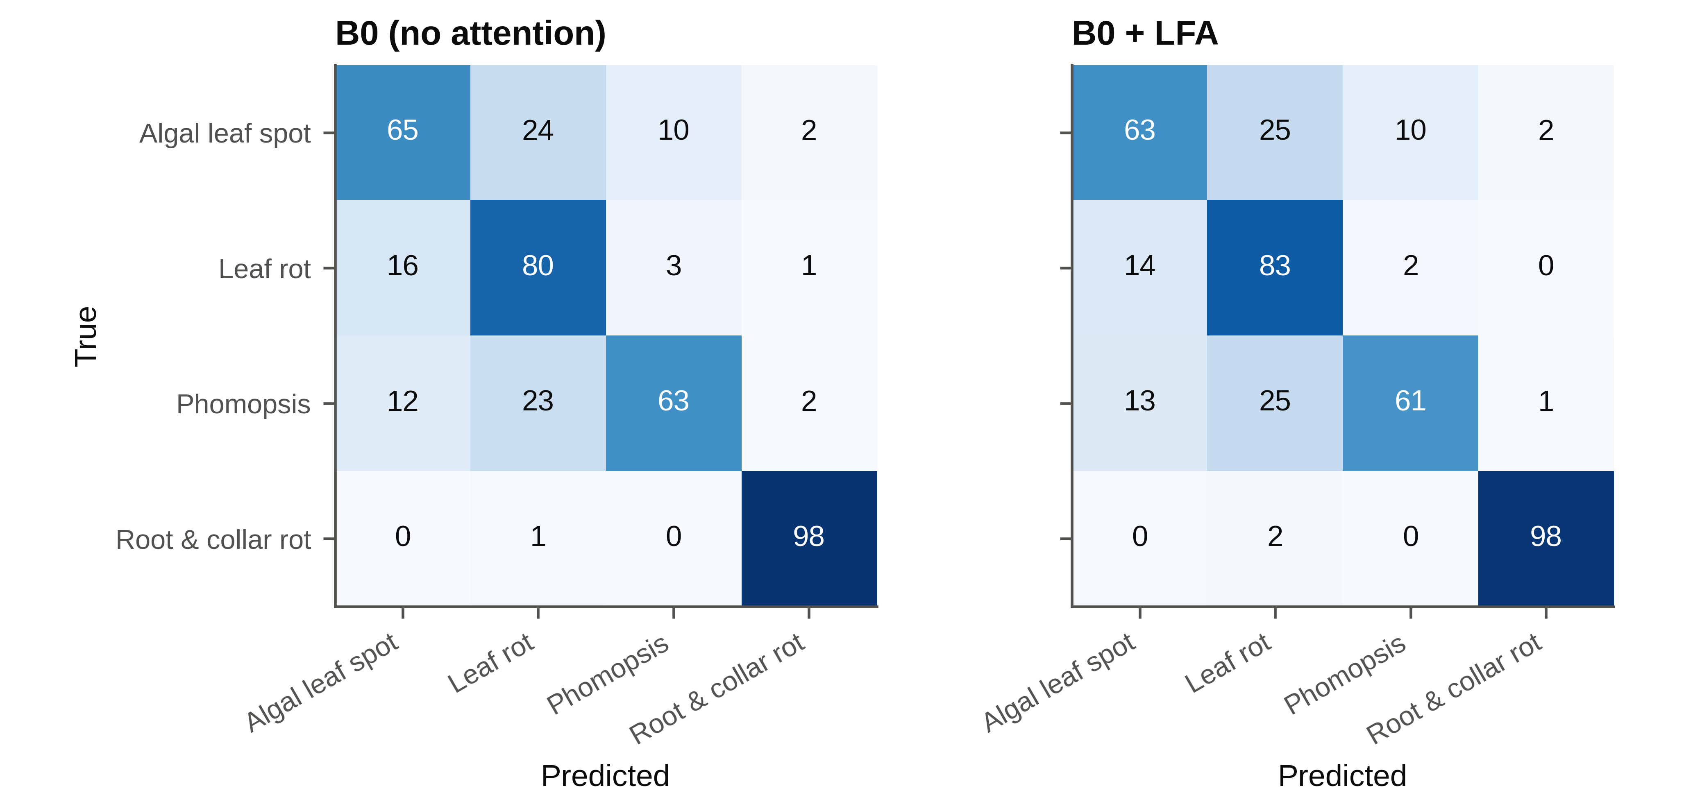
Confusion matrices of the plain network and LFA, pooled over the 40 runs of each configuration and normalised by row (%).
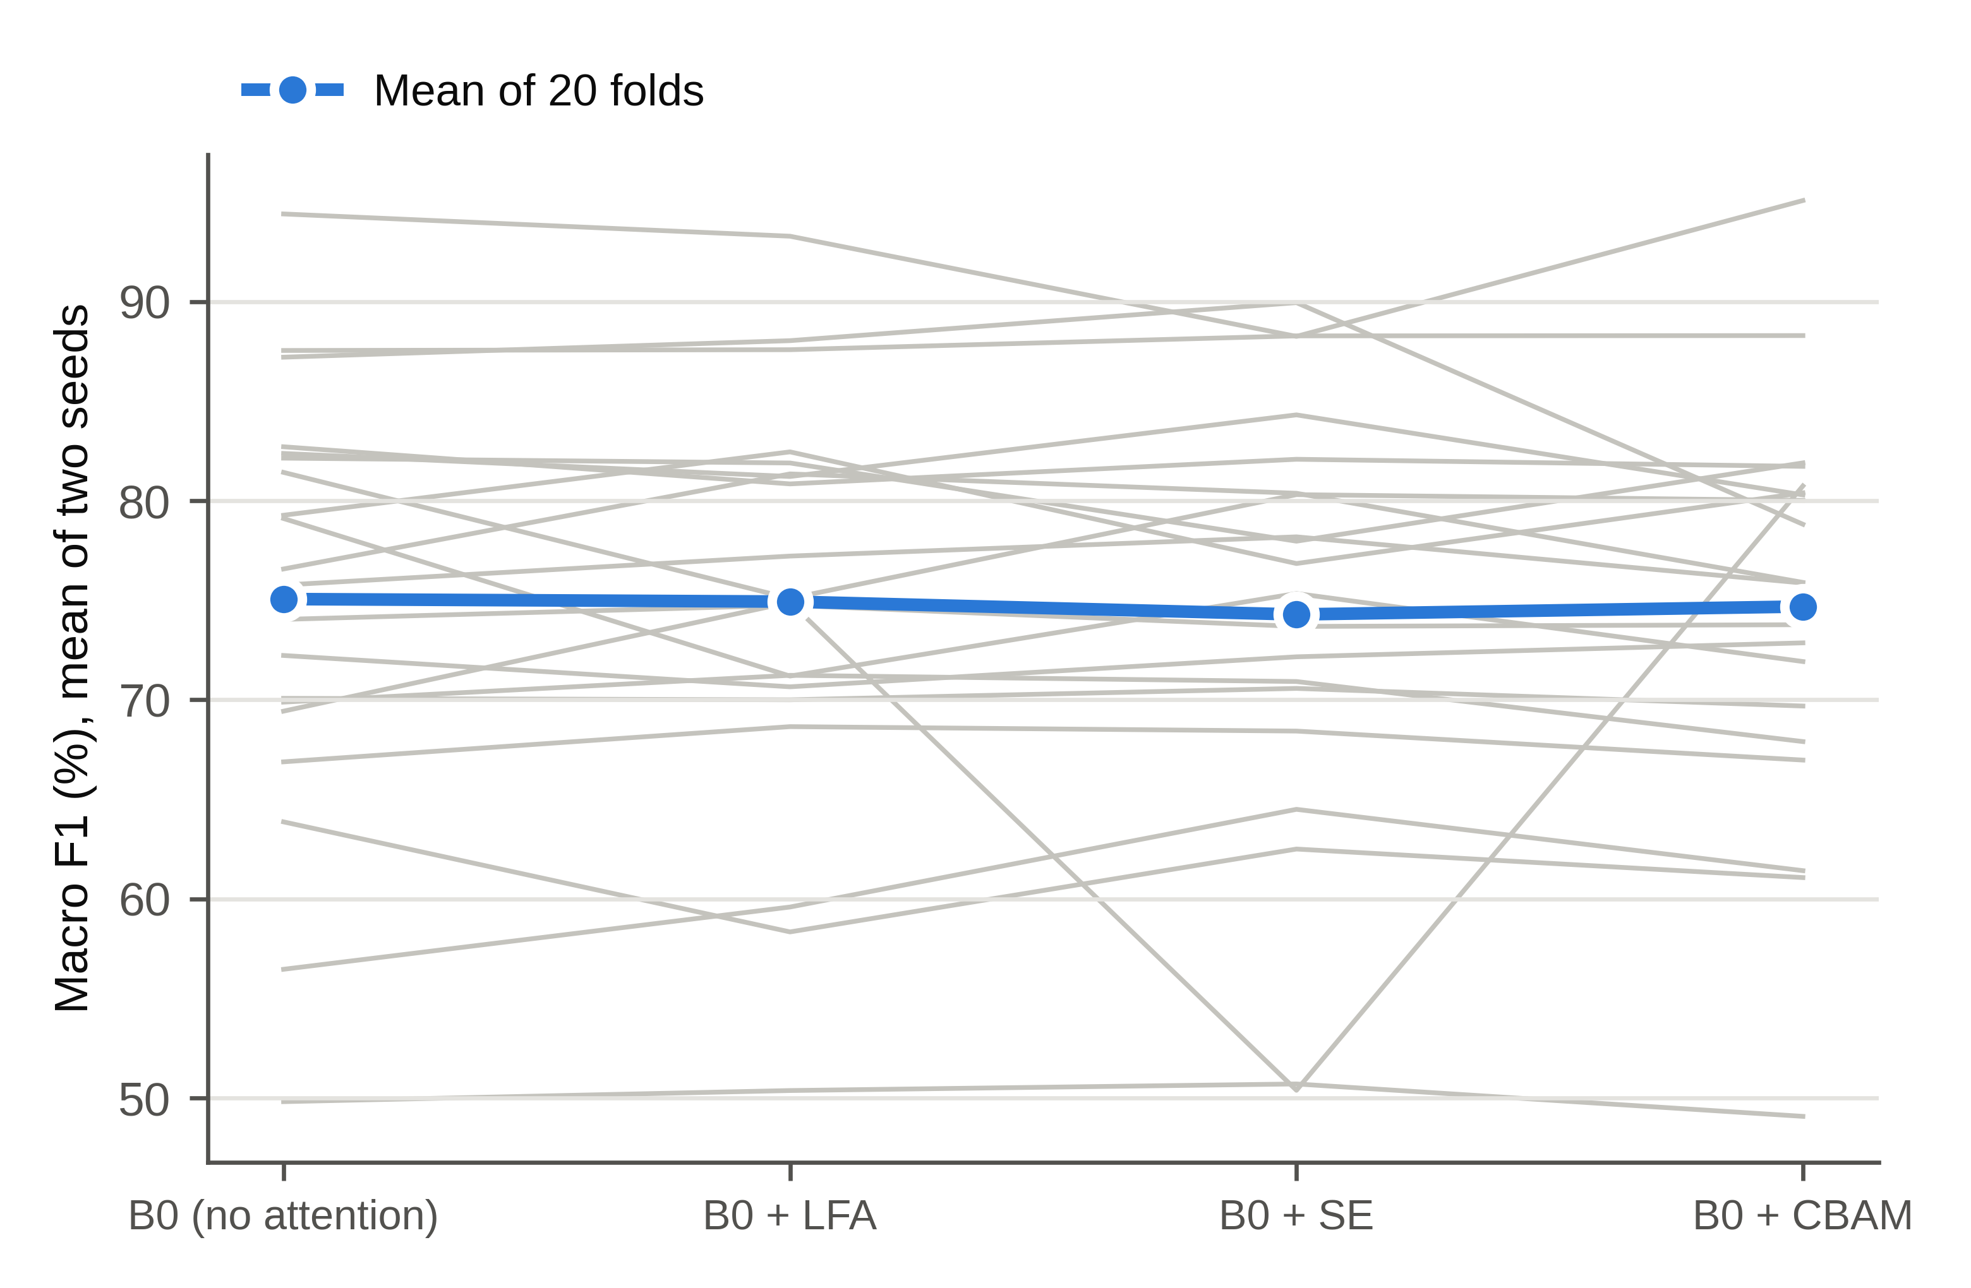
Macro F1 of each configuration on each of the 20 folds (grey lines, mean of two seeds) and the mean over folds (blue).

