2.代码分析

2.1代码结构分析

2.1.1代码

import os

import libcst as cst

flask_repo_path = "./flask-main" # 用实际的 Flask 仓库路径替换

def analyze_code(file_path):

with open(file_path, "r", encoding="utf-8") as file:

code = file.read()

module = cst.parse_module(code)

return module

def extract_classes_functions_imports(node):

classes = [c for c in node.body if isinstance(c, cst.ClassDef)]

functions = [f for f in node.body if isinstance(f, cst.FunctionDef)]

imports = [i for i in node.body if isinstance(i, cst.Import) or isinstance(i, cst.ImportFrom)]

return classes, functions, imports

def explore_module_structure(module):

classes, functions, imports = extract_classes_functions_imports(module)

print(f"Classes in module: {len(classes)}")

for class_node in classes:

print(f" - {class_node.name}")

print(f"\nFunctions in module: {len(functions)}")

for function_node in functions:

print(f" - {function_node.name}")

print(f"\nImports in module: {len(imports)}")

for import_node in imports:

print(f" - {import_node}")

def main():

for root, dirs, files in os.walk(flask_repo_path):

for file in files:

if file.endswith(".py"):

file_path = os.path.join(root, file)

module = analyze_code(file_path)

print(f"\nAnalyzing module: {file_path}")

explore_module_structure(module)

if __name__ == "__main__":

main()

利用上述代码分析出每个python文件中的类、函数和导入语句

运行结果：

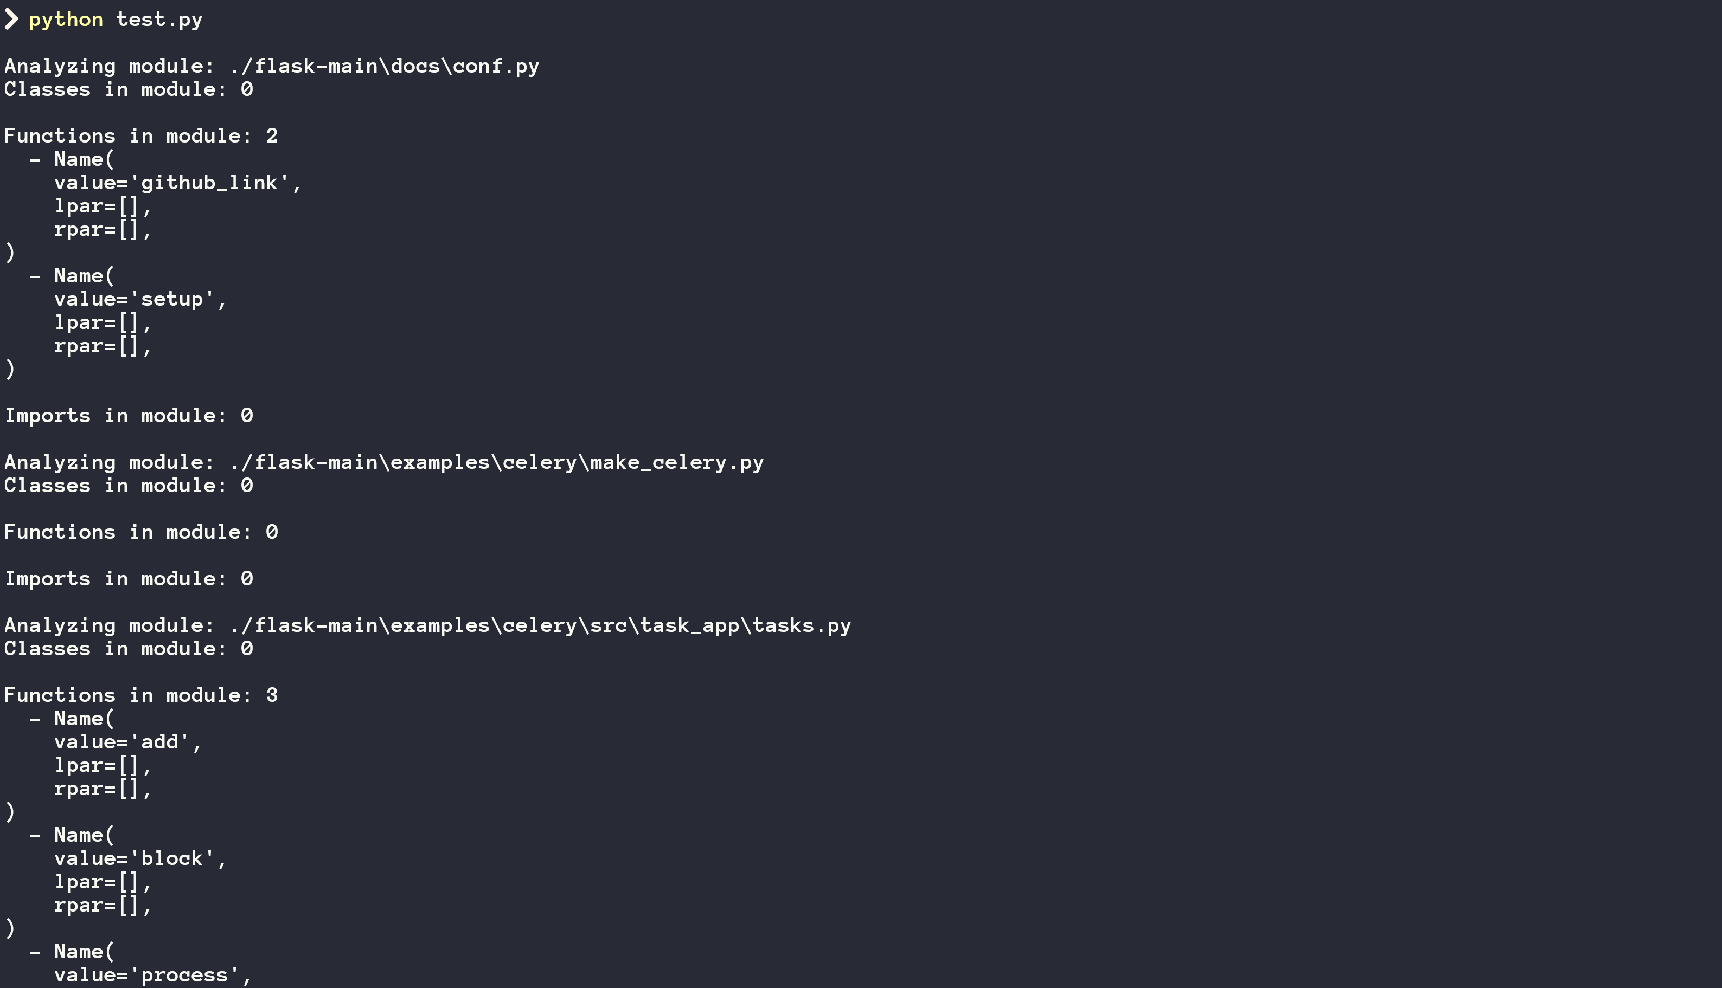

修改代码：

import os

import libcst as cst

flask_repo_path = "./flask-main" # 用实际的 Flask 仓库路径替换

output_file_path = "./output_1.txt" # 指定输出文件路径

def analyze_code(file_path):

with open(file_path, "r", encoding="utf-8") as file:

code = file.read()

module = cst.parse_module(code)

return module

def extract_classes_functions_imports(node):

classes = [c for c in node.body if isinstance(c, cst.ClassDef)]

functions = [f for f in node.body if isinstance(f, cst.FunctionDef)]

imports = [i for i in node.body if isinstance(i, cst.Import) or isinstance(i, cst.ImportFrom)]

return classes, functions, imports

def explore_module_structure(module, output_file):

classes, functions, imports = extract_classes_functions_imports(module)

output_file.write(f"Classes in module: {len(classes)}\n")

for class_node in classes:

output_file.write(f" - {class_node.name}\n")

output_file.write(f"\nFunctions in module: {len(functions)}\n")

for function_node in functions:

output_file.write(f" - {function_node.name}\n")

output_file.write(f"\nImports in module: {len(imports)}\n")

for import_node in imports:

output_file.write(f" - {import_node}\n")

def main():

with open(output_file_path, "w", encoding="utf-8") as output_file:

for root, dirs, files in os.walk(flask_repo_path):

for file in files:

if file.endswith(".py"):

file_path = os.path.join(root, file)

module = analyze_code(file_path)

output_file.write(f"\nAnalyzing module: {file_path}\n")

explore_module_structure(module, output_file)

if __name__ == "__main__":

main()

输出结果保存在txt中：

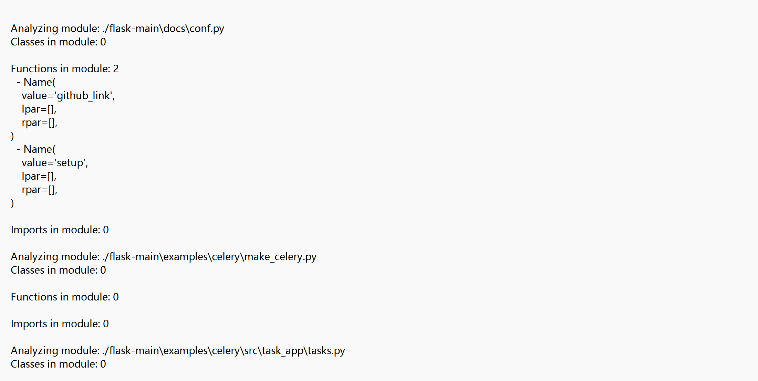

2.2代码函数调用分析

2.2.1代码

from pathlib import Path

from libcst import parse_module, CSTNode, CSTVisitor, Call

# 定义一个访问器来查找特定模式

class CustomAnalyzer(CSTVisitor):

def __init__(self):

super().__init__() # 调用父类的构造函数

self.function_calls = []

def visit_Call(self, node: "Call") -> None:

# 检查是否是函数调用

if isinstance(node.func, CSTNode):

self.function_calls.append(node.func)

super().visit_Call(node) # 调用父类的方法

def analyze_flask_codebase(flask_repo_path):

# 遍历 Flask 代码库中的所有 Python 文件

for python_file in flask_repo_path.glob("**/*.py"):

with python_file.open("r", encoding="utf-8") as file:

try:

# 尝试解析当前文件

module = parse_module(file.read())

# 初始化自定义分析器

analyzer = CustomAnalyzer()

module.visit(analyzer)

# 输出分析结果

print(f"File analyzed: {python_file}")

print(f"Function calls found: {analyzer.function_calls}")

except Exception as e:

print(f"Error analyzing {python_file}: {e}")

def main():

# Flask 代码库的根目录

flask_repo_path = Path("./flask-main")

analyze_flask_codebase(flask_repo_path)

if __name__ == "__main__":

main()

运行结果：

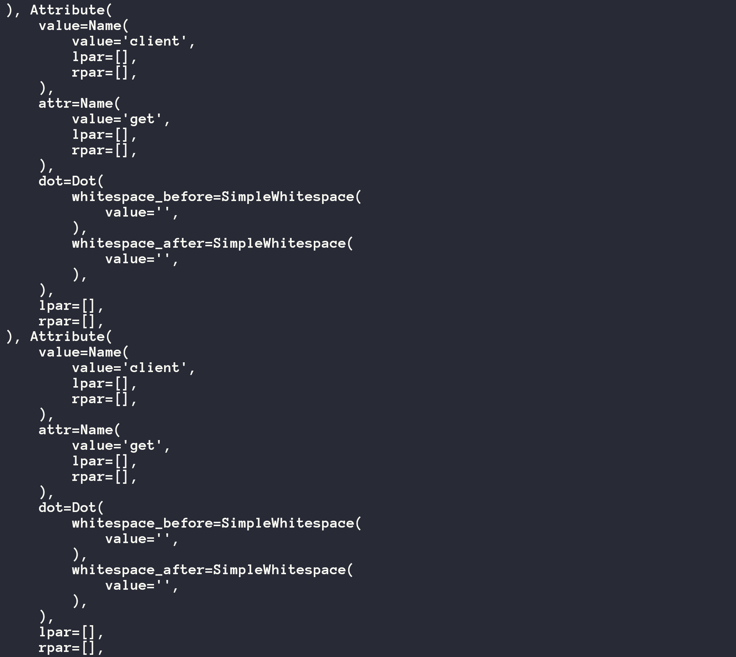

修改代码使其将结果输出到txt文本中：

from pathlib import Path

from libcst import parse_module, CSTNode, CSTVisitor, Call

# 定义一个访问器来查找特定模式

class CustomAnalyzer(CSTVisitor):

def __init__(self):

super().__init__() # 调用父类的构造函数

self.function_calls = []

def visit_Call(self, node: "Call") -> None:

# 检查是否是函数调用

if isinstance(node.func, CSTNode):

self.function_calls.append(node.func)

super().visit_Call(node) # 调用父类的方法

def analyze_flask_codebase(flask_repo_path, output_file):

with open(output_file, 'w', encoding='utf-8') as output:

# 遍历 Flask 代码库中的所有 Python 文件

for python_file in flask_repo_path.glob("**/*.py"):

with python_file.open("r", encoding="utf-8") as file:

try:

# 尝试解析当前文件

module = parse_module(file.read())

# 初始化自定义分析器

analyzer = CustomAnalyzer()

module.visit(analyzer)

# 输出分析结果到文件

output.write(f"File analyzed: {python_file}\n")

output.write(f"Function calls found: {analyzer.function_calls}\n")

output.write("\n")

except Exception as e:

output.write(f"Error analyzing {python_file}: {e}\n")

def main():

# Flask 代码库的根目录

flask_repo_path = Path("./flask-main")

output_file = "call_result.txt"

analyze_flask_codebase(flask_repo_path, output_file)

if __name__ == "__main__":

main()

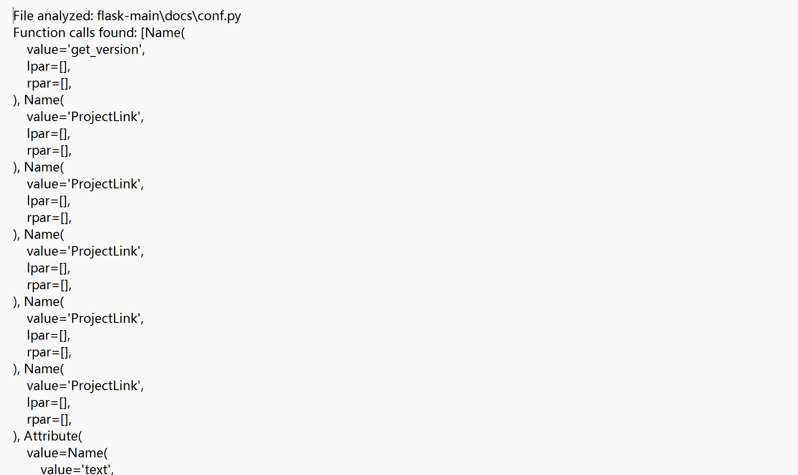

2.3代码复杂度（以函数个数为标准）

2.3.1代码：

from pathlib import Path

from libcst import parse_module, CSTNode, CSTVisitor, Call, FunctionDef

# 定义一个访问器来查找特定模式

class CustomAnalyzer(CSTVisitor):

def __init__(self):

super().__init__() # 调用父类的构造函数

self.function_calls = []

self.function_count = 0

def visit_Call(self, node: "Call") -> None:

# 检查是否是函数调用

if isinstance(node.func, CSTNode):

self.function_calls.append(node.func)

super().visit_Call(node) # 调用父类的方法

def visit_FunctionDef(self, node: "FunctionDef") -> None:

# 统计函数数量

self.function_count += 1

super().visit_FunctionDef(node)

def analyze_flask_codebase(flask_repo_path, output_file):

with open(output_file, 'w', encoding='utf-8') as output:

# 遍历 Flask 代码库中的所有 Python 文件

for python_file in flask_repo_path.glob("**/*.py"):

with python_file.open("r", encoding="utf-8") as file:

try:

# 尝试解析当前文件

module = parse_module(file.read())

# 初始化自定义分析器

analyzer = CustomAnalyzer()

module.visit(analyzer)

# 输出分析结果到文件

output.write(f"File analyzed: {python_file}\n")

output.write(f"Function calls found: {analyzer.function_calls}\n")

output.write(f"Function count: {analyzer.function_count}\n")

output.write("\n")

except Exception as e:

output.write(f"Error analyzing {python_file}: {e}\n")

def main():

# Flask 代码库的根目录

flask_repo_path = Path("./flask-main")

output_file = "complex_results.txt"

analyze_flask_codebase(flask_repo_path, output_file)

if __name__ == "__main__":

main()

输出结果将保存在txt文件中

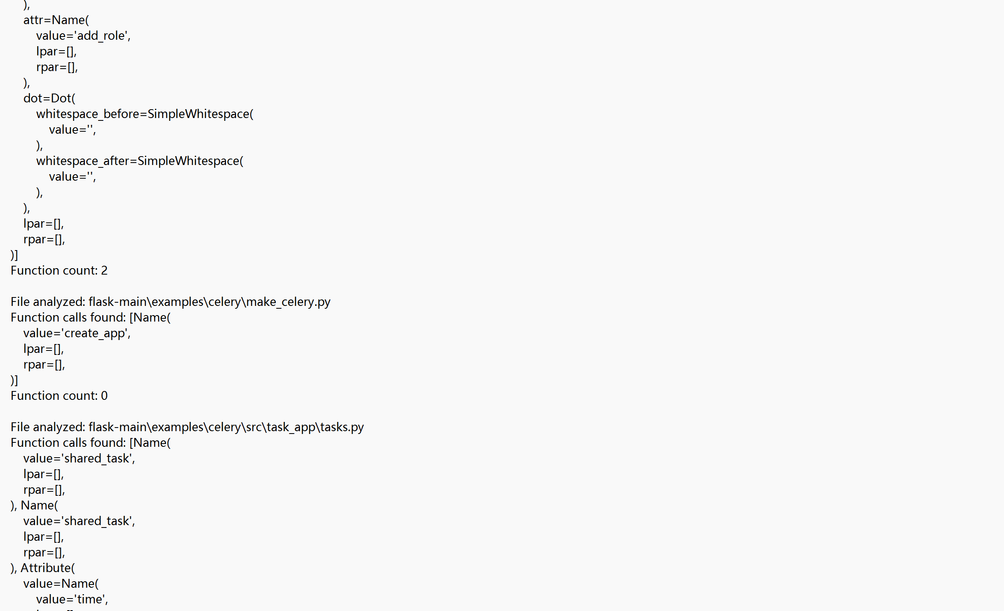

5.bug修复

5.1 使用git log命令得到所有提交记录

5.2 使用git log --grep="bug\|fix" >> log_bugfix.txt将关于修复bug的提交记录检索出来并保存到文件中

5.2.1查看每次提交所作改变

5.2.1.1 代码

import subprocess

# Read the log file

with open('./log_bugfix.txt', 'r',encoding='utf-16 le') as log_file:

log_content = log_file.read()

# Split the log content into individual commits

commits = log_content.split('\n\n')

# Open a file for writing the output

output_file_name = 'output_bugfix_detail.txt'

with open(output_file_name, 'w') as output_file:

# Iterate through each commit

for commit in commits:

# Split the commit into lines

commit_lines = commit.split('\n', 1) # Split only at the first newline

# Extract the commit SHA value

commit_info = commit_lines[0].split()

if len(commit_info) >= 2 and commit_info[0] == 'commit':

commit_sha = commit_info[1]

print(f'Processing commit {commit_sha}')

# Use git show to get commit information

git_show_output = subprocess.check_output(['git', 'show', commit_sha], universal_newlines=True)

# Write the git show output to the output file

output_file.write(f'Git show output for commit {commit_sha}:\n')

output_file.write(git_show_output)

output_file.write('\n' + '-' * 80 + '\n') # Separating commits

else:

print(f'Skipping invalid commit: {commit_lines[0]}')

print(f'Git show outputs written to {output_file_name}')

结果将输出到output_bugfix_detail.txt文件中

5.3 使用git log --grep="performance\|optimization" >> log_performance.txt命令检索出关于性能提升的提交记录并保存

5.3.1查看提交所作改变

5.3.1.1 代码

git show 6979265fa643ed982d062f38d386c37bbbef0d9b >> output_performance_detail.txt

git show 6e52355eb303e1b47f7b83ddbb94ff432e2df139 >> output_performance_detail.txt

结果将保存在output_performance_detail.txt中。