Chapter 1 Assignment

1、Suppose Tl(n) = O(f(n)) and T2(n) = O(f(n)). Which of the following are true?
a. T1(n) + T2(n) = O(f(n))√
b. T1(n) - T2(n) = o(f(n))√
c. T1(n)/T2(n) = O(1)×
d. T1(n) = O(T2(n))错O只是比小，如n =O（n^2）

2、For each of the following six program fragments:
a. Give an analysis of the running time (Big-Oh will do).
b. Implement the code in C language, and give the running time
for several values of n.
c. Compare your analysis with the actual running times.

(1) sum = 0;
for( i=0; i<n; i++ )
sum++;
O(n)
N=100000000 t=0.181
N=200000000 t=0.361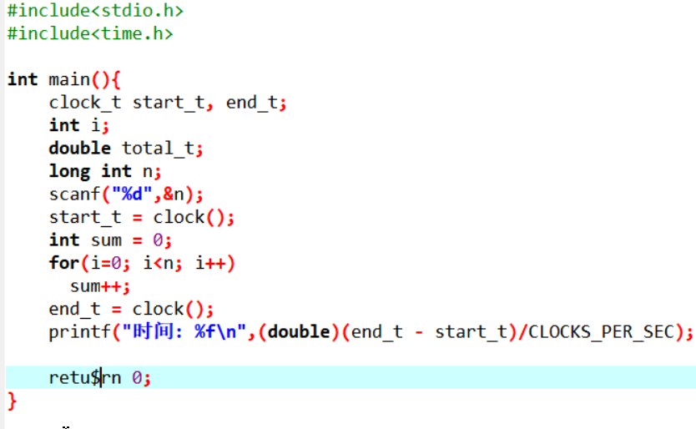
(2) sum = 0;
for( i=0; i<n; i++ )
for( j=0; j<n; j++ )
sum++;
O(n^2)
N=10000 t=0.19
N=100000 t=18.797
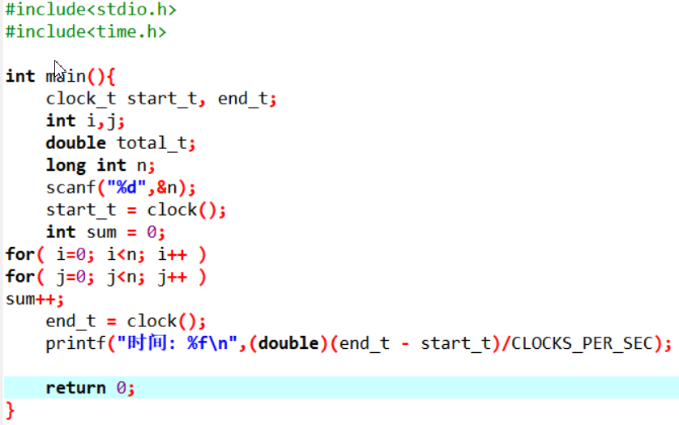
(3) sum = 0;
for( i=0; i<n; i++ )
for( j=0; j<n*n; j++ )
sum++;
N=100 t=0.002
N=1000 t=2.176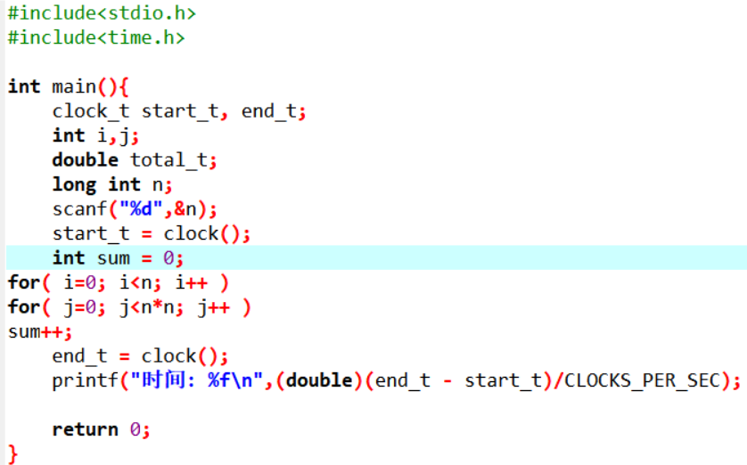
O(n^3)
(4) sum = 0;
for( i=0; i<n; i++ )
for( j=0; j<i; j++ )
sum++;
O(n^2)
N=10000 t=0.067
N=100000 t=6.14
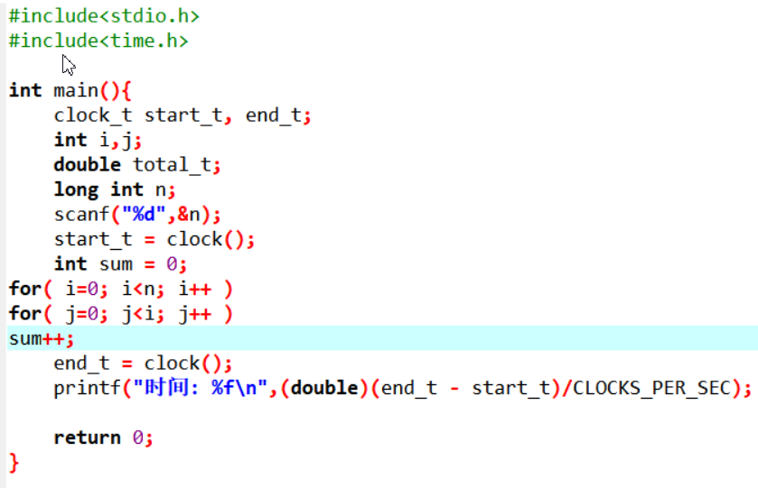
(5) sum = 0;
for( i=0; i<n; i++ )
for( j=0; j<i*i; j++ )
for( k=0; k<j; k++)
sum++;
N=100 t=1.245
N=200 t=40.03
O(n^5)
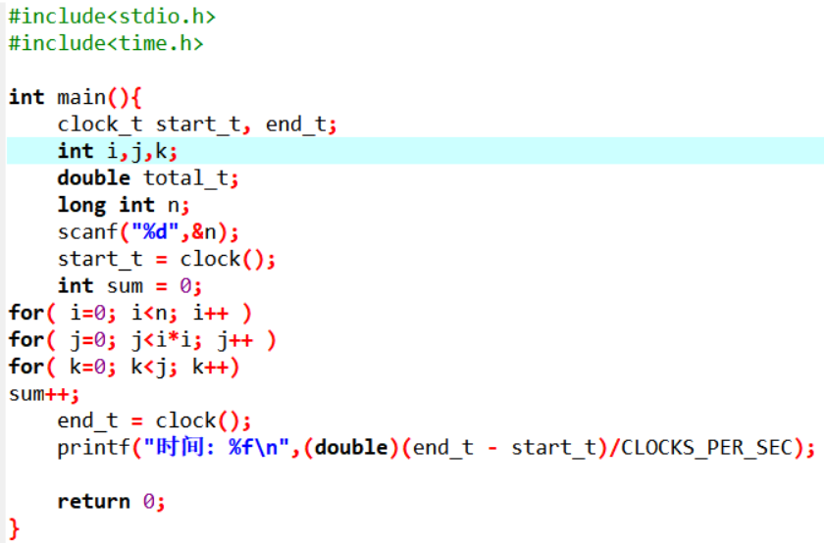
(6) sum = 0;
for( i=1; i<n; i++ )
for( j=1; j<i*i; j++ )
if( j%1 == 0 )
for( k=0; k<j; k++ )
sum++;
O(n^5)
N=100 t =1.246
N=200 t=39.97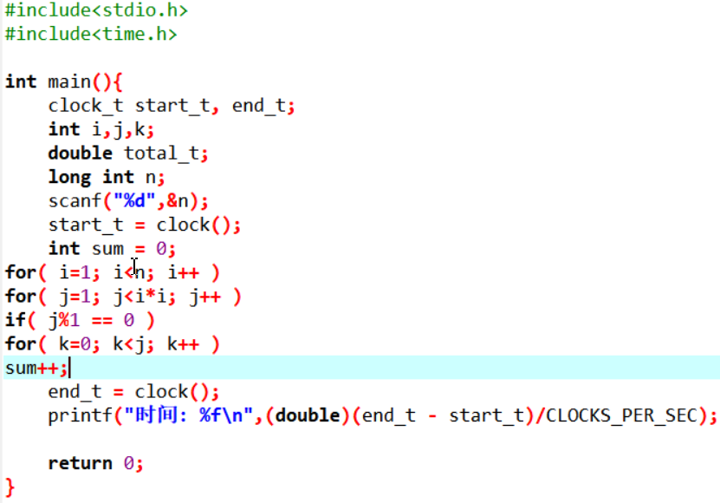
3、Give an efficient algorithm to determine if there exists an integer i such that ai = i in an array of integers a1< a2 < a3< . . . < an
. What is the running time of your algorithm?
#include<stdio.h>
#include<stdlib.h>
int main(){
int m;
int i,j;
int **b;
int *a;
scanf("%d",&m);
a=(int*)malloc(sizeof(int)*m);//用于存每个数组的长度
b=(int**)malloc(sizeof(int*)*m);//二维数组存不同的数组
for(i=0;i<m;i++){
scanf("%d",&a[i]);
b[i]=(int*)malloc(sizeof(int)*a[i]);
for(j=0;j<a[i];j++){
scanf("%d",&b[i][j]);
}
}
/* for(i=0;i<m;i++){
for(j=0;j<a[i];j++){
printf("%d ",b[i][j]);
}
printf("\n");
}*/
int x=0;
for(i=0;i<m;i++){
x=0;
for(j=0;j<a[i];j++){
if(b[i][j]==j){
printf("%d ",j);
x++;
}

}
if(x==0)
printf("-1");
printf("\n");
}
free(a);
for(i=0;i<m;i++)
free(b[i]);
free(b);
return 0;

}

4、 To display the complexity of the following expression with ascending sort order. c<d<a<b

- n*log₂(n) B、n+n²+n³ C、24 D、n^{0.5}

5、With a big O notation to describe the complexity of the following expression.

A、5n^{5/2}+n^{2/5} B、6*log₂n + 9n C、3n⁴+n*log₂n D、5n²+n^{3/2}

A O(n^5/2)
B O(n)
C O(n^4)
D O(n^2)

