Dear Fellow ECoG Researcher,

This folder contains the functions necessary to co-register and plot subtemporal electrodes to axial MRI.

The steps to localize electrode positions are listed explicitly in the function “xs_master.m”, which calls the other functions from the folder.

The first two steps are performed in the SPM environment (called by typing “spm” in the MATLAB command window to open the graphical user interface (GUI), then press ‘fmri’ button). This opens a second GUI:

* + Step 1 - convert MRI into standardized coordinates by pressing Co-Register(estimate)- must be saved as [patient code]_mri.nii - co-register to T1 (canonical) reference.
  + Step 2 - realign and reslice CT to MRI - must be saved as r[patient code]_ct.nii (resliced) - use SPM - co-register and reslice into MRI from 'step 1'.
* Step 3 - identify voxel intensity range for MRI, using the script “xs_getclims.m”. These have been determined for many patients in the library (the variable ‘clims’ defined in the “xs_master.m” function).
* Step 4 - localize electrodes using a variant ctmr GUI, “kjm_ctmr” from the ‘ctmr’ folder.
* Step 5 - assign channel labels -- e.g. location electrode number index corresponds with data electrode number index, using the function call “locs=kjm_sortElectrodes;”.
* Step 6 - segregate electrodes by anatomy, done using the following code in (“fhpred” and “fhnoisy”)

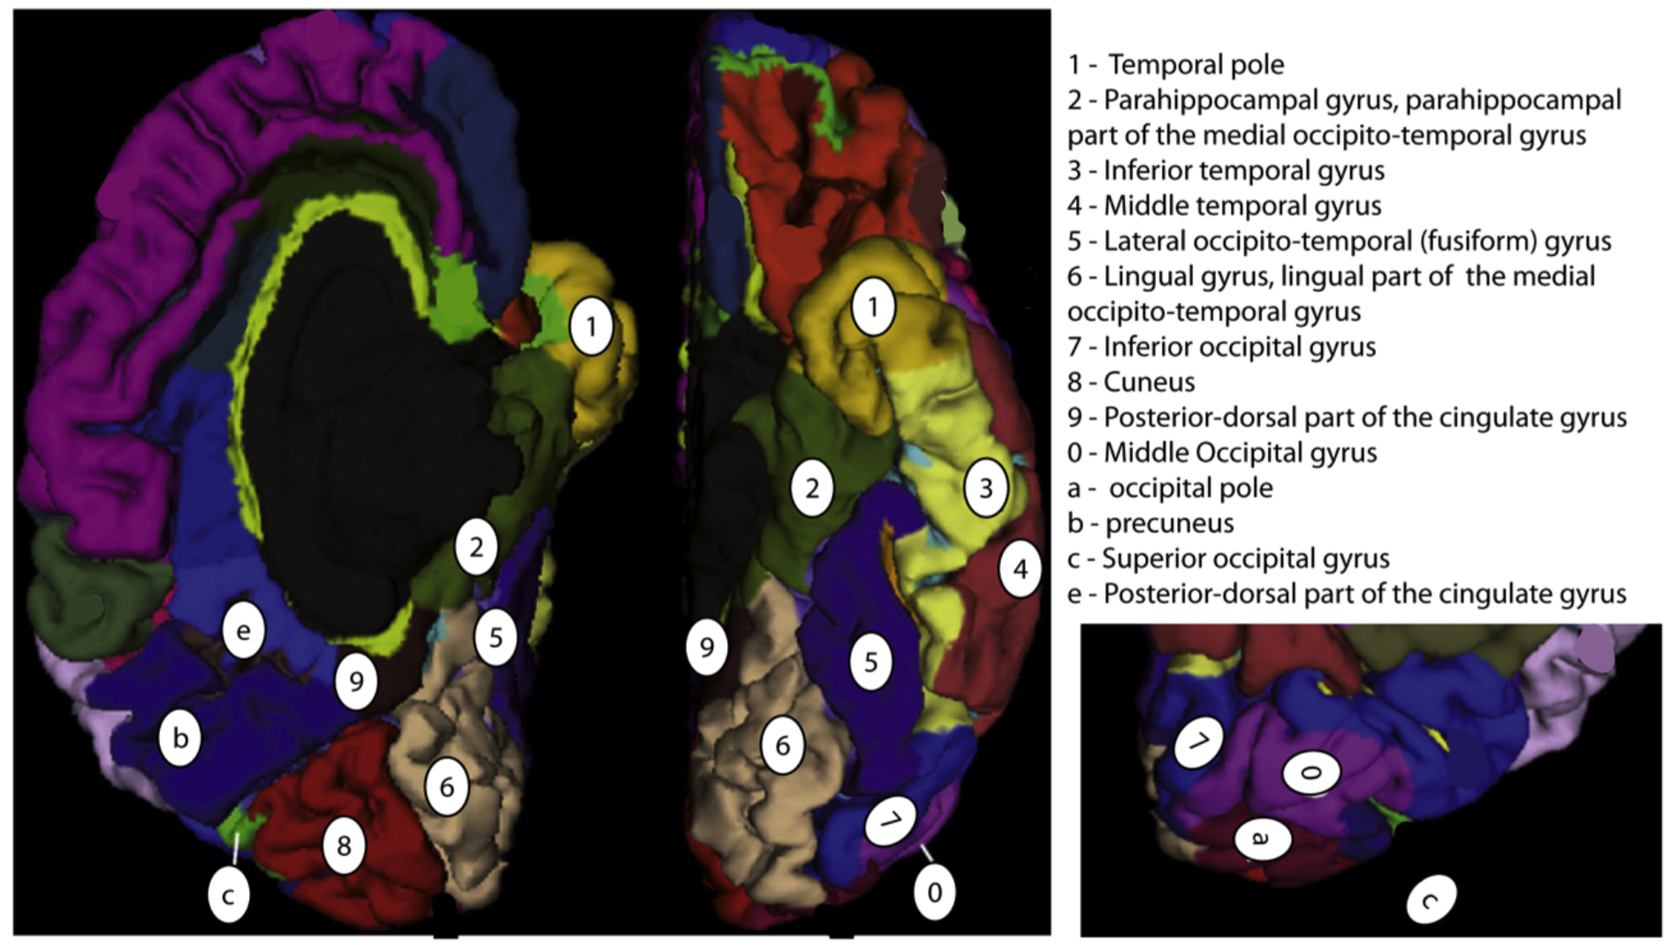

Electrode positions can be plotted using “xs_disp(subject, locs, clims)”, and weighted activities plotted at each electrode position “xs_weighted(subject, locs, clims, weights)”.

Best Wishes!

Kai Miller,

Stanford University, 2015

[kai.miller@stanford.edu](mailto:kai.miller@stanford.edu), [kjmiller@gmail.com](mailto:kjmiller@gmail.com)

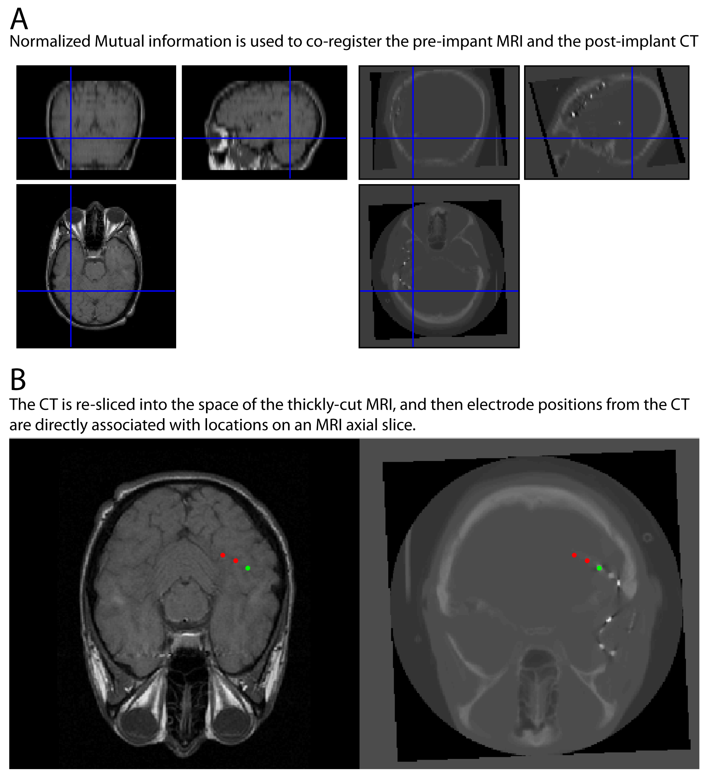

**Illustration of the electrode localization throughout the manuscript.** The MRI slice thickness used most often with the subjects studied were by clinical protocol, and 5mm. This is generally not sufficient to render surfaces and co-register electrodes by the standard methods used in lateral fronto-parietal cortical studies (Hermes et al., 2010). However, the clinical protocol axial T1 used most often does generate slices that are approximately parallel to the brain surface in the inferior temporal surface, a few centimeters anterior to the occipital pole. Therefore, electrode location relative to gyral surface anatomy was determined by projection of the post-implant CT to the pre-operative axial T1 in the following manner: CT is co-registered to T1 Axial MRI using normalized mutual information in SPM. CT is then interpolated and resliced into the T1 axial MRI. Electrodes are then identified in this mutual space on each slice so that their position is known with respect to gyral anatomy. Because of the tentorium cerebelli, there is little to no brain sag to distort the comparison of electrode position from post-op CT with the pre-operative MRI, so none of the standard correction techniques are necessary.