第0步，准备数据：

SERT INTO s (NAME,book,saledNumber) VALUES('小王','java从入门到精通',10);

INSERT INTO s (NAME,book,saledNumber)VALUES('小李','java从入门到精通',15);

INSERT INTO s (NAME,book,saledNumber)VALUES('小王','C#高级编程',8);

INSERT INTO s (NAME,book,saledNumber)VALUES('小李','java从入门到精通',7);

INSERT INTO s (NAME,book,saledNumber)VALUES('小王','java从入门到精通',9);

INSERT INTO s (NAME,book,saledNumber)VALUES('小李','java从入门到精通',2);

INSERT INTO s (NAME,book,saledNumber)VALUES('小王','C#高级编程',3);

INSERT INTO s (NAME,book,saledNumber)VALUES('小李','java从入门到精通',5);

INSERT INTO s (NAME,book,saledNumber)VALUES('小李','C#高级编程',5);

Select * from s;

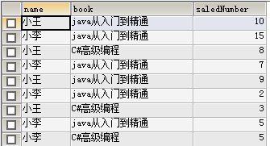

第一步：分组求平均

SELECT NAME,book,AVG(saledNumber) AS avg_s FROM s GROUP BY NAME,book;

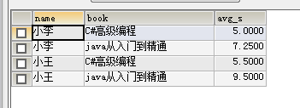

第二步：book列展成多个字段

SELECT sa.name,SUM(CASE sa.book WHEN 'C#高级编程' THEN sa.avg_s ELSE 0 END) AS c ,SUM(CASE sa.book WHEN 'java从入门到精通' THEN sa.avg_s ELSE 0 END) AS java FROM (SELECT NAME,book,AVG(saledNumber) AS avg_s FROM s GROUP BY NAME,book) sa GROUP BY sa.name;

