Your Daily Picture
Software Project Management Plan

Project Description:
Inspired by various “Pictures of the Day”, this application pulls an image from a search engine and then sends you a notifcation each day for a fun little surpise! Sign up is available from either mobile or web browser. You may save this picture to your local drive and/or share it through social media, text, etc. View the pictures you have been sent through an image gallery. There is also the option to save automatically to your drive and change which search engine is used.

Project Deliverables:
- Use cases & functional requirements
- SPMP
- Server configurations
- REST API documentation
- Frontend flutter application on Android, iOS, Chrome, and Firefox

Project Organization

Process Model:

The process model that will be used Incremental development. A component of the application will be developed in sucession and then integrated into the application stack. Each component will be tested individually and afterwards integration tests will be made. First a database and scheduler will be created to download images from the Custom Search API. Then a notifcation service will be integrated the scheduled tasks to send notifications to a test device regularly.
Then a REST API will be created to serve images and to create those regular tasks. At the same time authentication will be implemented along with user roles and user profile management. Sending notfications to targeted devices will also be implemented in this stage. \

The frontend flutter application will be developed

Management Process:

Self Managed

Organizational Interfaces:

Google - Custom Search API to obtain images

Auth0 - User Authentication Services

OneSignal – Notifcation Services

Work Breakdown Structure:

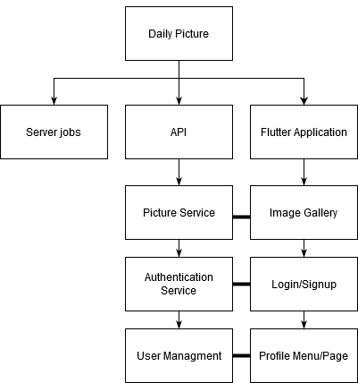

Work Schedule:

Technical Process

Approach:
Methodology:
NodeJS
Frontend Flutter application
Auth0 JWT Authentication
Search engine API calls to obtain images
postgres to store image metadata and some user data
Celery + Redis to schedule regular tasks
Django REST Framework to serve images and create tasks

Tools:
- Flutter (Frontend)
- Search Engine Custom Search APIs
  - Google
  - Bing
  - searx
- GitHub
- Auth0 (User Authenication)
- OneSignal (Notifications)
- PostgreSQL (image metadata, partial user data)
- Celery (task scheduler)
- Redis (message broker for Celery)
- Django (Backend API)
- Nginx (Serve flutter applicaiton)

Configuration Management
All code will be maintained on a single git branch with separate folders containing the server configuration, the django code, and the flutter frontend. Changes will be tested locally and pushed to the repository when it satisfies requirements. Potentially a Docker image could be made of the server installations for configuration management or redeployment. Otherwise server installations and configuration will simply be documented on the repository.

Handling Change

Changes will be handled depending on which part of the application is affected. UI related changes will be simply be made in the flutter application, for this reason API interactions will be abstracted to separate it from UI implementation. Changes such as API interactions or change of external services will be made in implementation dependent sections of code. Any changes to our own API will be made in conjunction with changes to frontend code to ensure compatability and will include updates to the API documentation.

