**软件测试上机报告**



第二次上机作业

**学 院智能与计算学部**

**专 业 软件工程___**

**姓 名____于海鑫__ _**

**学 号__3017218077__**

**年 级__ 2017级____**

**班 级___ 1班_____**

# 实验要求

Tasks:

1.     Install Selenium with Eclipse.

2.     Install Firefox and SeleniumIDE plugin.

3.     Try to record and export scripts using SeleniumIDE.

4.     Please complete the following task using Selenium Webdriver:

“Selenium Lab2020.xlsx” contains information about the students, and https://103.120.226.190/selenium-demo/git-repo can view someone’s information after logging in (student id as username, git address as password). Please check each record in the excel to make sure that each student’s information is consistent with the information on the website.

Requirements for the experiment:

1.     Finish the tasks above individually.

2.     Check in your java code to Github or gitee

3.     Please send your experiment report to 智慧树, the following information should be included in your report:

a)       The brief description that you install Selenium, Firefox, and SeleniumIDE.

b)       Steps for recording and exporting scripts.

c)       Steps for testing the website using Selenium.

# 源代码

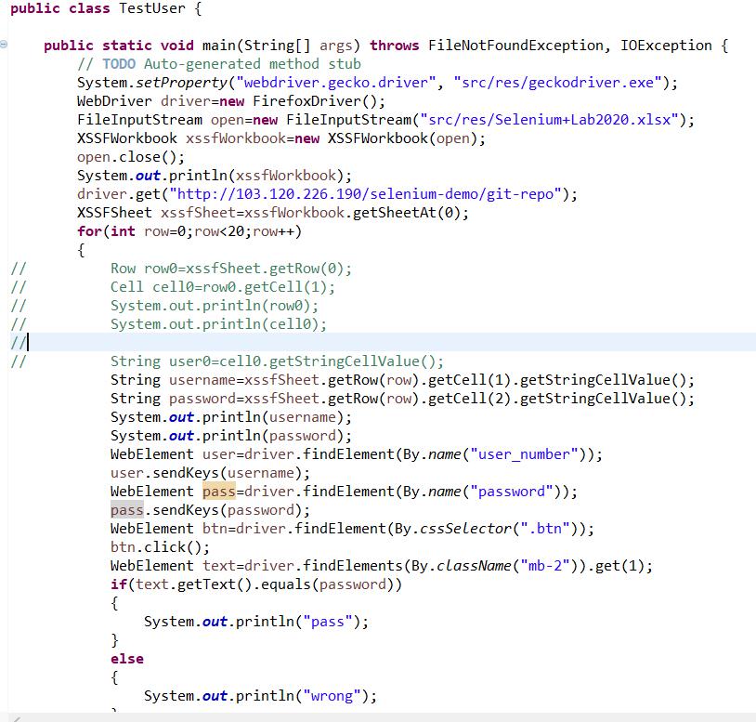

# 运行结果

1. selenium IDE

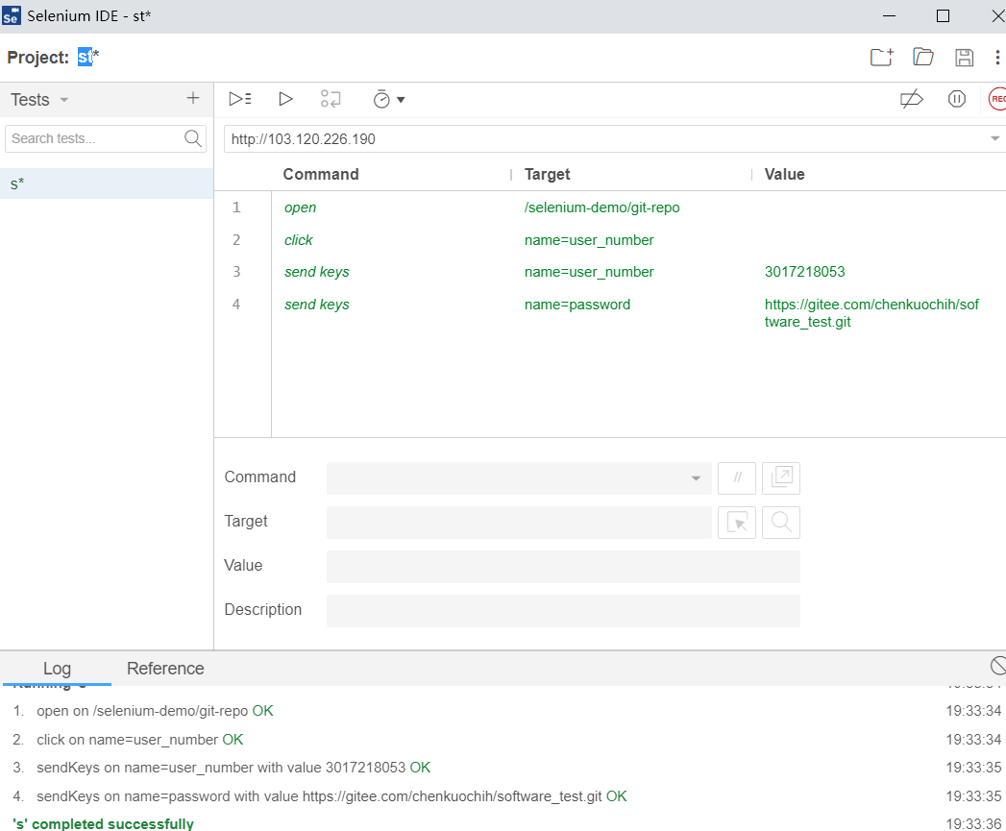

2.selenium webdriver

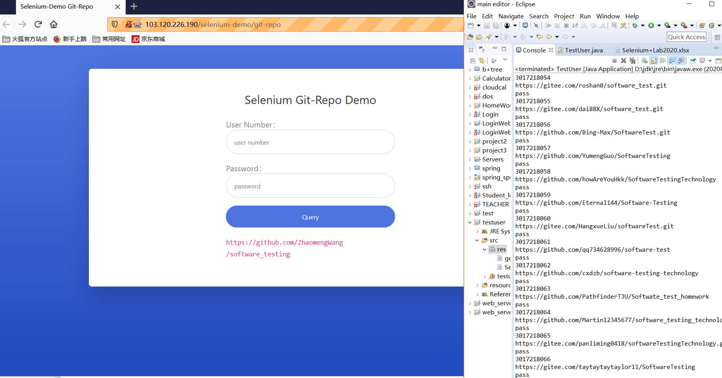

# 简要说明

1. 下载firefox的seleniumide扩展

2.分别选中用户名和密码部分，选择send keys的命令，填入xlsx中的内容。

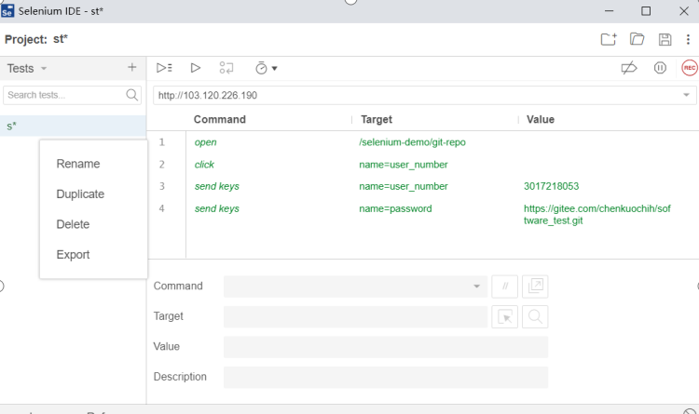

3.生成driver，并设定网址。选定chromedriver.exe。通过IO流获取xlsx中的表格内容

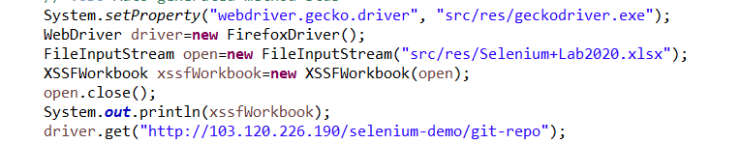



获取网页内的元素



逐个获取表格的内容

填入表格内容后提交之后获取结果的元素位置，如若相同，则在控制台输出“pass”

