**软件测试上机报告**



第四次作业

**学 院智能与计算学部**

**专 业 软件工程___**

**姓 名____于海鑫__ _**

**学 号__3017218077__**

**年 级__ 2017级____**

**班 级___ 1班_____**

# 实验要求

**Tasks:**

1. Install MuJava. The instruction of how to install and use Mujava can be seen in <https://cs.gmu.edu/~offutt/mujava/> .
2. Two small programs are given for your task. BubbleSort.java is an implementation of bubble sort algorithm and BackPack.java is a solution of 01 backpack problem. Try to generate Mutants of 2 given programs with MuJava.
3. Write testing sets for 2 programs with Junit, and run mutants on the test sets with MuJava.

**Requirements for the experiment:**

1. Finish the tasks above individually.
2. Check in your java code to github and send the URL to [tjuscsst@qq.com](mailto:tjuscsst@qq.com)
3. Post your experiment report to your blog and send the URL to [tjuscsst@qq.com](mailto:tjuscsst@qq.com) , the following information should be included in your report:
   1. The brief description that you install MuJava
   2. Steps for generating Mutants
   3. Steps for making test sets and running mutants.
   4. Your mutants result (The number of live mutants, killed mutants, etc.)

二、实验过程

1.安装mujava

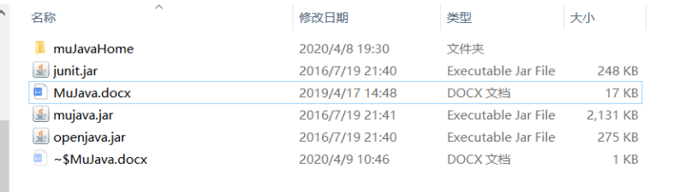

下载junit.jar , mujava.jar , openjava.jar ，添加到classpath路径

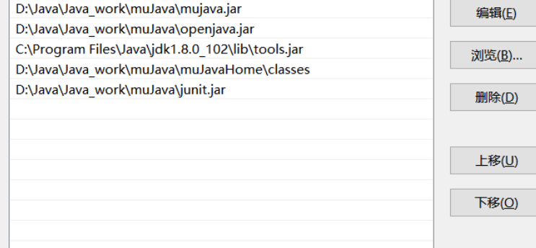

修改mujava.config

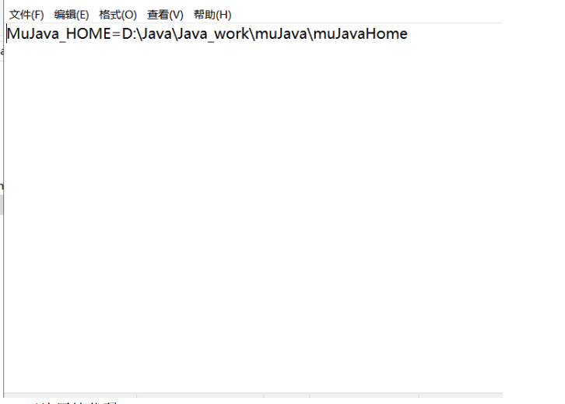

建四个文件夹，在名为src的文件夹下放原始代码

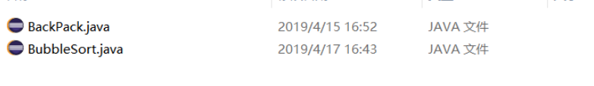

classes下面放编译过的class文件

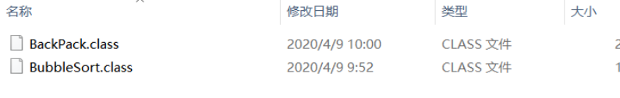

启动

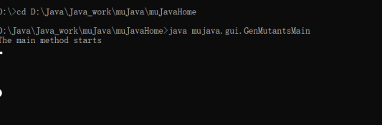

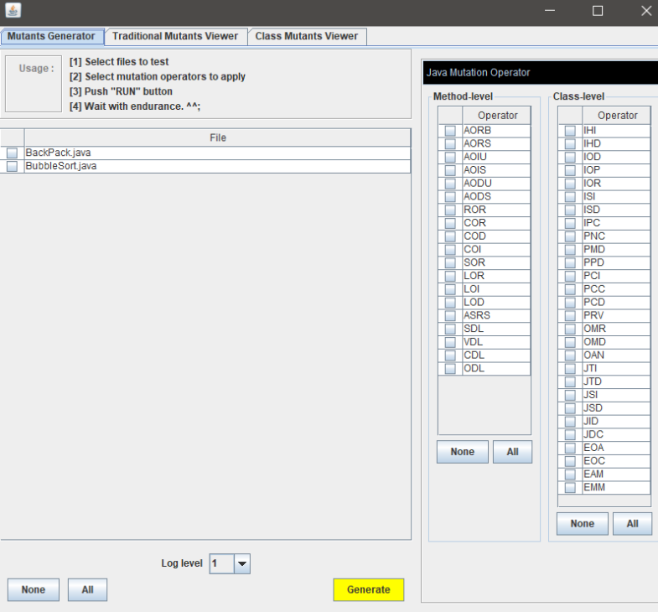

编写test



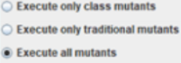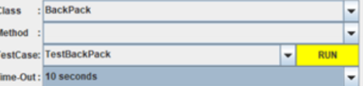

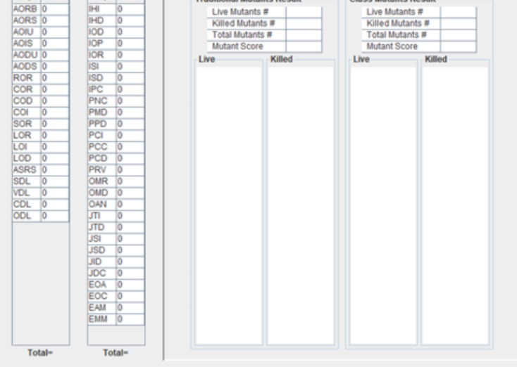

结果

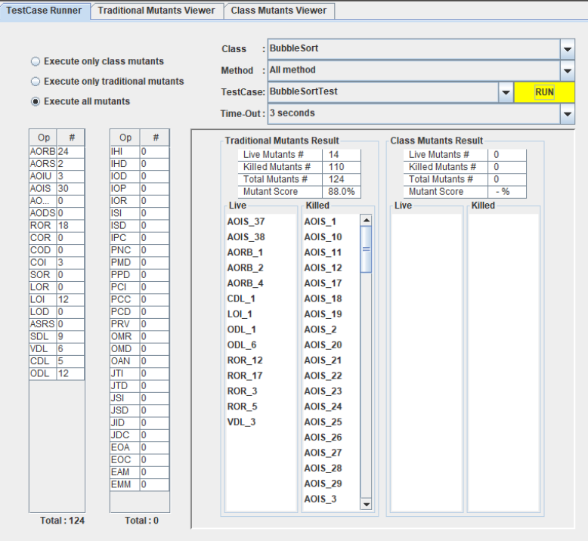

Killed110, live14