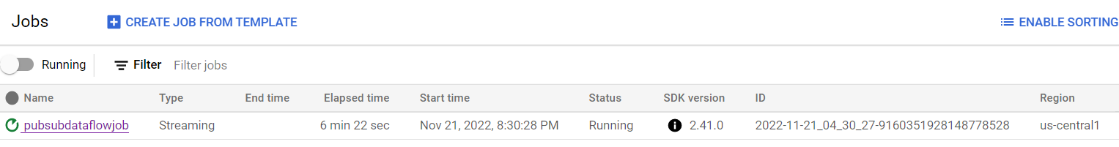

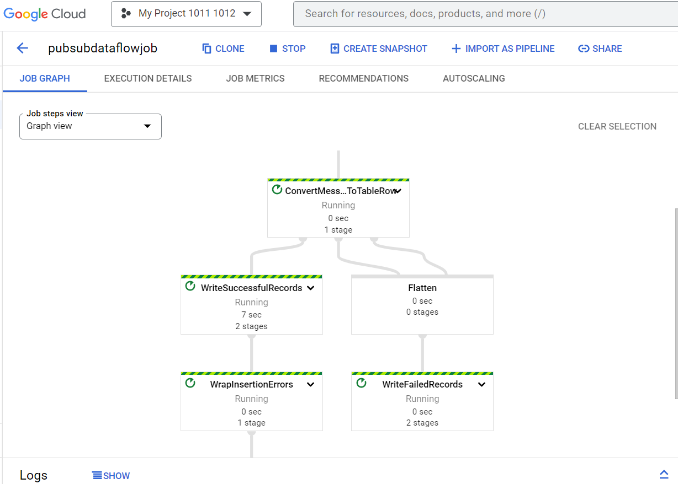

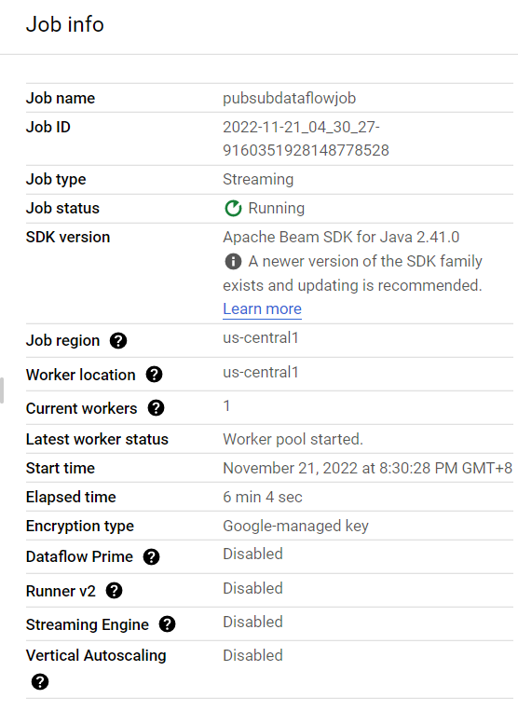

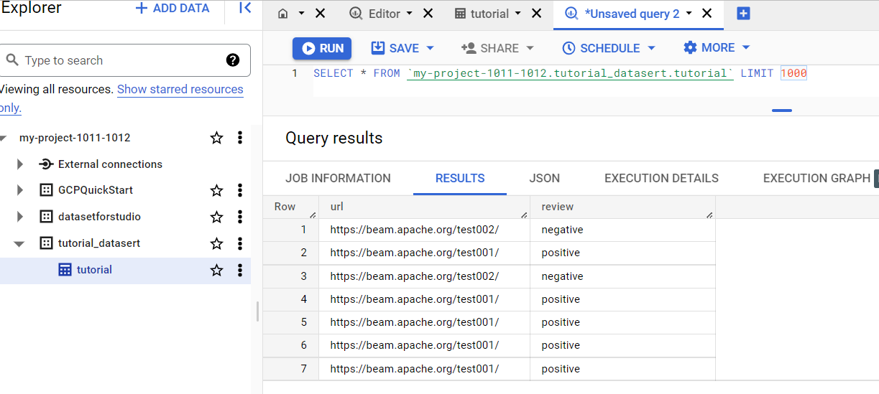

https://cloud.google.com/dataflow/docs/tutorials/dataflow-stream-to-bigquery#gcloud_4

