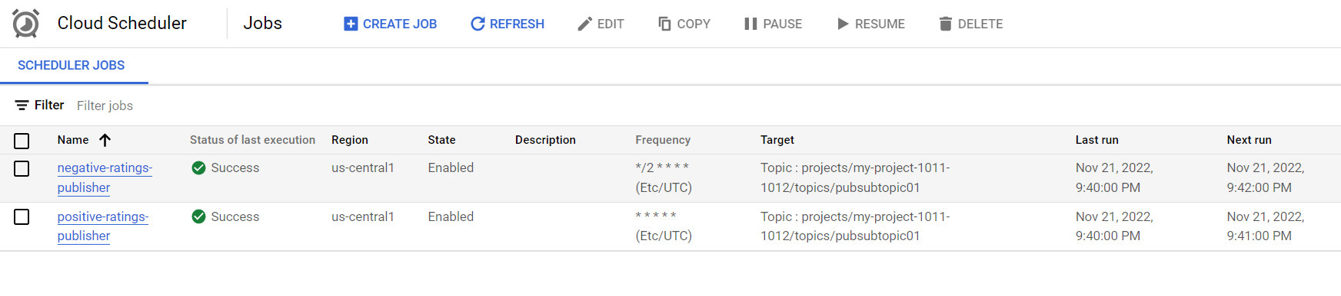

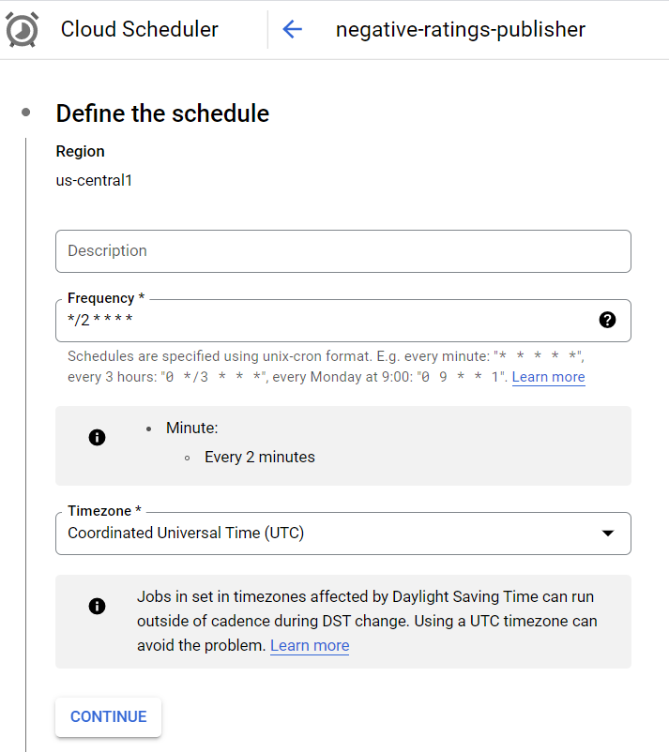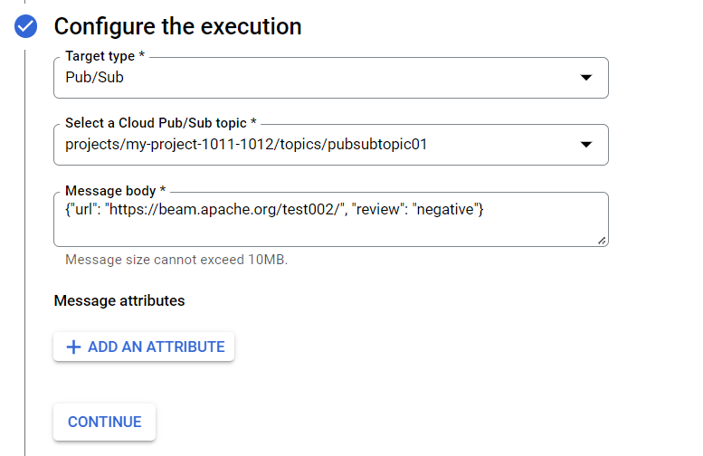

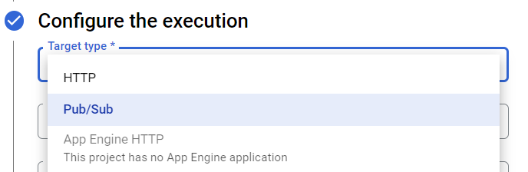

gcloud scheduler jobs create pubsub positive-ratings-publisher --schedule="* * * * *" --location=us-central1 --topic="pubsubtopic01" --message-body='{"url":"https://beam.apache.org/test001/","review":"positive"}'

gcloud scheduler jobs run --location=us-central1 positive-ratings-publisher

gcloud scheduler jobs create pubsub negative-ratings-publisher --schedule="*/2 * * * *" --location=us-central1 --topic="pubsubtopic01" --message-body='{"url": "https://beam.apache.org/test002/", "review": "negative"}'

gcloud scheduler jobs run --location=us-central1 negative-ratings-publisher

